Name:- Saksham Pathak

Enrollment Number:- 09914803119

EXPERIMENT 2:- LAB 2 DBMS

Understanding PRIMARY KEY FOREIGN KEY AND NOT NULL;

Database already created named college;

1)cmd): use College;

2)cmd: CREATE TABLE Teachers (teach_id int NOT NULL,LastName varchar(255),FirstName varchar(255),Address varchar(255),City varchar(255),PRIMARY KEY(teach_id);

3)cmd: INSERT INTO Teachers (teach_id,LastName,FirstName,Address,City)VALUES ('1', 'ferguson', 'sir alex', 'platama', 'Scotland');

4)cmd: INSERT INTO Teachers (teach_id,LastName,FirstName,Address,City)VALUES ('2', 'mourinhio', 'jose', 'porto', 'Portugal');

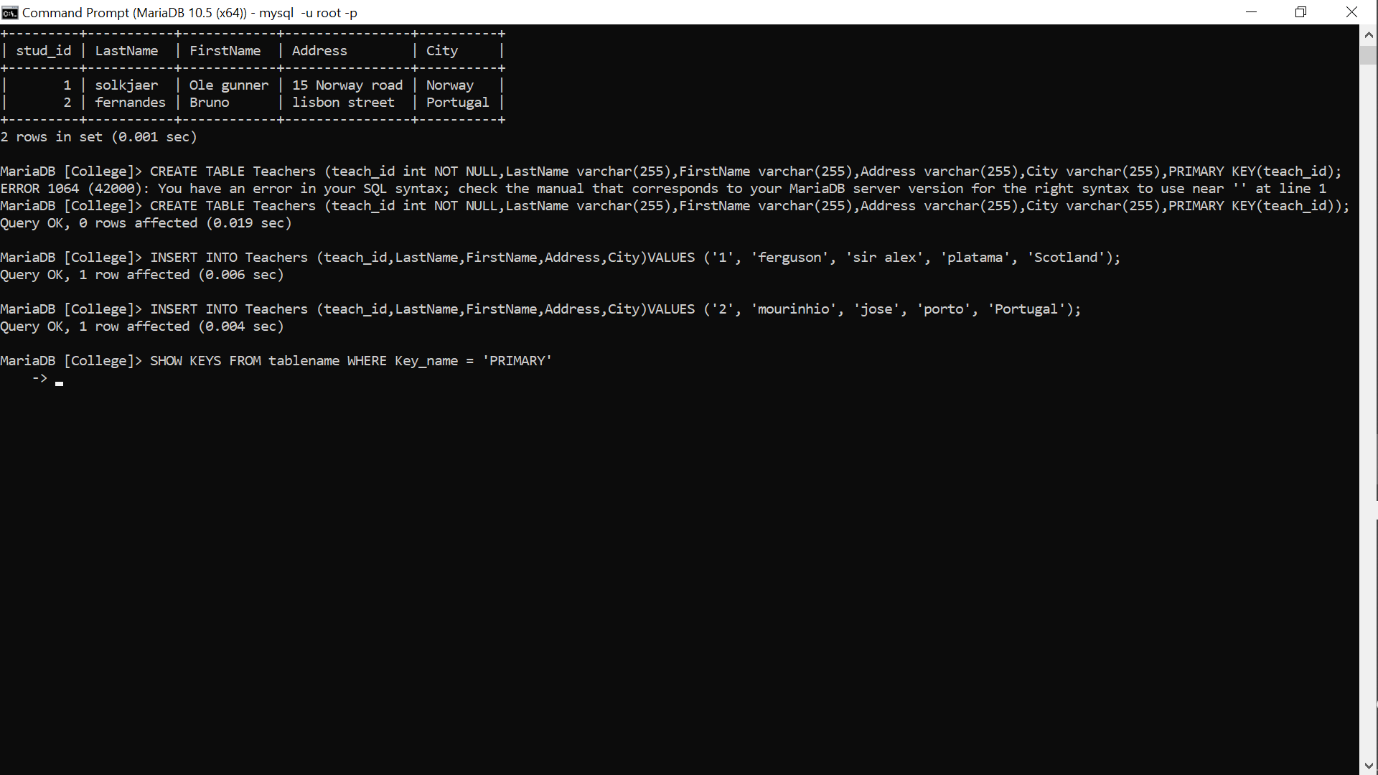

5)cmd: show tables;

6): SELECT * FROM TABLES;

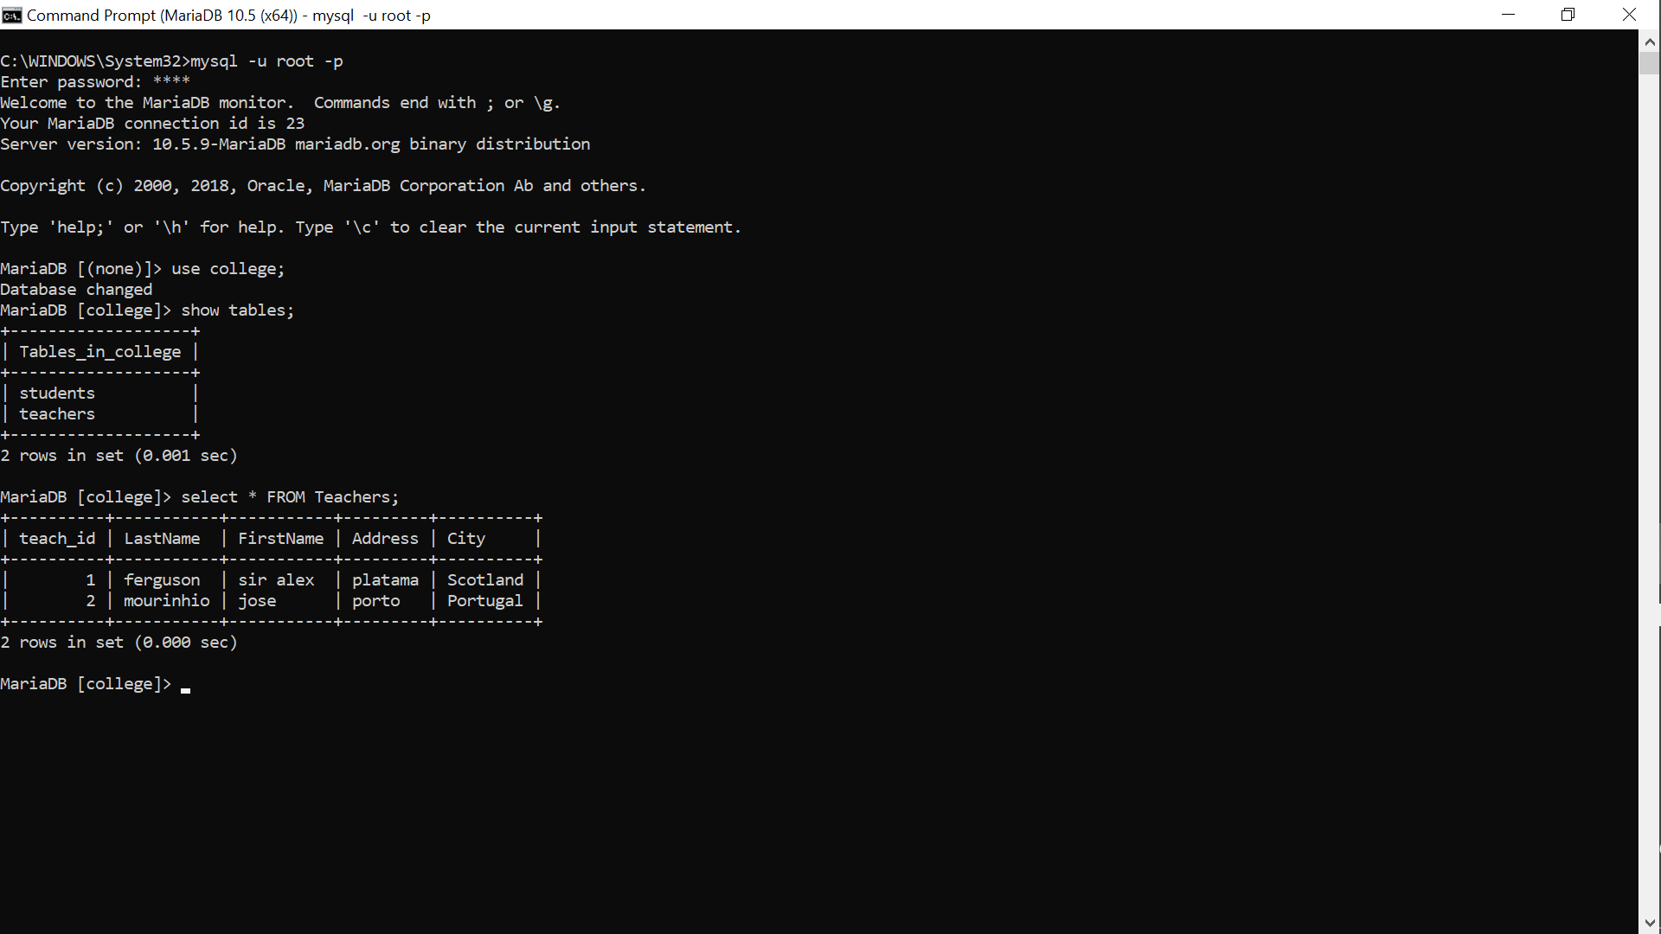

7): SHOW KEYS FROM Teachers WHERE Key_name = 'PRIMARY';

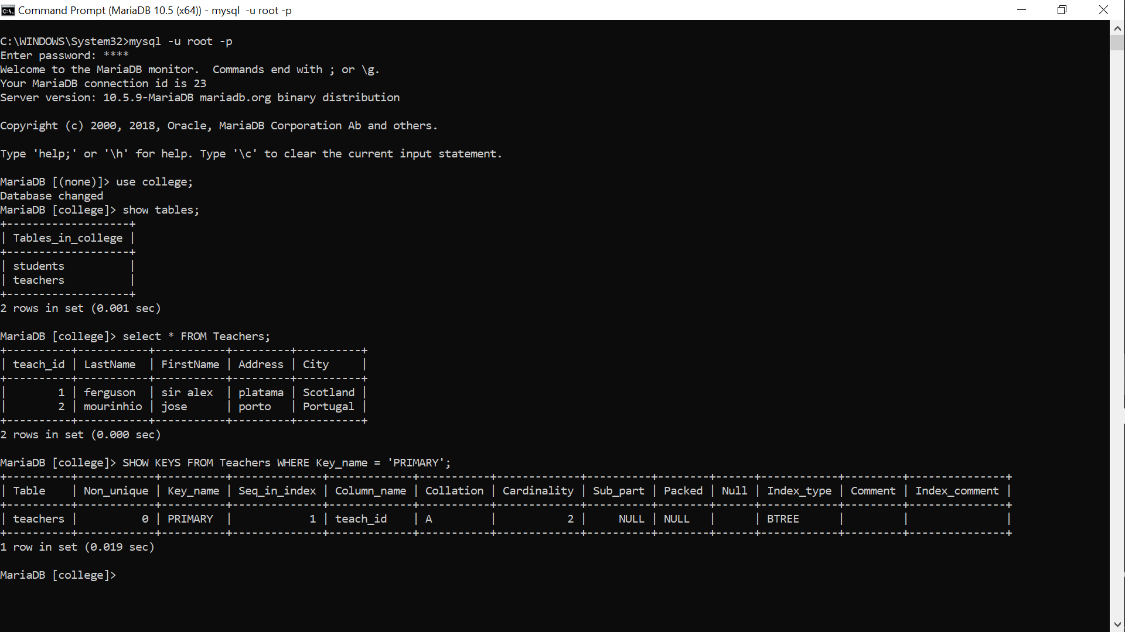

Here we can see The implementation of PRIMARY KEY AND NOT NULL CONSTRAINS

Now For FOREIGN KEY

8)cmd: CREATE TABLE Insititute (inst_id int NOT NULL,Name varchar(255) NOT NULL,teach_id int, PRIMARY KEY (inst_id),FOREIGN KEY (teach_id) REFERENCES Teachers(teach_id));

9)cmd: INSERT INTO Teachers (inst_id,Name,teach_id)VALUES ('1', 'MIT','1');

10)cmd: INSERT INTO Insititute (inst_id,Name,teach_id)VALUES ('2', 'IIT','2');

11)cmd: SELECT * FROM Insititute;

