**LAB FILE OF**

**DATABASE**

**MANAGEMENT**

**SYSTEMS**

Faculty: Mrs. Prerna Sharma Student name: Aayushi Mittal

Roll No.: 21114802719

Semester: IV



Maharaja Agrasen Institute of Technology, PSP area,

Sector – 22, Rohini, New Delhi – 110085

( Affiliated to Guru Gobind Singh Indraprastha University, New Delhi )

**EXPERIMENT-2**

**AIM:**  **Creation of Database/Tables and insertion of Data.**

**TOOLS USED:** Maria DB

**QUERIES:**

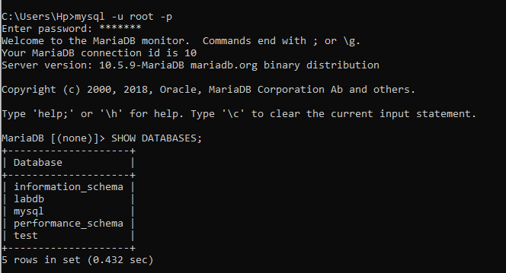



CREATE TABLE CLIENT_MASTER (

clientno varchar(6),

name varchar(20),

address1 varchar(30),

address2 varchar(30),

city varchar(15),

pincode int(8),

state varchar(15),

bal_due decimal(10,2)

);

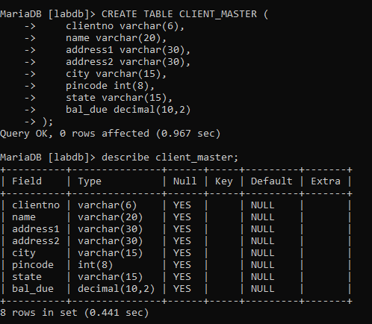

insert into CLIENT_MASTER values('C00001', 'Ivan', ‘’, ‘’, 'Mumbai', 400054, 'Maharashtra', 15000);

insert into CLIENT_MASTER values('C00002', 'MamtaMuzumdar', ‘’, ‘’, 'Madras', 780001, 'Tamil Nadu', 0);

insert into CLIENT_MASTER values('C00003', 'ChhayaBankar', ‘’, ‘’, 'Mumbai', 400057, 'Maharashtra', 5000);

insert into CLIENT_MASTER values('C00004', 'Ashwini Joshi', ‘’, ‘’, 'Banglore', 560001, 'Karnartaka', 0);

insert into CLIENT_MASTER values('C00005', 'Hansel Colaco', ‘’, ‘’, 'Mumbai', 400060, 'Maharashtra', 2000);

insert into CLIENT_MASTER values('C00006', 'Deepak Sharma', ‘’, ‘’, 'Manglore', 560050, 'Karnartaka', 0);

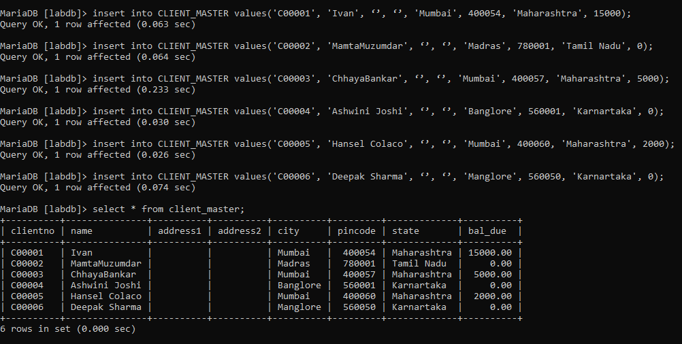

CREATE TABLE PRODUCT_MASTER (

production varchar(6),

description varchar(15),

profitpercent decimal(4,2),

unitmeasure varchar(10),

qtyonhand int(8),

reordervl int(8),

sellprice decimal(8,2),

costprice decimal(8,2)

);

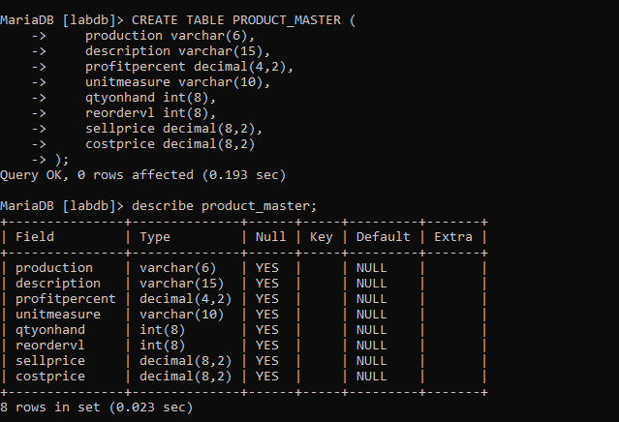

insert into product_master values('P00001','T-Shirts',5,'Piece',200,50,5350,250);

insert into product_master values('P0345','Shirts',6,'Piece',150,50,500,350);

insert into product_master values('P07868','Trousers',2,'Piece',150,50,850,550);

insert into product_master values('P07865','Jeans',5,'Piece',100,20,750,500);

insert into product_master values('P07965','Denim Shirts',4,'Piece',100,40,350,250);

insert into product_master values('P07885','Pull Overs',2.5,'Piece',80,30,700,450);

insert into product_master values('P08865','Skirts',5,'Piece',75,30,450,300);

insert into product_master values('P06734','Cotton Jeans',5,'Piece',100,20,600,450);

insert into product_master values('P07975','Lycra Tops',5,'Piece',70,30,300,175);

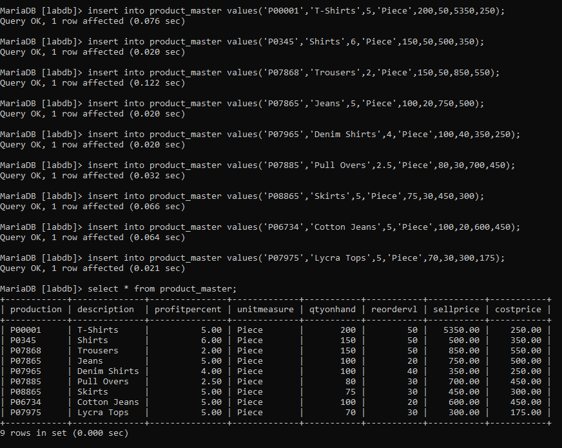

CREATE TABLE SALESMAN_MASTER (

SALESMANNO varchar(6),

SALESMANNAME varchar(20),

ADDRESS1 varchar(20),

ADDRESS2 varchar(20),

CITY varchar(20),

PINCODE int(8),

STATE varchar(20),

SALAMT int,

TGTTOGET int,

YTDSALES int,

REMARKS varchar(20)

);

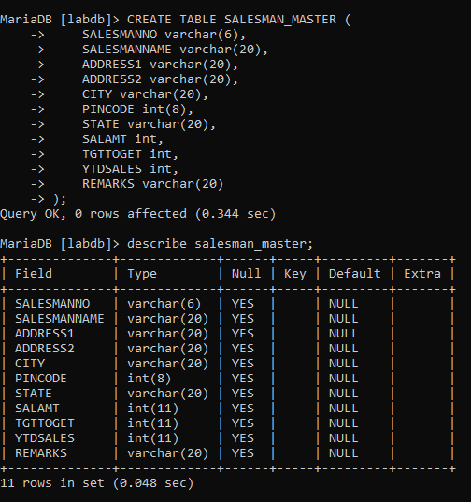

insert into SALESMAN_MASTER values('S00001', 'Kiran', 'A/14', 'Worli', 'Mumbai', 400002, 'Maharashtra', 30000, 100, 50, 'Good');

insert into SALESMAN_MASTER values('S00002', 'Manish', '65', 'Nariman', 'Mumbai', 400001, 'Maharashtra', 3000, 200, 100, 'Good');

insert into SALESMAN_MASTER values('S00003', 'Ravi', 'P-7', 'Bandra', 'Mumbai', 400032, 'Maharashtra', 3000, 200, 100, 'Good');

insert into SALESMAN_MASTER values('S00004', 'Ashish', 'A/9', 'Juhu', 'Mumbai', 400044, 'Maharashtra', 3000, 200, 150, 'Good');

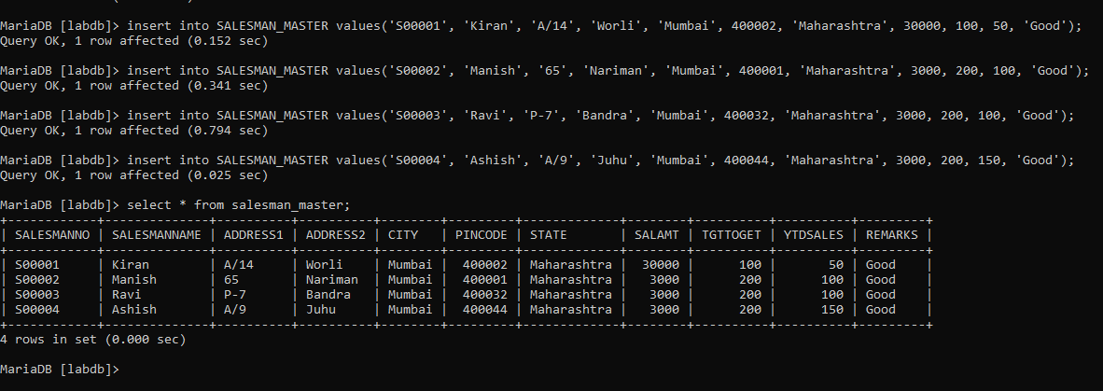

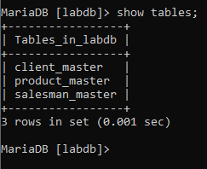

**VIVA QUESTIONS:**

**Que1. What is a NULL value and how does it differ from a zero value?**

Zero is a number value. It is a definite with precise mathematical properties. (You can do arithmetic on it .

NULL means the absence of any value. You can't do anything with it except test for it.

**Que2. What are SQL Constraints?**

SQL constraints are used to specify rules for the data in a table. Constraints are used to limit the type of data that can go into a table. This ensures the accuracy and reliability of the data in the table. If there is any violation between the constraint and the data action, the action is aborted.

The following constraints are commonly used in SQL:

• NOT NULL- Ensures that a column cannot have a NULL value

• UNIQUE- Ensures that all values in a column are different

• PRIMARY KEY- A combination of a NOT NULL and UNIQUE. Uniquely identifies each row in a table

• FOREIGN KEY- Uniquely identifies a row/record in another table

• CHECK- Ensures that all values in a column satisfies a specific condition

• DEFAULT- Sets a default value for a column when no value is specified

• INDEX- Ued to create and retrieve data from the database very quickly

**Que3. What is the difference between CHAR and VARCHAR?**

CHAR is fixed length and VARCHAR is variable length. CHAR always uses the same

amount of storage space per entry, while VARCHAR only uses the amount necessary to store the actual text

Varchar cuts off trailing spaces if the entered characters is shorter than the declared

length. Char will pad spaces and will always be the length of the declared length. In

in terms of efficiency, varchar is more adept .

**Que 4. What is Difference between NUMBER, INTEGER and INT DataTypes?**

Number allows a decimal component Integer doesn't. If we try to store 3.43 in an

Integer, it will just store 3.Number allows for much larger values than Integer does.

**EXPERIMENT-3**

**AIM:**  **Write the queries for viewing all databases, creating a Database, viewing all Tables in a Databases (With and Without Constraints).**

**TOOLS USED:** Maria DB

**QUERIES:**

1. **Find out the names of all the clients.**

SELECT NAME FROM CLIENT_MASTER;

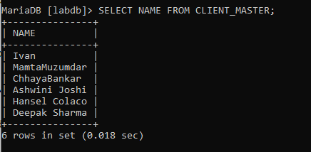

1. **Retrieve the entire contents of the CLIENT_MASTER table.**

SELECT * FROM CLIENT_MASTER;

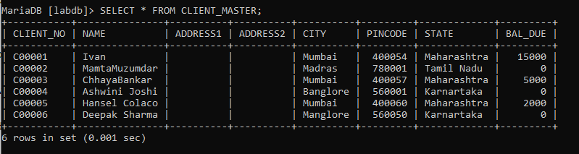

**3) Retreive the list of NAME, CITY, STATE of all the clients.**

SELECT NAME, CITY, STATE FROM CLIENT_MASTER;

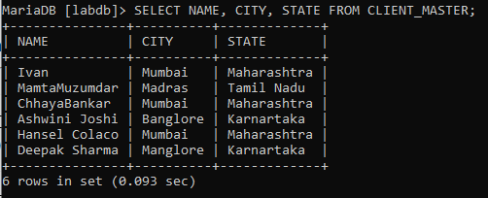

1. **Find names of client from CLIENT_MASTER whose BAL_DUE is zero.**

SELECT NAME FROM CLIENT_MASTER WHERE BAL_DUE>0;

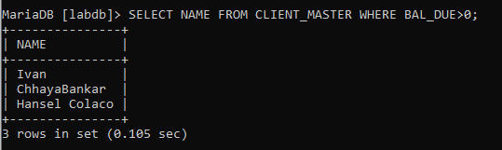

1. **List all the clients who are located in ‘Mumbai’.**

SELECT NAME FROM CLIENT_MASTER WHERE CITY='Mumbai';

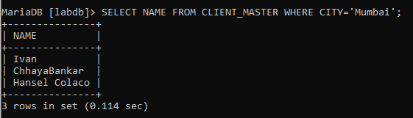

1. **List the various products available from the PRODUCT_MASTER table.**

SELECT DESCRIPTION FROM PRODUCT_MASTER;

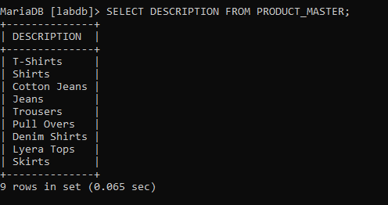

1. **Find the names of salesmen who have a salary equal to 3000 rupees.**

SELECT SALESMANNAME FROM SALESMAN_MASTER WHERE SALAMT= 3000;

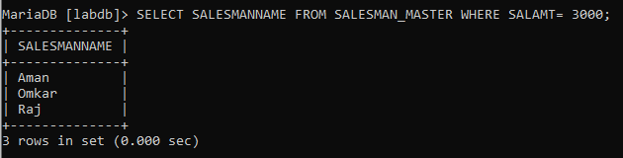

1. **List all SALESMANNO who live in CITY ‘Mumbai’.**

SELECT SALESMANNO FROM SALESMAN_MASTER WHERE CITY = 'Mumbai';

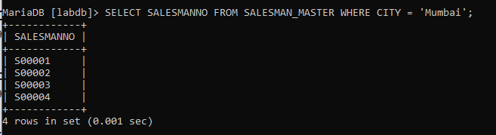

1. **Find PRODUCTNO. whose COSTPRICE is equal to 150 Rs.**

SELECT PRODUCTION FROM PRODUCT_MASTER WHERE COSTPRICE= 150;



1. **Find PRODUCTNO of ‘T-Shirts’ in PRODUCT_MASTER table.**

SELECT PRODUCTION FROM PRODUCT_MASTER WHERE DESCRIPTION= 'T-Shirts';

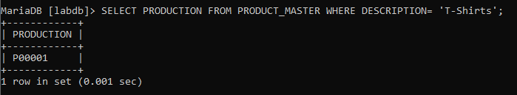

**VIVA QUESTIONS:**

**Que1. What is the use of SELECT command?**

The SELECT Statement in SQL is used to retrieve or fetch data from a database. We

can fetch either the entire table or according to some specified rules. The data

returned is stored in a result table. This result table is also called result-set.

**Que2. What is the purpose of WHERE clause?**

The SQL WHERE clause is used to specify a condition while fetching the data from a

single table or by joining with multiple tables. If the given condition is satisfied, then

only it returns a specific value from the table.

**Ques3. Which language supports SELECT command?**

In most applications, SELECT is the most commonly used data manipulation language

(DML) command. As SQL is a declarative programming language, SELECT queries

specify a result set, but do not specify how to calculate it.

**Que4. How to select entire content of a table?**

SELECT * FROM table_name;

The star will return all the records available in the specified table

**EXPERIMENT-4**

**AIM:**  **Write a SQL Statement for implementing ALTER, UPDATE and DELETE.**

**TOOLS USED:** Maria DB

**QUERIES:**

1. **Change the City of Client No ' Bangalore' C00005' to**

UPDATE CLIENT_MASTER  
SET CITY= 'Banglore'  
WHERE CLIENTNO= 'C00005';

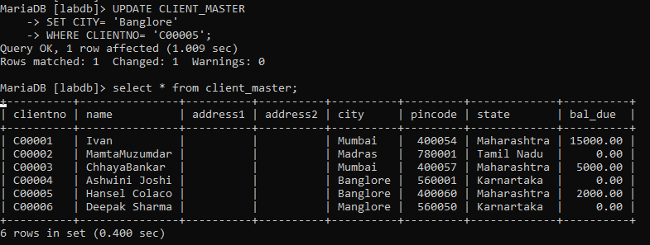

1. **Change the Bal Due of Client No ' to Rs.1000 C00001'**

UPDATE CLIENT_MASTER  
SET BAL_DUE= 1000  
WHERE CLIENTNO= 'C00001';

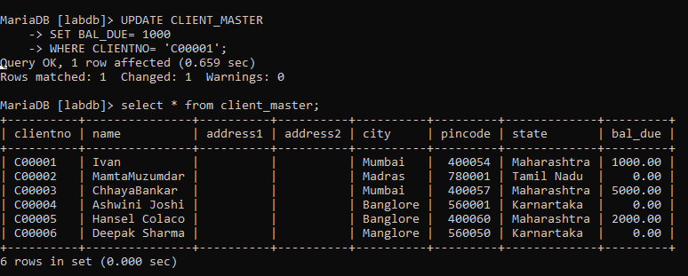

1. **Change the Cost Price of 'Trousers' to Rs.950.**

UPDATE PRODUCT_MASTER  
SET COSTPRICE = 950.00  
WHERE DESCRIPTION = 'Trousers';

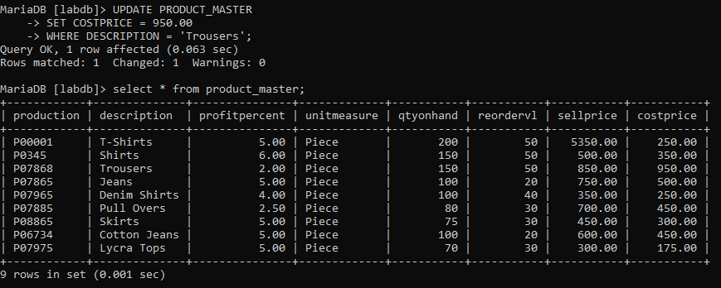

1. **Change the City of the Salesman to ' Pune'**

UPDATE SALESMAN_MASTER  
SET CITY= 'Pune';

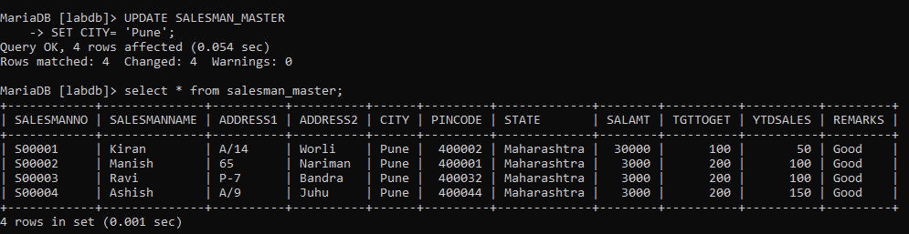

1. **Delete all Salesman from the Salesman Master whose salaries are equal to Rs. 30000.**

DELETE FROM SALESMAN_MASTER WHERE SALAMT =30000;

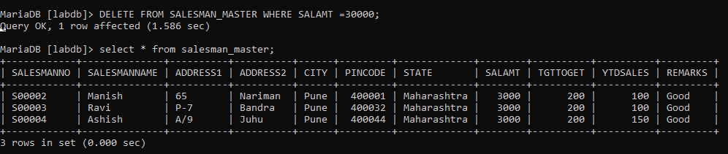

1. **Delete all Products from Product Master where the QtyOnHand = 100.**

DELETE FROM PRODUCT_MASTER WHERE QTYONHAND =100;

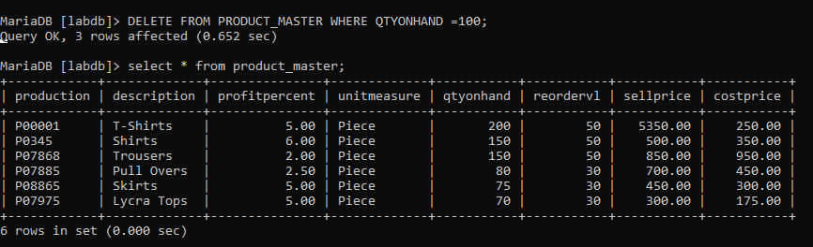

1. **Delete from Client_Master where the column state holds the value Tamil Nadu'.**

DELETE FROM CLIENT_MASTER WHERE STATE ='Tamil Nadu';

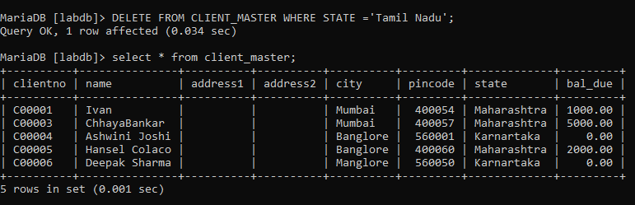

1. **Add a column called Telephone' of data Number' and size = '10' to the type ' Client Master Table.**

ALTER TABLE CLIENT_MASTER ADD TELEPHONE INTEGER(10);

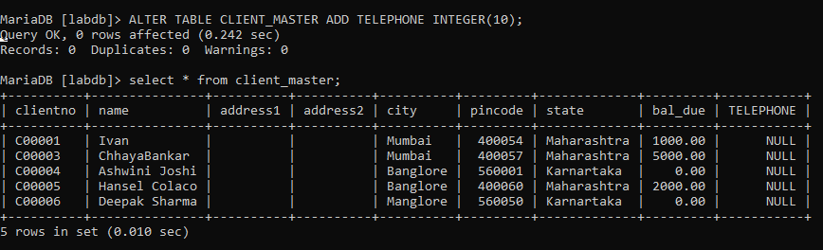

1. **Change the size of Sell Price column in Product Master to 10.2.**

ALTER TABLE PRODUCT_MASTER MODIFY SELLPRICE DECIMAL(10.2);



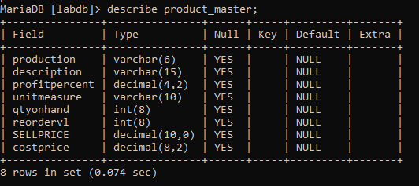

1. **Destroy the table Client Master along with its data.**

DROP TABLE CLIENT_MASTER;



1. **Change the name of the Salesman Master table to SMAN_MAST Teams.**

ALTER TABLE SALESMAN_MASTER  
RENAME SMAN_MAST;

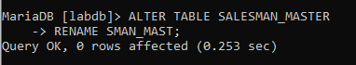

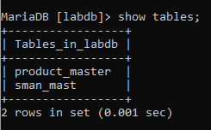

**VIVA QUESTIONS:**

**Que1. What are different DML commands?**

DML is short name of Data Manipulation Language which deals with data manipulation

and includes most common SQL statements such SELECT, INSERT, UPDATE,

DELETE, etc., and it is used to store, modify, retrieve, delete and update data in a

database.

* SELECT- retrieve data from a database
* INSERT- insert data into a table
* UPDATE- updates existing data within a table
* DELETE- Delete all records from a database table
* MERGE - UPSERT operation (insert or update)
* CALL - call a PL/SQL or Java subprogram
* EXPLAIN PLAN - interpretation of the data access path
* LOCK TABLE - concurrency Control

**Que2. What is the purpose of ALTER command .What is the Syntax?**

The ALTER TABLE statement is used to add, delete, or modify columns in an existing

table. The ALTER TABLE statement is also used to add and drop various constraints on an

existing table.

ALTER TABLE table_name

ADD column_name datatype;

**Que3. What is the purpose of DELETE command?**

The DELETE Statement in SQL is used to delete existing records from a table. We can

delete a single record or multiple records depending on the condition we specify in the

WHERE clause.

Basic Syntax:

DELETE FROM table_name WHERE some_condition;

**Que4. What is difference between ALTER and UPDATE commands?**

The point that distinguishes both ALTER and UPDATE Command is that ALTER

command is Data Definition Language (DDL). On the other hands, the UPDATE

Command is a Data Manipulation Language (DML).

* ALTER Command add, delete, modify, rename the attributes of the relation whereas, the UPDATE Command modifies the values of the records in the relations.
* ALTER Command by default set values of all the tuples or record as NULL. On the other hands, the UPDATE Command set the value specified in the command to the tuples of the relation.
* ALTER command is attribute or column specific whereas, the UPDATE command is attribute value specific.

**EXPERIMENT-5**

**AIM:**  **Write the queries to implement the concept of integrity constraints like primary key, foreign key, NOT NULL to the tables.**

**TOOLS USED:** Maria DB

**QUERIES:**

CREATE TABLE CLIENT_MASTER (

clientno varchar(6) primary key,

name varchar(20),

address1 varchar(30),

address2 varchar(30),

city varchar(15),

pincode int(8),

state varchar(15),

bal_due decimal(10,2)

);

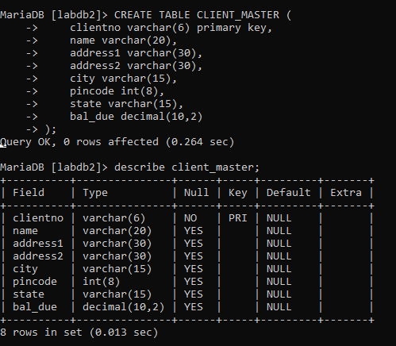

insert into CLIENT_MASTER values('C00001', 'Aman', 'A/14', 'Worli', 'Mumbai', 400002, 'Maharashtra', 30000);

insert into CLIENT_MASTER values('C00002', 'Omkar', '65', 'Nariman', 'Mumbai', 400001, 'Maharashtra', 8000);

insert into CLIENT_MASTER values('C00003', 'Raj', 'P-7', 'Bandra', 'Mumbai', 400032, 'Maharashtra', 12000);

insert into CLIENT_MASTER values('C00004', 'Ashi', 'A/9', 'Juhu', 'Mumbai', 400044, 'Maharashtra', 0);

insert into CLIENT_MASTER values('C00005', 'Ashish', 'A/5', 'Juhu', 'Mumbai', 400044, 'Maharashtra', 3500);

insert into CLIENT_MASTER values('C00006', 'Ashutosh', 'F/5', 'Andheri', 'Mumbai', 400044, 'Maharashtra', 0);

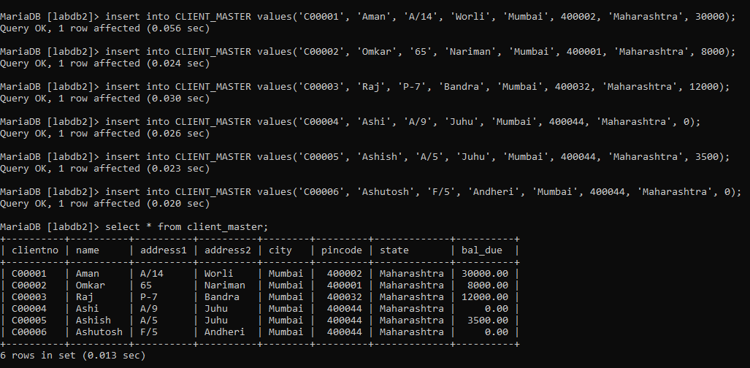

CREATE TABLE SALESMAN_MASTER (

SALESMANNO varchar(6) primary key,

SALESMANNAME varchar(20),

ADDRESS1 varchar(20),

ADDRESS2 varchar(20),

CITY varchar(20),

PINCODE int(8),

STATE varchar(20),

SALAMT int,

TGTTOGET int,

YTDSALES int,

REMARKS varchar(20)

)

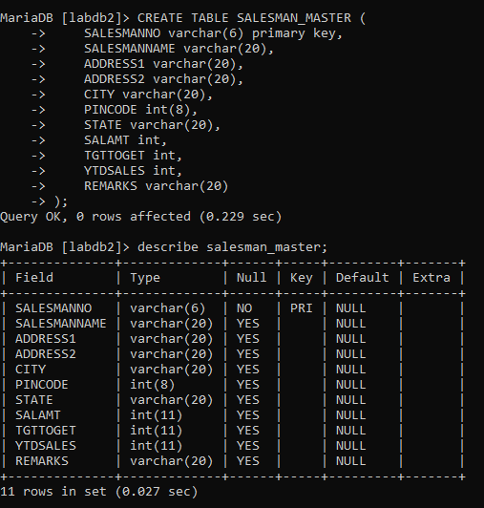

insert into SALESMAN_MASTER values('S00001', 'Kiran', 'A/14', 'Worli', 'Mumbai', 400002, 'Maharashtra', 30000, 100, 50, 'Good');

insert into SALESMAN_MASTER values('S00002', 'Manish', '65', 'Nariman', 'Mumbai', 400001, 'Maharashtra', 3000, 200, 100, 'Good');

insert into SALESMAN_MASTER values('S00003', 'Ravi', 'P-7', 'Bandra', 'Mumbai', 400032, 'Maharashtra', 3000, 200, 100, 'Good');

insert into SALESMAN_MASTER values('S00004', 'Ashish', 'A/9', 'Juhu', 'Mumbai', 400044, 'Maharashtra', 3000, 200, 150, 'Good');

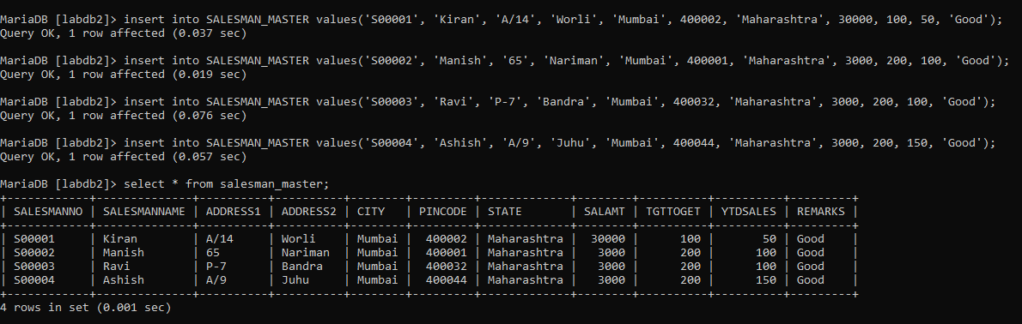

CREATE TABLE SALES_ORDER (

orderno varchar(6) not null primary key,

clientno varchar(6),

foreign key (clientno) references CLIENT_MASTER(clientno),

orderdate date,

salesmanno varchar(6),

foreign key (salesmanno) references SALESMAN_MASTER(salesmanno),

delivtype varchar(1) default 'F',

billyn varchar(1),

delivdate date,

orderstatus varchar(10),

constraint ck_delivtype check(delivtype in('P','F')),

constraint ck_delivdate check(delivdate > orderdate),

constraint ck_orderstatus check(orderstatus in('In Process', 'Fulfilled', 'Backorder','Cancelled'))

);

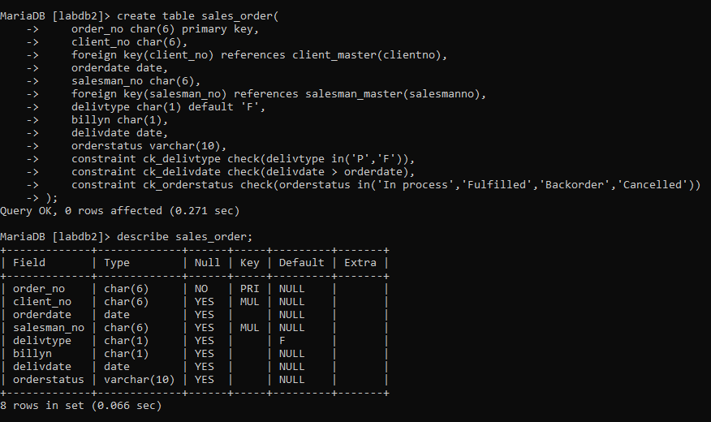

insert into sales_order values('O19001','C00001', '12-01-10', 'S00001', 'F', 'N', '20-01-10', 'In process');

insert into sales_order values('O19002','C00002', '25-01-10', 'S00002', 'P', 'N', '27-01-10', 'Cancelled');

insert into sales_order values('O46865','C00003', '18-02-10', 'S00003', 'F', 'Y', '20-02-10', 'Fulfilled');

insert into sales_order values('O19003','C00004', '03-04-10', 'S00001', 'F', 'Y', '07-04-10', 'Fulfilled');

insert into sales_order values('O46866','C00005', '20-05-10', 'S00002', 'P', 'N', '22-05-10', 'Cancelled');

insert into sales_order values('O19008','C00006', '24-05-10', 'S00004', 'F', 'N', '26-05-10', 'In process');

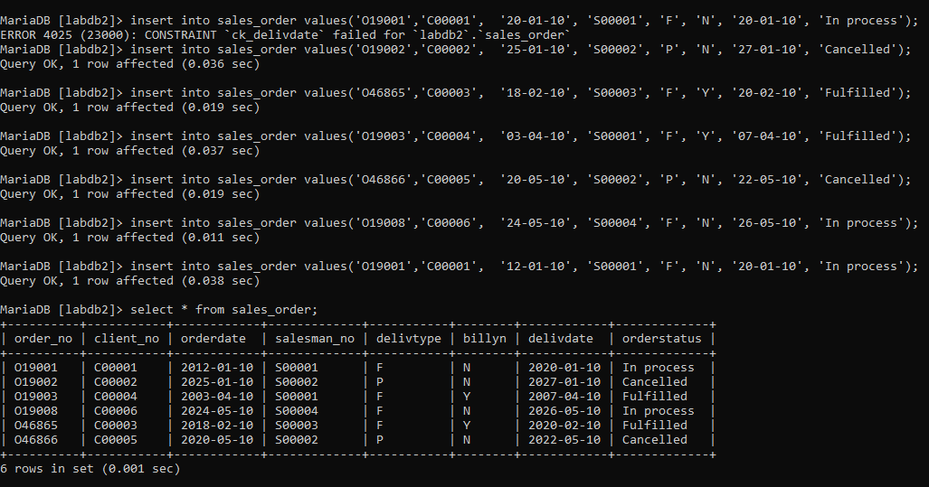

CREATE TABLE PRODUCT_MASTER (

production varchar(6) primary key,

description varchar(15) not null,

profitpercent decimal(4,2) not null,

unitmeasure varchar(10) not null,

qtyonhand int(8) not null,

reordervl int(8) not null,

sellprice decimal(8,2) not null,

costprice decimal(8,2) not null

);

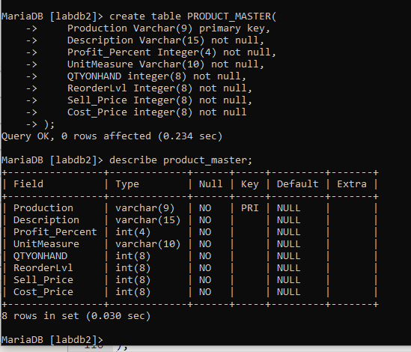

insert into product_master values('P00001','T-Shirts',5,'Piece',200,50,5350,250);

insert into product_master values('P0345','Shirts',6,'Piece',150,50,500,350);

insert into product_master values('P07868','Trousers',2,'Piece',150,50,850,550);

insert into product_master values('P07865','Jeans',5,'Piece',100,20,750,500);

insert into product_master values('P07965','Denim Shirts',4,'Piece',100,40,350,250);

insert into product_master values('P07885','Pull Overs',2.5,'Piece',80,30,700,450);

insert into product_master values('P08865','Skirts',5,'Piece',75,30,450,300);

insert into product_master values('P06734','Cotton Jeans',5,'Piece',100,20,600,450);

insert into product_master values('P07975','Lycra Tops',5,'Piece',70,30,300,175);

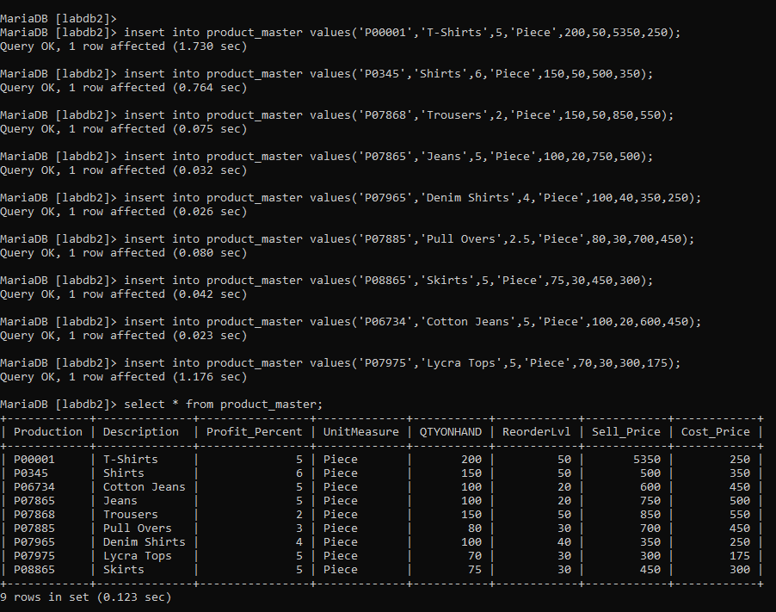

CREATE TABLE SALES_ORDER_DETAILS (

orderno varchar(6),

foreign key (orderno) references SALES_ORDER(order_no),

productno varchar(6),

foreign key (productno) references PRODUCT_MASTER(production),

qtyordered int(8),

qtydisp int(8),

productrate decimal(10,2)

);

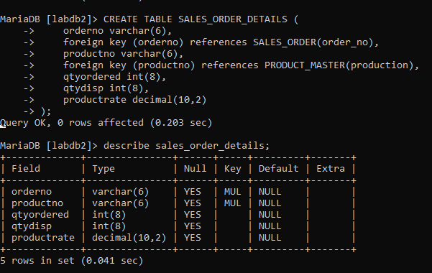

insert into sales_order_details values('O19001','P00001', 4, 4, 525);

insert into sales_order_details values('O19001','P07965', 2, 1, 8400);

insert into sales_order_details values('O19001','P07885', 2, 1, 5250);

insert into sales_order_details values('O19002','P00001', 10, 0, 525);

insert into sales_order_details values('O46865','P07868', 3, 3, 3150);

insert into sales_order_details values('O46865','P07885', 3, 1, 5250);

insert into sales_order_details values('O46865','P00001', 10, 10, 525);

insert into sales_order_details values('O46865','P03453', 4, 4, 1050);

insert into sales_order_details values('O19003','P03453', 2, 2, 1050);

insert into sales_order_details values('O19003','P06734', 1, 1, 12000);

insert into sales_order_details values('O04686','P07965', 1, 0, 8400);

insert into sales_order_details values('O04686','P07975', 1, 0, 1050);

insert into sales_order_details values('O19008','P00001', 10, 5, 525);

insert into sales_order_details values('O19008','P07975', 5, 3, 1050);

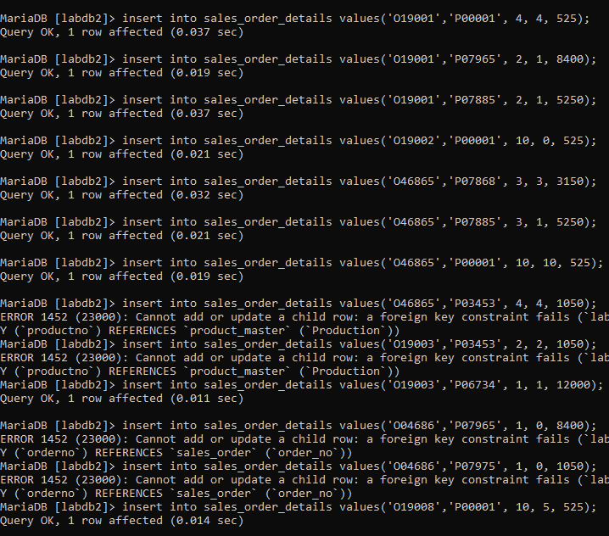

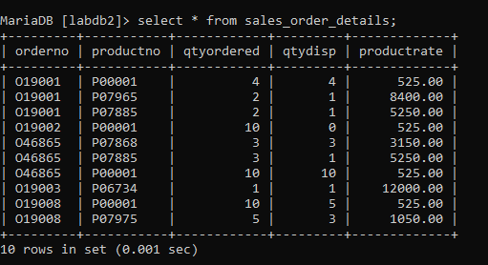

**VIVA QUESTIONS:**

**Que1. What are different Constraints in SQL?**

-NOT NULL Constraint restricts a column from having a NULL value. Once NOT NULL

constraint is applied to a column, you cannot pass a null value to that column.

-UNIQUE Constraint ensures that a field or column will only have unique values. A

-UNIQUE constraint field will not have duplicate data.

-Primary key Constraint uniquely identifies each record in a database. A Primary Key

must contain unique value and it must not contain null value.

-Foreign key Constraint is also used to restrict actions that would destroy links between

tables. Foreign key is used to relate two tables.

-CHECK Constraint is used to restrict the value of a column between a range. It performs

check on the values, before storing them into the database.

-Default Constraint is used to assign a default value to a column when no value is

specified. Index Constraint is used to create and retrieve data from the database very quickly. An Index can be created by using a single or group of columns in a table.

**Que2. What is the purpose of Null Constraint?**

Ans. This implies that the column need not receive any value during insert or update

operations. a column can hold NULL values. The NULL constraint is logically equivalent to omitting the NOT NULL constraint from the column definition. Once NULL constraint is applied to a column, you can pass a null value to that column.

**Que 3. What is Index Constraint?**

Ans. Indexes are used to retrieve data from the database more quickly than otherwise. The users cannot see the indexes, they are just used to speed up searches/queries. When the index is created, it is assigned a ROWID for each row before it sorts out the data. Proper indexes are good for performance in large databases

**Que 4. What is the purpose of Default Constraint?**

Ans. The DEFAULT constraint provides a default value to a column when the INSERT INTO statement does not provide a specific value. It is used to provide a default value for a column. The default value will be added to all new records IF no other value is specified.

**EXPERIMENT-6**

**AIM:**  **Write the queries for implementing the following functions: MAX(), MIN(), AVG(), COUNT() and other logical pattern matching operations.**

**TOOLS USED:** Maria DB

**QUERIES:**

1. **List the names of all clients having 'a' as the second letter in their names.**

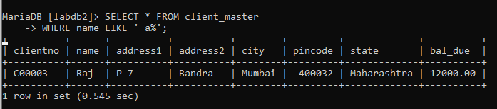

1. **List the client who stay in the city whose first letter is 'M.**

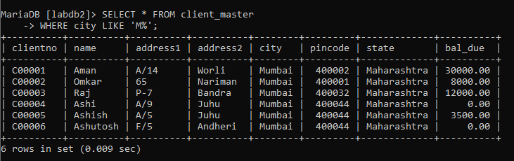

1. **List all clients who stay in 'Manglore’ or ‘Banglore'**

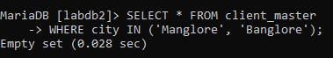

1. **List all the clients whose bal due=8,000.**

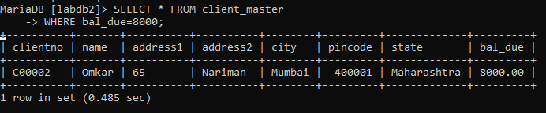

1. **List all the information frome sales order for orders placed in the month of ~~June~~ October.**

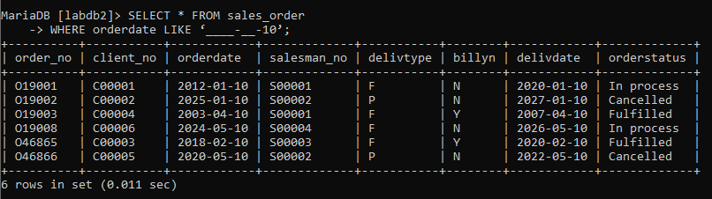

1. **List the order information for the client number 'C00001' and ' C00002**
2. **List the products who selling price is greater than 500 and less than or equal to 750.**

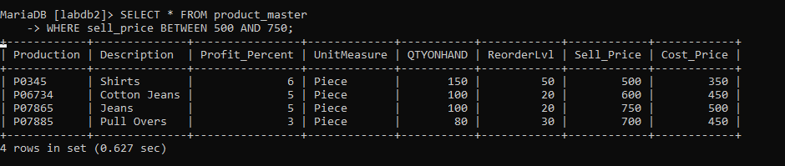

1. **List products who's selling price is more than 500. Calculate a new Selling Price as original selling price multiplied by 0.15.**

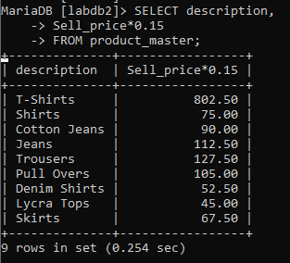

1. **Rename the new column in the output of above query as new_price.**

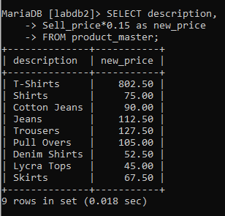

1. **List the name city of clients who are not in the state of Maharashtra'.**

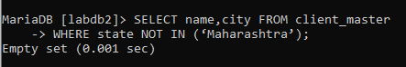

1. **Count the total number of orders.**

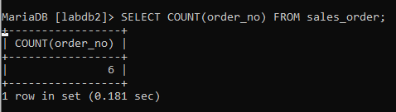

1. **Calculate the average price of all the products.**

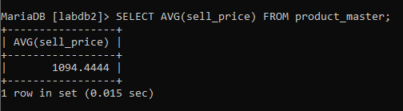

1. **Determine the maximum and minimum product prices. Rename the output as max price and min_price respectively.**

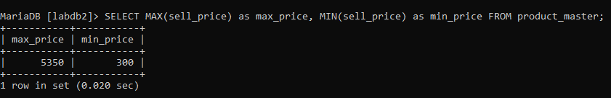

1. **Count the number of products having price less than or equal to 500**
2. **List the products whose qtyonhand is less than 3 order level.**

SELECT * FROM client_master  
WHERE name LIKE '_a%';

SELECT * FROM client_master  
WHERE city LIKE 'M%';

SELECT * FROM client_master   
WHERE city IN ('Manglore', 'Banglore');

SELECT * FROM client_master   
WHERE bal_due=8000;

SELECT * FROM sales_order   
WHERE orderdate LIKE ‘____-__-10’;

______________________________________

**SELECT * FROM sales_order_details   
WHERE clientno IN ('C00001', 'C00002');**

**____________________________________________**

SELECT * FROM client_master   
WHERE city IN ('Manglore', 'Banglore');

SELECT * FROM product_master   
WHERE sell_price BETWEEN 500 AND 750;

SELECT * FROM product_master   
WHERE sell_price BETWEEN 500 AND 750;

SELECT description,

Sell_price*0.15

FROM product_master;

SELECT description,

Sell_price*0.15 as new_price

FROM product_master;

SELECT name,city FROM client_master   
WHERE state NOT IN (‘Maharashtra’);

SELECT COUNT(order_no) FROM sales_order;

SELECT AVG(sell_price) FROM product_master;

SELECT MAX(sell_price) as max_price, MIN(sell_price) as min_price FROM product_master;

**VIVA QUESTIONS:**

**Que1.**