**MAHARAJA AGRASEN INSTITUTE OF TECHNOLOGY**

**DATA BASE MANAGEMENT SYSTEM**

**PRACTICAL FILE**

**Submitted to :**

**Dr . Prerna Sharma**

**Submitted By:**

Name: Ridham

Sec:4C-9

Roll no :75114802719

**DATA BASE MANAGEMENT SYSTEM**

**EXPERIMENT :1**

**Aim:Creation Of Database/tables and insertion of data .**

**Tool Used :** Maria DB**.**

**Procedure:**

This experiment has two parts , creation of tables and inserting values into tables. First we need to use CREATE command of DDL language for creation of tables and in second part we will insert the values into the tables .

Here we will create there tables , client_master, product_master and salesman_master and then will add their respective values into the tables.

**Syntax of Creation of Tables :**

SYNTAX: CREATE command

Create table table_name (

Column1 datatype,

Column2 datatype,

Column3 datatype,

…………..);

**Part -1 Creation Of Tables :**

1. **Table Name**: Client_master

**Description:** Used to store client information.

**Input Query :**

**CREATE** **TABLE** CLIENT_MASTER

(

ClientNo **CHAR**(6),

**Name** **VARCHAR** (20),

Address1 **VARCHAR** (30),

Address2 **VARCHAR** (30),

City **VARCHAR** (15),

Pincode **float**(8),

State **VARCHAR**(15),

BalDue **float**(10,2));

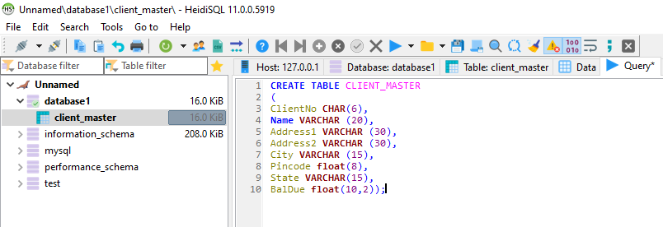

1. **Table Name**: Product_master

**Description:** Used to store product information.

**Input Query :**

**CREATE** **TABLE** PRODUCT_MASTER

(

Production **VARCHAR**(6),

Description **VARCHAR** (15),

ProfitPercent **float**(4,2),

UnitMeasure **VARCHAR** (30),

QtyOnHand **float**(8),

ReOrderLvl **float**(8),

SellPrice **float**(8,2),

CostPrice **float**(8,2));

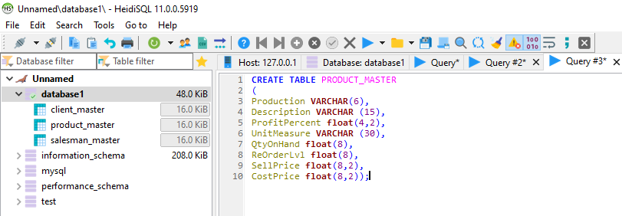

1. **Table Name**: Salesman_master

**Description:** Used to store salesman information.

**Input Query :**

**CREATE** **TABLE** SALESMAN_MASTER

(

SalesmanNo **VARCHAR**(6),

SalesmanName **VARCHAR** (20),

Address1 **VARCHAR** (30),

Address2 **VARCHAR** (30),

City **VARCHAR** (20),

PinCode **FLOAT** (8),

State **VARCHAR** (20),

SalAmt **FLOAT** (8,2),

TgtToGet **FLOAT** (6,2),

YtdsSales **FLOAT** (6,2),

Remarks **VARCHAR** (60));

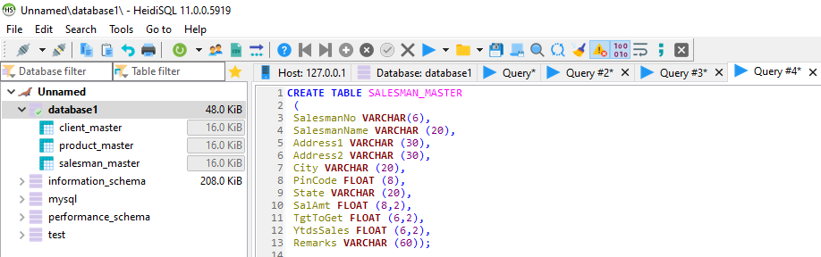

**Part -2 Insertion of values into the Tables :**

SYNTAX: INSERT command

INSERT into table_name (column1,column2,column3,……)

Values (value1,value2,value3,…….);

**Data For Client_master:**

**insert** **INTO** client_master **VALUES**('C00001','Ivan','','','Mumbai','Maharashtra',400054,15000);

**insert** **INTO** client_master **VALUES**('C00002','MamtaMuzumdar','','','Madras','TamilNadu',780001,0);

**insert** **INTO** client_master **VALUES**('C00003','ChhayaBankar','','','Mumbai','Maharashtra',400054,15000);

**insert** **INTO** client_master **VALUES**('C00004','AshwiniJoshi','','','Bangalore','Karnataka',560001,0);

**insert** **INTO** client_master **VALUES**('C00005','HanselColaco','','','Mumbai','Maharashtra',400060,2000);

**insert** **INTO** client_master **VALUES**('C00006','DeepakSharma','','','Mangalore','karnataka',560050,0);

OUTPUT

**Data For Product_master:**

**INSERT** **INTO** product_master **VALUES**('P00001','T-shirts',5,'Piece',200,50,5350,250);

**INSERT** **INTO** product_master **VALUES**('P0345','Shirts',6,'Piece',150,50,500,350);

**INSERT** **INTO** product_master **VALUES**('P06734','CottonJeans',5,'Piece',100,20,600,450);

**INSERT** **INTO** product_master **VALUES**('P07865','Jeans',5,'Piece',100,20,750,500);

**INSERT** **INTO** product_master **VALUES**('P07868','Trousers',2,'Piece',150,50,850,550);

**INSERT** **INTO** product_master **VALUES**('P07885','PullOvers',2.5,'Piece',80,30,700,450);

**INSERT** **INTO** product_master **VALUES**('P07965','DenimShirts',4,'Piece',100,40,350,250);

**INSERT** **INTO** product_master **VALUES**('P07975','LycraTops',5,'Piece',70,30,300,175);

**INSERT** **INTO** product_master **VALUES**('P08865','Skirts',5,'piece',75,30,450,300);

OUTPUT

**Data For Salesman_master:**

**INSERT** **INTO** salesman_master **VALUES**('S00001','Aman','A/14','Worli','Mumbai',400002,'Maharashtra',3000,100,50,'Good');

**INSERT** **INTO** salesman_master **VALUES**('S00002','Omkar','65','Nariman','Mumbai',400001,'Maharashtra',3000,200,100,'Good’);

**insert** **INTO** salesman_master

**VALUES**('S00003','Raj','P-7','Bandra','Mumbai',400032,'Maharashtra',3000,200,100,'Good');

**INSERT** **INTO** salesman_master **VALUES**('S00004','Ashish','A/5','Juhu','Mumbai',400044,'Maharashtra',3500,200,150,'Good');

OUTPUT

