**EXPERIMENT – 4**

AIM : Implementation of Arithmetic and String functions on a given database.

**THEORY :**

**1. POWER ():**

The POWER() function returns the value of a number raised to the power of another number.

SYNTAX:-

POWER(a, b)

**2. ROUND() :**

The ROUND() function rounds a number to a specified number of decimal places.

SYNTAX:

ROUND(number, decimals, operation)

**3. SQRT () :**

The SQRT() function returns the square root of a number.

SYNTAX:

SQRT(number)

**4. COS() :**

The COS() function returns the cosine of a number.

Syntax

COS(*number*)

**5. SIN() :**

The SIN() function returns the sine of a number.

Syntax

SIN(*number*)

**6. TAN() :**

The TAN() function returns the tangent of a number.

Syntax

TAN(*number*)

**7. ABS() :**

The ABS() function returns the absolute value of a number.

Syntax

ABS(*number*)

**8. MOD() :**

SQL MOD() function is used to get the remainder from a division. The SQL DISTINCT command along with the SQL MOD() function is used to retrieve only unique records depending on the specified column or expression.

**Syntax:**

**Mod(dividend , divider);**

**9. MAX () :**

The MAX() function returns the maximum value in a set of values.

Syntax

MAX(*expression*)

**10. MIN() :**

The MIN() function returns the minimum value in a set of values.

## Syntax

MIN(*expression*)

**11. AVG () :**

The AVG() function returns the average value of an expression.

## Syntax

AVG(*expression*)

**12. CEILING () :**

The CEILING() function returns the smallest integer value that is larger than or equal to a number.

Syntax

CEILING(*number*)

**13. FLOOR () :**

The FLOOR() function returns the largest integer value that is smaller than or equal to a number.

## Syntax

FLOOR(*number*)

**OUTPUT :**

**1. POWER, ROUND, SQRT, COS FUNCTIONS :**

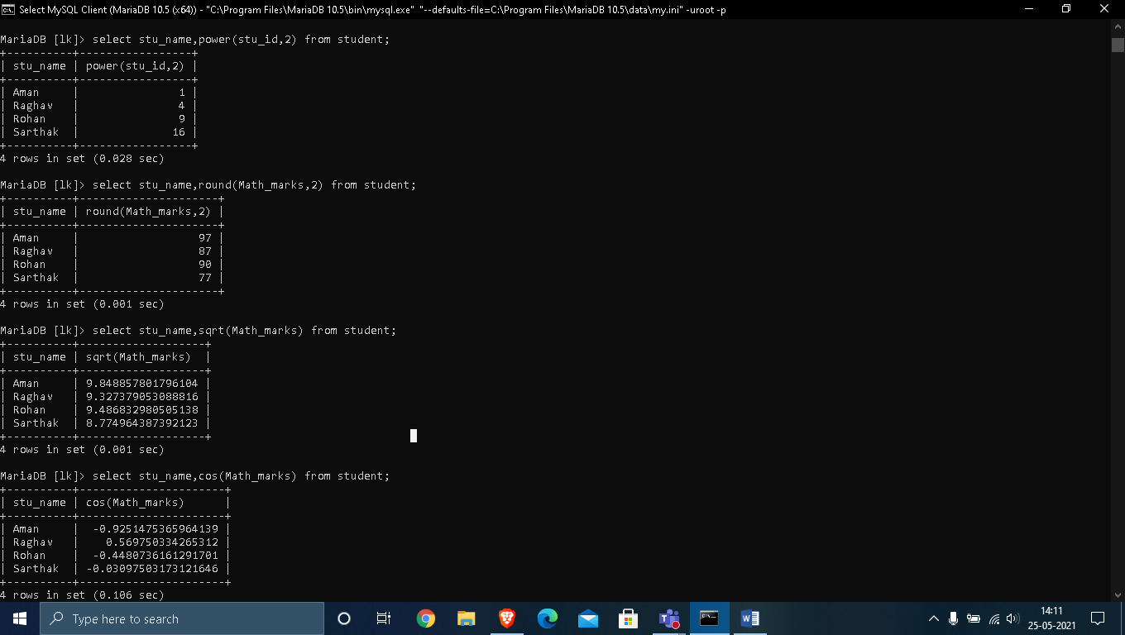

**2. SIN() ,TAN() :**

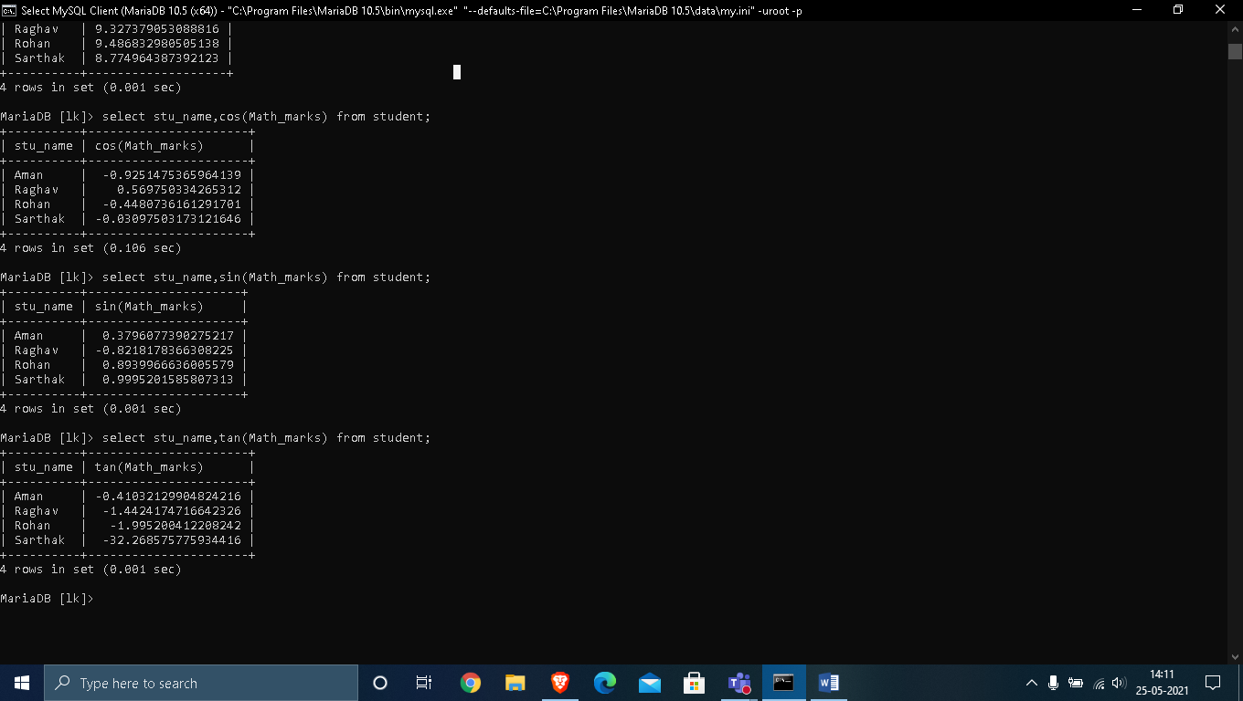

**3. ABS() , MOD() :**

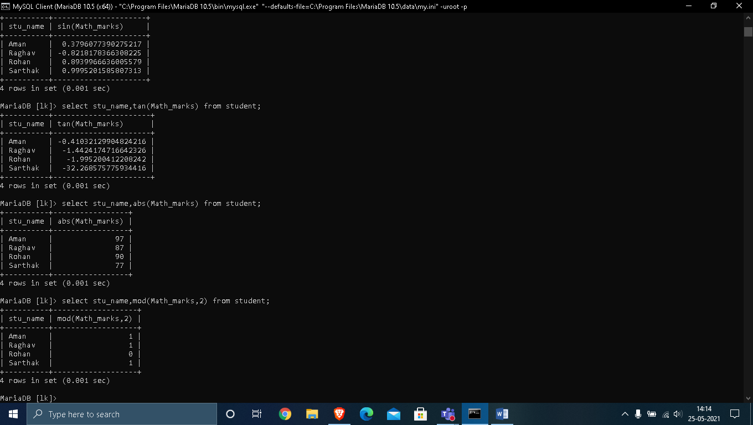

**4. MAX() , MIN() :**

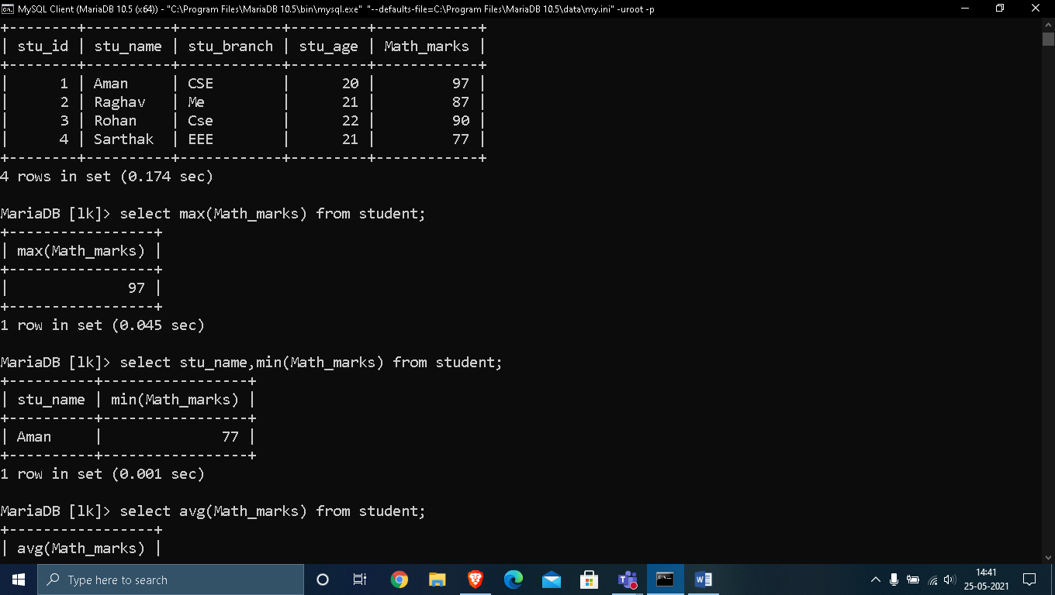

**5. AVG() , CEILING() :**

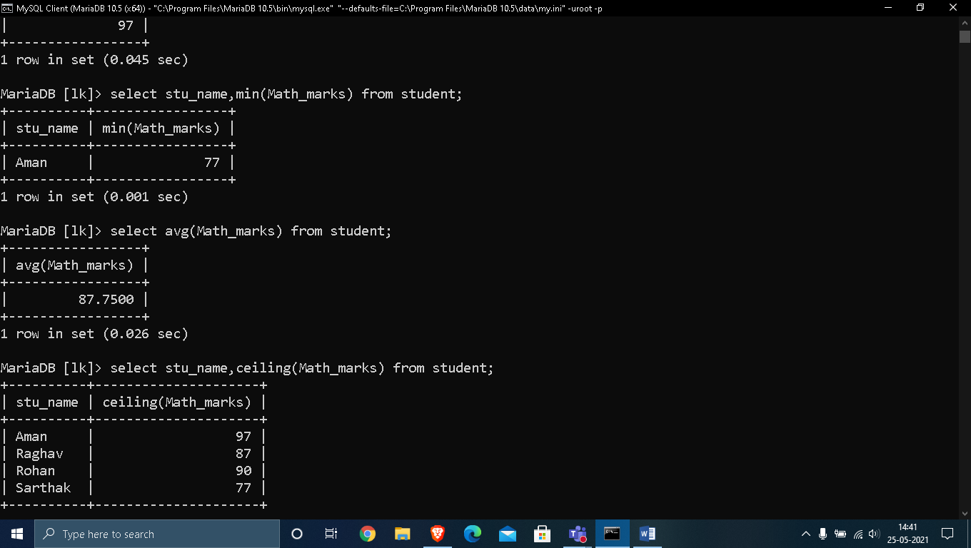

**# STRING FUNCTIONS :**

1. **ASCII():** This function is used to find the ASCII value of a character.

**Syntax:** SELECT ascii('t');

**Output:** 116

**2. CHAR_LENGTH():** Doesn’t work for SQL Server. Use LEN() for SQL Server. This function is used to find the length of a word.

**Syntax:** SELECT char_length('Hello!');

**Output:** 6

**3. CONCAT():** This function is used to add two words or strings.

**Syntax:** SELECT 'Geeks' || ' ' || 'forGeeks' FROM dual;

**Output:** ‘GeeksforGeeks’

**4. INSERT():** This function is used to insert the data into a database.

**Syntax:** INSERT INTO database (geek_id, geek_name) VALUES (5000, 'abc');

**Output:** successfully updated

**5. LCASE():** This function is used to convert the given string into lower case.

**Syntax:** LCASE ("GeeksFor Geeks To Learn");

**Output:** geeksforgeeks to learn

**6. LENGTH():** This function is used to find the length of a word.

**Syntax:** LENGTH('GeeksForGeeks');

**Output:** 13

**7. LOWER():** This function is used to convert the upper case string into lower case.

**Syntax:** SELECT LOWER('GEEKSFORGEEKS.ORG');

**Output:** geeksforgeeks.org

**8. LPAD():** This function is used to make the given string of the given size by adding the given symbol.

**Syntax:** LPAD('geeks', 8, '0');

**Output:**

000geeks

**9. LTRIM():** This function is used to cut the given sub string from the original string.

**Syntax:** LTRIM('123123geeks', '123');

**Output:** geeks

**10. REVERSE():** This function is used to reverse a string.

**Syntax:** SELECT REVERSE('geeksforgeeks.org');

**Output:** ‘gro.skeegrofskeeg’

**11. RPAD():** This function is used to make the given string as long as the given size by adding the given symbol on the right.

**Syntax:** RPAD('geeks', 8, '0');

**Output:** ‘geeks000’

**12.RTRIM():** This function is used to cut the given sub string from the original string.

**Syntax:** RTRIM('geeksxyxzyyy', 'xyz');

**Output:** ‘geeks’

**13. STRCMP():** This function is used to compare 2 strings.

* + If string1 and string2 are the same, the STRCMP function will return 0.
  + If string1 is smaller than string2, the STRCMP function will return -1.
  + If string1 is larger than string2, the STRCMP function will return 1.

**Syntax:** SELECT STRCMP('google.com', 'geeksforgeeks.com');

**Output:** -1

**14. SUBSTRING():** This function is used to find an alphabet from the mentioned size and the given string.

**Syntax:** SELECT SUBSTRING('GeeksForGeeks.org', 9, 1);

**Output:** ‘G’

**15.UCASE():** This function is used to make the string in upper case.

**Syntax:** UCASE ("GeeksForGeeks");

**Output:**

GEEKSFORGEEKS

**# OUTPUT :**

**1. ASCII() :**

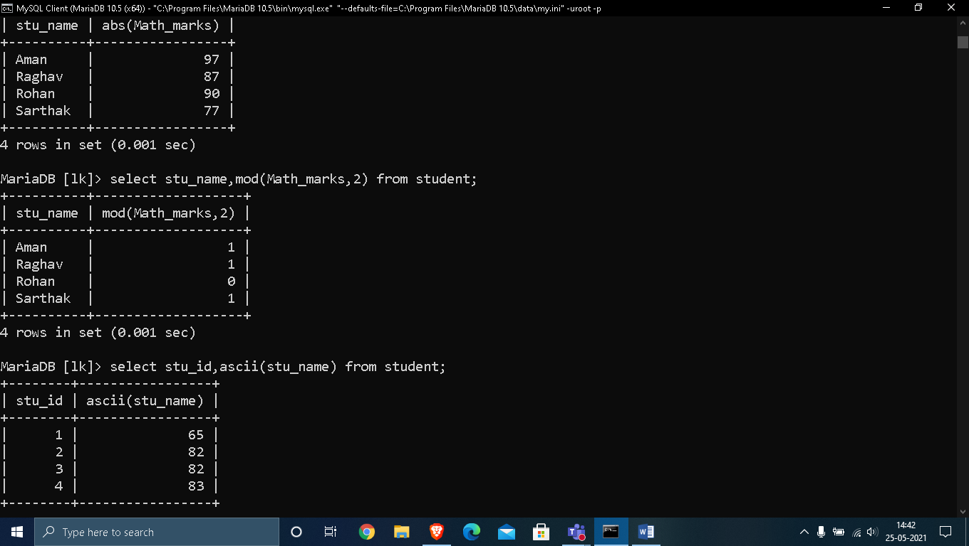

**2. CHAR_LENGTH () , CONCAT():**

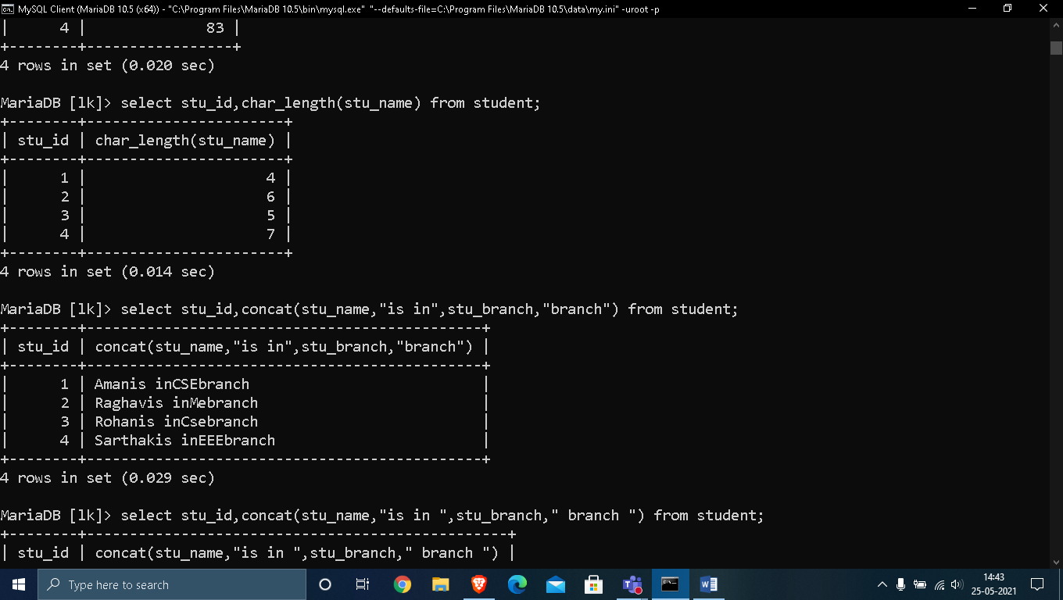

**3. Lcase():**

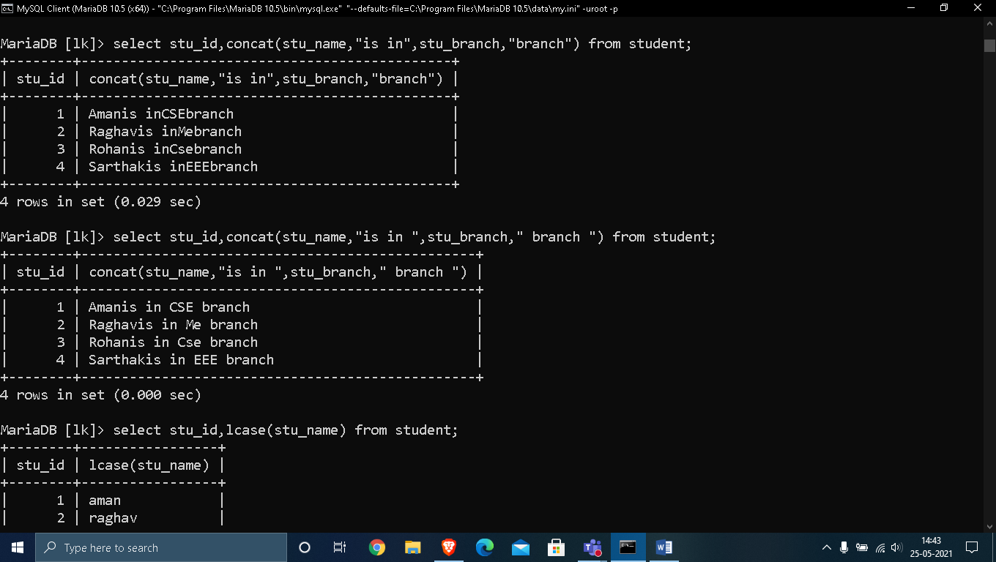

**4. LOWER() , UPPER() :**

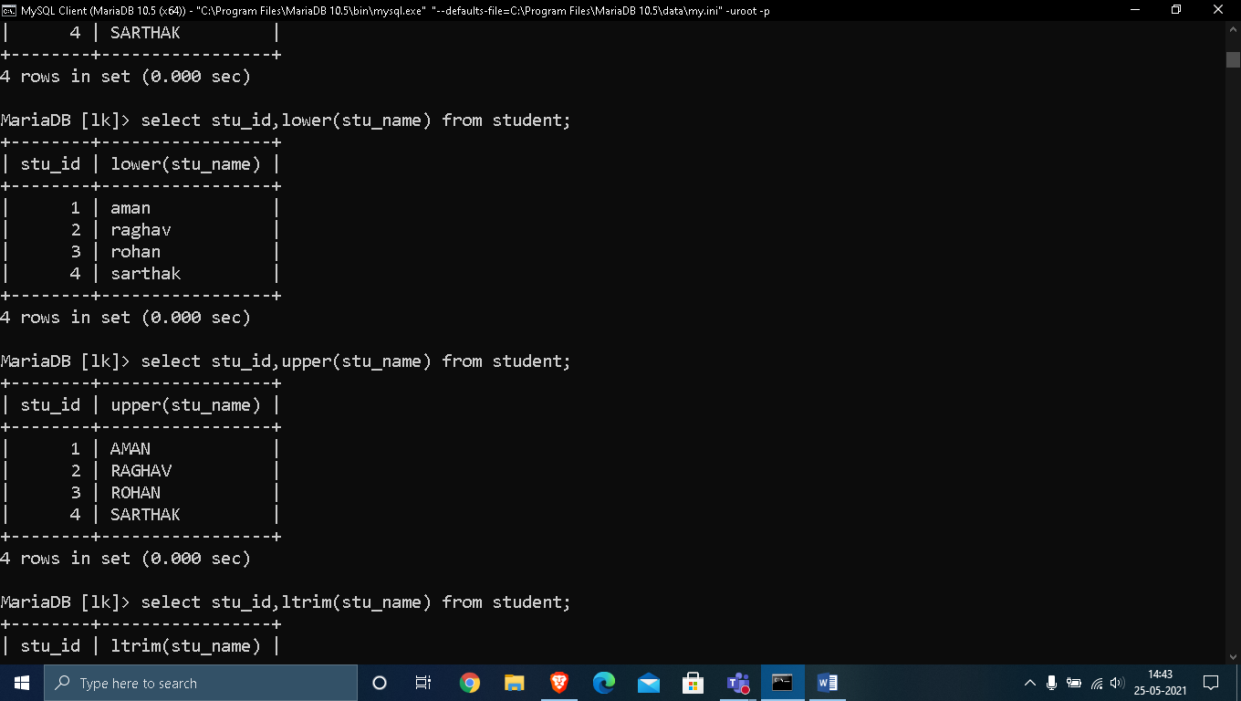

**5. LTRIM() , RTRIM() :**

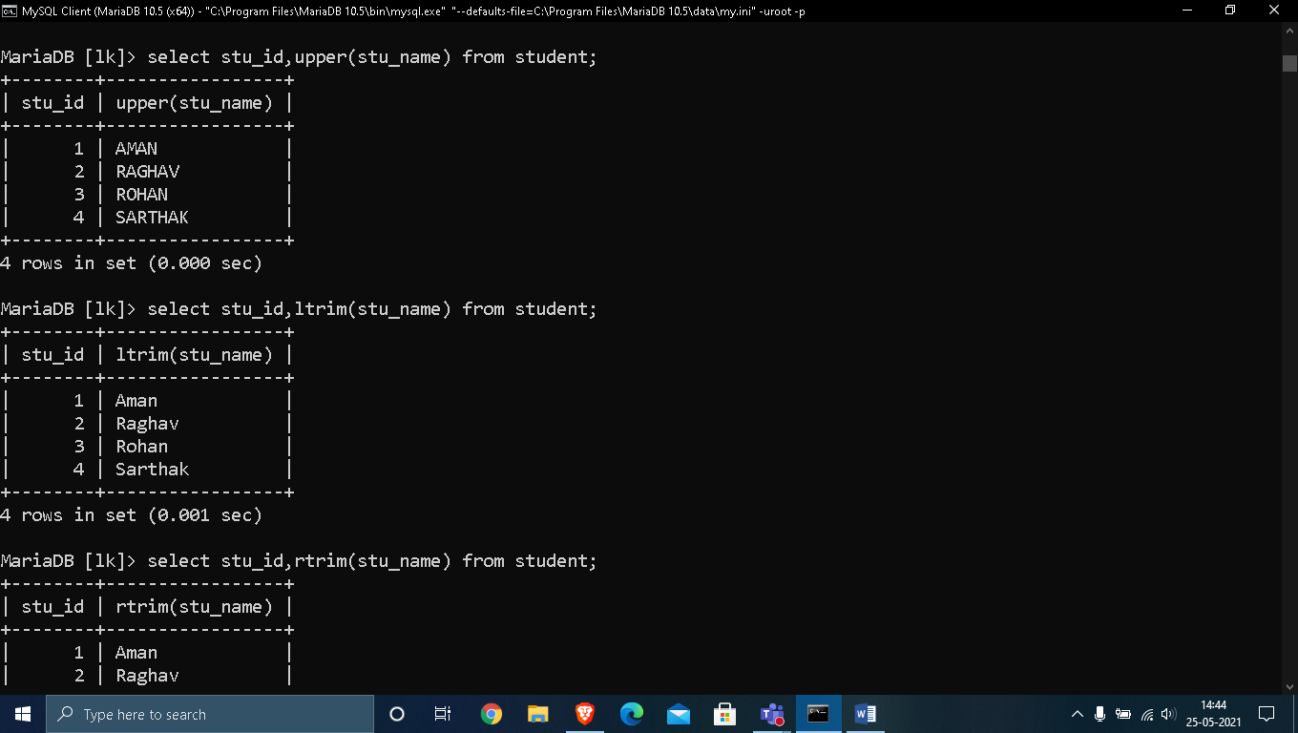

**6. LPAD() :**

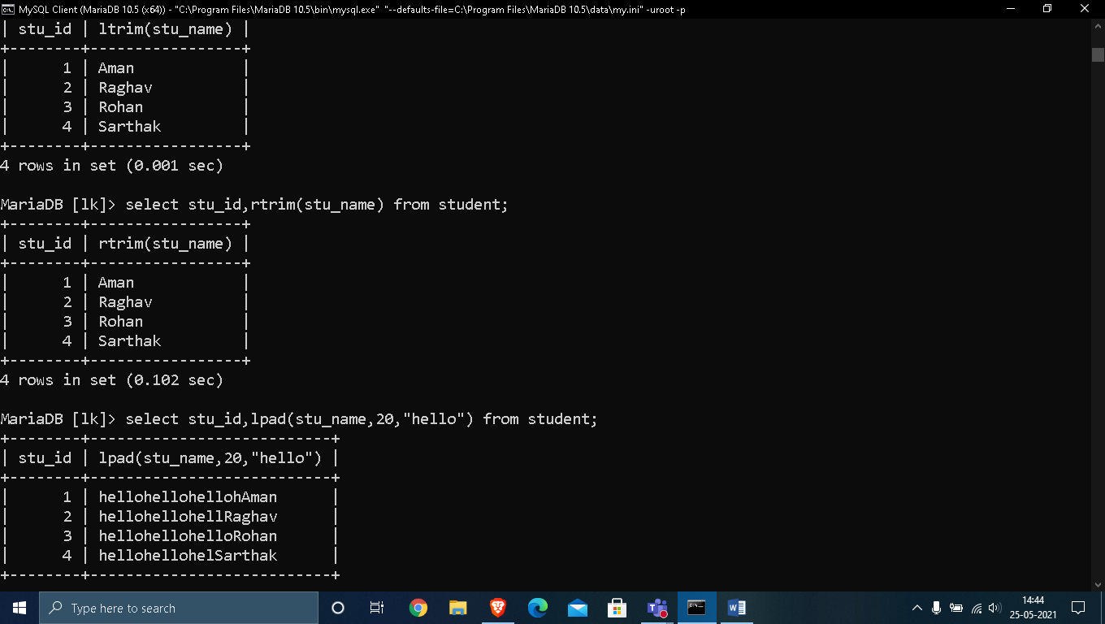

**7. RPAD() , REVERSE() :**

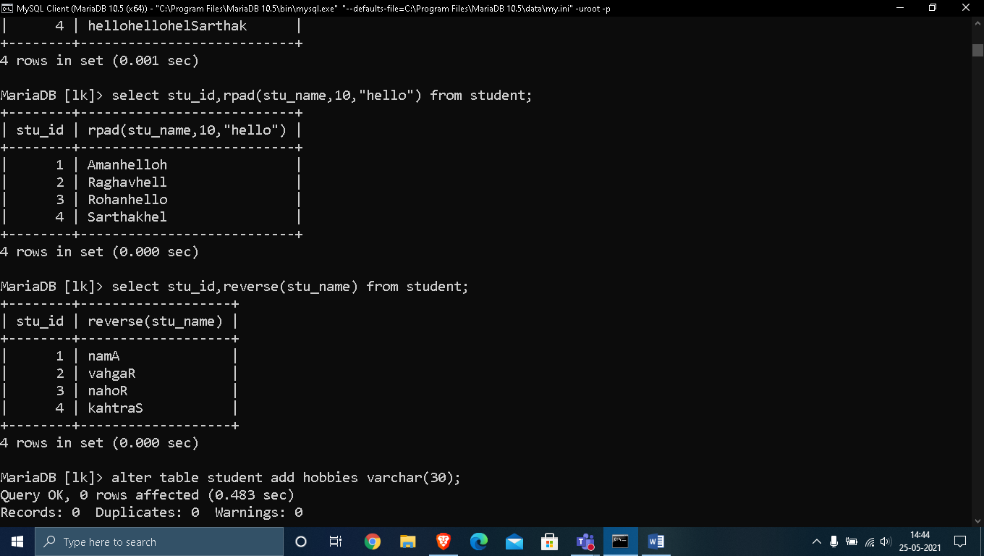

**8. STRCMP() :**

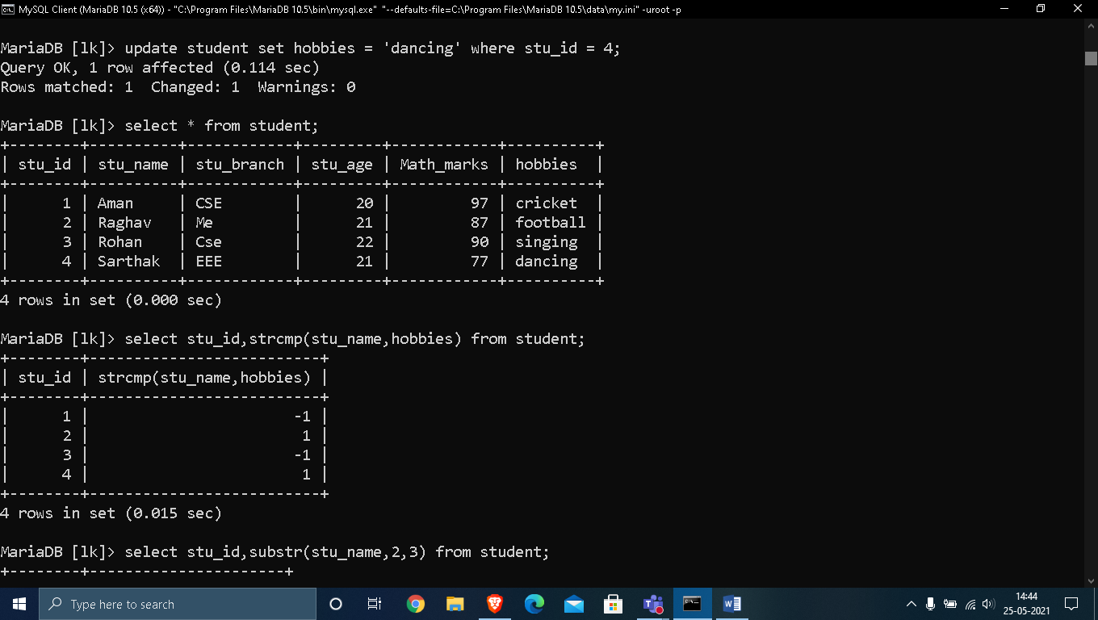

**9.SUBSTRING() , BIT_LENGTH() :**

