**EXPERIMENT – 6**

**AIM : Implementation of Joins and Index on a given Database.**

**THEORY :**

SQL JOIN

As the name shows, JOIN means to combine something. In case of SQL, JOIN means "to combine two or more tables".

In SQL, JOIN clause is used to combine the records from two or more tables in a database.

Types of SQL JOIN

1. INNER JOIN
2. LEFT JOIN
3. RIGHT JOIN
4. FULL JOIN

### **1. INNER JOIN**

In SQL, INNER JOIN selects records that have matching values in both tables as long as the condition is satisfied. It returns the combination of all rows from both the tables where the condition satisfies.

**Syntax**

1. SELECT table1.column1, table1.column2, table2.column1,....
2. FROM table1
3. INNER JOIN table2
4. ON table1.matching_column = table2.matching_column;

### **2. LEFT JOIN**

The SQL left join returns all the values from left table and the matching values from the right table. If there is no matching join value, it will return NULL.

**Syntax**

1. SELECT table1.column1, table1.column2, table2.column1,....
2. FROM table1
3. LEFT JOIN table2
4. ON table1.matching_column = table2.matching_column;

### **3. RIGHT JOIN**

In SQL, RIGHT JOIN returns all the values from the values from the rows of right table and the matched values from the left table. If there is no matching in both tables, it will return NULL.

**Syntax**

1. SELECT table1.column1, table1.column2, table2.column1,....
2. FROM table1
3. RIGHT JOIN table2
4. ON table1.matching_column = table2.matching_column;

### **4. FULL JOIN**

In SQL, FULL JOIN is the result of a combination of both left and right outer join. Join tables have all the records from both tables. It puts NULL on the place of matches not found.

**Syntax**

1. SELECT table1.column1, table1.column2, table2.column1,....
2. FROM table1
3. FULL JOIN table2
4. ON table1.matching_column = table2.matching_column;

**OUTPUT :**

**1. INNER JOIN & LEFT JOIN :**

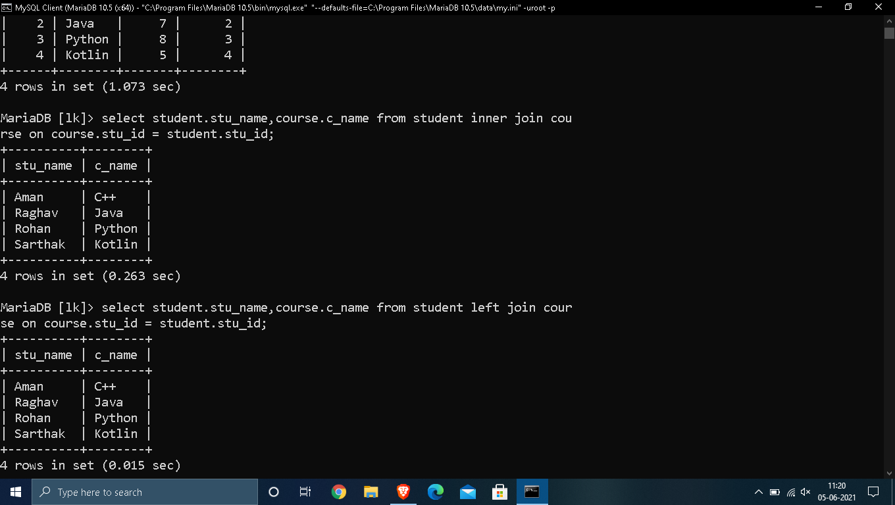

**2. RIGHT JOIN:**

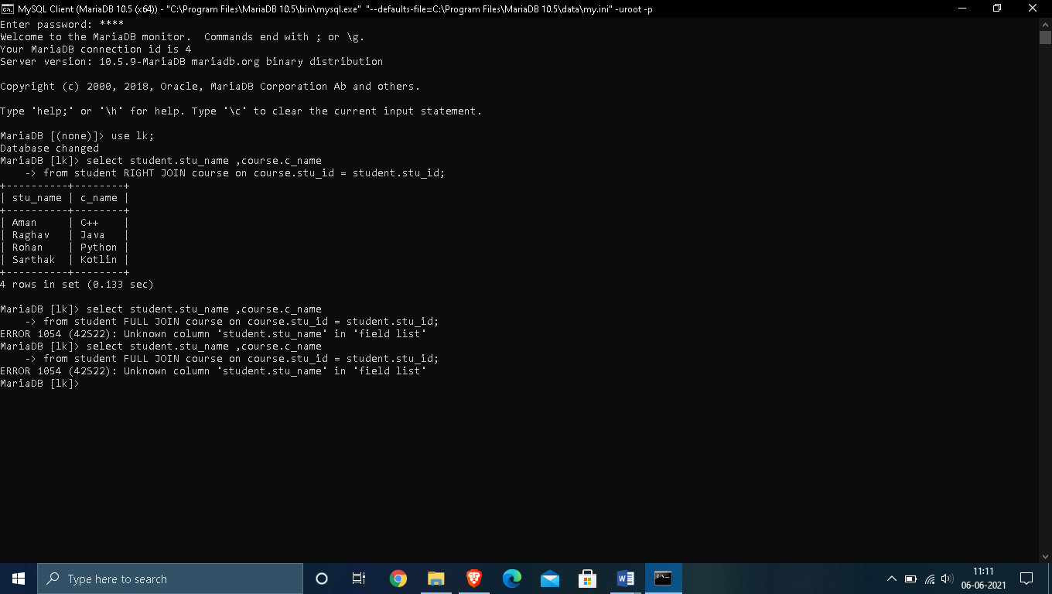

**3. FULL JOIN :**

SQL Index

* Indexes are special lookup tables. It is used to retrieve data from the database very fast.
* An Index is used to speed up select queries and where clauses. But it shows down the data input with insert and update statements. Indexes can be created or dropped without affecting the data.
* An index in a database is just like an index in the back of a book.
* **For example:** When you reference all pages in a book that discusses a certain topic, you first have to refer to the index, which alphabetically lists all the topics and then referred to one or more specific page numbers.

1. Create Index statement

It is used to create an index on a table. It allows duplicate value.

**Syntax**

CREATE INDEX index_name

ON table_name (column1, column2, ...);

2. Unique Index statement

It is used to create a unique index on a table. It does not allow duplicate value.

**Syntax**

CREATE UNIQUE INDEX index_name

ON table_name (column1, column2, ...);

3. Drop Index Statement

It is used to delete an index in a table.

**Syntax**

DROP INDEX index_name;

**OUTPUT :**

**1. Create Index :**

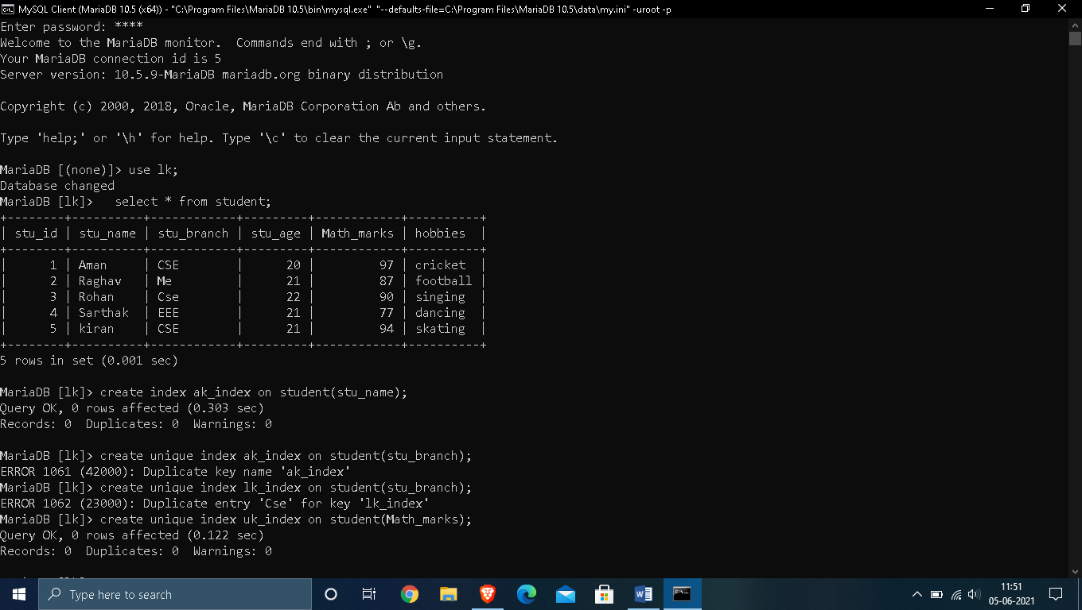

**2. Create Unique Index & Drop Index :**

