**SETS**

**Definition**

A set is an unordered collection of different elements. A set can be written explicitly by

listing its elements using set bracket. If the order of the elements is changed or any

element of a set is repeated, it does not make any changes in the set.

Some Example of Sets

* A set of all positive integers
* A set of all the planets in the solar system
* A set of all the states in India
* A set of all the lowercase letters of the alphabet

**Representation of a Set**

Sets can be represented in two ways:

* Roster or Tabular Form
* Set Builder Notation

**Roster or Tabular Form**

The set is represented by listing all the elements comprising it. The elements are enclosed

within braces and separated by commas.

Example 1: Set of vowels in English alphabet, A = {a,e,i,o,u}

Example 2: Set of odd numbers less than 10, B = {1,3,5,7,9}

**Set Builder Notation**

The set is defined by specifying a property that elements of the set have in common. The

set is described as A = { x : p(x)}

Example 1: The set {a,e,i,o,u} is written as:

A = { x : x is a vowel in English alphabet}

Example 2: The set {1,3,5,7,9} is written as:

B = { x : 1≤x<10 and (x%2) ≠ 0}

If an element x is a member of any set S, it is denoted by x∈ S and if an element y is not

a member of set S, it is denoted by y ∉ S.

Example: If S = {1, 1.2,1.7,2}, 1∈ S but 1.5 ∉S

Some Important Sets

N: the set of all natural numbers = {1, 2, 3, 4, .....}

Z: the set of all integers = {....., -3, -2, -1, 0, 1, 2, 3, .....}

+: the set of all positive integers

Q: the set of all rational numbers

R: the set of all real numbers

W: the set of all whole numbers

Cardinality of a Set

Cardinality of a set S, denoted by |S|, is the number of elements of the set. The number

is also referred as the cardinal number. If a set has an infinite number of elements, its

cardinality is ∞.

Example: |{1, 4, 3,5}| = 4, |{1, 2, 3,4,5,…}| = ∞

If there are two sets X and Y,

* |X| = |Y| denotes two sets X and Y having same cardinality. It occurs when the

number of elements in X is exactly equal to the number of elements in Y. In this

case, there exists a bijective function ‘f’ from X to Y.

* | X| ≤ | Y | denotes that set X’s cardinality is less than or equal to set Y’s cardinality.

It occurs when number of elements in X is less than or equal to that of Y. Here,

there exists an injective function ‘f’ from X to Y.

* |X| < |Y| denotes that set X’s cardinality is less than set Y’s cardinality. It occurs

when number of elements in X is less than that of Y. Here, the function ‘f’ from X

to Y is injective function but not bijective.

* If |X | ≤ | Y | and | Y | ≤ | X | then | X | = | Y |. The sets X and Y are commonly

referred as equivalent sets.

**Types of Sets**

Sets can be classified into many types. Some of which are finite, infinite, subset, universal,

proper, singleton set, etc.

* Finite Set

A set which contains a definite number of elements is called a finite set.

Example: S = {x | x ∈ N and 70 > x > 50}

* Infinite Set

A set which contains infinite number of elements is called an infinite set.

Example: S = {x | x ∈ N and x > 10}

* Subset

A set X is a subset of set Y (Written as X ⊆Y) if every element of X is an element of set Y.

Example 1: Let, X = { 1, 2, 3, 4, 5, 6 } and Y = { 1, 2 }. Here set Y is a subset of

set X as all the elements of set Y is in set X. Hence, we can write Y ⊆ X.

Example 2: Let, X = {1, 2, 3} and Y = {1, 2, 3}. Here set Y is a subset (Not a proper

subset) of set X as all the elements of set Y is in set X. Hence, we can write Y ⊆ X.

* Proper Subset

The term “proper subset” can be defined as “subset of but not equal to”. A Set X is a

proper subset of set Y (Written as X ⊂ Y) if every element of X is an element of set Y and

| X| < | Y |.

Example: Let, X = {1, 2, 3, 4, 5, 6} and Y = {1, 2}. Here set Y ⊂ X since all elements

in Y are contained in X too and X has at least one element is more than set Y.

* Universal Set

It is a collection of all elements in a particular context or application. All the sets in that

context or application are essentially subsets of this universal set. Universal sets are

represented as U.

Example: We may define U as the set of all animals on earth. In this case, set of all

mammals is a subset of U, set of all fishes is a subset of U, set of all insects is a subset

of U, and so on.

* Empty Set or Null Set

An empty set contains no elements. It is denoted by ∅. As the number of elements in an

empty set is finite, empty set is a finite set. The cardinality of empty set or null set is zero.

* Equal Set

If two sets contain the same elements they are said to be equal.

Example: If A = {1, 2, 6} and B = {6, 1, 2}, they are equal as every element of set

A is an element of set B and every element of set B is an element of set A.

* Equivalent Set

If the cardinalities of two sets are same, they are called equivalent sets.

Example: If A = {1, 2, 6} and B = {16, 17, 22}, they are equivalent as cardinality of A

is equal to the cardinality of B. i.e. |A|=|B|=3

* Overlapping Set

Two sets that have at least one common element are called overlapping sets.

In case of overlapping sets:

* n(A ∪ B) = n(A) + n(B) - n(A ∩ B)
* n(A ∪ B) = n(A - B) + n(B - A) + n(A ∩ B)
* n(A) = n(A - B) + n(A ∩ B)
* n(B) = n(B - A) + n(A ∩ B)

Example: Let, A = {1, 2, 6} and B = {6, 12, 42}. There is a common element ‘6’, hence

these sets are overlapping sets.

* Disjoint Set

Two sets A and B are called disjoint sets if they do not have even one element in common.

Therefore, disjoint sets have the following properties:

* n(A ∩ B) = ∅
* n(A ∪ B) = n(A) + n(B)

Example: Let, A = {1, 2, 6} and B = {7, 9, 14}; there is not a single common element,

hence these sets are overlapping sets.

**Venn Diagrams**

Venn diagram, invented in1880 by John Venn, is a schematic diagram that shows all

possible logical relations between different mathematical sets.

**Set Operations**

Set Operations include Set Union, Set Intersection, Set Difference, Complement of Set,

and Cartesian Product.

* Set Union

The union of sets A and B (denoted by A ∪ B) is the set of elements which are in A, in B,

or in both A and B. Hence, A∪B = {x | x ∈A OR x ∈B}.

Example: If A = {10, 11, 12, 13} and B = {13, 14, 15}, then A ∪ B = {10, 11, 12, 13,

14, 15}. (The common element occurs only once)

Figure: Venn Diagram of A ∪ B Set union

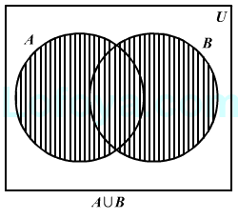

**Intersection**

The intersection of sets A and B (denoted by A ∩ B) is the set of elements which are in

both A and B. Hence, A∩B = {x | x ∈A AND x ∈B}.

Example: If A = {11, 12, 13} and B = {13, 14, 15}, then A∩B = {13}.

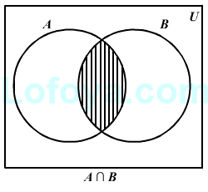

* Set Difference/ Relative Complement

The set difference of sets A and B (denoted by A–B) is the set of elements which are only

in A but not in B. Hence, A−B = {x | x ∈A AND x ∉B}.

Example: If A = {10, 11, 12, 13} and B = {13, 14, 15}, then (A−B) = {10, 11, 12} and

(B−A) = {14,15}. Here, we can see (A−B) ≠ (B−A)

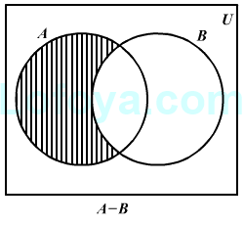

* Complement of a Set

The complement of a set A (denoted by A’) is the set of elements which are not in set A.

Hence, A' = {x | x ∉A}.

More specifically, A'= (U–A) where U is a universal set which contains all objects.

Example: If A ={x | x belongs to set of odd integers} then A' ={y | y does not belong

to set of odd integers}

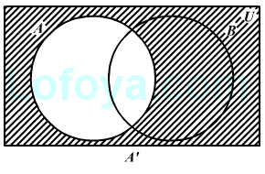

**Cartesian Product/Cross Product**

The Cartesian product of n number of sets A1, A2.....An, denoted as A1 × A2 ×..... × An,

can be defined as all possible ordered pairs (x1,x2,....xn) where x1∈ A1 , x2∈ A2 , ...... xn ∈ AnExample: If we take two sets A= {a, b} and B= {1, 2},

The Cartesian product of A and B is written as: A×B= {(a, 1), (a, 2), (b, 1), (b, 2)}

The Cartesian product of B and A is written as: B×A= {(1, a), (1, b), (2, a), (2, b)}

Power Set

Power set of a set S is the set of all subsets of S including the empty set. The cardinality

of a power set of a set S of cardinality n is 2n

. Power set is denoted as P(S).

Example:

For a set S = {a, b, c, d} let us calculate the subsets:

* Subsets with 0 elements: {∅} (the empty set)
* Subsets with 1 element: {a}, {b}, {c}, {d}
* Subsets with 2 elements: {a,b}, {a,c}, {a,d}, {b,c}, {b,d},{c,d}
* Subsets with 3 elements: {a,b,c},{a,b,d},{a,c,d},{b,c,d}
* Subsets with 4 elements: {a,b,c,d}

Hence, P(S) = { {∅},{a}, {b}, {c}, {d},{a,b}, {a,c}, {a,d}, {b,c},

{b,d},{c,d},{a,b,c},{a,b,d},{a,c,d},{b,c,d},{a,b,c,d} }

| P(S) | = 24 =16

Note: The power set of an empty set is also an empty set.

| P ({∅}) | = 20 = 1

**Partitioning of a Set**

Partition of a set, say S, is a collection of n disjoint subsets, say P1, P2,...… Pn, that satisfies

the following three conditions:

Pi does not contain the empty set.

[ Pi ≠ {∅} for all 0 < i ≤ n]

▪ The union of the subsets must equal the entire original set.

[P1 ∪ P2 ∪ .....∪ Pn = S]

▪ The intersection of any two distinct sets is empty.

[Pa ∩ Pb ={∅}, for a ≠ b where n ≥ a, b ≥ 0 ]

Example

Let S = {a, b, c, d, e, f, g, h}

Another probable partitioning is {a,b}, { c, d}, {e, f, g,h}One probable partitioning is {a}, {b, c, d}, {e, f, g,h}

**Bell Numbers**

Bell numbers give the count of the number of ways to partition a set. They are denoted

by Bn where n is the cardinality of the set.

Example:

Let S = { 1, 2, 3}, n = |S| = 3

The alternate partitions are:

1. ∅, {1, 2, 3}

2. {1}, {2, 3}

3. {1, 2}, {3}

4. {1, 3}, {2}

5. {1}, {2},{3}

Hence B3 = 5

**Examples:**

#### **Example 1:**

Draw Venn diagrams for:

**(1)** A - B – C

**(2)** (A ∩ B) ∪ C’

**(3)** (A ∪ B) ∩ C’

#### **Solution:**

**(1)** A - B – C

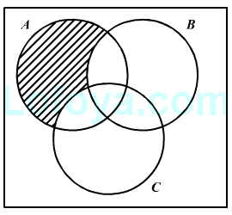

**(2)** (A ∩ B) ∪ C’

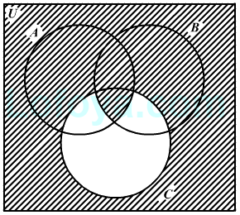

**(3)** (A ∪ B) ∩ C’

