***Information Security Lab***

***ETCS -451***

Faculty: **Mr. Alok Bhardwaj** Name: **Syeda Reeha Quasar**

Roll No.: **14114802719**

Semester: **7**

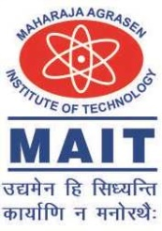

Maharaja Agrasen Institute of Technology, PSP Area,

Sector – 22, Rohini, New Delhi – 110085

