JAVA PROGRAMMING LAB (ETCS – 357)

# LAB-11

## Faculty Name : Student Name:

Dr. Sandeep Tayal Udit Agarwal

12914802719

Sem 5

5C7



Maharaja Agrasen Institute of Technology, PSP Area, Sector – 22, Rohini, New Delhi – 110085

# INDEX

|  |  |  |  |  |  |  |  |  |  |  |
| --- | --- | --- | --- | --- | --- | --- | --- | --- | --- | --- |
| **S.no** | **Experiments** | **Date of performance** | **Date checked** | **Marks** | | | | | **Total Marks** | **Sign.** |
| **R1** | **R2** | **R3** | **R4** | **R5** |
| 11.1 | Create runnable jar file in java | 2.12.21 |  |  |  |  |  |  |  |  |
| 11.2 | Display image on a button in swing | 2.12.21 |  |  |  |  |  |  |  |  |
| 11.3 | Change the component color by choosing a color from ColorChooser | 2.12.21 |  |  |  |  |  |  |  |  |
| 11.4 | Display the digital watch in swing tutorial | 2.12.21 |  |  |  |  |  |  |  |  |
| 11.5 | Create a notepad in swing | 2.12.21 |  |  |  |  |  |  |  |  |

## EXPERIMENT 11.1

**AIM : Create runnable jar file in java**

## Theory :

**Java swing : Java Swing tutorial** is a part of Java Foundation Classes (JFC) that is *used to create window-based applications*. It is built on the top of AWT (Abstract Windowing Toolkit) API and entirely written in java.Unlike AWT, Java Swing provides platform- independent and lightweight components. The javax.swing package provides classes for java swing API such as JButton, JTextField, JTextArea, JRadioButton, JCheckbox, JMenu, JColorChooser etc.

**JFrame :** The javax.swing.JFrame class is a type of container which inherits the java.awt.Frame class. JFrame works like the main window where components like labels, buttons, textfields are added to create a GUI. Unlike Frame, JFrame has the option to hide or close the window with the help of setDefaultCloseOperation(int) method.

**Source Code :**

import javax.swing.*; public class exp1{ exp1(){

JFrame f=new JFrame("My Jar File");

JButton b=new JButton("Click Me!"); b.setBounds(100,150,100, 40);

JLabel l1 = new JLabel("Udit : 12914802719"); l1.setBounds(100,50, 170,100);

f.add(b);

f.add(l1); f.setSize(300,400); f.setLayout(null); f.setVisible(true);

f.setDefaultCloseOperation(JFrame.EXIT_ON_CLOSE);

}

public static void main(String[] args) { new exp1();

}

}

**Output :**

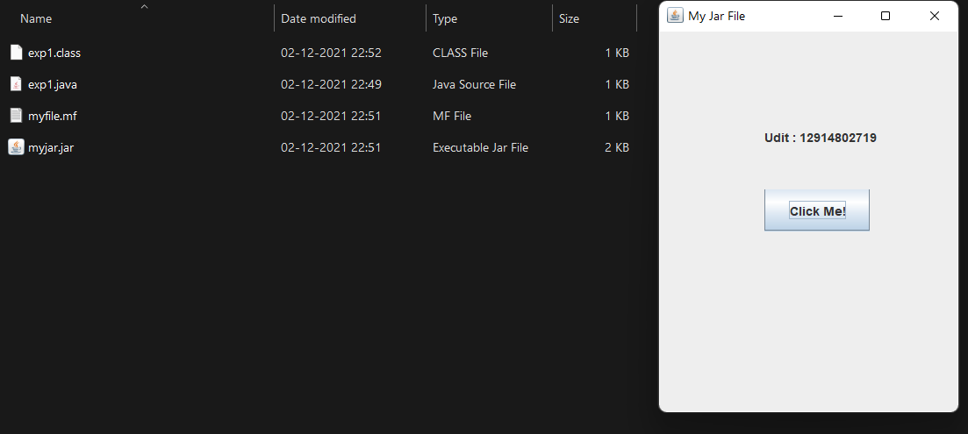

## EXPERIMENT 11.2

**AIM : Display image on a button in swing**

## Theory :

**Java swing : Java Swing tutorial** is a part of Java Foundation Classes (JFC) that is *used to create window-based applications*. It is built on the top of AWT (Abstract Windowing Toolkit) API and entirely written in java.Unlike AWT, Java Swing provides platform- independent and lightweight components. The javax.swing package provides classes for java swing API such as JButton, JTextField, JTextArea, JRadioButton, JCheckbox, JMenu, JColorChooser etc.

**JFrame :** The javax.swing.JFrame class is a type of container which inherits the java.awt.Frame class. JFrame works like the main window where components like labels, buttons, textfields are added to create a GUI. Unlike Frame, JFrame has the option to hide or close the window with the help of setDefaultCloseOperation(int) method

**Jbutton :** The JButton class is used to create a labeled button that has platform independent implementation. The application result in some action when the button is pushed. It inherits AbstractButton class.

**Source Code :**

import javax.swing.ImageIcon; import javax.swing.JButton; import javax.swing.JFrame;

import javax.swing.SwingUtilities; import javax.swing.WindowConstants; import java.awt.FlowLayout;

public class exp2 extends JFrame { public exp2() {

initComponents();

}

public static void main(String[] args) {

SwingUtilities.invokeLater(() -> new exp2().setVisible(true));

}

private void initComponents() {

setTitle("Image inside Button"); setSize(500, 500);

setDefaultCloseOperation(WindowConstants.EXIT_ON_CLOSE); getContentPane().setLayout(new

FlowLayout(FlowLayout.CENTER));

JButton helloButton = new JButton("Hello", new ImageIcon(

this.getClass().getResource("/images/hello.png"))); helloButton.setMnemonic('H');

getContentPane().add(helloButton);

}

}

**Output :**

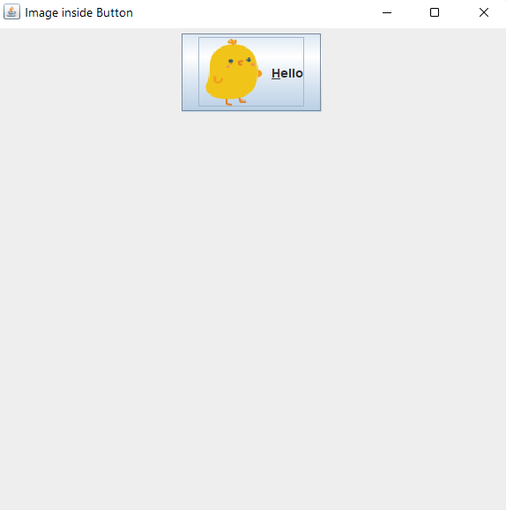

## EXPERIMENT 11.3

**AIM : Change the component color by choosing a color from ColorChooser**

## Theory :

**Java swing : Java Swing tutorial** is a part of Java Foundation Classes (JFC) that is *used to create window-based applications*. It is built on the top of AWT (Abstract Windowing Toolkit) API and entirely written in java.Unlike AWT, Java Swing provides platform- independent and lightweight components. The javax.swing package provides classes for java swing API such as JButton, JTextField, JTextArea, JRadioButton, JCheckbox, JMenu, JColorChooser etc.

**JFrame :** The javax.swing.JFrame class is a type of container which inherits the java.awt.Frame class. JFrame works like the main window where components like labels, buttons, textfields are added to create a GUI. Unlike Frame, JFrame has the option to hide or close the window with the help of setDefaultCloseOperation(int) method

**Jbutton :** The JButton class is used to create a labeled button that has platform independent implementation. The application result in some action when the button is pushed. It inherits AbstractButton class.

**JColorChooser :** The JColorChooser class is used to create a color chooser dialog box so that user can select any color. It inherits JComponent class.

**Source Code :**

import java.awt.event.*; import java.awt.*; import javax.swing.*; public class exp3 extends

JFrame implements ActionListener { JButton b = new JButton("color"); protected JLabel label;

Container c = getContentPane(); exp3() {

label = new JLabel("UDIT AGARWAL : 12914802719", JLabel.CENTER);

label.setForeground(Color.BLACK); label.setBackground(Color.WHITE); label.setOpaque(true);

label.setFont(new Font("SansSerif", Font.BOLD, 25));

c.setLayout(new FlowLayout()); b.addActionListener(this); c.add(label);

c.add(b);

}

public void actionPerformed(ActionEvent e) { Color initialcolor = Color.RED;

Color color = JColorChooser.showDialog(this, "Select a color", initialcolor);

label.setForeground(color);

}

public static void main(String[] args) { exp3 ch = new exp3(); ch.setSize(400, 400); ch.setVisible(true);

ch.setDefaultCloseOperation(EXIT_ON_CLOSE);

}

}

**Output :**

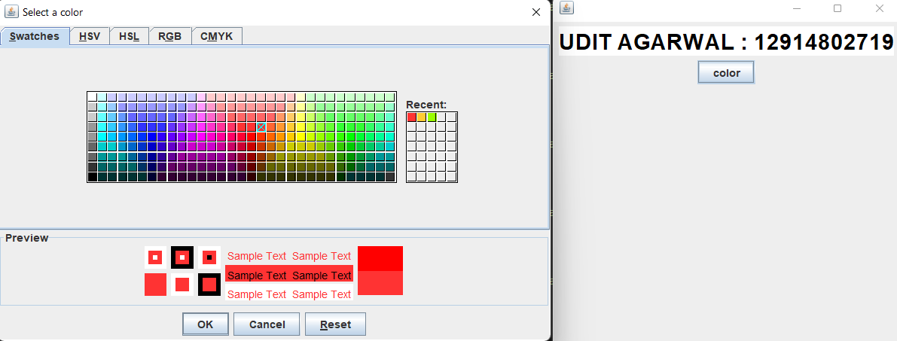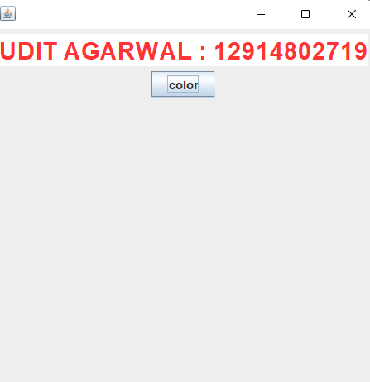

## EXPERIMENT 11.4

**AIM : Display the digital watch in swing tutorial**

## Theory :

**Java swing : Java Swing tutorial** is a part of Java Foundation Classes (JFC) that is *used to create window-based applications*. It is built on the top of AWT (Abstract Windowing Toolkit) API and entirely written in java.Unlike AWT, Java Swing provides platform- independent and lightweight components. The javax.swing package provides classes for java swing API such as JButton, JTextField, JTextArea, JRadioButton, JCheckbox, JMenu, JColorChooser etc.

**Thread :** Threads allows a program to operate more efficiently by doing multiple things at the same time. Threads can be used to perform complicated tasks in the background without interrupting the main program.

**JFrame :** The javax.swing.JFrame class is a type of container which inherits the java.awt.Frame class. JFrame works like the main window where components like labels, buttons, textfields are added to create a GUI. Unlike Frame, JFrame has the option to hide or close the window with the help of setDefaultCloseOperation(int) method

**Jbutton :** The JButton class is used to create a labeled button that has platform independent implementation. The application result in some action when the button is pushed. It inherits AbstractButton class.

**Source Code :**

import javax.swing.*; import java.awt.*; import java.text.*; import java.util.*;

public class exp4 implements Runnable { JFrame f;

Thread t = null;

int hours = 0, minutes = 0, seconds = 0; String timeString = "";

JButton b; JLabel l1;

exp4() {

f = new JFrame();

t = new Thread(this); t.start();

b = new JButton(); b.setBounds(100, 100, 100, 50);

l1 = new JLabel("Udit : 12914802719"); l1.setBounds(100, 10, 170, 100);

f.add(l1);

f.add(b); f.setSize(300, 400); f.setLayout(null); f.setVisible(true);

}

public void run() { try {

while (true) {

Calendar cal = Calendar.getInstance(); hours = cal.get(Calendar.HOUR_OF_DAY); if (hours > 12)

hours -= 12;

minutes = cal.get(Calendar.MINUTE); seconds = cal.get(Calendar.SECOND);

SimpleDateFormat formatter = new SimpleDateFormat("hh:mm:ss"); Date date = cal.getTime();

timeString = formatter.format(date); printTime();

t.sleep(1000);

}

} catch (Exception e) {

}

}

public void printTime() { b.setText(timeString);

}

public static void main(String[] args) { new exp4();

}

}

**Output :**

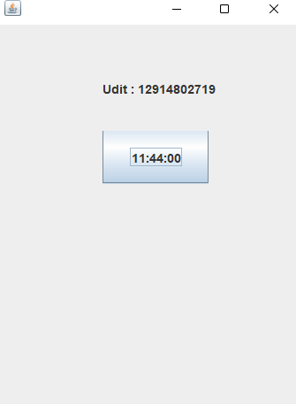

## EXPERIMENT 11.5

**AIM : Create a notepad in swing**

**Source Code :**

import java.awt.*;

import java.awt.datatransfer.Clipboard; import java.awt.datatransfer.DataFlavor; import java.awt.datatransfer.Transferable; import java.awt.event.*;

import java.io.File;

import java.io.PrintWriter; import java.util.Scanner;

import javax.swing.*;

public class Notepad extends JFrame {

private static final long serialVersionUID = 1L; JFrame frame;

JMenuBar menuBar; JMenu file;

JMenu edit;

JMenuItem open, newFile,save, exit; JMenuItem undo,paste, selectAll ; JMenu format;

JMenu help;

JFileChooser fileChooser; JTextArea textArea; Clipboard clip ;

Notepad() {

frame = new JFrame("Notepad Application"); file = new JMenu("File");

edit = new JMenu("Edit"); format = new JMenu("Format"); help = new JMenu("Help");

Ctrl+Z");

Ctrl+V");

");

newFile = new JMenuItem("New"); open = new JMenuItem("Open"); save = new JMenuItem("Save"); exit = new JMenuItem("Exit"); undo = new JMenuItem("Undo

paste = new JMenuItem("Paste

selectAll = new JMenuItem("Select All Ctrl+A

textArea = new JTextArea(); fileChooser = new JFileChooser(); menuBar = new JMenuBar();

frame.setLayout(new BorderLayout()); frame.setDefaultCloseOperation(JFrame.EXIT_ON_CLOSE);

frame.add(textArea); file.add(open); file.add(newFile); file.add(save); file.add(exit); edit.add(undo); edit.add(paste); edit.add(selectAll); menuBar.add(file); menuBar.add(edit); menuBar.add(format); menuBar.add(help);

frame.setJMenuBar(menuBar);

OpenListener openL = new OpenListener(); NewListener NewL = new NewListener(); SaveListener saveL = new SaveListener(); ExitListener exitL = new ExitListener(); open.addActionListener(openL); newFile.addActionListener(NewL); save.addActionListener(saveL); exit.addActionListener(exitL);

//UndoListener UndoL = new UndoListener(); PasteListener pasteL = new PasteListener();

//EditListener EditL = new EditListener();

//SelectListener SelectL = new SelectListener();

//undo.addActionListener(UndoL);

//paste.addActionListener(EditL);

//selectAll.addActionListener(SelectL); frame.setSize(800, 600); frame.setVisible(true);

}

class OpenListener implements ActionListener { public void actionPerformed(ActionEvent e) {

if (JFileChooser.APPROVE_OPTION == fileChooser.showOpenDialog(frame)) {

File file = fileChooser.getSelectedFile(); textArea.setText("");

Scanner in = null; try {

in = new Scanner(file);

while(in.hasNext()) {

String line = in.nextLine(); textArea.append(line+"\n");

}

} catch (Exception ex) { ex.printStackTrace();

} finally {

in.close();

}

}

}

}

class SaveListener implements ActionListener { public void actionPerformed(ActionEvent e) {

if (JFileChooser.APPROVE_OPTION == fileChooser.showSaveDialog(frame)) {

File file = fileChooser.getSelectedFile(); PrintWriter out = null;

try {

out = new PrintWriter(file);

String output = textArea.getText(); System.out.println(output); out.println(output);

} catch (Exception ex) { ex.printStackTrace();

} finally {

try {

out.flush();

} catch(Exception ex1)

{

try {

}

}

}

}

}

out.close();

} catch(Exception ex1) {

}

class NewListener implements ActionListener { public void actionPerformed(ActionEvent e) {

textArea.setText("");

//frame.add(newFile);

//textArea.(newFile+"\n");

}

}

class ExitListener implements ActionListener { public void actionPerformed(ActionEvent e) {

System.exit(0);

}

}

class PasteListener implements ActionListener { public void actionPerformed(ActionEvent e) {

Transferable cliptran =

clip.getContents(Notepad.this); try

{

String sel = (String) cliptran.getTransferData(DataFlavor.stringFlavor);

textArea.replaceRange(sel,textArea.getSelectionStart(),textAre a.getSelectionEnd());

}

catch(Exception exc)

{

System.out.println("not string flavour");

}

}

}

public static void main(String args[]) { Notepad n = new Notepad();

}

}

**Output :**

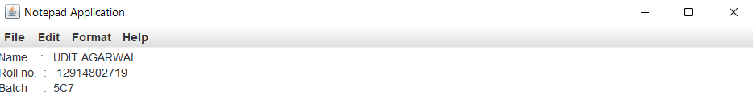

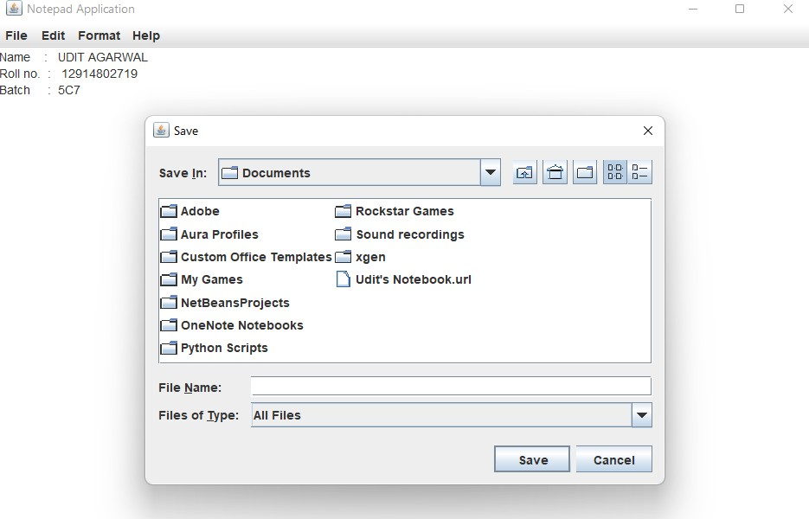

## VIVA QUESTIONS :

**Q1) What is Java Swing?**

**Ans**. It is a part of JFC (Java Foundation Classess) that is used to create window-based applications.

Java Swing components are platform independent and lightweight .

**Q2) What are the methods of component class in Java Swing? Ans**. There are four types of methods of component class are:

* public void add(Component c)
* public void setSize(int width, int height)
* public void setLayout(LayoutManager m)
* public void setVisible(boolean b)

**Q3) How many ways to create a frame in Java Swing ? Ans**. There are two ways to create a frame:

* By Association(creating the object of Frame class)
* By Inheritance(extending Frame class)

**Q4) What are differences between Swing and AWT?**

**Ans.** There is couple of differences between swing and AWT.

* AWT component are considered to be heavyweight while Swing component are lightweights.
* Swing has plug gable look and feel.
* AWT is platform dependent same GUI will look different platform while Swing is developed in Java and is platform dependent.

.