Mobile Computing

Paper code : ETIT-452



Maharaja Agrasen Institute Of Technology

PSP Area,Sector-22,Rohini,New Delhi -110086

Submitted To : Submitted By :

Mr. Ashish Sharma Pavitra Walia

(Assistant Professor) ( Enrollment Number : 42414802718 )

(Department of Computer Science) ( Branch : Computer science )

( Semester : 8th ) ( Batch : 8C789 )

**Index**

|  |  |  |  |  |  |
| --- | --- | --- | --- | --- | --- |
| **Exp. no** | **Experiment Name** | **Date of performance** | **Date of checking** | **Marks** | **Signature** |
| 1 | Write a WML program to print a formatted Text on the mobile Screen using various tags. |  |  |  |  |
| 2 | Write a WML program to  connect multiple cards from same desk. |  |  |  |  |
| 3 | Write WML program to display  table with three columns Image name, Image and third  column contain hyperlink to open another card |  |  |  |  |
| 4 | Write a WML program to create  a form with multiple options. |  |  |  |  |
| 5 | Write a WML program to use the time control and to trigger On pick event |  |  |  |  |
| 6 | Write a WML script to find maximum out of two numbers with help of inbuilt function Lang.Max() and to find absolute value with help of inbuilt  function Lang.abs() |  |  |  |  |
| 7 | Write a Program in NS3 to Simulate OLSR |  |  |  |  |
| 8 | Write a Program in NS3 to  Simulate AODV |  |  |  |  |

# Experiment 1

**Aim :** Write a WML program to print a formatted Text on the mobile Screen using various tags.

# Theory :

|  |  |  |
| --- | --- | --- |
| **Attribute** | **Value** | **Description** |
| align | left right center | Aligns the paragraph. Default is "left" |
| mode | wrap nowrap | Sets whether a paragraph should wrap lines or not. |
| xml:lang | language_code | Sets the language used in the element |
| class | cdata | Sets a class name for the element. The class name is case sensitive. An element can be connected to multiple classes. Multiple class names within the class Attribute are separated by white space |
| id | id | Sets a unique name for the element |

|  |  |
| --- | --- |
| **WML Elements** |  |
| <b> | Defines bold text |
| <big> | Defines big text |
| <em> | Defines emphasized text |
| <i> | Defines italic text |
| <small> | Defines small text |
| <strong> | Defines strong text |
| <u> | Defines underlined text |
|  | **Purpose** |

|  |  |
| --- | --- |
| <!--> | Defines a WML comment |
| <wml> | Defines a WML deck (WML root) |
| <head> | Defines head information |
| <meta> | Defines meta information |
| <card> | Defines a card in a deck |
| <access> | Defines information about the access control of a deck |
| <template> | Defines a code template for all the cards in a deck |

**Code :**

<?xml version="1.0"?>

<!DOCTYPE wml PUBLIC "-//WAPFORUM//DTD WML 1.3//EN"

["http://www.wapforum.org/DTD/wml13.dtd">](http://www.wapforum.org/DTD/wml13.dtd)

<wml>

<card id="ABC" title="Practical 1">

<p>

Pavitra Walia 42414802718

</p>

<onevent type="ontimer">

<go href="#ABC1"/>

</onevent>

<timer value="50"/>

</card>

<card id="ABC1" title="SYNTAX 1">

<p>

<b>Pavitra Walia</b><br>

<big>Pavitra Walia</big><br>

<em>Pavitra Walia</em><br>

<i>Pavitra Walia</i><br>

<small>Pavitra Walia</small><br>

<strong>Pavitra Walia</strong><br>

<u>Pavitra Walia</u>

</p>

</card>

</wml>

# Output :

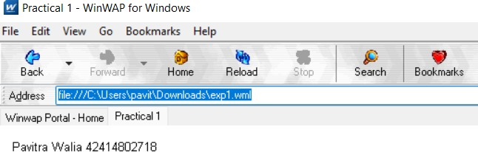

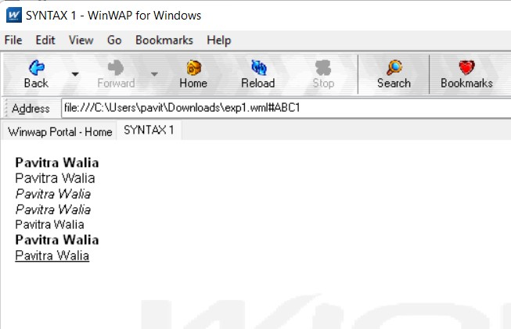

**VIVA QUESTIONS**

# Q1. What is the use of WML decks?

* WML document used for creating an application called a deck that provides way to add more pages.
* Decks can be used to insert the data into one or more cards or pages.
* Deck interacts with the user and the framework on which the application is being built.
* Decks are stored on a configured web server who’s function is to include data of MIME type.

# Q2. What is WSDL?

WSDL stands for Web Services Description Language. WSDL is an XML-based protocol for information exchange in decentralized and distributed environments. It describe how to access a web service and what operations it will perform. WSDL is a language for describing how to interface with XML-based services.

# Q3. What are WML variables? How to use them?

Variables are named storage areas that can be manipulated.

Variable expansion occurs at runtime, in the micro-browser or emulator. This means it can be concatenated with or embedded in other text. Variables are referenced with a preceding dollar sign, and any single dollar sign in your WML deck is interpreted as a variable reference.

You can set the value of a variable in the following ways:

* Using the <setvar/> tag
* Using data collection tags <select> and <input/>
* Using the setVar() function of WMLScript's WMLBrowser standard library

# Q4. How can we refresh card variables?

The refresh() function, as suggested by its function name, is used to refresh the current card on the WML browser.

# Experiment 2

**Aim :** Write a WML program to connect multiple cards from same desk.

# Code :

<?xml version="1.0"?>

<!DOCTYPE wml PUBLIC "-//WAPFORUM//DTD WML 1.3//EN"

["http://www.wapforum.org/DTD/wml13.dtd">](http://www.wapforum.org/DTD/wml13.dtd)

<wml>

<card id="CardNo.1" title="Program2Card1">

<p>You Are Visiting Card 1</p>

<do type="accept" name="CardNo.2" label="Continue">

<go href="#CardNo.2"/>

</do>

</card>

<card id="CardNo.2" title="Program2Card2">

<p>You Are Visiting Card 2</p>

<do type="accept" name="CardNo.3" label="Continue">

<go href="#CardNo.3"/>

</do>

</card>

<card id="CardNo.3" title="Program2Card3">

<p>You Are Visiting Card 3</p>

<do type="accept" name="CardNo.1" label="Go Back">

<go href="#CardNo.1"/>

</do>

</card>

</wml>

# Output :

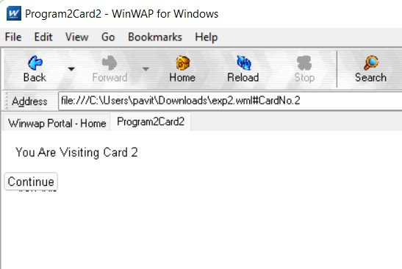

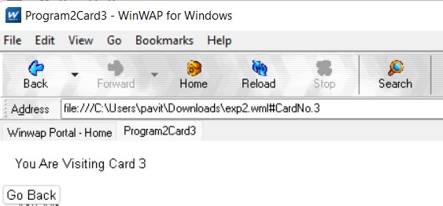

**VIVA QUESTIONS**

# Q1. What is the use of XML?

* XML can keep data separated from your HTML
* XML can be used to store data inside HTML documents
* XML can be used as a format to exchange information
* XML can be used to store data in files or in databases

# Q2. What is Meta data?

Metadata is data that describes other data. Meta is a prefix that -- in most information technology usages -- means "an underlying definition or description." Metadata summarizes basic information about data, which can make finding and working with particular instances of data easier.

# Q3. What is the difference between HTML and WML?

A main difference between HTML and WML is that the basic unit of navigation in HTML is a page, while that in WML is a card.

WML is used on phones while HTML is used for desktop clients HTML requires a lot more processing power than WML

# Q4. What is XML DOM Document?

The XML DOM is a standard object model for XML, a standard programming interface for XML, platform- and language independent. The XML DOM is a standard for how to get, change, add, or delete XML elements.

# Experiment 3

**Aim :** Write WML program to display table with three columns Image name, Image and third column contain hyperlink to open another card

# Code :

<?xml version="1.0"?>

<!DOCTYPE wml PUBLIC "-//WAPFORUM//DTD WML 1.3//EN"

["http://www.wapforum.org/DTD/wml13.dtd">](http://www.wapforum.org/DTD/wml13.dtd)

<wml>

<card id="CardNo.1" title="Program3Card1">

<p>

<table columns="3" align="LCR">

<tr>

<td>Image Name</td>

<td>Image</td>

<td>Link</td>

</tr>

<tr>

<td>Thumb Image</td>

<td><img src="thumb.wbmp" alt="Thumb Image"/></td>

<td><anchor><a href="#CardNo.2">CardNo2</a></anchor></td>

</tr>

<tr>

<td>Heart Image</td>

<td><img src="heart.wbmp" alt="Heart Image"/></td>

<td><anchor><a href="#CardNo.3">CardNo3</a></anchor></td>

</tr>

</table>

</p>

</card>

<card id="CardNo.2" title="Program3Card2">

<p>You Are Visiting Card 2</p>

<do type="accept" name="CardNo.3" label="Continue">

<go href="#CardNo.3"/>

</do>

</card>

<card id="CardNo.3" title="Program3Card3">

<p>You Are Visiting Card 3</p>

<do type="accept" name="CardNo.1" label="Go Back">

<go href="#CardNo.1"/>

</do>

</card>

</wml>

# Output :

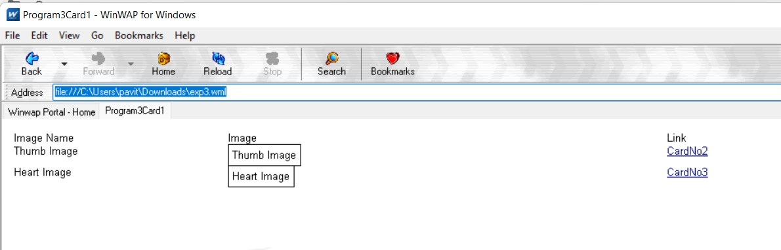

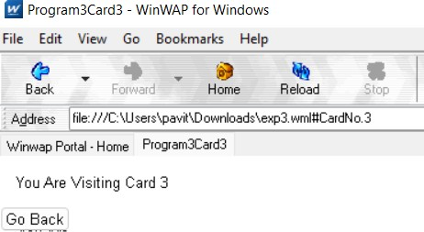

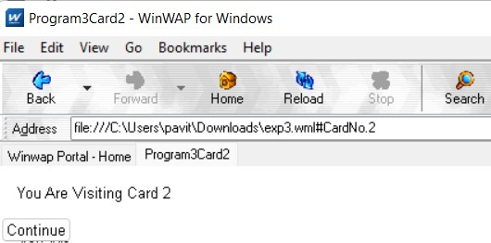

**VIVA QUESTIONS**

# Q1. What is the function of WAP Gateway?

A WAP gateway sits between mobile devices using the Wireless Application Protocol (WAP) and the World Wide Web, passing pages from one to the other much like a proxy. This translates pages into a form suitable for the mobiles, for instance using the Wireless Markup Language (WML). It decodes the encoded WAP requests from the microbrowser and send the HTTP requests to the internet or to a local application server. It also encodes the WML and HDML data returning from the web for transmission to the microbrowser in the handset.

# Q2. What is distillation technique in WAP?

Distillation is a technique to reduce wireless traffic. It is a lossy, real time, data specific Compression.

# Q3. What is the use of UAProf?

The UAProf (User Agent Profile) specification is concerned with capturing capability and preference information for wireless devices. This information can be used by content providers to produce content in an appropriate format for the specific device. A UAProf file describes the capabilities of a mobile handset, including Vendor, Model, Screensize, Multimedia Capabilities, Character Set support, and more.

# Q4. Why WML is called Light Weight Language?

WML is called a light weight language because it provides programming functionalities but not up to the same extent as Java or C++. With it, the wireless device can do some of the processing and computation.

# Experiment 4

**Aim :** Write a WML program to create a form with multiple options.

# Code :

<?xml version="1.0"?>

<!DOCTYPE wml PUBLIC "-//WAPFORUM//DTD WML 1.2//EN"

["http://www.wapforum.org/DTD/wml12.dtd">](http://www.wapforum.org/DTD/wml12.dtd)

<wml>

<card title="Practical4">

<p> Select a Tutorial :

<select>

<option value="htm">HTML Tutorial</option>

<option value="xml">XML Tutorial</option>

<option value="wap">WAP Tutorial</option>

</select>

</p>

</card>

</wml>

# Output :

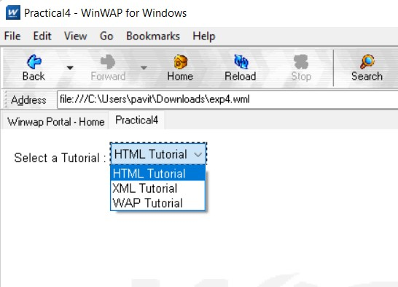

**VIVA QUESTIONS**

# Q1. What is Push and Pull technique in WAP?

In push protocols, the client opens a connection to the server and keeps it constantly active. The server will send (push) all new events to the client using that single always-on connection. In other words, the server PUSHes the new events to the client.

In pull protocols, the client periodically connects to the server, checks for and gets (pulls) recent events and then closes the connection and disconnects from the server. The client repeats this whole procedure to get updated about new events. In this mode, the clients periodically PULLs the new events from the server.

# Q2. List out the Databases used to store Data of WML pages?

MySQL, PostgreSQL, Microsoft SQL Server, Oracle Database store data of WML pages.

# Q3. What is the advantage of using XML DOM document?

XML DOM is language and platform independent.

XML DOM is traversable - Information in XML DOM is organized in a hierarchy which allows developer to navigate around the hierarchy looking for specific information.

XML DOM is modifiable - It is dynamic in nature providing the developer a scope to add, edit, move or remove nodes at any point on the tree.

# Q4. What is DTD?

A DTD is a Document Type Definition. DTD defines the structure and the legal elements and attributes of an XML document. With a DTD, independent groups of people can agree on a standard DTD for interchanging data.

# Experiment 5

**Aim :** Write a WML program to use the time control and to trigger On pick event

# Code :

<?xml version="1.0"?>

<!DOCTYPE wml PUBLIC "-//WAPFORUM//DTD WML 1.3//EN"

["http://www.wapforum.org/DTD/wml13.dtd">](http://www.wapforum.org/DTD/wml13.dtd)

<wml>

<card id="ABC" title="Practical 5">

<p>

Hello World

</p>

<onevent type="ontimer">

<go href="#ABC1"/>

</onevent>

<timer value="100"/>

</card>

<card id="ABC1" title="Practical 5">

<p>Select a Tutorial :

<select title="tutorials" name="selection_list">

<option onpick="#xhtml">XHTML Tutorial</option>

<option onpick="#wap">WAP Tutorial</option>

</select>

</p>

</card>

<card id="xhtml" title="Practical 5">

<p>

XHTML stands for EXtensible HyperText Markup Language.

</p>

</card>

<card id="wap" title="Practical 5">

<p>

Wireless Application Protocol (WAP) is a technical standard for accessing information over a mobile wireless network.

</p>

</card>

</wml>

# Output :

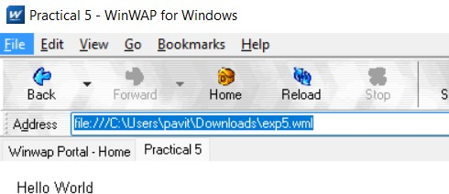

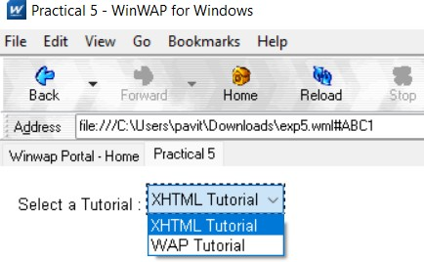

**VIVA QUESTIONS**

# Q1. Does WAP run over GPRS?

Yes, it can do. GPRS is a new over-the-air service that transmits data packets to hand-held devices. It will allow much faster WAP transmission than currently available over SMS or CSD when using GSM.

# Q2. Which security is used in WAP?

It has its own security mechanism, named Wireless Transport Layer Security (WTLS). WTLS is a wireless relative of the more common SSL mechanism used by all major web browsers. WTLS resembles SSL in that both rely on certificates on the client and server to verify the identity of the participants involved. While SSL implementations generally rely on RSA encryption, WTLS supports RSA, Diffie-Hellman, and Elliptic Curve encryption.

WTLS also doesn't provide for end-to-end security due to WAP's current architecture and limitations of server-side Transport Layer Security (another name for SSL). While WAP clients can securely exchange data with a WAP gateway using WTLS, the gateway must open an SSL session with a back-end server in order to complete the transaction.

# Q3. Is WML case sensitive?

WML is case sensitive. No case folding is performed when parsing a WML deck. All enumerated attribute values are case sensitive.

# Q4. What does Post field tag do?

The <postfield> tag contains information to be sent to the server along with a <go> tag.

# Experiment 6

**Aim :** Write a WML script to find maximum out of two numbers with help of inbuilt function Lang.Max() and to find absolute value with help of inbuilt function Lang.abs()

# Code :

1. lang.max():

<?xml version="1.0"?>

<!DOCTYPE wml PUBLIC "-//WAPFORUM//DTD WML 1.1//EN"

["http://www](http://www.WAPforum.org/DTD/wml_1.1.xml).[WAPforum.org/DTD/wml_1.1.xml">](http://www.WAPforum.org/DTD/wml_1.1.xml)

<wml>

<card id="card1">

<p>

max example

</p>

<do type="Accept">

<go href="Max.wmls#findmax()" />

</do>

</card>

<card id="card2">

<p>

1st number = $(number1)

<br />

2nd number = $(number2)

<br />

maximum number = $(maxnumber)

</p>

</card>

</wml>

1. lang.abs():

<?xml version="1.0"?>

<!DOCTYPE wml PUBLIC "-//WAPFORUM//DTD WML 1.1//EN"

["http://www](http://www.WAPforum.org/DTD/wml_1.1.xml).[WAPforum.org/DTD/wml_1.1.xml">](http://www.WAPforum.org/DTD/wml_1.1.xml)

<wml>

<card id="card1">

<p>

abs example

</p>

<do type="accept">

<go href="Abs.wmls#findabs()" />

</do>

</card>

<card id="card2">

<p>

original number = $(number)

<br />

absolute number = $(absnumber)

</p>

</card>

</wml>

1. Custom function[findmax()]:

extern function findmax(){

var result1 = Dialogs.prompt("Enter 1st number", ""); var result2 = Dialogs.prompt("Enter 2nd number", ""); var maxnum = Lang.max(result1, result2); WMLBrowser.setVar("number1", result1); WMLBrowser.setVar("number2", result2); WMLBrowser.setVar("maxnumber", maxnum); WMLBrowser.go("Exp-6.wml#card2");

};

extern function findabs()

{

var result = Dialogs.prompt("Enter any number",""); var absnum = Lang.abs(result*1); WMLBrowser.setVar("number", result); WMLBrowser.setVar("absnumber", absnum); WMLBrowser.go("Exp-6-b.wml#card2");

};

# Output : (a)

(b)

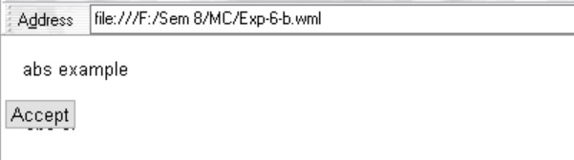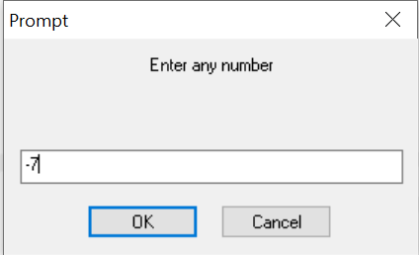

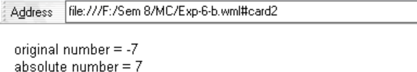

# VIVA QUESTIONS

**Q1. What are the data types used in WMLScript?**

1. Boolean: A Boolean value can be true or false.
2. Integer: WMLScript uses 32-bit integers with two's complement. This means an integer value can be in the range from -232/2 to 232/2-1, i.e. -2147483648 to 2147483647.
3. Float: WMLScript uses 32-bit single precision format to represent floating-point numbers. The maximum value supported is 3.40282347E+38. The smallest positive nonzero value supported is 1.17549435E-38
4. String: A string contains some characters.
5. Invalid. This is used to indicate that a variable is invalid.

# Q2. What are the different components of WMLScript?

* Operators
* Control Statements
* Functions
* Standard Libraries
* Comments
* Case Sensitivity
* White spaces, termination by semi-colon

# Q3. What are the standard libraries used by WMLScripts?

1. Lang − The Lang library provides functions related to the WMLScript language core.
2. Float − The Float library contains functions that help us perform floating-point arithmetic operations.
3. String − The String library provides a number of functions that help us manipulate strings.
4. URL − The URL library contains functions that help us manipulate URLs.
5. WMLBrowser − The WMLBrowser library provides a group of functions to control the WML browser or to get information from it.
6. Dialogs − The Dialogs library Contains the user interface functions.

# Q4. What is the function of WMLScript Control Statements?

Control statements of WMLScript provide a way to control the sequence of the program. They also manage the iterations information used in the program to write the code more efficiently.

**Experiment 7 Aim :** Write a Program in NS3 to Simulate OLSR

# Code :

#include <iostream> #include <fstream> #include <string> #include <cassert>

#include "ns3/core-module.h" #include "ns3/network-module.h" #include "ns3/internet-module.h"

#include "ns3/point-to-point-module.h" #include "ns3/applications-module.h" #include "ns3/olsr-helper.h"

#include "ns3/ipv4-static-routing-helper.h" #include "ns3/ipv4-list-routing-helper.h" using namespace ns3;

NS_LOG_COMPONENT_DEFINE ("SimplePointToPointOlsrExample"); int main (int argc, char *argv[])

{

// Users may find it convenient to turn on explicit debugging

// for selected modules; the below lines suggest how to do this #if 0

LogComponentEnable ("SimpleGlobalRoutingExample", LOG_LEVEL_INFO); #endif

// Set up some default values for the simulation. Use the

Config::SetDefault ("ns3::OnOffApplication::PacketSize", UintegerValue (210)); Config::SetDefault ("ns3::OnOffApplication::DataRate", StringValue ("448kb/s"));

//DefaultValue::Bind ("DropTailQueue::m_maxPackets", 30);

// Allow the user to override any of the defaults and the above

// DefaultValue::Bind ()s at run-time, via command-line arguments CommandLinecmd;

cmd.Parse (argc, argv);

// Here, we will explicitly create four nodes. In more sophisticated

Agrima Mehandiratta 60714802716

// topologies, we could configure a node factory. NS_LOG_INFO ("Create nodes."); NodeContainer c;

c. Create (5);

NodeContainer n02 = NodeContainer (c.Get (0), c.Get (2)); NodeContainer n12 = NodeContainer (c.Get (1), c.Get (2)); NodeContainer n32 = NodeContainer (c.Get (3), c.Get (2)); NodeContainer n34 = NodeContainer (c.Get (3), c.Get (4));

// Enable OLSR

NS_LOG_INFO ("Enabling OLSR Routing."); OlsrHelperolsr;

Ipv4StaticRoutingHelper staticRouting; Ipv4ListRoutingHelperlist; list.Add (staticRouting, 0); list.Add (olsr, 10);

InternetStackHelper internet;

internet.SetRoutingHelper (list); // has effect on the next Install () internet.Install (c);

// We create the channels first without any IP addressing information NS_LOG_INFO ("Create channels.");

PointToPointHelper p2p;

p2p.SetDeviceAttribute ("DataRate", StringValue ("5Mbps")); p2p.SetChannelAttribute ("Delay", StringValue ("2ms")); NetDeviceContainer nd02 = p2p.Install (n02); NetDeviceContainer nd12 = p2p.Install (n12); p2p.SetDeviceAttribute ("DataRate", StringValue ("1500kbps")); p2p.SetChannelAttribute ("Delay", StringValue ("10ms")); NetDeviceContainer nd32 = p2p.Install (n32); NetDeviceContainer nd34 = p2p.Install (n34);

// Later, we add IP addresses. NS_LOG_INFO ("Assign IP Addresses."); Ipv4AddressHelper ipv4;

ipv4.SetBase ("10.1.1.0", "255.255.255.0");

Ipv4InterfaceContainer i02 = ipv4.Assign (nd02); ipv4.SetBase ("10.1.2.0", "255.255.255.0");

Agrima Mehandiratta 60714802716

Ipv4InterfaceContainer i12 = ipv4.Assign (nd12); ipv4.SetBase ("10.1.3.0", "255.255.255.0");

Ipv4InterfaceContainer i32 = ipv4.Assign (nd32); ipv4.SetBase ("10.1.4.0", "255.255.255.0");

Ipv4InterfaceContainer i34 = ipv4.Assign (nd34);

// Create the OnOff application to send UDP datagrams of size

// 210 bytes at a rate of 448 Kb/s from n0 to n4 NS_LOG_INFO ("Create Applications."); uint16_t port = 9; // Discard port (RFC 863)

OnOffHelper onoff ("ns3::UdpSocketFactory", InetSocketAddress (i34.GetAddress

(1), port));

onoff.SetConstantRate (DataRate ("448kb/s")); ApplicationContainer apps = onoff.Install (c.Get (0)); apps.Start (Seconds (1.0));

apps.Stop (Seconds (10.0));

// Create a packet sink to receive these packets

PacketSinkHelpersink ("ns3::UdpSocketFactory", InetSocketAddress (Ipv4Address::GetAny (), port));

apps = sink.Install (c.Get (3)); apps.Start (Seconds (1.0));

apps.Stop (Seconds (10.0));

// Create a similar flow from n3 to n1, starting at time 1.1 seconds onoff.SetAttribute ("Remote", AddressValue (InetSocketAddress (i12.GetAddress (0), port)));

apps = onoff.Install (c.Get (3)); apps.Start (Seconds (1.1));

apps.Stop (Seconds (10.0));

// Create a packet sink to receive these packets apps = sink.Install (c.Get (1)); apps.Start (Seconds (1.1));

apps.Stop (Seconds (10.0)); AsciiTraceHelper ascii;

Agrima Mehandiratta 60714802716

p2p.EnableAsciiAll (ascii.CreateFileStream ("simple-point-to-point-olsr.tr")); p2p.EnablePcapAll ("simple-point-to-point-olsr");

Simulator::Stop (Seconds (30)); NS_LOG_INFO ("Run Simulation."); Simulator::Run (); Simulator::Destroy (); NS_LOG_INFO ("Done.");

return 0;

}

# Output :

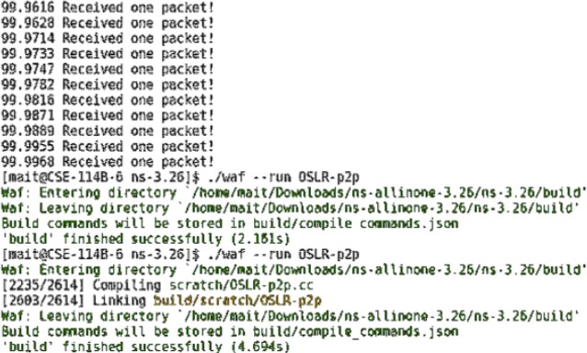

**VIVA QUESTIONS**

# Q1. List of Security Issues in Adhoc Networks?

The constantly changing nature of the network topology coupled with data transmission in open medium makes it highly susceptible to attacks. Security issues with respect to data confidentiality, availability of systems and applications, authentication, system integrity are just as threatening as in conventional networks. Vulnerabilities can lead to message eavesdropping, injection of fake messages, denial of service attack or poor monitoring of routing information.

MANETs are susceptible to both internal and external attacks.

# Q2. What is Multi Casting?

Multicasting in computer network is a group communication, where a sender(s) send data to multiple receivers simultaneously. It supports one – to – many and many – to – many data transmission across LANs or WANs. Through the process of multicasting, the communication and processing overhead of sending the same data packet or data frame in Minimized.

# Q3. What is MANET?

MANET stands for Mobile adhoc Network also called as wireless adhoc network or adhoc wireless network that usually has a routable networking environment on top of a Link Layer ad hoc network. They consist of set of mobile nodes connected wirelessly in a self- configured, self-healing network without having a fixed infrastructure. MANET nodes are free to move randomly as the network topology changes frequently. Each node behave as a router as they forward traffic to other specified node in the network.

# Q4. What are the Characteristics of MANETs?

* Dynamic topologies
* Bandwidth constrained, variable capacity links
* Autonomous behavior
* Energy constrained operation
* Limited security
* Less human intervention

**Experiment 8 Aim :** Write a Program in NS3 to Simulate AODV

# Code :

#include "ns3/aodv-module.h" #include "ns3/core-module.h" #include "ns3/network-module.h" #include "ns3/internet-module.h" #include "ns3/mobility-module.h"

#include "ns3/point-to-point-module.h" #include "ns3/wifi-module.h"

#include "ns3/v4ping-helper.h" #include <iostream>

#include <cmath> using namespace ns3; class AodvExample{ public:

AodvExample ();

bool Configure (int argc, char **argv); void Run ();

void Report (std::ostream & os); private:

// parameters uint32_t size; doublestep; doubletotalTime; boolpcap; boolprintRoutes;

// network NodeContainernodes; NetDeviceContainerdevices; Ipv4InterfaceContainerinterfaces; private:

void CreateNodes (); void CreateDevices ();

void InstallInternetStack (); void InstallApplications ();

};

int main (int argc, char **argv)

{

AodvExampletest;

if (!test.Configure (argc, argv))

NS_FATAL_ERROR ("Configuration failed. Aborted.");

test.Run (); test.Report (std::cout); return 0;

}

//-----------------------------------------------------------------------------

AodvExample::AodvExample () : size (10), step (100), totalTime (10), pcap (true), printRoutes (true){}

bool AodvExample::Configure (int argc, char **argv)

{

// Enable AODV logs by default. Comment this if too noisy

// LogComponentEnable("AodvRoutingProtocol", LOG_LEVEL_ALL); SeedManager::SetSeed (12345);

CommandLinecmd;

cmd.AddValue ("pcap", "Write PCAP traces.", pcap);

cmd.AddValue ("printRoutes", "Print routing table dumps.", printRoutes); cmd.AddValue ("size", "Number of nodes.", size);

cmd.AddValue ("time", "Simulation time, s.", totalTime); cmd.AddValue ("step", "Grid step, m", step);

cmd.Parse (argc, argv); returntrue;

}

void AodvExample::Run ()

{

// Config::SetDefault ("ns3::WifiRemoteStationManager::RtsCtsThreshold", UintegerValue (1));

// enable rts cts all the time. CreateNodes (); CreateDevices (); InstallInternetStack (); InstallApplications ();

std::cout <<"Starting simulation for "<<totalTime<<" s ...\n"; Simulator::Stop (Seconds (totalTime));

Simulator::Run (); Simulator::Destroy ();

}

void AodvExample::Report (std::ostream &){} void AodvExample::CreateNodes ()

{

std::cout <<"Creating "<< (unsigned)size<<" nodes "<<step<<" m apart.\n"; nodes.Create (size);

// Name nodes

for (uint32_t i = 0; i <size; ++i)

{

std::ostringstream os;

os <<"node-"<< i;

Names::Add (os.str (), nodes.Get (i));

}

// Create static grid MobilityHelpermobility;

mobility.SetPositionAllocator ("ns3::GridPositionAllocator", "MinX", DoubleValue (0.0),

"MinY", DoubleValue (0.0), "DeltaX", DoubleValue (step), "DeltaY", DoubleValue (0), "GridWidth", UintegerValue (size),

"LayoutType", StringValue ("RowFirst")); mobility.SetMobilityModel ("ns3::ConstantPositionMobilityModel"); mobility.Install (nodes);

}

void AodvExample::CreateDevices ()

{

WifiMacHelper wifiMac; wifiMac.SetType ("ns3::AdhocWifiMac");

YansWifiPhyHelper wifiPhy = YansWifiPhyHelper::Default (); YansWifiChannelHelper wifiChannel = YansWifiChannelHelper::Default (); wifiPhy.SetChannel (wifiChannel.Create ());

WifiHelperwifi;

wifi.SetRemoteStationManager ("ns3::ConstantRateWifiManager", "DataMode", StringValue ("OfdmRate6Mbps"), "RtsCtsThreshold", UintegerValue (0)); devices = wifi.Install (wifiPhy, wifiMac, nodes);

if (pcap)

{

wifiPhy.EnablePcapAll (std::string ("aodv"));

}

}

void AodvExample::InstallInternetStack ()

{

AodvHelper aodv;

// you can configure AODV attributes here using aodv.Set(name, value) InternetStackHelperstack;

stack.SetRoutingHelper (aodv); // has effect on the next Install () stack.Install (nodes);

Ipv4AddressHelperaddress; address.SetBase ("10.0.0.0", "255.0.0.0"); interfaces = address.Assign (devices);

if (printRoutes)

{

Ptr<OutputStreamWrapper> routingStream = Create<OutputStreamWrapper>

("aodv.routes", std::ios::out);

aodv.PrintRoutingTableAllAt (Seconds (8), routingStream);

}

}

void AodvExample::InstallApplications ()

{

V4PingHelper ping (interfaces.GetAddress (size - 1)); ping.SetAttribute ("Verbose", BooleanValue (true)); ApplicationContainer p = ping.Install (nodes.Get (0)); p.Start (Seconds (0));

p.Stop (Seconds (totalTime) - Seconds (0.001));

// move node away

Ptr<Node> node = nodes.Get (size/2);

Ptr<MobilityModel> mob = node->GetObject<MobilityModel> (); Simulator::Schedule (Seconds (totalTime/3), &MobilityModel::SetPosition, mob, Vector (1e5, 1e5, 1e5));

}

# Output :

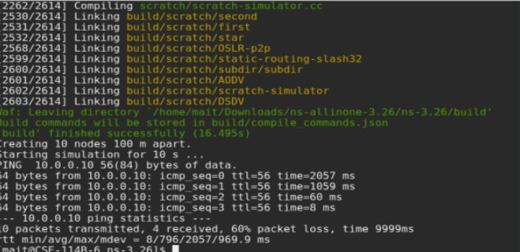

**VIVA QUESTIONS**

# Q1. How routing in Adhoc networks different from fixed networks?

In infrastructure mode, the routing part is handled by the access point and the distribution system; every wireless device just need to forward all its data packets to this access point. But, in AD Hoc networks, there is no common access point for connections, and, every device acts as a router. This scenario is totally new. Adding to this, devices are not fixed, they can be mobile, contrary to the Internet where every router has fixed neighbours (excepts if a link fails).

# Q2. What is hidden and exposed terminal problem in Adhoc Networks?

In wireless networks, the exposed node problem occurs when a node is prevented from sending packets to other nodes because of co-channel interference with a neighboring transmitter.

In wireless networking, the hidden node problem or hidden terminal problem occurs when a node can communicate with a wireless access point (AP), but cannot directly communicate with other nodes that are communicating with that AP.

# Q3. What is Hiper Access?

HiperAccess is an ETSI (European Telecommunications Standards Institute), now 3GPP (Third Generation Partnership Project), standard used to provide outdoor, high speed (25Mbps typical data rate) fixed radio access to customer premises. The system is capable of supporting multi-media applications and will be operated in either licensed or licensed exempted spectrum – typically 5GHz.

# Q4. What are hybrid routing Protocols?

Hybrid protocols utilize the capabilities of both reactive and proactive protocols, and unite them together to achieve better results. The network is separated into zones and use different protocols in two different zones that one protocol is used within the zone and other protocol is used between them. An example of hybrid routing protocol is zone routing protocol (ZRP).