# MOBILE COMPUTING LAB ETIT 452

Faculty Name: **Mr. Ashish Sharma** Student Name: RUCHIR BISHT

Enrolment No: 05914802717 Semester : 8th Sem



Maharaja Agrasen Institute of Technology, PSP Area, Sector – 22, Rohini, New Delhi – 110086

# List of Experiments

1. Write a WML program to print a formatted Text on the mobile Screen using various tags.
2. Write a WML program to connect multiple cards from same desk.
3. Write WML program to display table with three columns Image name, Image and third column contain hyperlink to open another card.
4. Write a WML program to create a form with multiple options.
5. Write a WML program to use the time control and to trigger on pick event.
6. Write a WML script to find maximum out of two numbers with help of inbuilt function Lang.Max() and to find absolute value with help of inbuilt function Lang.abs().
7. Write a Program in NS3 to Simulate OLSR
8. Write a Program in NS3 to Simulate AODV..
9. Make an application of your choice using WML or Android.
10. Write an Android Program to create list view, grid view and database connectivity.

# Experiment-01

**Aim:** Write a WML program to print a formatted Text on the mobile Screen using various tags.

## Program:

<?xml version="1.0"?>

<!DOCTYPE wml PUBLIC "-//WAPFORUM//DTD WML 1.1//EN"

["http://ww](http://www.wapforum.org/DTD/wml_1.1.xml)w[.wapforum.org/DTD/wml_1.1.xml">](http://www.wapforum.org/DTD/wml_1.1.xml)

<wml>

<card id="text" title="059 Exp-1">

<p>Ruchir Bisht</p>

<p><b> Ruchir Bisht </b></p>

<p><big> Ruchir Bisht </big></p>

<p><em> Ruchir Bisht </em></p>

<p><i> Ruchir Bisht </i></p>

<p><small> Ruchir Bisht </small></p>

<p><strong> Ruchir Bisht </strong></p>

<p><u> Ruchir Bisht </u></p>

</card>

</wml>

**Output:**

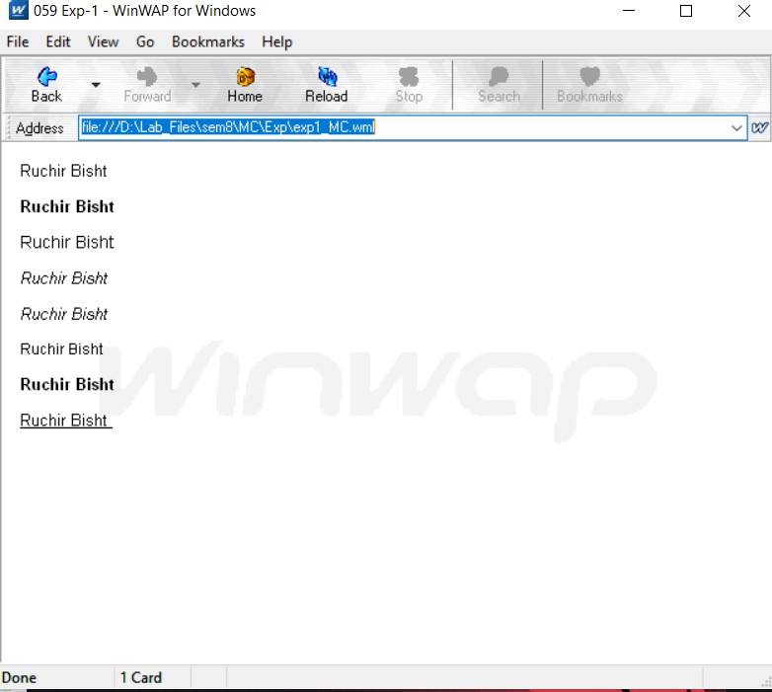

**Viva Questions:**

## What is the Use of Wml Decks?

* Deck provides the insertion of the data into one or more cards which is also called as pages.
* Deck interacts with the user and the framework on which the application is being built.

## What is WSDL?

WSDL(Web Service Definition Language) is an XML format for describing network services as a set of endpoints operating on messages containing either document- oriented or procedure-oriented information.

The operations and messages are described abstractly, and then bound to a concrete network protocol and message format to define an endpoint.

## What are the Wml variable? How To Use Them?

In WML, variables do not have to be declared explicitly. You can choose a variable name you like and assign a value to it directly. If you read a variable without assigning a value to it earlier, you will obtain an empty string.

You can set the value of a variable in the following ways:

* + 1. Using the <setvar/> tag
    2. Using data collection tags <select> and <input/>
    3. Using the setVar() function of WMLScript's WMLBrowser standard library

## How Can We Refresh Card Variables?

The refresh() function, as suggested by its function name, is used to refresh the current card on the WML browser. It does not take any arguments:

*WMLBrowser.refresh();*

# Experiment-02

**Aim:** Write a WML program to connect multiple cards from same desk.

## Program:

**Page 1:**

<?xml version="1.0"?>

<!DOCTYPE wml PUBLIC "-//WAPFORUM//DTD WML 1.2//EN"

["http://ww](http://www.wapforum.org/DTD/wml12.dtd)w[.wapforum.org/DTD/wml12.dtd">](http://www.wapforum.org/DTD/wml12.dtd)

<wml>

<card title="059 Exp2">

<b> This is First Page.</b>

<p>

<anchor>Next page

<go href="exp2_MC_2.wml"/>

</anchor>

</p>

</card>

</wml>

## Page 2:

<?xml version="1.0"?>

<!DOCTYPE wml PUBLIC "-//WAPFORUM//DTD WML 1.2//EN"

["http://ww](http://www.wapforum.org/DTD/wml12.dtd)w[.wapforum.org/DTD/wml12.dtd">](http://www.wapforum.org/DTD/wml12.dtd)

<wml>

<card title="059 Exp2">

<b> This is Second Page.</b>

<p>

<anchor> Prev Page

<prev/>

</anchor>

</p>

</card>

</wml>

**Output:**

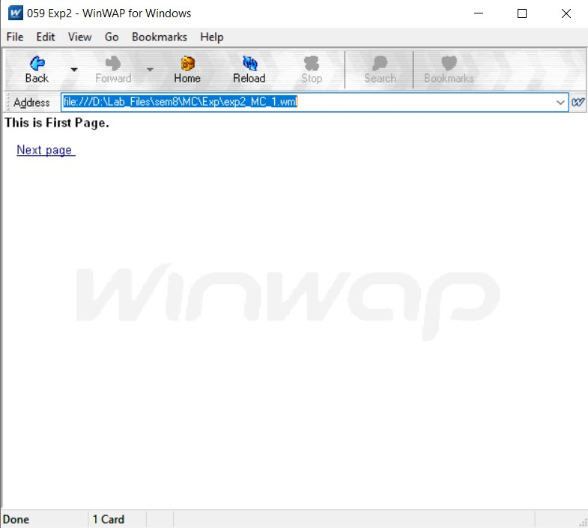

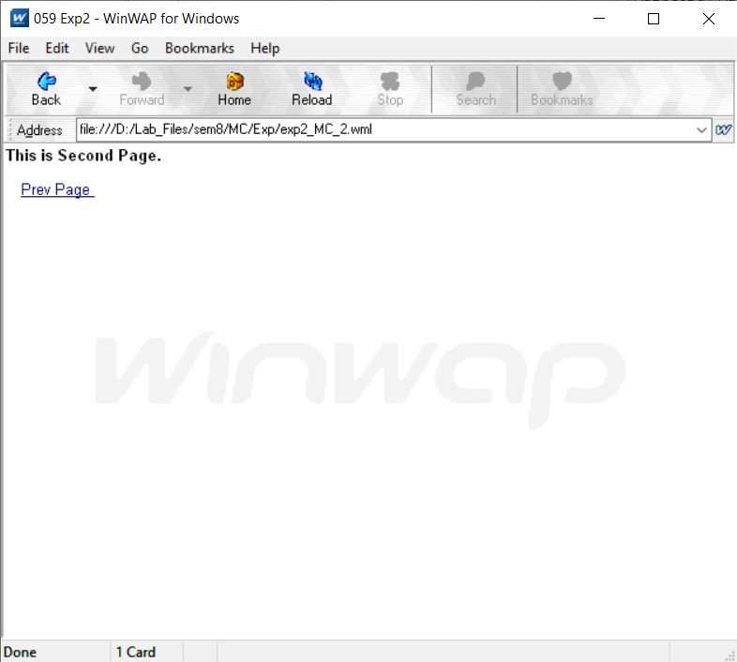

**Viva Questions:**

## What is the use of XML?

XML provides a standard method to access information, making it easier for applications and devices of all kinds to use, store, transmit, and display data.

## What is Meta Data?

Metadata is defined as the data providing information about one or more aspects of the data; it is used to summarize basic information about data which can make tracking and working with specific data easier.

## What is the difference between HTML and WML?

|  |  |
| --- | --- |
| **HTML** | **WML** |
| HTML refers to Hyper Text Markup Language. | WML refers to Wireless Markup Language. |
| HTML is the markup language for wired communication. | WML is the markup language for wireless communication. |
| It does not use variable. | It makes use of variables. |
| HTML is applied for desktop computers. | WML is applied for wireless devices  i.e. cellular phones, PDAs. |
| Content is integrated with  presentation. | Content separates from presentation. |
| JavaScript is embedded in the same HTML file. | WML scripts stored in separate file. |
| It is not case sensitive. | It is case sensitive. |
| Set of HTML pages makes a site. | Set of WML cards makes a Deck. |
| It has more tags as compared to WML. | It has fewer tags as compared to HTML. |
| For transmission of HTML  documents requires more bandwidth as compared to WML. | For transmission of WML documents  requires less bandwidth as compared to HTML. |

* 1. **What is XML DOM Document?**

The HTML DOM defines a standard way for accessing and manipulating HTML documents. It presents an HTML document as a tree-structure.The XML DOM defines a standard way for accessing and manipulating XML documents. It presents an XML document as a tree-structure.

# Experiment-03

**Aim:** Write WML program to display table with three columns Image name, Image and third column contain hyperlink to open another card.

## Program:

**Main Page:**

<?xml version="1.0"?>

<!DOCTYPE wml PUBLIC "-//WAPFORUM//DTD WML 1.1//EN"

["http://ww](http://www.wapforum.org/DTD/wml_1.1.xml)w[.wapforum.org/DTD/wml_1.1.xml">](http://www.wapforum.org/DTD/wml_1.1.xml)

<wml>

<card id="text" title="059 Exp-3">

<p><b>Image Table</b></p>

<p>

<table columns="3" align="LCR">

<tr>

<td><b>Image name</b></td>

<td><b>Image</b></td>

<td><b>Image link</b></td>

</tr>

<tr>

<td>Sun</td>

<td><img src="sun.jpg" alt="Sun image" height="55" width="55"/></td>

<td><anchor>Image Link<go href="sun.wml"/></anchor></td>

</tr>

<tr>

<td>Earth</td>

<td><img src="earth.png" alt="Earth image" height="47" width="50"/></td>

<td><anchor>Image Link<go href="earth.wml"/></anchor></td>

</tr>

<tr>

<td>Moon</td>

<td><img src="moon.jpg" alt="Moon image" height="55" width="55"/></td>

<td><anchor>Image Link<go href="moon.wml"/></anchor></td>

</tr>

</table>

</p>

</card>

</wml>

## Moon, Sun & Earth Page:

<?xml version="1.0"?>

<!DOCTYPE wml PUBLIC "-//WAPFORUM//DTD WML 1.2//EN"

["http://ww](http://www.wapforum.org/DTD/wml12.dtd)w[.wapforum.org/DTD/wml12.dtd">](http://www.wapforum.org/DTD/wml12.dtd)

<wml>

<card title="059 Exp3 Sun">

<b>Sun</b>

<p><img src="sun.jpg" alt="Sun image" height="100" width="100"/></p>

<p>

<anchor> Prev Page

<prev/>

</anchor>

</p>

</card>

</wml>

<?xml version="1.0"?>

<!DOCTYPE wml PUBLIC "-//WAPFORUM//DTD WML 1.2//EN"

["http://ww](http://www.wapforum.org/DTD/wml12.dtd)w[.wapforum.org/DTD/wml12.dtd">](http://www.wapforum.org/DTD/wml12.dtd)

<wml>

<card title="059 Exp3 Earth">

<b>Earth</b>

<p><img src="earth.png" alt="Earth image" height="100" width="100"/></p>

<p>

<anchor> Prev Page

<prev/>

</anchor>

</p>

</card>

</wml>

<?xml version="1.0"?>

<!DOCTYPE wml PUBLIC "-//WAPFORUM//DTD WML 1.2//EN"

["http://ww](http://www.wapforum.org/DTD/wml12.dtd)w[.wapforum.org/DTD/wml12.dtd">](http://www.wapforum.org/DTD/wml12.dtd)

<wml>

<card title="059 Exp3 Moon">

<b>Moon</b>

<p><img src="moon.jpg" alt="Moon image" height="100" width="100"/></p>

<p>

<anchor> Prev Page

<prev/>

</anchor>

</p>

</card>

</wml>

**Output:**

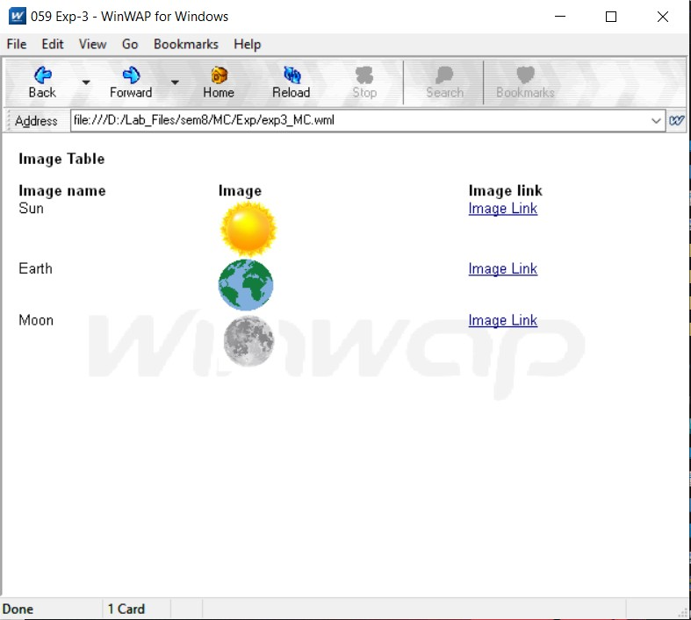

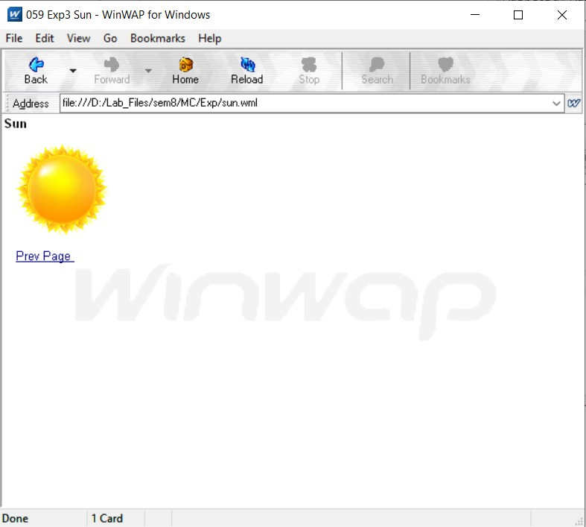

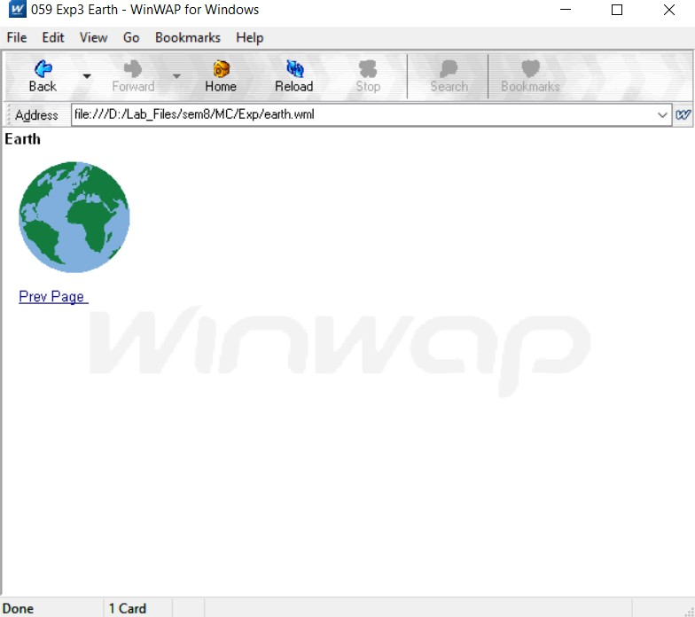

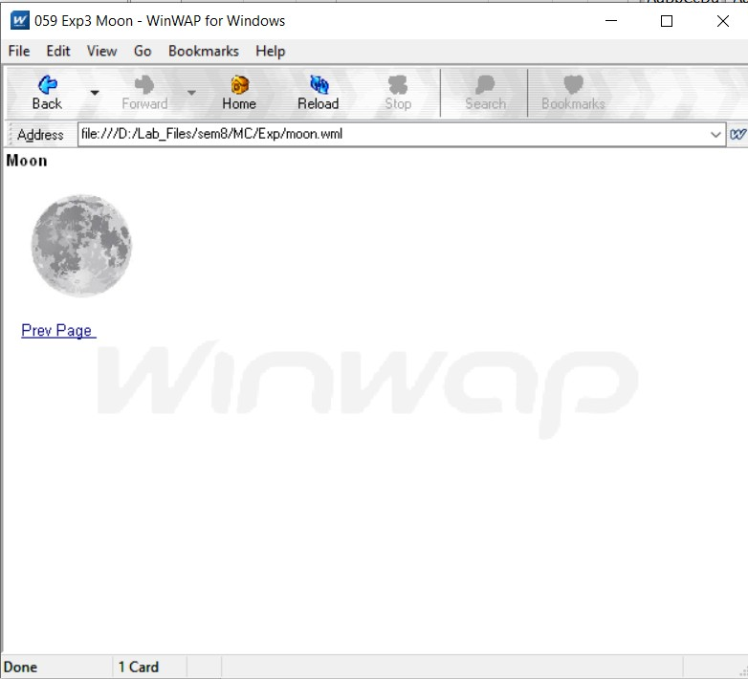

**Viva Questions:**

## What is the function of WAP Gateway?

A WAP gateway sits between mobile devices using the Wireless Application Protocol (WAP) and the World Wide Web, passing pages from one to the other much like a proxy. This translates pages into a form suitable for the mobiles, for instance using the Wireless Markup Language (WML).

## What is Distillation technique in WAP?

Distillation is lossy, real time, datatype specific compression. WAP uses distillation to reduce wireless traffic

## What is the use of UAProf?

The UAProf (User Agent Profile) specification is concerned with capturing capability and preference information for wireless devices. This information can be used by content providers to produce content in an appropriate format for the specific device.

## Why WML is called Light weight Language?

WML is called Light wight language since a lightweight markup language designed to meet the constraints of a wireless environment with low bandwidth and small handheld devices.

# Experiment-04

**Aim:** Write a WML program to create a form with multiple options.

## Program:

<?xml version="1.0"?>

<!DOCTYPE wml PUBLIC "-//WAPFORUM//DTD WML 1.1//EN"

["http://ww](http://www.wapforum.org/DTD/wml_1.1.xml)w[.wapforum.org/DTD/wml_1.1.xml">](http://www.wapforum.org/DTD/wml_1.1.xml)

<wml>

<card title="059 Exp4">

<p>Tutorial Form</p>

<p> Select a Branch :

<select>

<option value="cse">CSE</option>

<option value="ece">ECE</option>

<option value="it">IT</option>

</select>

</p>

<p>

<p> Select a Tutorial (Multiple) :

<select multiple="true">

<option value="htm">HTML Tutorial</option>

<option value="xml">XML Tutorial</option>

<option value="wap">WAP Tutorial</option>

</select>

</p>

</p>

</card>

**Output:**

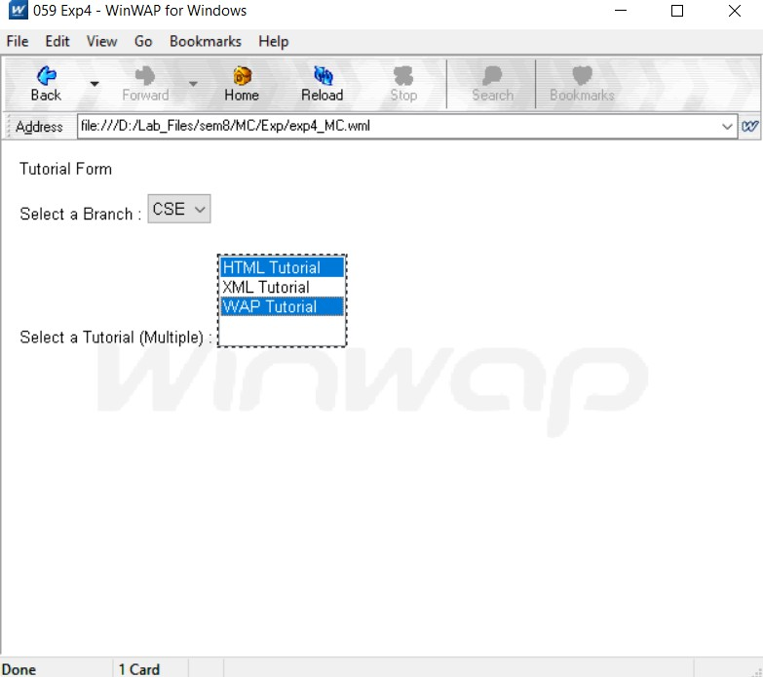

**Viva Questions:**

## What is Push and Pull technique in WAP?

The pull approach for requesting content, meaning the client makes the request for content from the server. However, WAP also supports the ability to push content from the server to the client using the Wireless Telephony Application Specification (WTA), which provides the ability to access telephony functions on the client device.

## List out the Databases used to store Data of WML pages?

MySQL, PostgreSQL, Microsoft SQL Server, Oracle Database store data of WML pages

## What is the advantages of using XML DOM document?

* + - XML DOM is language and platform independent.
    - XML DOM is traversable - Information in XML DOM is organized in a hierarchy which allows developer to navigate around the hierarchy looking for specific information
    - XML DOM is modifiable - It is dynamic in nature providing the developer a scope to add, edit, move or remove nodes at any point on the tree.

## What is DTD?

DTD (Document Type Definition) & DTD defines the structure and the legal elements and attributes of an XML document.

# Experiment-05

**Aim:** Write a WML program to use the time control and to trigger on pick event.

## Program:

**Time Control**

<?xml version="1.0"?>

<!DOCTYPE wml PUBLIC "-//WAPFORUM//DTD WML 1.2//EN"

["http://ww](http://www.wapforum.org/DTD/wml12.dtd)w[.wapforum.org/DTD/wml12.dtd">](http://www.wapforum.org/DTD/wml12.dtd)

<wml>

<card id="splash" title="Exp-5 059">

<onevent type="ontimer">

<go href="#welcome"/>

</onevent>

<timer value="50"/>

<p>

<a href="#home">Click</a>

</p>

</card>

<card id="welcome" title="Welcome Page">

<p>

Welcome to the welcome page.

</p>

</card>

<card id="home" title="Home Page">

<p>

Welcome to the home page.

</p>

</card>

</wml>

## Output:

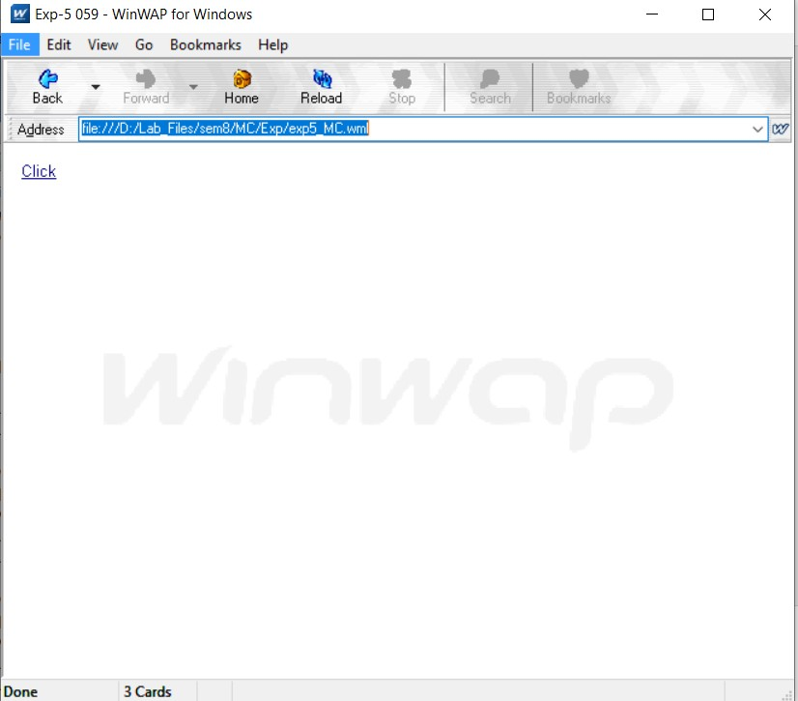

If clicked then control will go to **home page** otherwise to the **welcome Page**.

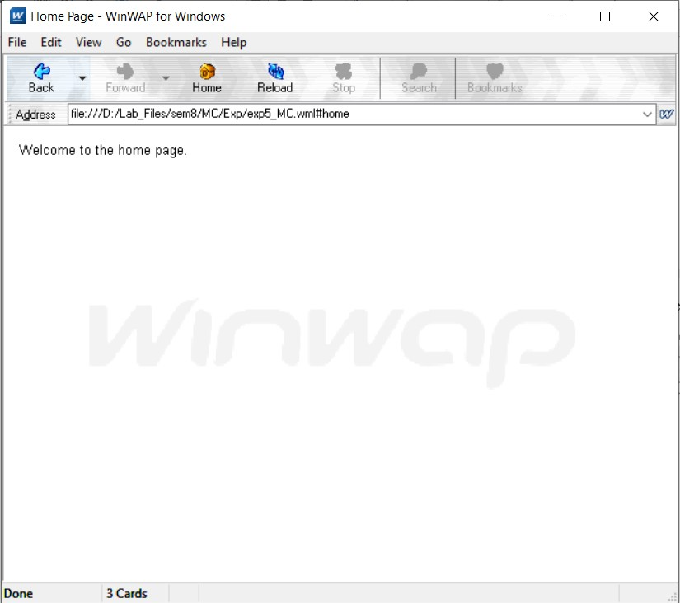

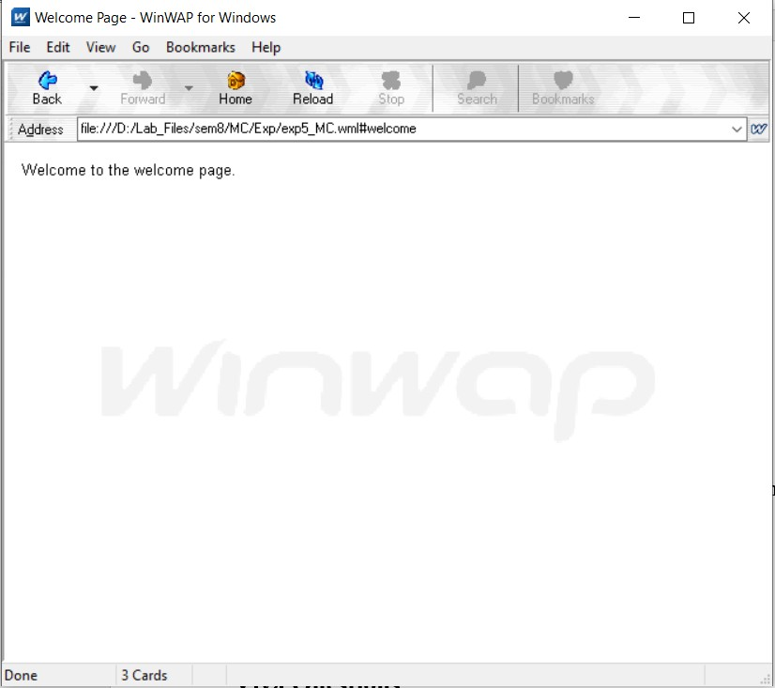

**OnPick Event**

<?xml version="1.0"?>

<!DOCTYPE wml PUBLIC "-//WAPFORUM//DTD WML 1.2//EN"

["http://ww](http://www.wapforum.org/DTD/wml12.dtd)w[.wapforum.org/DTD/wml12.dtd">](http://www.wapforum.org/DTD/wml12.dtd)

<wml>

<card id="tutorials" title="Exp-5 059">

<p>Welcome to Tutorials.</p>

<p>

Select a tutorial :

<select title="tutorials" name="selection_list">

<option onpick="#xhtml">XHTML Tutorial</option>

<option onpick="#wap">WAP Tutorial</option>

</select>

</p>

</card>

<card id="xhtml" title="XHTML Tutorial">

<p>

Go through our XHTML tutorial

</p>

</card>

<card id="wap" title="WAP Tutorial">

<p>

Go through our WAP tutorial

</p>

</card>

</wml>

**Output:**

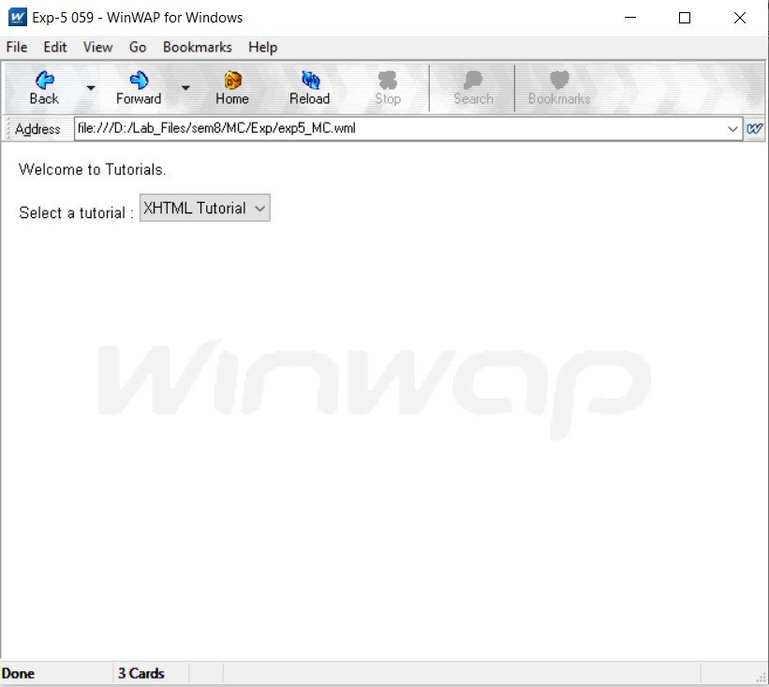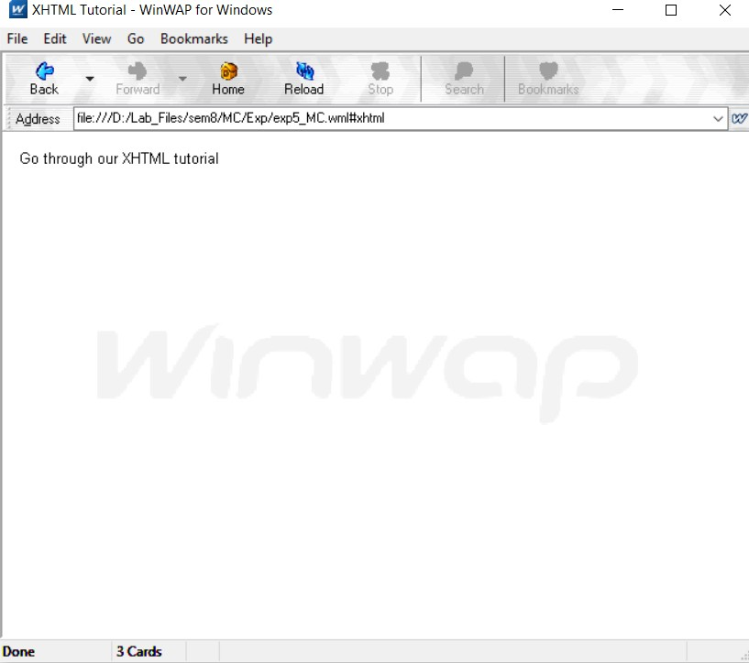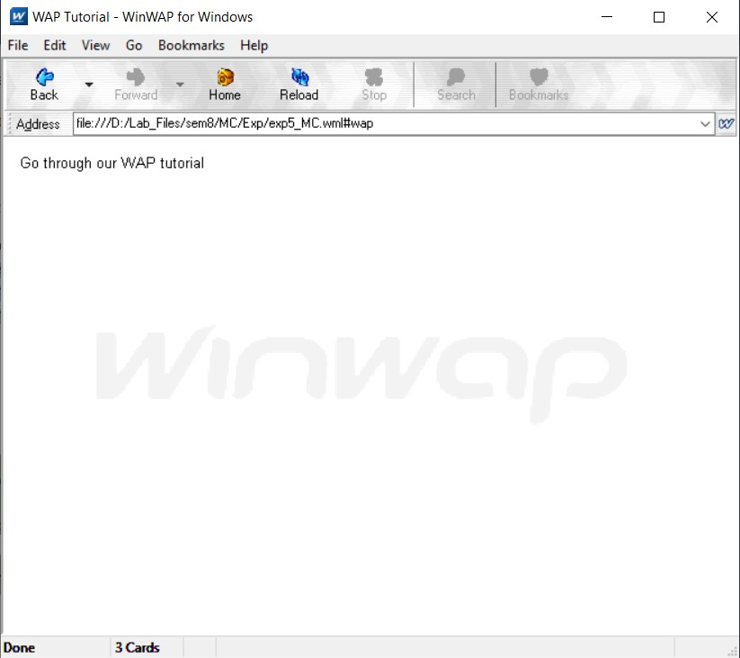

**Viva Questions:**

## Does WAP run over GPRS?

Yes, WAP can be delivered over any WDP-supported bearer, such as GPRS or SMS.

## Which Security is used in WAP?

Wireless Transport Layer Security (WTLS)

## Is WML case sensitive?

WML is case sensitive.

## What does Post field tag do?

The Post Tags field allows users to submit data that is then used to populate the tags for a post. This field works in tandem with the other Post fields to allow you to create a form that can generate post data from a user submission.

# Experiment-06

**Aim:** Write a WML script to find maximum out of two numbers with help of inbuilt function Lang.Max() and to find absolute value with help of inbuilt function Lang.abs().

## Program:

**Maximum of Two Numbers**

<?xml version="1.0"?>

<!DOCTYPE wml PUBLIC "-//WAPFORUM//DTD WML 1.1//EN"

["http://ww](http://www.WAPforum.org/DTD/wml_1.1.xml)w[.WAPforum.org/DTD/wml_1.1.xml">](http://www.WAPforum.org/DTD/wml_1.1.xml)

<wml>

<card id="card1">

<p>

max example

</p>

<do type="Accept">

<go href="Max.wmls#findmax()" />

</do>

</card>

<card id="card2">

<p>

1st number = $(number1)

<br />

2nd number = $(number2)

<br />

maximum number = $(maxnumber)

</p>

</card>

</wml>

## Max Function

extern function findmax(){

var result1 = Dialogs.prompt("Enter 1st number", ""); var result2 = Dialogs.prompt("Enter 2cd number", ""); var maxnum = **Lang.max(result1, result2);** WMLBrowser.setVar("number1", result1); WMLBrowser.setVar("number2", result2); WMLBrowser.setVar("maxnumber", maxnum); WMLBrowser.go("exp6(a)_MC.wml#card2");

};

## Output:

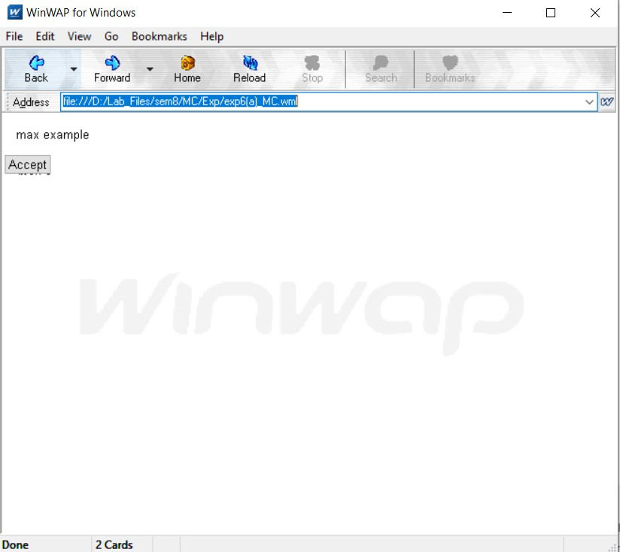

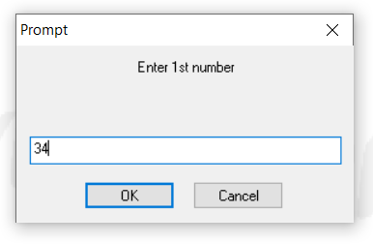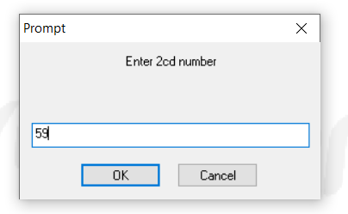



**Absolute value of a Number**

<?xml version="1.0"?>

<!DOCTYPE wml PUBLIC "-//WAPFORUM//DTD WML 1.1//EN"

["http://ww](http://www.WAPforum.org/DTD/wml_1.1.xml)w[.WAPforum.org/DTD/wml_1.1.xml">](http://www.WAPforum.org/DTD/wml_1.1.xml)

<wml>

<card id="card1">

<p>

abs example

</p>

<do type="accept">

<go href="Func.wmls#findabs()" />

</do>

</card>

<card id="card2">

<p>

original number = $(number)

<br />

absolute number = $(absnumber)

</p>

</card>

</wml>

## Abs Function

extern function findabs()

{

var result = Dialogs.prompt("Enter any number",""); var absnum = Lang.abs(result*1); WMLBrowser.setVar("number", result); WMLBrowser.setVar("absnumber", absnum); WMLBrowser.go("exp6(b)_MC.wml#card2");

};

## Output:

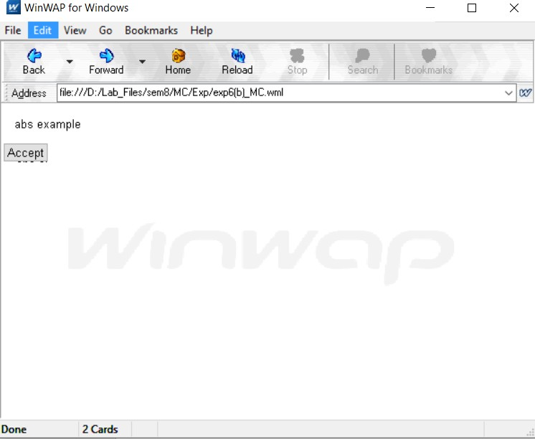

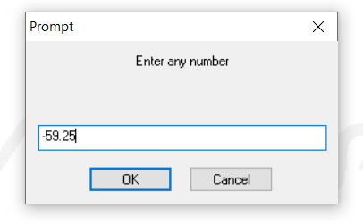 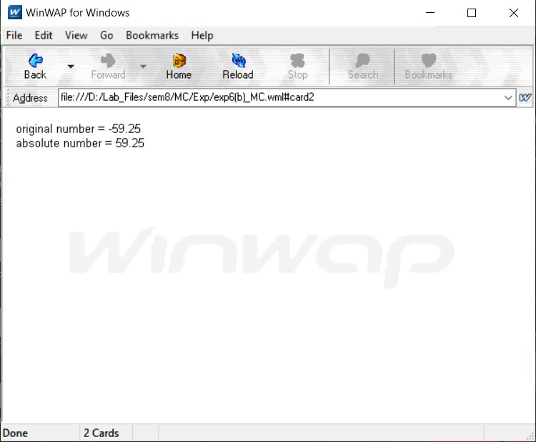

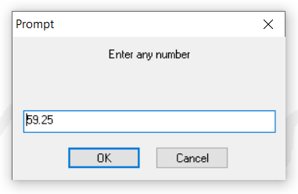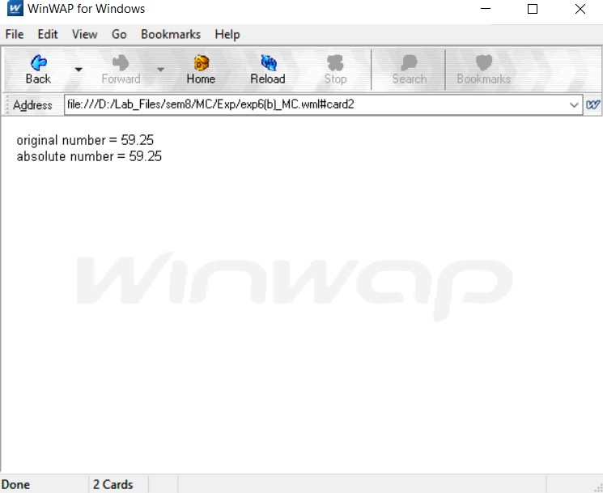

**Viva Questions:**

## What is the function of WMLScript?

* + - WMLScript is the alternative language of the JavaScript and used to develop the WML pages.
    - It is a function and comes under the Wireless Application Protocol (WAP) that provides it to be written for wireless applications.
    - It is used for the client side and has many tasks that provide user input validation, generation of error messages, etc.
    - WMLScript provides the scripts to be written in the specific manner that it can provide the additional functionality by the user.
    - WMLScript is based on the ECMAScript and it is similar to the standardized version of the java.

## What is the use of WML in WMLScript?

* + - WML is also known as Wireless Markup Language based on the XML and implement the WAP.
    - WAP is also known as Wireless application Protocol is used for devices that uses mark-up languages.
    - WML provides many features to, represent the content that needs to, be displayed like, navigational support, data input, hyperlinks, etc
    - It has the provision to put the image and present it in variety of forms with the help of HTML.
    - It uses other markup languages with the WAP to provide flexibility in the use of WML in WMLScript.

## What is the use of WML decks? – WMLScript

* + - WML document that is used to create an application is called as deck and it provides way to add more pages.
    - Deck provides the insertion of the data into one or more cards which is also called as pages.
    - Deck interacts with the user and the framework on which the application is being built.
    - Decks are stored on a configured web server that serves the purpose of including the MIME type of data.
    - This also includes the plain HTML files as well with their variants intact in the file vnd.wap.wml.

## What is the process where WML cards request the device to access WAP? – WMLScript

* + - WML cards are just like pages on the Decks that are used to request the services on the device to access WAP.
    - WAP gateway acts as a bridge between the mobile device and World Wide Web for the communication purpose.
    - It provides the pages or cards from one system to another system using the proxy on the [WWW.](http://WWW/)
    - The gateways are used to send the WML cards in the form of a form applicable to use in a mobile device.
    - The process can’t be seen by the device but the pages can be accessed using the browser and the URL.

## What is the support of mobile devices for WMLScript?

* + - Mobile devices are used to run and showcase the result of the input that is given and written by the use of WMLScript.
    - Mobile devices are supporting XHTML and standards of HTML due to increase in the processing power.
    - The standards of HTML provide a way of formatting and presenting it to the users with suitable options.
    - WMLScript is written such that it provides hardware interfacing with the mobile using the WML.
    - Mobile devices are used for WAP that provides large coverage areas to use the applications and run it on many devices.

## What is the process of adding the client-side logic to WAP using WMLScript?

* + - WMLScript is similar to the JavaScript and it provides the same feature as JavaScript.
    - The standardization is being provided using the ECMAScript standard based on WMLScript.
    - WMLScript provides the client only scripting platform on the Internet that is used with the WML.
    - It also provides the client side with some procedural logics so that it becomes easier to program and create applications.
    - WMLScript is used with the WAP gateway to provide the logics and implementation of it in the mobile devices.

## What is the purpose of using WMLScript?

* + - WMLScript is given in the binary form that allows the mobile devices to run the applications using the WAP functionality.
    - WMLScript provides the validator that can be used to validate the user input given in the form.
    - WMLScript provides the advanced functioinality to write and read the code with the tools provided by it.
    - It provides the facilities that can be accessed by the user agent and more application can run on the devices.
    - WMLScript is used to create the dialog boxes and messages that can be used locally to check for the error messages.

## What are the data types used in WMLScript?

* + - WMLScript is a weakly typed language that provides no type checking during the compile time or the run time.
    - WMLScript uses the data types as follows:
    - **Boolean**: this is the data type used for the values like true or false and it usually deals in decision making.
    - **Integer**: this is a data type containing the numerical values
    - **Floating-point**: this is the data type used to provide the value in decimal points like 1.00, 1 e-10.
    - **String**: this is the data type that stores the values in the form of characters in a contiguous memory location.
    - **Invalid**: is the data type that describes the value of a function valid or invalid.

## What are the different components of WMLScript?

* + - WMLScript is also known as Wireless Markup Language Script that is used for the client side
    - It is a light weight script that runs on wireless devices for some processing and computation.
    - The components used in WMLScript are as follows:
      * WML Script Operators: they are used to provide the operators to make it work on operands.
      * It includes operators like Arithmetic, comparison, logical, etc. operators to make the writing of the script easier.

## What is the function of WMLScript Control Statements?

* + - Control statements of WMLScript provide a way to control the sequence of the program.
    - It also manages the iterations information used in the program to write the code more efficiently.
    - The control statements used in the program are as follows:
      * **Statement**: it is the description about the program that helps in executing according to the code written.
      * **if-else**: is used for the conditional branching where the decision of one branch over another takes place.
      * **for**; this allows self-incrementation of the loop over some lines of codes to make it execute.
      * **while**: this is used to create a variable that provides iteration loop over the codes of lines.

## How does WMLScript function written?

* + - WMLScript provides functions that are either user defined or inbuilt so that it can be used with the Script.
    - The user defined functions are usually made and declared in different file having the extension as .wmls.
    - The format of the function is as follows: function name (parameters)

{

control statements; return var;

}

* + - This function contains some values in the form of parameters and it is being called by using the filename followed by hash.
    - It is represented as: **maths.wmls#squar()**

## What are the standard libraries used by WMLScript?

* + - The standard libraries are used for inbuilt functions and their usage that provides a way to use all that in the programming.
    - The standard libraries that exist are as follows:
    - **Lang**: this is the library that provides the support for different language functions that are related to the WMLScript core language. The functions that are used as follows: abs(), abort(), characterSet(),float(), isFloat(), isInt(), etc.
    - **Float**: this is the library that allows the built-in functions to perform the floating point operations The functions that are uses as follows: sqrt(), round(), pow(), ceil(), floor(), int(), maxFloat(), minFloat(
    - **String**: it is the library that provides the functions for creation and manipulation of strings.The functions that are uses as follows: length(), charAt(), find(), replace(), trim(), compare(), format(), etc.
    - **URL**: this is the library that is used to provide the URL’s for manipulation and consists of the functions like: getPath(), getReferer(), getHost(), getBase(), escapeString(), isValid(), etc.
    - **WMLBrowser**: this consists of the libraries that used to provide the group of functions controlling the data on the browser by using the functions like: go(), prev(), next(), etc.
    - **Dialogs**: this is the library consisting of the user interface and related functions like: prompt(), confirm(), alert()

# Experiment-07

**Aim:** Write a Program in NS3 to Simulate OLSR.

## Program:

#include <iostream> #include <fstream> #include <string> #include <cassert>

#include "ns3/core-module.h" #include "ns3/network-module.h" #include "ns3/internet-module.h"

#include "ns3/point-to-point-module.h" #include "ns3/applications-module.h" #include "ns3/olsr-helper.h"

#include "ns3/ipv4-static-routing-helper.h" #include "ns3/ipv4-list-routing-helper.h" using namespace ns3;

NS_LOG_COMPONENT_DEFINE ("SimplePointToPointOlsrExample"); int

main (int argc, char *argv[])

{

// Users may find it convenient to turn on explicit debugging

// for selected modules; the below lines suggest how to do this #if 0

LogComponentEnable ("SimpleGlobalRoutingExample", LOG_LEVEL_INFO); #endif

// Set up some default values for the simulation. Use the

Config::SetDefault ("ns3::OnOffApplication::PacketSize", UintegerValue (210)); Config::SetDefault ("ns3::OnOffApplication::DataRate", StringValue ("448kb/s"));

//DefaultValue::Bind ("DropTailQueue::m_maxPackets", 30);

// Allow the user to override any of the defaults and the above

// DefaultValue::Bind ()s at run-time, via command-line arguments CommandLinecmd;

cmd.Parse (argc, argv);

// Here, we will explicitly create four nodes. In more sophisticated

// topologies, we could configure a node factory. NS_LOG_INFO ("Create nodes."); NodeContainer c;

c.Create (5);

NodeContainer n02 = NodeContainer (c.Get (0), c.Get (2)); NodeContainer n12 = NodeContainer (c.Get (1), c.Get (2)); NodeContainer n32 = NodeContainer (c.Get (3), c.Get (2)); NodeContainer n34 = NodeContainer (c.Get (3), c.Get (4));

// Enable OLSR

NS_LOG_INFO ("Enabling OLSR Routing."); OlsrHelperolsr;

Ipv4StaticRoutingHelper staticRouting; Ipv4ListRoutingHelperlist;

list.Add (staticRouting, 0);

list.Add (olsr, 10); InternetStackHelper internet;

internet.SetRoutingHelper (list); // has effect on the next Install () internet.Install (c);

// We create the channels first without any IP addressing information NS_LOG_INFO ("Create channels.");

PointToPointHelper p2p;

p2p.SetDeviceAttribute ("DataRate", StringValue ("5Mbps")); p2p.SetChannelAttribute ("Delay", StringValue ("2ms"));

NetDeviceContainer nd02 = p2p.Install (n02); NetDeviceContainer nd12 = p2p.Install (n12); p2p.SetDeviceAttribute ("DataRate", StringValue ("1500kbps")); p2p.SetChannelAttribute ("Delay", StringValue ("10ms")); NetDeviceContainer nd32 = p2p.Install (n32); NetDeviceContainer nd34 = p2p.Install (n34);

// Later, we add IP addresses. NS_LOG_INFO ("Assign IP Addresses."); Ipv4AddressHelper ipv4;

ipv4.SetBase ("10.1.1.0", "255.255.255.0");

Ipv4InterfaceContainer i02 = ipv4.Assign (nd02); ipv4.SetBase ("10.1.2.0", "255.255.255.0");

Ipv4InterfaceContainer i12 = ipv4.Assign (nd12); ipv4.SetBase ("10.1.3.0", "255.255.255.0");

Ipv4InterfaceContainer i32 = ipv4.Assign (nd32); ipv4.SetBase ("10.1.4.0", "255.255.255.0");

Ipv4InterfaceContainer i34 = ipv4.Assign (nd34);

// Create the OnOff application to send UDP datagrams of size

// 210 bytes at a rate of 448 Kb/s from n0 to n4 NS_LOG_INFO ("Create Applications."); uint16_t port = 9; // Discard port (RFC 863) OnOffHelper onoff ("ns3::UdpSocketFactory", InetSocketAddress (i34.GetAddress (1), port)); onoff.SetConstantRate (DataRate ("448kb/s"));

ApplicationContainer apps = onoff.Install (c.Get (0)); apps.Start (Seconds (1.0));

apps.Stop (Seconds (10.0));

// Create a packet sink to receive these packets PacketSinkHelpersink ("ns3::UdpSocketFactory",

InetSocketAddress (Ipv4Address::GetAny (), port)); apps = sink.Install (c.Get (3));

apps.Start (Seconds (1.0));

apps.Stop (Seconds (10.0));

// Create a similar flow from n3 to n1, starting at time 1.1 seconds onoff.SetAttribute ("Remote",

AddressValue (InetSocketAddress (i12.GetAddress (0), port))); apps = onoff.Install (c.Get (3));

apps.Start (Seconds (1.1));

apps.Stop (Seconds (10.0));

// Create a packet sink to receive these packets apps = sink.Install (c.Get (1));

apps.Start (Seconds (1.1));

apps.Stop (Seconds (10.0)); AsciiTraceHelper ascii;

p2p.EnableAsciiAll (ascii.CreateFileStream ("simple-point-to-point-olsr.tr")); p2p.EnablePcapAll ("simple-point-to-point-olsr");

Simulator::Stop (Seconds (30)); NS_LOG_INFO ("Run Simulation."); Simulator::Run (); Simulator::Destroy (); NS_LOG_INFO ("Done.");

return 0;

}

**Output:**

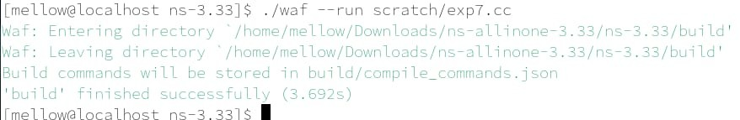

**Viva Questions:**

## List of Security Issues in Adhoc Networks?

* + - The constantly changing nature of the network topology coupled with data transmission in open medium makes it highly susceptible to attacks.
    - Security issues with respect to data confidentiality, availability of systems and applications, authentication, system integrity are just as threatening as in conventional networks.
    - Vulnerabilities can lead to message eavesdropping, injection of fake messages, denial of service attack or poor monitoring of routing information.
    - **Adhoc Networks** are susceptible to both internal and external attacks.

## What is Multi Casting?

Multicasting in computer network is a group communication, where a sender(s) send data to multiple receivers simultaneously. It supports one – to – many and many – to – many data transmission across LANs or WANs.

## What is MANET?

MANET stands for "Mobile Ad Hoc Network." A MANET is a type of ad hoc network that can change locations and configure itself on the fly. For example, A VANET (Vehicular Ad Hoc Network), is a type of MANET that allows vehicles to communicate with roadside equipment.

## What are the Characteristics of MANETs?

* + - **Dynamic Network Topologies**: The nodes in MANETs are free to move independently in any direction.
    - **Low Bandwidth**: These networks have lower capacity and shorter transmission range than fixed infrastructure networks.
    - **Limited Battery Power**: The nodes or hosts operate on small batteries and other exhaustible means of energy.
    - **Decentralized Control**: Due to unreliable links, the working of MANET depends upon cooperation of participating nodes
    - **Unreliable Communications**: The shared-medium nature and unstable channel quality of wireless links may result in high packet-loss rate and re-routing instability, which is a common phenomenon that leads to throughput drops in multi-hop networks.
    - **Weak Physical Protection**: MANETs are more prone to physical security threats than fixed-cable nets. Mobile nodes are usually compact, soft and hand- held in nature. Today, portable devices are getting smaller and smaller.
    - **Scalability**: Due to the limited memory and processing power on mobile devices, the scalability is a key problem when we consider a large network size.

# Experiment-08

**Aim:** Write a Program in NS3 to Simulate AODV.

## Program:

#include "ns3/aodv-module.h" #include "ns3/core-module.h" #include "ns3/network-module.h" #include "ns3/internet-module.h" #include "ns3/mobility-module.h"

#include "ns3/point-to-point-module.h" #include "ns3/wifi-module.h"

#include "ns3/v4ping-helper.h" #include <iostream>

#include <cmath> using namespace ns3; class AodvExample

{

public:

AodvExample ();

bool Configure (int argc, char **argv); void Run ();

void Report (std::ostream & os); private:

// parameters uint32_t size; doublestep; doubletotalTime; boolpcap; boolprintRoutes;

// network NodeContainernodes; NetDeviceContainerdevices;

Ipv4InterfaceContainerinterfaces; private:

void CreateNodes (); void CreateDevices ();

void InstallInternetStack (); void InstallApplications ();

};

int main (int argc, char **argv)

{

AodvExampletest;

if (!test.Configure (argc, argv))

NS_FATAL_ERROR ("Configuration failed. Aborted."); test.Run ();

test.Report (std::cout); return 0;

}

// AodvExample::AodvExample () :

size (10),

step (100),

totalTime (10), pcap (true), printRoutes (true)

{

}

bool

48

AodvExample::Configure (int argc, char **argv)

{

// Enable AODV logs by default. Comment this if too noisy

// LogComponentEnable("AodvRoutingProtocol", LOG_LEVEL_ALL); SeedManager::SetSeed (12345);

CommandLinecmd;

cmd.AddValue ("pcap", "Write PCAP traces.", pcap);

cmd.AddValue ("printRoutes", "Print routing table dumps.", printRoutes); cmd.AddValue ("size", "Number of nodes.", size);

cmd.AddValue ("time", "Simulation time, s.", totalTime); cmd.AddValue ("step", "Grid step, m", step);

cmd.Parse (argc, argv); returntrue;

}

void AodvExample::Run ()

{

// Config::SetDefault ("ns3::WifiRemoteStationManager::RtsCtsThreshold",

UintegerValue

(1)); // enable rts cts all the time. CreateNodes ();

CreateDevices (); InstallInternetStack (); InstallApplications ();

std::cout <<"Starting simulation for "<<totalTime<<" s ...\n"; Simulator::Stop (Seconds (totalTime));

Simulator::Run (); Simulator::Destroy ();

}

void

AodvExample::Report (std::ostream &)

{

}

void AodvExample::CreateNodes ()

{

std::cout <<"Creating "<< (unsigned)size<<" nodes "<<step<<" m apart.\n"; nodes.Create (size);

// Name nodes

for (uint32_t i = 0; i <size; ++i)

{

std::ostringstream os; os <<"node-"<< i;

Naes::Add (os.str (), nodes.Get (i));

}

// Create static grid MobilityHelpermobility;

mobility.SetPositionAllocator ("ns3::GridPositionAllocator", "MinX", DoubleValue (0.0),

"MinY", DoubleValue (0.0), "DeltaX", DoubleValue (step), "DeltaY", DoubleValue (0), "GridWidth", UintegerValue (size),

"LayoutType", StringValue ("RowFirst")); mobility.SetMobilityModel ("ns3::ConstantPositionMobilityModel"); mobility.Install (nodes);

}

void AodvExample::CreateDevices ()

{

WifiMacHelper wifiMac; wifiMac.SetType ("ns3::AdhocWifiMac");

YansWifiPhyHelper wifiPhy = YansWifiPhyHelper::Default (); YansWifiChannelHelper wifiChannel = YansWifiChannelHelper::Default (); wifiPhy.SetChannel (wifiChannel.Create ());

WifiHelperwifi;

wifi.SetRemoteStationManager ("ns3::ConstantRateWifiManager", "DataMode", StringValue ("OfdmRate6Mbps"), "RtsCtsThreshold", UintegerValue (0)); devices = wifi.Install (wifiPhy, wifiMac, nodes);

if (pcap)

{

wifiPhy.EnablePcapAll (std::string ("aodv"));

}

}

void AodvExample::InstallInternetStack ()

{

AodvHelper aodv;

// you can configure AODV attributes here using aodv.Set(name, value) InternetStackHelperstack;

stack.SetRoutingHelper (aodv); // has effect on the next Install () stack.Install (nodes);

Ipv4AddressHelperaddress; address.SetBase ("10.0.0.0", "255.0.0.0"); interfaces = address.Assign (devices);

if (printRoutes)

{

Ptr<OutputStreamWrapper> routingStream = Create<OutputStreamWrapper> ("aodv.routes", std::ios::out);

aodv.PrintRoutingTableAllAt (Seconds (8), routingStream);

} 50

}

void AodvExample::InstallApplications ()

{

V4PingHelper ping (interfaces.GetAddress (size - 1)); ping.SetAttribute ("Verbose", BooleanValue (true)); ApplicationContainer p = ping.Install (nodes.Get (0)); p.Start (Seconds (0));

p.Stop (Seconds (totalTime) - Seconds (0.001));

// move node away

Ptr<Node> node = nodes.Get (size/2);

Ptr<MobilityModel> mob = node->GetObject<MobilityModel> ();

Simulator::Schedule (Seconds (totalTime/3), &MobilityModel::SetPosition, mob,

Vector

(1e5, 1e5, 1e5));

}

**Output:**

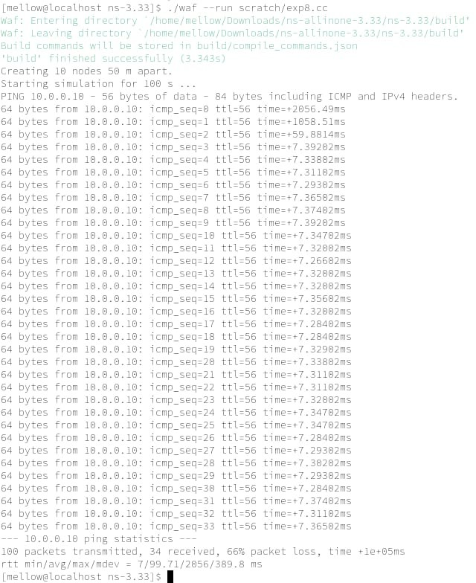

**Viva Questions:**

## How routing in Adhoc networks different from fixed networks?

An Adhoc network is a self-organizing multi-hop wireless network, which is independent neither on fixed infrastructure nor on predetermined connectivity. It is a collection of nodes, which communicate with each other using radio transmissions. In ad hoc network, there is no base station to act as router.

## What is hidden and exposed terminal problem in Adhoc Networks?

The hidden terminal problem is known to degrade the throughput of wireless networks due to collisions, while the exposed terminal problem results in poor performance by wasting valuable transmission opportunities.

## What is HiperLAN?

HiperLAN (High Performance Radio LAN) is a wireless LAN standard. HiperLAN/2 can also be used as a home network and supports a data rate of up to 54 Mbps.

## What are hybrid routing Protocols?

Hybrid Routing Protocol (HRP) is a network routing protocol that combines Distance Vector Routing Protocol (DVRP) and Link State Routing Protocol (LSRP) features. HRP is used to determine optimal network destination routes and report network topology data modifications.

# Experiment-09

**Aim:** Make an application of your choice using WML or Android.

## Phone Book using WML Script. Phonebook.wml File:

<?xml version="1.0"?>

<!DOCTYPE wml PUBLIC "-//WAPFORUM//DTD WML 1.1//EN"

["http://ww](http://www.wapforum.org/DTD/wml_1.1.xml)w[.wapforum.org/DTD/wml_1.1.xml">](http://www.wapforum.org/DTD/wml_1.1.xml)

<wml>

<card id="card1" title="Phone Book" newcontext="true">

<p>

<b>Phone Book</b>

</p>

<p>

Select Contact Name:

<select name="name" value="Ruchir" title="Name">

<option value="Ruchir">Ruchir</option>

<option value="Kaushik">Kaushik</option>

<option value="Gaurav">Gaurav</option>

<option value="Bhuvan">Bhuvan</option>

</select>

<br><br>

<do type="accept" label="Get number">

<go href="Phonebook.wmls#phone()"/>

</do>

</p>

</card>

<card id="card2" title="Phone Number">

<p>

Contact Details

</p>

<p>

<b>$(fullname)</b><br>

<b>$(phoneNumber)</b><br>

<b>$(email)</b>

</p>

</card>

</wml>

## Phonebook.wmls File:

extern function phone() {

var a = WMLBrowser.getVar("name"); var username = "Full Name : ";

var email = "Email Id : "; var phone = "Contact No : ";

if(String.compare(a,"Ruchir")==0) { username = username + "Ruchir Bisht"; email = email + ["ruchir](mailto:ruchir@gmail.com)@[gmail.com";](mailto:ruchir@gmail.com) phone = phone + "9998997856";

}

else if(String.compare(a,"Kaushik")==0) { username = username + "Kaushik Pandey"; email = email + ["kush@gm](mailto:kush@gmail.com)a[il.com";](mailto:kush@gmail.com) phone = phone + "54678987898";

}

else if(String.compare(a,"Gaurav")==0) { username = username + "Gaurav Cherwal"; email = email + ["gaur](mailto:gaurav@gmail.com)a[v@gmail.com";](mailto:gaurav@gmail.com)

phone = phone + "9898786765";

}

else if(String.compare(a,"Bhuvan")==0){ username = username + "Bhuvan Kumar"; email = email + ["bhuvan@gm](mailto:bhuvan@gmail.com)a[il.com";](mailto:bhuvan@gmail.com) phone = phone + "9887867677";

}

else{

username = "Invalid"; email = "Invalid"; phone = "Invalid";

}

WMLBrowser.setVar("fullname",username); WMLBrowser.setVar("phoneNumber",phone); WMLBrowser.setVar("email",email); WMLBrowser.go("Phonebook.wml#card2");

}

**Output:**

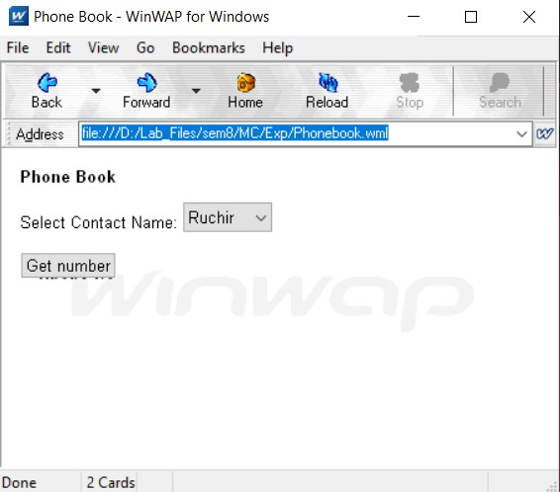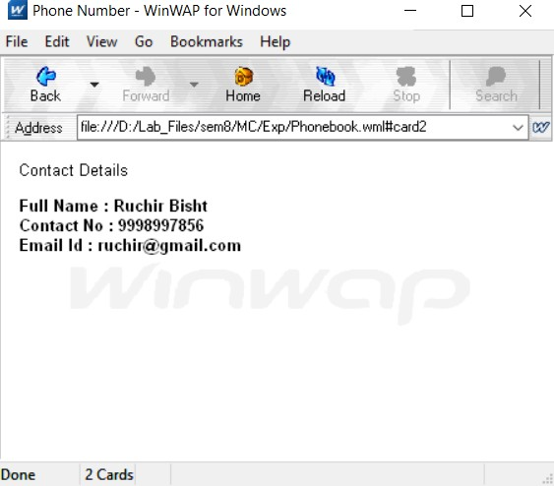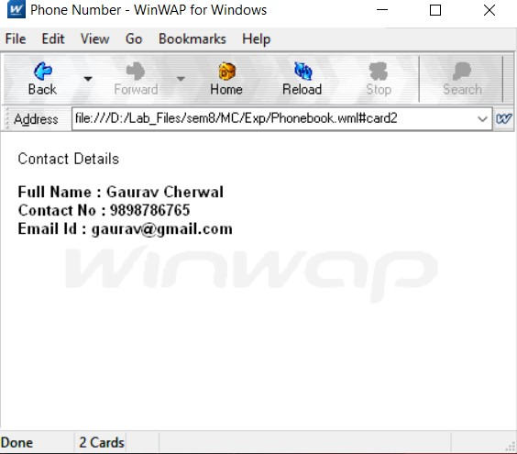

**Viva Questions:**

## What is an Activity in Android?

An Android activity is one screen of the Android app's user interface. In that way an Android activity is very similar to windows in a desktop application. An Android app may contain one or more activities, meaning one or more screens.

## What is an APK format?

Android Package (APK) is the Android application package file format used by the Android operating system, and a number of other Android-based operating.

## What is an Intent?

An Intent in the Android operating system is a software mechanism that allows users to coordinate the functions of different activities to achieve a task.

## What is an Android Manifest File?

The manifest file describes essential information about your app to the Android build tools, the Android operating system, and Google Play. Among many other things, the manifest file is required to declare the following: The app's package name, which usually matches your code's namespace.

# Experiment-10

**Aim:** Write an Android Program to create list view, grid view and database connectivity.

## List View Code:

MainActivity.java

package com.example.listview;

import androidx.appcompat.app.AppCompatActivity; import android.os.Bundle;

import android.widget.ArrayAdapter; import android.widget.ListView;

import java.util.ArrayList;

public class MainActivity extends AppCompatActivity { ListView listView;

@Override

protected void onCreate(Bundle savedInstanceState) { super.onCreate(savedInstanceState); setContentView(R.layout.*activity_main*);

listView = (ListView)findViewById(R.id.*listview*); ArrayList<String> arrayList = new ArrayList<>(); arrayList.add("Java");

arrayList.add("C++"); arrayList.add("Python"); arrayList.add("JavaScript"); arrayList.add("C");

ArrayAdapter arrayAdapter = new ArrayAdapter(this,android.R.layout.*simple_list_item_1*,arrayList);

listView.setAdapter(arrayAdapter);

}

}

activity_main.xml

<?xml version="1.0" encoding="utf-8"?>

<RelativeLayout xmlns:android[="http://schemas.android.com/apk/res/android"](http://schemas.android.com/apk/res/android) xmlns:app[="http://schemas.android.com/apk/res-auto"](http://schemas.android.com/apk/res-auto) xmlns:tools[="http://schemas.android.com/tools"](http://schemas.android.com/tools) android:layout_width="match_parent" android:layout_height="match_parent"

tools:context=".MainActivity">

<ListView

android:id="@+id/listview" android:layout_width="match_parent" android:layout_height="match_parent" />

</RelativeLayout>

## Output:

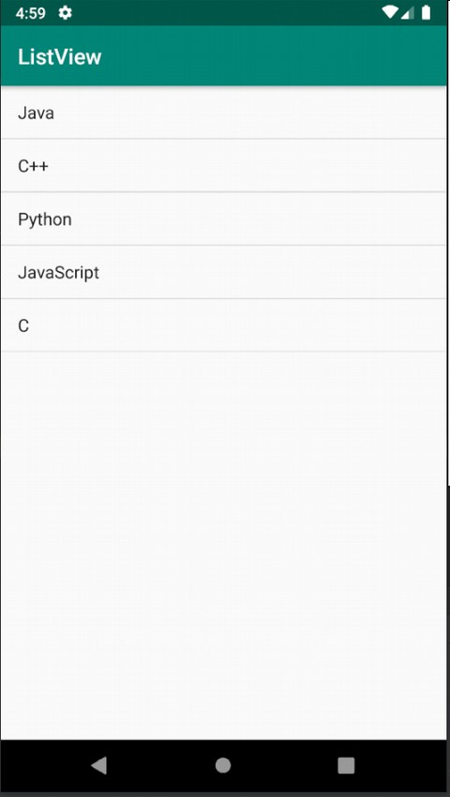

**Grid View**

**Code:** MainActivity.java

package com.example.gridview;

import androidx.appcompat.app.AppCompatActivity; import android.os.Bundle;

import android.view.View;

import android.widget.AdapterView; import android.widget.ArrayAdapter; import android.widget.GridView; import android.widget.TextView; import android.widget.Toast;

public class MainActivity extends AppCompatActivity { GridView gridView;

static final String[] *gridViewValue* = new String[]{ "FOC" , "DSA" , "CN" ,

"OOPs" , "STQA" , "COA" ,

"ADBMS" , "DBMS" , "OS" ,

"SE" , "TOC" , "WebD",

"MC" , "PPL" , "SC"

} ;

@Override

protected void onCreate(Bundle savedInstanceState) { super.onCreate(savedInstanceState); setContentView(R.layout.*activity_main*); gridView = findViewById(R.id.*gridView*);

ArrayAdapter adapter = new ArrayAdapter(this,android.R.layout.*simple_list_item_1*,*gridViewValue*);

gridView.setAdapter(adapter);

}

}

activity_main.xml

<?xml version="1.0" encoding="utf-8"?>

<RelativeLayout xmlns:android[="http://schemas.android.com/apk/res/android"](http://schemas.android.com/apk/res/android) xmlns:app[="http://schemas.android.com/apk/res-auto"](http://schemas.android.com/apk/res-auto) xmlns:tools[="http://schemas.android.com/tools"](http://schemas.android.com/tools) android:layout_width="match_parent" android:layout_height="match_parent"

tools:context=".MainActivity">

<GridView

android:layout_width="match_parent" android:layout_height="match_parent" android:id="@+id/gridView" android:columnWidth="100dp" android:minHeight="100dp" android:numColumns="auto_fit" android:stretchMode="columnWidth"

/>

</RelativeLayout>

## Output:

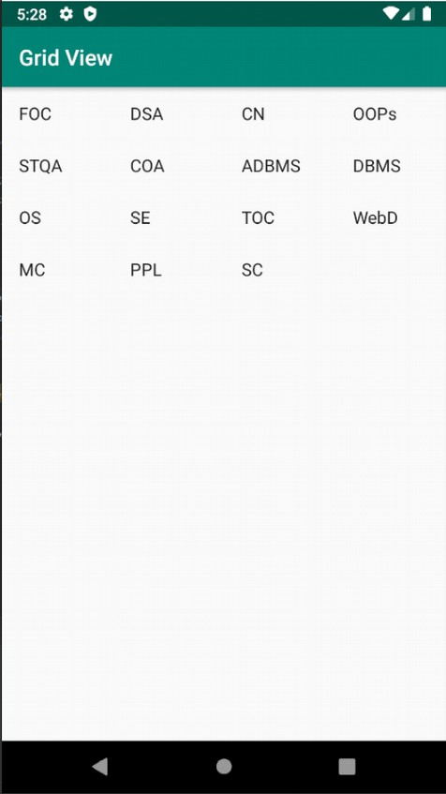

**Database connectivity Code:** MainActivity.java

import android.database.Cursor;

import android.database.sqlite.SQLiteDatabase; import android.support.v7.app.AlertDialog; import android.support.v7.app.AppCompatActivity; import android.os.Bundle;

import android.util.Log; import android.view.View; import android.widget.Button;

import android.widget.EditText; import android.widget.TextView;

import android.widget.Toast;

import java.text.DateFormat; import java.text.SimpleDateFormat; import java.util.Date;

public class MainActivity extends AppCompatActivity {

//Initializing fields DatabaseHelper myDB;

EditText edit_name, edit_surname, edit_marks, edit_id; Button addData, viewData, updateData, deleteData; String name, surname, marks, id;

boolean isUpdated; TextView textView;

@Override

protected void onCreate(Bundle savedInstanceState) { super.onCreate( savedInstanceState ); setContentView( R.layout.activity_main );

//Initialize Database

myDB = new DatabaseHelper( this );

//Initialize EditText

edit_name = findViewById( R.id.name ); edit_surname = findViewById( R.id.surname ); edit_marks = findViewById( R.id.marks ); edit_id = findViewById( R.id.id );

// TextView

textView = findViewById( R.id.textView5 );

textView.setText( "Important Notes:\n1. Both Date and Time will be stored automatically on the time of insertion.\n2. Existing Date and Time will be updated when you update your data." );

//Initialize Button

addData = findViewById( R.id.button ); viewData = findViewById( R.id.button2 ); updateData = findViewById( R.id.button3 ); deleteData = findViewById( R.id.button4 );

//Call Methods AddData(); viewData(); updateData(); deleteData();

}

//Adding or inserting data to database public void AddData(){

addData.setOnClickListener( new View.OnClickListener() { @Override

public void onClick(View view) {

name = edit_name.getText().toString(); surname = edit_surname.getText().toString(); marks = edit_marks.getText().toString();

//Current Date and Time Date date1 = new Date();

String date = DateFormat.getDateTimeInstance(). format(date1); boolean isInserted = myDB.instertData( name, surname, marks, date); if(isInserted == true){

Toast.makeText( MainActivity.this, "Data is inserted", Toast.LENGTH_SHORT ).show();

}

else

Toast.makeText( MainActivity.this, "Data is not inserted", Toast.LENGTH_SHORT ).show();

}

} );

}

//For viewing data in database public void viewData(){

viewData.setOnClickListener( new View.OnClickListener() { @Override

public void onClick(View view) { Cursor res = myDB.getData();

if (res.getCount() == 0){ showMessage("Error", "Data not found!");

}

else{

StringBuffer buffer = new StringBuffer(); while (res.moveToNext()){

buffer.append( "ID: " + res.getString( 0 ) + "\n" ); buffer.append( "Name: " + res.getString( 1 ) + "\n" ); buffer.append( "Surname: " + res.getString( 2 ) + "\n" ); buffer.append( "Marks: " + res.getString( 3 ) + "\n" ); buffer.append( "Insertion/Updation Date:\n" +

res.getString( 4 ) + "\n\n" );

}

showMessage( "Data", buffer.toString() );

}

}

} );

}

//For updating existing data in database public void updateData(){

updateData.setOnClickListener( new View.OnClickListener() { @Override

public void onClick(View view) {

id = edit_id.getText().toString(); name = edit_name.getText().toString();

surname = edit_surname.getText().toString(); marks = edit_marks.getText().toString();

//Current Date and Time Date date1 = new Date();

String date = DateFormat.getDateTimeInstance(). format(date1);

boolean isUpdated = myDB.updateData( id, name, surname, marks, date

);

updated!" );

if (isUpdated == true){

showMessage( "Update", "Your data has been successfully

}

} );

}

}

else

showMessage( "Update failed", "Cannot Update your data :(" );

//For deleting data in the database public void deleteData(){

deleteData.setOnClickListener( new View.OnClickListener() { @Override

public void onClick(View view) {

id = edit_id.getText().toString();

Integer res = myDB.deleteData( id ); if(res > 0){

Toast.makeText( getApplicationContext(), "Row effected", Toast.LENGTH_SHORT ).show();

}

else{

Toast.makeText( getApplicationContext(), "Row not effected", Toast.LENGTH_SHORT ).show();

}

}

} );

}

//Method for creating AlertDialog box

private void showMessage(String title, String message) {

AlertDialog.Builder builder = new AlertDialog.Builder( this ); builder.setCancelable( true );

builder.setTitle( title ); builder.setMessage( message ); builder.show();

}

}

activity_main.xml

<?xml version="1.0" encoding="utf-8"?>

<android.support.constraint.ConstraintLayout [xmlns:android="http://schemas.android.com/apk/res/android"](http://schemas.android.com/apk/res/android)

[xmlns:app="http://schemas.android.com/apk/res-auto"](http://schemas.android.com/apk/res-auto) [xmlns:tools="http://schemas.android.com/tools"](http://schemas.android.com/tools) android:layout_width="match_parent" android:layout_height="match_parent" tools:context="com.example.laksh.sqlapp.MainActivity">

<Button

android:id="@+id/button" android:layout_width="wrap_content" android:layout_height="52dp" android:text="Add Data"

app:layout_constraintBottom_toBottomOf="parent" app:layout_constraintEnd_toEndOf="parent" app:layout_constraintHorizontal_bias="0.054" app:layout_constraintStart_toStartOf="parent" app:layout_constraintTop_toTopOf="parent" app:layout_constraintVertical_bias="0.84" />

<TextView

android:id="@+id/textView" android:layout_width="wrap_content" android:layout_height="wrap_content" android:text="Name" app:layout_constraintBottom_toBottomOf="parent" app:layout_constraintEnd_toEndOf="parent"

app:layout_constraintHorizontal_bias="0.049" app:layout_constraintStart_toStartOf="parent" app:layout_constraintTop_toTopOf="parent" app:layout_constraintVertical_bias="0.063" />

<EditText

android:id="@+id/name" android:layout_width="wrap_content" android:layout_height="wrap_content" android:ems="10" android:inputType="textPersonName" app:layout_constraintBottom_toBottomOf="parent" app:layout_constraintEnd_toEndOf="parent" app:layout_constraintHorizontal_bias="0.502" app:layout_constraintStart_toStartOf="parent" app:layout_constraintTop_toTopOf="parent" app:layout_constraintVertical_bias="0.034" />

<TextView

android:id="@+id/textView2" android:layout_width="wrap_content" android:layout_height="wrap_content" android:text="Surname" app:layout_constraintBottom_toBottomOf="parent" app:layout_constraintEnd_toEndOf="parent" app:layout_constraintHorizontal_bias="0.049" app:layout_constraintStart_toStartOf="parent" app:layout_constraintTop_toTopOf="parent" app:layout_constraintVertical_bias="0.17" />

<EditText

android:id="@+id/surname" android:layout_width="wrap_content" android:layout_height="wrap_content" android:ems="10" android:inputType="textPersonName" app:layout_constraintBottom_toBottomOf="parent" app:layout_constraintEnd_toEndOf="parent" app:layout_constraintHorizontal_bias="0.502" app:layout_constraintStart_toStartOf="parent" app:layout_constraintTop_toTopOf="parent" app:layout_constraintVertical_bias="0.133" />

<TextView

android:id="@+id/textView3" android:layout_width="wrap_content" android:layout_height="wrap_content" android:text="Marsks" app:layout_constraintBottom_toBottomOf="parent" app:layout_constraintEnd_toEndOf="parent" app:layout_constraintHorizontal_bias="0.049" app:layout_constraintStart_toStartOf="parent" app:layout_constraintTop_toTopOf="parent" app:layout_constraintVertical_bias="0.258" />

<EditText

android:id="@+id/marks" android:layout_width="wrap_content" android:layout_height="wrap_content" android:ems="10" android:inputType="textPersonName" app:layout_constraintBottom_toBottomOf="parent" app:layout_constraintEnd_toEndOf="parent" app:layout_constraintHorizontal_bias="0.502" app:layout_constraintStart_toStartOf="parent" app:layout_constraintTop_toTopOf="parent" app:layout_constraintVertical_bias="0.232" />

<Button

android:id="@+id/button2" android:layout_width="wrap_content" android:layout_height="51dp" android:text="View Data"

app:layout_constraintBottom_toBottomOf="parent" app:layout_constraintEnd_toEndOf="parent" app:layout_constraintHorizontal_bias="0.447" app:layout_constraintStart_toStartOf="parent" app:layout_constraintTop_toTopOf="parent" app:layout_constraintVertical_bias="0.84" />

<Button

android:id="@+id/button3" android:layout_width="wrap_content" android:layout_height="51dp" android:text="Update data" app:layout_constraintBottom_toBottomOf="parent" app:layout_constraintEnd_toEndOf="parent" app:layout_constraintHorizontal_bias="0.939" app:layout_constraintStart_toStartOf="parent" app:layout_constraintTop_toTopOf="parent" app:layout_constraintVertical_bias="0.84" />

<EditText

android:id="@+id/id" android:layout_width="wrap_content" android:layout_height="wrap_content" android:ems="10" android:inputType="textPersonName" app:layout_constraintBottom_toBottomOf="parent" app:layout_constraintEnd_toEndOf="parent" app:layout_constraintHorizontal_bias="0.5" app:layout_constraintStart_toStartOf="parent" app:layout_constraintTop_toTopOf="parent" app:layout_constraintVertical_bias="0.331" />

<Button

android:id="@+id/button4" android:layout_width="wrap_content" android:layout_height="50dp" android:text="delete data" app:layout_constraintBottom_toBottomOf="parent" app:layout_constraintEnd_toEndOf="parent" app:layout_constraintHorizontal_bias="0.474" app:layout_constraintStart_toStartOf="parent" app:layout_constraintTop_toTopOf="parent" app:layout_constraintVertical_bias="0.984" />

<TextView

android:id="@+id/textView4" android:layout_width="wrap_content" android:layout_height="wrap_content" android:text="Id" app:layout_constraintBottom_toBottomOf="parent" app:layout_constraintEnd_toEndOf="parent" app:layout_constraintHorizontal_bias="0.049" app:layout_constraintStart_toStartOf="parent" app:layout_constraintTop_toTopOf="parent" app:layout_constraintVertical_bias="0.339" />

<TextView

android:id="@+id/textView5" android:layout_width="wrap_content" android:layout_height="wrap_content" android:text="TextView" android:paddingStart="10dp" android:paddingEnd="10dp"

android:layout_marginTop="20dp" app:layout_constraintBottom_toBottomOf="parent" app:layout_constraintEnd_toEndOf="parent" app:layout_constraintHorizontal_bias="0.049" app:layout_constraintStart_toStartOf="parent" app:layout_constraintTop_toTopOf="parent" app:layout_constraintVertical_bias="0.453" />

</android.support.constraint.ConstraintLayout>

**Output:**

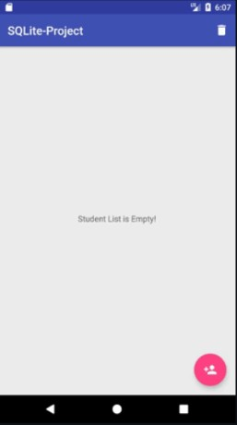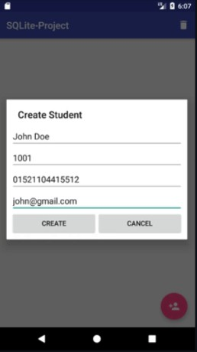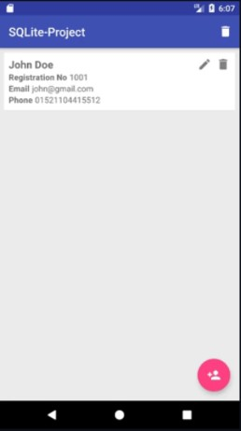

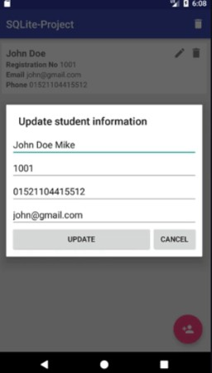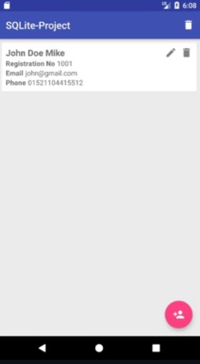

**Viva Questions:**

## Q.1What is View group in Android?

A ViewGroup is a special view that can contain other views. The ViewGroup is the base class for Layouts in android, like Linear Layout, Relative Layout , Frame Layout etc. In other words, ViewGroup is generally used to define the layout in which views(widgets) will be set/arranged/listed on the android screen.

## What is a Content Provider in Android?

A content provider manages access to a central repository of data. A provider is part of an Android application, which often provides its own UI for working with the data. However, content providers are primarily intended to be used by other applications, which access the provider using a provider client object.

## What is Container in Android?

A container is a view used to contain other views. Android offers a collection of view classes that act as containers for views. These container classes are called layouts, and as the name suggests, they decide the organization, size, and position of their children views.

## What is a ADB and ANR in Android?

The Android Debug Bridge (ADB) command line utility lets you communicate with an instance of an Android emulator or an Android device that is connected.

ANR or Application Not Responding is an android error that happens when the UI thread becomes unresponsive to the user. When the application becomes unresponsive, the user is presented with an ANR dialog that gives them the option to force quit the application.

**You can access ANR traces from a device or emulator by using Android Debug Bridge (adb).**

**************