***Computer Networks Lab***

***ETMA 354***

Faculty: **Dr. Pooja Gupta**  Name: **Syeda Reeha Quasar**

Roll No.: **14114802719**

Semester: **6**

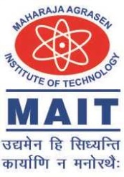

Maharaja Agrasen Institute of Technology, PSP Area,

Sector – 22, Rohini, New Delhi – 110085

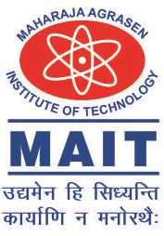

**MAHARAJA AGRASEN INSTITUTE OF TECHNOLOGY**

**VISION**

To nurture young minds in a learning environment of high academic value and imbibe spiritual and ethical values with technological and management competence.

**MISSION**

**The Institute shall endeavor to incorporate the following basic missions in the teaching methodology:**

**Engineering Hardware – Software Symbiosis**

Practical exercises in all Engineering and Management disciplines shall be carried out by Hardware equipment as well as the related software enabling deeper understanding of basic concepts and encouraging inquisitive nature.

**Life – Long Learning**

The Institute strives to match technological advancements and encourage students to keep updating their knowledge for enhancing their skills and inculcating their habit of continuous learning.

**Liberalization and Globalization**

The Institute endeavors to enhance technical and management skills of students so that they are intellectually capable and competent professionals with Industrial Aptitude to face the challenges of globalization.

**Diversification**

The Engineering, Technology and Management disciplines have diverse fields of studies with different attributes. The aim is to create a synergy of the above attributes by encouraging analytical thinking.

**Entrepreneurship**

The Institute strives to develop potential Engineers and Managers by enhancing their skills and research capabilities so that they become successful entrepreneurs and responsible citizens.

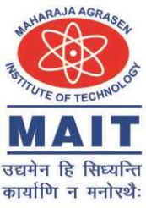

**MAHARAJA AGRASEN INSTITUTE OF TECHNOLOGY**

**COMPUTER SCIENCE AND ENGINEERING DEPARTMENT**

**VISION**

To produce “Critical Thinkers of Innovative Technology”.

**MISSION**

To foster an open, multidisciplinary, and highly collaborative research environment for producing world-class engineers capable of providing innovative solutions to real-life problems and fulfilling societal needs.