Principles of Programming Languages

Paper code : ETHS-402



Maharaja Agrasen Institute Of Technology

PSP Area,Sector-22,Rohini,New Delhi -110086

Submitted To : Submitted By :

Mr. Mool Chand Sharma Pavitra Walia

(Assistant Professor) ( Enrollment Number : 42414802718 )

(Department of Computer Science) ( Branch : Computer science )

( Semester : 8th ) ( Batch : 8C789 )

**Index**

|  |  |  |  |  |  |
| --- | --- | --- | --- | --- | --- |
| **Exp. no** | **Experiment Name** | **Date of performance** | **Date of checking** | **Marks** | **Signature** |
| 1 | Implement all major functions of string.h in single C program using switch case to select  specific function  from user choice (like strlen, strcat, strcpy, strcmp, strrev) |  |  |  |  |
| 2 | Write a program (WAP) in C to  reverse a linked list iterative and recursive. |  |  |  |  |
| 3 | WAP in C to implement  iterative Towers of Hanoi. |  |  |  |  |
| 4 | WAP in C++ to count the no.s of object of a class with the help of static data member, funtion  and constructor. |  |  |  |  |
| 5 | WAP in C++ & Java to declare a class Time with data members mm for minutes, ss for seconds and hh for hours. Define a parameterize constructor to  assign time to its objects. Add two time objects using member function and assign to third objects. Implement all possible cases of time. |  |  |  |  |
| 6 | WAP in C++ to define a class  Complex to represents set of all complex numbers. Overload ‘+’ operator to add two complex numbers using member function of the class and overload ‘*’ operator to multiply two  complex numbers using friend function of the class complex |  |  |  |  |
| 7 | Implement simple  multi-threaded server to perform all mathematics operation parallel in Java. |  |  |  |  |

# Experiment 1

**Aim :** Implement all major functions of string.h in single C program using switch case to select specific function from user choice (like strlen, strcat, strcpy, strcmp, strrev)

**Code :**

include<stdio.h> include<string.h>

void main(){ char str[50]; char temp[20]; char choice, ch;

//printf("For ")

printf("Pavitra Walia 42414802718 \n");

puts("To get the length of string, choose 'L'."); //strlen();//

puts("To convert the whole string in lower case, choose 'l'."); //strlwr(); puts("To convert the whole string in upper case, choose 'U'."); //strupr(); puts("To append a string behind other, choose 'A'."); //strcat();// puts("To copy a string into another, choose 'c'."); //strcpy();//

puts("To compare two strings, choose 'C'."); //strcmp();//

puts("To find out first ocurence of given character in a string, choose 'O'");

//strchr();

puts("To find out first ocurence of given string in another string, choose 'S'");

//strstr();

puts("To reverse the string, choose 'R'"); //strrev();// printf("\nEnter Your Choice: ");

scanf("%c", &choice); switch(choice){

case 'L':

printf("\nEnter The String To Get Its Length: "); scanf("%s", str);

printf("The Length Of The Entered String Is: %d", strlen(str)); break;

case 'l':

printf("\nEnter The String To Convert It Into Lower Case : "); scanf("%s", str);

printf("The Entered String In Lowercase: %s", strlwr(str)); break;

case 'U':

printf("\nEnter The String To Convert It Into Upper Case : "); scanf("%s", str);

printf("\nThe Entered String In Lowercase: %s", strupr(str)); break;

case 'A':

printf("\nEnter The First String: ");

scanf("%s", str);

printf("Enter The Second String To Append It Behind First One:"); scanf("%s", temp);

strcat(str, temp);

printf("\nNow, The First String Is: %s", str); break;

case 'c':

printf("\nEnter The First String: "); scanf("%s", str);

printf("Enter The Second String: "); scanf("%s", temp);

strcpy(str, temp);

printf("\nNow, The First String Is: %s", str); printf("\nAnd, The Second String Is: %s", temp); break;

case 'C':

printf("\nEnter The First String: "); scanf("%s", str);

printf("Enter The Second String: "); scanf("%s", temp);

if(strcmp(str, temp)==0)printf("\nBoth Strings Are Similar."); else printf("\nBoth Strings Are Different.");

break; case 'O':

printf("\nEnter The String: "); scanf("%s", str);

printf("Enter The Character To Be Searched: "); scanf("%c", &ch);

printf("\nThe First Occurence of Character Is At: %s", strchr(str,ch));

break; case 'S':

printf("\nEnter The String: "); scanf("%s", str);

printf("Enter The String To Be Searched: "); scanf("%s", temp);

printf("\nThe First Occurence of Character Is At: %s", strstr(str,temp));

break; case 'R':

printf("\nEnter The String To Get Its Reverse: "); scanf("%s", str);

printf("\nThe Reverse Of The Entered String Is: %s", strrev(str)); break;

default:

printf("\nYou Entered A Wrong Choise."); break;

}

}

## Output :

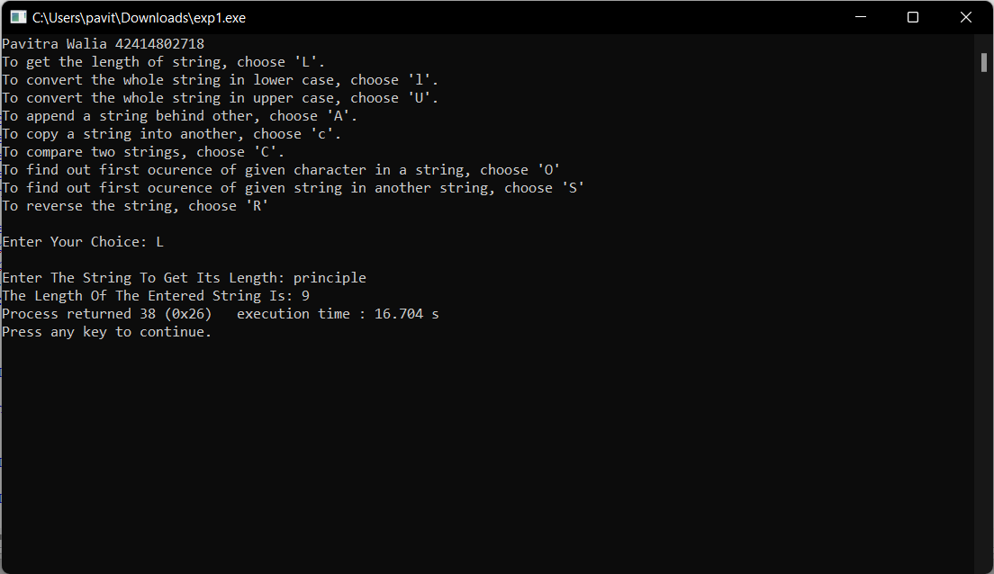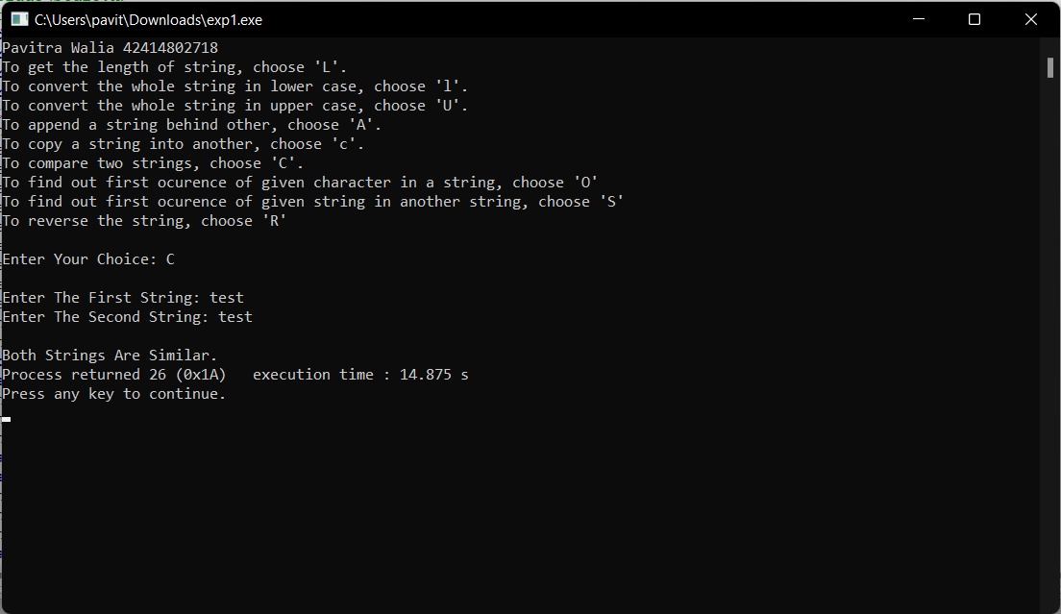

**Viva Voce**

## Q1. What is the use of string.h header while and where is this file stored.

In C programming language, string.h is a header that defines one variable type, one macro, and various functions for manipulating arrays of characters. All C inbuilt functions are declared in string.h header file.

## Q2. How can we create a header file?

To make a header file, we have to create one file with a name, and the extension should be (*.h). In that function, there will be no main() function. In that file, we can put some variables, some functions, etc.

## Q3. Write the function to find the length of a string.

The strlen() function in C is used to calculate the length of a string.

## Q4. Write the function to concatenate two strings.

The best way to concatenate two strings in C programming is by using the strcat() function.

## Q5. Explain the use of the header file.

Header files are simply files in which you can declare your own functions that you can use in your main program or these can be used while writing large C programs. The header file implementation brings lots of readability to our program and it becomes easy to understand. If it is the way to write our code systematically and the header file brings abstraction,

standardization, and loose coupling between our main function file(.c) and other (.c) files which we are using.

# Experiment 2

**Aim :** Write a program (WAP) in C to reverse a linked list iterative and recursive.

**Code :**

// Iterative C program to reverse a linked list include<stdio.h>

include<stdlib.h>

/* Link list node */

struct Node

{

int data;

struct Node* next;

};

/* Function to reverse the linked list */

void recursiveReverse(struct Node* head, struct Node** headRef)

{

struct Node* first; struct Node* rest;

// empty list base case if (head == NULL) return;

first = head; // suppose first = {1, 2, 3} rest = first->next; // rest = {2, 3}

// base case: List has only one node if (rest == NULL)

{

// fix the head pointer here

*headRef = first; return;

}

// Recursively reverse the smaller {2, 3} case

// after: rest = {3, 2} recursiveReverse(rest, headRef);

// put the first elem on the end of the list rest->next = first;

first->next = NULL; // (tricky step -- make a drawing)

}

void reverse(struct Node** head_ref)

{

struct Node* prev = NULL;

struct Node* current = *head_ref; struct Node* next = NULL;

printf("\n\nReversing Linked List Ittereatively...\n"); while (current != NULL)

{

// Store next

next = current->next;

// Reverse current node's pointer current->next = prev;

// Move pointers one position ahead. prev = current;

current = next;

}

*head_ref = prev;

}

/* Function to push a node */

void push(struct Node** head_ref, int new_data)

{

struct Node* new_node =

(struct Node*) malloc(sizeof(struct Node)); new_node->data = new_data;

new_node->next = (*head_ref); (*head_ref) = new_node;

}

/* Function to print linked list */ void printList(struct Node *head)

{

struct Node *temp = head; while(temp != NULL)

{

printf("%d ", temp->data); temp = temp->next;

}

}

int main()

{

printf("Pavitra Walia 42414802718 \n");

/* Start with the empty list */ struct Node* head = NULL; push(&head, 20);

push(&head, 4);

push(&head, 15);

push(&head, 85);

printf("Given linked list\n"); printList(head);

//reverse(&head);

printf("\n\nReversing LinkedList Recursivly \n");

recursiveReverse(head, &head); printf("\nReversed Linked list \n"); printList(head);

getchar();

}

## Output :

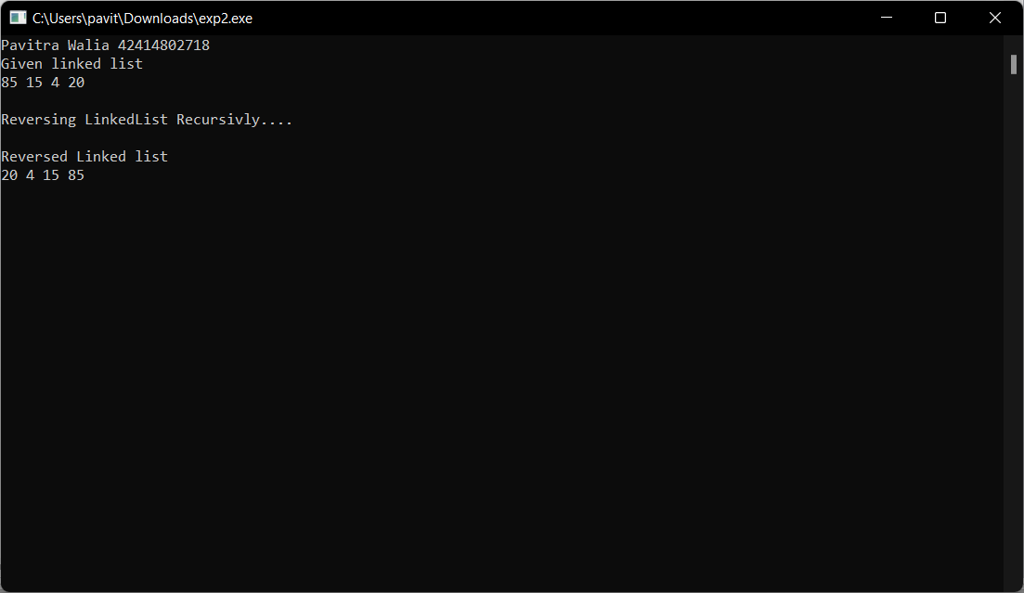

**Viva Voce**

## Q1. What is the difference between iterative and recursive function call?

Recursion and iteration are both different ways to execute a set of instructions repeatedly. The main difference between these two is that in recursion, we use function calls to execute the

statements repeatedly inside the function body, while in iteration, we use loops like “for” and “while” to do the same. Iteration is faster and more space-efficient than recursion, whereas it's easier to code a recursive approach for a given problem.

## Q2. What are formal parameters in functions?

Formal parameters are the variables defined by the function that receives values when the function is called.

## Q3. How is the structure node declared?

The general syntax for a struct declaration in C is:

struct tag_name { type member1; type member2;

/* declare as many members as desired, but the entire structure size must be known to the compiler. */

};

## Q4. Define a link list.

A linked list is a sequence of data structures, which are connected together via links. Linked List is a sequence of links which contains items. Each link contains a connection to another link. Linked list is the second most-used data structure after array.

## Q5. Why do we need to store the address of the starting node of a link list for reversing a list?

To reverse a LinkedList iteratively, we need to store the references of the next and previous elements, so that they don't get lost when we swap the memory address pointers to the next element in the LinkedList.

**Experiment 3 Aim :** WAP in C to implement iterative Towers of Hanoi. **Code :**

include <stdio.h> include <math.h> include <stdlib.h> include <limits.h>

// A structure to represent a stack struct Stack

{

unsigned capacity; int top;

int *array;

};

// function to create a stack of given capacity. struct Stack* createStack(unsigned capacity)

{

struct Stack* stack =

(struct Stack*) malloc(sizeof(struct Stack)); stack -> capacity = capacity;

stack -> top = -1; stack -> array =

(int*) malloc(stack -> capacity * sizeof(int)); return stack;

}

// Stack is full when top is equal to the last index int isFull(struct Stack* stack)

{

return (stack->top == stack->capacity - 1);

}

// Stack is empty when top is equal to -1 int isEmpty(struct Stack* stack)

{

return (stack->top == -1);

}

// Function to add an item to stack. It increases

// top by 1

void push(struct Stack *stack, int item)

{

if (isFull(stack)) return;

stack -> array[++stack -> top] = item;

}

// Function to remove an item from stack. It

// decreases top by 1

int pop(struct Stack* stack)

{

if (isEmpty(stack)) return INT_MIN;

return stack -> array[stack -> top--];

}

//Function to show the movement of disks

void moveDisk(char fromPeg, char toPeg, int disk)

{

printf("Move the disk %d from \'%c\' to \'%c\'\n", disk, fromPeg, toPeg);

}

// Function to implement legal movement between

// two poles

void moveDisksBetweenTwoPoles(struct Stack *src, struct Stack *dest, char s, char d)

{

int pole1TopDisk = pop(src); int pole2TopDisk = pop(dest);

// When pole 1 is empty

if (pole1TopDisk == INT_MIN)

{

push(src, pole2TopDisk); moveDisk(d, s, pole2TopDisk);

}

// When pole2 pole is empty

else if (pole2TopDisk == INT_MIN)

{

push(dest, pole1TopDisk); moveDisk(s, d, pole1TopDisk);

}

// When top disk of pole1 > top disk of pole2

else if (pole1TopDisk > pole2TopDisk)

{

push(src, pole1TopDisk); push(src, pole2TopDisk); moveDisk(d, s, pole2TopDisk);

}

// When top disk of pole1 < top disk of pole2 else

{

push(dest, pole2TopDisk); push(dest, pole1TopDisk); moveDisk(s, d, pole1TopDisk);

}

}

//Function to implement TOH puzzle

void tohIterative(int num_of_disks, struct Stack

*src, struct Stack *aux, struct Stack *dest)

{

int i, total_num_of_moves;

char s = 'S', d = 'D', a = 'A';

//If number of disks is even, then interchange

//destination pole and auxiliary pole if (num_of_disks % 2 == 0)

{

char temp = d; d = a;

a = temp;

}

total_num_of_moves = pow(2, num_of_disks) - 1;

//Larger disks will be pushed first for (i = num_of_disks; i >= 1; i--) push(src, i);

for (i = 1; i <= total_num_of_moves; i++)

{

if (i % 3 == 1) moveDisksBetweenTwoPoles(src, dest, s, d); else if (i % 3 == 2) moveDisksBetweenTwoPoles(src, aux, s, a);

else if (i % 3 == 0) moveDisksBetweenTwoPoles(aux, dest, a, d);

}

}

// Driver Program int main()

{

printf("Pavitra Walia 42414802718 \n");

// Input: number of disks unsigned num_of_disks = 3; struct Stack *src, *dest, *aux;

// Create three stacks of size 'num_of_disks'

// to hold the disks

src = createStack(num_of_disks); aux = createStack(num_of_disks); dest = createStack(num_of_disks);

tohIterative(num_of_disks, src, aux, dest); return 0;

}

## Output :

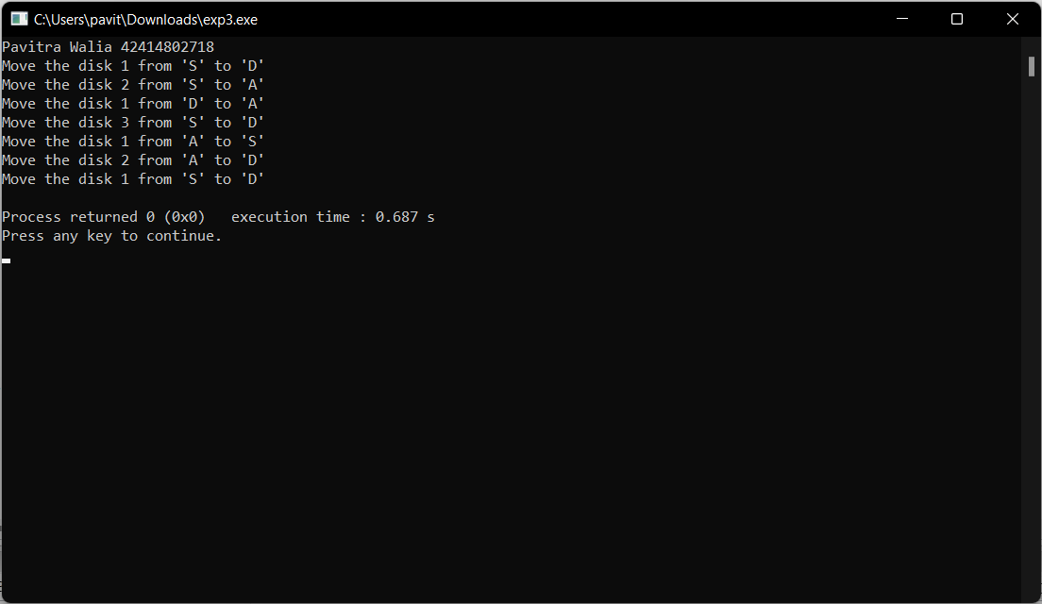

**Viva Voce**

## Q1. What is the tower of Hanoi problem?

Tower of Hanoi is a mathematical puzzle where we have three rods and n disks. The objective of the puzzle is to move the entire stack to another rod, obeying the following simple rules:

* Only one disk can be moved at a time.
* Each move consists of taking the upper disk from one of the stacks and placing it on top of another stack i.e. a disk can only be moved if it is the uppermost disk on a

stack.

* No disk may be placed on top of a smaller disk.

## Q2. What are the various ways is stack created?

There are two ways to implement a stack: Using array. Using linked list.

## Q3. List the models of computation of language.

Models of computation can be classified into three categories: sequential models, functional models, and concurrent models.

## Q4. What are objectives of principle of programming language?

Objectives are: To introduce several different paradigms of programming. To gain experience with these paradigms by using example programming languages. To understand concepts of syntax, translation, abstraction, and implementation.

## Q5. What are the Paradigms of Programming?

Major Programming Paradigms

* Imperative.
* Logical.
* Functional.
* Object-Orient

# Experiment 4

**Aim :** WAP in C++ to count the no.s of object of a class with the help of static data member, funtion and constructor

**Code :**

include <iostream> using namespace std; class Counter

{

private:

//static data member as count static int count;

public:

//default constructor Counter()

{ count++; }

//static member function static void Print()

{

cout<<"\nTotal objects are: "<<count;

}

};

//count initialization with 0 int Counter :: count = 0;

int main()

{

printf("Pavitra Walia 42414802718 \n"); Counter OB1;

OB1.Print(); Counter OB2; OB2.Print(); Counter OB3; OB3.Print(); return 0;

}

## Output :

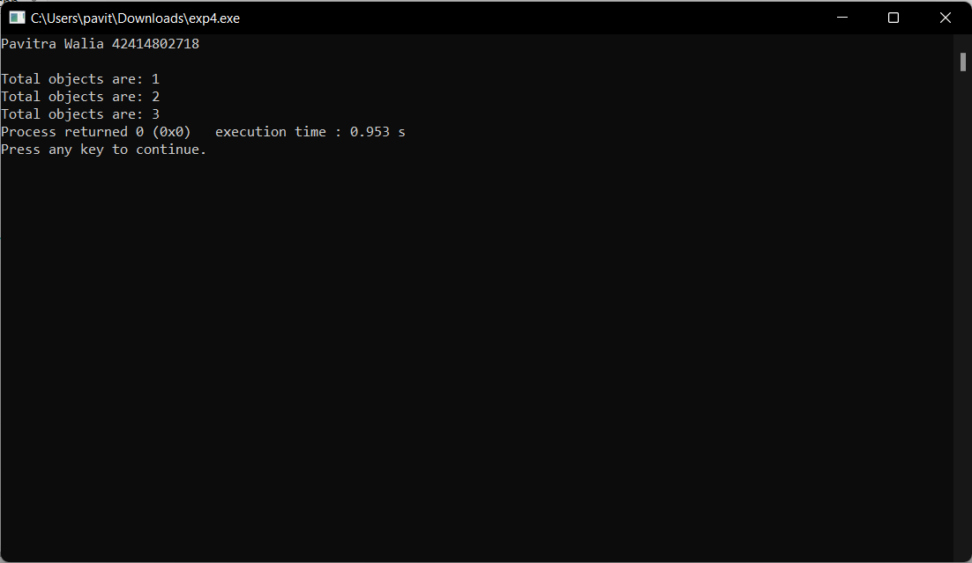

**Viva Voce**

## Q1. List various type of languages.

The different types of programming languages are:

* Procedural Programming Language
* Functional Programming Language
* Object-oriented Programming Language
* Scripting Programming Language
* Logic Programming Language

## Q2. What are the issues for languages?

Issues are:

* Development on hardware technologies
* Simplicity and performance trade off
* Usage Area
* Potability
* Variety of Project's Design Patterns
* Safety and security

## Q3. What is translation?

Translation is a programming language processor that modifies a computer program from one language to another. It takes a program written in the source program and modifies it into a machine program. It can find and detect the error.

## Q4. What are different types of translation and their roles?

Generally, there are three types of translators -

* Compilers - A compiler takes the source code as a whole and translates it into object code all in one go.
* Interpreters - An interpreter translates source code into object code one instruction at a time.
* Assemblers - The purpose of an assembler is to translate assembly language into object code.

# Experiment 5

**Aim :** WAP in C++ & Java to declare a class Time with data members mm for minutes, ss for seconds and hh for hours. Define a parameterize constructor to assign time to its objects. Add two time objects using member function and assign to third objects. Implement all possible

cases of time

**Code : C++**

include<iostream> using namespace std; class Time

{

int hh,mm,ss; public:

Time(){}

Time(int hh, int mm, int ss)

{

this->hh=hh; this->mm=mm; this->ss=ss;

}

void disp()

{

cout<<hh<<":"<<mm<<":"<<ss;

}

void sum(Time t1,Time t2)

{

ss=t1.ss+t2.ss; mm=ss/60; ss=ss%60; mm=mm+t1.mm+t2.mm; hh=mm/60; mm=mm%60; hh=hh+t1.hh+t2.hh;

}

};

int main(){

printf("Pavitra Walia 42414802718 \n"); Time t1(2,22,34);

cout<<"The Time T1 Is: "; t1.disp();

Time t2(4, 33, 50);

cout<<"\n\nThe Time T2 Is: "; t2.disp();

Time t3; t3.sum(t1,t2);

cout<<"\n\nThe Resultant Time Is: "; t3.disp();

}

## JAVA

import java.io.*; class time

{

int hour,min,sec;

public time(int h,int m,int s)

{

hour = h; min = m; sec = s;

}

public time()

{

hour = 0;

min = 0;

sec = 0;

}

public time sum(time t2)

{

time t3 = new time(); t3.sec = sec + t2.sec; t3.min = min + t2.min; t3.hour = hour + t2.hour;

if(t3.sec >= 60)

{

t3.min = t3.sec / 60; t3.sec = t3.sec % 60;

}

if(t3.min >= 60)

{

t3.hour = t3.min / 60; t3.min = t3.min % 60;

}

return(t3);

}

public void display()

{

System.out.println(hour+ ":"+min+":"+sec);

}

}

public class Main {

public static void main(String args[])throws IOException

{

BufferedReader br = new BufferedReader(new InputStreamReader(System.in));

System.out.print ("Pavitra Walia 42414802718 \n\n" );

time t1 = new time(1,56,55); time t2 = new time(2,00,10); time t3 = new time();

t3 = t1.sum(t2); System.out.print ("Time 1:- " ); t1.display();

System.out.print ("Time 2:- " ); t2.display();

System.out.print ("Resultant time after addition is:- " ); t3.display();

}

}

## Output :

C++

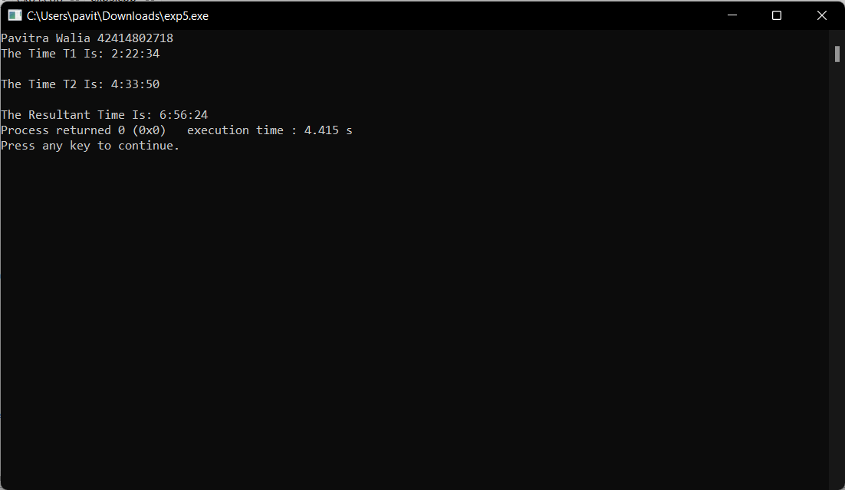

JAVA

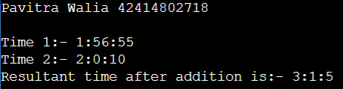

## Viva Voce

**Q1. Write any four important uses of programming languages.**

A programming language is an artificial language that can be used to control the behaviour of a machine, particularly a computer. Programming languages, like human languages, are defined through the use of syntactic and semantic rules, to determine structure and meaning respectively. Programming languages are used to facilitate communication about the task of organizing and manipulating information, and to express algorithms precisely.

**Q2. Write the differences between lexical syntax and concrete syntax of the language.** Lexical syntax for defining the rules for basic symbols involving identifiers, literals, punctuators and operators. Concrete syntax specifies the real representation of the programs with the help of lexical symbols like its alphabet.

## Q3. List the design principle of imperative languages.

Imperative programming is a software development paradigm where functions are implicitly coded in every step required to solve a problem. In imperative programming, every operation is coded and the code itself specifies how the problem is to be solved, which means that

pre-coded models are not called on.

## Q4. Write the differences between array and enumerated data types in imperative languages?

The main difference is that an array is a value and an enum is a type. And One main difference we can say that an array is a collection of other values (that is it contains other values, you can iterate through them or access individual ones by index), whereas an enum value is simply one atomic value.

## Q5. Distinguish between dangling pointers and memory leakage.

Generally, daggling pointers arise when the referencing object is deleted or deallocated,

without changing the value of the pointers. In opposite to the dangling pointer, a memory leak occurs when you forget to deallocate the allocated memory.

# Experiment 6

**Aim :** WAP in C++ to define a class Complex to represents set of all complex numbers.

Overload ‘+’ operator to add two complex numbers using member function of the class and overload ‘*’ operator to multiply two complex numbers using friend function of the class

complex.

**Code :**

include<iostream> using namespace std; class Complex

{

int real,img; public:

Complex(){}; Complex(int i,int j)

{

real=i; img=j;

}

void show()

{

cout<<real<<" + i"<<img;

}

Complex operator +(Complex obj){ Complex temp; temp.real=real+obj.real; temp.img=img+obj.img; return(temp);

}

Complex operator *(Complex);

};

Complex Complex::operator *(Complex c)

{

double real1,real2; real1=real; real2=c.real;

real=(real*c.real)-(img*c.img); img=(real1*c.img)+(img*real2); Complex temp;

temp.real=real; temp.img=img; return temp;

}

int main()

{

printf("Pavitra Walia 42414802718 \n"); Complex c1(5,6), c2(7,8), c3, c4; cout<<"The 1st no. is: ";

c1.show();

cout<<"\n\nThe 2nd no. is: "; c2.show();

c3=c1+c2; cout<<"\n\nSum is: "; c3.show();

c4=c1*c2; cout<<"\n\nMultiplication is: "; c4.show();

}

## Output :

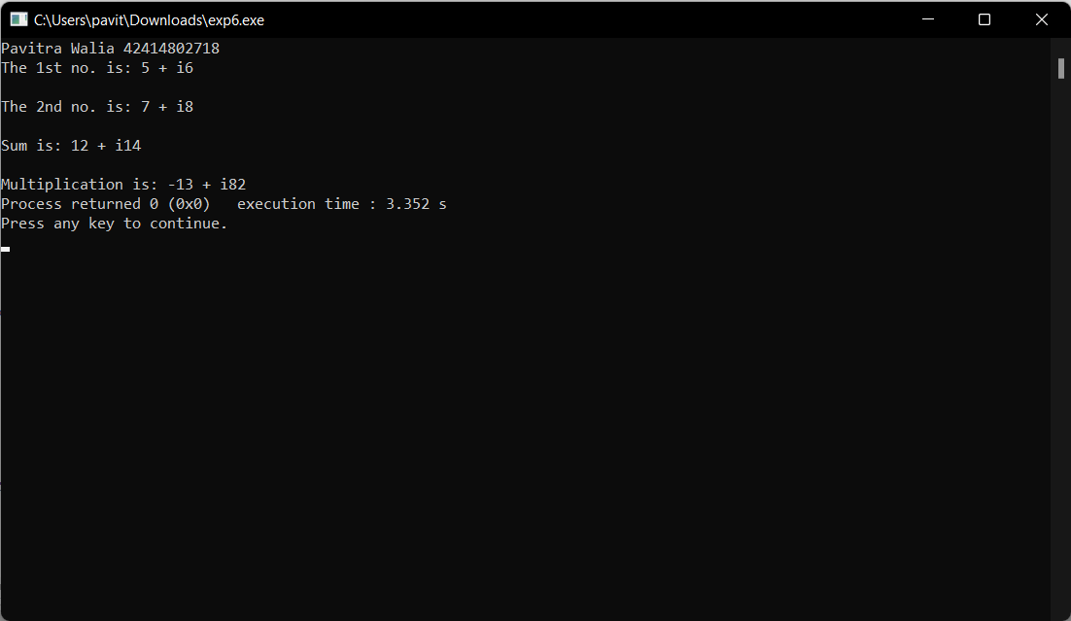

**Viva Voce**

## Q1. List the benefits of the modular development approach.

The advantages of the modular design include:

* Consistency. The fact that the engine allows all applications to run using the same base RAD applications brings consistency to the Service Manager application suite.
* Reduced Development Times.
* Flexibility.

## Q2. Give some reasons why computer scientists and professional software developers should study general concepts of language design and evaluation.

Reasons for Studying Concepts of Programming Languages

* Increased capacity to express ideas
* Improved ability to choose an appropriate language
* Increased ability to learn new languages
* A better understanding of implementation issues (i.e., how language constructs are implemented)

## Q3. What constitutes a programming environment?

In a general sense, a programming environment combines hardware and software that allows a developer to build applications. Developers typically work in integrated development

environments or IDEs. These connect users with all the features necessary to write and test their code correctly.

## Q4. Give an example of how aliasing deters reliability.

Aliasing makes it particularly difficult to understand, analyze and optimize programs.

## Q5. How do type declaration statements affect the readability of programming language?

Readability is a key element in any programming language and thus, very important. The addition of type declarations helps to improve code readability. This is because it makes it easy to identify and differentiate different variables by data types. A program with

well-defined type declarations is easy to understand.

# Experiment 7

**Aim :** Implement simple multi-threaded server to perform all mathematics operation parallel in Java.

**Code :**

//arithtcpclient.java

import java.io.*; import java.net.*;

public class arithtcpclient

{

public static void main(String[] args) throws IOException

{

System.out.println(); System.out.println(“ARITHMETIC CLIENT”); System.out.println(“*****************”);

System.out.println(“Enter the host name to connect”); String str;

DataInputStream inp=new DataInputStream(System.in); str=inp.readLine();

Socket clientsoc = new Socket(str, 9); System.out.println(“Enter the inputs”);

PrintWriter out = new PrintWriter(clientsoc.getOutputStream(), true); BufferedReader in = new BufferedReader(new InputStreamReader(clientsoc.getInputStream()));

BufferedReader stdin = new BufferedReader(new InputStreamReader(System.in)); String userinput;

try

{

while (true)

{

do

{

userinput = stdin.readLine(); out.println(userinput);

}while(!userinput.equals(“.”)); System.out.println(“Sever Says : ” + in.readLine());

}

}

catch(Exception e)

{

System.exit(0);

}

}

}

//arithtcpserver import java.io.*; import java.net.*;

public class arithtcpserver

{

public static void main(String arg[]) throws Exception

{

System.out.println(); System.out.println(“ARITHMETIC SERVER”); System.out.println(“*****************”);

System.out.println(“Server is ready to accept inputs…”); ServerSocket serversoc=new ServerSocket(9);

Socket clientsoc = serversoc.accept();

PrintWriter out = new PrintWriter(clientsoc.getOutputStream(), true); BufferedReader in = new BufferedReader(new InputStreamReader(clientsoc.getInputStream()));

String inputline;

BufferedReader stdin = new BufferedReader(new InputStreamReader(System.in)); try

{

while (true)

{

String s,op=””,st; int i=0,c=0;

int[] a=new int[2]; while(true)

{

s=in.readLine();

if(s.equals(“+”) || s.equals(“-“) || s.equals(“*”) || s.equals(“/”)) op=s;

else if(s.equals(“.”)) break;

else

{

a[i]=Integer.parseInt(s); i++;

}}

if(op.equals(“+”))

c=a[0]+a[1];

else if(op.equals(“-“))

c=a[0]-a[1];

else if(op.equals(“*”))

c=a[0]*a[1];

else if(op.equals(“/”))

c=a[0]/a[1]; s=Integer.toString(c); out.println(s);

}

catch(Exception e)

{

System.exit(0);

}

}}

## Output :

### SERVER SIDE

*************

C:\jdk1.5\bin>javac arithtcpserver.java C:\jdk1.5\bin>java arithtcpserver

ARITHMETIC SERVER

*********************

Server is ready to accept inputs…

### CLIENT SIDE

************

C:\JDK1.5\bin>javac arithtcpclient.java C:\JDK1.5\bin>java arithtcpclient

ARITHMETIC CLIENT

********************

Enter the host name to connect p4-221

Enter the inputs 8

+ 3

Sever Says : 11

9

– 11

Sever Says : -2

7

* 9

Sever Says : 63

12

/ 3

Sever Says : 4

## Viva Voce

**Q1. Write the uses of constructors and destructors in OOP.**

Constructor is used to initializing an object of the class and assign values to data members corresponding to the class. While destructor is used to deallocate the memory of an object of a class. There can be multiple constructors for the same class.

## Q2. Explain language evaluation criteria and the characteristics that affect them.

Language Evaluation Criteria

* Criteria. Readability. Writability. Reliability. Cost.
* Affected by. Simplicity. Orthogonality. Data types and structures. Syntax.

Support for Abstraction. Type checking. Exception handling. Aliasing. Control structures. Expressivity.

## Q3. What Is Backus-naur Form (bnf)?

Backus–Naur form or Backus normal form is a metasyntax notation for context-free grammars, often used to describe the syntax of languages used in computing, such as computer programming languages, document formats, instruction sets, and communication protocols.

## Q4. What is the use of pointers?

Pointers are used to store and manage the addresses of dynamically allocated blocks of memory. Such blocks are used to store data objects or arrays of objects.

## Q5. What is a Void pointer?

The void pointer is a pointer that is not associated with any data types. It points to some data location in the storage. This means that it points to the address of variables. It is also called the general-purpose pointer.