***WEB TECHNOLOGY ETCS-356***

Faculty Name: Dr. Farzil Kidwai Student Name: Tanya Goel Roll Number: 36614802718 Semester: 6th

Group: 6C6



Maharaja Agrasen Institute of Technology, PSP Area, Sector – 22, Rohini, New Delhi - 110085

**Web Technology Lab (ETCS -356)**

**Lab Assessment Sheet**

Student Enrollment No: 36614802718 Student Name: Tanya Goel

|  |  |  |  |  |  |  |  |  |
| --- | --- | --- | --- | --- | --- | --- | --- | --- |
| S.No | Experiment | Mark  s | | | | | Total marks | Signa ture with  date |
|  | R1 | R2 | R3 | R4 | R5 |
| 1 | Prepare a stepwise instruction set to configure Apache/XAMPP/WAMPP web Server for web application. Ensure that the server includes Apache. |  |  |  |  |  |  |  |
| 2 | Design a static home page based on your interest (using basic HTML tags). |  |  |  |  |  |  |  |
| 3 | Design webpage to demonstrate use of Tables. |  |  |  |  |  |  |  |
| 4 | Design webpage to demonstrate use of Forms. |  |  |  |  |  |  |  |
| 5 | Design webpage to demonstrate use of Internal Cascading Style Sheets. |  |  |  |  |  |  |  |
| 6 | Design webpage to demonstrate use of Embedded/Inline Cascading Style Sheets. |  |  |  |  |  |  |  |
| 7 | Design webpage to demonstrate use of  External Cascading Style Sheets. |  |  |  |  |  |  |  |
| 8 | Design a web page using a frameset. The left pane in the frameset should include a menu and the right pane should be the content page. Design the page based on your interest. You can include External CSS to the pages for theme based layout on this website. |  |  |  |  |  |  |  |
| 9 | Design an XML Catalogue of a CD database to understand the working structure of  XML. |  |  |  |  |  |  |  |
| 10 | Design an XML Catalogue of a Food Menu to understand the working structure of XML. |  |  |  |  |  |  |  |

|  |  |  |  |  |  |  |  |  |
| --- | --- | --- | --- | --- | --- | --- | --- | --- |
| 11 | Design a webpage that implements a  simple interest calculator using JavaScript. |  |  |  |  |  |  |  |
| 12 | Design a webpage that displays Current Date and Time using JavaScript. |  |  |  |  |  |  |  |
| 13 | Design a simple form that includes Email, Password and Phone Number as a field and use JavaScript to validate the Email Address (for proper Structure), Phone number (to follow 10- Digit norms) and Password (to include at-least one Alphanumeric and one number). |  |  |  |  |  |  |  |
| 14 | Deploy a Content Management System (CMS) and prepare a stepwise instruction on how to configure the CMS on Apache/XAMPP/WAMPP. |  |  |  |  |  |  |  |
| 15 | In a Team of Two, choose a topic to design a website and decide upon the content. Prepare the content in a word file that will appear on the website. Also, Design a  Visual site-map for the website (Pictorial representation of page linkage). |  |  |  |  |  |  |  |
| 16 | Configure the CMS and Add the content  according to the design and visual site-map for the website. |  |  |  |  |  |  |  |

Overall Comments:

Faculty Name: Dr. Farzil Kidwai Signature:

Index

|  |  |  |  |  |  |
| --- | --- | --- | --- | --- | --- |
| **Exp. No.** | **Experiment Name** | **Date of performance** | **Date of checking** | **Remarks** | **Marks (10)** |
| 1. | Prepare a stepwise instruction set to configure apache/XAMPP/WAMPP web Server for web application. Ensure that the server includes Apache. | 09/04/2021 |  |  |  |
| 2. | Design a static home page based on your interest (using basic HTML tags). | 09/04/2021 |  |  |  |
| 3. | Design webpage to demonstrate use of Tables. | 09/04/2021 |  |  |  |
| 4. | Design webpage to demonstrate use of Forms. | 09/04/2021 |  |  |  |
| 5. | Design webpage to demonstrate use of Internal Cascading Style Sheets. | 09/04/2021 |  |  |  |
| 6. | Design webpage to demonstrate use of Embedded/Inline Cascading Style Sheets. | 09/04/2021 |  |  |  |
| 7. | Design webpage to demonstrate use of External Cascading Style Sheets. | 09/04/2021 |  |  |  |

|  |  |  |  |  |  |
| --- | --- | --- | --- | --- | --- |
| 8. | Design a web page using a frameset. The left pane in the frameset should include a menu and the right pane should be the content page. Design the  page based on your interest. You can include External CSS to the pages for theme based layout on this website. | 09/04/2021 |  |  |  |
| 9. | Design an XML Catalogue of a CD database to understand the working structure of XML. | 21/05/2021 |  |  |  |
| 10. | Design an XML Catalogue of a Food Menu to understand the working structure of XML. | 21/05/2021 |  |  |  |
| 11. | Design a webpage that implements a simple interest calculator using JavaScript. | 04/06/2021 |  |  |  |
| 12. | Design a webpage that displays Current Date and Time using JavaScript. | 04/06/2021 |  |  |  |
| 13. | Design a simple form that includes Email, Password and Phone Number as a field and use JavaScript to validate the Email Address (for proper Structure), Phone number (to follow 10- Digit norms) and Password (to include at-least one Alphanumeric and one number). | 04/06/2021 |  |  |  |
| 14. | Deploy a Content Management System (CMS) and prepare a stepwise instruction on how to configure the CMS on Apache/XAMPP/WAMPP. | 11/06/2021 |  |  |  |
| 15. | In a Team of Two, choose a topic to design a website and decide upon the content. Prepare the | 11/06/2021 |  |  |  |

|  |  |  |  |  |  |
| --- | --- | --- | --- | --- | --- |
|  | content in a word file that will appear on the website. Also, Design a Visual site-map for the website (Pictorial representation of page linkage). |  |  |  |  |
| 16. | Configure the CMS and Add the content according to the design and visual site-map for the website. | 11/06/2021 |  |  |  |
|  |  |  |  |  |  |

# EXPERIMENT NO. - 1

**Aim:** Design a webpage that implements a simple interest calculator using JavaScript. Prepare a stepwise instruction set to configure Apache/XAMPP/WAMPP web Server for web application. Ensure that the server includes Apache.

## Steps:

Step 1:

Go to http[s://w](http://www.apachefriends.org/index.html)ww[.apachefriends.or](http://www.apachefriends.org/index.html)g[/index.html.](http://www.apachefriends.org/index.html) Click XAMPP for windows.

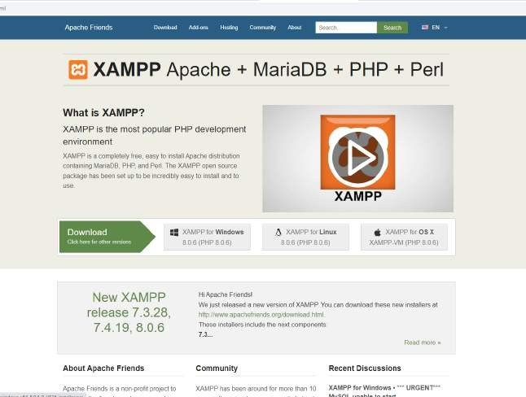

Step 2:

Download XAMPP executable.

After the download is completed, double click the .exe extension file to start the process of installation.

Just before the installation, a pop-up window appears with a warning to disable UAC. User Account Control (UAC) interrupts the XAMPP installation because it restricts the access to write to the C: drive. Therefore, it is suggested to disable it for the period of installation.

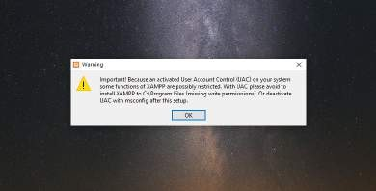

Click on "NEXT" to start the configuration of the settings.

After that, a 'Select Components' panel appears, which gives you the liberty to choose amongst the separate components of the XAMPP software stack for the installation. To get a complete localhost server, it is recommended to install using the default options of containing all available components. Click "NEXT" to proceed further.

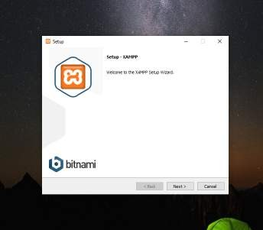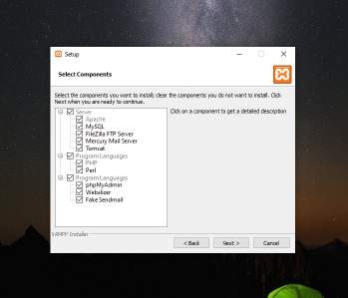

Select the location where the XAMPP software packet needs to be installed. The original setup creates a folder titled XAMPP under C:\ for you. After choosing a location, click "NEXT".

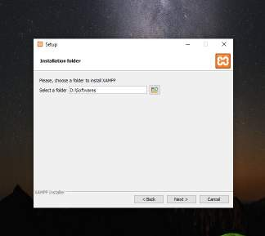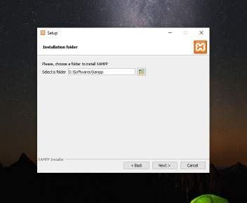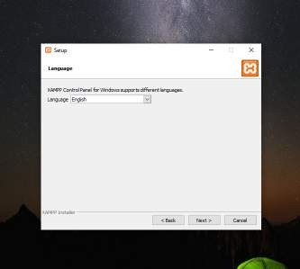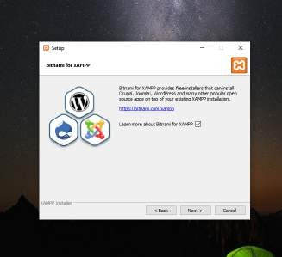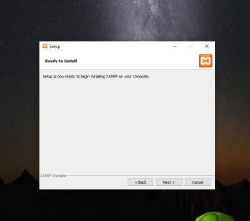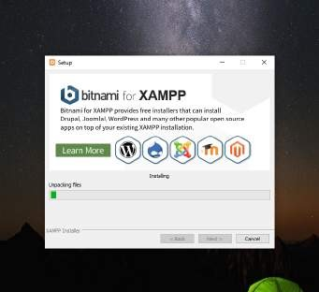

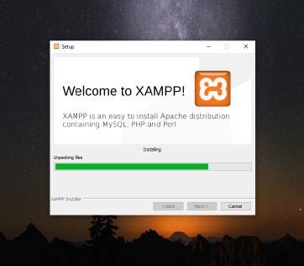

After the successful installation of the XAMPP setup on your desktop, press the "FINISH" button.

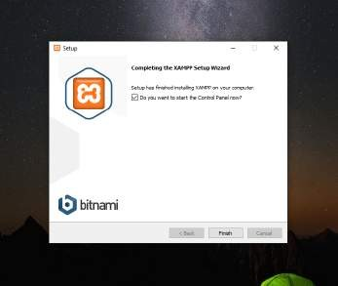

Click ‘finish’. Step 3:

The XAMPP control panel

Controls for the individual components of your test server can be reached through the XAMPP Control Panel. The clear user interface logs all actions and allows you to start or stop individual modules with a single. The XAMPP Control Panel also offers you various other buttons, including:

* Config: allows you to configure the XAMPP as well as the individual components
* Netstat: shows all running processes on the local computer
* Shell: opens a UNIX shell
* Explorer: opens the XAMPP folder in Windows Explorer
* Services: shows all services currently running in the background
* Help: offers links to user forums
* Quit: closes the XAMPP Control Panel

Individual modules can be started or stopped on the XAMPP Control Panel through the corresponding buttons under ‘Actions’. You can see which modules have been started because their names are highlighted green under the ‘Module’ title.

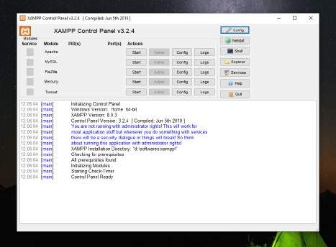

An active module is marked in green in the Control Panel

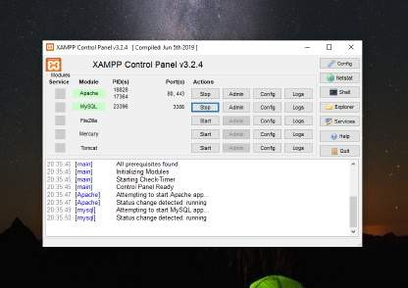

Step 4:

Setting up XAMPP

A common source of error connected with Apache is blocked ports. If you’re using the standard setup, then XAMPP will assign the web server to main port 80 and the SSL port 443. The latter of

these particularly is often blocked by other programs. In the example above, it’s likely that the Tomcat port is being blocked, meaning the web server can’t be started. There are three ways to solve this issue:

* Change the conflicting port: Let’s assume for the sake of example that the instant messenger program Skype is blocking SSL port 443 (this is a common problem). One way to deal with this issue is to change Skype’s port settings. To do this, open the program and navigate via ‘Actions’, ‘Options’, and ‘Advanced’, until you reach the ‘Connections’ menu. You should find a box checked to allow Skype access to ports 80 and 443. Deselect this checkbox now.
* Change the XAMPP module port settings: Click the Config button for the module in question and open the files httpd.conf and httpd-ssl.conf. Replace port number 80

in httpd.conf and port number 443 in httpd-ssl.conf with any free ports, before saving the file data. Now click on the general Config button on the right-hand side and select ‘Services and Ports Settings’. Customize the ports for the module server to reflect the changes in

the conf files.

* End the conflicting program: The simplest way to avoid port conflicts in the short term is to end the conflicting program (Skype in this case). If you restart Skype after your XAMPP module servers are already running, it will select a different port and your issue will be resolved.

**Result:** XAMPP successfully installed and configured.

# EXPERIMENT NO. - 2

**Aim:** Design a static home page based on your interest (using basic HTML tags).

## Code:

<!DOCTYPE html>

<html>

<head>

<title>Nainital</title>

</head>

<body bgcolor="lightblue">

<font size="7" color="red">

<center><b>NAINITAL</b></center>

</font>

<marquee>

<img src="https://cdn.theculturetrip.com/wp-content/uploads/2018/02/nainital.jpg" height="200" width="200">

<img src="https://static.toiimg.com/thumb/64598895/Nainital.jpg?width=1200&height=900" height="200" width="200">

<img

src="http[s://w](http://www.clubmahindra.com/blog/media/section_images/shuttersto-15213af2157d70f)ww[.clubmahindra.com/blog/media/section_images/shut](http://www.clubmahindra.com/blog/media/section_images/shuttersto-15213af2157d70f)t[er](http://www.clubmahindra.com/blog/media/section_images/shuttersto-15213af2157d70f)s[to-15213af2157d70f](http://www.clubmahindra.com/blog/media/section_images/shuttersto-15213af2157d70f)

.jpg" height="200" width="200">

</marquee>

<p>

<font face="Comic Sans MS" color="white" size="4">

</font>

</p>

<p>

<font face="Comic Sans MS" color="black" size="4">

Nainital (Kumaoni: Naintāl)(IPA: [nɛːniːtaːl]) is a popular hill station of India.

It is the judicial capital of Uttarakhand, the High Court of the state being located there, and is the

headquarters of the Kumaon division as well as an eponymous district. It also houses the Governor of

Uttarakhand,[4] who resides in the Raj Bhavan. Nainital was the summer capital[5] of the United Provinces.

</font>

</p>

<p>

<font face="Comic Sans MS" color="black" size="4">

Nainital is located in the Kumaon foothills of the outer Himalayas at a distance of 285 km (177 mi) from the

state capital Dehradun and 345 km (214 mi) from New Delhi, the capital of India. Situated at an altitude of

1,938 metres (6,358 ft) above sea level, the city is set in a valley containing an eye-shaped lake,

approximately two miles in circumference, and surrounded by mountains, of which the highest are Naina Peak

(2,615 m (8,579 ft)) on the north, Deopatha (2,438 m (7,999 ft)) on the west, and Ayarpatha (2,278 m (7,474

ft)) on the south. From the tops of the higher peaks, "magnificent views can be obtained of the vast plain

to the south, or of the mass of tangled ridges lying north, bound by the great snowy range which forms the

central axis of the Himalayas."[6] The hill station attracts tourists round the year.

</font>

</p><br><br><br>

<div style="margin-left: 50%; color: red;">

<p>Made By - 36614802718</p>

</div>

</body>

</html>

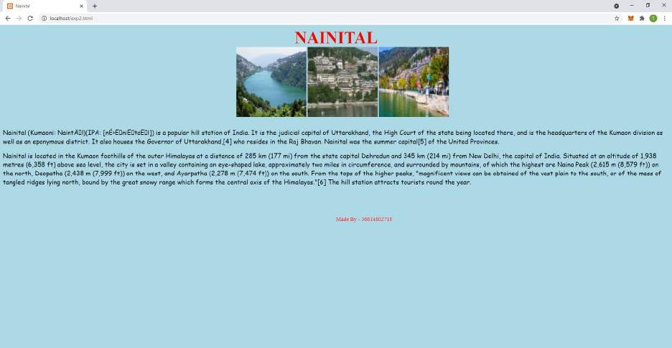

# EXPERIMENT NO. - 3

**Aim:** Design webpages to demonstrate use of Tables.

## Code:

<!DOCTYPE html>

<html>

<head>

<title>C, C++ AND JAVA</title>

</head>

<body>

<h1>

<font face="Verdana" color="Red">

<center>DIFFERENCE BETWEEN C, C++ AND

JAVA</center>

</font>

</h1>

<table border="1" cellspacing="4" cellpadding="4" width="100%">

<tr>

<th>ASPECT</th>

<th>C</th>

<th>C++</th>

<th>JAVA</th>

</tr>

<tr>

<th>Developed Year</th>

<td>

<center>1972</center>

</td>

<td>

<center>1979</center>

</td>

<td>

<center>1991</center>

</td>

</tr>

<tr>

<th>Developed By</th>

<td>

<center>Dennis Ritchie</center>

</td>

<td>

<center>BjarneStroustrup</center>

</td>

<td>

<center>James Gosling</center>

</td>

</tr>

<tr>

<th>Successor Of</th>

<td>

<center>BCPL</center>

</td>

<td>

<center>C</center>

</td>

<td>

<center>C(Syntax) and C++(Structure)</center>

</td>

</tr>

<tr>

<th>Paradigms</th>

<td>

<center>Procedural</center>

</td>

<td>

<center>Object Oriented</center>

</td>

<td>

<center>Object Oriented</center>

</td>

</tr>

<tr>

<th>Approach</th>

<td>

<center>Top Down Approach</center>

</td>

<td>

<center>Bottom Up Approach</center>

</td>

<td>

<center>Bottom Up Approach</center>

</td>

</tr>

<tr>

<th>Platform Dependency</th>

<td>

<center>Dependent</center>

</td>

<td>

<center>Dependent</center>

</td>

<td>

<center>Independent</center>

</td>

</tr>

<tr>

<th>Keywords</th>

<td>

<center>32</center>

</td>

<td>

<center>63</center>

</td>

<td>

<center>50</center>

</td>

</tr>

<tr>

<th>Datatypes: Structures,Unions</th>

<td>

<center>Supported</center>

</td>

<td>

<center>Supported</center>

</td>

<td>

<center>Not Supported</center>

</td>

</tr>

<tr>

<th>Pre-Processor Directives</th>

<td>

<center>Supported</center>

</td>

<td>

<center>Supported</center>

</td>

<td>

<center>Not Supported</center>

</td>

</tr>

<tr>

<th>Header Files</th>

<td>

<center>Supported</center>

</td>

<td>

<center>Supported</center>

</td>

<td>

<center>Uses Packages</center>

</td>

</tr>

<tr>

<th>Inheritance</th>

<td>

<center>No Inheritance</center>

</td>

<td>

<center>Supported</center>

</td>

<td>

<center>Multiple Inheritance Not Supported</center>

</td>

</tr>

<tr>

<th>Overloading</th>

<td>

<center>No Overloading</center>

</td>

<td>

<center>Supported</center>

</td>

<td>

<center>Operator Overloading Not Supported</center>

</td>

</tr>

<tr>

<th>Pointers</th>

<td>

<center>Supported</center>

</td>

<td>

<center>Supported</center>

</td>

<td>

<center>No Pointers</center>

</td>

</tr>

<tr>

<th>Code Translation</th>

<td>

<center>Compiled</center>

</td>

<td>

<center>Compiled</center>

</td>

<td>

<center>Interpreted</center>

</td>

</tr>

<tr>

<th>Storage Allocation</th>

<td>

<center>Uses calloc and malloc functions</center>

</td>

<td>

<center>Uses new and delete keywords</center>

</td>

<td>

<center>Uses Garbage Collector</center>

</td>

</tr>

<tr>

<th>Multi Threading</th>

<td>

<center>Not Supported</center>

</td>

<td>

<center>Not Supported</center>

</td>

<td>

<center>Supported</center>

</td>

</tr>

<tr>

<th>Interfaces</th>

<td>

<center>Not Supported</center>

</td>

<td>

<center>Not Supported</center>

</td>

<td>

<center>Supported</center>

</td>

</tr>

<tr>

<th>Exception Handling</th>

<td>

<center>No Exception Handling</center>

</td>

<td>

<center>Supported</center>

</td>

<td>

<center>Supported</center>

</td>

</tr>

<tr>

<th>Templates</th>

<td>

<center>Not Supported</center>

</td>

<td>

<center>Supported</center>

</td>

<td>

<center>Not Supported</center>

</td>

</tr>

<tr>

<th>Storage Class: Auto,Extern</th>

<td>

<center>Supported</center>

</td>

<td>

<center>Supported</center>

</td>

<td>

<center>Not Supported</center>

</td>

</tr>

<tr>

<th>Constructors And Destructors</th>

<td>

<center>Not Supported</center>

</td>

<td>

<center>Supported</center>

</td>

<td>

<center>Constructor Supported But Destructor Not Supported</center>

</td>

</tr>

<tr>

<th>Database Connectivity</th>

<td>

<center>Not Supported</center>

</td>

<td>

<center>Not Supported</center>

</td>

<td>

<center>Supported</center>

</td>

</tr>

</table>

<div style="margin-left: 50%; color: red;">

<p>Made By - 36614802718</p>

</div>

</body>

<html>

</html>

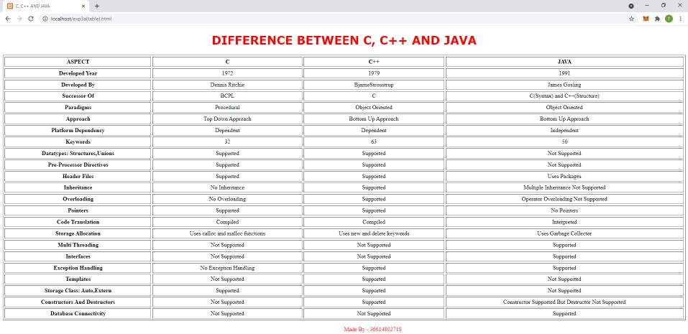

# EXPERIMENT NO. - 4

**Aim:** Design webpages to demonstrate use of Forms.

## Code:

<!DOCTYPE html>

<html>

<head>

<title>PERSONAL DETAILS</title>

</head>

<body>

<h2>

<font face="Verdana" color="Blue">

<center>Please Enter Your Personal Details</center>

</font>

</h2>

<form method="post">

First name: <input type="text" name="first_name">

<br><br><br><br>

Last name: <input type="text" name="last_name">

<br><br><br><br>

User ID : <input type="text" name="user_id">

<br><br><br><br>

Password: <input type="password" name="password">

<br><br><br><br>

Address: <textarea rows="5" cols="50" name="description">

</textarea>

<br><br><br><br>

Gender: <input type="radio" name="gender" value="female"> Female

<input type="radio" name="gender" value="male"> Male

<br><br><br><br>Subjects To Be Studied: <input type="checkbox" name="maths" value="on">Maths

<input type="checkbox" name="physics" value="on"> Physics

<br><br><br><br>

Nationality: <select name="dropdown">

<option value="Indian" selected>Indian</option>

<option value="NRI">NRI</option>

<option value="Others">Others</option>

</select>

<br><br><br><br>

<input type="submit" name="submit" value="Submit">

<div style="margin-left: 50%; color: red;">

<p>Made By - 36614802718</p>

</div>

</body>

</html>

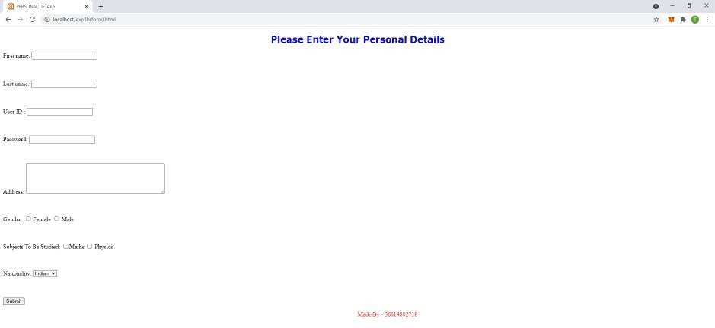

# EXPERIMENT NO. - 5

**Aim:** Design webpages to demonstrate use of Internal Cascading Style Sheets.

## Code:

<html>

<head>

<title>LOGIN</title>

<style type="text/css" media="all"> html,

body, div, h1,

h2,

h3,

h4,

h5,

h6,

p, footer, header {

display: block;

}

body {

text-align: center;

font-family: 'Oleo Script', cursive;

}

.center-container { padding: 0em;

background: rgba(0, 0, 0, 0.42)

}

.header-w3l {

padding-top: 2em;

}

.header-w3l h1 { font-size: 3em; color: green;

letter-spacing: 4px; font-weight: 500;

text-transform: uppercase;

}

.main-content-agile { margin: 7em 0em 3em;

}

.wthree-pro h2 { font-size: 1.5em; color: green;

letter-spacing: 1px; margin-top: 0.3em; margin-bottom: 2em; font-weight: 400;

}

.sub-main-w3 input[type="email"],

.sub-main-w3 input[type="password"] { outline: none;

font-size: 1em;

padding: 1em 3em 1em 1em; border: none;

margin-bottom: 0.3em; background: none; border: 1px solid #eee; width: 82%;

color: #fff;

font-weight: 400;

font-family: 'Oleo Script', cursive;

letter-spacing: 1px;

}

.sub-main-w3 { position: relative; width: 23%;

margin: 0 auto;

}

.sub-w3l h6 a { font-size: 1em; color: #fff;

letter-spacing: 2px; text-align: right; display: inherit;

}

.sub-w3l {

margin-top: 2em;

}

.sub-main-w3 input[type="submit"]

{ color: white; background: #2baf2b; border: none; padding: 8px 0px; outline: none;

width: 38%;

font-size: 1.1em; cursor: pointer; letter-spacing: 2px; font-weight: 400;

font-family: 'Oleo Script', cursive; transition: 0.5s all;

}

.sub-main-w3 input[type="submit"]:hover { background: #fff;

color: black; transition: 0.5s all;

}

.footer {

padding: 0.5cm 0 3em;

}

.footer p {

font-size: 1em; color: red;

letter-spacing: 2px;

}

</style>

</head>

<body>

<div class="header-w3l">

<h1>Classic Login Form</h1>

</div>

<div class="main-content-agile">

<div class="sub-main-w3">

<div class="wthree-pro">

<h2>Login Here</h2>

</div>

<form action="#" method="post">

<input placeholder="Username or E-mail" name="Name" class="user" type="email" required="">

<input placeholder="Password" name="Password" class="pass" type="password" required="">

<div class="sub-w3l">

<h6><a href="#">Forgot Password?</a></h6>

<div class="right-w3l">

<input type="submit" value="Login">

</div>

</div>

</form>

</div>

</div>

<div class="footer">

<p>Made By - 36614802718</p>

</div>

</div>

</div>

</body>

</html>

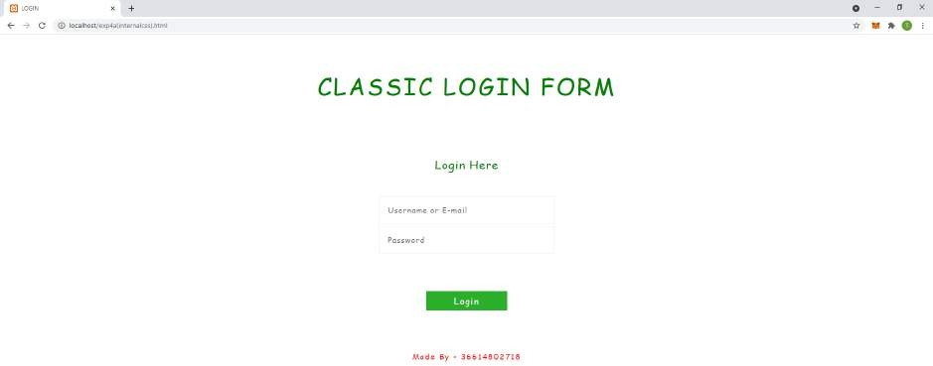

# EXPERIMENT NO. - 6

**Aim:** Design webpages to demonstrate use of Embedded/Inline Cascading Style Sheets.

## Code:

<html>

<head>

<title>WE ARE COMING SOON</title>

</head>

<body>

<div style="background-color: lightgrey;">

<h1

style="margin-top:7px;font-family:'Lobster',cursive;font-size:38px;line-height:42px;font-weight: 400;color:#555;">

<a href="index.html" style="color:#555;">Tanya Goel (36614802718)</a><span style="color:#e75967;">.</span></h1>

<p style="font-size:18px;line-height:22px;text-align:right;margin-top:18px;">Tel:

<span

style="font-size:18px;line-height:22px;margin-top:18px;text-align:right;color:#888;">+91-98765 43210</span> | Skype: <span

style="font-size:18px;line-height:22px;margin-top:18px;text-align:right;color:#888;">info@dom ain.it</span>

</p>

</div>

<div style="margin:0 auto;text-align:center;color:#fff;padding:55px 0 60px 0;background:url(https://nakedsecurity.sophos.com/wp-content/uploads/sites/2/2019/04/shut terstock_407554567-compressor-1.jpg);">

<h2

style="font-size:40px;line-height:44px;font-weight:700;text-transform:uppercase;text-shadow:0 1px 7px rgba(0,0,0,.2);">

We're Coming Soon</h2>

<p style="margin-top:20px;font-size:18px;line-height:36px;text-shadow:0 1px 7px rgba(0,0,0,.2);">We are working

very hard on the new version of our site. It will bring a lot of new features. Stay tuned!</p>

</div>

<div style="margin-top:30px;text-align:center;background-color: lightgrey;">

<h3

style="font-size:32px;font-weight:400;color:#4d4d4d;line-height:40px;text-transform:uppercase

;text-shadow:1px 2px 1px #fff;">

Subscribe to our newsletter</h3>

<form method="post">

<p style="font-size:18px;font-weight:400;line-height:36px;">Email

address</p>

<input type="text" name="email" placeholder="Enter your email..." style="width:310px;height:46px;margin:0;padding:0

10px;background:#fff;font-family:'Lato',sans-serif;font-size:18px;line-height:46px;color:#888;bor der:0;">

<br><br>

<button type="submit" class="btn"

style="width:130px;height:46px;margin:0;padding:0;background:#e75967;border:0;font-family:' Lato',sans-serif;font-size:18px;line-height:46px;color:#fff;text-transform:uppercase;text-shadow: 1px 1px 1px rgba(0,0,0,.3);">Subscribe</button>

</form>

</div>

</body>

</html>

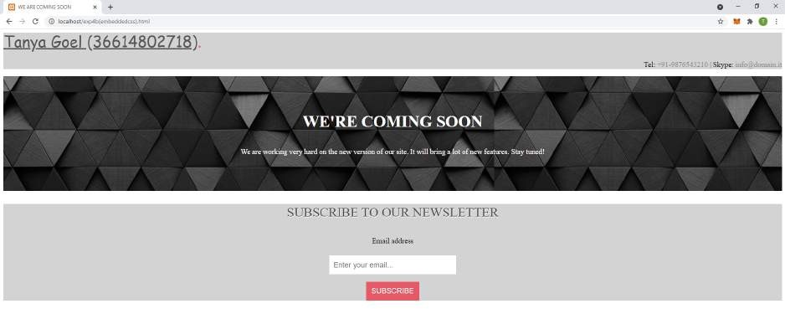

# EXPERIMENT NO. - 7

**Aim:** Design webpages to demonstrate use of External Cascading Style Sheets.

## Code:

HTML CODE:

<html>

<head>

<title>First CSS Doc</title>

<link rel="stylesheet" type="text/css" href="style.css" />

</head>

<body>

<section id="page">

<header>

<hgroup>

<h1>MAIT</h1>

<h3>Maharaja Agrasen Institue Of Technology</h3>

</hgroup>

<nav class="clear">

<ul>

<li><a href="#article1">About Us</a></li>

<li><a href="#article2">Our Mission</a></li>

<li><a href="#article3">Departments</a></li>

</ul>

</nav>

</header>

<section id="articles">

<div class="line"></div>

<article id="article1">

<h2>About Us</h2>

<div class="line"></div>

<div class="articleBody clear">

<figure>

<img

src="https://images.shiksha.com/mediadata/images/1551422825phpZFFgVq.jpeg" width="620"

height="340">

</figure>

<p>

Maharaja Agrasen Institute of Technology (MAIT) is a private Engineering College, located in New Delhi, India. One of the reputed engineering colleges of India, MAIT has 10 departments

(Five-Engineering, Four-Research and

Three-Auxiliary). It is affiliated to the Guru Gobind Singh Indraprastha University, Delhi. It is among the top 5 engineering colleges in New Delhi.

</p>

<p>

MAIT has been ranked as the 9th best engineering college in India by the DataQuest Magaize for

the year 2014-15. It has also been ranked at 70 among engineering colleges in India by the The Week-Hansa survey conducted by The Week magazine, and also the 27th best private engineering college in India by the same magazine. The college has been rated AAA+ by Careers 360 (Magazine)

Top Engineering Colleges in India 2015. The alumni of the college are in prestigious Institutes

such as Indian School Of Business(ISB) and

companies Advance Micro Devices(AMD), ReckittBenckiser & Nokia. </p>

</div>

</article>

<section>

<footer>

<div class="line"></div>

</footer>

</section>

</section>

</section>

<div class="footer" style="margin-left: 50%;">

<p>Made By - 36614802718</p>

</div>

</body>

</html>

EXTERNAL CSS CODE (style.css):

@charset "UTF-8";

*

{

margin:0; padding:0;

}

header,footer,article,section,hgroup,nav,figure

{

display:block;

}

body

{

font-size:0.825em; color:#fcfcfc;

background-color:#355664;

font-family:Arial, Helvetica, sans-serif;

}

a, a:visited

{

color:#0196e3;

text-decoration:none; outline:none;

}

a:hover

{

text-decoration:underline;

}

img

{

border:none;

}

h1,h2,h3

{

font-family:"Myriad Pro","Helvetica Neue",Helvetica,Arial,Sans-Serif; text-shadow:0 1px 1px black;

}

h1

{

font-size:3.5em; padding:0.5em 0 0;

text-transform:uppercase;

}

h3

{

font-family:forte,"Myriad Pro","Helvetica Neue",Helvetica,Arial,Sans-Serif; font-size:2em;

font-weight:normal; margin:0 0 1em;

}

h2

{

font-size:2.2em; font-weight:normal;

letter-spacing:0.01em;

text-transform:uppercase;

}

p

{

line-height:1.5em; padding-bottom:1em;

}

.line

{

height:1px;

background-color:#24404c; border-bottom:1px solid #416371; margin:1em 0; overflow:hidden;

}

article .line

{

background-color:#15242a; border-bottom-color:#204656

; margin:1.3em 0;

}

footer .line

{

margin:2em 0;

}

nav

{

background-color:#f8f8f8; padding:0 5px; position:absolute;

right:0; top:4em;

border:1px solid #FCFCFC;

}

nav ul li

{

display:inline;

}

nav ul li a,nav ul li a:visited

{

color:#565656; display:block; float:left;

font-size:1.25em; font-weight:bold; margin:5px 2px;

padding:7px 10px 4px;

text-shadow:0 1px 1px white; text-transform:uppercase; }

nav ul li a:hover

{

text-decoration:none; background-color:#f0f0f0

; }

#page

{

width:960px; margin:0 auto; position:relative;

}

article

{

background-color:#213E4A; margin:3em 0;

padding:20px;

text-shadow:0 2px 0 black;

}

figure

{

border:3px solid #142830; float:right; height:300px; margin-left:15px; overflow:hidden; width:500px;

}

figure img

{

margin-left:-60px;

}

footer

{

margin-bottom:30px; text-align:center; font-size:0.825em;

}

footer p

{

margin-bottom:-2.5em; position:relative;

}

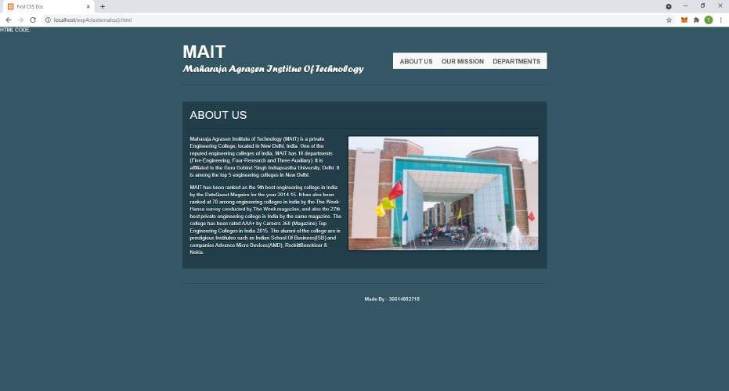

# EXPERIMENT NO. - 8

**Aim:** Design a web page using a frameset. The left pane in the frameset should include a menu and the right pane should be the content page. Design the page based on your interest. You can include External CSS to the pages for theme based layout on this website.

## Code:

Frame 1:

<!DOCTYPE html>

<html>

<head>

<style>

.frame_1 {

background-color: lightblue; font-size: 20pt;

font-weight: bold; text-align: center;

}

</style>

</head>

<body class="frame_1">

<h1>Food Catalogue</h1>

</body>

</html> Frame 2:

<!DOCTYPE html>

<html>

<head>

<style>

.frame_2 {

background-color: rosybrown; font-size: 20pt;

float: left; margin-left: 0;

margin-top: 0;

}

</style>

</head>

<body class="frame_2" style="margin-left: 0; float: left;">

<ul style="list-style-type: disc;">

<li>Indian</li>

<li>Chinese</li>

<li>Italian</li>

<li>Mexican</li>

<li>American</li>

</ul>

</body>

</html> Frame 3:

<!DOCTYPE html>

<html>

<head>

<style>

.frame_3 {

background-color: rgb(116, 226, 88); font-size: 20pt;

float: left;

margin-top: 30px; text-align: center;

}

.food-image { width: 400px; height: 400px; margin-left: 30px;

}

.column { float: left;

width: 33.33%; padding: 5px;

}

.row::after {

content: ""; clear: both; display: table;

}

</style>

</head>

<body class="frame_3">

<div class="row">

<div class="col">

<img id="biryani" class="food-image"

src="https://static.toiimg.com/thumb/54308405.cms?imgsize=510571&width=800&height=800" alt="Biryani" />

<img id="dal" class="food-image"

src="http[s://w](http://www.cookwithmanali.com/wp-content/uploads/2019/04/Restaurant-Style-Dal-Mak)ww.c[ookwithmanali.com/wp-content/uploads/2019/04/Restaurant-Style-Dal-Mak](http://www.cookwithmanali.com/wp-content/uploads/2019/04/Restaurant-Style-Dal-Mak) hani-500x500.jpg"

alt="Dal Makhni" />

<img id="paneer" class="food-image"

src="http[s://w](http://www.cookwithmanali.com/wp-content/uploads/2015/07/Restaurant-Style-Recipe-P)ww.c[ookwithmanali.com/wp-content/uploads/2015/07/Restaurant-Style-Recipe-P](http://www.cookwithmanali.com/wp-content/uploads/2015/07/Restaurant-Style-Recipe-P) aneer-Tikka.jpg"

alt="Paneer Tikka" />

</div>

</div>

</body>

</html> HTML Code:

<!DOCTYPE html>

<html>

<frameset rows="140px,*">

<frame noresize src="frame1.html"></frame>

<frameset cols="150px,*">

<frame noresize src="frame2.html"></frame>

<frame src="frame3.html"></frame>

</frameset>

</frameset>

</html>

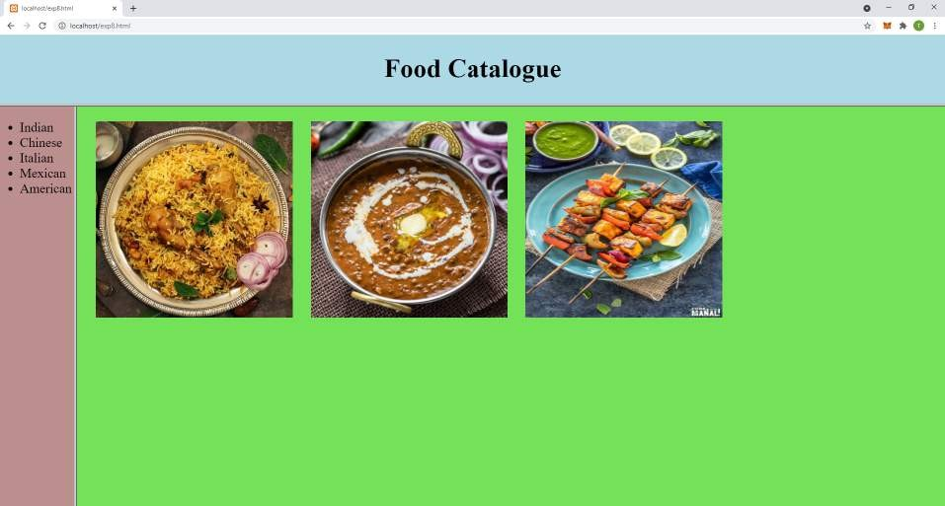

# EXPERIMENT NO. - 9

**Aim:** Design an XML Catalogue of CD database to understand the working structure of XML.

## Code:

<?xml version="1.0" encoding="UTF-8"?>

<CATALOG>

<CD>

<TITLE>Empire Burlesque</TITLE>

<ARTIST>Bob Dylan</ARTIST>

<COUNTRY>USA</COUNTRY>

<COMPANY>Columbia</COMPANY>

<PRICE>10.90</PRICE>

<YEAR>1985</YEAR>

</CD>

<CD>

<TITLE>Hide Your Heart</TITLE>

<ARTIST>Bonnie Tyler</ARTIST>

<COUNTRY>UK</COUNTRY>

<COMPANY>CBS Records</COMPANY>

<PRICE>9.90</PRICE>

<YEAR>1988</YEAR>

</CD>

<CD>

<TITLE>Greatest Hits</TITLE>

<ARTIST>Dolly Parton</ARTIST>

<COUNTRY>USA</COUNTRY>

<COMPANY>RCA</COMPANY>

<PRICE>9.90</PRICE>

<YEAR>1982</YEAR>

</CD>

<CD>

<TITLE>Black Angel</TITLE>

<ARTIST>Savage Rose</ARTIST>

<COUNTRY>EU</COUNTRY>

<COMPANY>MEGA</COMPANY>

<PRICE>10.90</PRICE>

<YEAR>1995</YEAR>

</CD>

<CD>

<TITLE>Still Got The Blues</TITLE>

<ARTIST>Gary Moore</ARTIST>

<COUNTRY>UK</COUNTRY>

<COMPANY>Virgin Records</COMPANY>

<PRICE>8.10</PRICE>

<YEAR>1990</YEAR>

</CD>

<CD>

<TITLE>Eros</TITLE>

<ARTIST>Eros Ramazzotti</ARTIST>

<COUNTRY>EU</COUNTRY>

<COMPANY>BMG</COMPANY>

<PRICE>9.90</PRICE>

<YEAR>1997</YEAR>

</CD>

<CD>

<TITLE>One Night Only</TITLE>

<ARTIST>Bee Gees</ARTIST>

<COUNTRY>UK</COUNTRY>

<COMPANY>Polydor</COMPANY>

<PRICE>10.90</PRICE>

<YEAR>1998</YEAR>

</CD>

<CD>

<TITLE>Sylvias Mother</TITLE>

<ARTIST>Dr. Hook</ARTIST>

<COUNTRY>UK</COUNTRY>

<COMPANY>CBS</COMPANY>

<PRICE>8.10</PRICE>

<YEAR>1973</YEAR>

</CD>

<CD>

<TITLE>Maggie May</TITLE>

<ARTIST>rod Stewart</ARTIST>

<COUNTRY>UK</COUNTRY>

<COMPANY>Pickwick</COMPANY>

<PRICE>8.50</PRICE>

<YEAR>1990</YEAR>

</CD>

</CATALOG>

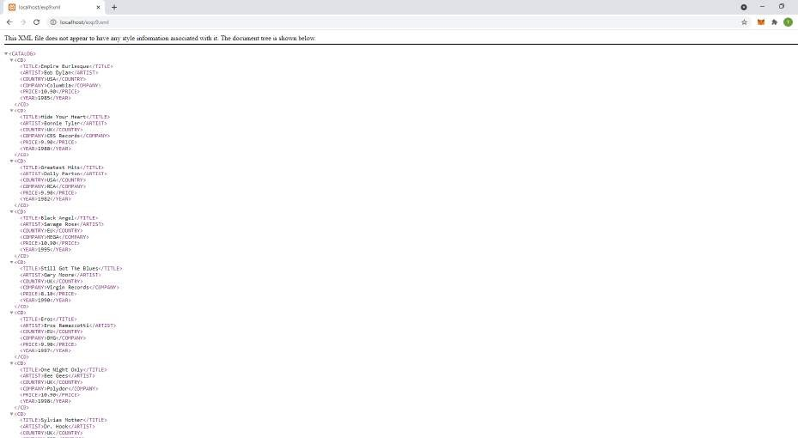

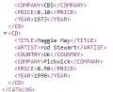

## VIVA-VOCE QUESTIONS

Q1) What is XML?

Ans) XML stands for extensible markup language. A markup language is a set of codes, or tags, that describes the text in a digital document. The most famous markup language is the hypertext markup language (HTML), which is used to format Web pages.

Q2) What are the features of XML? Ans) Features of XML are:

1. Excellent for handling data with a complex structure or atypical data.
2. Data described using markup language.
3. Text data description.
4. Human- and computer-friendly format.
5. Handles data in a tree structure having one-and only one-root element.

Q3) What are the differences between HTML and XML? Ans) Differences between HTML and XML are:

1. XML is an abbreviation for eXtensible Markup Language whereas HTML stands for Hypertext Markup Language.
2. XML mainly focuses on transfer of data while HTML is focused on presentation of the data.
3. XML is content driven whereas HTML is format driven.
4. XML is Case sensitive while HTML is Case insensitive.
5. XML provides namespaces support while HTML doesn't provide namespaces support.
6. XML is strict for closing tags while HTML is not strict.
7. XML tags are extensible whereas HTML has limited tags.
8. XML tags are not predefined whereas HTML has predefined tags.

Q4) Which tag is used to find the version of XML and the syntax?

Ans) XPath is used to find information in an XML document and contains standard functions.

Q5) What is the XML DOM Document?

Ans) The XML Document Object Model (DOM) class is an in-memory representation of an XML document. The DOM allows you to programmatically read, manipulate, and modify an XML document. The XML DOM defines a standard way for accessing and manipulating XML documents. It presents an XML document as a tree-structure.

Q6) Can we have empty XML tags? Ans) Yes, we can have empty XML tags.

Q7) What are the basic rules while writing XML? Ans) Basic rules while writing XML include:

1. All XML elements must have a closing tag.
2. XML tags are case sensitive.
3. All XML elements must be properly nested.
4. All XML documents must have a root element.
5. Attribute values must always be quoted.

Q8) What is XML Element?

Ans) An XML element is everything from (including) the element's start tag to (including) the element's end tag.

Q9) What is CDATA?

Ans) A CDATA section contains text that will NOT be parsed by a parser. Tags inside a CDATA section will NOT be treated as markup and entities will not be expanded. The primary purpose is for including material such as XML fragments, without needing to escape all the delimiters.

Q10) How can a comment be represented in XML?

Ans) A comment starts with <! -- and ends with -->. You can add textual notes as comments between the characters.

Q11) What are XML Namespaces?

Ans) When using prefixes in XML, a namespace for the prefix must be defined. The namespace can be defined by an xmlns attribute in the start tag of an element. The namespace declaration has the following syntax. xmlns:prefix="URI". An XML namespace is a collection of names that can be used as element or attribute names in an XML document. The namespace qualifies element names uniquely on the Web in order to avoid conflicts between elements with the same name.

# EXPERIMENT NO. - 10

**Aim:** Design an XML Catalogue of a Food Menu to understand the working structure of XML.

## Code:

<?xml version="1.0" encoding="UTF-8"?>

<breakfast_menu>

<food>

<name>Belgian Waffles</name>

<price>$5.95</price>

<description>Two of our famous Belgian Waffles with plenty of real mapple syrup</description>

<calories>650</calories>

</food>

<food>

<name>Strawberry Belgian Waffles</name>

<price>$7.95</price>

<description>Light Belgian Waffles covered with strawberries and whipped cream</description>

<calories>900</calories>

</food>

<food>

<name>Berry-Berry Belgian Waffles</name>

<price>$8.95</price>

<description>Light Belgian Waffles covered with an assortment of fresh berries and whipped cream</description>

<calories>650</calories>

</food>

<food>

<name>French toast</name>

<price>$4.50</price>

<description>Thick slices made from our homemade sourdough bread</description>

<calories>600</calories>

</food>

<food>

<name>Homestyle Breakfast</name>

<price>$6.95</price>

<description>Two eggs, bacon or sausage, toast, and our ever-popular hash browns</description>

<calories>950</calories>

</food>

</breakfast_menu>

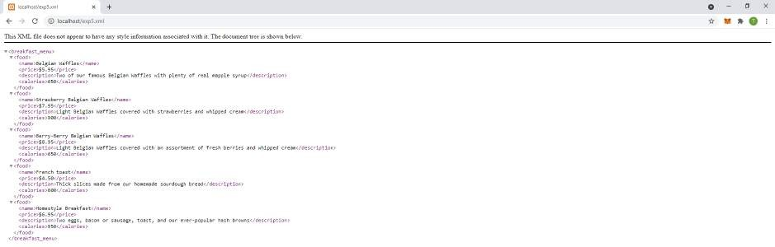

## VIVA-VOCE QUESTIONS

Q1) What is an XML schema?

Ans) An XML Schema describes the structure of an XML document. The XML Schema language is also referred to as XML Schema Definition (XSD).

Q2) What is a well formed XML document?

Ans) An XML document with correct syntax is called "Well Formed". An XML document validated against a DTD is both "Well Formed" and "Valid".

Q3) Why has XML been used for development?

Ans) Extensible Markup Language (XML) is the universal language for data on the Web XML is a technology which allows us to create our own markup language. XML documents are universally accepted as a standard way of representing information in platform and language independent manner. Hence, it is used for development.

Q4) What is SGML?

Ans) SGML (Standard Generalized Markup Language) is an internationally agreed standard for information representation. SGML can be used for publishing in its broadest definition - from single medium conventional publishing on paper to on-line multimedia database publishing.

Q5) Can an XML document be executed?

Ans) XML itself is not a programming language, so normal XML documents don't 'run' or 'execute'. If you want to view or display an XML file, open it with an XML editor or an XML browser.

Q6) Can HTML be replaced with XML?

Ans) No. XML itself does not replace HTML: instead, it provides an alternative which allows you to define your own set of markup elements. HTML is expected to remain in common use for some time to come, and a Document Type Definition for HTML is available in XML syntax as well as in original SGML.

# EXPERIMENT NO. - 11

**Aim:** Design a webpage that implements a simple interest calculator using JavaScript.

## Code:

<html>

<head>

<title>SI Calculator</title>

<script>

function calculate() {

p = document.getElementById("p").value; r = document.getElementById("r").value; m = document.getElementById("m").value; d = document.getElementById("d").value; t = (m / 12) + (d / 365);

result = document.getElementById("result"); result.innerHTML = ((p * r * t) / 100);

}

function resetData() { document.getElementById("body").reset();

}

</script>

<style type="text/css" media="all"> #body {

text-align: center; font-size: 20pt;

}

.table {

font-size: 20pt; border: coral 5px solid; padding: 20px;

}

.footer {

padding: 0.5cm 0 3em;

}

.footer p {

font-size: 1em; color: red;

letter-spacing: 2px;

}

</style>

</head>

<body id="body" style="background: skyblue;">

<h1 style="color: green;">Simple Interest Calculator</h1>

<div style="margin-left: 37%;">

<table class="table">

<tr>

<td>Principle amount : <input id="p"/></td>

</tr>

<tr>

<td>Rate of Interest : <input id="r"/></td>

</tr>

<tr>

<td>Duration : </td>

</tr>

<tr>

<td>Months : <input id="m"/></td>

</tr>

<tr>

<td>Days : <input id="d"/></td>

</tr>

<tr>

<td><button onclick="calculate()" style="font-size: 20pt;">Submit</button>

<td><a href="exp11.html" style="font-size: 20pt; color: black; text-decoration: none;"><button onClick="">Reset</a></td>

</td>

</tr>

<tr>

<td>Result : <output id="result"></td>

</tr>

</table>

</div>

<div class="footer">

<p>Made By - 36614802718</p>

</div>

</body>

</html>

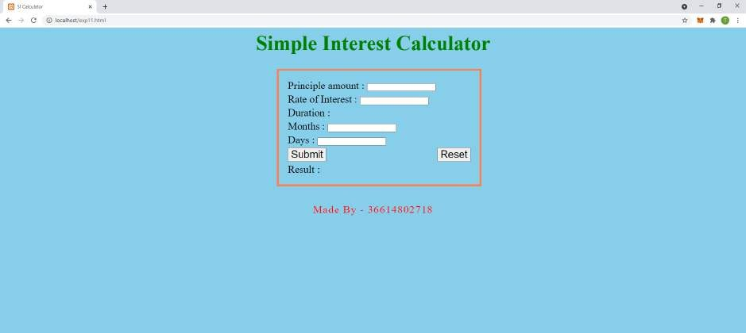

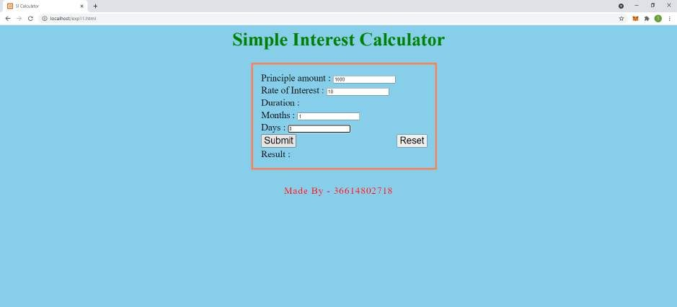

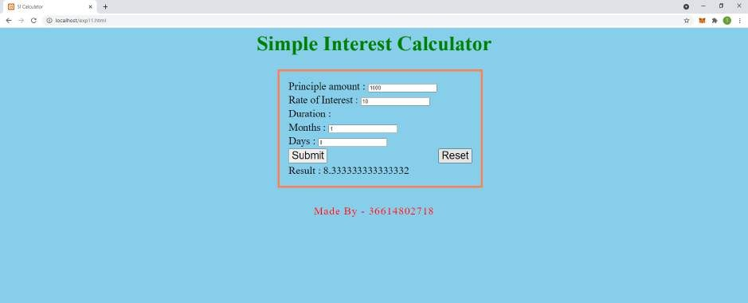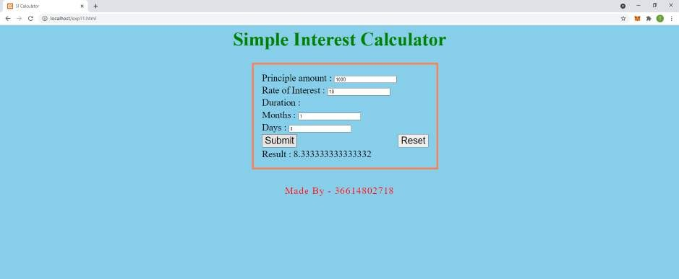

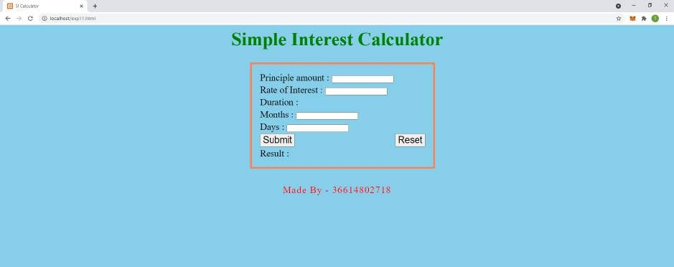

## VIVA-VOCE QUESTIONS

Q1) What is JavaScript?

Ans) JavaScript is a text-based programming language used both on the client-side and

server-side that allows you to make web pages interactive. Where HTML and CSS are languages that give structure and style to web pages, JavaScript gives web pages interactive elements that engage a user.

Q2) What is the difference between JavaScript and jScript?

Ans) JavaScript is a scripting language developed by Netscape Communications designed for developing client and server Internet applications.Whereas Microsoft JScript is an open implementation of Netscape's JavaScript. JScript is a high-performance scripting language designed to create active online content for the World Wide Web.

Q3) How to use an external Javascript file?

Ans) To include an external JavaScript file, we can use the script tag with the attribute src. The value for the src attribute should be the path to our JavaScript file. This script tag should be included between the <head> tags in our HTML document.

Q4) Is JavaScript case sensitive language?

Ans) Yes, JavaScript is Case Sensitive. All JavaScript identifiers are case sensitive.

Q5) How to write a comment in JavaScript?

Ans) To create a single line comment in JavaScript, you place two slashes "//" in front of the code or text you wish to have the JavaScript interpreter ignore. When you place these two slashes, all text to the right of them will be ignored, until the next line. Multi-line comments start with /* and end with */. Any text between /* and */ will be ignored by JavaScript.

Q6) How to create a function in JavaScript? Ans) Steps to create a function in JavaScript:

1. Use the keyword function followed by the name of the function.
2. After the function name, open and close parentheses.
3. After parenthesis, open and close curly braces.
4. Within curly braces, write your lines of code.

Q7) What are the JavaScript data types?

Ans) Data types in JavaScript are as following:

1. String - represents textual data
2. Number - an integer or a floating-point number
3. BigInt - an integer with arbitrary precision
4. Boolean - Any of two values: true or false
5. Undefined - a data type whose variable is not initialized
6. Null - denotes a null value
7. Symbol - data type whose instances are unique and immutable

# EXPERIMENT NO. - 12

**Aim:** Design a webpage that displays Current Date and Time using JavaScript.

## Code:

<html>

<head>

<title>Current DateTime</title>

<script>

function show() {

var d = new Date(); document.getElementById("demo").innerHTML = d;

}

</script>

<style type="text/css" media="all">

.footer {

padding: 0.5cm 0 3em;

}

.footer p {

font-size: 1em; color: red;

letter-spacing: 2px;

}

</style>

</head>

<body style="margin: 0;">

<div

style="padding: 20px; background: url(https://previews.123rf.com/images/mimacz/mimacz1512/mimacz151200006/50193669-ligh t-yellow-background-low-poly.jpg);">

<button onclick="show()">Current Date And Time</button><br>

<p id="demo"></p>

<p style="font-size: 1em; color: red; letter-spacing: 2px;">Made By - 36614802718</p>

</div>

</body>

</html>

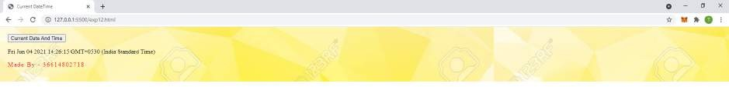

# EXPERIMENT NO. - 13

**Aim:** Design a simple form that includes Email, Password and Phone Number as a field and use JavaScript to validate the Email Address (for proper Structure), Phone number (to follow 10- Digit norms) and Password (to include at-least one Alphanumeric and one number).

## Code:

<html>

<head>

<title> Form Validation:Email, Password and Phone Number</title>

<script>

*");

function formValidation() {

var email = document.getElementById('email');

var password = document.getElementById('password'); var number = document.getElementById('number');

emailValidation(email, "* Please enter a valid email address *"); inputPassword(password, "* For your password please use alphabets and numerals only

numberValidation(number, "* Please enter a valid phone number *");

}

function emailValidation(inputtext, alertMsg) {

var emailExp = /^[\w\-\.\+]+\@[a-zA-Z0-9\.\-]+\.[a-zA-z0-9]{2,4}$/; if (inputtext.value.match(emailExp)) {

document.getElementById('p3').innerText = "* Entered Email Is Valid *";

}

else {

document.getElementById('p3').innerText = alertMsg;

}

}

function inputPassword(inputtext, alertMsg) {

var alphaExp = /^[0-9a-zA-Z]+$/;

if (inputtext.value.match(alphaExp)) { document.getElementById('p1').innerText = "* Entered Password Is Valid *";

}

else {

document.getElementById('p1').innerText = alertMsg;

}

}

function numberValidation(inputtext, alertMsg) { var numericExpression = /^[0-9]+$/;

if (inputtext.value.match(numericExpression) && inputtext.value.length == 10) { document.getElementById('p2').innerText = "* Entered Number Is Valid *"; } else {

document.getElementById('p2').innerText = alertMsg;

}

}

</script>

<style type="text/css" media="all">

.footer {

padding: 0.5cm 0 3em;

}

.footer p {

font-size: 1em; color: red;

letter-spacing: 2px;

}

</style>

</head>

<body>

<h2>JavaScript Form Validation</h2>

<br><br> Email:

<input type='text' id='email'><br><br><br><br>

<p id="p3"></p>

<br><br> Password:

<input type='text' id='password'><br><br><br><br>

<p id="p1"></p>

<br><br> Phone Number:

<input type='text' id='number'><br><br><br><br>

<p id="p2"></p>

<br><br>

<button onclick="formValidation()">Validate Form</button><br><br><br><br>

<div class="footer">

<p>Made By - 36614802718</p>

</div>

</body>

</html>

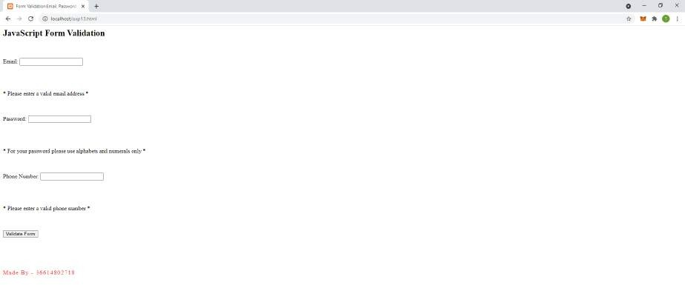

# EXPERIMENT NO. - 14

**Aim:** Deploy a Content Management System (CMS) and prepare a stepwise instruction on how to configure the CMS on Apache/XAMPP/WAMPP.

## Steps:

1. Installation of XAMPP is already done in experiment 1.
2. Download CMS Made Simple 2.1.04 installer from the official website.
3. Unzip the installation of the folder.
4. Create 2 folders - \cmsms and \cmsms.installer in the XAMPP htdocs folder.

Copy all files from unzipped folder CMS Made simple installer to \cmsms.installer

1. Run XAMPP Control Panel:
   * Start Apache
   * Start Database
2. Open the following URL in a browser to start the installation: <http://localhost/cms.installer>
   * Select the destination directory “C;\xampp\htdocs\cmsms”.
   * Click the “Next” button.
3. Here click on the “Next” button on “Detect Existing Software”.
4. Next page is test - click the “Next” button.
5. Next step is Basic configuration information.

Here we will create a new user and database for CMSMS.

* + Open phpMyAdmin in the browser.
  + Open the SQL Tab.
  + Then execute the following query:

user(s)

‘cmsms-db-owner’ @’localhost’ ‘cmsms-db-owner’ @’127.0.01’ ‘cmsms-db-owner’ @’::1’

With password ‘test’

Now go back to the CMSMS installation and add all the details and click “Next”.

1. Now we enter data in the Admin info page and click “Next”.
2. Enter the site name and additional language on the site settings page and click “Next”.
3. Click “Next” on the Install application files page.
4. Click “Next” on the Database Work Page.
5. CMS is deployed and configured successfully on Apache.

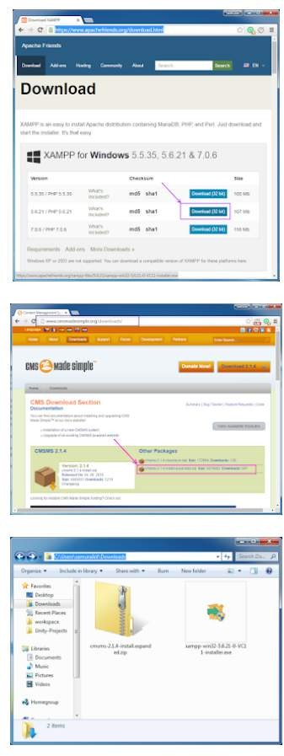

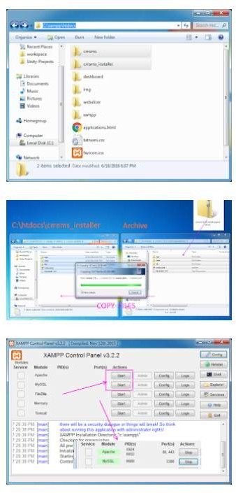

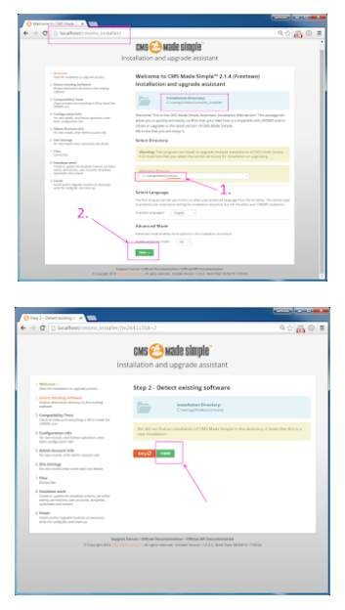

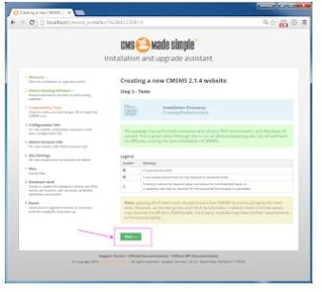

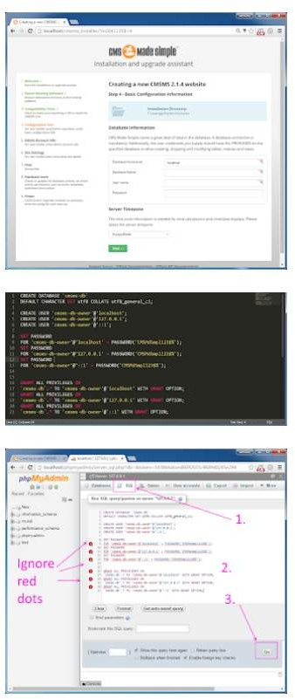

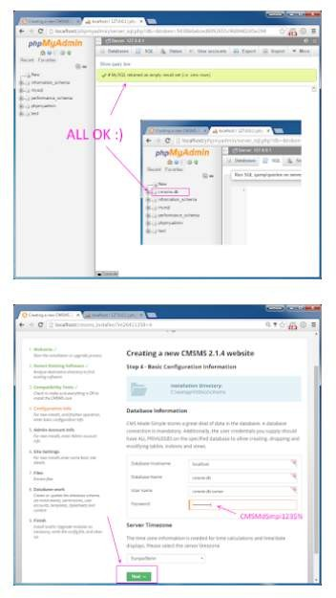

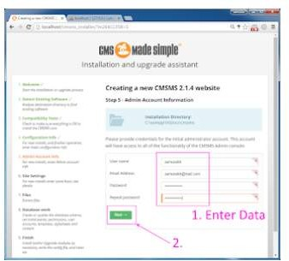

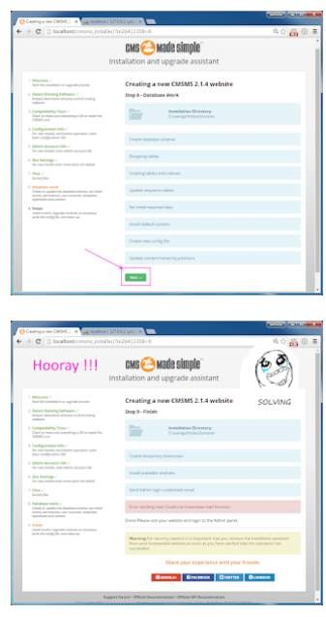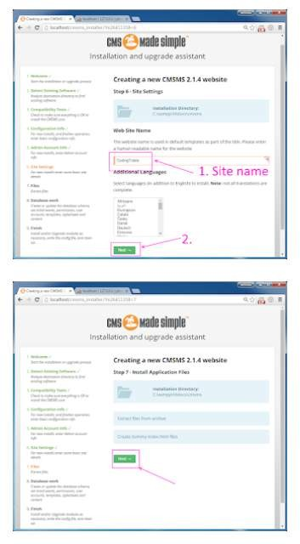

# EXPERIMENT NO. - 15

**Aim:** In a Team of Two, choose a topic to design a website and decide upon the content. Prepare the content in a word file that will appear on the website. Also, Design a Visual site-map for the website (Pictorial representation of page linkage).

**Topic:** Portfolio Website

**Content of Word file:** Portfolio Website

## My Page

Hi, I'm Samrat.

A Developer

Self-driven, quick starter, passionate programmer with a curious mind who enjoys solving complex and challenging real-world problems.

## About

I am a Computer Science Grad Student at Maharaja Agrasen Institute Of Technology.

Detail-oriented Software Developer with professional experience in Backend Development, Machine Learning, Computer Vision. I am adept in Python, Django, Flask, SQL, Machine Learning, Computer Vision.

## Skills

* + **Languages and Databases:** Python, HTML5, CSS3, MySQL, PostgreSQL
  + **Libraries:** NumPy, Pandas, OpenCV
  + **Frameworks:** Django, Flask, Bootstrap
  + **Other:** Git, AWS, Heroku

## Experience

* + **Zhiffy-Software Developer**

Developed modular REST APIs for multiple portals of e-commerce web applications. Improved the loading time of the web application by improving the database schema and queries.

Tools: Python, Flask, MongoDB

## MTAG Innovations-Data Scientist

Developed a cloud-based data visualization and analytics web application aimed at

storing and visualizing data-points of each IoT device.

Designed and implemented a stacking model predicting the degradation of drugs and achieved 75% - 83% accuracy depending on the data for each drug.

Tools: Python, IBM Cloud, Node Red, Flask

## Contact Me

Email: [abhinav@gmail.com](mailto:abhinav@gmail.com) LinkedIn: linked.com/in/Abhinav

**Site Map:**

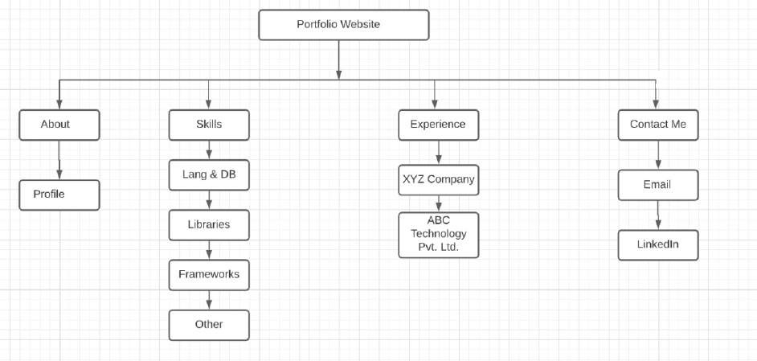

# EXPERIMENT NO. - 16

**Aim:** Configure the CMS and Add the content according to the design and visual site-map for the website.

## Code:

Style.css

.header { overflow: hidden;

background-color: #f1f1f1; padding: 20px 10px;

}

/* Style the header links */

.header a { float: left; color: black;

text-align: center; padding: 12px;

text-decoration: none; font-size: 18px;

line-height: 25px; border-radius: 4px;

}

/* Style the logo link (notice that we set the same value of line-height and font-size to prevent the header to increase when the font gets bigger */

.header a.logo { font-size: 25px; font-weight: bold;

}

/* Change the background color on mouse-over */

.header a:hover {

background-color: #ddd; color: black;

}

/* Style the active/current link*/

.header a.active {

background-color: dodgerblue; color: white;

}

/* Float the link section to the right */

.header-right { float: right;

}

/* Add media queries for responsiveness - when the screen is 500px wide or less, stack the links on top of each other */

@media screen and (max-width: 500px) {

.header a { float: none; display: block; text-align: left;

}

.header-right { float: none;

}

}

about.html

<div class="header">

<a href="#default" class="logo">Portfolio Website</a>

<div class="header-right">

<a href="file:///C:/Users/pavit/Downloads/index.html">Home</a>

<a class="active" href="file:///C:/Users/pavit/Downloads/about.html">About</a>

<a href="file:///C:/Users/pavit/Downloads/skills.html">Skills</a>

<a href="file:///C:/Users/pavit/Downloads/experience.html">Experience</a>

<a href="file:///C:/Users/pavit/Downloads/contact.html">Contact Me</a>

</div>

</div>

<h4>I am a Computer Science Graduate Student at Maharaja Agrasen Institute Of Technology.</h2>

<br>

</p>Detail-oriented Software Developer with professional experience in Backend Development, Machine Learning, Computer Vision. I am adept in Python, Django, Flask, SQL, Machine Learning, Computer Vision.</p>

contact.html

<div class="header">

<a href="#default" class="logo">Portfolio Website</a>

<div class="header-right">

<a href="file:///C:/Users/pavit/Downloads/index.html">Home</a>

<a href="file:///C:/Users/pavit/Downloads/about.html">About</a>

<a href="file:///C:/Users/pavit/Downloads/skills.html">Skills</a>

<a href="file:///C:/Users/pavit/Downloads/experience.html">Experience</a>

<a class="active" href="file:///C:/Users/pavit/Downloads/contact.html">Contact Me</a>

</div>

</div>

<h2>Email: </h2> [<p>random@gmail.c](mailto:random@gmail.com)om</p><br>

<h2>LinkedIn: </h2> <p>linked.com/in/random</p><br> Experience.html

<div class="header">

<a href="#default" class="logo">Portfolio Website</a>

<div class="header-right">

<a href="file:///C:/Users/pavit/Downloads/index.html">Home</a>

<a href="file:///C:/Users/pavit/Downloads/about.html">About</a>

<a href="file:///C:/Users/pavit/Downloads/skills.html">Skills</a>

<a class="active" href="file:///C:/Users/pavit/Downloads/experience.html">Experience</a>

<a href="file:///C:/Users/pavit/Downloads/contact.html">Contact Me</a>

</div>

</div>

<h2>XYZ Company -Software Developer</h2>

<p>

Developed modular REST APIs for multiple portals of e-commerce web application. Improved the loading time of the web application by improving the database schema and queries.<br>

Tools: Python, Flask, MongoDB

<p><br>

<h2>ABC Technology Pvt. Ltd. -Data Scientist</h2>

</p>

Developed a cloud-based data visualization and analytics web application aimed at storing and visualizing data-points of each IoT device.

Designed and implemented a stacking model predicting the degradation of drugs and achieved 75% - 83% accuracy depending on the data for each drug. <br>

Tools: Python, IBM Cloud, Node Red, Flask

</p> index.html

<div class="header">

<a href="#default" class="logo">Portfolio Website</a>

<div class="header-right">

<a class="active" href="file:///C:/Users/pavit/Downloads/index.html.html">Home</a>

<a href="file:///C:/Users/pavit/Downloads/about.html">About</a>

<a href="file:///C:/Users/pavit/Downloads/skills.html">Skills</a>

<a href="file:///C:/Users/pavit/Downloads/experience.html">Experience</a>

<a href="file:///C:/Users/pavit/Downloads/contact.html">Contact Me</a>

</div>

</div>

<h1>Hi, I'm a Random Person.</h1>

<h2>A developer </h2>

<br>

</p>Self-driven, quick starter, passionate programmer with a curious mind who enjoys solving a complex and challenging real-world problems.</p>

skills.html

<div class="header">

<a href="#default" class="logo">Portfolio Website</a>

<div class="header-right">

<a href="file:///C:/Users/pavit/Downloads/index.html">Home</a>

<a href="file:///C:/Users/pavit/Downloads/about.html">About</a>

<a class="active" href="file:///C:/Users/pavit/Downloads/skills.html">Skills</a>

<a href="file:///C:/Users/pavit/Downloads/experience.html">Experience</a>

<a href="file:///C:/Users/pavit/Downloads/contact.html">Contact Me</a>

</div>

</div>

<h3>Languages and Databases:</h3> <p>Python, HTML5, CSS3, MySQL, PostgreSQL</p><br>

<h3>Libraries:</h3> <p> NumPy, Pandas, OpenCV</p><br>

<h3>Frameworks: </h3> <p>Django, Flask, Bootstrap</p><br>

<h3>Other: </h3> <p>Git, AWS, Heroku</p><br>

