JAIBB
Laws and Practice of General Banking (LPGB)
7th Banking Professional Examination, 2025
7th Banking Professional Examination, 2025
Part A - Broad Questions (Marks: 20)
Complete Module-wise Guide
Based on Past Exam Analysis (96th - 99th, 5th & 6th)
Subject Code: 104 | Full Marks: 100 | Pass Marks: 45 | Time: 3 Hours

Table of Contents

Past Exam Analysis - Broad Questions (Part A, 20 Marks) 1
Topic 1: Artha Rin Adalat Ain, 2003 2
Question [Marks: 20] 2
Answer 2
Key Provisions Table 2
Loan Recovery Process Flowchart 3
Time Limit for Filing Suit (Sec 46) 4
Auction Sale Procedure (Sec 33) 4
Appeal and Revision 5
Topic 2: Bank Company Act, 1991 5
Question [Marks: 20] 5
Answer (a): Director Vacancy Situations 5
Answer (b): Restrictions on Loans and Advances 6
Answer (c): PCA - Section 77 Ka 7
Capital Adequacy Requirements 7
Topic 3: Banker-Customer Relationship 8
Question [Marks: 20] 8
General Relationship - Debtor and Creditor 8
Special Relationships 8
Rights and Duties 9
Exceptions to Secrecy 10
Topic 4: Negotiable Instruments Act, 1881 10
Question [Marks: 20] 10
Crossing of Cheque 10
Types of Crossing 11
Endorsement (Sec 15-16) 11
Payment vs Holder in Due Course 12
Topic 5: FERA, 1947 & KYC/CDD/EDD 13
Question [Marks: 20] 13
FERA 1947 13
Authorized Dealers vs Money Changers 14
KYC, CDD, EDD 14
KYC Documents Required 15
Topic 6: Hundi & Guarantee vs Indemnity 15
Question [Marks: 20] 15
Hundi 15
Guarantee vs Indemnity 16
Quick Reference - Important Legal Sections 17

Note: Right-click the Table of Contents and select “Update Field” to show correct page numbers.

Past Exam Analysis - Broad Questions (Part A, 20 Marks)

Module / Topic | 96th | 97th | 98th | 99th | 5th | 6th | 7th Prob.
Artha Rin Adalat Ain, 2003 | Yes | - | Yes | Yes | - | - | HIGH
BCA 1991 - Credit/Director/PCA | Yes | Yes | Yes | - | - | - | HIGH
Banker-Customer Relationship | - | Yes | Yes | Yes | Yes | - | HIGH
NI Act - Crossing/Endorsement | Yes | Yes | Yes | Yes | - | - | HIGH
FERA 1947 + KYC/CDD/EDD | Yes | Yes | Yes | Yes | Yes | - | HIGH
Hundi + Guarantee vs Indemnity | - | Yes | - | Yes | Yes | - | MEDIUM
MLPA 2012 + CTR/STR | Yes | - | Yes | Yes | Yes | Yes | LOW
Bankruptcy Act 1997 | Yes | - | Yes | - | - | Yes | LOW
Registration Act / Gift | - | - | - | Yes | Yes | Yes | LOW
Dormant Account / Positive Pay | - | Yes | - | Yes | - | Yes | LOW

HIGH = Very likely for 7th exam | MEDIUM = Possible | LOW = Already covered in 6th exam

Topic 1: Artha Rin Adalat Ain, 2003
Money Loan Court Act, 2003 - Loan Recovery Law

Question [Marks: 20]
(a) Discuss the main provisions of Artha Rin Adalat Ain, 2003. What duties should banker follow before filing suit? [10]
(b) Describe the auction sale procedure and appeal/revision provisions. How does this law help in loan recovery? [10]

Answer
Artha Rin Adalat Ain, 2003 is a special law enacted for speedy recovery of classified loans. It has 60 sections in 8 chapters. This law supersedes the Civil Procedure Code for loan recovery matters. Suit minimum value: Tk 1,00,000 (Sec 4).

Key Provisions Table
Section | Provision | Details
Sec 4 | Minimum suit value | Tk 1,00,000 (1 lakh)
Sec 6 | Plaint format | Plaint + Affidavit (treated as substantive evidence)
Sec 7 | Summons | Must be served within 15 days
Sec 9-10 | Written reply | Defendant must reply within 40 days
Sec 12 | Sale before suit | Sell lien/pledge/hypothecation securities FIRST
Sec 16 | Judgment time | Within 10 days of hearing completion
Sec 17 | Case settlement | 90 days (30 + 30 extension)
Sec 28 | Execution case | Must file within 360 days
Sec 33 | Auction sale | Through sealed tenders, 15 days notice
Sec 34 | Civil imprisonment | Up to 6 months for non-payment
Sec 41 | Appeal | 50% decretal amount, 90 days
Sec 42 | Revision | 75% decretal amount, 60 days
Sec 46 | Filing time limit | 10%/15%/25% in 1st/2nd/3rd year
Sec 47 | Suit value limit | Principal + max 200% interest

Loan Recovery Process Flowchart
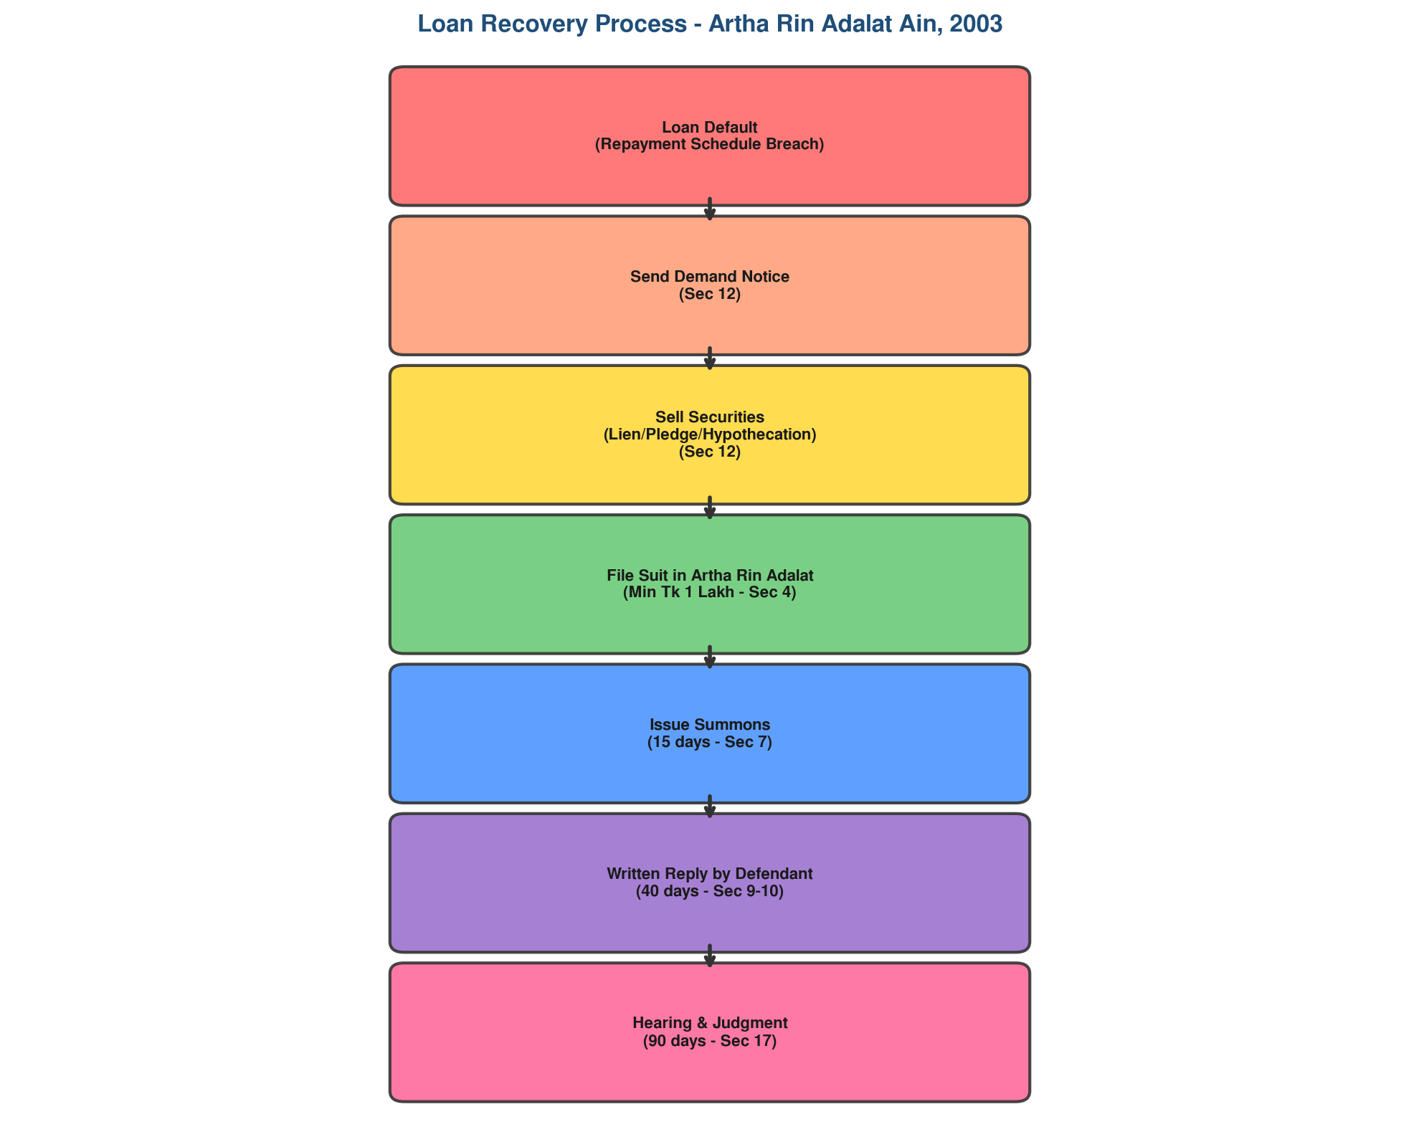

Time Limit for Filing Suit (Sec 46)
Period | Minimum Repayment Required | Time to File Suit
1st Year | 10% of scheduled amount | Within next 1 year
2nd Year | 15% of scheduled amount | Within next 1 year
3rd Year | 25% of scheduled amount | Within next 1 year
Less than 3 years total | Less than 20% total | Within next 1 year

Auction Sale Procedure (Sec 33)
Step 1: Publish notice - 15 days in national Bangla daily + local paper + court notice board
Step 2: Receive sealed tenders from bidders with bank draft/pay order
Step 3: Security deposit - 20% (up to Tk 10 lac) / 15% (10-50 lac) / 10% (above 50 lac)
Step 4: Open tenders, evaluate, accept highest valid bid
Step 5: Payment - 30/60/90 days respectively for the three slabs
Step 6: If bidder defaults, security money forfeited
Step 7: Court issues title deed certificate to decree holder

Appeal and Revision
Matter | Appeal (Sec 41) | Revision (Sec 42)
Deposit Required | 50% of decretal amount | 75% of decretal amount
Forum (< Tk 50 lac) | District Judge | Appropriate court
Forum (> Tk 50 lac) | High Court Division | High Court Division
Time Limit | 90 days + 30 extension | 60 days + 30 extension
Interest Rate | 16% | 16%

Interest rates: Normal decree = 12% | Appeal/Revision = 16% | Higher court = 18% | Writ discharged = 25%

Topic 2: Bank Company Act, 1991
Credit Restrictions, Director Vacancy & Prompt Corrective Action

Question [Marks: 20]
(a) Under what situations does a director's office fall vacant per BCA 1991? [6]
(b) State the general limitations and restrictions on loans and advances. [7]
(c) What is Prompt Corrective Action (PCA) under Section 77 Ka? [7]

Answer (a): Director Vacancy Situations
No. | Ground for Vacancy | Legal Basis
1 | Convicted for offence involving moral turpitude | Sec 14(2)(a)
2 | Unsound mind / mental incapacity | Sec 14(2)(b)
3 | Undischarged insolvent | Sec 14(2)(c)
4 | Fails to pay call money on shares | Sec 14(2)(d)
5 | Removal by shareholders (special resolution) | Sec 15
6 | Holds notable shares (>5%) without BB approval | Sec 14-Ka
7 | Resignation by director | Sec 14
8 | Death of director | Sec 14
9 | Failure to attend 3 consecutive board meetings | Sec 14(2)
10 | Director of bank classified as willful defaulter | Sec 27KaKa

Answer (b): Restrictions on Loans and Advances
Section | Restriction | Details | Punishment
Sec 27 | Loans against own shares | No loan against security of bank's own shares | -
Sec 27 | Unsecured to directors | No unsecured loans to directors/family | -
Sec 27 | Director-related loans | Majority approval (excl. concerned director) | -
Sec 27KaKa | Defaulters list | No fresh loan to any loan defaulter | -
Sec 28 | Respite of loans | BB approval mandatory for director-related respite | 3 years + Tk 30,000
Sec 29 | BB control on advances | BB sets: credit ceilings, small loan ratio, purpose | -
Sec 13 | Capital maintenance | Min CAR 10% + 2.5% CCB = 12.5% | Penalty per Sec 13(7)
Sec 22 | Dividend payment | No dividend without writing off expenses | -
Sec 14-Ka | Share holding | Max 10% per family, 5% notable shares BB approval | Share forfeiture
Sec 25 | CRR | Cash Reserve Ratio maintained with BB (4%) | Penalty
Sec 33 | SLR | 13% conventional, 5.5% Islamic banking | Penalty

Answer (c): Prompt Corrective Action (PCA) - Section 77 Ka (2023 Amendment)
Section 77 Ka of the BCA (Amendment) Act, 2023 empowers Bangladesh Bank to take early action for proper management of weak bank companies. Key features:
1. Early Intervention: BB can act BEFORE a bank becomes critically weak
2. Resolution Measures: BB can order merger, reconstruction, or restructuring
3. Capital Conservation Buffer (CCB): Banks must maintain 2.5% buffer above minimum CAR
4. Regulatory Power: BB can restrict business, impose penalties, remove directors
5. Merger Authority: BB can direct merger of weak banks with stronger ones
6. Good Governance: Ensures discipline through timely intervention

Capital Adequacy Requirements
Ratio | Minimum Required | Description
CET1 | 4.5% of RWA | Common Equity Tier 1 Capital
Tier-1 | 6.0% of RWA | Core Capital (CET1 + AT1)
Total CAR | 10.0% of RWA | Tier-1 + Tier-2 Capital
CCB | 2.5% of RWA | Capital Conservation Buffer (in CET1 form)
Effective CAR | 12.5% of RWA | Total CAR + CCB combined
Formula: CAR = (Total Eligible Capital / Total Risk Weighted Assets) x 100

Topic 3: Banker-Customer Relationship
Rights, Duties & Special Relationships

Question [Marks: 20]
(a) Describe General and Special relationship between banker and customer. [10]
(b) What are the rights and duties of banker and customer? [10]

Answer (a): General Relationship - Debtor and Creditor
The fundamental relationship is DEBTOR-CREDITOR. When a customer deposits money, the bank is DEBTOR and customer is CREDITOR. When the bank lends, the roles reverse. Key point: Bank as debtor must pay ON DEMAND.

Aspect | When Depositing Money | When Borrowing Money
Bank is | DEBTOR (owes money to customer) | CREDITOR (customer owes bank)
Customer is | CREDITOR (bank owes customer) | DEBTOR (owes bank)
Nature of debt | Payable on DEMAND | Payable per SCHEDULE
Obligation | Bank must pay when customer demands | Customer must repay per loan terms

Special Relationships
No. | Relationship | When It Arises | Example
1 | Bailor - Bailee | Safe custody / Locker service | Valuables in bank locker
2 | Principal - Agent | Collection of cheques/bills | Bank collects outstation cheques
3 | Lessor - Lessee | Hiring safe deposit locker | Bank rents locker to customer
4 | Trustee - Beneficiary | Trust accounts | Bank manages trust funds
5 | Pledger - Pledgee | Pledge of securities as collateral | Customer pledges shares for loan
6 | Indemnifier - Indemnified | Bank drafts, TT, mail transfers | Customer indemnifies bank for DD
7 | Mortgagor - Mortgagee | Mortgage loans against property | Customer mortgages property

Answer (b): Rights and Duties
Party | Rights | Duties
Banker's Rights | 1. General Lien on customer's securities  2. Right of Set-off  3. Right to charge interest  4. Right to close accounts (with notice)  5. Right to refuse cheques (valid grounds) | 1. Maintain secrecy of accounts  2. Honor cheques (if funds available)  3. Provide account statement  4. Give reasonable notice before closing  5. Follow standing instructions
Customer's Rights | 1. Receive interest on deposits  2. Get periodic statements  3. Sue for wrongful dishonor  4. Receive notice before closure  5. Withdraw money on demand | 1. Present cheques within validity  2. Inform bank about forgeries  3. Maintain minimum balance  4. Keep cheque book safely  5. Provide KYC documents

Exceptions to Banker's Duty of Secrecy
1. Legal Requirement - Court order, tax authority, BB requirements
2. Public Duty - Disclosure in national interest, crime prevention
3. Bank's Own Interest - Recovery of dues, legal proceedings
4. Customer Consent - With express or implied permission
5. Under AML/CFT Laws - CTR, STR reporting to BFIU per MLPA 2012

Topic 4: Negotiable Instruments Act, 1881
Crossing, Endorsement & Payment/Holder in Due Course

Question [Marks: 20]
(a) What is crossing of cheque? Discuss types under NI Act 1881. [7]
(b) What is endorsement? Explain types and general principles. [7]
(c) Differentiate Payment in Due Course and Holder in Due Course. [6]

Answer (a): Crossing of Cheque (Sec 123-131)
Crossing means drawing two parallel transverse lines on the face of a cheque. It directs the paying bank to pay only through a bank account, NOT in cash over the counter. This reduces fraud risk significantly.

Types of Crossing
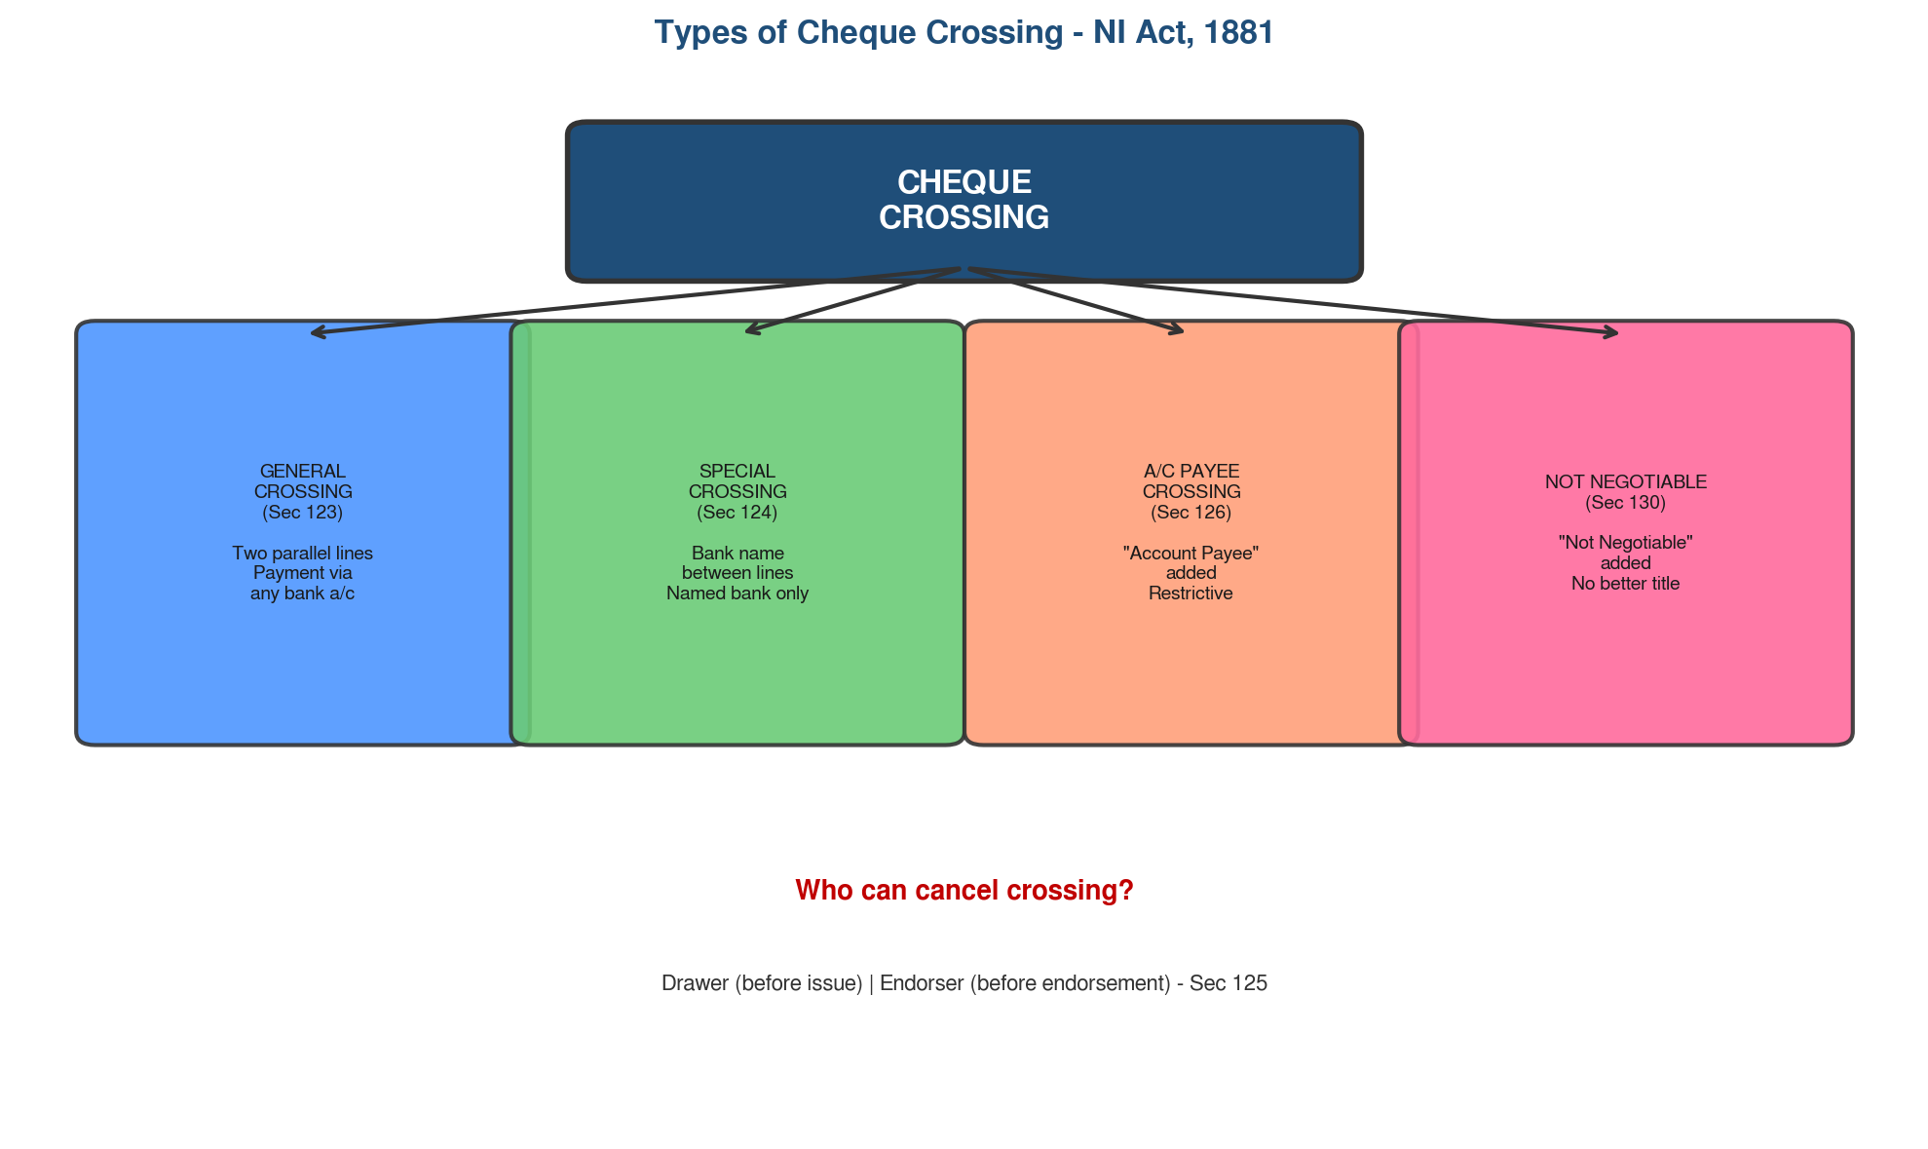

Type | Section | Description | Effect
General | Sec 123 | Two parallel lines (with or without 'and company') | Payment via any bank a/c
Special | Sec 124 | Bank name written between parallel lines | Only named bank collects
A/C Payee | Sec 126 | 'Account payee' added to crossing | Restrictive - payee's a/c only
Not Negotiable | Sec 130 | 'Not negotiable' added | Transferee gets no better title
Double | Sec 127 | Already specially crossed, crossed again | Banker may refuse payment
Who can cancel crossing: Drawer (before issue) or Endorser (before endorsement) - Sec 125

Answer (b): Endorsement (Sec 15-16)
Endorsement means signing the back of a negotiable instrument for negotiation. The endorser signs, the endorsee receives. Must be on the instrument, signed by endorser.

Type | Description | Valid/Invalid
Blank | Only signature, no name - becomes bearer instrument | VALID
Special/Full | Signature + direction to pay specific person | VALID
Restrictive | Restricts further negotiation | VALID
Partial | Endorses only part of amount | INVALID (Sec 50)
Conditional | Payment subject to condition | Bank may ignore condition
Principles: Must be on instrument; must sign; must be for full amount; if two payees, all must endorse; maker cannot endorse (Sec 51).

Answer (c): Payment in Due Course vs Holder in Due Course
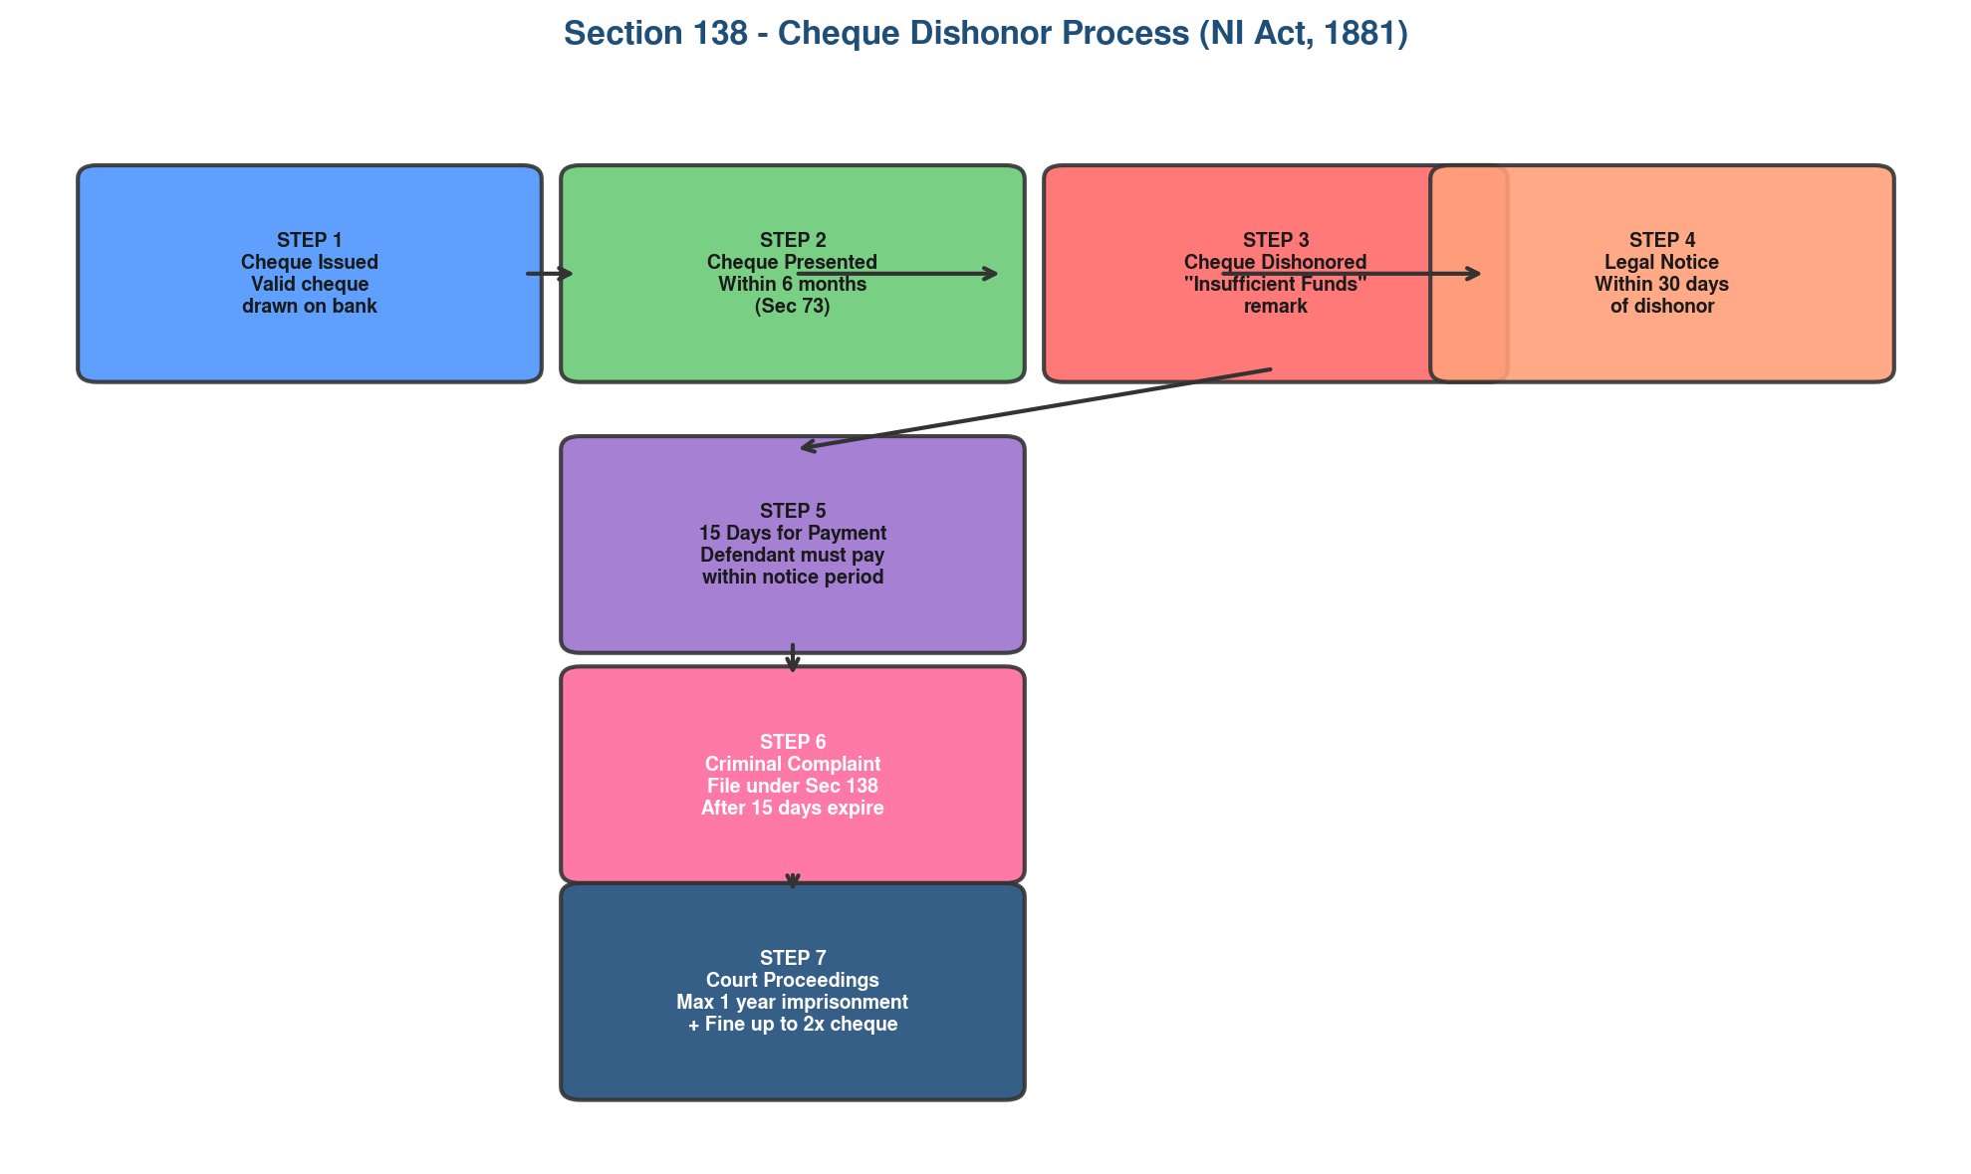

Basis | Payment in Due Course (Sec 10) | Holder in Due Course (Sec 9)
Who | BANK/Paying banker | HOLDER/Receiver of instrument
Definition | Payment in good faith, without notice of defect in title | Takes for consideration, before maturity, in good faith
Conditions | 1. Good faith  2. No notice of defect  3. Per apparent tenor | 1. For consideration  2. Before maturity  3. Good faith  4. No notice of defect
Rights | Bank discharged from liability to true owner | Gets better title than transferor (free from defects)
Protection | Bank protected from true owner's claim | HDC takes free from all prior claims

Topic 5: FERA, 1947 & KYC/CDD/EDD
Foreign Exchange Regulation & Customer Due Diligence

Question [Marks: 20]
(a) State scope and main purposes of FERA 1947. Who are Authorized Dealers? [10]
(b) Discuss importance of KYC, CDD, and EDD. What documents required? [10]

Answer (a): Foreign Exchange Regulation Act, 1947
FERA 1947 is the primary law governing foreign exchange transactions in Bangladesh. It provides the regulatory framework for all dealings in foreign exchange, foreign securities, and payments to/from persons outside Bangladesh.

Scope: All foreign exchange transactions, import/export of currency/gold, opening foreign currency accounts, remittance abroad, acquisition of foreign securities, payments to/from persons outside Bangladesh.

Authorized Dealers vs Money Changers
Category | Authorized Dealers (Sec 3) | Money Changers (Sec 3A)
Who | Scheduled banks with BB license | Authorized firms/individuals
Scope | ALL types of forex transactions | Limited to tourist/travel only
Operations | Full range of forex banking services | Only buying/selling forex notes
Reporting | Full reporting to BB/BFIU | Limited reporting
Blocked Account (Sec 9): No withdrawal without BB permission. Special Account (Sec 10): Non-resident accounts for approved purposes.

Answer (b): KYC, CDD, and EDD
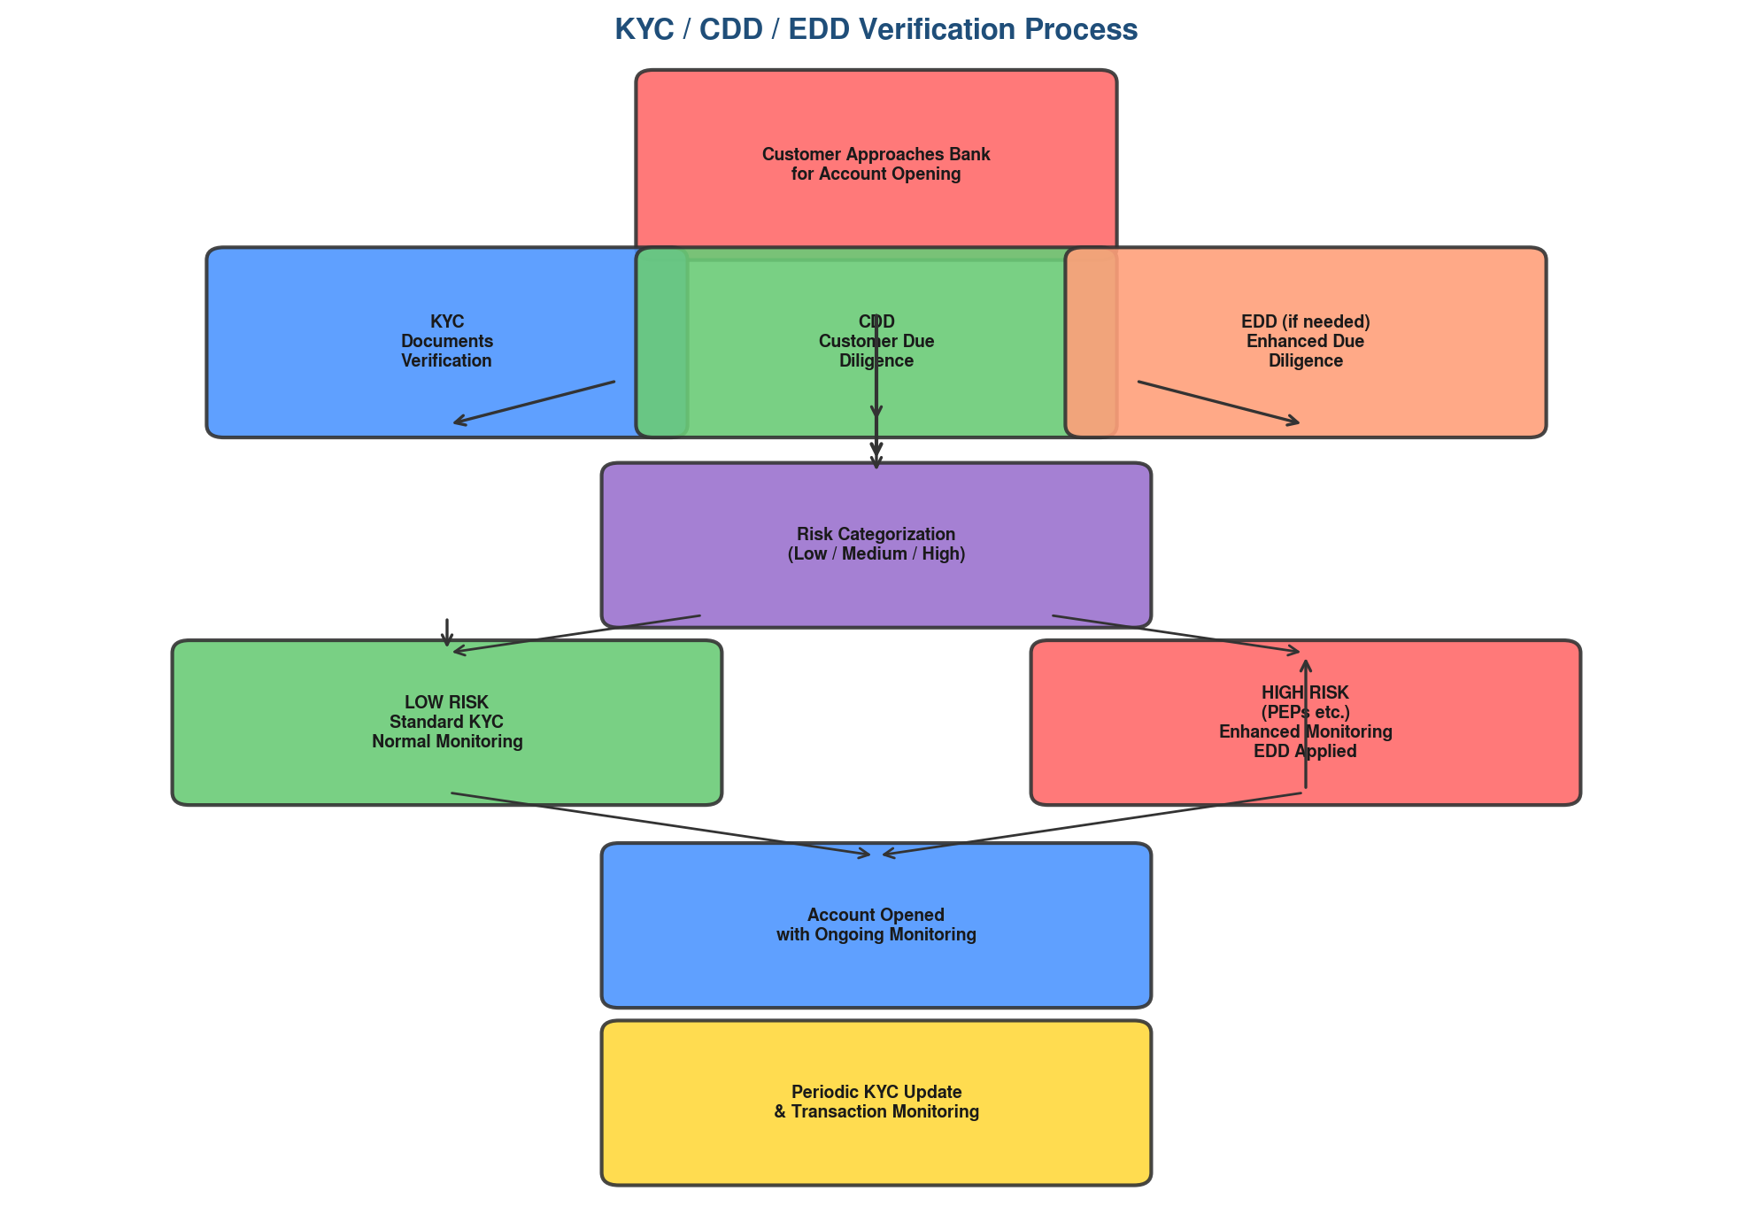

KYC = Know Your Customer (foundation for all customer identification)
CDD = Customer Due Diligence (standard verification measures for all customers)
EDD = Enhanced Due Diligence (additional scrutiny for PEPs and high-risk customers)

KYC Documents Required
Customer Type | Required Documents
Individual | NID/Passport, Photograph, Utility Bill (address proof)
Company (Ltd.) | Certificate of Incorporation, MOA/AOA, Trade License, TIN, Board Resolution
Partnership | Partnership Deed, Trade License, TIN, Partners' NID
Sole Proprietorship | Trade License, TIN, Owner's NID, Utility Bill
Minor/Student | Birth Certificate, Guardian's NID, Guardian's signature, School ID
PEP | All individual docs + source of wealth + PEP status declaration

EDD Measures (High-Risk): Senior management approval, enhanced monitoring, source of funds/wealth verification, Enhanced CPV, lower transaction thresholds, additional identity documents.

Topic 6: Hundi & Guarantee vs Indemnity
Contract Act, 1872 - Traditional Instruments & Contractual Relationships

Question [Marks: 20]
(a) What is Hundi? Can it be considered a negotiable instrument? Discuss reasons and economic impact. [10]
(b) Differentiate between Contract of Guarantee and Contract of Indemnity. [10]

Answer (a): Hundi
Hundi is a traditional financial instrument used in the Indian subcontinent for remitting money. It is an unconditional written order by one person on another directing payment of a certain sum to a specified person.
Is Hundi a Negotiable Instrument? NO - Hundi is NOT recognized under the Negotiable Instruments Act, 1881. It operates outside the formal banking system.

Types of Hundi
Type | Description
Darshani Hundi | Payable on sight/presentation - like demand draft
Muddati Hundi | Payable after a specified time period - like usance bill
Nam-jad Hundi | Payable to specified person (order instrument)
Shah-jad Hundi | Payable to bearer - whoever presents gets payment
Jokhmi Hundi | Conditional Hundi - payment subject to safe arrival of goods

Reasons for Using Hundi & Economic Impact
Reasons: Avoid banking channels, maintain secrecy, evade tax/forex regulations, no documentation needed, lower/no fees, no KYC requirements.
Negative Impact: (1) Loss of foreign exchange - bypasses official channels; (2) Money laundering tool; (3) Tax evasion - escapes tax net; (4) Strengthens informal/black economy; (5) Finances terrorism/anti-national activities; (6) Reduces monetary policy effectiveness.

Answer (b): Guarantee vs Indemnity (Contract Act, 1872)
Contract of Indemnity (Sec 124): A contract where one party promises to save the other from loss caused by the promisor's own conduct or a third party. Example: FDR indemnity bond.
Contract of Guarantee (Sec 126): A contract to perform the promise or discharge the liability of a THIRD person in case of default. Three parties: Surety, Principal Debtor, Creditor. Example: Bank loan guarantee.

Basis | Guarantee (Sec 126) | Indemnity (Sec 124)
Parties | THREE: Surety, Principal Debtor, Creditor | TWO: Indemnifier, Indemnified
Purpose | Answer for default of THIRD PARTY | Protect from loss by promisor/third party
Liability | Secondary/Co-extensive (after principal defaults) | Primary (indemnifier directly liable)
Contracts | Three contracts between three parties | One contract between two parties
Consideration | Must exist (Sec 127) | Can be anything
Right to Sue | After paying creditor, can sue principal debtor | Immediately after loss
Nature | Joint and several (Sec 128) | Only indemnifier liable
Continuing | Can be continuing guarantee (Sec 129) | Generally single transaction
Example | Third person guarantees bank loan | FDR indemnity bond for lost original

Quick Reference - Important Legal Sections

Act | Section | Subject
NI Act 1881 | Sec 4, 5, 6 | Promissory Note, Bill of Exchange, Cheque definitions
NI Act 1881 | Sec 9 | Holder in Due Course
NI Act 1881 | Sec 10 | Payment in Due Course
NI Act 1881 | Sec 73 | Cheque presentation time (6 months)
NI Act 1881 | Sec 123-131 | Crossing provisions
NI Act 1881 | Sec 138 | Cheque dishonor punishment
MLPA 2012 | Sec 2(cha) | Money Laundering definition
MLPA 2012 | Sec 4 | ML punishment (4-12 years)
MLPA 2012 | Sec 25 | Reporting obligation (CTR/STR)
BCA 1991 | Sec 13 | Maintenance of Capital/CAR
BCA 1991 | Sec 25, 33 | CRR and SLR
BCA 1991 | Sec 27 | Restrictions on loans/advances
BCA 1991 | Sec 35 | Unclaimed deposits (10 years)
BCA 1991 | Sec 77 Ka | Prompt Corrective Action (PCA)
Artha Rin 2003 | Sec 4, 12, 33, 46, 47 | Suit value, sale, auction, time limit, suit value
Artha Rin 2003 | Sec 41, 42 | Appeal (50%) and Revision (75%)
FERA 1947 | Sec 3, 9, 10 | Authorized Dealers, Blocked/Special Account
Contract Act 1872 | Sec 124, 126 | Indemnity and Guarantee
Contract Act 1872 | Sec 172 | Pledge definition
Registration 1908 | Sec 17, 49 | Compulsory registration, non-registration effects
TPA 1882 | Sec 122, 123 | Gift definition and registration
TPA 1882 | Sec 53 | Fraudulent transfer
Bankruptcy 1997 | Sec 9, 18, 24 | Min debt Tk 1L, fraudulent transfer, restrictions
Majority Act 1875 | Sec 3 | Minor = Below 18 years
ICT Act 2006 | Sec 9 | Electronic records retention (5 years)

