* **QUERIES AND THEIR OUTPUT:**

**1b) Query:**SELECT Company.cname, W.pid, W.salary

FROM Company, worksFor W, Knows, (SELECT pid FROM personSkill WHERE skill = 'Operating Systems') OS

WHERE Company.cname = W.cname

AND W.pid = Knows.pid1

AND Knows.pid2 = OS.pid

AND W.salary = (SELECT MIN(W2.salary) FROM worksFor W2 WHERE W2.cname = Company.cname)

ORDER BY Company.cname, W.pid;  
**Output/ Result:***Empty Result Set*

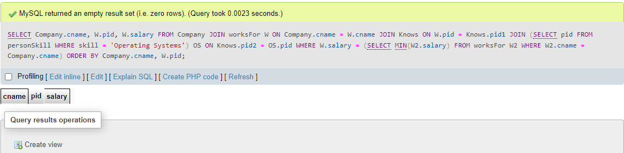



**2b) Query:**SELECT P.pname, W.salary, P.city

FROM Person P

JOIN worksFor W ON P.pid = W.pid

LEFT JOIN (

SELECT DISTINCT P2.pid, P2.city

FROM Person P2

JOIN personSkill PS ON P2.pid = PS.pid

WHERE PS.skill = 'Networks'

) NetworkCities ON P.city = NetworkCities.city AND P.pid = NetworkCities.pid

WHERE NetworkCities.pid IS NULL

AND W.salary = (

SELECT MAX(W2.salary)

FROM worksFor W2

WHERE W2.cname = W.cname

)

ORDER BY P.pname;  
**Output/ Result:**

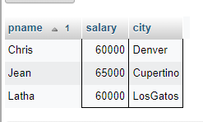

**3b) Query:**SELECT DISTINCT W1.cname AS c1, W2.cname AS c2

FROM worksFor W1

JOIN worksFor W2 ON W1.cname < W2.cname

LEFT JOIN Person P1 ON P1.pid = W1.pid AND P1.city = 'Chicago'

LEFT JOIN Person P2 ON P2.pid = W2.pid AND P2.city = 'Chicago'

WHERE P1.pid IS NULL AND P2.pid IS NULL

ORDER BY c1, c2;

**Output/ Result:**

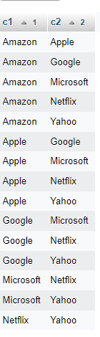

**12) Query:**CREATE VIEW CompanyKnownPerson AS

SELECT DISTINCT W1.pid AS known_person

FROM worksFor W1

JOIN Knows K1 ON W1.pid = K1.pid1

LEFT JOIN Knows K2 ON K1.pid2 = K2.pid2 AND K1.pid1 <> K2.pid1

LEFT JOIN worksFor W2 ON K1.pid2 = W2.pid AND W1.cname = W2.cname AND W1.salary > W2.salary

WHERE K2.pid2 IS NULL AND W2.pid IS NULL;

-- Test your view

SELECT * FROM CompanyKnownPerson;  
**Output/Result:**

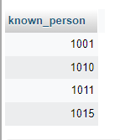

**13) Query:**DELIMITER //

CREATE PROCEDURE SkillOnlyOnePerson(IN skill1 TEXT)

BEGIN

-- Create a temporary table to store the result

CREATE TEMPORARY TABLE TempSkillOnlyOnePerson AS

SELECT PS1.pid AS pid1, PS2.pid AS pid2

FROM personSkill PS1

JOIN personSkill PS2 ON PS1.pid <> PS2.pid

LEFT JOIN personSkill PS3 ON PS3.pid = PS2.pid AND PS3.skill = skill1

WHERE PS1.skill = skill1 AND PS3.pid IS NULL;

-- Query the temporary table

SELECT * FROM TempSkillOnlyOnePerson;

-- Drop the temporary table

DROP TEMPORARY TABLE TempSkillOnlyOnePerson;

END //

DELIMITER ;

-- Call the stored procedure to get the result for 'WebDevelopment'

CALL SkillOnlyOnePerson('WebDevelopment');

**Output/Result:**

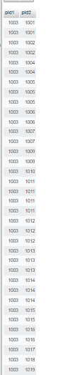

**14) Query:**

DROP PROCEDURE RecursiveSameGeneration;

-- Create a temporary table to store the intermediate results

CREATE TEMPORARY TABLE TempSameGeneration AS

SELECT parent, child

FROM PC;

-- Create a stored procedure for recursive processing

DELIMITER //

CREATE PROCEDURE RecursiveSameGeneration()

BEGIN

DECLARE done INT DEFAULT FALSE;

REPEAT

-- Insert the next generation into the temporary table

INSERT IGNORE INTO TempSameGeneration

SELECT PC.parent, PC.child

FROM PC

JOIN TempSameGeneration SG ON PC.child = SG.parent;

-- Check if no new rows were inserted

SET done = ROW_COUNT() = 0;

UNTIL done END REPEAT;

END //

DELIMITER ;

CALL RecursiveSameGeneration ();

-- Query the temporary table

SELECT * FROM TempSameGeneration;

-- Drop the temporary table

DROP TEMPORARY TABLE TempSameGeneration; **Output/Result:**

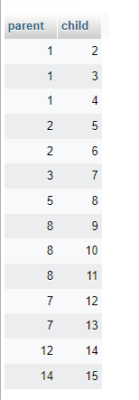

**15) Query:**DROP PROCEDURE RecursiveInheritance;

-- Create a temporary table to store the intermediate results

CREATE TEMPORARY TABLE TempInheritance AS

SELECT child_id AS m, gold_accumulated AS p

FROM Hierarchy

WHERE parent_id IS NULL;

-- Create a stored procedure for recursive processing

DELIMITER //

CREATE PROCEDURE RecursiveInheritance()

BEGIN

DECLARE done INT DEFAULT FALSE;

REPEAT

-- Insert the next generation into the temporary table

INSERT IGNORE INTO TempInheritance

SELECT H2.child_id AS m, H1.p + H2.gold_accumulated AS p

FROM TempInheritance H1

JOIN Hierarchy H2 ON H1.m = H2.parent_id;

-- Check if no new rows were inserted

SET done = ROW_COUNT() = 0;

UNTIL done END REPEAT;

END //

DELIMITER ;

CALL RecursiveInheritance();

-- Query the temporary table

SELECT * FROM TempInheritance;

-- Drop the temporary table

DROP TEMPORARY TABLE TempInheritance;  
**Output/Result:**

