*E-Blood Services System*

**Abstract**— “Blood” one of the most important necessities of our life. E-Blood Services System intends to provide an efficient and a real time coordination of blood management among blood banks. The proposed work further discusses the components of enhanced framework in numerous perspectives such as the data being stored, data for future applications like kind of blood groups being donated and received by the individuals. Every time the new user accesses the system as a donor, he/she has to register himself/herself and provide a proof of their identity like license or government document on which the blood group of the person is mentioned. This project is an android application, it will contain all the information of the donor and nearby hospitals and other nearby official organizations like NGO’s. The application will also contain a GPS (Global Positioning System) system to track the location of the nearby blood banks or hospitals. Every registered user will get the notification regarding health checkup drives, blood donation camps in particular area etc. As the person did not need to go out far, for the search of the blood banks and hospitals, this application helps to save the time to a great extent. This system has an integration of user interaction also, where users and even hospitals can make requests for blood through the app. The mobile application helps users to connect with the system including the fastest way to reach the blood bank and even live tracking

if the blood is to be delivered from the bank to the hospital and more.

**Keywords**: donors; recipients; blood banks; hospitals; NGO’s; database; gps; php; MySQL; firebase.

1. INTRODUCTION

The requirement for the blood is an important factor in contemporary medicine and healthcare. Blood donation is a vital part of worldwide healthcare. The primary responsibility of a Blood Bank Service is to provide a safe, sufficient and timely supply of blood and blood products. In fulfilling this responsibility, the Blood Bank should ensure that the act of blood donation is safe and causes no harm to the donor. It should build and maintain a pool of safe, voluntary non-remunerated blood donors and take all necessary steps to ensure that the products derived from donated blood are efficacious for the recipient, with a minimal risk of any infection that could be transmitted through transfusion.

The Main aspect of E-blood services is to plan blood donation campaigns effectively and timely so that a high number of blood donors can gather for the donation process. In the current context, the organizers of the blood donation campaign find it difficult to select the most effective place to have the donation campaign. There are campaigns with fewer donors, and campaigns with higher donors and campaigns that have fewer donors are not very effective. Therefore, suggesting the most effective area where it is most likely to be able to gather many donors who are willing to donate blood, results in conducting an effective blood donation campaign.

Another aspect of blood bank management is to ensure a secure blood supply chain. Every blood transfusion process faces two security challenges. First, preserving the confidentiality of donors’ and receivers’ data privacy, so that sensitive data is not disclosed to unauthorized personal. Second, ensuring the integrity of blood transfusion requests, so that fake blood transfusion requests are avoided. Therefore, maintaining confidentiality and integrity during the blood transfusion process will ensure a secure blood supply chain. This study focus on designing a new system to maintain donation process by providing computerized system that saves donor information and blood tests details, using a programming language PHP which is a server-side scripting language, and My SQL, Firebase database which is a program that can store large amounts of information in an organized format that’s easily accessible through scripting languages like PHP

1. LITERATURE SURVEY

Many studies were conducted in the concept of blood bank, some of them concerned about managing donor records to facilitate the process of donation, the other focused on connecting blood banks to each other in one system and one database, the rest used modern technology such as electronic card and barcode system. Blood Bank Information Management System is an information system which helps to manage the records of donors and patient at a blood bank. It is mainly designed to store, process, retrieve and analyze information concerned with the administrative and inventory management within a blood bank . Such kind of system will allow the authorized blood bank officer to login using a secret password and easily manage the records of the blood donors and the patients in need of blood. In addition, the blood bank information management system is not obsolete to the professionals; rather it plays a great role in attracting the donors and other stakeholders due to its simplicity in the reservation, and notification of donation time to the needy. On top of this any stakeholder and/or regional blood banks in need of blood can easily access to the type and quantity of blood available in any blood bank center.

* **Existing System:**

**Blood Connect:** Blood cannot be manufactured in factories; it can only come from generous donors. To cater to this demand, Blood Connect was launched on 1st April, 2010 (as a project under NSS IIT Delhi) with an unparalleled objective of solving the problem of blood shortage in India. According to WHO data, India faces a shortage of 3 million blood units. This shortage can easily be eliminated if only an additional 2% of India's youth donates blood. To make this possible, Blood Connect acts as a channel connecting voluntary blood donors with those who need blood. It is a youth-run organization and provides free help and specially works to target the poor and the needy. Since its inception, the organization has grown a lot in terms of working for this cause. Blood Connect has developed a 360-degree solution to the problem of blood shortage.

The model revolves around 4 focal points:

• Ensuring continuous, sufficient blood supply to blood banks

• Improving awareness

• Helping those in need

• Establishing a network of youth.

**E- Blood Services:** This application helps you find people donating blood in your area. You can contact them through phone number or email address. You can see the location of user in map and if register yourself with App, you can get push notification in case your blood group matches with the need of blood. You can find nearby hospitals and access them.

**Features:**

* Find donor with your specific blood group and with your respective states and cities.
* Send notification for perfect match: This will help you know who all are having the same blood group in your local area.
* Find nearby hospitals and blood bank centers in maps.
* Provided helpline numbers in case of emergency.

**Inference from Literature Survey:** The overall review say that, blood is essential need for every human without blood no one can live in this world. In case of any emergency the patient needs blood, the doctors will check in hospital or blood bank. In case if blood is not available, we can use this type of applications. In this application who are all willing to donate blood can register they information. In case of emergency the patient may not get blood at that time once we enter the blood group which we needed it will show the nearby donor who are willing to donate blood. Once the blood is donated the account of the donor will be disabled temporarily for recovery period. Different blood banks and other authorized organizations can be connected among themselves using this application.

1. PROPOSED SYSTEM

One has to download the application E-Blood services. After downloading the application, registration form appears. The person has to select the category like donor, recipient, hospital, blood bank center etc. For registration basic details like name, address, contact, date of birth, blood group, email id, government id proof, emergency contact etc. are needed. If the person has already registered, then he/she has to login. During registration mobile verification is done. After successful verification an account is created of the person and all his/her details are stored in the database.

The user gets various options on screen:

* Donor
* Recipient
* Organize Blood Camps
* Search Blood Camps
* Search nearby Blood Bank centers
* Blood Banks
* Hospitals
* Speed Dial
* Medical First Aid
* Request for Blood
* Person profile

Just by selecting any of the options mentioned above he /she will get the information accordingly like information about blood camp, the nearby hospital, any notification etc. All the detail of the blood donor, hospital is stored in database. Security care is taken; the confidential data can only be access by the administrator. Data of each user is stored safely on cloud [5]. By using this application the user will not have to search for the blood in case of emergency and can directly get the detail of required blood donor by accessing this application.

The user can search for blood banks and blood camps. He can view other people who have already registered and he can search donors by location or type. He can organize blood camps by specifying the venue and date of the activity. This information is added in blood camps. By using GPS „Search nearby places‟ searches nearby hospitals and also gives the direction to the hospital. The user can also request for required blood by giving any small description. This request is submitted to admin who accepts or rejects the request. Accepted request is published by admin. The registered user gets notification of this published request. This information about the request is added to Requirement for blood‟ option. The user can also check various first aid details. He can update his own profile.

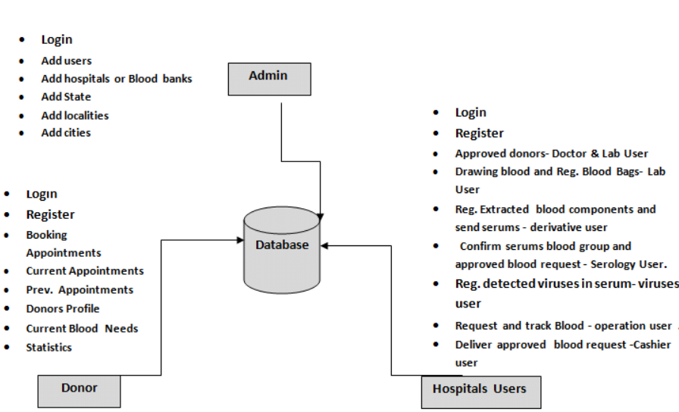

1. METHODOLOGY

PHP: PHP is a server-side scripting language designed for web development but also used as a general-purpose programming language. It is used to create dynamic Web pages, or Web pages that update and display information depending on the user's activity. PHP code is interpreted by a web server with a PHP processor module, which generates the resulting web page: PHP commands can be embedded directly into an HTML source document rather than calling an external file to process data. . PHP can be deployed on most web servers and also as a standalone shell on almost every operating system and platform, free of charge. There are four major advantages when using PHP: accessibility, compatibility, simplicity and extensive community support. Because PHP is open source, access has no restrictions. Programmers interested in using PHP only need to download the scripts, without paying a single cent. Session support in PHP consists of a way to preserve certain data across subsequent accesses. This enables you to build more customized applications and increase the appeal of your web site. PHP is designed to work well with the web, and so things like accessing the GET and POST and working with HTML and URLs are built-ins in the PHP language. This makes it really concise and straightforward to make a website. Any text editor can be used in order to code PHP such as Notebook++, jEdit, vscode, Emacs, Bluefish, or even just Notepad. Since PHP does not use a lot of a system’s resources in order to run, it operates much faster than other scripting languages. When used with other software, PHP still retains speed without slowing down other processes.

**Firebase:** Google Firebase is a Google-backed application development software that enables developers to develop iOS, Android and [Web apps](https://www.techtarget.com/searchsoftwarequality/definition/Web-application-Web-app). Firebase provides tools for tracking analytics, reporting and fixing app crashes, creating marketing and product experiment.

Realtime database – the Firebase Realtime Database is a cloud-hosted NoSQL database that enables data to be stored and synced between users in real time. The data is synced across all clients in real time and is still available when an app goes offline.

* Reliable & Extensive Databases.
* Fast & Safe Hosting.
* Provides A Free Start to Newbies.
* Google Analytics.
* Firebase Cloud Messaging for Cross-Platform.
* Free Multi-Platform Firebase Authentication.
* Firebase Testing Services to Improve App Quality.
* Increment in Revenues with App Indexing APP.

1. ARCHITECTURE

**Modules:**

**Login Module:** The first page is sign in and sign up, where admin enters his login details correctly to proceed further and all the details required in registration.

**Verification Module:** In this module the persons basic verification is done using Registered Mobile number or Email by OTP.

**Admin Panel:** After successful authentication, the admin can add, update, delete and view blood banks and blood camps. He can check profiles of registered users. He has the option to change his own password. He has the right to accept/reject users‟ request and if accepted he will publish the requests. He may log out from the system whenever required.

**Donor Module:** This module is for donors; they can register themselves by providing specific details required. They can search for nearby hospitals, blood bank centers and blood donation camps if any available with the help of GPS.

**Recipient Module:** This module is for recipients; they can register themselves by providing all the necessary details and documents. They can upload all the required documents of the person for whom the blood is needed. They can request for the required blood and units required. They can search for nearby hospitals, blood bank centers and blood donation camps if any available with the help of GPS.

**Bank Module:** This module is for Blood Bank centers and hospitals; Different blood banks can be connected among themselves. They can also be connected with hospitals and can manage the required blood.

**Organization module:** This module is for different Authorized organizations like NGO’s and medical institute trainees. These organizations can request for conducting camps. E-Blood services can help in decision making like the locations where conducting camps will be beneficial.

**Speed dial:** This is the category in which all the Emergency required Numbers are listed and the persons who are in need can use it when required.

**Healthy tips:** In this section some Health care tips which are important for donors and other persons are listed. As an awareness for the people who uses this application.

1. CONCLUSION