

By: Syed Muhammad

Ashar Sagheer

“Sec:A (EE – 18019)”

Interest: non – electrical

**Object : front end website game**

**What problem it will solve :**

My project is a word guessing game (hangman) so it will be an attractive way to teach kids new words my simply playing a game. Moreover it is built on a webpage so by learning how to make it one can also make webpages very easily for himself or for others and can also e-lance through this skill.

**About :**

The project is a front end web project on which a word guessing game is made, this project is of 5 webpages. Languages like HTML, CSS, and JAVASCRIPT are used for this.

HTML : to build webpages from scratch

CSS : to position things and styling

JAVASCRIPT : to make the game playable

No. of webpages = 5

Lines of CODE for 1 page :

Html : 55 lines

CSS : 230 lines

JavaScript : 320 lines

**Cost :**

This project is purely software based so the cost of hardware is **Zero .**

**Possible modification:**

Some additional libraries can be used to reduce the effort and also do more work by less code , these libraries include:

1. JQuery (JS library)
2. Bootstrap (CSS library)

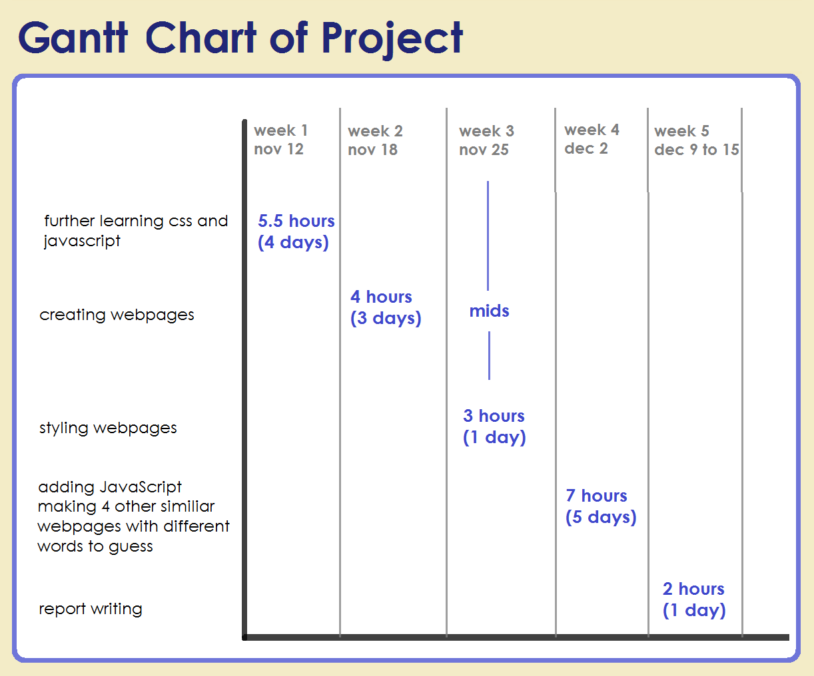

**Functional working :**

