Software Requirement Specifications
AgriSense Al: Early Detection & Precision Treatment to Safeguard Global Yields



Submitted by
Syed Ashiq Ali (F22BINFT1M01139)

Submitted to

Mr. Zaman Ali

Department of Information Technology Faculty of Computing

The Islamia University of Bahawalpur

Meeting Details

Sr No | Details | Date | Supervisor Signature
1 | Project Proposal & Scope Finalization: Discussed and finalized the project scope, objectives, and problem statement: Focusing on early disease detection using image processing/CNN model.  Confirmed target crops/diseases and data collection plan. | 07/11/2025
2 | Literature Review & Tool Selection:  Presented a review of existing Al models (e.g., ResNet, VGG) for plant disease classification.  Finalized the primary development tools (e.g., Python, TensorFlow/PyTorch, dataset source).  Action Item: Begin initial dataset collection/curation. | 10/11/2025
 | Data Preparation & Pre- processing: Discussed challenges

3 | in dataset imbalance and image augmentation techniques.  Presented the data cleaning process. Supervisor advised on appropriate data split ratio and feature extraction methods. | 21/11/2025
4 | Data Preparation & Pre- processing: Discussed challenges in dataset imbalance and image augmentation techniques.  Presented the data cleaning process. Supervisor advised on appropriate data split ratio and feature extraction methods. | 28/11/2025
5 | Transfer Learning Implementation:  Demonstrated the improved performance after implementing Transfer Learning (e.g., fine- tuning MobileNet or VGG).  Discussed the implementation of the precision treatment recommendation algorithm (rule-based or recommendation engine). | 05/12/2025

6 | Prototype & System Integration:  Presented the end-to-end prototype (e.g., the web or mobile interface for uploading an image and displaying detection/treatment).  Addressed integration issues between the Al model and the front-end application. | 16/12/2025
7 | Final Testing & Validation: Presented the final model's performance metrics (accuracy, precision, recall) and validation report. Reviewed the project report's Methodology and Results chapters. Action Item: Start writing the Conclusion and Future Work sections. | 27/12/2025
8 | Final Report Draft Review: Submitted the complete draft of the Final Year Project report.  Supervisor provided feedback on formatting, referencing, and structure, and cleared the project for final submission. | 10/01/2026

Summary
AgriSence is a web-based agricultural support platform that helps farmers diagnose crop diseases using AI, connect with certified field officers, and access genuine pesticide products and solar irrigation services. The system includes modules for AI crop diagnosis, company product listings, solar installer services, and social media/event promotions. With real-time notifications, ratings, and a secure role-based system, AgroSphere aims to provide fast expert help, improve farmer decisions, and digitally transform agricultural support.

1. Introduction
AgriSence is a comprehensive web-based platform designed to connect farmers with agricultural service providers including pesticide companies, field officers, and solar irrigation installers through AI-powered crop diagnosis and digital service management.
1. Purpose
To provide farmers with fast, reliable agricultural solutions through AI diagnosis, expert assistance, product access, and service connections in a unified digital platform.
1. Scope
The system includes AI crop diagnosis, pesticide product marketplace, solar service booking, event management, and multi-role user management. Excludes payment processing, logistics, and mobile app in initial phase.

1. Product Perspective
A standalone web platform that can integrate with third-party services and may expand to mobile applications.

1. User Characteristics

Farmers (basic tech skills), Pesticide Companies (moderate), Field Officers (moderate), Solar Installers (basic), Admin (advanced).

1. Similar apps and systems/Literature Review
Plantix (AI diagnosis only), AgroStar (product sales only), FarmLogs (data management only). AgriSence integrates all these features.

1. Proposed Technologies
Frontend: HTML5, CSS3, JavaScript(React.js), Tailwind CSS Backend: PHP, Node.js, Python; Database: MySQL, MongoDB;
AI: TensorFlow/PyTorch; AI based Integration Cloud: AWS S3, Firebase

Requirements
AgriSence provides several key functionalities:Farmers can sign up, upload crop images, receive AI diagnosis, request expert field officer review, browse pesticide products, contact companies, request solar installation, rate services, and receive notifications. Companies and installers manage products & services. Admin approves users and maintains system integrity.

Function Requirements

User Registration
Name: FR001
Purpose: Secure registration with role-based access.
User(s): All roles
Input: User details, role selection
Output: User account, dashboard access

Crop Disease Diagnosis
Name: FR002
Purpose: Farmers upload crop images for AI diagnosis
User(s): Farmers, Field Officer
Input: Crop image, symptoms, location
Output: Diagnosis, confidence score, recommendations

Product Marketplace
Name: FR003
Purpose: Companies list products; farmers compare and contact
User(s): Pesticide Company, Farmer
Input: Product details, pricing, offers
Output: Product catalog, comparison view

Solar Service Booking
Name: FR004
Purpose: Farmers Book solar installation/maintenance
User(s): Solar Installer, Farmer
Input: Service type, location, requirements
Output: Service booking, quotations

Event Management
Name: FR005
Purpose: Promote agricultural events and training.
User(s): All roles
Input: Event details, registration links
Output: Event calendar, notifications

1. Non-Functional Requirements
- Performance: Page load < 3s, AI response < 10s
- Availability: 99.5% uptime
- Security: SSL, role-based access
- Usability: Responsive, multilingual

1. Use Cases and Flow of Processes
Use cases are the formal representation of process flow defined by functional requirements. There should be system level use case which is directly influenced to project functions with their user(s) (called actor(s)) which are described in requirements chapters.

a. Use Case 1
ID

Name

Description

Requirement(s)

Actor(s)

Precondition

Postcondition

Basic Flow
UC001

Role-Based Registration

User registers with specific role and permissions

FR001

All roles, Admin

New user, valid email

Account created with role permissions

Basic Flow

1. Select role
2. Enter details
3. Submit for approval
4. Admin reviews
5. Account activated

I

Diagram:

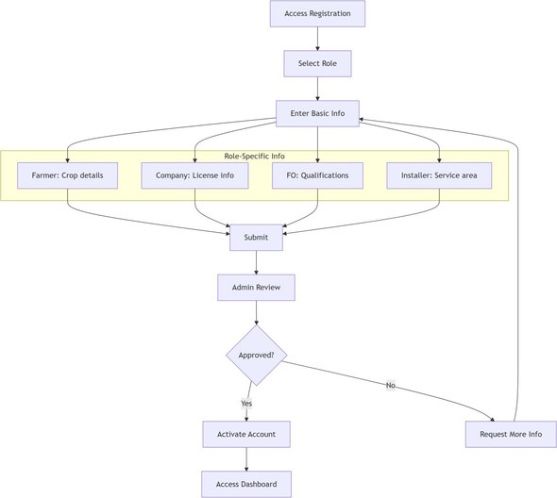

a. Use Case 2

ID

Name

Description

Requirement(s)

Actor(s)

Precondition

Postcondition

Basic Flow

Diagram:
UC002

AI Crop Disease Diagnosis

Farmer uploads crop image for AI diagnosis with expert feedback

FR002

Farmer, Field Officer

Farmer logged in, has crop image

Diagnosis stored, notifications sent

Basic Flow

1. Upload image+symptoms
2. AI analyzes
3. If confidence high, show results
4. Else notify FO
5. FO reviews
6. Notify farmer Alternative Flow FO directly diagnoses without AI Exceptions
Invalid image, AI unavailable

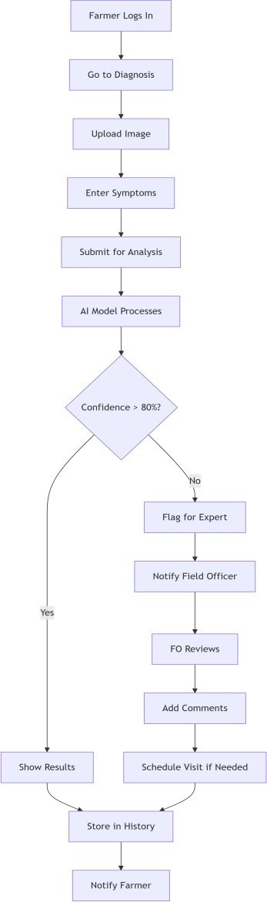

a. Use Case 3

ID

Name

Description

Requirement(s)

Actor(s)

Precondition

Postcondition

Basic Flow

Diagram:
UC003

Product Comparison Purchase

Farmer compares pesticide products and contacts companies

FR003

Farmer, Pesticide Company

Products listed, farmer logged in

Contact established, potential sale

Basic Flow

1. Search products
2. Filter and compare
3. Contact company
4. Negotiate
5. Rate experience

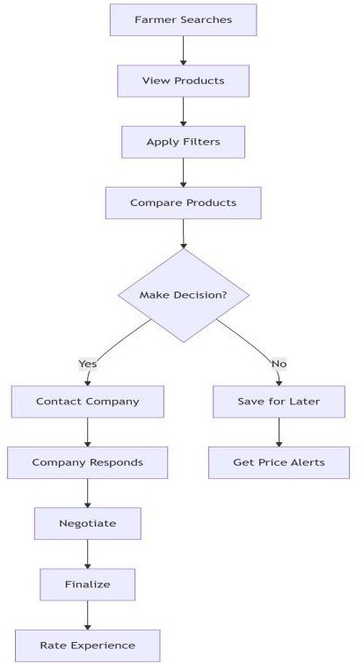

a. Use Case 4

ID

Name

Description

Requirement(s)

Actor(s)

Precondition

Postcondition

Basic Flow

Diagram:
UC004

Solar Service Booking

Farmer requests solar irrigation services

FR004

Farmer, Solar Installer

Installers registered, farmer logged in

Service booked or declined

Basic Flow

1. Submit request
2. Installer responds
3. Quote negotiation
4. Schedule service
5. Rate service

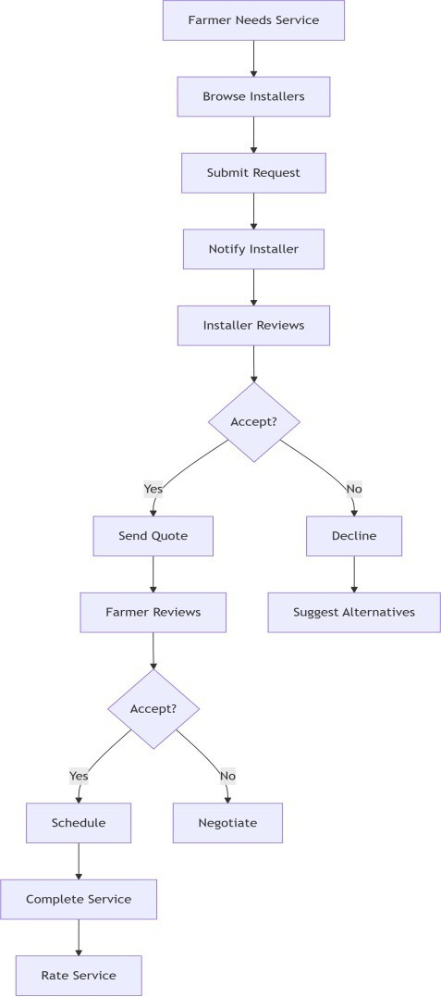

a. Use Case 5

ID

Name

Description

Requirement(s)

Actor(s)

Precondition

Postcondition

Basic Flow

Diagram:
UC005

Event Registration

Farmers register for agricultural events

FR005

Company, Farmer

Event created, farmer logged in

Registration completed or saved

Basic Flow

1. View event
2. Register interest
3. Get confirmation
4. Attend event
5. Provide feedback

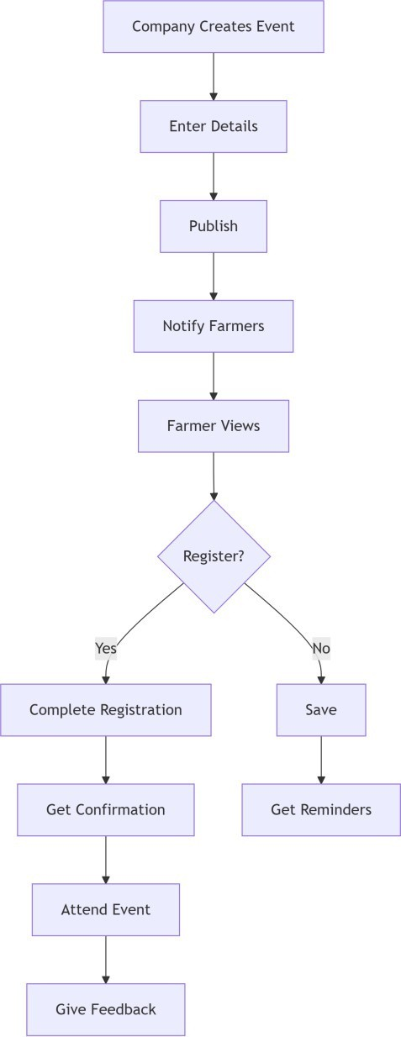

1. References
- Project Proposal: "AgriSense Al: Early Detection & Precision Treatment to Safeguard Global Yields"
- IEEE Std 830-1998, Software Requirements Specifications
- Plantix App: https://plantix.net
- React.js Documentation: https://reactjs.org
- MongoDB Documentation: https://docs.mongodb.com

