LOVELY PROFESSIONAL UNIVERSITY
CSE570 – Machine Learning with Python
Academic Task 2 – Skill Based Assignment (Session 2026–27)
RetailPulse 360
Predicting 90-Day Customer Churn from Online Retail Transactions:
an end-to-end, leakage-safe machine-learning solution
Submitted by | [Your full name]
Registration number | [Registration no.]
Roll number / Section | [Roll no.] / [Section]
Submitted to | [Faculty name]
Date of submission | 8 November 2026
GitHub repository | https://github.com/syedasif3018/retailpulse-360
Live dashboard | https://retailpulse-360-541d.azurewebsites.net
LinkedIn post | [add post URL after publishing]

Contents
Abstract 3
1. Problem Statement 3
1.1 Context 3
1.2 Machine-learning task and target variable 3
1.3 Intended users and impact 3
2. Objectives and Success Criteria 3
3. Assumptions and Constraints 4
4. Dataset Description 4
4.1 Source, citation and licence 4
4.2 Size 4
4.3 Data dictionary 5
4.4 Missing values and data quality 5
4.5 Target distribution 5
4.6 Why this dataset is appropriate 5
5. Methodology and Workflow 5
6. Data Cleaning and Preparation 6
7. Exploratory Data Analysis 7
7.1 Univariate analysis 7
7.2 Trends over time 7
7.3 Bivariate analysis 8
7.4 Is a 90-day horizon sensible? 9
7.5 Customer-level and multivariate analysis 9
8. Statistical Analysis 11
9. Model Development 12
9.1 Features 12
9.2 Train / validation / test strategy 13
9.3 Models and hyper-parameter tuning 13
10. Results and Model Comparison 14
10.1 Validation month (used for selection) 14
10.2 Test month (single, final evaluation) 14
11. Model Interpretation 16
12. Business Impact 16
13. Deployment 17
14. Conclusion 17
15. Limitations and Future Work 17
16. References 18
Appendix A. Project Links and Reproduction 18

Abstract
Many repeat business customers of an online retailer stop buying without telling anyone. This project predicts, for every active customer, whether they will make no purchase in the next 90 days (churn). It uses the public UCI Online Retail II dataset (1,067,371 invoice lines, Dec 2009 – Dec 2011). The transactions were cleaned (exact duplicates, a December-2010 overlap between the two source sheets, cancelled data-entry errors) and converted into 42,832 leakage-safe customer snapshots at ten monthly cutoffs, with features computed only from the past and labels only from the future. EDA and non-parametric tests show that churners have far lower purchase frequency and spend (large effect sizes), while country is not associated with churn. Two baselines and four tuned classifiers were compared with a strictly time-based train/validation/test design. The selected Gradient Boosting model reaches ROC-AUC 0.774 (95% CI 0.759–0.786), PR-AUC 0.746 and macro-F1 0.693 on a later, untouched month, meeting all pre-defined success criteria and clearly beating a "no order for 90 days" business rule (AUC 0.708). Regular monthly buying, recency and frequency drive the predictions. The model is served through a Streamlit dashboard deployed on Azure App Service (free tier).

1. Problem Statement

1.1 Context
The retailer is a UK-based online seller of giftware with many wholesale and repeat business customers. There is no subscription, so customers never formally cancel: they simply stop ordering. Keeping an existing customer is usually cheaper than winning a new one. If the retention team knew early which active customers are drifting away, they could contact them (offers, reminders, account calls) before the revenue is lost.

1.2 Machine-learning task and target variable
The task is supervised binary classification at customer level: at an observation date (the cutoff), using only transactions before that date, predict whether an active customer will make no valid purchase in the following 90 days.
Table 1. Target and unit-of-prediction definitions
Item | Definition
Unit of prediction | One customer at one monthly cutoff date (a customer snapshot)
Eligible customer | Known Customer ID and at least one valid purchase in the 365 days before the cutoff
Valid purchase | Non-cancelled invoice line, Quantity > 0, Price > 0, merchandise stock code
Target churn_90d | 1 = no valid purchase in [cutoff, cutoff + 90 days); 0 = at least one purchase
Features | Computed only from transactions strictly before the cutoff (365-day window)

1.3 Intended users and impact
- Retention / CRM team: a ranked list of at-risk customers to contact first.
- Sales management: the size of revenue at risk by risk band and country.
- Analysts: a documented, reusable pipeline (code, notebooks, saved model, dashboard).

2. Objectives and Success Criteria
- Audit, clean and document the transactions, with every cleaning decision recorded.
- Explore purchasing behaviour and test at least one hypothesis statistically.
- Build a baseline and at least three classifiers inside leakage-free pipelines, tuned on a time-based validation set.
- Explain what drives churn and estimate the revenue at risk.
- Deliver the model as a usable dashboard.
Measurable success criteria (fixed before training and measured once on a later, held-out month):
- ROC-AUC ≥ 0.75 (no-skill baseline 0.50).
- PR-AUC for the churn class clearly above the churn base rate.
- Macro-F1 clearly above the majority-class baseline. Churn is the majority class here (50–67% per month), so "predict everyone churns" already gets 100% churn recall, and recall alone is not a useful target.

3. Assumptions and Constraints
- Historical data (2009–2011) from one retailer: results demonstrate the method and are not a claim about today's retail market.
- Rows without a Customer ID (22.8%) cannot be followed over time. They are excluded from modelling but kept for transaction-level EDA.
- Churn is a behavioural proxy: a customer labelled as churned may return after 90 days.
- Time order is respected everywhere: training labels must be fully known before the validation and test dates.
- Compute: a single CPU laptop. Cloud is used only to host the finished dashboard, on a free tier.

4. Dataset Description

4.1 Source, citation and licence
Chen, D. (2012). Online Retail II [Dataset]. UCI Machine Learning Repository. https://doi.org/10.24432/C5CG6D. It is published under the Creative Commons Attribution 4.0 (CC BY 4.0) licence. The workbook online_retail_II.xlsx (45.6 MB, two sheets) was downloaded on 4 November 2026 and its SHA-256 hash recorded in the repository. The raw file is not redistributed in the repository.

4.2 Size
Table 2. Records per source sheet (from the automated audit)
Sheet | Rows | Date range
Year 2009-2010 | 525,461 | 2009-12-01 → 2010-12-09
Year 2010-2011 | 541,910 | 2010-12-01 → 2011-12-09
Total | 1,067,371 | 2009-12-01 → 2011-12-09
There are 8 source columns, 53,628 invoices, 5,942 known customers, 5,305 stock codes and 43 countries.

4.3 Data dictionary
Table 3. Data dictionary and feature types
Column | Type | Feature type | Meaning / notes
Invoice | text | Identifier | Order number; prefix C = cancellation, A = bad-debt adjustment
StockCode | text | Identifier / nominal | Product code; also service codes (POST, M, fees, vouchers)
Description | text | Text | Product name; 4,382 missing
Quantity | integer | Numeric (discrete) | Units; negative for returns (22,950 rows)
InvoiceDate | datetime | Datetime | Timestamp used to build time windows
Price | float | Numeric (continuous) | Unit price in GBP; 6,207 rows ≤ 0
Customer ID | float → text | Identifier | 243,007 missing (22.8%)
Country | text | Nominal | Customer country; the UK accounts for 85% of revenue

4.4 Missing values and data quality
Table 4. Raw data-quality issues and their treatment
Issue | Rows | Treatment
Missing Customer ID | 243,007 | Kept for EDA; excluded from customer modelling
Missing Description | 4,382 | Filled with UNKNOWN (text not used)
Exact duplicate rows | 34,335 | Removed (most come from the 1–9 Dec 2010 sheet overlap)
Cancellation lines | 19,494 | Flagged; used for a return-rate feature
Price ≤ 0 | 6,207 | Excluded from purchases

4.5 Target distribution
The target is engineered at ten monthly cutoffs (Dec 2010 – Sep 2011), each with about 4,200–4,300 eligible customers. Churn is the majority class: 65–67% for the Dec–Feb cutoffs, 61–63% for Mar–Jul and 57% for Aug, falling to 50.5% for the September 2011 cutoff, whose 90-day window covers the pre-Christmas peak (Figure 10).

4.6 Why this dataset is appropriate
- Real transactions with customer IDs and timestamps: exactly what is needed to observe whether, and when, a customer buys again.
- Two years of history allow several historical cutoffs with a 365-day feature window and a 90-day outcome window, plus a time-ordered train/validation/test split.
- Realistic data problems (duplicates, cancellations, missing IDs, non-product codes) exercise the full cleaning workflow.
- Open licence and widely cited, so the work is reproducible.

5. Methodology and Workflow
- Ingest and audit: read both Excel sheets, cache them as Parquet, and run an automated audit (counts of missing values, duplicates, cancellations and the sheet overlap).
- Clean: remove exact duplicates and immediately reversed orders; fix data types; flag cancellations, adjustments, non-product codes and missing customers; define a valid purchase.
- EDA and statistics: univariate, bivariate and multivariate analysis; Mann–Whitney U, chi-square, bootstrap and Wilson confidence intervals.
- Customer snapshots: 13 behavioural features plus a country group per customer and cutoff, with churn_90d from the following 90 days.
- Modelling: two baselines plus four classifiers in scikit-learn Pipelines; RandomizedSearchCV on a time-based PredefinedSplit; customer-grouped 5-fold CV; threshold tuned on validation.
- Evaluation and interpretation: one-time test evaluation, permutation importance, coefficients, tree rules, lift and revenue at risk.
- Deployment: score customers, build a Streamlit dashboard, deploy it to Azure App Service (Free F1).
Table 5. Tools and libraries
Purpose | Libraries / tools
Data handling | Python 3.14, pandas 3.1, NumPy 2.5, PyArrow (Parquet), openpyxl
Statistics | SciPy 1.18 (Mann–Whitney U, chi-square)
Machine learning | scikit-learn 1.9 (Pipelines, ColumnTransformer, RandomizedSearchCV, models, metrics), joblib
Visualisation | Matplotlib, Altair (dashboard)
Application and cloud | Streamlit 1.67, Azure App Service (Linux, Free F1), Azure CLI
Engineering | Git/GitHub (feature branches and pull requests), pytest (9 automated tests), Jupyter notebooks

6. Data Cleaning and Preparation
Cleaning is implemented in a tested module (src/retailpulse/cleaning.py) and logged to reports/cleaning_log.json. Problem rows are flagged rather than deleted wherever a later step may still need them. Only rows that are not real business events are removed.
Table 6. Cleaning steps and results
Step | Rows | Reason
Raw rows | 1,067,371
Exact duplicates removed | 34,335 | Mostly the 1–9 Dec 2010 week present in both sheets (1,088 shared invoices)
Reversed order/cancellation lines removed | 2,762 | Order cancelled with an exact match within one day, e.g. 80,995 and 74,215-unit entry errors
Clean rows | 1,030,274 | Customer ID converted to text; dates, integers and floats typed
Valid purchase lines with Customer ID | 775,265 | 5,851 customers; £16.72M revenue
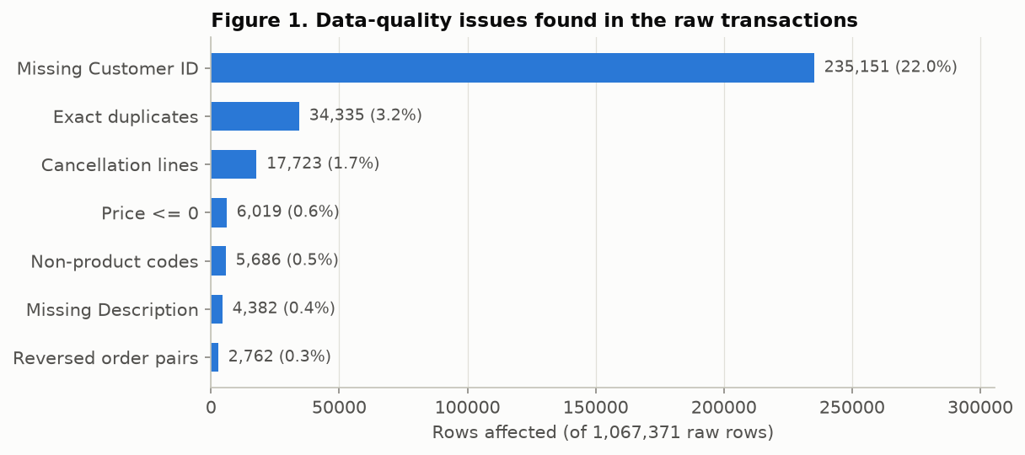
Figure 1. Data-quality issues found in the raw transactions (rows affected).
Outliers. With the Tukey 1.5×IQR rule, 5.26% of quantities, 7.48% of prices and 8.16% of line revenues lie above the upper fence. Inspection showed these are genuine wholesale orders (for example 12,960 units at £0.10), not errors. Removing them would delete the most valuable customers, so they were kept. Skew is handled with log1p transformation for the linear model and with tree-based models, which are insensitive to monotonic scaling.
Encoding and scaling. Done inside the model pipelines, so they are fitted on training data only: median imputation with a missing-value indicator, log1p and standardisation (Logistic Regression only), and one-hot encoding of the country group, with unseen categories ignored.

7. Exploratory Data Analysis

7.1 Univariate analysis
All money and volume variables are heavily right-skewed (skewness 7–163). The median order is £301 but the mean is £490, and the median customer placed 3 orders over the two years. Medians and log scales are therefore used throughout.
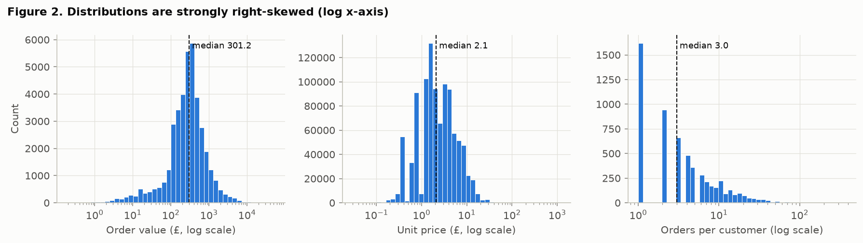
Figure 2. Distributions of order value, unit price and orders per customer (log scale).

7.2 Trends over time
Revenue and active customers rise sharply every September–November (pre-Christmas wholesale buying) and fall in January–February. This seasonality changes the churn rate per cutoff and is the main reason for a time-based evaluation.
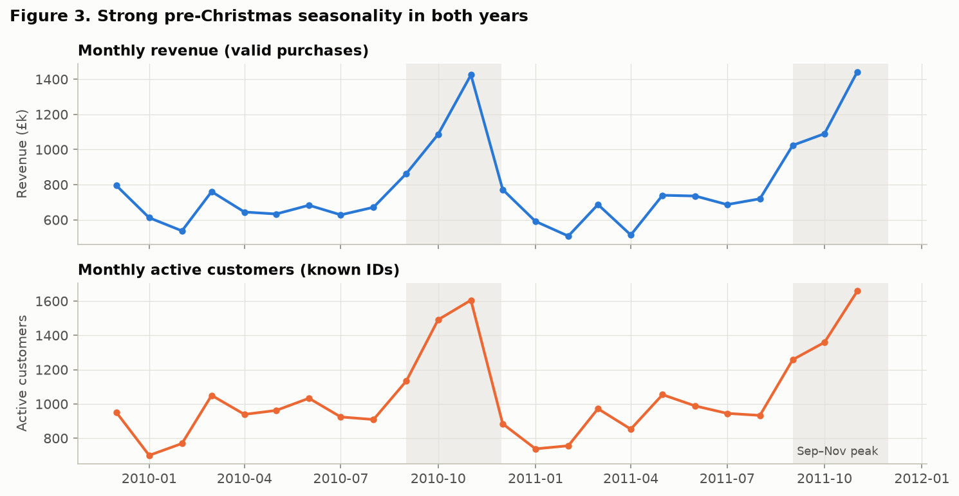
Figure 3. Monthly revenue and active customers, with the September–November peak shaded.

7.3 Bivariate analysis
The UK produces 85% of revenue, but overseas orders are larger (median £422 vs £299). Orders arrive almost only on working days (30 Saturday orders in two years), mainly between 10:00 and 15:00, which reflects business-to-business ordering.
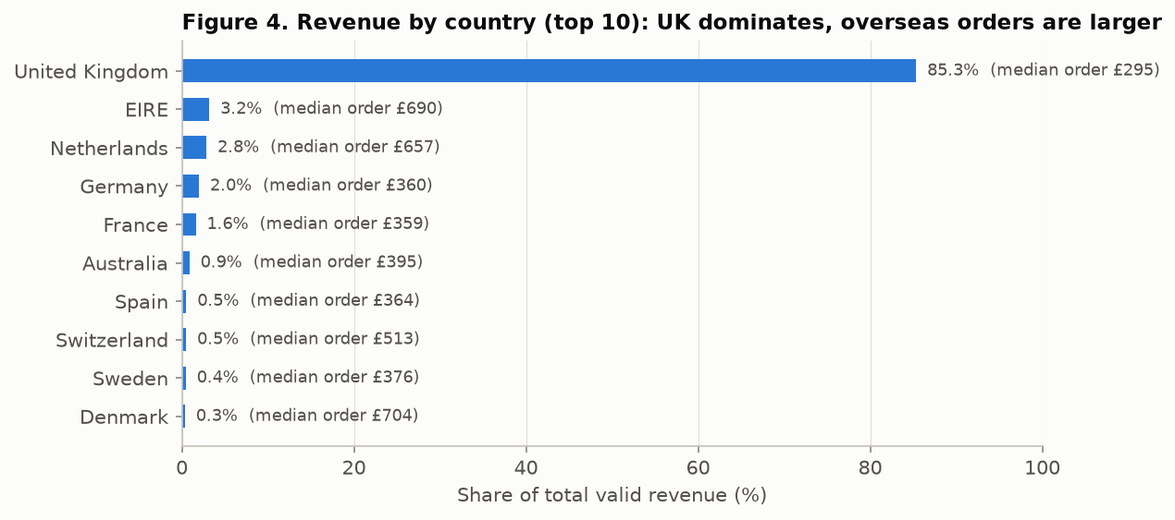
Figure 4. Revenue share by country (top 10) with median order value.
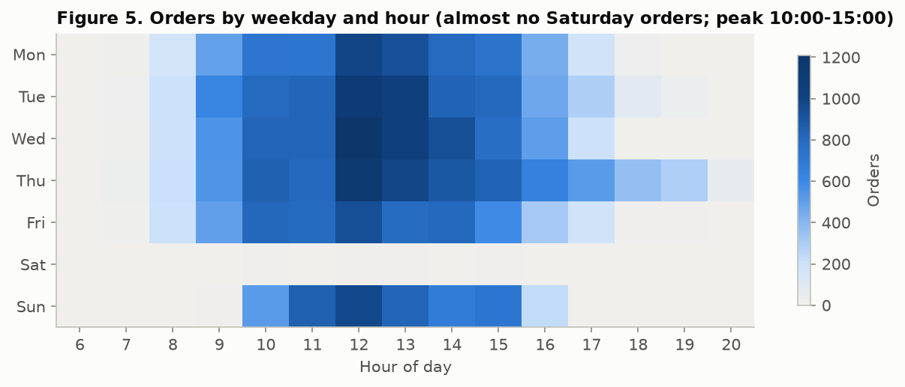
Figure 5. Orders by weekday and hour of day.

7.4 Is a 90-day horizon sensible?
For returning customers, the median gap between purchase days is 32 days and 80.6% of gaps are 90 days or less (80th percentile 88 days). A customer silent for more than 90 days has therefore broken their normal rhythm, which justifies the churn definition.
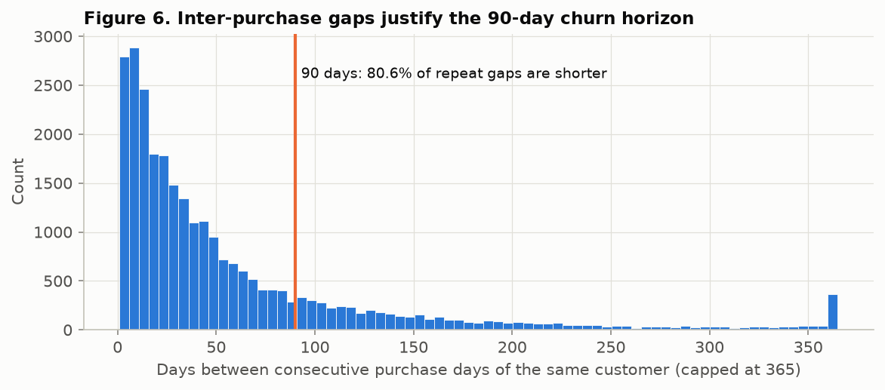
Figure 6. Gaps between consecutive purchase days; 80.6% are at most 90 days.

7.5 Customer-level and multivariate analysis
At the training cutoff 1 March 2011 (4,258 customers, 63.1% churn), churners had ordered longer ago (median 124 vs 71 days), placed fewer orders (2 vs 5), spent less (£455 vs £1,469), bought fewer distinct products (27 vs 64) and were newer customers. Average order value differs much less, so engagement, not basket size, separates the groups. Several features are strongly inter-correlated (frequency, active months, spend, quantity, products), which motivates regularisation and permutation-based interpretation.
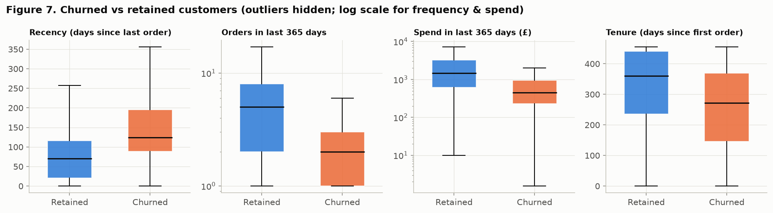
Figure 7. Churned vs retained customers at the 2011-03-01 training cutoff.
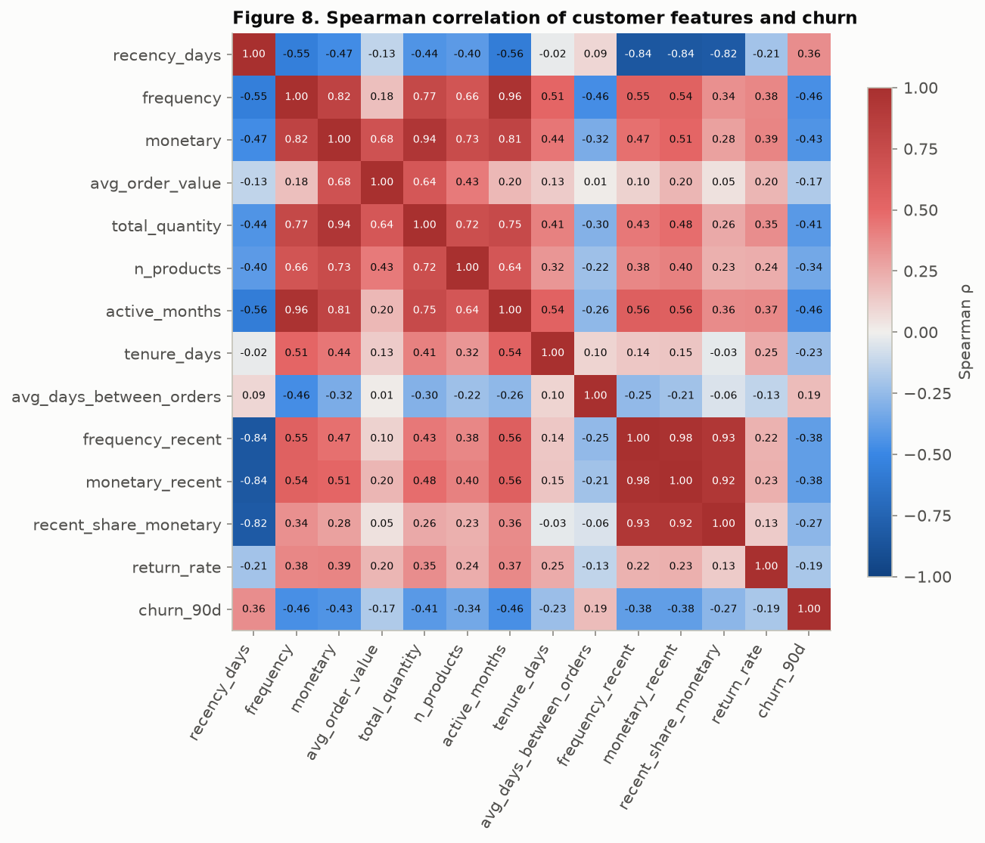
Figure 8. Spearman correlations between customer features and churn.
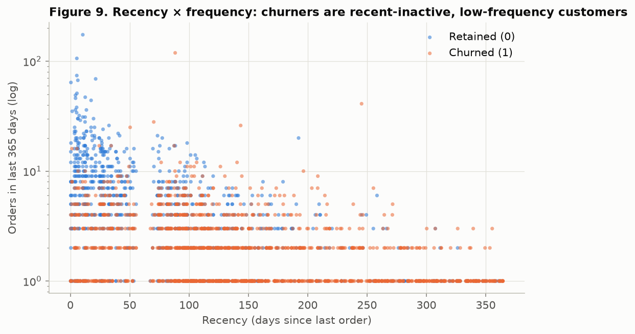
Figure 9. Recency vs frequency coloured by outcome: churners cluster at high recency and low frequency.

8. Statistical Analysis
The features are skewed, so non-parametric tests were used (α = 0.05). All tests use the training-period cutoff only.
Table 7. Hypothesis tests and confidence intervals
Test | Hypothesis (H0) | Result | Conclusion
Mann–Whitney U | Churned and retained customers have the same distribution of frequency | p ≈ 2×10⁻¹⁹⁵; rank-biserial r = −0.53 | Reject H0: large effect
Mann–Whitney U | … of spend (monetary) | p ≈ 1.5×10⁻¹⁷³; r = −0.52 | Reject H0: large effect
Mann–Whitney U | … of recency | p ≈ 3×10⁻¹²⁰; r = +0.43 | Reject H0: medium effect
Chi-square independence | Churn is independent of UK vs international | χ² = 0.42, p = 0.52, Cramér's V = 0.01 | Fail to reject: country not associated
Bootstrap 95% CI | Median order value is the same for UK and international | Difference £122; CI £105–£142; MWU p ≈ 10⁻¹⁴³ | International orders are larger
Wilson 95% CI | Churn rate constant over cutoffs | 66.8% (Dec 2010, ±1.4 pts) vs 50.5% (Sep 2011, ±1.5 pts) | Real seasonal shift
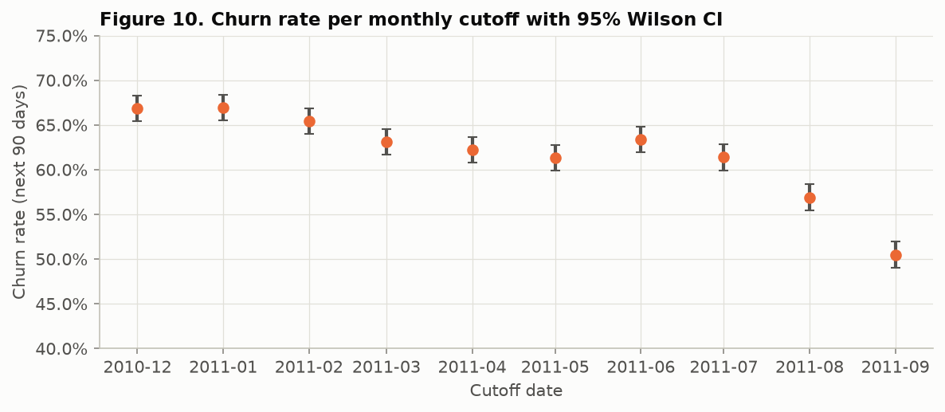
Figure 10. Churn rate per monthly cutoff with 95% Wilson confidence intervals.
Interpretation. Purchasing intensity separates churners from retained customers, with large effect sizes rather than significance driven only by sample size. Country affects how much customers spend per order but not whether they return. The seasonal fall in churn means the test month will have a different base rate from training, so threshold-independent metrics (ROC-AUC) are reported alongside PR-AUC.

9. Model Development

9.1 Features
Table 8. Model features (all computed from data before the cutoff)
Feature | Definition
recency_days | Days since the last order
frequency | Orders in the last 365 days
monetary | Spend (£) in the last 365 days
avg_order_value | monetary / frequency
total_quantity | Units bought in the last 365 days
n_products | Distinct products bought
active_months | Distinct months with a purchase
tenure_days | Days since the first ever order
avg_days_between_orders | Average gap between orders (missing for single-order customers; imputed in the pipeline)
frequency_recent / monetary_recent | Orders / spend in the last 90 days
recent_share_monetary | Share of yearly spend made in the last 90 days
return_rate | Cancelled lines / all product lines
country_group | UK, EIRE, Germany, France, Netherlands, Other (one-hot)

9.2 Train / validation / test strategy
Table 9. Time-based data split
Set | Cutoffs | Snapshots | Churn rate | Purpose
Train | Dec 2010 – Mar 2011 | 16,914 | 65.6% | Fit models during tuning
Validation | Jun 2011 | 4,324 | 63.4% | Tuning, model and threshold selection
Final refit | Dec 2010 – Jun 2011 | 29,871 | 64.2% | Re-train chosen settings
Test | Sep 2011 | 4,323 | 50.5% | Single final evaluation
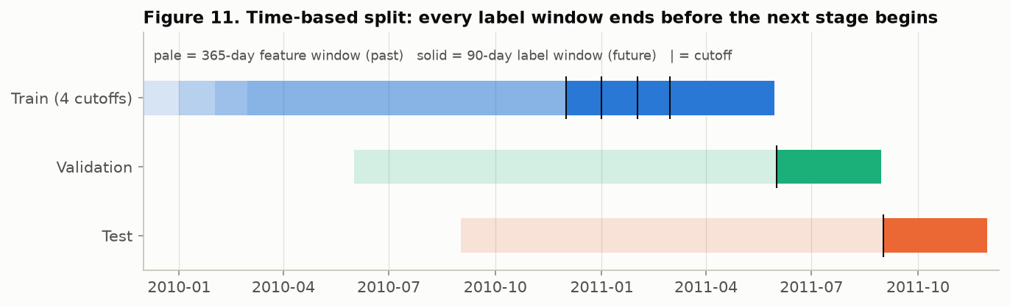
Figure 11. Time-based design. Pale bars are 365-day feature windows (past) and solid bars are 90-day label windows (future). Every training label window ends before the validation cutoff, and every refit label window ends before the test cutoff.
A random row split would let a model learn from a customer's later months and be tested on earlier ones (temporal leakage). Instead, training uses only cutoffs whose 90-day outcome is fully known before the validation date. All preprocessing sits inside the pipeline, so imputation medians, scaling statistics and categories are learned from training rows only. As a stability check, a 5-fold GroupKFold on the training months (grouped by customer, so no customer appears in two folds) gives AUC 0.77–0.79 with a standard deviation of about 0.015.

9.3 Models and hyper-parameter tuning
Table 10. Candidate models, search spaces and selected settings
Model | Search space (RandomizedSearchCV) | Best settings
Majority-class baseline | – | predicts churn for everyone
Recency rule baseline | – | churn if no order for 90 days
Logistic Regression (L2, balanced) | C ∈ [0.001, 100] log-uniform; 20 draws | C = 0.029
Decision Tree (balanced) | depth 3–12/none, min leaf 5–200, gini/entropy; 40 draws | depth 4, min leaf 50, gini
Random Forest (balanced) | 200/400 trees, depth 6–16/none, min leaf 1–50, max features; 25 draws | 400 trees, depth 8, sqrt features
Gradient Boosting (HistGB, balanced) | learning rate 0.02–0.3, 100–400 iterations, 7–63 leaves, min leaf 20–200, L2 0–10; 30 draws | lr 0.022, 200 iter, 7 leaves, min leaf 200, L2 = 10
Selection metric: ROC-AUC on the validation month. The decision threshold for each model was chosen on validation by maximising macro-F1. All tuned settings are strongly regularised, which suggests the signal comes from a few strong RFM effects.

10. Results and Model Comparison

10.1 Validation month (used for selection)
Table 11. Validation metrics, June 2011 cohort (4,324 customers)
Model | ROC-AUC | AUC 95% CI | PR-AUC | Macro-F1 | Precision (churn) | Recall (churn) | Threshold
Baseline: majority class | 0.5000 | – | 0.6339 | 0.3880 | 0.6339 | 1.0000 | 0.50
Baseline: recency > 90 days | 0.7456 | – | 0.8167 | 0.6810 | 0.7972 | 0.6884 | 0.25
Logistic Regression | 0.7963 | 0.781–0.810 | 0.8441 | 0.7240 | 0.8099 | 0.7694 | 0.55
Decision Tree | 0.7893 | 0.774–0.803 | 0.8257 | 0.7329 | 0.7906 | 0.8417 | 0.48
Random Forest | 0.8015 | 0.787–0.815 | 0.8520 | 0.7338 | 0.7855 | 0.8603 | 0.47
Gradient Boosting (selected) | 0.8016 | 0.787–0.815 | 0.8540 | 0.7330 | 0.7950 | 0.8293 | 0.50
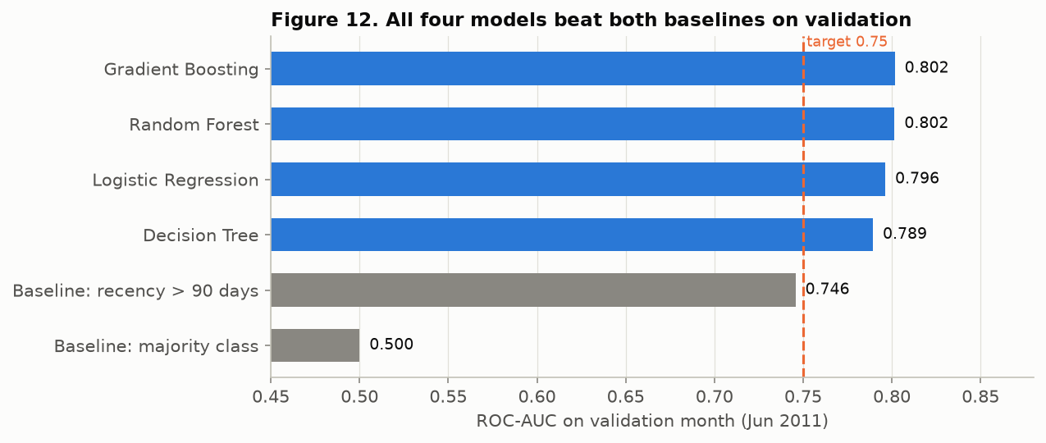
Figure 12. Validation ROC-AUC of baselines and models against the 0.75 target.
Final model: Gradient Boosting. It has the highest validation ROC-AUC (0.8016) and PR-AUC (0.854). Random Forest is statistically tied (0.8015, overlapping confidence intervals). The tie was broken by PR-AUC and by practical advantages: a 0.2 MB model, fast predictions and native handling of missing values. Logistic Regression (0.796) is kept as the interpretable reference.

10.2 Test month (single, final evaluation)
Table 12. Test metrics, September 2011 cohort (4,323 customers, 50.5% churn)
Model | ROC-AUC | AUC 95% CI | PR-AUC | Macro-F1 | Precision (churn) | Recall (churn) | Threshold
Baseline: majority class | 0.5000 | – | 0.5047 | 0.3354 | 0.5047 | 1.0000 | 0.50
Baseline: recency > 90 days | 0.7078 | – | 0.6801 | 0.6631 | 0.6520 | 0.7186 | 0.25
Logistic Regression | 0.7705 | 0.756–0.784 | 0.7359 | 0.7024 | 0.6776 | 0.7929 | 0.55
Decision Tree | 0.7639 | 0.749–0.778 | 0.7125 | 0.6728 | 0.6380 | 0.8676 | 0.48
Random Forest | 0.7741 | 0.760–0.787 | 0.7445 | 0.6915 | 0.6532 | 0.8694 | 0.47
Gradient Boosting (selected) | 0.7736 | 0.759–0.786 | 0.7458 | 0.6933 | 0.6613 | 0.8277 | 0.50
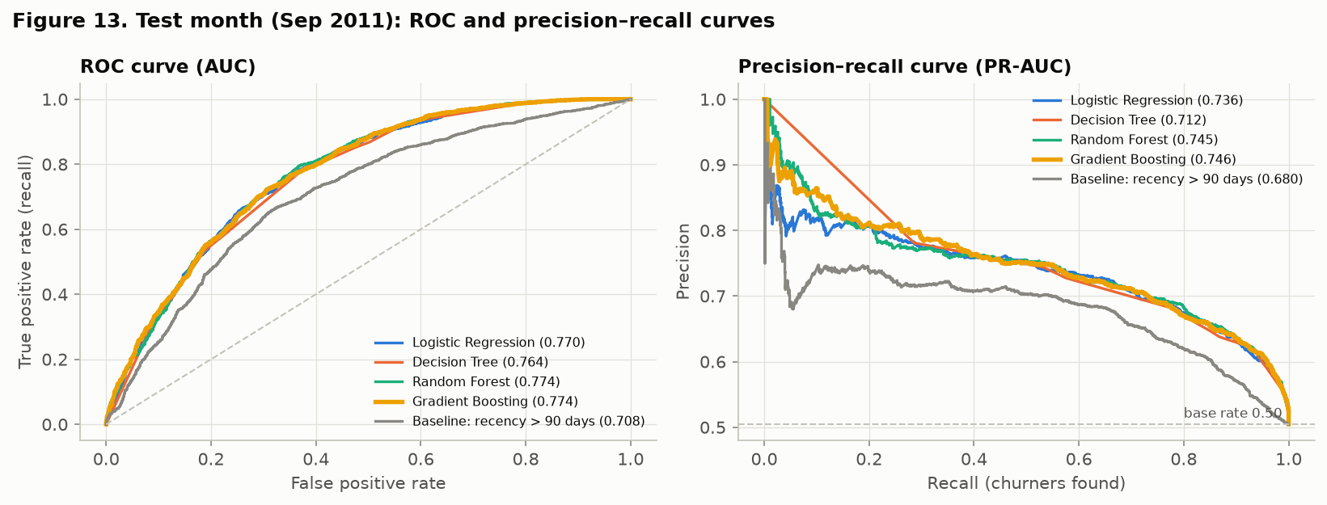
Figure 13. ROC and precision–recall curves on the test month.
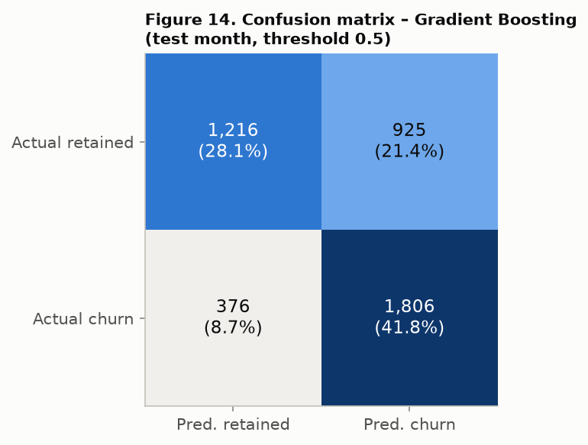
Figure 14. Confusion matrix of the selected model at threshold 0.50 (test month).
All success criteria are met: ROC-AUC 0.774 ≥ 0.75, PR-AUC 0.746 against a base rate of 0.505, and macro-F1 0.693 against 0.335. At the validation-chosen threshold the model finds 82.8% of churners with 66.1% precision; 925 retained customers (43%) would also be contacted. Test scores are lower than validation scores (0.774 vs 0.802) because the September–November window is the seasonal peak. Many customers who looked inactive returned, the churn rate fell to 50.5%, and the model slightly over-predicts churn (mean predicted probability 0.54).

11. Model Interpretation
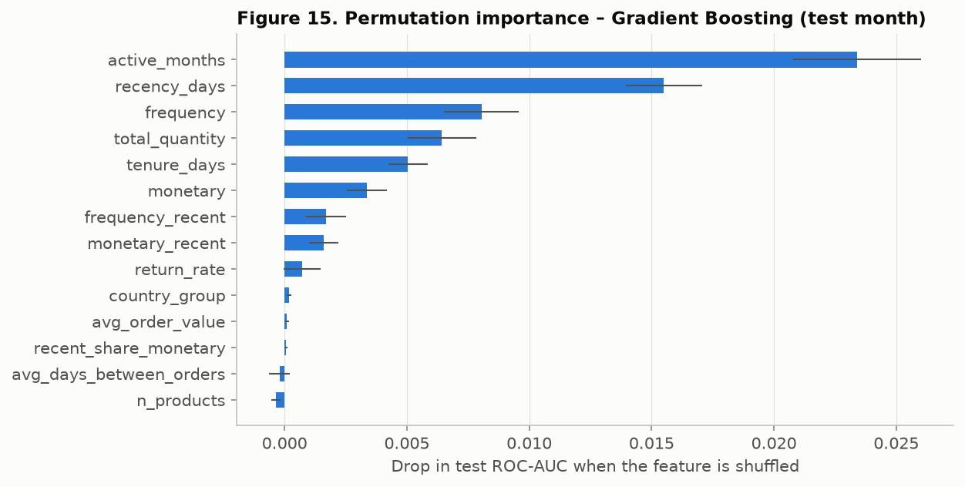
Figure 15. Permutation importance: drop in test ROC-AUC when each feature is shuffled.
- Active months (regular monthly buying) is the strongest driver, followed by recency, frequency, total quantity and tenure. Country, average order value and return rate add almost nothing, which agrees with the chi-square result.
- Logistic Regression odds ratios: each standard-deviation increase in active months multiplies the churn odds by 0.55; more recent orders and higher frequency also lower the risk, while higher recency raises it. Some coefficients have counter-intuitive signs because of multicollinearity, so individual coefficients are not read in isolation.
- Decision Tree rules: customers with ≤ 3 orders and only 1 active month are mostly churners; customers with > 3 orders who bought within about the last 140 days are mostly retained.

12. Business Impact
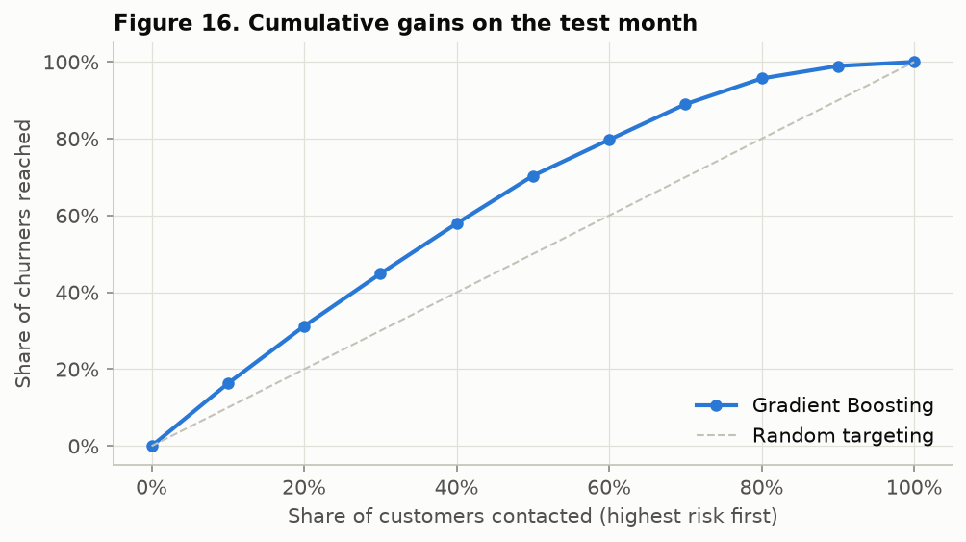
Figure 16. Cumulative gains: share of churners reached when contacting customers in order of predicted risk.
Ranking by predicted risk is useful for targeting. The top 10% riskiest customers churn at 82% (lift 1.62×), and the top 20% at 79% against 50.5% overall. Contacting the riskiest half reaches 70% of all churners. High-risk customers are mostly small, occasional buyers: those flagged hold only 19% of last year's spend. The probability-weighted revenue at risk (Σ p(churn) × past-year spend) is about £1.9M. This is a planning estimate, not a forecast. The retention team should therefore prioritise by risk × value, which is how the dashboard's contact list is sorted.

13. Deployment
The trained pipeline (models/churn_model.joblib) scores two cohorts: the test month, where the actual outcome is known, and the latest cutoff, 1 December 2011 ("who to contact now"). A Streamlit dashboard offers KPIs, risk bands, a risk-vs-value chart, a priority contact list with CSV export, a customer lookup, a what-if scorer, batch CSV scoring and a model-performance page. It is deployed on Azure App Service (Linux, Python 3.14, Free F1 tier, East Asia) from a 0.74 MB package, at no cost. Live link: https://retailpulse-360-541d.azurewebsites.net. A headless Streamlit AppTest is part of the automated test suite.

14. Conclusion
The project converts one million raw invoice lines into a validated churn-prediction service. Careful target design (a 90-day horizon justified by purchase gaps), leakage-safe snapshots and a time-based evaluation give honest performance estimates. All four tuned models beat both baselines. The selected Gradient Boosting model generalises to a later, seasonally different month with ROC-AUC 0.774 and meets every pre-defined success criterion. The analysis shows that churn is driven by engagement regularity, recency and frequency, not by order size or country, and the dashboard turns these predictions into a prioritised, value-aware contact list.

15. Limitations and Future Work
- Seasonal shift: test churn (50.5%) differs from training (about 64–66%), so the threshold and calibration drift with the season. Monitoring and periodic re-training are needed.
- Short history: two years of data, so tenure is right-censored and same-season data from previous years is limited.
- Proxy label: "no purchase in 90 days" is not a cancelled contract; some "churners" are simply infrequent buyers.
- Limited features: there is no demographic, marketing, web or service data, and 22.8% of rows lack a customer ID.
- Single retailer, 2009–2011: results show that the method works, not that it predicts today's retail churn.
- Near-tie between models: Random Forest, Gradient Boosting and Logistic Regression overlap in confidence intervals; the choice rests on practicality.
Future work: add category and same-month-last-year features, calibrate probabilities on recent data, optimise expected value (risk × spend), try survival analysis (time to next purchase), and evaluate on several rolling test months.

16. References
- Chen, D. (2012). Online Retail II [Dataset]. UCI Machine Learning Repository. https://doi.org/10.24432/C5CG6D (CC BY 4.0).
- Chen, D., Sain, S. L., & Guo, K. (2012). Data mining for the online retail industry: A case study of RFM model-based customer segmentation using data mining. Journal of Database Marketing & Customer Strategy Management, 19(3), 197–208.
- Pedregosa, F., et al. (2011). Scikit-learn: Machine Learning in Python. Journal of Machine Learning Research, 12, 2825–2830.
- McKinney, W. (2010). Data Structures for Statistical Computing in Python. Proceedings of the 9th Python in Science Conference, 56–61.
- Harris, C. R., et al. (2020). Array programming with NumPy. Nature, 585, 357–362.
- Virtanen, P., et al. (2020). SciPy 1.0: Fundamental Algorithms for Scientific Computing in Python. Nature Methods, 17, 261–272.
- Hunter, J. D. (2007). Matplotlib: A 2D Graphics Environment. Computing in Science & Engineering, 9(3), 90–95.
- Breiman, L. (2001). Random Forests. Machine Learning, 45(1), 5–32.
- Friedman, J. H. (2001). Greedy function approximation: A gradient boosting machine. Annals of Statistics, 29(5), 1189–1232.
- Ke, G., et al. (2017). LightGBM: A Highly Efficient Gradient Boosting Decision Tree. Advances in Neural Information Processing Systems 30.
- Mann, H. B., & Whitney, D. R. (1947). On a test of whether one of two random variables is stochastically larger than the other. Annals of Mathematical Statistics, 18(1), 50–60.
- Wilson, E. B. (1927). Probable inference, the law of succession, and statistical inference. Journal of the American Statistical Association, 22(158), 209–212.
- Streamlit documentation. https://docs.streamlit.io
- Microsoft. Azure App Service documentation – configure a Linux Python app. https://learn.microsoft.com/azure/app-service/

Appendix A. Project Links and Reproduction
GitHub repository: https://github.com/syedasif3018/retailpulse-360
Live dashboard: https://retailpulse-360-541d.azurewebsites.net
LinkedIn post: [add the post URL and attach the dated screenshot]
Development history: 5 feature branches merged through pull requests (data understanding, cleaning/EDA, modelling, dashboard, deployment), with daily commits from 4 to 8 November 2026.
Table 13. Reproducing the results (Windows PowerShell, from the repository root)
Step | Command / file
Install | py -3 -m venv .venv; .venv\Scripts\Activate.ps1; pip install -r requirements.txt
Audit raw data | python -m src.retailpulse.audit
Clean | python -m src.retailpulse.cleaning
EDA & statistics | notebooks/02_eda_statistics.ipynb
Modelling | notebooks/03_churn_modelling.ipynb
Score & dashboard | python -m src.retailpulse.scoring; streamlit run app/streamlit_app.py
Tests | python -m pytest -q (9 tests)

