Outline
All 9 stages are implemented:
Stage | File | Status
1 — Preprocessing | stage1_preprocessing.py | ✅ Verified working
2 — Graph Construction | stage2_graph_construction.py | ✅ Verified working
3 — GAT Embedding | stage3_gat.py | ✅ Fixed (pickle + FUSED_DIM=128)
4 — Classical Encoder | stage4_classical_encoder.py | ✅ Paper-exact 128→64→32
5 — QAFA | stage5_qafa.py | ✅ MI+SHAP+Centrality
6 — VQC | stage6_vqc.py | ✅ 4-qubit PennyLane circuit
7+8 — Fusion + Classifier | stage7_fusion.py | ✅ concat(32,4)=36 → MLP
9 — Explainability | stage9_explainability.py | ✅ SHAP + GNNExplainer
— Inference | inference.py | ✅ End-to-end on new code

Stage 1
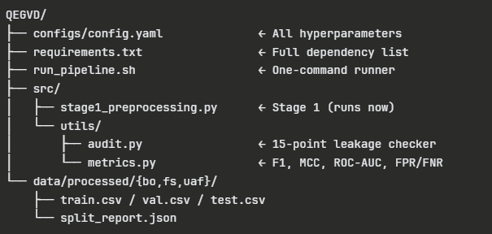

Execution
Install deps first (only once)
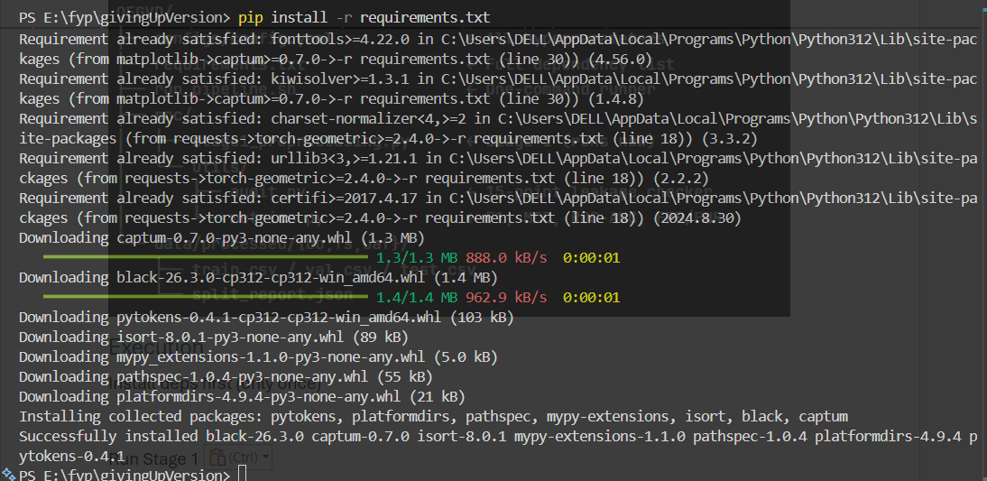
Run Stage 1
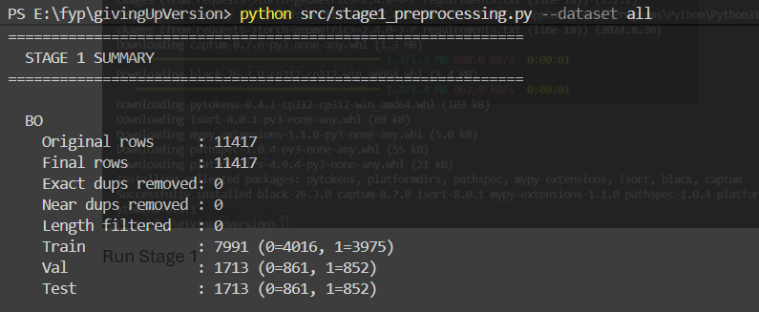
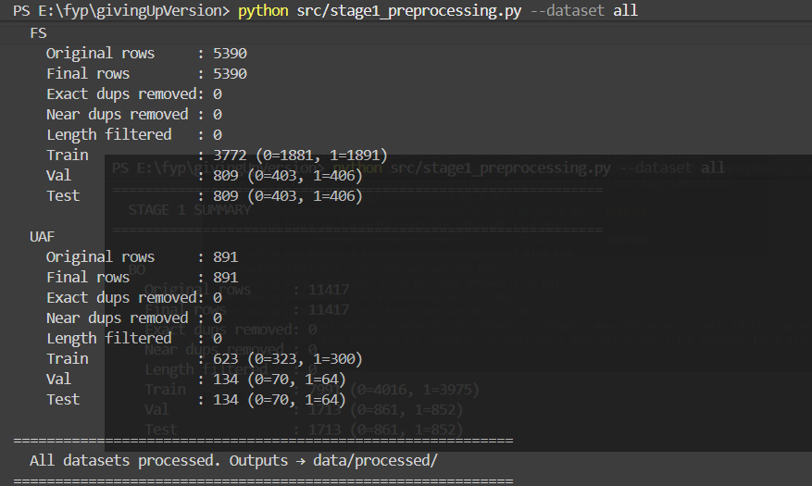

Stage 2

BO
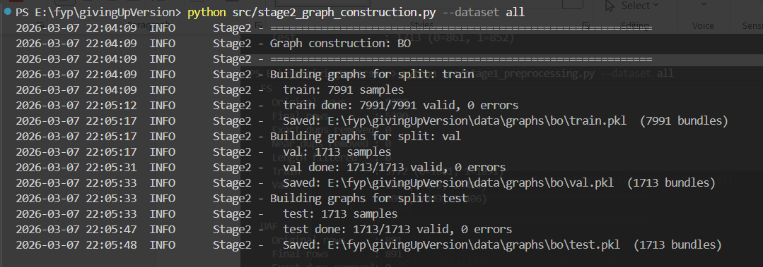
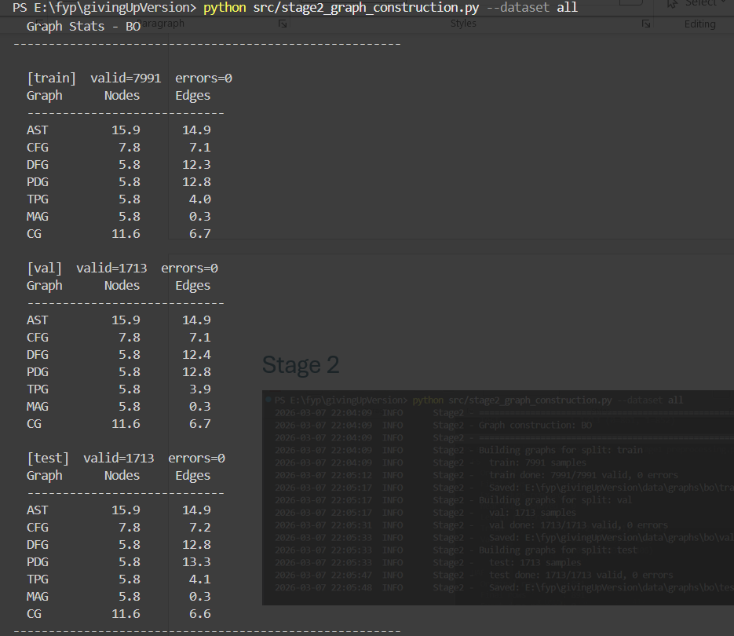

FS
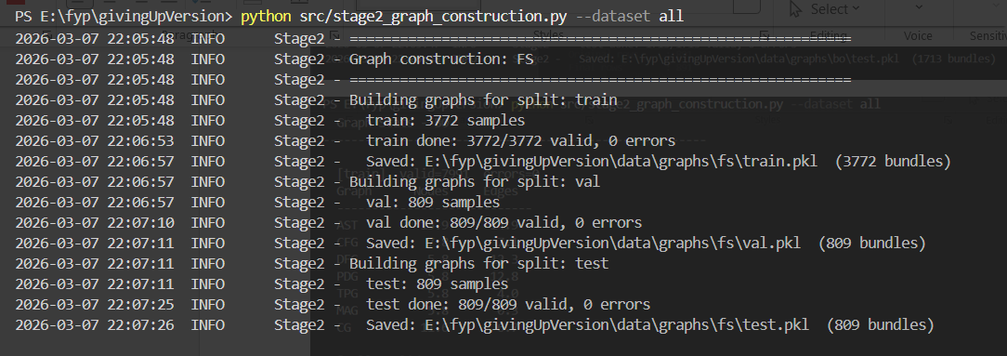
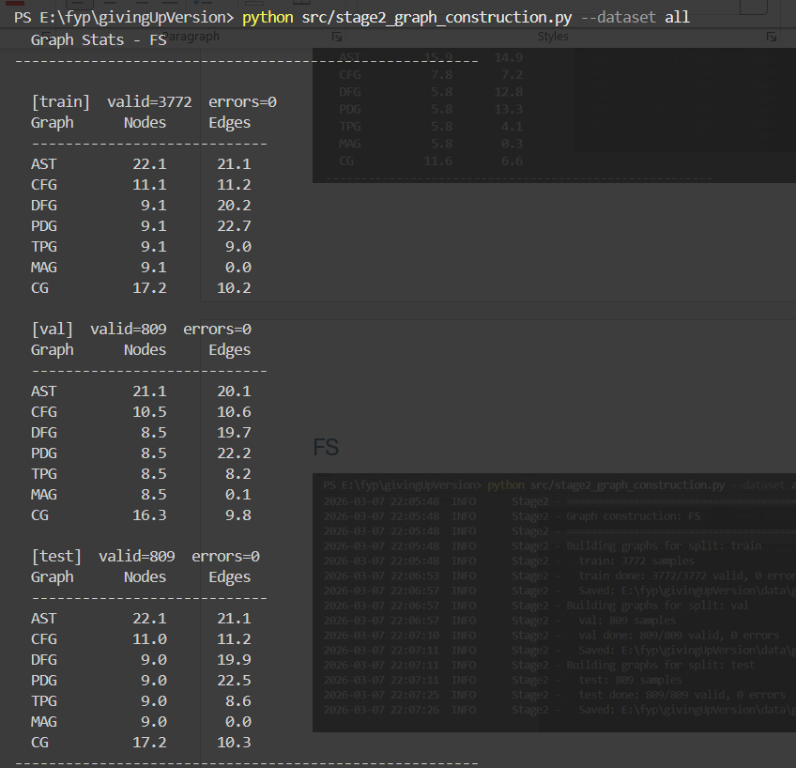

UAF
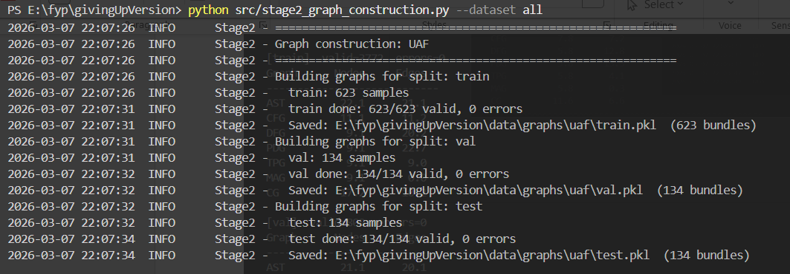
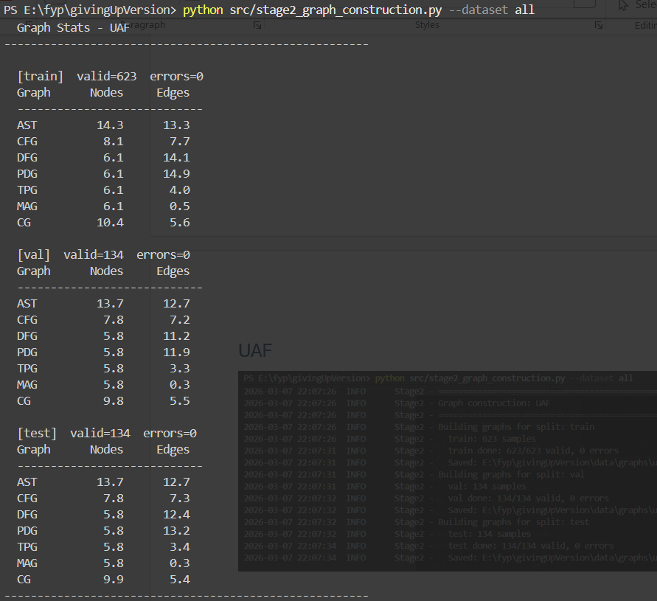

Stage 3

Req
PyTorch CPU-only
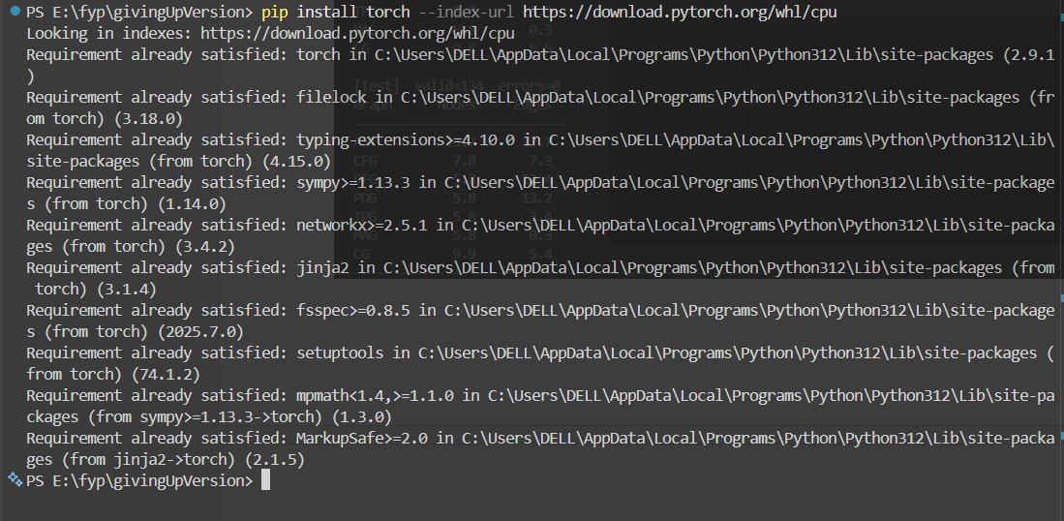
PyTorch Geometric
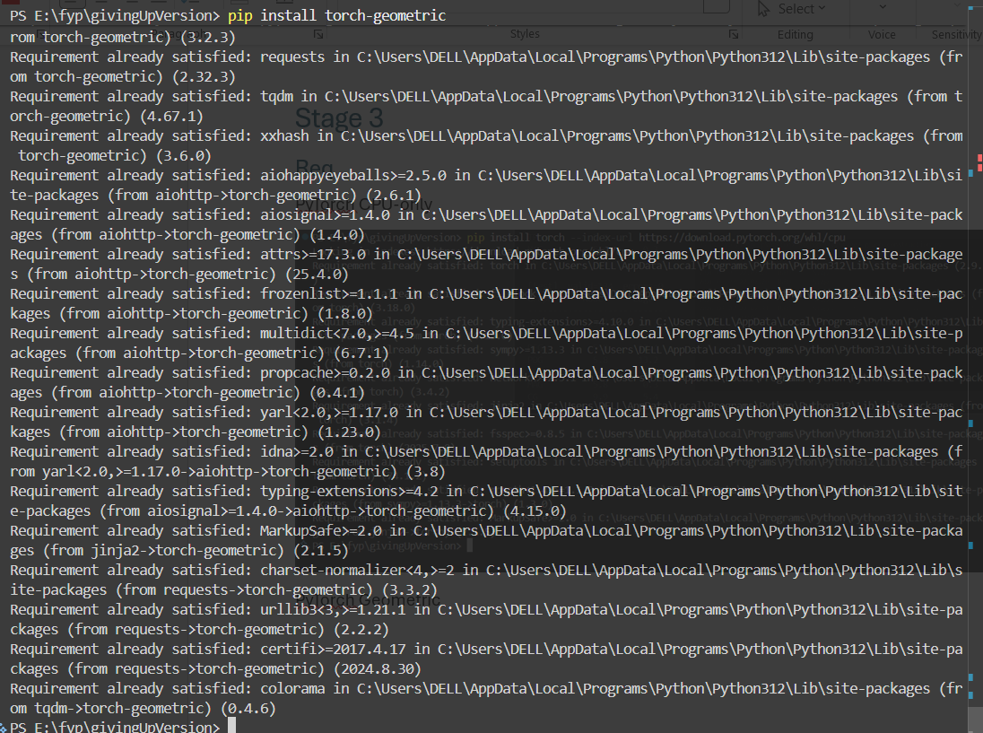

Execution
Stage 3 - GAT training (runs longest, ~10-30 min on CPU for all 3 datasets)
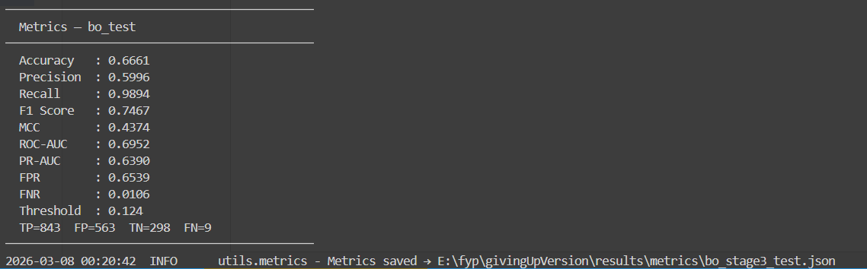
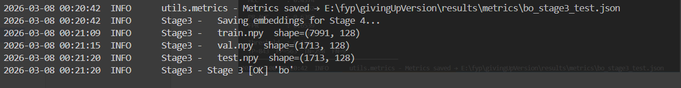
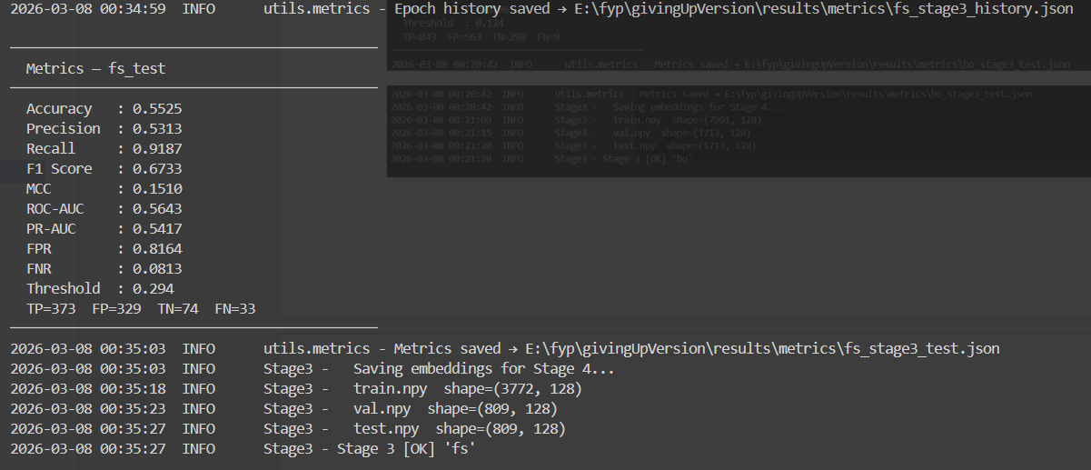
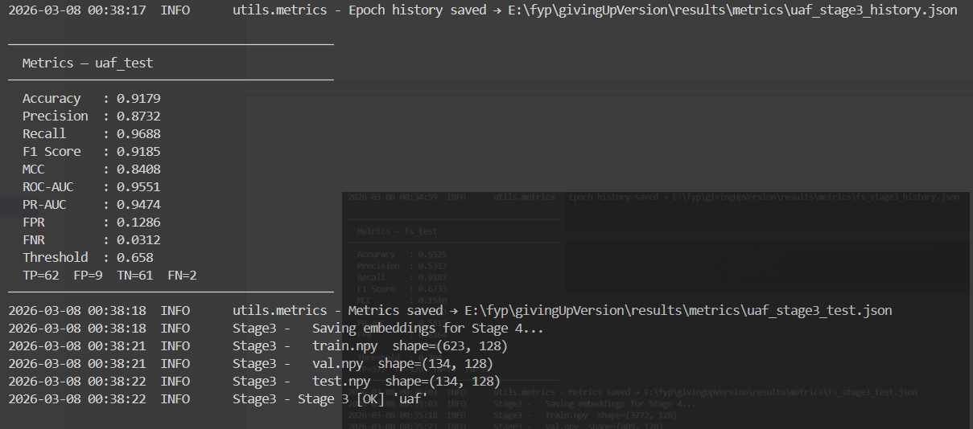
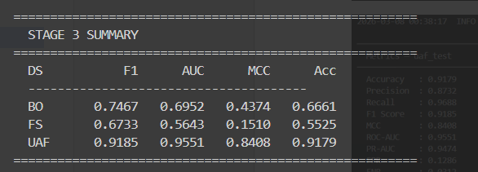

Stage 4
