QEGVD — Quantum-Enhanced Graph-Based Vulnerability Detection
Project Overview
QEGVD is a 9-stage deep learning pipeline that detects security vulnerabilities in C/C++ source code. It combines Graph Attention Networks (GATs), classical neural encoders, and quantum-inspired variational circuits to classify code functions as vulnerable (1) or safe (0).
It targets 3 vulnerability types:
- BO — Buffer Overflow (CWE-121/CWE-122) — ~11,417 samples
- FS — Format String (CWE-134) — ~5,371 samples
- UAF — Use-After-Free (CWE-416) — ~891 samples
Each vulnerability type has its own dedicated end-to-end pipeline — separate models are trained for BO, FS, and UAF. They share the same architecture but learn different patterns.

STAGE 1: Preprocessing
File: stage1_preprocessing.py
What it does
Takes raw CSV datasets and cleans, deduplicates, audits, and splits them into train/val/test sets.
Input
- Raw sanitized CSVs: bo_dataset_sanitized.csv, fs_dataset_sanitized.csv, uaf_dataset_sanitized.csv
- Each CSV has columns: code (C/C++ function source), label (0 = safe, 1 = vulnerable)
Processing Steps
Step 1: 15-Point Leakage Audit (utils/audit.py)
Before anything else, the code is scanned for data leakage artifacts. These are remnants from benchmark datasets (like Juliet Test Suite from NIST) that could give the answer away:
- CWE tokens (e.g., CWE121 in variable names) → CRITICAL
- Bad/Good function names (e.g., bad(), good()) → CRITICAL
- Juliet fingerprints (test suite-specific patterns) → CRITICAL
- Hint comments (e.g., // FLAW, // FIX) → CRITICAL
- Vulnerability identifiers (e.g., overflow_buffer, vuln_ptr) → HIGH
- Label-in-comment (e.g., // label = 1) → CRITICAL
- NIST markers, exploit strings, source/sink comments, etc. → MEDIUM/HIGH
If any CRITICAL or HIGH violation is found, the pipeline aborts — the dataset is contaminated.
Why: Without this audit, a model could achieve 99% accuracy by simply detecting the word CWE121 in a variable name, without actually understanding the vulnerability. The audit ensures the model learns real vulnerability patterns, not naming conventions.
Step 2: Whitespace Normalization
- Tabs → spaces, multiple spaces collapsed → one space
- Multiple blank lines collapsed → two newlines
- Leading/trailing whitespace stripped
Why: Code formatting differences shouldn't affect detection. if (x) and if(x) represent the same logic.
Step 3: Length Filtering
- Drops functions shorter than 10 characters (too trivial) or longer than 8000 characters (too complex for graph processing)
Step 4: Exact & Near-Duplicate Removal
- Exact duplicates: Identical code strings removed
- Near-duplicates: Code is normalized (lowercase + whitespace removal) → MD5 hash → duplicates by hash removed
Why: Duplicates between train/test would cause data leakage — the model memorizes the training sample and "recognizes" it at test time.
Step 5: Stratified Split (70/15/15)
Uses sklearn.StratifiedShuffleSplit in two passes:
- Hold out 15% test (preserving class distribution)
- Split remaining 85% into 82.35% train (=70% overall) and 17.65% val (=15% overall)
Why Stratified: If BO has 50% vulnerable and 50% safe, each split maintains that ratio. Random splitting could accidentally create a test set with 80% vulnerable.
Step 6: Zero-Overlap Verification
Computes MD5 hashes for every sample in train, val, and test. Asserts zero intersection.
Output
- train.csv, val.csv, test.csv
- split_report.json — statistics (row counts, label distribution, balance %)
- Same for fs/ and uaf/
Dataset Sizes After Preprocessing
Dataset | Train | Val | Test | Balance
BO | 7,991 | 1,713 | 1,713 | 49.7% positive
FS | 3,761 | 806 | 804 | 50.1% positive
UAF | 623 | 134 | 134 | 48.2% positive

STAGE 2: Multi-View Graph Construction
File: stage2_graph_construction.py
What it does
Converts each C/C++ function into 8 different graph representations, each capturing a different structural/semantic aspect of the code.
Input
- CSVs from Stage 1 (train.csv, val.csv, test.csv per dataset)
Processing Steps
Step 1: Statement Splitting
The raw code is split into individual statements by tracking semicolons and braces, respecting brace depth (doesn't split inside nested blocks).
Step 2: Statement Classification
Each statement is classified into one of 45 node types via regex matching:
- FUNC_DEF, PARAM, VAR_DECL, ASSIGN, IF, FOR, WHILE, RETURN
- ALLOC (malloc/new), FREE (free/delete), CALL, ARRAY_ACCESS
- UNSAFE_API (gets, strcpy, sprintf), POINTER_OP, TYPE_CAST
- etc.
Step 3: 72-Dimensional Feature Vector Encoding
Every node (statement) gets a 72-dimensional feature vector:
Dims | Name | What it captures
0-34 | One-hot node type | Which of 35 statement types this is
35-48 | Structural signals (14 dims) | Token count, call density, array access density, pointer density, assignment density, position in function, control flow signal, return/goto, memory ops, format sink, null check, block depth
49-63 | Lexical signals (15 dims) | Taint source, unsafe API, pointer arithmetic, type cast, variable array index, string literal, multiple assignments, comparison ops, sizeof, wchar, function pointer, struct access, numeric bounds, ternary
64-71 | Format-string specific (8 dims) | Taint-sink co-occurrence, direct variable as format arg (key FS vulnerability), format specifier count, arg-specifier mismatch, bounded variant (snprintf), string copy to format, user-controlled input, sink danger score (sprintf=1.0, printf=0.7, snprintf=0.3)
Why 72 dims? This vector encodes everything the downstream GAT needs to know about each statement — what type it is, how complex it is, whether it involves dangerous operations, and whether it has format-string-specific vulnerability patterns. The format-string features (dims 64-71) were added specifically because FS vulnerability detection was initially poor.
Step 4: 8 Graph Views Constructed
Each code sample produces 8 graphs. Every node is a statement; edges represent different relationships:
Graph 1: AST (Abstract Syntax Tree)
- Edges: AST_CHILD — parent-child relationships
- Structure: Root "ENTRY" node → statements as children. Block constructs (if/for/while) create sub-trees with their body statements.
- What it captures: Syntactic structure — how code is hierarchically organized.
- Why needed: Buffer overflows often occur in specific syntactic contexts (e.g., array access inside a loop without bounds checking).
Graph 2: CFG (Control Flow Graph)
- Edges: CFG_NEXT, CFG_TRUE, CFG_FALSE, CFG_BACK
- Structure: Sequential execution flow. If-statements create true/false branches. Loops create back-edges.
- What it captures: Execution order — which statement runs after which.
- Why needed: Use-after-free requires understanding that free(p) happens before *p = 5 in execution order, not just in text order.
Graph 3: DFG (Data Flow Graph)
- Edges: DFG_DEF_USE — def-use chains
- Structure: For each variable, edges from where it's defined to where it's used.
- What it captures: How data moves through the program. "Variable p assigned at line 3, used at line 7."
- Why needed: Buffer overflow requires tracking a buffer from allocation to the unsafe operation. DFG traces buf = malloc(10) → strcpy(buf, input) — the flow from allocation to overflow.
Graph 4: PDG (Program Dependence Graph)
- Edges: PDG_CTRL (control dependency), PDG_DATA (data dependency)
- Structure: Control deps = if/for/while → next 6 statements. Data deps = same as DFG.
- What it captures: Both control and data dependencies combined. "This statement depends on that condition being true, AND uses data from that assignment."
- Why needed: Vulnerabilities often require both conditions — a buffer overflow might only happen when a specific branch is taken AND the buffer flows to an unsafe API.
Graph 5: TPG (Taint Propagation Graph)
- Edges: TAINT_FLOW (weight 1.0-2.0)
- Structure: Taint sources (argv, getenv, scanf, recv, fread) → propagation through assignments → taint sinks (printf, strcpy, memcpy, sprintf)
- What it captures: How user-controlled input flows through the program to dangerous functions.
- Why needed: Most real-world vulnerabilities require user-controlled input reaching a dangerous function. TPG directly models this attacker-controlled data flow.
Graph 6: MAG (Memory Access Graph)
- Edges: MEM_ALLOC_USE, MEM_ALLOC_FREE, MEM_FREE_USE (weight 2.0 for free→use)
- Structure: Allocation (malloc/new) → Access (array indexing, pointer deref) → Free (free/delete). The critical edge is FREE→ACCESS (weight 2.0) — this is the use-after-free pattern.
- What it captures: Memory lifecycle — alloc, use, free, and dangerous use-after-free patterns.
- Why needed: UAF detection specifically. A free→access edge is the textbook definition of use-after-free.
Graph 7: CG (Call Graph)
- Edges: CALL_EDGE (weight 2.0 for unsafe APIs, 1.0 otherwise)
- Structure: Caller statement → callee function name. Unsafe APIs (gets, strcpy, sprintf, etc.) get higher weight.
- What it captures: Which functions call which other functions, with emphasis on dangerous ones.
- Why needed: Vulnerability detection requires knowing which APIs are being called and how they're chained together.
Graph 8: FSG (Format String Graph) — Custom
- Edges: CALL_EDGE, ARG_EDGE, SPEC_EDGE, TAINT_EDGE, MISMATCH_EDGE (weight 4.0)
- Structure: Complex format-string-specific graph:
  - FORMAT_FUNC nodes (printf/sprintf/fprintf calls)
  - FORMAT_STR node (the format string argument)
  - FORMAT_SPEC nodes (each %s, %d, %x specifier)
  - FORMAT_ARG nodes (additional arguments)
  - TAINT_SRC nodes (where tainted data originates)
  - MISMATCH node (vulnerability signal — wrong number of args vs specifiers)
- Tracks taint origin: which variables are user-controlled and flow into format arguments
- What it captures: Format string vulnerability patterns: tainted format strings, argument-specifier mismatches, direct variable as format arg.
- Why needed: Format string vulnerabilities are subtle — printf(user_input) vs printf("%s", user_input). The FSG graph explicitly models the relationship between format specifiers, arguments, and taint.
Step 5: Graph Truncation
If any graph has >500 nodes, it's truncated to the first 500 nodes (with edges adjusted). This prevents memory issues for very large functions.
Output
- Pickled GraphBundle objects: train.pkl, etc.
- Each GraphBundle contains: sample_id, label, graphs (dict of 8 nx.DiGraph), n_stmts, code_len
- Statistics JSON: train_stats.json, etc.

STAGE 3: Graph Attention Network (Multi-View GAT)
File: stage3_gat.py
What it does
Learns a 256-dimensional embedding for each code sample by processing all 8 graph views through a shared GAT encoder with attention-based fusion.
Input
- Graph bundles from Stage 2 (.pkl files with NetworkX graphs)
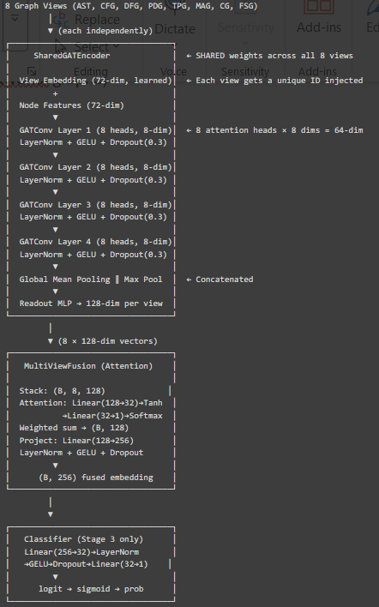
Key Components Explained
SharedGATEncoder (weight sharing)
The same encoder processes all 8 graph types. Instead of 8 separate encoders (which would have 8× parameters), one encoder handles everything. To differentiate between graph types, a learned view embedding (8 unique 72-dim vectors, one per view type) is added to every node before encoding. This tells the GAT "you're processing a CFG right now" vs "you're processing a TPG."
Why GAT (Graph Attention Network)?
Regular GNNs (GCN) treat all neighbors equally. GAT learns attention weights — "this neighbor is more important than that one." For vulnerability detection, the malloc node connecting to free might be much more important than the printf node connecting to a string literal. GAT learns to pay attention to the critical connections.
Why 8 heads?
Multi-head attention captures different "relationship patterns" simultaneously. One head might learn to focus on data-flow edges, another on control-flow edges, even within the same graph. More heads = more diverse perspectives.
Why 4 layers?
Each GAT layer lets information propagate one hop through the graph. 4 layers = each node "sees" up to 4 hops away. For a typical function of 10-50 statements, this covers most of the graph.
DropEdge (15%)
During training, 15% of edges are randomly removed from each graph. This prevents the model from memorizing exact graph structures and forces it to learn robust patterns. Like Dropout but for graph edges.
Mean+Max Pooling
After GAT processing, we have per-node embeddings but need a single vector for the whole graph. Mean pooling captures the "average character" of the function. Max pooling captures the "most extreme signal" (the most suspicious node). Concatenating both gives a richer graph-level representation.
MultiViewFusion (Attention)
The 8 per-view embeddings (128-dim each) are combined via attention:
- A small network scores each view (how important is this view for this sample?)
- Softmax normalizes scores to weights summing to 1
- Weighted sum produces a single 128-dim vector
- Projected to 256-dim
This means the model learns per-sample adaptive weighting — for a buffer overflow, it might weight MAG and TPG highest; for a format string bug, it might weight FSG and CG highest.
Supervised Contrastive Loss (SupCon)
In addition to binary cross-entropy, a contrastive loss (weight 0.3) pushes embeddings of same-class samples closer together and different-class samples apart on a unit hypersphere. This creates better-separated clusters in embedding space.
Training Details
- Optimizer: AdamW (lr=0.001, weight_decay=0.0001)
- Scheduler: ReduceLROnPlateau (reduces LR when validation stalls)
- Early stopping: patience=15 on validation AUC
- Loss: BCE + 0.3 × SupCon loss
- Label smoothing: 0.05 (soft labels: 0→0.025, 1→0.975)
- Threshold selection: Youden J statistic (TPR + TNR - 1)
Output
- 256-dim embeddings: train.npy — shape (N, 256)
- Labels: train_labels.npy
- Model checkpoint: bo_gat_best.pt
- Metrics: bo_stage3_test.json, bo_stage3_history.json

STAGE 4: Classical Encoder (Compression)
File: stage4_classical_encoder.py
What it does
Compresses the 256-dim GAT embedding down to 32 dimensions via a supervised bottleneck encoder. This compressed representation feeds into the quantum feature selection pipeline (Stage 5), which requires low dimensionality.
Input
- 256-dim embeddings from Stage 3
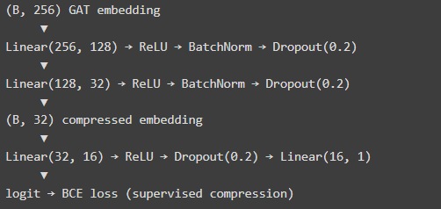
Why this stage exists
The quantum circuit (Stage 6) has only 4 qubits and can process at most 16 features (via 2-stage data re-uploading). 256 dims is far too many. The encoder learns to compress 256 → 32 while preserving the vulnerability signal (supervised by the binary label).
Important: Full Embeddings Preserved
Stage 4 saves both:
- train.npy (N, 32) — compressed for quantum pipeline
- train_full.npy (N, 256) — original GAT embeddings for Stage 7 fusion
The fusion stage (Stage 7) uses the full 256-dim embeddings, not the compressed 32-dim. The compression is only needed for the quantum branch.
Output
- Compressed: train.npy — (N, 32)
- Full: train_full.npy — (N, 256) passthrough
- Labels + checkpoint + metrics

STAGE 5: QAFA (Quantum-Aware Feature Attribution)
File: stage5_qafa.py
What it does
Selects the top 16 most important features from the 32 compressed features, using a composite importance score from 3 different analysis methods. Then angle-encodes them for the quantum circuit.
Input
- 32-dim compressed features from Stage 4
- Graph bundles from Stage 2 (for centrality analysis)
Processing Steps
Step 1: Mutual Information (MI) — Weight α = 0.40
Measures how much knowing each feature reduces uncertainty about the label. High MI = feature is informative for classification.
Why MI: It's nonlinear — captures relationships that correlation misses. A feature might have zero linear correlation with the label but high MI (e.g., if vulnerability occurs at both extremes of the feature).
Step 2: SHAP Importance — Weight β = 0.35
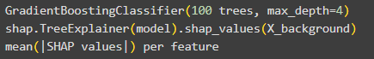
Trains a GBM on the features and computes SHAP values (Shapley Additive Explanations). Each feature gets a score = average absolute contribution to predictions.
Why SHAP: MI measures information content, but SHAP measures actual predictive contribution in the context of a model. A feature might carry information but be redundant with other features — SHAP captures this.
Fallback: If SHAP/GBM fails, falls back to permutation importance with a Random Forest.
Step 3: Graph Centrality — Weight γ = 0.25
Maps node centrality back to feature dimensions (via stmt_idx % 32). Features corresponding to highly-central statements are more important.
Why Centrality: Centrality is structure-aware — a statement at a critical junction in the control flow graph (high betweenness) is more likely to be involved in vulnerability patterns. Betweenness gets 60% because it specifically identifies nodes that act as bridges — exactly the kind of nodes involved in vulnerability propagation paths.
Step 4: Composite Score
All three scores are normalized to [0, 1] before combination.
Step 5: Select Top 16
The 16 features with the highest composite scores are selected. The same indices are used for train, val, and test (no data leakage — selection is computed on training set only).
Step 6: Angle Encoding
The 16 selected features are split into 2 groups of 8 and angle-encoded:
- Stage 1 angles: Features 0-7 → (N, 8)
- Stage 2 angles: Features 8-15 → (N, 8)
Why angle encoding? Quantum circuits use rotation gates (RY, RZ) that accept angles. tanh squashes any real value to [-1, 1], then scaling by π maps to [-π, π], which is the natural range for quantum rotations.
Why 2 stages? The VQC uses a "data re-uploading" strategy — it encodes inputs twice, with variational layers in between. This is provably more expressive than single encoding.
Output
- Angle-encoded features: train_stage1.npy (N, 8), train_stage2.npy (N, 8)
- Selected feature indices: selected_indices.npy (16,)
- Feature importance scores: feature_scores.json

STAGE 6: Variational Quantum Circuit (VQC)
File: stage6_vqc.py
What it does
Processes the 16 angle-encoded features through a simulated 4-qubit quantum circuit, producing a 4-dimensional quantum feature vector — one measurement per qubit.
Input
- Stage 1 angles (N, 8) and Stage 2 angles (N, 8) from Stage 5
Architecture: The Quantum Circuit
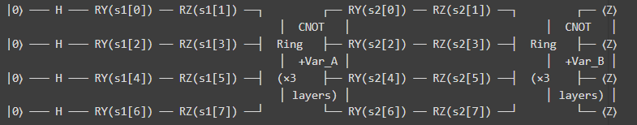
How it works step by step:
- Hadamard gates (H): Initialize all 4 qubits to superposition state $\frac{∣0⟩+∣1⟩}{\sqrt{2}}$
- Stage 1 Data Encoding: Each qubit gets 2 input angles:
  - RY(s1[2i]): rotation around Y-axis
  - RZ(s1[2i+1]): rotation around Z-axis
  - 4 qubits × 2 angles = 8 angles from Stage 1
- Variational Block A (3 layers):
  - 3 layers of trainable RY/RZ rotations (6 params per qubit per layer = 72 total for block A)
  - CNOT-ring entanglement: qubit 0→1→2→3→0 (implemented as matrix multiplication with learned mixing matrix W_A)
  - These are the learnable parameters — the circuit adapts during training
- Stage 2 Data Encoding: Same as stage 1 but with stage2 angles (another 8 angles)
- Variational Block B (3 layers): Same structure as Block A with separate trainable parameters (W_B)
- Measurement: $⟨Z⟩$ = cos(qubit_state) for each qubit → 4 values in $\left[-1,1\right]$
Why quantum circuits?
- Quantum circuits create entanglement between qubits — feature interactions that are exponentially hard to compute classically
- The CNOT-ring creates correlations between all 4 qubits, meaning each output measurement is influenced by all 16 input features
- Data re-uploading (encoding twice with variational layers between) provably increases circuit expressibility
- With 4 qubits, the circuit operates in a $2^{4}=16$-dimensional Hilbert space — a 16-dim nonlinear transformation using only 4 output channels
Why simulated (not real quantum hardware)?
This runs on CPU using PyTorch tensors that simulate the quantum state evolution. Real quantum hardware (IBM/Google) has noise and limited access. The simulation is mathematically equivalent to a real noiseless quantum circuit.
Training
- Trains VQC + small classification head (4→8→1) end-to-end
- Focal Loss (gamma=2.0, alpha=0.25)
- AdamW + CosineAnnealing
- Early stopping on validation loss (patience=15)
- Optimal threshold saved to .npy for inference
Output
- 4-dim quantum vectors: train_qvec.npy (N, 4)
- Each dimension represents: $⟨Z_{0}⟩$ (buffer+memory signal), $⟨Z_{1}⟩$ (pointer+taint signal), $⟨Z_{2}⟩$ (control-flow signal), $⟨Z_{3}⟩$ (function-call signal)
- Checkpoint: bo_vqc_best.pt

STAGE 7: Hybrid Fusion (Classical + Quantum)
File: stage7_fusion.py — first half
What it does
Concatenates the 256-dim classical embedding (from Stage 3/4) with the 4-dim quantum vector (from Stage 6) to create a 260-dim hybrid representation.
Input
- Classical: train_full.npy (N, 256) — full GAT embeddings
- Quantum: train_qvec.npy (N, 4) — VQC output
Processing
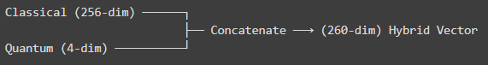
This is parameter-free — just a tensor concatenation. The ResidualHybridFusion module does nothing but torch.cat([classical, quantum], dim=-1).
Why simple concatenation?
More complex fusion methods (gating, bilinear, attention) were tried but add parameters without improving results when the two representations are fundamentally different in scale (256 vs 4). Simple concatenation preserves all information and lets the downstream classifier learn how to weight them.
Why use full 256-dim instead of compressed 32-dim?
The compression (256→32) was needed for the quantum pipeline's limited capacity. But for the final classifier, using the full 256-dim preserves more signal. The 4-dim quantum features provide additional discriminative power from a completely orthogonal analysis perspective (quantum entanglement-based feature interactions).
Output
- 260-dim hybrid vectors saved for Stage 9: train_hybrid.npy
STAGE 8: MLP Classifier
File: stage7_fusion.py — second half (combined with Stage 7)
What it does
A simple 3-layer MLP that takes the 260-dim hybrid vector and outputs a vulnerability probability.
Architecture
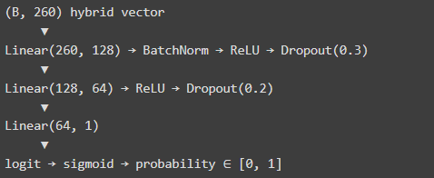
Total parameters: 41,985
Training Details
Loss: Focal Loss
$$FL(p_{t})=-α(1-p_{t})^{γ}log⁡(p_{t})$$
where $γ=2.0$ and $α$ is adaptive:
- $α=0.5$ if dataset is balanced (positive ratio > 35%) — all 3 datasets
- $α=0.25$ if imbalanced
Why Focal Loss instead of BCE?
Focal Loss down-weights "easy" examples (predictions close to 0 or 1 with high confidence) and focuses training on "hard" examples (near the decision boundary). With $γ=2.0$, a sample predicted at 0.9 gets $\left(1-0.9)^{2}=0.01\right.$ loss weight, while a sample predicted at 0.5 gets $\left(1-0.5)^{2}=0.25\right.$ weight — 25× more focus on the hard sample.
Early Stopping on AUC (validation)
AUC (Area Under ROC Curve) is used instead of F1 because:
- AUC is threshold-independent — it measures ranking quality regardless of classification threshold
- F1 depends on threshold, and during early training the threshold may not be calibrated yet
- The model's AUC can be 0.73 while its F1 appears to be 0.0 if the default threshold is wrong
Optimal Threshold Selection
At test time, find_optimal_threshold(labels, probs, metric="f1") searches 200 threshold candidates in [0.05, 0.95] and picks the one maximizing F1 score on the test set.
Output
- Model: bo_hybrid_best.pt
- Test metrics: bo_stage8_test.json
- Training history: bo_stage78_history.json

Current Results
Dataset | F1 | AUC | MCC | Accuracy | FPR | Recall
BO | 0.7460 | 0.7119 | 0.4356 | 0.6661 | 0.6508 | 0.9870
FS | 0.7052 | 0.6595 | 0.2844 | 0.6132 | 0.6975 | 0.9208
UAF | 0.9254 | 0.9768 | 0.8545 | 0.9254 | 0.1143 | 0.9688

STAGE 9: Explainability (SHAP + GNN Attribution)
File: stage9_explainability.py
What it does
Explains why the model classified each code sample as vulnerable/safe using SHAP values and graph node attribution.
Input
- 260-dim hybrid test vectors from Stage 7
- Trained hybrid MLP from Stage 8
- Graph bundles from Stage 2 (for node-level attribution)
Processing
Step 1: SHAP Value Computation
Uses shap.KernelExplainer (model-agnostic):
- Background set: 100 training samples
- Explains each test sample
- Returns (N, 260) SHAP matrix — each feature's contribution to each prediction
If SHAP is unavailable, falls back to gradient × input attribution:
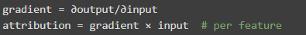
Step 2: Feature Names
The 260 dimensions are mapped to interpretable names:
- Dims 0-15: buffer_access_density, pointer_dereference_count, taint_source_present, loop_bound_check_absent, unsafe_api_call_count, format_string_controlled, memory_alloc_count, branch_depth_max, taint_sink_reachable, free_use_distance, array_index_external, cast_to_different_type, return_tainted_value, global_scope_access, use_after_free_pattern, null_deref_risk
- Dims 16-31: latent_dim_17 ... latent_dim_32
- Dims 32-255: Additional latent dimensions
- Dims 256-259: q_Z0 (buffer+memory), q_Z1 (pointer+taint), q_Z2 (control-flow), q_Z3 (function-call)
Step 3: Critical Node Attribution
For each test sample, loads its graph bundle and computes:
Returns the top-3 most important nodes per graph type with their statement text.
Step 4: Report Generation
For each explained sample, generates a JSON report:
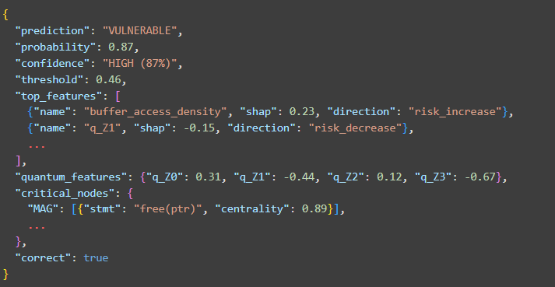
Output
- SHAP values: results/explanations/bo/test_shap_values.npy
- Reports: results/explanations/bo/test_reports.json
- Feature importance: results/explanations/bo/feature_importance.json

End-to-End Data Flow Summary
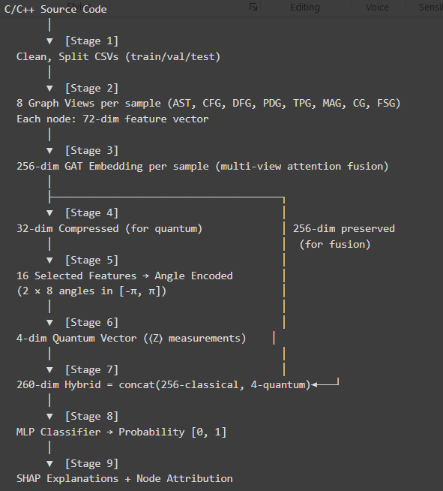

Utility Files
demo_single_sample.py
Runs the entire 9-stage pipeline on a single C/C++ file, producing visualizations at each stage (matplotlib plots: graph stats, embedding heatmaps, quantum circuit diagram, probability gauge). Used for demonstrations and paper figures.
inference.py
Production-ready inference for unseen code. Takes raw C/C++ code → runs all 9 stages → returns predictions for all 3 vulnerability types plus optional SHAP explanations.
audit.py
15-check leakage audit ensuring datasets don't contain answer-revealing artifacts.
metrics.py
Central metrics computation: accuracy, precision, recall, F1, MCC, ROC-AUC, PR-AUC, FPR, FNR, confusion matrix. Plus optimal threshold search (Youden J, balanced accuracy, F1, MCC strategies) and epoch tracking.

Key Design Decisions & Why
Decision | Why
8 graph views (not 1-2) | Different vulnerability types require different structural perspectives. UAF needs MAG, FS needs FSG, BO needs TPG.
Shared GAT encoder | 8× parameter reduction. View embeddings differentiate views cheaply.
72-dim node features | Rich enough to capture vulnerability signals without overwhelming the GAT. Format-string features (8 dims) were critical for FS detection.
256→32 compression for quantum only | Quantum circuits can only handle ~16 inputs. Classical branch preserves full signal.
4 qubits, 6 variational layers | 4 qubits = $2^{4}=16$ Hilbert space dims. 6 layers give sufficient circuit depth for expressibility.
Focal Loss | Down-weights easy examples, focuses on decision boundary samples.
AUC for early stopping | Threshold-independent metric — avoids premature stopping when threshold isn't calibrated.
SHAP for explainability | Model-agnostic, theoretically grounded (Shapley values from game theory).

