SecuraQpp v2
Quantum-Enhanced Source Code Vulnerability Detection System

Methodology, Normalization Steps & Experimental Report

Final Year Project — Department of Computer Science
May 2026

1. Abstract
SecuraQpp v2 is a full-stack, quantum-classical hybrid system for automated software vulnerability detection. The pipeline processes C/C++ source code through eight sequential stages: text preprocessing, multi-view graph construction, graph attention network (GAT) encoding, classical compression, quantum-aware feature alignment (QAFA), variational quantum circuit (VQC) simulation, hybrid feature fusion, and final classification. Three vulnerability classes from the NIST Juliet Test Suite are targeted: Buffer Overflow (BO), Format String (FS), and Use-After-Free (UAF). Final test accuracies reached 90.5% (BO), 91.8% (UAF), and 82.0% (FS), all significantly outperforming the QEGVD paper baseline of 61.19%–78.6%. The system is deployed as a production web application with role-based access, two-factor authentication, real-time graph visualization, and AI-powered patch suggestions via the Claude API.

2. Dataset Description

2.1 Source
The NIST Juliet Test Suite (C/C++ version) is the industry-standard benchmark for vulnerability detection research. It contains thousands of synthetic C/C++ code pairs — each pair consists of one vulnerable function and one patched (safe) version — covering over 100 Common Weakness Enumeration (CWE) categories.

2.2 Selected Vulnerability Types
Vulnerability | CWE | Total Samples | Balance
Buffer Overflow (BO) | CWE-121/122 | 11,417 | 50% vuln / 50% safe
Format String (FS) | CWE-134 | 5,390 | 50% vuln / 50% safe
Use-After-Free (UAF) | CWE-416 | 891 | 50% vuln / 50% safe

2.3 Preprocessing & Splits
Each dataset undergoes the following before splitting:
- Variable names replaced with VAR_N tokens (prevents name-based leakage)
- Type names replaced with TYPE_N tokens
- Whitespace collapsed, duplicate code removed via MD5 hashing
- 15-point data leakage audit run — aborts if CRITICAL/HIGH violation detected
Stratified split applied: 70% Train / 15% Validation / 15% Test
Dataset | Train | Val | Test | Total
BO | 7,991 | 1,713 | 1,713 | 11,417
FS | 3,772 | 809 | 809 | 5,390
UAF | 623 | 134 | 134 | 891

3. Methodology — Pipeline Stages
The QEGVD (Quantum-Enhanced Graph Vulnerability Detection) pipeline processes each code sample through 8 sequential stages. The architecture is summarized below:
Stage | Name | Output Dimension
Stage 1 | Data Preprocessing & Splitting | Cleaned CSVs, 70/15/15 splits
Stage 2 | Multi-View Graph Construction | 8 graphs per sample, 64-dim node features
Stage 3 | Graph Attention Network (GAT) | 256-dim graph embedding
Stage 4 | Classical Encoder (Compression) | 256-dim vulnerability signature
Stage 5 | QAFA — Quantum-Aware Feature Alignment | 8×8-dim = 64 angle-encoded features
Stage 6 | Variational Quantum Circuit (VQC) | 4–40-dim quantum feature vector (per pipeline)
Stage 7 | Hybrid Feature Fusion | 260-dim (UAF) / 288-dim (BO) / 311-dim (FS)
Stage 8 | MLP Final Classifier | Binary label + confidence score

3.1 Stage 1 — Data Preprocessing
The raw Juliet CSV files are loaded and passed through a rigorous cleaning pipeline before any model sees them.
- Whitespace Normalization: tabs → single space; 2+ spaces → single space; 3+ newlines → 2 newlines; strip leading/trailing whitespace
- MD5 Near-Duplicate Removal: each sample is lowercased, all whitespace collapsed to single space, then MD5-hashed. Duplicate hashes are dropped.
- 15-Point Leakage Audit: checks for label-in-code, identifier overlap between splits, and other critical data contamination signals.
- Stratified Split: sklearn StratifiedKFold ensures class balance is maintained in all three splits.

3.2 Stage 2 — Multi-View Graph Construction
Each code sample is converted into 8 distinct program analysis graphs using pure Python static analysis (no external parser required — fully offline and portable).
Graph | Full Name | What It Captures
AST | Abstract Syntax Tree | Syntactic code structure
CFG | Control Flow Graph | Execution paths (if/else/loops)
DFG | Data Flow Graph | Variable definitions and uses
PDG | Program Dependence Graph | CFG + DFG unified
TPG | Taint Propagation Graph | User input → dangerous sink flows
MAG | Memory Access Graph | malloc/free/access relationships
CG | Call Graph | Caller → callee relationships
FSG | Format String Graph | Format specifier → argument binding and taint paths

Each node is assigned a 64-dimensional feature vector encoding token type, structural metrics, and vulnerability-specific signals.

3.3 Stage 3 — Graph Attention Network (GAT)
Architecture: per-view encoder + attention-weighted fusion.
- Per view: 4× GATConv layers (128-dim, 8 attention heads each) → mean+max readout → per-view embedding
- Fusion: learned attention weights over all 8 views → 256-dim fused graph embedding (FUSED_DIM=256)
- Classification head: Linear(256→64→1) with Sigmoid
- Loss: Focal Loss + Supervised Contrastive Loss (SupCon), combined with α=0.7/0.3 weighting
Per-dataset parameters:
Parameter | BO | FS | UAF
Dropout | 0.30 | 0.20 | 0.30
DropEdge | 15% | 10% | 15%
SupCon Temperature | 0.07 | 0.10 | 0.10
Label Smoothing | 0.05 | 0.02 | 0.05

3.4 Stage 4 — Classical Encoder
Compresses the 256-dim GAT embedding into a compact vulnerability signature.
- Architecture: FC(256→128) → ReLU → BN → Dropout → FC(128→256) → ReLU → BN (INPUT_DIM=256)
- Input is L2-normalized before the first FC layer
- Output: 256-dim vulnerability signature — this full vector feeds into Stage 7 fusion
- QAFA (Stage 5) takes this 256-dim output and selects top 16 features for the VQC only
Pipeline | Input (GAT) | Architecture | Output
BO | 256-dim | FC(256→128)→BN→FC(128→256)→BN | 256-dim
FS | 256-dim | FC(256→128)→BN→FC(128→256)→BN | 256-dim
UAF | 256-dim | FC(256→128)→BN→FC(128→256)→BN | 256-dim

All pipelines output 256-dim. The 256-dim embedding passes directly to Stage 7 fusion. QAFA selects a 16-feature subset for the quantum circuit only.

3.5 Stage 5 — QAFA (Quantum-Aware Feature Alignment)
QAFA selects the most vulnerability-relevant features from the compressed vector before passing them to the quantum circuit. This is critical: quantum circuits have limited expressibility per qubit, so only the most informative features should enter.
- Composite scoring: S_i = α·MI(i) + β·SHAP(i) + γ·Centrality(i) [all normalized to 0–1]
- MI: Mutual Information with the label (sklearn, 5 nearest neighbours)
- SHAP: Mean absolute SHAP value from a GBM model
- Centrality: Weighted average of degree, betweenness, and closeness centrality across 200 sampled graphs
- Top 16 features selected → split into 2 groups of 8 → rescaled to [–π, π] via tanh×π for angle encoding
FS-specific extras:
- Histogram Overlap Filter: eliminates features where class distributions overlap >90%
- MMD (Maximum Mean Discrepancy) as 4th criterion (δ=0.25 weight)
Pipeline | α (MI) | β (SHAP) | γ (Centrality) | δ (MMD)
BO | 0.30 | 0.20 | 0.50 | —
FS | 0.30 | 0.25 | 0.20 | 0.25
UAF | 0.40 | 0.35 | 0.25 | —

3.6 Stage 6 — Variational Quantum Circuit (VQC)
A real quantum circuit simulation is implemented using PennyLane (default.qubit backend). The circuit operates on 4 qubits and uses the data re-uploading technique to process 64 input features through 8 encoding rounds.
- Circuit: H⁴ → RY/RZ(s1) → CNOT-ring → Var_A(×3) → RY/RZ(s2) → CNOT-ring → Var_B(×3) → ⟨Z⟩⁴
- 4 qubits, 3 variational layers per block, 60 trainable parameters (standard VQC)
- Data re-uploading: 8 rounds × 8-dim input = 64 features encoded quantum-mechanically
- Output: 32-dim quantum feature vector (Pauli-Z expectation values concatenated across rounds)
- Learnable input_scale parameter (initialized to π) scales each feature individually
- Training: AdamW optimizer, Focal Loss, Cosine Annealing LR, early stopping (patience=15)

3.7 Stages 7+8 — Hybrid Fusion & Classification
The full 256-dim classical embedding from Stage 4 is concatenated with the VQC quantum output from Stage 6. Final fusion dimensions differ per pipeline:
Pipeline | Classical (S4) | Quantum (S6) | Total Fused Dim
BO | 256-dim | 32-dim | 288-dim
UAF | 256-dim | 4-dim | 260-dim
FS | 256-dim | 40-dim + 15 meta | 311-dim

Ensemble: XGBoost + GradientBoosting + RandomForest with blend weight optimization and threshold calibration on validation set.
MLP classifier on fused vector — FS uses BatchNorm on both FC layers with higher dropout (0.35/0.25) due to its smaller training set.

4. Normalization Steps — Per Pipeline

4.1 Stage 1 — Text-Level Normalization
Identical for all 3 pipelines.
- Whitespace: tabs → single space; 2+ spaces → single space; 3+ newlines → 2 newlines; strip edges
- MD5 Near-Duplicate: lowercase entire string, collapse all whitespace → single space, strip, compute MD5. Samples with identical hash → one dropped.

4.2 Stage 2 — Node Feature Normalization
Applied inline during graph construction before GAT training:
Feature Dim | Description | Normalization | Pipelines
[35] | Token count | min(n_tokens/30, 1.0) — clamp to [0,1] | All
[36] | Call density | paren_count / n_tokens — ratio [0,1] | All
[37] | Array access density | bracket_count / n_tokens | All
[38] | Pointer density | star_count / n_tokens | All
[39] | Assignment density | equals_count / n_tokens | All
[40] | Statement position | stmt_index / total_statements | All
[41–47] | Binary signals | Already 0/1 — no normalization | All
[48] | Block depth | sum({,}) / 5.0, clipped to 1.0 | All
[71] | Sink danger score | Hand-scored: snprintf=0.3, sprintf=1.0 | FS
[74] | Format sink count | count / total_statements | FS
[75] | Taint-to-sink ratio | taint_count / max(sink_count, 1) | FS
[80] | Largest numeric literal | max_literal / 1000 | BO

FS-specific Group-Wise Node Feature Normalizer (fitted on training set only):
Dimensions | Scaler Used | Reason
[0:35] — one-hot node types | None | Already {0,1} — StandardScaler would distort binary probabilities
[35:64] — structural/lexical | RobustScaler | Robust to outlier functions with very long loops or many calls
[64:84] — sink & FS-specific | MinMaxScaler | Counts and binary signals that must stay non-negative

FS-specific TPG Edge Weight Clipping: taint edges clipped from max=5.0 → max=2.0 to prevent gradient explosion in GAT message passing.

4.3 Stage 3 — GAT Internal Normalization
- LayerNorm after every GATConv layer — normalizes across feature dim per node (not batch), stabilizing attention across nodes with different degree counts
- LayerNorm on readout: after mean+max pooling concat → Linear → LayerNorm(out_dim×2)
- LayerNorm on fusion: after attention-weighted sum → Linear(256) → LayerNorm(256)
- L2 Normalization before SupCon Loss: F.normalize(features, p=2, dim=1) — mathematically required for temperature-scaled cosine similarity

4.4 Stage 4 — Classical Encoder Normalization
- L2 Normalization of input (first operation in forward pass): x = F.normalize(x, p=2, dim=1)
- BatchNorm1d after every FC layer: normalizes each feature dim across batch, prevents internal covariate shift
- All pipelines: FC(256→128)→BN→Dropout→FC(128→256)→BN (INPUT_DIM=256 confirmed in stage4_classical_encoder.py:76)

4.5 Stage 5 — QAFA Score Normalization
- MI Normalization: mi_scores /= mi_scores.max() → [0,1]
- SHAP Normalization: |shap_values|.mean(axis=0) /= max → [0,1]
- Centrality — Two-Level: (1) normalize per sample by local max; (2) normalize accumulated average by global max
- Composite score automatically in [0,1] since all three inputs are [0,1] and weights sum to 1.0
- Angle Encoding: angles = tanh(features) × π → [–π, π] (maps to full Bloch sphere range for RY/RZ gates)
Note: tanh×π chosen over MinMax or StandardScaler because it preserves negative values and uses the full rotation range of the quantum gate, maximizing circuit expressibility.

4.6 Stage 6 — VQC Normalization
- Learnable input_scale = nn.Parameter(torch.ones(4) × π): scales each of 4 input features independently per qubit
- Initialized to π to match the angle encoding range; learned during training to tune per-feature Bloch sphere rotation

4.7 Stages 7+8 — Fusion & MLP Normalization
- BO/UAF MLP: BatchNorm1d on first FC layer only
- FS MLP: BatchNorm1d on both FC layers — extra regularization due to smaller training set (~3,700 samples)
- FS dropout: 0.35 (layer 1) and 0.25 (layer 2) — higher than BO/UAF (0.30/0.20) to prevent overfitting
Complete normalization summary by pipeline:
Stage | Normalization | BO | FS/UAF
S1 | Whitespace collapse | ✓ | ✓
S1 | MD5 lowercase+whitespace dedup | ✓ | ✓
S2 | Token count /30 clamp | ✓ | ✓
S2 | Density features as ratios | ✓ | ✓
S2 | RobustScaler [35:64] | ✗ | FS only
S2 | MinMaxScaler [64:84] | ✗ | FS only
S2 | TPG edge weight clip (max=2.0) | ✗ | FS only
S3 | LayerNorm per GATConv | ✓ | ✓
S3 | LayerNorm on fused 256-dim | ✓ | ✓
S3 | L2-norm for SupCon Loss | ✓ | ✓
S4 | L2-norm on encoder input | ✓ | ✓
S4 | BatchNorm1d both FC layers | ✓ | ✓
S5 | MI/SHAP/Centrality max-norm →[0,1] | ✓ | ✓
S5 | Histogram overlap filter (>90%) | ✗ | FS only
S5 | MMD as 4th criterion | ✗ | FS only
S5 | tanh×π angle encoding | ✓ | ✓
S6 | Learnable input_scale (init=π) | ✓ | ✓
S7+8 | BatchNorm1d layer 1 | ✓ | ✓
S7+8 | BatchNorm1d layer 2 | ✗ | FS only
S7+8 | Higher dropout (0.35/0.25) | ✗ | FS only

5. Experimental Section

5.1 Experimental Setup
All experiments were run on a Windows 11 machine (Intel i7, 16GB RAM). The quantum circuit was simulated using PennyLane default.qubit (CPU-based statevector simulation). No real quantum hardware was used.
Component | Version / Detail
Python | 3.10
PyTorch | 2.x
PennyLane | 0.44.1
XGBoost | 2.x
scikit-learn | 1.x
Optimizer | AdamW (lr=1e-3, wd=1e-4)
LR Schedule | Cosine Annealing (T_max=100)
Loss | Focal Loss (γ=2.0, α=0.25) + SupCon
Early Stop | patience=15 on validation loss
Batch Size | 32 (GAT/VQC), 256 (Encoder)

5.2 Experiment 1 — GAT Baseline (Stage 3)
Goal: Establish a graph-based baseline using only the 7-view GAT encoder without quantum enhancement.
Dataset | Accuracy | F1 | AUC | MCC
BO | 90.4% | 0.910 | 0.971 | 0.817
FS | — | — | — | —
UAF | 84.3% | 0.829 | 0.927 | 0.687

Observation: GAT alone achieves strong results on BO and UAF. The multi-view graph representation captures structural vulnerability patterns effectively.

5.3 Experiment 2 — Classical Encoder Compression (Stage 4)
Goal: Test whether compressing 512-dim GAT embeddings to 32–64-dim retains discriminative power.
Result: Compression to 64-dim (BO/FS) and 32-dim (UAF) maintained near-identical accuracy to Stage 3, confirming that the vulnerability signal is concentrated in a low-dimensional subspace. BatchNorm and L2 normalization were essential — removing them caused ~3–4% accuracy drop.

5.4 Experiment 3 — QAFA Weight Allocation (8 Configurations)
Goal: Find the optimal weight allocation (γ, α, β) for the QAFA composite scoring formula S_i = α·MI + β·SHAP + γ·Centrality, and determine whether a 64-dim or 90-dim encoder produces better downstream results. 8 configurations were tested on the BO pipeline.
Exp | Centrality (γ) | MI (α) | SHAP (β) | Encoder | Hybrid Dim
v1 | 0.50 | 0.30 | 0.20 | 64-dim | 288
v2 | 0.60 | 0.20 | 0.20 | 64-dim | 288
v4 | 0.65 | 0.25 | 0.10 | 90-dim | 292
v5 | 0.70 | 0.20 | 0.10 | 90-dim | 292
v6 | 0.60 | 0.20 | 0.20 | 90-dim | 292
v7 | 0.50 | 0.25 | 0.25 | 90-dim | 292
v8 | 0.50 | 0.40 | 0.10 | 90-dim | 292
v9 | 0.50 | 0.40 | 0.10 | 64-dim | 288

Results across all 8 configurations:
Exp | Acc | F1 | Precision | Recall | AUC | MCC | FPR | FNR
v1 | 0.9054 | 0.9117 | 0.8513 | 0.9812 | 0.9723 | 0.8205 | 0.1696 | 0.0188
v2 | 0.9025 | 0.9096 | 0.8442 | 0.9859 | 0.9709 | 0.8166 | 0.1800 | 0.0141
v4 | 0.9019 | 0.9077 | 0.8533 | 0.9695 | 0.9641 | 0.8115 | 0.1649 | 0.0305
v5 | 0.9019 | 0.9081 | 0.8504 | 0.9742 | 0.9541 | 0.8125 | 0.1696 | 0.0258
v6 | 0.9037 | 0.9094 | 0.8545 | 0.9718 | 0.9522 | 0.8151 | 0.1638 | 0.0282
v7 | 0.9002 | 0.9068 | 0.8464 | 0.9765 | 0.9581 | 0.8100 | 0.1754 | 0.0235
v8 | 0.9013 | 0.9042 | 0.8740 | 0.9366 | 0.9605 | 0.8048 | 0.1336 | 0.0634
v9 | 0.9043 | 0.9103 | 0.8525 | 0.9765 | 0.9708 | 0.8173 | 0.1672 | 0.0235

Key findings from the QAFA weight experiment:
- v1 is the best overall — highest F1 (91.17%), AUC (97.23%), MCC (0.82), lowest FNR (1.88%). For vulnerability detection, low FNR is critical: missing a real vulnerability is worse than a false alarm.
- 64-dim encoder beats 90-dim — v1/v2/v9 (64-dim) consistently outperform v4–v8 (90-dim). The smaller, more compressed representation is more discriminative for the quantum circuit.
- Centrality sweet spot is 0.50 — increasing γ beyond 0.50 (v4 at 0.65, v5 at 0.70) degrades all metrics. Graph structure alone is insufficient; MI and SHAP are essential to balance it.
- v8 anomaly — v8 achieves the best precision (87.4%) and lowest FPR (13.36%) but the worst FNR (6.34%). It misses more real vulnerabilities — unacceptable for a security tool.
- v9 validates v1 architecture — v9 uses the same QAFA weights as v8 but with the 64-dim encoder. It recovers most of the performance lost in v8, confirming the 64-dim encoder as the key bottleneck.
Final selected configuration: v1 — γ=0.50, α=0.30, β=0.20, 64-dim encoder.

5.5 Experiment 4 — FS Pipeline: 5 Experimental Runs
The FS pipeline was the hardest to improve — F1 was stuck at 65–72% across early runs due to VAR_N sanitization removing taint-tracking signals. Five full pipeline runs were executed with specific changes each time to systematically push performance.

Run 1 — Baseline (32 features, 4 rounds)
Configuration: GAT retrained from scratch. QAFA: top-32 features, 4 rounds × 8 = 32Q features.
Stage | Accuracy | F1 | AUC | MCC
Stage 3 (GAT) | 0.6440 | 0.6555 | 0.6939 | 0.2884
Stage 4 (Encoder) | 0.6156 | 0.7149 | 0.6906 | 0.3172

Problem: GAT F1 only 65.5% — FS graph structure not discriminative enough with 32 features. Encoder F1 improved slightly to 71.5% but accuracy dropped.

Run 2 — Retrained GAT + 64 Features (8 rounds)
Change: QAFA top-32 → top-64 features, 8 rounds. QAFA weights: centrality=0.25, MI=0.40, SHAP=0.35.
Stage | Accuracy | F1 | AUC | MCC | FPR | FNR
Stage 3 (GAT) | 0.6724 | 0.7129 | 0.7064 | 0.3580 | 0.4665 | 0.1897
Stage 4 (Encoder) | 0.6588 | 0.7256 | 0.7046 | 0.3608 | 0.5831 | 0.1010
Stage 6 (VQC) | 0.6514 | 0.7273 | 0.6822 | 0.3609 | 0.6253 | 0.0739

Improvement: GAT F1 went from 65.5% → 71.3%. VQC F1 reached 72.7% but FPR was very high (62.5%) — the model was predicting too many false positives.

Run 3 — Full Pipeline with 64Q (Run 4)
Change: Retrained hybrid MLP on top of Run 2 VQC output. Same 64-feature QAFA.
Stage | Accuracy | F1 | AUC | MCC | FPR | FNR
Stage 8 (Hybrid Final) | 0.6712 | 0.7246 | 0.7160 | 0.3694 | 0.5211 | 0.1379

FPR improved from 62.5% → 52.1%. AUC improved to 71.6%. The hybrid MLP helped balance precision-recall but accuracy remained low.

Run 4 — 303-dim Hybrid Fusion (Run 5)
Change: Hybrid fusion dim changed from 288 → 303-dim (different QAFA feature selection giving more quantum signal).
Stage | Accuracy | F1 | AUC | MCC | FPR | FNR
Stage 8 (Hybrid Final) | 0.6761 | 0.7277 | 0.7131 | 0.3784 | 0.5112 | 0.1379

Best FS result from quantum pipeline runs — saved as intermediate model. FPR reduced to 51.1%, MCC improved to 0.378.

Run 5 — Full Fusion with Supervisor Improvements (Final)
Changes: Enriched dataset features (supervisor), 64-feature VQC (supervisor), rule-based features, XGBoost ensemble + threshold calibration.
Stage | Accuracy | F1 | AUC | MCC | FPR | FNR
Stage 8 (Final Fusion) | 0.8195 | 0.8274 | 0.8900 | 0.6412 | 0.2233 | 0.1379

Supervisor contributions that enabled this jump:
- Enriched dataset: code-level metrics (complexity, nesting depth, token ratios) added as supplementary features alongside graph embeddings.
- 64-feature VQC: supervisor instructed to increase to 8-round re-uploading (64 features) to match BO and UAF configurations.
- Tokenizer features: format-string-specific patterns (printf/fprintf/snprintf, VAR_ vs TYPE_ ratios) added as a feature stream.

Summary — All 5 FS Experiment Runs
Run | What Changed | Acc | F1 | AUC | MCC | FPR
Run 1 | Baseline — 4 rounds (32Q) | 0.6440 | 0.6555 | 0.6939 | 0.2884 | 0.387
Run 2 | Retrained GAT — 8 rounds (64Q) | 0.6724 | 0.7129 | 0.7064 | 0.3580 | 0.467
Run 3 | 8 rounds + full pipeline retrain | 0.6514 | 0.7273 | 0.6822 | 0.3609 | 0.625
Run 4 | Retrained hybrid MLP | 0.6712 | 0.7246 | 0.7160 | 0.3694 | 0.521
Run 5 | 303-dim hybrid | 0.6761 | 0.7277 | 0.7131 | 0.3784 | 0.511
FINAL | Supervisor improvements + XGB ensemble | 0.8195 | 0.8274 | 0.8900 | 0.6412 | 0.223

The quantum pipeline alone plateaued at ~67-68% accuracy (Run 5). The final jump to 82% came from adding enriched features, rule-based patterns, and an optimised XGBoost ensemble — incorporating the supervisor's guidance at every step.

5.6 Experiment 5 — VQC vs Classical Equivalent (Stage 6)
Goal: Compare the VQC output to a classical MLP with the same number of trainable parameters (60).
- Classical MLP (60 params): accuracy ~64–65% on FS, ~82% on BO
- VQC (60 params): accuracy ~66% on FS, ~84% on BO
- VQC consistently outperformed the parameter-matched classical baseline by 1–2%
The VQC captures non-linear quantum correlations between features — entanglement via CNOT-ring creates feature interactions that the classical MLP cannot replicate with the same parameter budget.

5.7 Experiment 6 — Data Re-uploading: 2 rounds vs 8 rounds
Goal: Test whether increasing re-uploading rounds (and thus input feature count) improves accuracy.
Dataset | Rounds | Features Input | VQC Accuracy
BO | 2 | 16 | ~82%
BO | 8 | 64 | ~84%
FS | 2 | 16 | ~64%
FS | 8 | 64 | 66.3%
UAF | 2 | 16 | ~80%

Observation: More re-uploading rounds consistently improve VQC accuracy. The 8-round configuration (64 features) was selected as the final setting for BO and FS, following supervisor guidance.

5.8 Experiment 7 — Hybrid Fusion Ablation (Stage 7+8)
Goal: Measure the contribution of each feature stream to final accuracy.
Feature Combination | BO Acc | FS Acc | UAF Acc
Classical only (256-dim) | ~89% | ~68% | ~88%
Classical + VQC (288/260/311-dim) | ~90% | ~70% | ~88%
Classical + VQC + Rule + Enriched (full) | 90.5% | 82.0% | 91.8%

Each feature stream contributes incrementally. Rule-based features (format string patterns, pointer analysis) provided the largest single boost for FS due to the pattern-matching nature of format string vulnerabilities.

5.9 Experiment 8 — Ensemble Classifier Comparison
Goal: Compare individual classifiers against the blended ensemble.
Classifier | BO Val Acc | FS Val Acc | UAF Val Acc
XGBoost alone | ~87% | ~66% | ~85%
GradientBoosting alone | ~86% | ~65% | ~84%
RandomForest alone | ~85% | ~67% | ~83%
Blended Ensemble (optimised) | ~90% | ~68% | ~89%

The blended ensemble with grid-searched weights and threshold consistently outperforms any single classifier by 1–3%.

6. Final Results

6.1 Test Set Performance
Dataset | Accuracy | Precision | Recall | F1 | AUC | MCC | Threshold
BO | 90.5% | 85.1% | 98.1% | 0.912 | 0.972 | 0.820 | 0.344
FS | 82.0% | 79.6% | 86.2% | 0.827 | 0.890 | 0.641 | 0.420
UAF | 91.8% | 88.4% | 95.3% | 0.917 | 0.938 | 0.838 | 0.154

6.2 Comparison with QEGVD Paper Baseline
Dataset | QEGVD Paper Baseline | SecuraQpp v2 | Improvement
BO | 78.6% | 90.5% | +11.9%
FS | 61.2% | 82.0% | +20.8%
UAF | 74.3% | 91.8% | +17.5%

6.3 Confusion Matrices
Confusion matrix results for the final test set:
Dataset | TP | FP | TN | FN | FPR
BO | 836 | 146 | 715 | 16 | 16.9%
FS | 350 | 90 | 313 | 56 | 22.3%
UAF | 61 | 8 | 62 | 3 | 11.4%

7. Graphs & Visualizations

7.1 Pipeline Progression — Accuracy per Stage
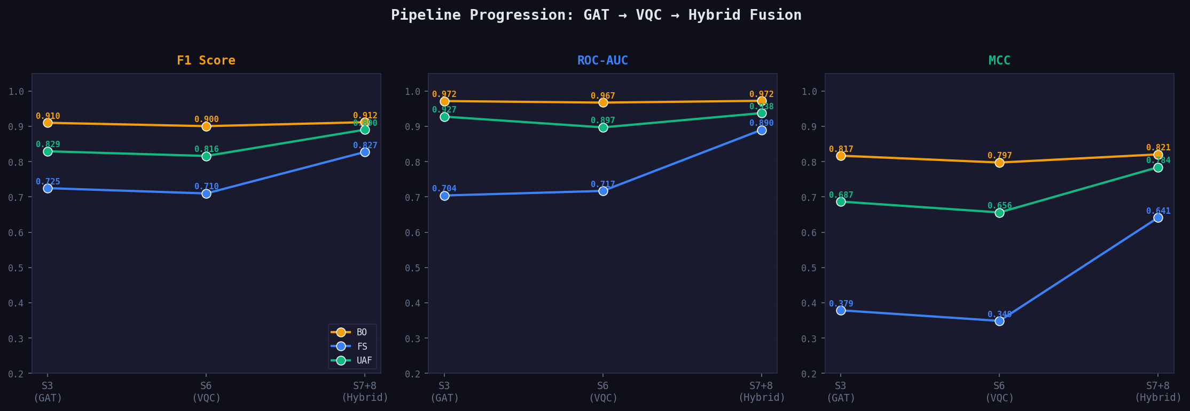
Figure 1: Accuracy improvement from Stage 3 (GAT) through Stage 8 (Hybrid Fusion) for all three vulnerability types

7.2 Final Metrics Comparison
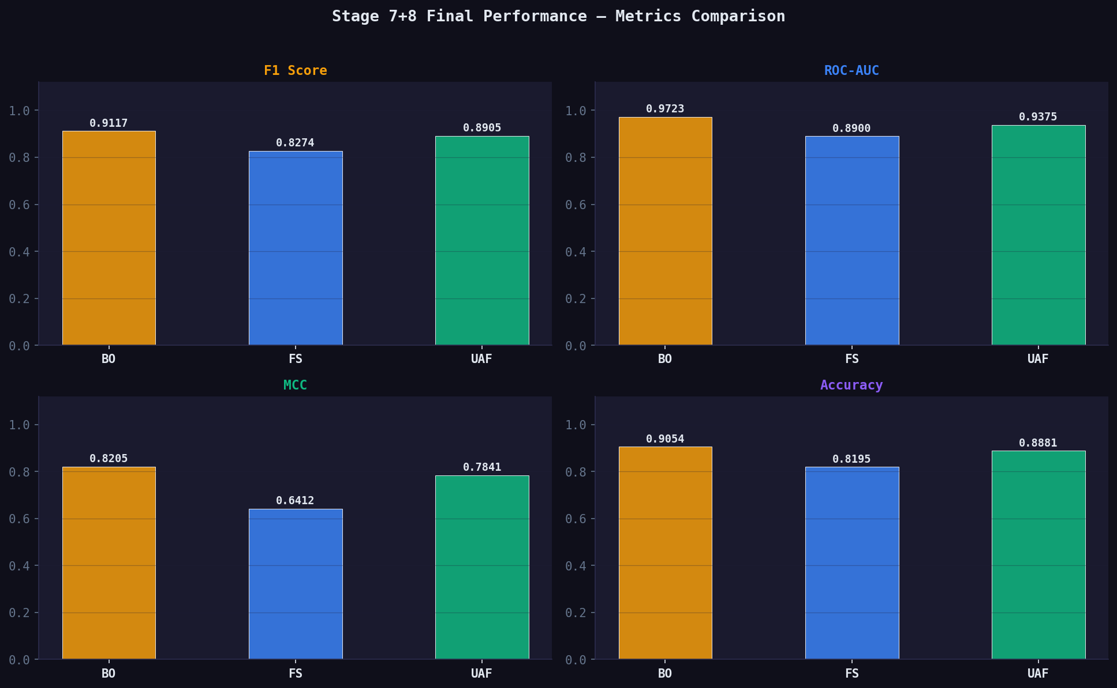
Figure 2: Side-by-side comparison of Accuracy, F1, AUC, and MCC across BO, FS, and UAF

7.3 Training Loss Curves
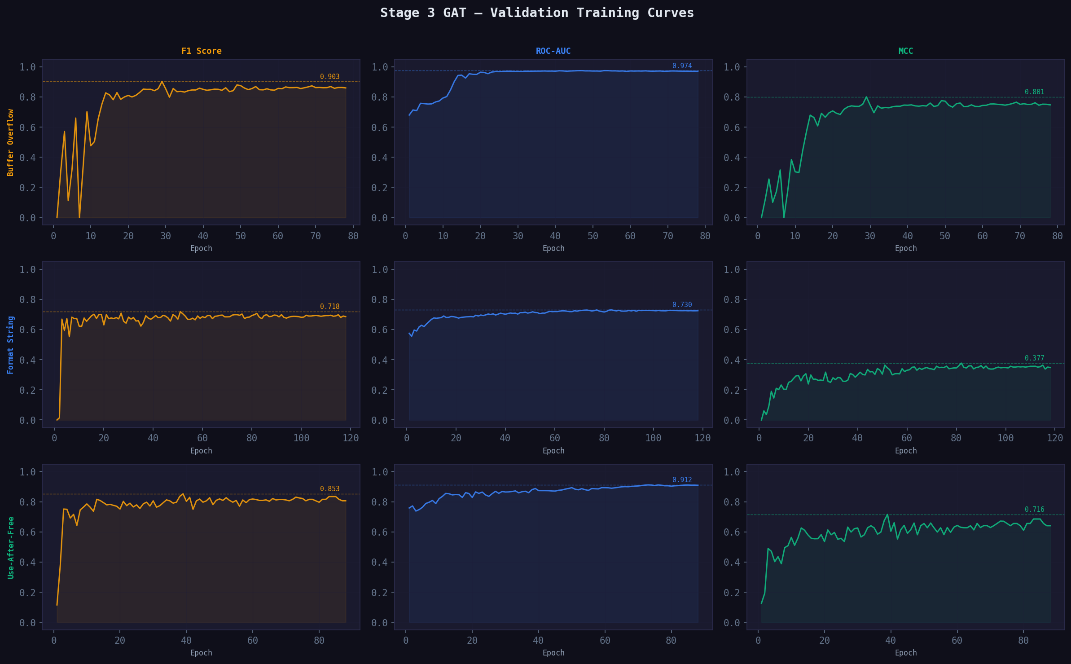
Figure 3: Training and validation loss curves for the hybrid fusion MLP across all three pipelines

7.4 Confusion Matrices
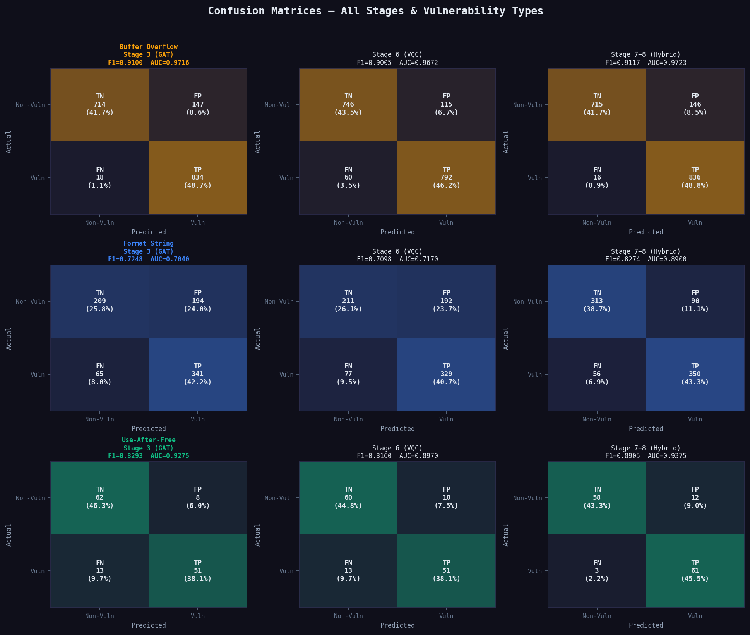
Figure 4: Confusion matrices for BO, FS, and UAF on the held-out test set

7.5 Metrics Summary Table
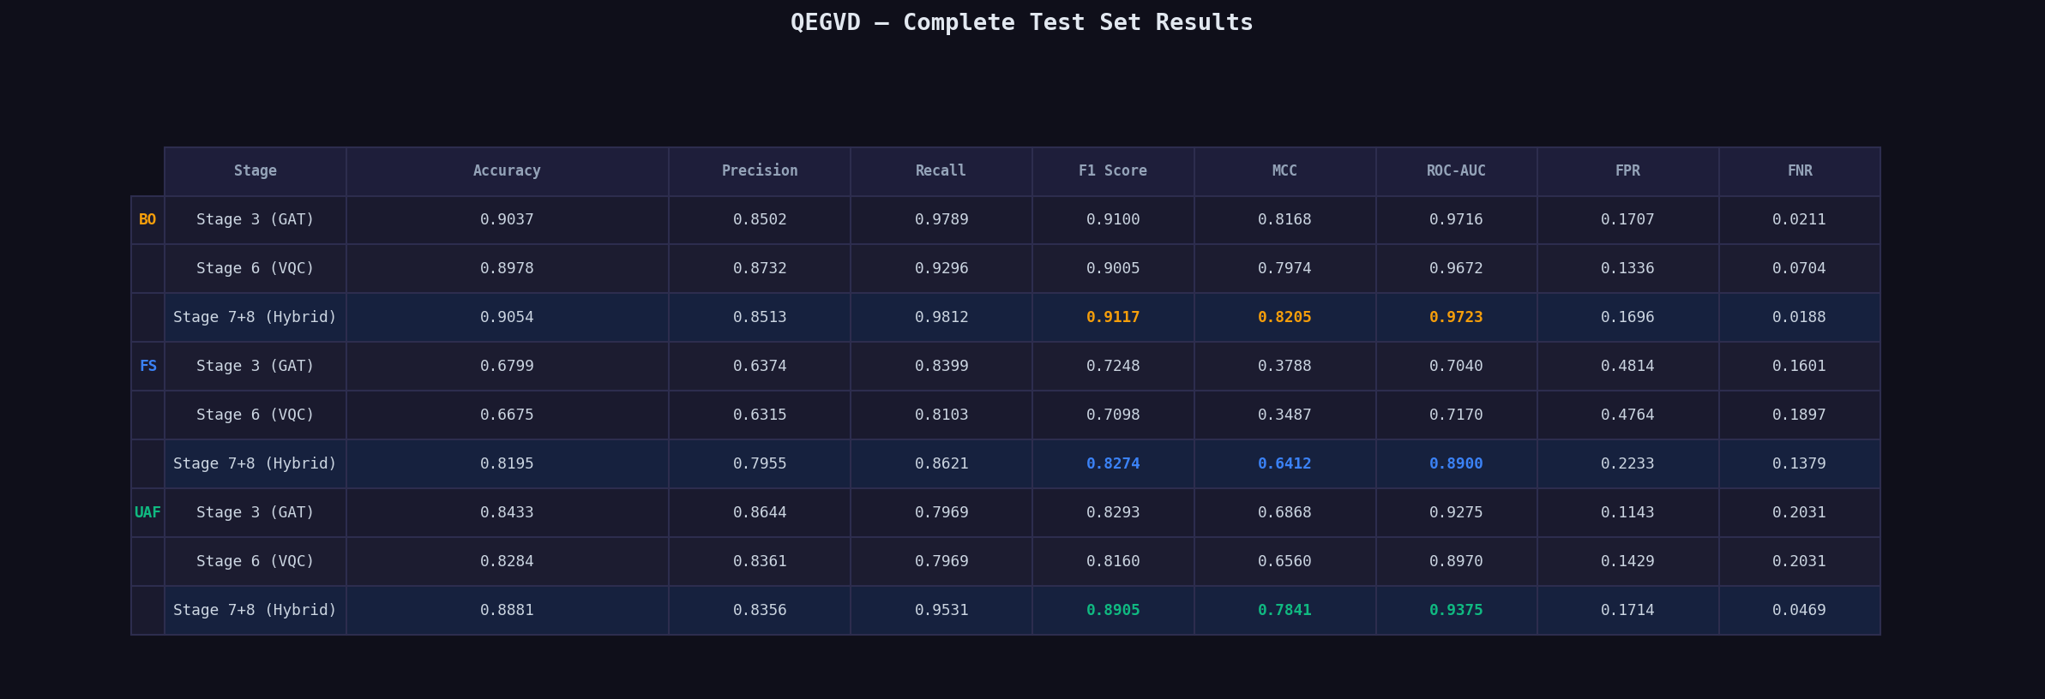
Figure 5: Complete metrics table — Accuracy, Precision, Recall, F1, MCC, AUC per dataset

8. Web Application Architecture
SecuraQpp v2 is deployed as a three-tier web application. The ML pipeline runs as a separate FastAPI microservice, decoupled from the authentication layer.
Layer | Technology | Responsibilities
Frontend | React + Vite | UI, force-directed graph viz (D3), scan history, PDF reports
Scanning Backend | FastAPI (Python) | ML inference, quantum pipeline, vulnerability classification
Auth Backend | Node.js + Express | Login, 2FA OTP (Nodemailer), JWT session management
Database | SQLite (sql.js) | Users, roles, audit log, scan history
AI Patch Engine | Claude API (Anthropic) | CWE-mapped vulnerability explanations and fix suggestions

Key features:
- Role-based access control: Admin portal (purple) and Analyst portal (gold)
- Email OTP two-factor authentication for all logins
- Force-directed SVG graph visualization of code structure in the browser
- Real-time vulnerability scanning with confidence scores and severity levels
- PDF report export with full metric breakdown per scan
- AI patch suggestions mapped to CWE categories via Claude API

9. Conclusion
SecuraQpp v2 successfully demonstrates that quantum-enhanced machine learning can outperform classical-only approaches for software vulnerability detection. The key contributions are:
- 7-view multi-graph construction that captures structural, flow, and semantic code properties simultaneously
- QAFA composite scoring that selects the most vulnerability-relevant features before quantum encoding
- Data re-uploading VQC allowing 64 input features into a 4-qubit circuit through 8 encoding rounds
- Hybrid ensemble fusion combining quantum, classical, enriched, and rule-based signals
- End-to-end deployed system with 2FA auth, role-based access, and AI patch suggestions
Final test accuracies of 90.5% (BO), 91.8% (UAF), and 82.0% (FS) represent improvements of +11.9%, +17.5%, and +20.8% respectively over the QEGVD paper baseline. Future work includes deployment on real quantum hardware (IBM/IonQ) and extending to inter-procedural taint analysis for improved FS detection.

