Spring MVC : project 2

Creating Project:

File 🡪 New 🡪 project🡪 Web 🡪 Dynamic Web Project🡪 Next🡪Give Project Name (eg:SpringMVC) 🡪 Dynamic Web Module(3.0) 🡪 Next 🡪 Finish

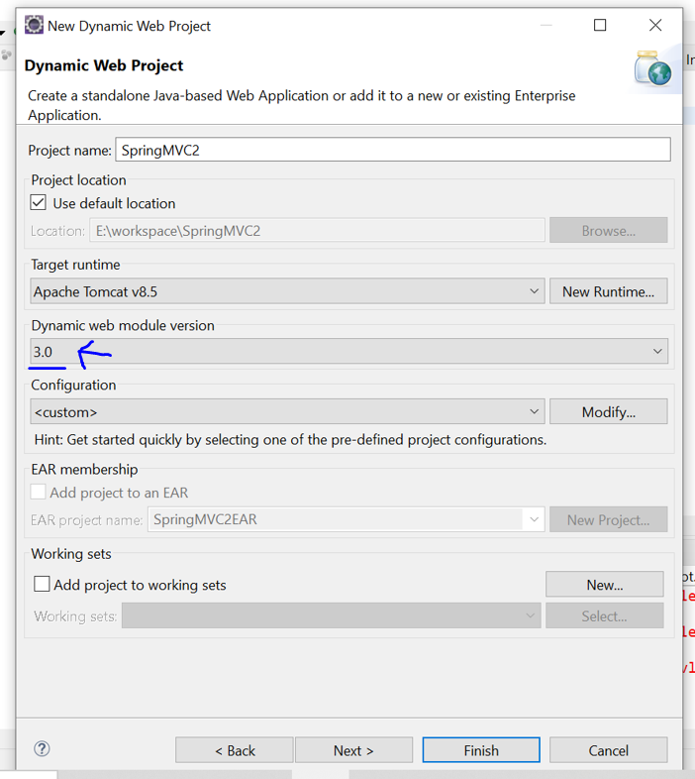

Creating Class:

Src(right click)🡪New🡪class🡪Give Project and Name🡪Finish

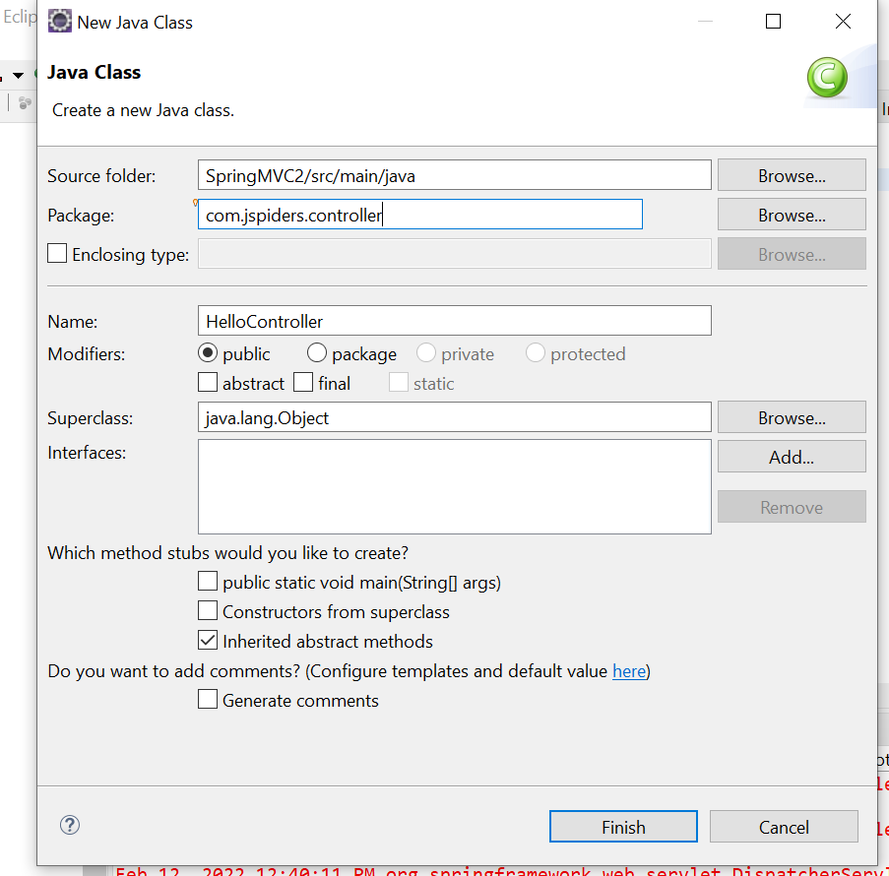

Downloading Tomcat:

Download following and Extract it.

<https://tomcat.apache.org/download-80.cgi>(Download [zip](https://dlcdn.apache.org/tomcat/tomcat-8/v8.5.75/bin/apache-tomcat-8.5.75.zip) ([pgp](https://downloads.apache.org/tomcat/tomcat-8/v8.5.75/bin/apache-tomcat-8.5.75.zip.asc), [sha512](https://downloads.apache.org/tomcat/tomcat-8/v8.5.75/bin/apache-tomcat-8.5.75.zip.sha512) and [64-bit Windows zip](https://dlcdn.apache.org/tomcat/tomcat-8/v8.5.75/bin/apache-tomcat-8.5.75-windows-x64.zip) ([pgp](https://downloads.apache.org/tomcat/tomcat-8/v8.5.75/bin/apache-tomcat-8.5.75-windows-x64.zip.asc), [sha512](https://downloads.apache.org/tomcat/tomcat-8/v8.5.75/bin/apache-tomcat-8.5.75-windows-x64.zip.sha512)) )

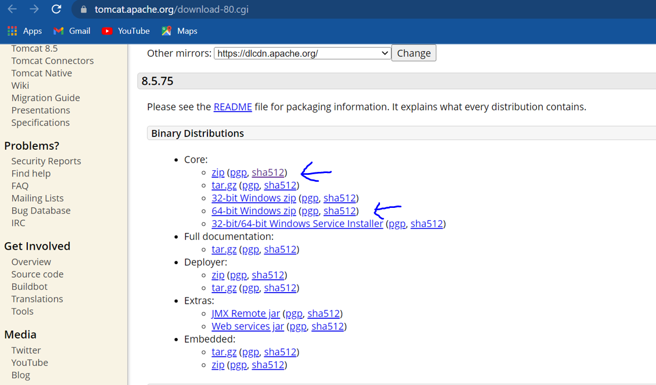

Adding jars:

Download and Extract it.

<https://github.com/Nagabushangowdamd/springMVCfirstApplication>

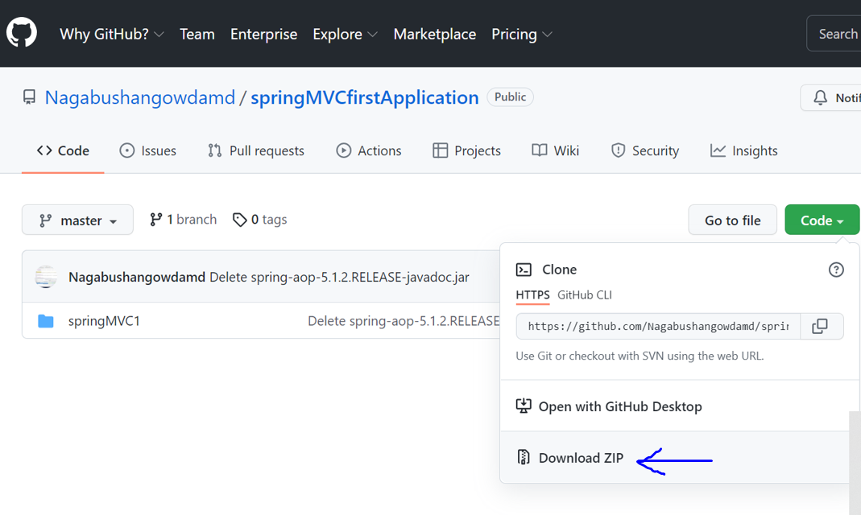

Downloads🡪SpringMVCfirstApplicatio-master🡪 Extract here(right click)…

Open SpringMVCfirstApplicatio-master(Extracted file)🡪 springMVC1🡪 WebContent 🡪

WEB-INF(Select and Copy)

Eclipse🡪 Paste in WEB-INF

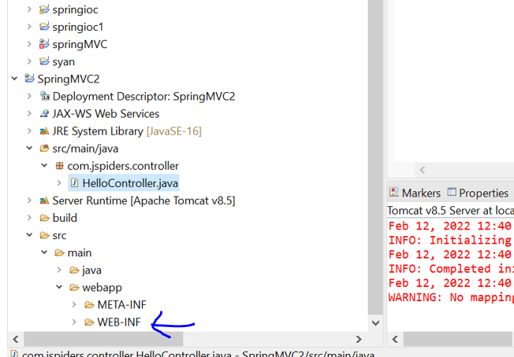

After Copying:

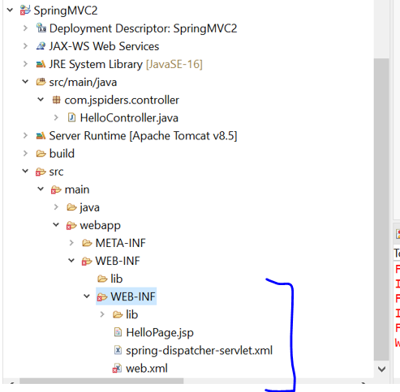

Code:

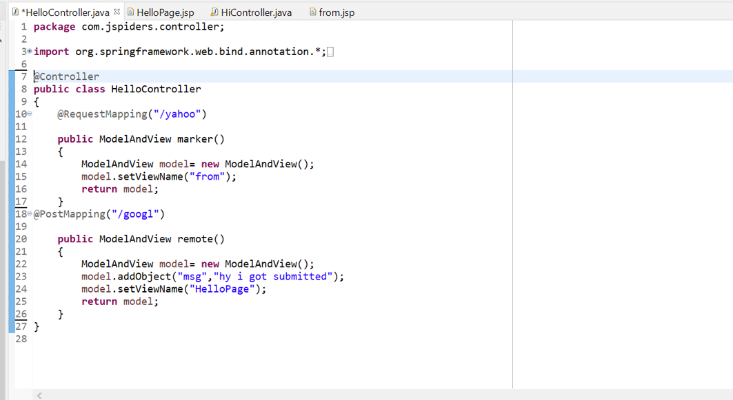

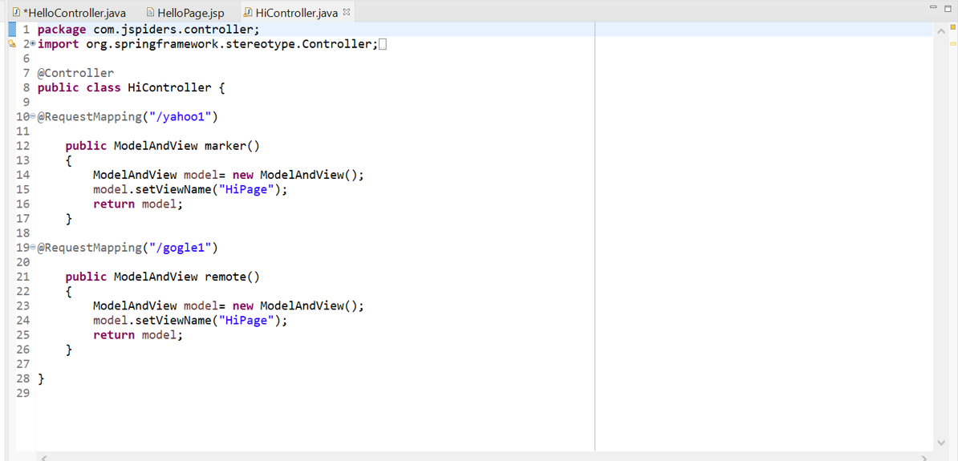

Creating .jsp file:

WEF-INF(right click)🡪New🡪file🡪file.jsp🡪Finish

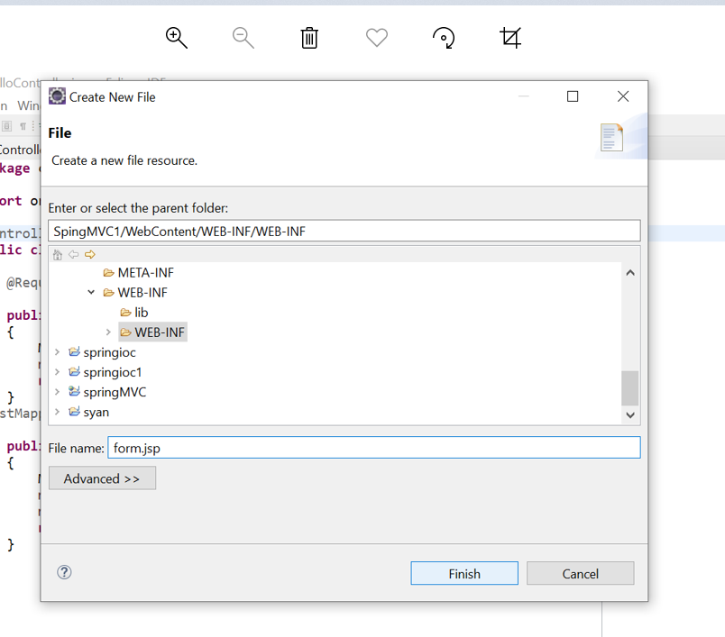

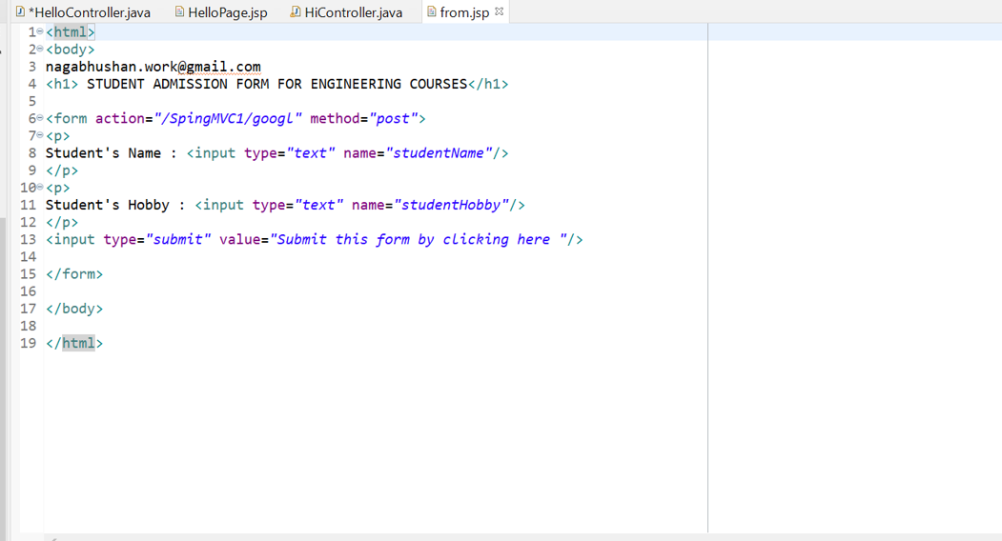

Output:

Right click(on Project Name)🡪Run as🡪Run on server🡪apache 🡪Tomcat 8.5🡪finish

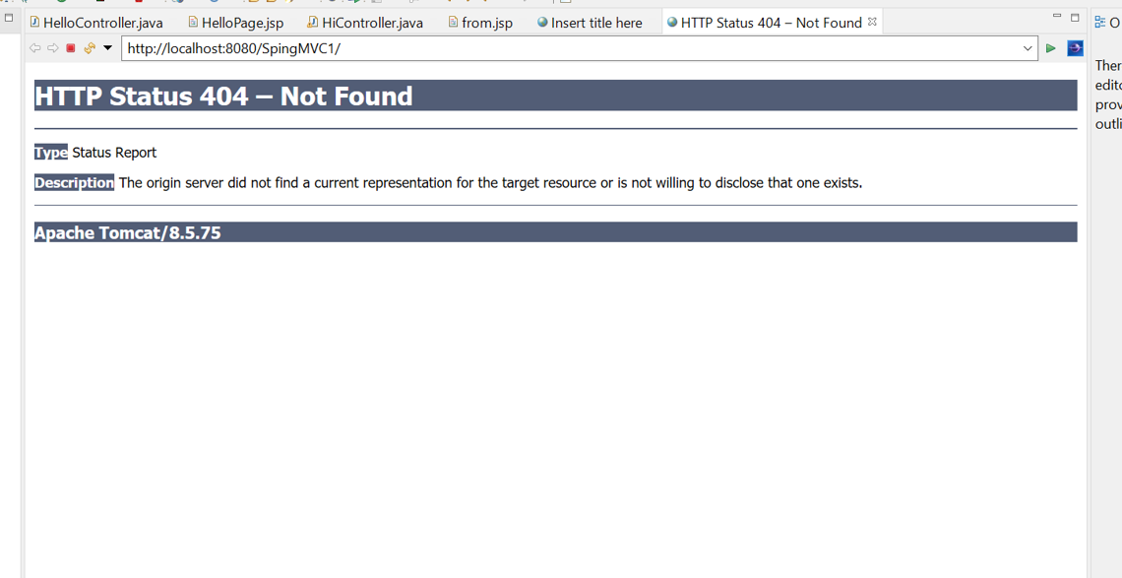

In URL type yahoo and press enter……

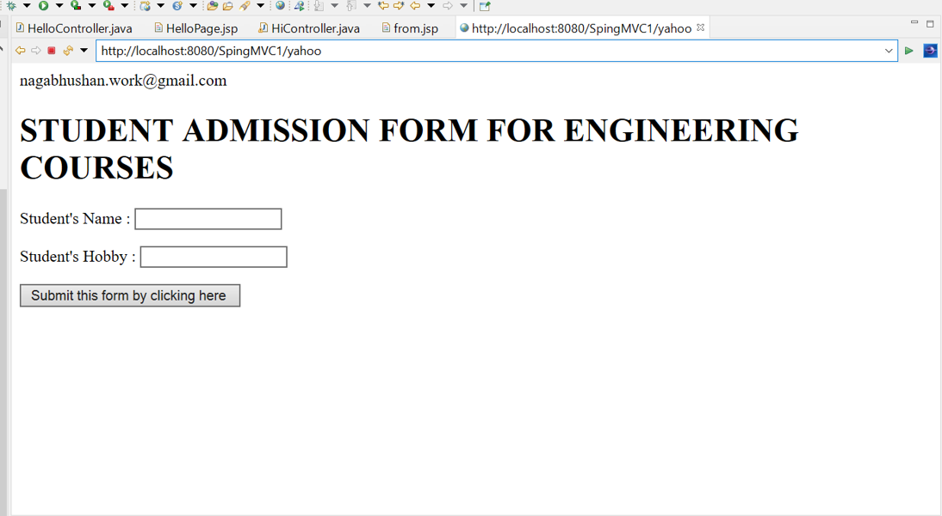

Press Submit Button: Output

