# Project Characteristics

## Project information

*Please provide important facts for your project, e.g. acronym, title, proposed period, principal investigator and contractor.*

|  |  |  |  |  |
| --- | --- | --- | --- | --- |
| Project |  | | | |
| Acronym | Salzburg and vaccine | | | |
| Title | Vaccination Dashboard: Land Salzburg | | | |
| Period | Start: | 11.10.21 | End: 31.12.21 |  |
| Principal investigator | Syeda Zahra Kazmi | | | |
| Contractor | Dr Manfred Mittlböck, Dr Barbara Schernthanner-Hofe | | | |

## Document version

|  |  |  |  |  |  |
| --- | --- | --- | --- | --- | --- |
| Nr. | Date | Version | Altered chapters | Type of altering | Author |
| 1 | 07.01.2021 | 1.1 | all | Creation | Syeda Zahra Kazmi |
| 2 |  |  |  |  |  |
| 3 |  |  |  |  |  |
| 4 |  |  |  |  |  |
| 5 |  |  |  |  |  |

## Project Content and Project Goals

*Please provide an overview of your project with its main activities. Additionally give some information on the purpose, benefits and target groups as well as the proposed goals of your project. Please also provide explicit information on those aspects of the overall challenges, which you will not tackle with your project.*

|  |
| --- |
| Content & Goals |
| Project description *(~100-150 words)* |
| Corona virus stormed over the world with lightning speed. With millions of deaths and the nations all over the world effected by the pandemic, vaccination proved to be the only solution. With the repeated lock downs and an emergence of a group of people who deny the corona control measures including the vaccination, it is really important to keep track of the present number of fully vaccinated people in order to have an overview of the work needed to be done in this regard. The projects take a small study area- Land Salzburg and aims at the updated fully vaccinated population in all the municipalities of Salzburg Land. |
| Project purpose, benefits and target group description *(~100 words)* |
| Present study will analyse the present situation of vaccination in Salzburg. |
| Project objectives (please also include a listing of the sub-goals) *(~100 words)* |
| * To find the total fully vaccinated population according to municipalities * To find the municipalities with the most and least number of vaccinations. |
| Non-Goals |
|  |

## Frame of the project

*Please provide a description of the existing situation. Therefore, please describe the actual state and the identified challenges. As a second part, please also provide the most important information with regard to the proposed project period and the most important dates (Kick-off, interim/mid-term report/presentation, final report, paper submission etc.)*

|  |
| --- |
| Context |
| Up-to-date status *(~50-100 words)* |
| Finished . |
| Project setting *(~50 Wörter)* |
| * Project members consist of Me, Syeda Zahra Kazmi . * Data is downloaded from the Land Salzburg and Austrian government website as a csv. * Csv is used to make map in arc gis online and is published in dashboard. * Data is stored in Post gis database as shape file * And is also published as WFS * The project is published in Github. |

|  |  |  |  |  |  |
| --- | --- | --- | --- | --- | --- |
| Dates | | | | | |
| Time period | | | | | |
| Start: | | 09.11.2021 | | End | 31.12.2021 |
| Important Dates | | | | | |
| 1 | dd.mm.yyyy | | Beschreibung | | |
| 2 |  | |  | | |
| 3 |  | |  | | |

## Resources & Budget

*Please provide information on the project lead and the project team. Please include information on name, role and qualification. Additionally provide information about the planned resources with regard to personal costs and other costs,*

|  |
| --- |
| Project Team |
| Projekt Lead |
| Syeda Zahra Kazmi |
| Project Team |
| Syeda Zahra Kazmi |

|  |
| --- |
| Resources |
| Personal costs |
| Time |
| Project costs |
|  |
| Other Costs |
|  |

## Project structure, description and risk matrix

*Please provide a description about your work plan (work breakdown structure) your work packages in tabular and graphical form.*

### Work packages overview:

|  |  |  |
| --- | --- | --- |
| WP | Name | Time Frame |
| 1 | Project Management | dd.mm.yyyy – 07.01.2022 |
| 2 |  |  |
| 3 |  |  |
| 4 |  |  |
| 5 |  |  |
| 6 |  |  |
| 7 |  |  |

### Work Breakdown Structure (WBS)

*Create a work breakdown structure for your work packages including the important tasks*

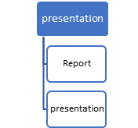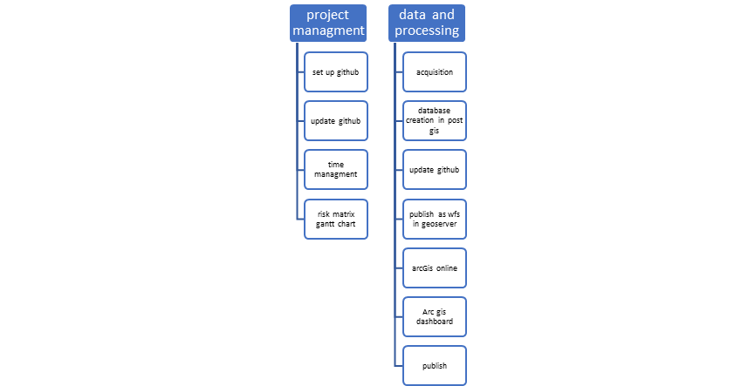

Figure 1 Work breakdown Structure

## Detailed work plan

*Please document the goals,content and expected results for each work package. Provide information on the planned approach and methods you want to apply as well as the expected results (including the planned milestones and deliverables). As a first work packe please use ‘project management‘.*

|  |  |  |  |  |
| --- | --- | --- | --- | --- |
| WP 1 | Project management |  | | dd.mm.yyyy – dd.mm.yyyy |
| Project Lead | | | **Project team** | |
|  | | | Syeda Zahra Kazmi | |
| Objectives | | | | |
| * To find the total vaccinated population * To get the recent situation on the vaccination in Salzburg | | | | |
| Content & Tasks | | | | |
| 1. Data collection (download from source: https://www.data.gv.at/?s=covid )   Online secondary data sources   1. Data analysis 2. Publishing as WMS and WFS on geo server 3. Report writing and presentation | | | | |
| Expected results | | | | |
| A dashboard showing the vaccination in tourism industry in Salzburg, which will be shared as WMS and WFS on Geoserver and published on Github. | | | | |
| Milstones & Deliverables | | | | |
| M1: Data Acquisition  M2: Data pre-processing  D1: Post gis database  D2: Dashboard creation in Arc dashboard.  D2 : Published as open services | | | | |

## Milestone plan

*Please provide a summary of the planned milestones and provide an according overview graphic.*

|  |  |  |
| --- | --- | --- |
|  | Name | Date Completion |
| M1 | Milestone description | 09.11.2021 |
| 1 | **Data Acquisistion** | 15.11.21 |
| 2 | **Data processing and** Data analysis | 30.11.21 |
| 3 | Report writing | 20.12.21 |
| 4 | Results publication | 31.12.21 |

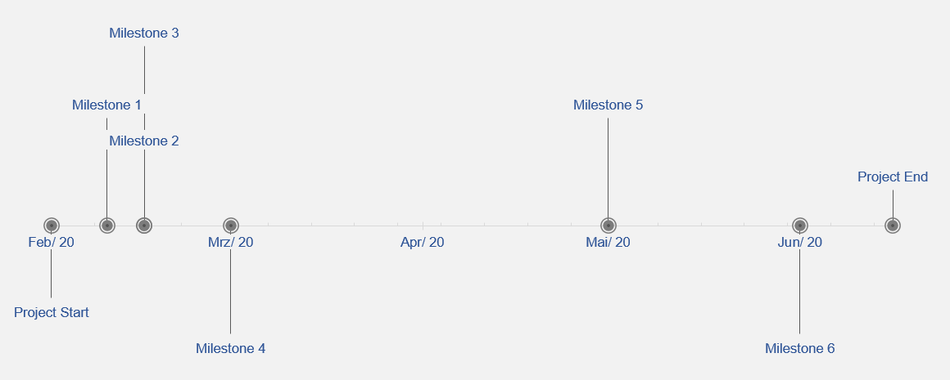

Figure 2 Milestones

## Gantt Chart

*Please provide an image of your Gantt Chart as overview graphics. Please attach the Gantt chart and it’s monthly updates in addition to this document.*

Figure 3 Gantt Chart

## Risk matrix

*In this table, please provide the important risk information. Please categorize the risks accordingly. ([L]ow, [ M ]edium, [****H****]igh], [C]leared)as well as your mitigation strategy. Please update this list accordingly during your project execution time frame.*

|  |  |  |  |  |
| --- | --- | --- | --- | --- |
|  | Risk | Mitigation Strategy | Type | Update |
| 1 | Risk 1 | Time management | L | 09.11.2021 |
| 2 | Risk 2 | No christmas | *M* | 09.11.2021 |
| 3 | Risk n | No holidays | *M* | 09.11.2021 |

## Additional comments

*Add additional comments if necessary.*

|  |
| --- |
| Comments |
| Result is quite interesting |

## Approval

*Please provide further information if necessary.*

|  |  |  |  |
| --- | --- | --- | --- |
| Freigabe | | | |
| Approval: | Date: | | 07.01.2021 |
|  | |  | |
| Signature principal investigator | | Signature project lead/contractor | |