Verdant Capital
  - Green Capital Allocation & Portfolio Intelligence
Team Cypher • Technical submission report
12 November 2026

1. Our mission

Pillar 2: Green Capital Allocation & Portfolio Intelligence
Focus: Utilizing machine learning and market intelligence to optimize sustainable capital flows, forecast carbon-credit price trajectories, or balance risk/return in climate-screened investment portfolios.
Guiding intent: How can AI systems process market dynamics and climate indicators to direct capital toward verifiable sustainable investments?
Our mission is to make the route from a sustainability claim to an investment recommendation inspectable. Verdant Capital brings source evidence, dated market signals and explicit portfolio rules into a single research workspace. The aim is to support capital allocation that can be questioned, reproduced and justified, especially when evidence is incomplete or financial incentives conflict with sustainability concerns.
Implemented scope. This submission demonstrates a three-specialist investment simulator and a separate machine-learning assurance laboratory. It does not execute trades, approve loans, certify ESG claims, or establish real-world fraud-detection performance. Its carbon projection uses a carbon-related ETF proxy, not spot carbon-credit prices.

Figure 1. Actual charcoal-and-gold Streamlit interface after a fictional investment review. SOLR, WIND and FOSS are demonstration issuers; this is a runtime screenshot, not a static mockup.
How to read the flags: Implemented identifies current behavior; Synthetic identifies generated evidence; Assumption identifies a chosen policy or economic input; Limitation identifies what the evidence does not establish. These distinctions apply throughout this report.

2. Problem statement
Climate-screened investment decisions combine information that is fragmented in both format and reliability. An issuer may publish an ambitious sustainability narrative without an independently supported baseline. Its market price may nevertheless rise. A portfolio decision must reconcile these signals without pretending that missing evidence proves misconduct or that price momentum verifies sustainability.
The practical problem is therefore broader than ranking assets. A useful system must answer: What evidence was available? Which signals were historical? What was inferred? Which investment rules were enforced? Why was an asset restricted, excluded or assigned zero weight? How costly is a mistaken risk flag compared with a missed adverse event?
Problem | Consequence | Required response
Sustainability reports and market data are disconnected | Attractive narratives can obscure evidence gaps | Preserve issuer, document, page and date provenance
A language model can produce persuasive but unsupported numbers | Recommendations may be impossible to defend | Validate analysis and keep numerical allocation under a deterministic optimizer
Price upside can conflict with ESG concerns | Informal debate may override policy | Detect a specified conflict and resolve it through explicit constraints
Adverse events are rare | A model can achieve 99% accuracy by detecting nothing | Evaluate at 99:1 and emphasize precision–recall behavior
An anomaly flag can be difficult to interpret | Reviewers cannot explain an error or challenge a decision | Produce held-out feature attributions, including mistakes
False alarms and missed events have different costs | A statistically attractive threshold can be economically poor | Optimize a decision threshold using explicit monetary consequences
Formal decision question: Given capital, a candidate universe, dated prices, available ESG evidence and a risk mandate, produce a long-only allocation plus a cash reserve, with a traceable explanation of every enforced rule.
Mission boundary. “Verifiable” is the intended standard for evidence-led investing. The current application provides traceability and uncertainty flags; it does not independently authenticate uploaded reports or prove that an investment is sustainable. Obtaining independently labeled issuer evidence is a necessary next step.

3. The solution we provide

3.1 A hybrid decision-intelligence workflow
Verdant Capital combines three specialist responsibilities. The ESG Verifier handles issuer evidence and uncertainty. The Carbon & Market Analyst summarizes dated market behavior and the available carbon-ETF outlook. The Portfolio Optimizer calculates weights under mathematical constraints. LangGraph coordinates these stages sequentially; review, synthesis and persistence are deterministic workflow steps rather than additional investment agents.
The product produces an investment memo, a policy ledger, specialist evidence, portfolio diagnostics and a downloadable JSON audit. Its separate Risk Lab supplies C02 rare-event evaluation, C06 attribution and C13 decision economics. Those benchmark outputs do not automatically become ESG ratings for the historical ticker portfolio.
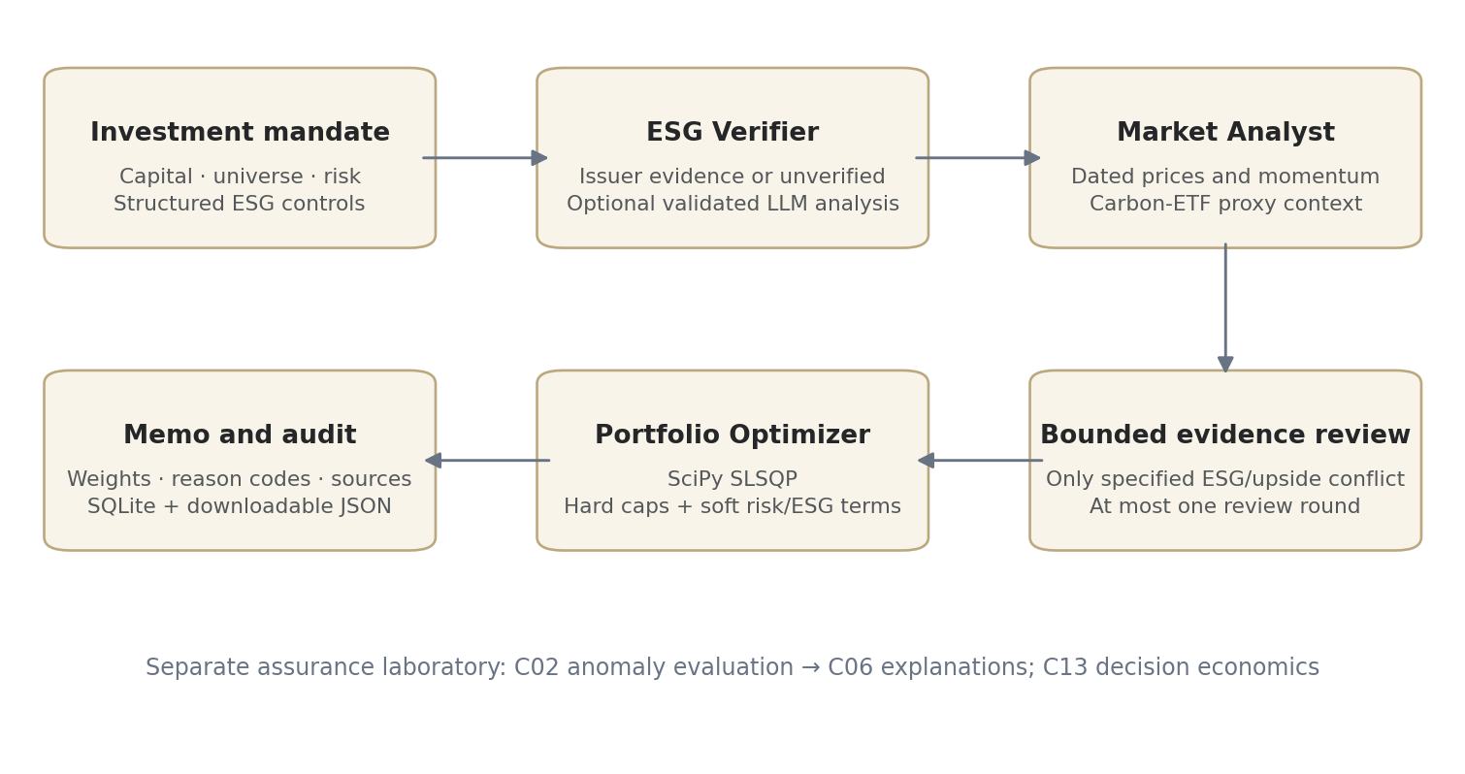
Figure 2. Implemented decision workflow. The risk laboratory is separate from the capital-allocation path; it is not an additional autonomous trading agent.

3.2 Inputs, data modes and contracts
Input | Meaning and implemented handling
Capital | Finite USD amount from 0 to $100 million; converts weights to dollars
Candidate universe | At most 20 requested entries through the orchestration contract; deduplicated, normalized ticker symbols; CASH is reserved
Risk profile | Conservative, moderate or aggressive; changes risk penalty and general exposure limit
Strict ESG control | Applies high-risk exclusions and tighter unverified exposure caps
Investment principles | Recorded mandate text; arbitrary prose does not create a new mathematical constraint
Hypothetical event | Demo-only baseline, carbon-price spike, policy tightening or market selloff
Data mode | Explicit fictional simulation or historical market cache
Fictional mode — Synthetic. SOLR, WIND and FOSS have predefined disclosure fixtures and deterministic generated prices. Per-asset seeds derive from the ticker hash, making histories reproducible. The price generator uses cumulative normal log returns over a fixed business-date grid. Hypothetical events modify only the last 30 observations; earlier history stays unchanged.
For example, the fictional market-selloff scenario progressively applies final price changes of −40% to SOLR, −32% to WIND and −45% to FOSS. These are selected scenario shocks, not measured market outcomes. Carbon-price-spike and policy-tightening scenarios are also predefined fictional changes; they do not infer causal carbon exposure from real companies.
Historical mode — Implemented. yfinance.download retrieves approximately one year of adjusted closing prices with auto_adjust=True. The default investment universe is NEE, ENPH, TSLA, XOM and ICLN; KRBN supplies the carbon-related ETF proxy. Prices are saved to a dated local CSV cache. A review reads that cache instead of fetching a streaming feed.
The loader normalizes supported yfinance layouts, converts numeric values, normalizes dates, removes invalid/duplicate date entries and replaces infinite prices with missing values. A malformed or missing cache fails closed. The optimizer separately checks whether each holding has usable positive finite history.
Limitation. Cached market data can become stale. The system does not automatically refresh it for each review, infer news, authenticate ESG claims from prices, or account for execution costs and liquidity.

3.3 ESG Verifier: evidence, scores and flags
ESG refers to environmental, social and governance considerations. In this implementation, the verifier assesses the credibility and possible inconsistency of sustainability disclosures. Its numerical scores are optional analyst/model estimates on a 0–100 scale; they are not certified third-party ratings.

Evidence retrieval
In historical mode, the optional retrieval-augmented generation path works as follows:
- Place permitted PDFs in data_cache/pdfs/ with issuer names such as NEE__2025_report.pdf.
- Extract text page by page using pypdf. Create approximately 850-character chunks with 120-character overlap; discard fragments shorter than 65 characters.
- Preserve ticker, filename, page, report year, source mode and a page citation for each chunk. A content-derived identifier supports repeatable upserts.
- Encode text using all-MiniLM-L6-v2 sentence embeddings and store it in a persistent Chroma collection.
- Retrieve up to five relevant chunks with an issuer filter. The final result is filtered again so another issuer’s metadata is not accepted.
- If usable excerpts and an optional Gemini/OpenRouter provider are available, request structured ESG analysis grounded in those excerpts.

Validated output contract
Field | Allowed meaning / validation
ticker | Must agree with the requested issuer
verdict | credible, mixed, likely_greenwashing or unverified
greenwash_risk | Null or a numeric estimate from 0 to 100
esg_credibility | Null or a numeric estimate from 0 to 100
confidence | Value from 0 to 1; not independently calibrated
reasoning | Text, maximum 8,000 characters
red_flags | A list of at most 30 text entries
evidence | Replaced with registered retrieved citations, rather than accepting invented citation names
A non-unverified verdict requires both scores and nonzero confidence. An unverified verdict forces null scores and zero confidence in the optional-model validation path. Missing evidence, an unavailable provider or an invalid response falls back to an explicit unverified assessment.
Important flag: confidence = 0 means no supported classification confidence is asserted. It does not mean the issuer has zero sustainability, and a null score is not a numerical zero ESG rating.

Fictional fixture example
Demo issuer | Verdict | Credibility | Greenwash-risk estimate | Confidence
SOLR | Credible | 84 | 16 | 0.86
WIND | Unverified | Null | Null | 0.20
FOSS | Likely greenwashing | 24 | 86 | 0.81
These are explicitly specified fictional fixtures, not measured performance of a learned ESG classifier. WIND’s fixture confidence is a demo specification; a missing historical assessment defaults to 0.

Figure 3. Actual specialist evidence view for the fictional SOLR case. Source-bound fields and uncertainty are inspectable; the screenshot does not constitute independent issuer verification.
Limitations. Citation provenance establishes where text came from, not whether a report is true. Model schema checks reduce malformed output; they do not prove factual correctness or eliminate prompt injection. The six C02 features are not currently extracted automatically from these PDFs. A changed/deleted source PDF may require rebuilding the local index.

3.4 Carbon & Market Analyst: formulas and interpretation
Let $P_{i,t}$ denote the cached adjusted close for asset $i$ at observation $t$.
Daily fractional return:
$$r_{i,t}=\frac{P_{i,t}}{P_{i,t−1}}−1.$$
Historical 30-session percentage change:
$$R_{i,30}=100\left(\frac{P_{i,T}}{P_{i,T−30}}−1\right).$$
This requires 31 observations for 30 return intervals. It is a backward-looking change, not a return forecast. The 90-session direction compares the latest price with the price 90 intervals earlier and requires 91 observations.
Annualized historical volatility:
$$σ_{i,ann}=std\left(r_{i}\right)\sqrt{252}.$$
The displayed percentage multiplies this fractional volatility by 100. The market-statistics implementation uses the sample standard deviation.
Rule | Output
$R_{i,30}>2\%$ | Bullish
$R_{i,30}<−2\%$ | Bearish
Otherwise | Neutral
Sufficient recent signal and at least 90 observations | Confidence 0.60
Sufficient recent signal but fewer than 90 observations | Confidence 0.40
No usable recent signal | Neutral, confidence 0
Assumption flag. The 2% decision band and 0.60/0.40 confidence levels are heuristics. “60% confidence” is not a validated 60% probability of future gains. A short-window bullish label can coexist with a longer-window declining trend.

Carbon-related ETF projection
KRBN is a listed carbon-related ETF proxy. The code requires at least 65 positive finite observations and uses up to the latest 180. It fits a straight line to log prices:
$$logP_{t}=a+bt, \tilde{b}=clip\left(b,−0.009,0.009\right).$$
The forecast is anchored to the latest actual price:
$${\hat{P}}_{T+h}=P_{T}exp\left(\tilde{b}h\right), h=1,…,30.$$
The slope is fitted by ordinary least squares and then capped. Although the output calls the engine a regularized log-linear trend, there is no fitted ridge-regression penalty in this implementation.
With $s=std\left(ΔlogP−\tilde{b}\right)$, the indicative band is:
$${\hat{P}}_{T+h}exp\left(±1.28max\left(s,0.0001\right)\sqrt{h}\right).$$
The 30-session projected change determines “rising” above +1.5%, “falling” below −1.5%, otherwise “stable.” A holdout diagnostic trains on earlier observations and compares the next 30 projections with the final 30 observed prices:
$$MAPE=\frac{100}{H}\sum_{h=1}^{H}{\left|\frac{P_{h}−{\hat{P}}_{h}}{P_{h}}\right|}.$$
Limitations. Bands are heuristic and not calibrated confidence intervals. Future dates use a weekday business-date grid, not an exchange holiday calendar. KRBN is not the spot price of a specific allowance or credit. Its projection supplies context and does not directly enter the portfolio optimizer.

3.5 Portfolio Optimizer: calculations and hard constraints
The optimizer combines price history, ESG assessments, risk preference and permitted agent-influence weights. It uses SciPy SLSQP. Neither an optional LLM nor a narrative memo writes the numerical portfolio percentages.

Eligibility and estimation
An asset needs at least 45 positive finite price observations. After aligning the eligible assets and dropping incomplete rows, the optimizer requires at least 30 common return observations. Otherwise it retains all capital as cash.
The annual historical mean is clipped to reduce runaway estimates:
$$μ_{i}=clip\left(252{\overline{r}}_{i},−0.30,0.30\right).$$
Annual covariance is shrunk toward its diagonal and regularized:
$$Σ_{raw}=252Cov\left(r\right),$$
$$Σ=0.8Σ_{raw}+0.2diag\left(diag\left(Σ_{raw}\right)\right)+{10}^{−5}I.$$
Covariance captures joint movement, not just standalone volatility. These are historical estimates; neither clipping nor shrinkage guarantees future stability. Missing common-date rows may reduce usable history, and transaction costs are not modeled.

Influence and soft ESG preference
Let $a_{M}$ and $a_{E}$ be market and ESG influence weights, each clipped to $\left[0.5,1.5\right]$. Let $c_{i}$ be ESG credibility; unknown credibility is treated as 0 for this soft penalty only:
$$q_{i}=0.06 a_{E}\frac{max\left(0,65−c_{i}\right)}{100}, {\tilde{μ}}_{i}=a_{M}μ_{i}−q_{i}.$$
With neutral ESG influence, an unverified asset receives a 0.039, or 3.9-percentage-point, reduction in the objective’s annual return input. This is a chosen policy penalty, not an observed loss or a claim that missing evidence is fraud.

Optimization objective
For portfolio weights $w$, including cash, the solver minimizes:
$$L\left(w\right)=\frac{λ}{2}w^{⊤}Σw−{\tilde{μ}}^{⊤}w.$$
Subject to:
i​wi=1, 0≤wi≤ui, 0≤wcash≤1.
The objective favors adjusted estimated return while penalizing variance. The upper bound $u_{i}$ comes from price eligibility and ESG/risk policy.
Risk profile | Variance penalty $λ$ | General per-asset cap
Conservative | 22.0 | 35%
Moderate | 11.0 | 55%
Aggressive | 5.5 | 70%

Condition | Strict ESG enabled | Strict ESG disabled
Risk estimate >60 or likely-greenwashing verdict | Excluded: cap 0% | General profile cap if otherwise eligible
Missing risk assessment or unverified verdict | Cap 10% | Cap 20%
Otherwise assessed and eligible | General profile cap | General profile cap
Missing/insufficient/nonpositive/nonfinite prices | Cap 0% | Cap 0%
Constraint flag. Turning strict ESG off removes the hard high-risk exclusion; it is not simply a visual preference. Sector exclusions, such as “no fossil fuels,” are not automatically inferred from company names or free-text principles.

Solver verification and output
SLSQP starts at 100% cash, with up to 500 iterations and objective tolerance ${10}^{−10}$. Returned values must be finite, funded within ${10}^{−5}$, and within their bounds up to numerical tolerance ${10}^{−6}$. Failed/invalid solutions retain cash. Any rounding correction in weights is absorbed by cash, not by increasing a constrained asset.
For capital $K$:
$${Dollars}_{i}=Kw_{i}, σ_{p}=\sqrt{w^{⊤}Σw}.$$
The displayed historical annual estimate uses $100μ^{⊤}w$. The separate adjusted objective estimate uses $100{\tilde{μ}}^{⊤}w$. These are not interchangeable and neither guarantees future return. Cash defaults to zero modeled return and zero covariance; cash yield, inflation and execution costs are not represented. Dollar amounts are rounded to cents for the memo. Tiny solver values below ${10}^{−8}$ are suppressed in the presentation only.
The memo also reports a credibility average over assessed holdings only. For the set $V$ of holdings with a non-null credibility score:
Cassessed=i∈V​wicii∈V​wi,
when the denominator is positive; otherwise the field is null. Cash and unverified scores are excluded from this average. Coverage flag: a high assessed-only average does not mean the entire portfolio has verified ESG coverage; the soft penalty still treats unknown credibility as 0 for its separate calculation.
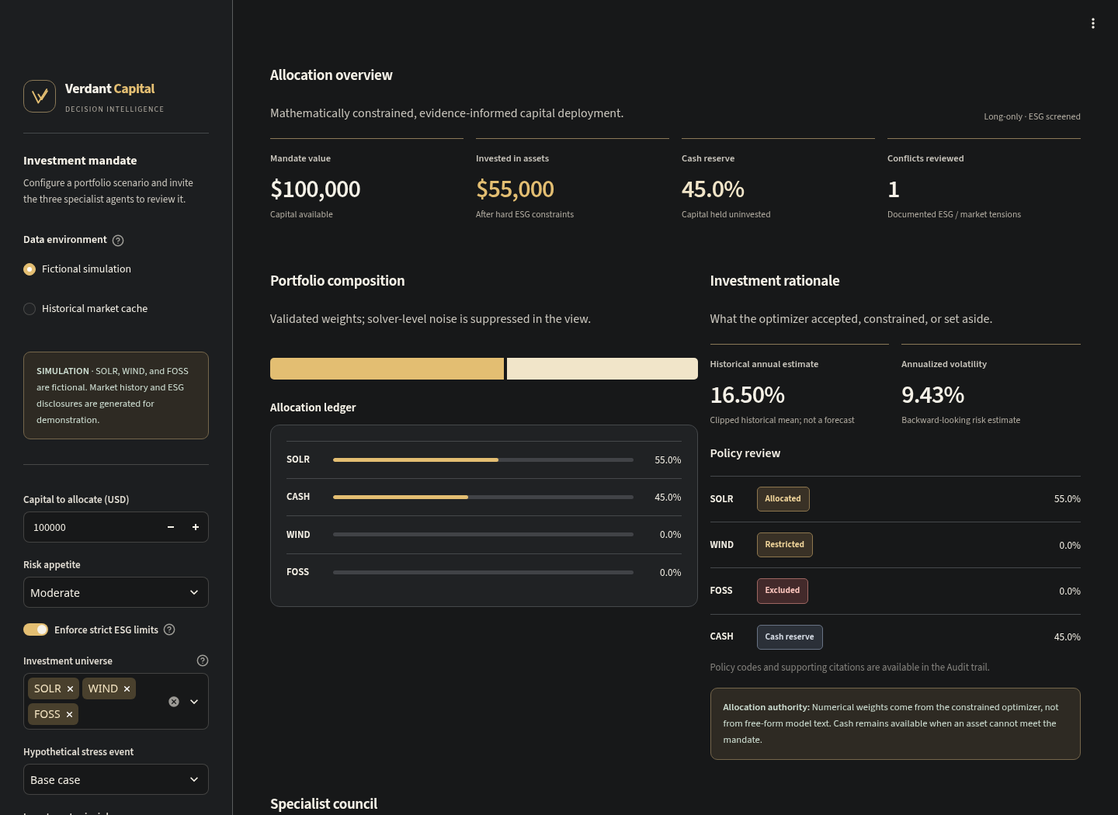
Figure 4. Actual allocation and policy view for the fictional $100,000 mandate. The visual ledger displays calculated weights, and the policy labels explain why an asset is permitted, restricted or excluded.

Explaining the historical allocation supplied by the user
The following weights came from the user’s historical review. They were not recomputed from a current price cache in this report; they illustrate the effect of the implemented policies rather than independently verified current performance.
Holding | Weight | Dollars on $100,000
NEE | 0.5810% | $581.04
ENPH | 2.9121% | $2,912.11
TSLA | Approximately 0% | $0.00
XOM | 10.0000% | $10,000.00
ICLN | 0% | $0.00
CASH | 86.5068% | $86,506.85
All five ESG assessments were unverified, so strict mode capped each at 10%. That alone limits total risky exposure to 50%, forcing at least 50% cash. The objective then selected still less exposure: approximately 13.5% invested and 86.5% cash.
XOM’s 10% does not mean verified sustainability; it means its unverified exposure reached the allowed cap. Tesla’s tiny value, approximately $2.37×{10}^{−17}$ in fractional-weight form, is numerical noise rather than a meaningful allocation. Zero weight in an eligible holding is not automatically an ESG exclusion.

3.6 Conflict review, audit and feedback
The implemented conflict requires high ESG risk or a likely-greenwashing verdict together with a bullish market view. Unverified ESG alone does not trigger that conflict. “No conflict detected” therefore means no case matched this rule, not that all evidence agrees or that the portfolio is sustainable.
At most one review round records both perspectives, available citations, residual uncertainty and the resolution: enforce quantitative exclusions/caps before allocating. It does not invent new facts or override the optimizer. A deterministic synthesis builds the final memo, validates full funding and checks that no unrequested holding entered the allocation.
Policy reason | Interpretation
EXCLUDED_HIGH_ESG_RISK | Strict policy blocks the holding
LIMITED_UNVERIFIED_ESG | Missing verification limits exposure
EXCLUDED_MISSING_PRICE_HISTORY | Price eligibility is inadequate
ALLOCATED_CONSTRAINT_VALIDATED | A nonzero allocation passed the implemented rules
ZERO_OPTIMAL_WEIGHT | Eligible holding receives zero from the objective
CASH_SAFETY_RESERVE | Capital remains unallocated to risky assets
SQLite stores timestamped recommendations and source-labeled outcomes. JSON exports preserve the current memo and workflow evidence. This is inspectable persistence, not a cryptographically immutable ledger or automatic regulatory compliance.
For an agent with $h$ correct labels among $n$ eligible outcomes, after at least three outcomes:
$$p_{smooth}=\frac{h+2}{n+4}, a=0.5+p_{smooth}.$$
With insufficient data, influence is 1.0. Demo adaptation uses a separate synthetic feedback database. Historical mode admits only outcome records explicitly labeled verified; the application does not independently establish those labels or automatically match future realized returns. Influence changes soft preferences, never hard ESG exclusions.

4. Challenge C02 — Severe Class Imbalance / Rare-Event Stress

4.1 Directive and our response
Directive: Real-world climate catastrophes, loan defaults and fraudulent green transactions are rare. The required demonstration is a 99:1 negative-to-positive evaluation split, maintaining meaningful precision–recall performance without majority-class collapse.
Our solution: A reproducible synthetic disclosure-feature benchmark using Isolation Forest, untouched held-out evaluation, five seeds, precision–recall curves, threshold metrics, a majority-class baseline and top-1% review precision. The benchmark is exactly 1% positive, as requested; it does not establish performance at prevalence lower than 1%.

4.2 Dataset and model
Each trial generates 25,000 shuffled samples, then uses a stratified split into 20,000 training cases and 5,000 held-out cases. The evaluation set contains 4,950 negatives and 50 positives. Seeds are 7, 13, 21, 34 and 55.
The six features are generated directly, rather than extracted from actual ESG reports:
Feature | Synthetic negative distribution | Synthetic positive distribution
Vague language ratio | Normal(0.15, 0.05) | Normal(0.38, 0.22)
Sentiment gap | Normal(0.10, 0.05) | Normal(0.40, 0.24)
Missing baseline | Bernoulli(0.08) | Bernoulli(0.50)
No third-party verification | Bernoulli(0.10) | Bernoulli(0.62)
Capex backing ratio | Normal(0.55, 0.15) | Normal(0.32, 0.22)
Intensity anomaly | Normal(0.05, 0.05) | Normal(0.48, 0.30)
Normal parameters are mean and standard deviation. These distributions intentionally differ between classes; they create a controlled stress test. They are not calibrated issuer populations, and the Gaussian “ratio” values are not clipped to physical 0–1 bounds.
The model has 200 trees, contamination 0.01, the specified random seed and parallel fitting. Training uses features without labels; labels are used for stratification and evaluation. The 1% contamination setting supplies an expected anomaly proportion rather than learning the true prevalence.
Isolation Forest isolates unusual observations using random partitions. Shorter expected isolation paths indicate greater anomaly. The exported score and native decision are:
$$s\left(x\right)=−decision_function\left(x\right), \hat{y}=1\left[s\left(x\right)>0\right].$$
The default zero threshold follows the fitted model’s contamination-based offset. A score is not a fraud probability. No SMOTE, supervised class-weighting or probability calibration is claimed.

4.3 Metrics and evidence
$$Precision=\frac{TP}{TP+FP}, Recall=\frac{TP}{TP+FN}, F_{1}=\frac{2PR}{P+R}.$$
PR-AUC is the trapezoidal area under the precision–recall curve. Average precision weights precision by recall increments; it is related to, but not identical to, trapezoidal PR-AUC. Undefined precision/recall cases are reported with the evaluation library’s explicit zero-division handling.
Seed | PR-AUC | Average precision | Precision | Recall | F1 | TP / FP / FN / TN
7 | 0.957579 | 0.957820 | 0.886792 | 0.940000 | 0.912621 | 47 / 6 / 3 / 4,944
13 | 0.988818 | 0.988917 | 0.875000 | 0.980000 | 0.924528 | 49 / 7 / 1 / 4,943
21 | 0.973582 | 0.973738 | 0.958333 | 0.920000 | 0.938776 | 46 / 2 / 4 / 4,948
34 | 0.928751 | 0.929256 | 0.857143 | 0.840000 | 0.848485 | 42 / 7 / 8 / 4,943
55 | 0.942764 | 0.943120 | 0.933333 | 0.840000 | 0.884211 | 42 / 3 / 8 / 4,947
Mean PR-AUC is 0.9583, with population standard deviation 0.0214 across these trials. Mean average precision is 0.9586, mean precision 0.9021, mean recall 0.9040 and mean F1 0.9017. These are cross-seed means, not metrics from an aggregated confusion matrix.
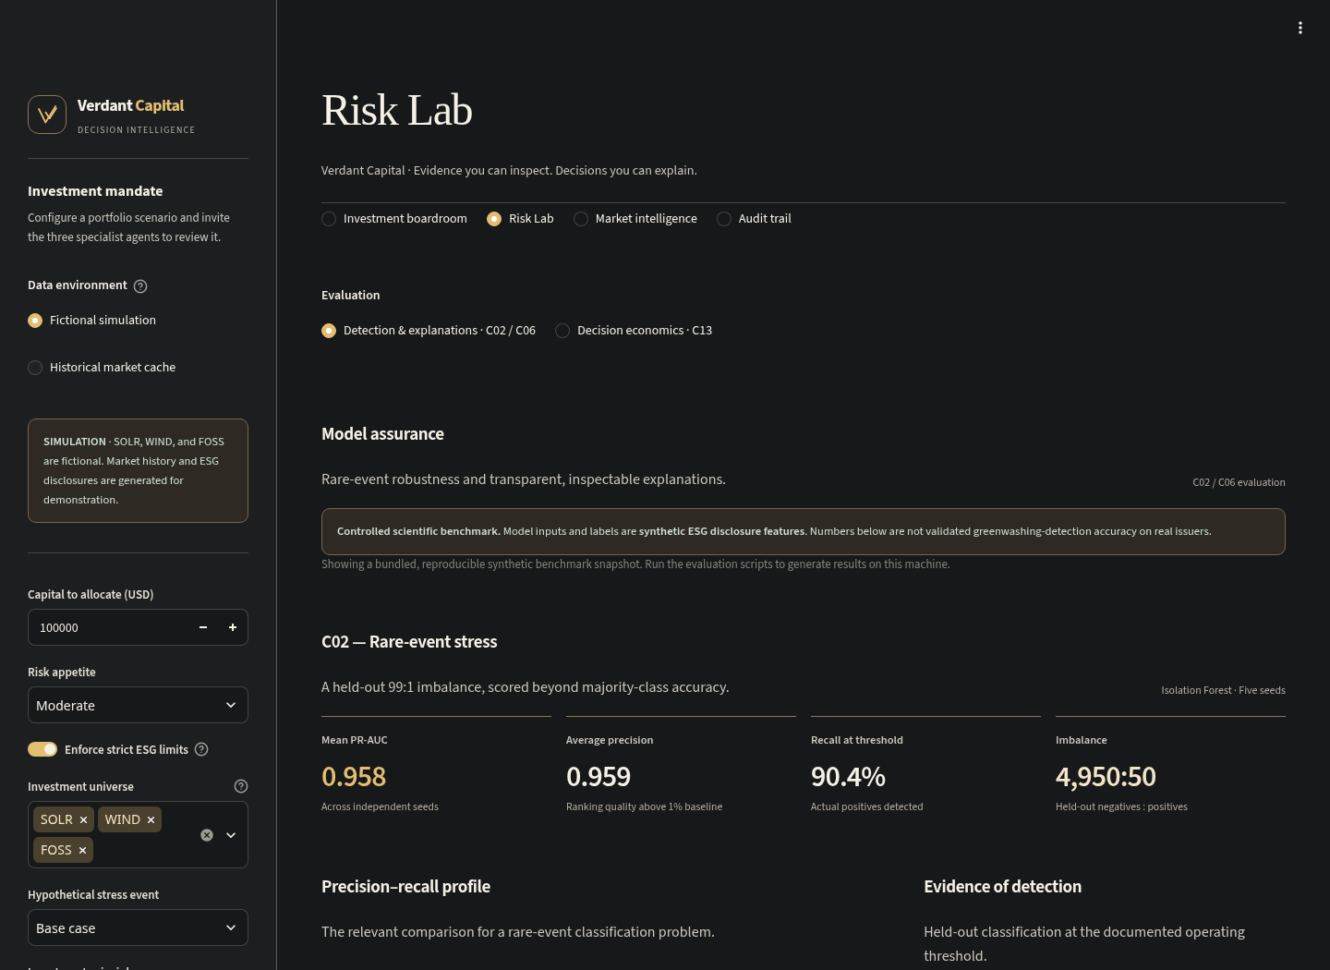
Figure 5. Actual Risk Lab runtime screen showing C02 outputs and provenance. The interface keeps the synthetic nature of the evidence visible.
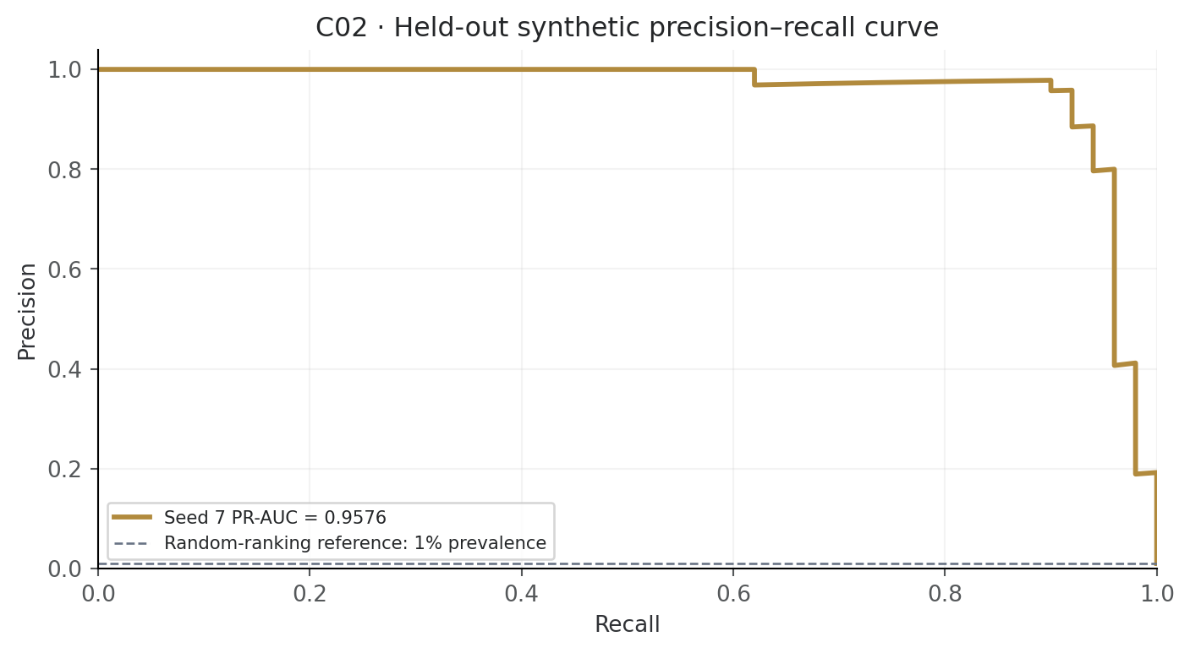
Figure 6. Seed-7 precision–recall curve generated from the saved full curve. The 1% line is the random-ranking prevalence reference; the five-seed mean is reported separately.
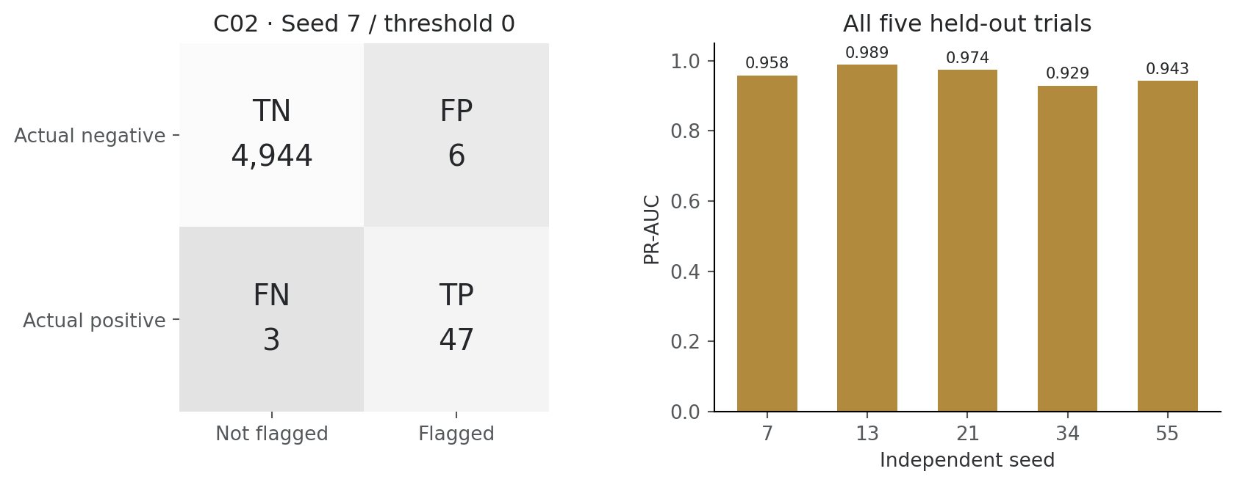
Figure 7. Seed-7 held-out confusion matrix beside all five PR-AUC results. False positives and missed positives remain visible.
A model predicting every case negative would achieve 99% accuracy but recall 0 and no useful detection. In contrast, every evaluated seed has at least one true positive and at least one flag. That is the implemented anti-collapse gate. It is a necessary sanity check, not proof of production robustness.
The top-1% review budget selects 50 cases per evaluation split. Mean precision in that queue is 90%, equivalent to 90× the 1% random-selection baseline. This queue metric differs from precision at the model’s native zero threshold.
Verification outcome: C02 demonstrates non-collapse and strong PR performance on the specified synthetic 99:1 experiment. It does not demonstrate real-company greenwashing detection, catastrophe prediction or default prediction. Independent labels, issuer/time splits and real prevalence testing remain necessary.

5. Challenge C06 — Explainability & Feature Attribution

5.1 Directive and our response
Directive: A financial regulator demands documented justification for algorithmic approvals or rejections. The deliverable is feature-attribution plots for three edge-case decisions with the principal driving features identified.
Our solution: A regulatory-style research audit of the C02 seed-7 Isolation Forest specification, using permutation SHAP on three actual held-out synthetic observations. The decisions are flag for review / not flagged, not real credit approvals or legal findings. The portfolio has its own reason-code audit; C06 does not explain portfolio weights.
The pipeline refits the same seed-7 C02 training specification reproducibly. It selects distinct true-positive, false-positive and false-negative rows nearest the score boundary within each category. If a category is absent, it uses and explicitly labels a real borderline substitute rather than fabricating a misclassification. No substitution was needed in the reported run.

5.2 Explanation method and checks
Permutation SHAP explains the exported anomaly score using a background of 32 training rows sampled with the same seed. Six features and a max_evals budget of 39 are used in the standard explanation call.
For each observation:
$$f\left(x\right)≈ϕ_{0}+\sum_{j=1}^{6}{ϕ_{j}}.$$
Here $ϕ_{0}$ is the background/base score and $ϕ_{j}$ is a feature’s contribution. Positive SHAP values increase the anomaly score; negative values reduce it. “Dominant feature” means largest absolute contribution. The code verifies reconstruction using relative and absolute tolerances of ${10}^{−4}$ before publishing a case.
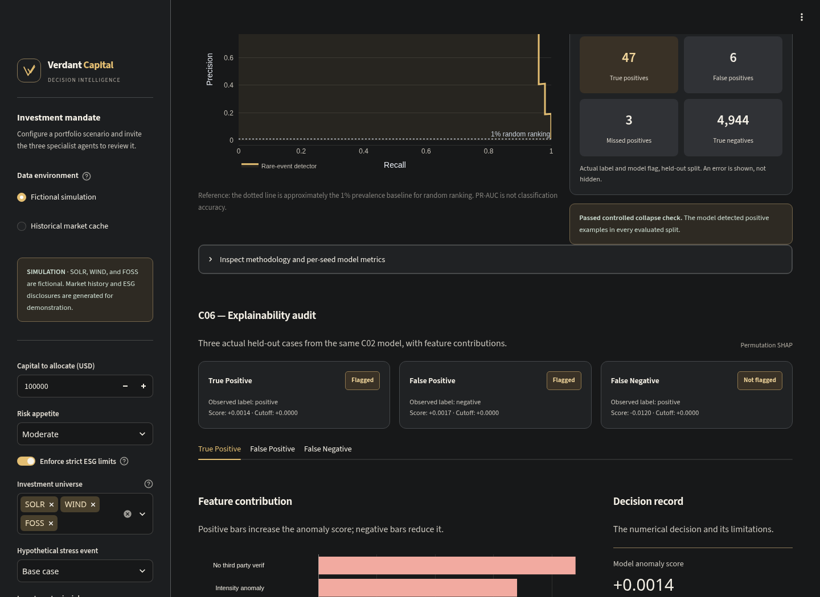
Figure 8. Actual C06 interface. The model score, feature contributions, decision threshold and downloadable audit are presented together.
Case | Held-out row | True / predicted label | Score | Primary feature | Primary SHAP contribution
True positive | 3,960 | 1 / 1 | +0.00141556 | No third-party verification | +0.08814664
False positive | 3,163 | 0 / 1 | +0.00174450 | Missing baseline | +0.10052287
False negative | 4,256 | 1 / 0 | −0.01198364 | Missing baseline | +0.11141636
All three decisions use threshold 0. The reported base score is −0.22598368, and each reconstructed score matches its recorded model score to the shown precision.

5.3 The three edge cases

Case 1: True positive — a correctly flagged synthetic case
The strongest upward contribution is absence of third-party verification, followed by the intensity anomaly. Together with other contributions, they move the score from a negative baseline to just above zero. The positive label and flag agree for this synthetic row.
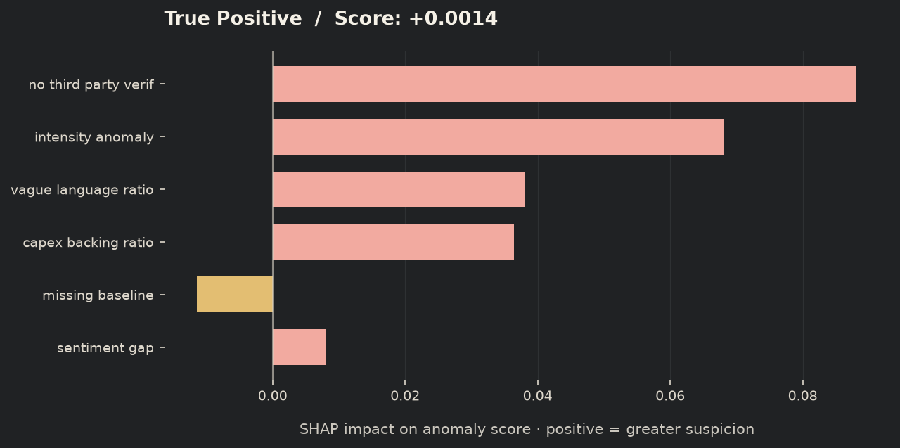
Figure 9. True-positive SHAP attribution. Coral raises the anomaly score; gold lowers it. The principal contributor is no third-party verification.

Case 2: False positive — an unnecessary audit
The row’s true label is negative, but missing baseline and absent third-party verification push the score above the review threshold. This is an explicit model mistake. The explanation documents why it happened instead of presenting every flag as correct.
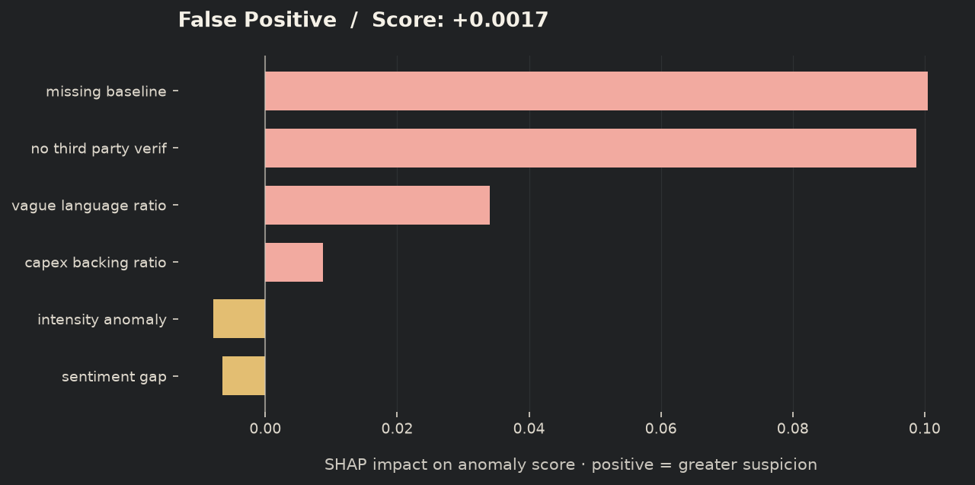
Figure 10. False-positive attribution. Missing baseline is the largest contributor, but the synthetic ground truth is negative. A persuasive explanation does not make the prediction correct.

Case 3: False negative — a missed positive
Missing baseline raises the score, but the sum of contributions is insufficient to cross zero from the background level. The final score stays negative even though the true synthetic label is positive. This case illustrates why false-negative economics matters in C13.
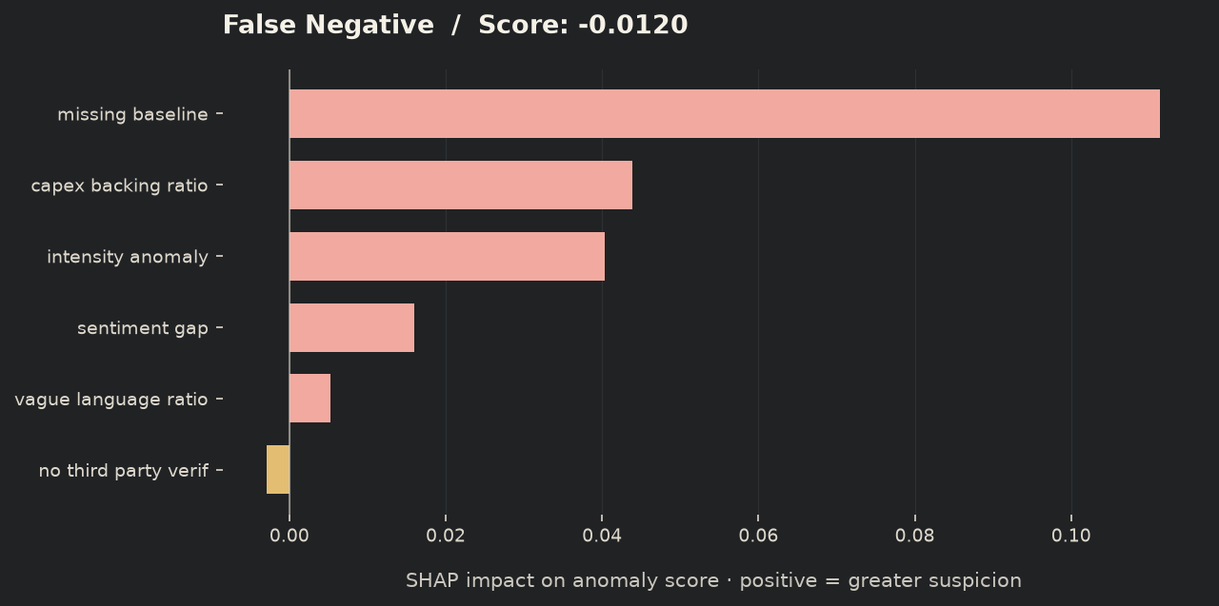
Figure 11. False-negative attribution. The principal feature raises suspicion, yet the total score remains below the flag threshold. The missed case is retained in the audit.
Verification outcome: Three genuine held-out cases, their feature values, labels, thresholds, contributions and additive reconstruction are documented. SHAP attributes a model score relative to a chosen background; it does not prove causality, authenticate an issuer disclosure, calibrate fraud probability or establish regulatory compliance. Feature dependence and background choice can affect the attribution.

6. Challenge C13 — Cost-Sensitive Threshold Optimization

6.1 Directive and financial assumptions
Directive: False positives incur manual audit overhead; false negatives can cause financial loss or defaults. The deliverable is an explicit financial cost matrix, a threshold optimized to minimize modeled economic loss, and the resulting confusion matrix.
Our solution: An exact validation-set search over anomaly thresholds, followed by a frozen-policy evaluation on untouched test cases. Costs are explicit, editable USD amounts per case. They are not inferred losses on the $100,000 investment portfolio.
The default illustrative scenario assumes $100 per audit and $10,000 per missed positive. For interpretation, $100 can represent two analyst hours at $50/hour; $10,000 can represent $25,000 exposure at 40% loss given default. These are selected scenario assumptions, not sourced operational measurements.
Actual outcome | Not flagged | Flagged for manual audit
Negative | TN: $0 | FP: $100
Positive | FN: $10,000 | TP: $100
A true-positive audit is assumed to prevent the modeled loss completely, while still incurring the audit cost. There is no recovery revenue, residual post-intervention loss, discounting or audit-capacity constraint in this scenario.
$$L\left(t\right)=\left(TP\left(t\right)+FP\left(t\right)\right)C_{A}+FN\left(t\right)C_{M}.$$
$C_{A}$ is the audit cost and $C_{M}$ the missed-positive loss. Prevented loss is reflected in the TP cost rather than subtracted again as revenue. Savings are a difference between policy losses on the same cases; they are not a second benefit term.

6.2 Independent threshold selection
C13 uses the C02 generator/model specification, but fits a separate model from a 30,000-case pool. It is not the identical fitted model used for the 25,000-case C02 experiment.
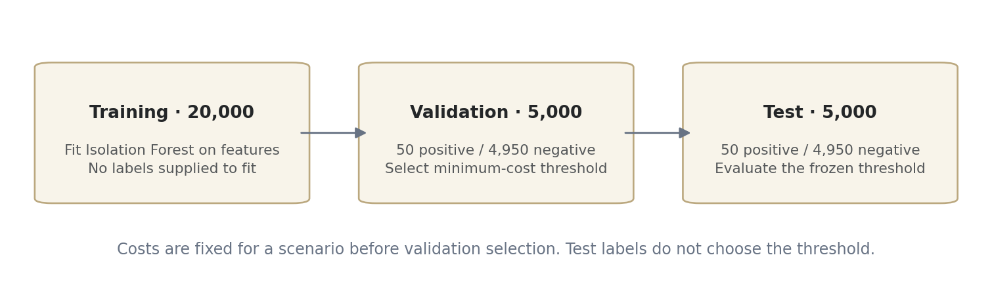
Figure 12. C13 train/validation/test separation. The model is fitted on training features; validation labels select the threshold; test labels only evaluate the frozen decision policy.
The split has 20,000 training, 5,000 validation and 5,000 test cases. Validation and test each contain 50 positives and 4,950 negatives. Seed 7 controls the initial model/data split; seed 8 controls the stratified validation/test partition.
The search evaluates every distinct validation score boundary plus a boundary immediately below the minimum score. The flag rule is strictly $s\left(x\right)>t$. Equal scores are never split. Audit-none and audit-all are included, so the search is exact over the available score-induced policies rather than an approximate threshold grid.
$$t^{*}=\underset{t∈T_{validation}}{argmin} L_{validation}\left(t\right).$$
Equal losses prefer fewer audits, then the higher threshold. Sorted scores and cumulative counts give $O\left(nlogn\right)$ selection. No probability cutoff is assumed because the model score is not calibrated as a probability.
The chosen threshold is −0.031598258945116586. At that threshold, validation has TP 49, FP 35, FN 1 and TN 4,915: 84 audits cost $8,400 and one miss costs $10,000, for total validation loss $18,400.
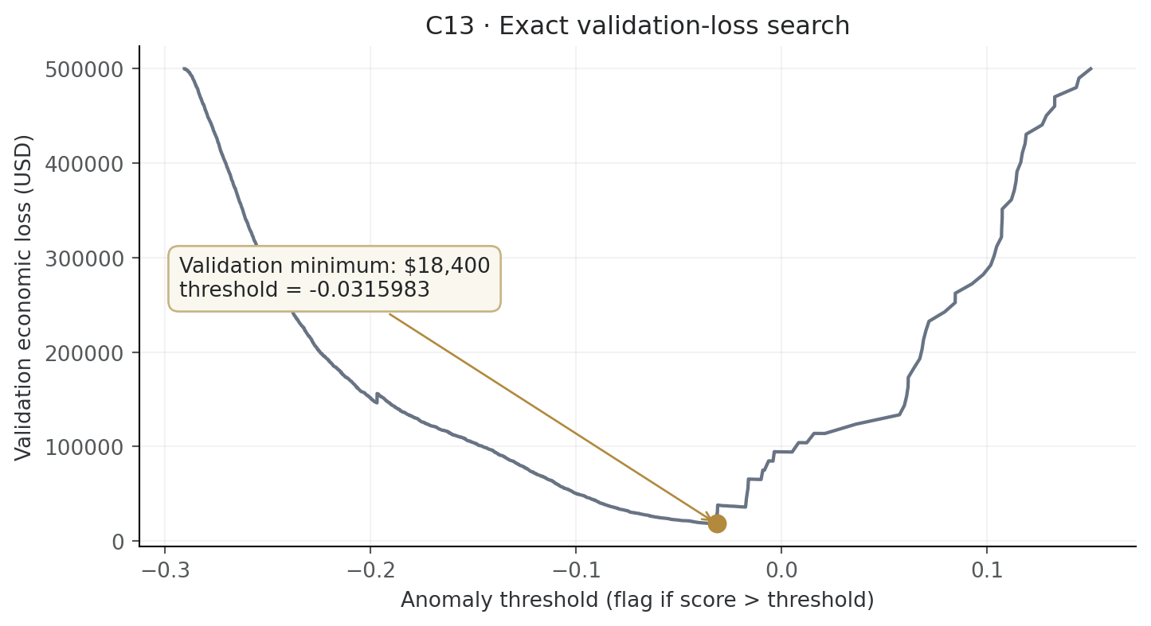
Figure 13. Exact validation economic-loss curve. The marked minimum is selected from validation cases only. The negative threshold is valid because these are anomaly scores, not probabilities.

6.3 Held-out results and confusion matrix
The selected threshold is frozen before test outcomes are used to compare the policies:
Test policy | TP | FP | FN | TN | Audits | Total economic loss
Default threshold 0 | 47 | 5 | 3 | 4,945 | 52 | $35,200
Validation-selected threshold | 49 | 30 | 1 | 4,920 | 79 | $17,900
Audit none | 0 | 0 | 50 | 4,950 | 0 | $500,000
Audit all | 50 | 4,950 | 0 | 0 | 5,000 | $500,000
For the selected test policy:
$$L_{test}=\left(49+30\right)×100+1×10,000=17,900.$$
For the default policy:
$$L_{default}=\left(47+5\right)×100+3×10,000=35,200.$$
The modeled reduction is $17,300, approximately 49.15% of default loss. The selected policy adds 27 audits, costing another $2,700, while avoiding two modeled misses worth $20,000. Precision decreases from 90.38% to 62.03%, but recall increases from 94% to 98%. This is the intended decision-economics tradeoff: maximizing precision is not the same as minimizing cost.
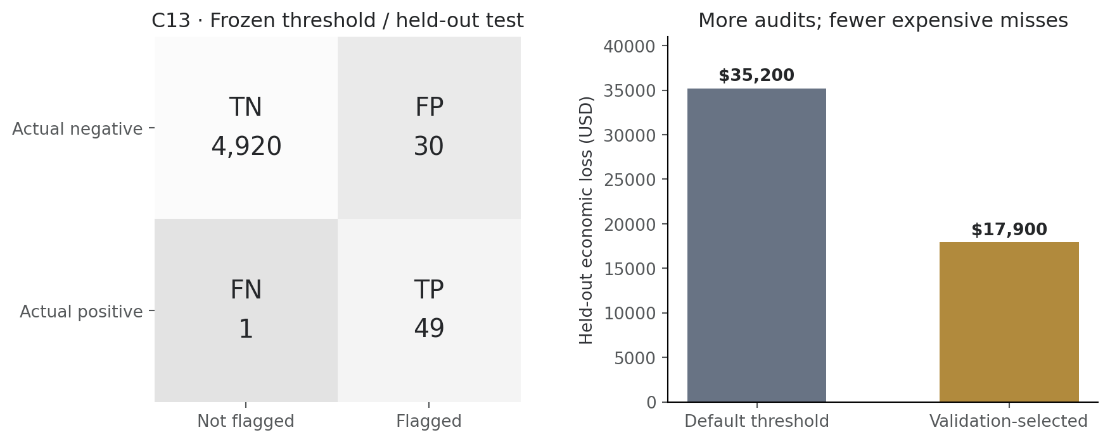
Figure 14. Frozen-policy held-out confusion matrix and direct default/selected loss comparison. These are synthetic test economics under the stated cost assumptions.
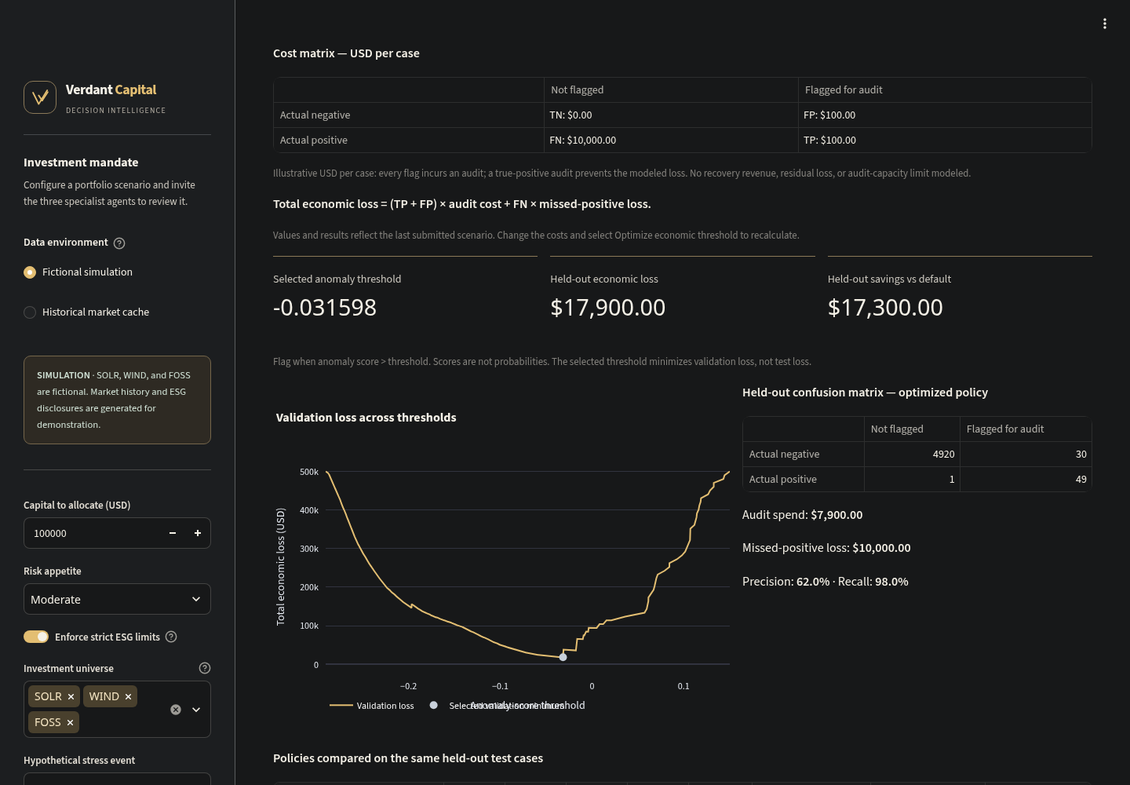
Figure 15. Actual C13 runtime results view. The cost matrix, selected threshold, confusion matrix, audit spend, missed loss and policy comparisons can be inspected and exported.

6.4 Sensitivity, verification and boundaries
The interface lets a reviewer change both costs and select Optimize economic threshold. The selected scenario has its own download identity and filename so its exported cost matrix matches the submitted values. Costs must be finite and nonnegative; the UI caps inputs at $1 billion and the numerical helper rejects amounts above $1 trillion.
Increasing missed-positive loss can justify additional audits and a lower threshold. Increasing audit expense can favor fewer flags. A minimum on validation does not guarantee a minimum on the test set or in production; negative held-out savings are retained. Repeatedly inspecting the same test set while exploring cost scenarios is sensitivity analysis, not fresh independent confirmation.

7. What we have achieved and how it is verified
Verdant Capital’s contribution is an integrated, inspectable process: uncertain evidence remains uncertain, investment policy is enforced numerically, model errors are shown, and the cost of an error is made explicit. The implementation separates claims that can be checked from assumptions that require validation.
Deliverable | Evidence provided | Boundary
Green-capital research workflow | Actual three-specialist graph, constrained allocation, policy ledger and audit export | Research simulation; no execution or independent sustainability certification
C02 | Five synthetic 99:1 evaluations; mean PR-AUC 0.9583; visible errors and anti-collapse check | No real-issuer accuracy claim
C06 | Three held-out synthetic cases; SHAP plots, feature values and reconstruction | Explains anomaly scores, not causality or portfolio weights
C13 | Explicit USD matrix; validation minimum; fixed test policy; $17,900 versus $35,200 modeled loss | Costs and intervention effectiveness are assumptions
Technical reliability | 56 local tests, lint/format/compile checks, actual Streamlit smoke flows | Latest Windows fix requires its platform CI confirmation
Browser presentation | Four Chromium viewport sizes; automated accessibility checks; actual gold-theme screenshots | No full WCAG certification or verified Firefox/WebKit coverage
The tests cover missing evidence, invalid capital/influence, unavailable or malformed price caches, empty/cash-only universes, ESG caps, bounded review, source-filtered feedback, economic threshold edge cases, atomic report writes and Windows-style file-contention recovery. Permanent file-write errors remain errors; the previous complete report is preserved.
The workspace defaults to loopback access with XSRF/CORS protection and disabled telemetry. It is a single trusted operator tool, with no login, tenant isolation or tamper-proof ledger. Public deployment requires additional controls.
Performance flag. The prior submission audit measured Lighthouse performance of 51 desktop and 13 under mobile throttling, below the requested 90+ target; accessibility and best practices scored 100. Framework bundles and layout shifts remain open work. The subsequent palette change was checked with tests and automated accessibility, not a new Lighthouse measurement.

8. Summary and conclusion
Pillar 2 asks how AI can use market dynamics and climate indicators to direct capital toward verifiable sustainable investments. Verdant Capital responds with a practical research architecture: evidence-aware ESG assessment, dated market interpretation, explicit numerical portfolio constraints and a reviewable decision record.
The three challenge demonstrations add complementary assurance. C02 shows that the synthetic detector does more than predict the majority class. C06 documents why three held-out decisions occurred, including a false alarm and a miss. C13 shows how a transparent monetary loss model can select a different operating threshold and reduce held-out modeled loss despite lower precision.
The submission’s strongest supported claim is therefore traceable, constraint-aware decision support with reproducible synthetic assurance evidence. It does not yet establish a validated real-world ESG classifier, a reliable carbon-credit forecaster, superior realized investment returns or a production-regulated financial service.
The next milestones are independently labeled issuer evidence; tested document-feature extraction; issuer/time-separated evaluation; measured audit expense and intervention effectiveness; realistic portfolio backtests with execution costs; verified future outcomes; and authenticated deployment. Licensing remains explicitly pending at the owner’s request.
Closing statement: Capital allocation should be supported by evidence a reviewer can inspect, constraints a model cannot casually override, and economic assumptions that remain visible. Verdant Capital demonstrates that decision discipline and makes the remaining validation work explicit.

Appendix A. Reproduction and evidence map
This report describes implementation baseline 501c33a in syedazoh/verdant_capital-. Its screenshots use the charcoal/gold application, and its analytical figures are generated from the saved model results. The report adds documentation and visuals; it does not change investment or evaluation logic.
From the project root, with the development environment installed:
.\.venv\Scripts\python.exe scripts/check.py
.\.venv\Scripts\python.exe -m challenge.c02_rare_event
.\.venv\Scripts\python.exe -m challenge.c06_explainability
.\.venv\Scripts\python.exe -m challenge.c13_cost_sensitive --audit-cost 100 --missed-loss 10000
.\.venv\Scripts\python.exe -m data.feedback_backtest
.\.venv\Scripts\python.exe -m orchestrator.graph
.\.venv\Scripts\python.exe -m streamlit run app.py
On Linux, use .venv/bin/python. Optional historical refresh is separate: python -m data.fetch_market, followed by python -m data.carbon_forecast. Optional report indexing is python -m data.build_rag after installing the RAG/provider extras and adding permitted source PDFs.
Subject | Source / reproducible artifact
Orchestration, verifier and conflict rule | orchestrator/graph.py
Optional provider calls and prompt | agents/llm.py, agents/prompts.py
Issuer-scoped retrieval | data/build_rag.py
Historical data and price statistics | data/fetch_market.py
Carbon proxy projection | data/carbon_forecast.py
Objective, caps and numerical verification | data/portfolio.py
Outcome provenance and influence | data/feedback_store.py
C02 generator, fit and metrics | challenge/c02_rare_event.py; data_cache/c02_report.json and c02_pr_curve.json
C06 cases and plots | challenge/c06_explainability.py; data_cache/c06_report.json and c06_plots/
C13 cost search and evaluation | challenge/c13_cost_sensitive.py; data_cache/c13_report.json
Evidence underlying this report | docs/report_assets/report_evidence.json; c13_validation_curve.csv
Current visual evidence | docs/screenshots/ and docs/report_assets/
Engineering checks and unresolved triage | QA_REPORT.md, tests/, .github/workflows/quality.yml

Appendix B. Terminology and judge-facing interpretation
Term | Meaning in this project
ESG | Environmental, social and governance considerations; not a single certified rating produced by this app
Greenwashing risk | Optional analyst/model estimate or explicit fictional fixture; not a legal finding
RAG | Retrieval-augmented generation: issuer-filtered source text supplies context for optional model analysis
Bullish / bearish | Rule-based labels from historical price movement, not guaranteed forecasts
Covariance | Estimated joint variation of asset returns
Long-only | Holdings cannot be negative; short selling is disallowed
PR-AUC | Area under the precision–recall curve; not classification accuracy
SHAP | Feature contributions relative to a background for a particular model output; not proof of causality
False positive | Negative synthetic case incorrectly flagged; modeled audit overhead
False negative | Positive synthetic case not flagged; modeled missed-event loss
Optimized | A solver or validation search succeeded under its stated assumptions; not proof of profitability
Cash reserve | Unallocated capital in the model; not a guarantee against inflation or all financial risks
Attribution and status. Team Cypher is the project attribution retained from the original repository. Original source attribution and pending licensing are recorded in NOTICE.md and LICENSE. Numerical results in this document must always be presented with their synthetic-data and financial-assumption labels.

