

Applications of Virtual Reality in School Counseling and in the treatment of Phobias



January 28, 2020

Eric Oberstar, Bilal Syed, Aaron Myhre

Milwaukee School of Engineering

GS1002-009

# Abstract

The NAE provides engineers with the fourteen grand engineering challenges of the twenty first century. Enhanced Virtual Reality is addressed as one of the fourteen challenges provided from the NAE. Research shows that VR can be beneficial for addressing specific phobias such as agoraphobia, arachnophobia, and claustrophobia. This report will analyze the applications of virtual reality in school counseling and in the treatment of phobias. The majority of the research was conducted using Google Scholar and the Milwaukee School of Engineering Walter Schroeder Library Summon database. The data was found using the keywords: “Virtual Reality”, “Phobias”, and “Treatment”. Studies put out by researchers show that VR is applicable to different types of environments including companies, universities, and hospitals. VR is proven to be an effective outlet to treat phobias in many different cases. Many companies are creating their own VR systems with their own software at different prices ranging from cheap systems at $400 to more tailored and expensive systems at $2000. VR exposure therapy (VRET) is an effective technique that broadens a counselor's ability to treat phobias and with VR systems ranging from basic kits to more advanced kits VR is accessible at any budget. Research demonstrates the easy adaptability VR has with almost any environment, the effectiveness it has towards treating individuals with phobias, and the flexibility in cost ranges. Overall, VRET is an effective, and affordable technique that is not gaining enough attention in school counseling due to a lack of awareness of the benefits of VR.

Contents

Abstract i

Introduction 1

Methodology 2

Implementation of VR in School Counseling and Treatment of Phobias 2

Applications of VR in Treating Phobias 2

Effectiveness of VR in Treating Phobias 3

Affordability of VR in Treating Phobias 5

Analysis 6

Conclusion 7

References 8

# Table of Figures

Figure 1: Footage from the VR Software SpiderWorld. (Hoffman, 2004) 3

Figure 2: Participant and Supporter’s Confidence Ratings (Maskey et al., 2019) 4

Figure 3: Oculus Quest overview (Oculus VR, 2020) 5

Figure 4: Limbix VR Kit overview (Limbix, 2020) 6

# 

# Introduction

“Meeting these challenges would be ‘game changing’... Success with any one of them could dramatically improve life.” This quote was taken from the President of the National Academy of Engineering (NAE) , Charles M. Vest, at the unveiling of the 14 Grand Challenges for Engineering twelve years ago (NAE,2008). The NAE tasks this century’s engineers with the goal to improve life on the planet through technological advancements. The NAE provides engineers with the fourteen grand engineering challenges of the twenty first century ranging from enhancements in cyber security to providing accessible and clean water to improving urban infrastructure. These challenges are reshaping the world as we know it.

Enhanced Virtual Reality is addressed as one of the fourteen challenges provided from the NAE (NAE Grand Challenges for Engineering, 2008). Enhanced Virtual Reality has a broad range of uses in society such as long-distance video conferences and providing soldiers and surgeons with realistic training in a virtual setting without any potential risks (National Association of Engineering, n.d.). With the constant enhancements in virtual reality it is becoming more realistic and accessible to the general public.

Research shows that Virtual Reality can be beneficial for addressing specific phobias. In a 2002 study, a group of 23 people with arachnophobia were treated with four one-hour sessions of VR exposure therapy and 83% showed significant improvement in their arachnophobia (Garacia-Palacios, Hoffman, Carlin, Furness, and Botella). For people who are struggling with certain phobias, it can be difficult to put them into a realistic setting that would allow these individuals to address their phobias (ie: claustrophobia, arachnophobia, glossophobia, etc.). With the implementation of virtual reality, we can make the treatment of these phobias more accessible in order to provide exposure therapy to these specific situations.

Specific key terms that are insightful to people who are unfamiliar with Virtual Reality Exposure Therapy (Definitions provided from the Merriam-Webster Dictionary):

* **Virtual Reality:** An artificial environment which is experienced through sensory stimuli (such as sights and sounds) provided by a computer and in which one's actions partially determine what happens in the environment.
* **Phobia**: an exaggerated usually inexplicable and illogical fear of a particular object, class of objects, or situation.
* **Exposure Therapy** **:** psychotherapy that involves repeated real, visualized, or simulated exposure to or confrontation with a feared situation or object or a traumatic event or memory in order to achieve habituation and that is used especially in the treatment of post-traumatic stress disorder, anxiety disorder, or phobias.
* **Agoraphobia**: abnormal fear of being helpless in a situation from which escape may be difficult or embarrassing that is characterized initially often by panic or anticipatory anxiety and finally by the avoidance of open or public places
* **Claustrophobia**:abnormal dread of being in closed or narrow spaces
* **Glossophobia:** fear of public speaking
* **Trypanophobia:** extreme fear of medical procedures involving injections or hypodermic needles
* **Acrophobia:** abnormal dread of being in a high place
* **Arachnophobia:** pathological fear or loathing of spiders

This report will analyze the applications of virtual reality in school counseling and in the treatment of phobias.

# Methodology

The majority of the research was conducted using Google Scholar and the Milwaukee School of Engineering Walter Schroeder Library Summon database. Keywords used included “Virtual Reality”, “Phobias”, and “Treatment”. We filtered down the results from the start of 2000 to 2020 to get more recent and credible data. Our final sources were filtered based off of their level of comprehension and readability compared to a school counselor and if they were peer reviewed. We also read through the abstracts and scanned through the articles to determine their relevance to our topic.

# Implementation of VR in School Counseling and Treatment of Phobias

The research in the report analyzes the importance of applications of VR in school counseling to treat phobias. The next sections elaborate on specific applications, affordability, and effectiveness of VR in school counseling and treatment of phobias.

## Applications of VR in Treating Phobias

VR has a variety of unique software to treat common phobias (eg. agoraphobia, claustrophobia). Studies put out by researchers show that VR is applicable to different types of environments including companies, universities, and hospitals. Universities have also taken to developing this software to treat individuals with phobias, with two of the main universities being the University of Valencia and Delft University of Technology (Stanica, Lulia-Cristina, Dascula, Maria-Luliana, Moldoveanu, Alin, Bodea, Constanta-Nicoleta, Hostic, Sorin, 2016). Valencia developed a software for dealing with acrophobia, as the simulation appears as if all the tiles in the room are beginning to fall. Once all these tiles fall, there is a hole in the middle and the user stands as close as they can to the ledge of the hole. To make this setting appear more realistic they offer correct lighting, shadows, and models which causes more anxiety. The University of Valencia conducted a study on a group of 20 students on October 3rd, 2015 to determine their anxiety levels after using the Virtual Reality application. Then students were to take a survey afterwards to indicate their level of anxiety. Research shows that the results received from the survey supported that this application in being beneficial for treating acrophobia (Stanica, Lulia-Cristina, Dascula, Maria-Luliana, Moldoveanu, Alin, Bodea, Constanta-Nicoleta, Hostic, Sorin, 2016).

Delft provided a software mainly for treating social phobia, where they used high school students as a part of their study (Stanica, Lulia-Cristina, Dascula, Maria-Luliana, Moldoveanu, Alin, Bodea, Constanta-Nicoleta, Hostic, Sorin, 2016). The software provided four different environments, being a train station, bus stop, restaurant, and clothes store. The University of Deft developed realistic sounds, lighting, dialogue, and movement to enhance their application. When conducting this test they had a set goal in mind, to determine the effects of their VR world on the level of anxiety. The University determined from their results that the VR world did have an effect on the level of anxiety, as VR decreased the students’ anxiety levels. However, the University found one other problem with their software, since the therapist had to control the interface many found the software interface difficult to use. Due to the difficulties the therapists experienced, many of the responses to the patient were delayed which in the long run could delay the “therapeutic process” (Stanica, Lulia-Cristina, Dascula, Maria-Luliana, Moldoveanu, Alin, Bodea, Constanta-Nicoleta, Hostic, Sorin, 2016).

Spiderworld is one of the first to use virtual reality to treat phobias, mainly aiming for arachnophobia. They programmed this technology, so it seemed like a normal kitchen, but it was filled with a large amount of spiders [Hoffman, 2004]. To make the experience seem more lifelike, they added “VR Glove” which would appear as a virtual hand within the system. The figure below represents footage from the software SpiderWorld has developed. The software can be seen as a casual kitchen where spider can occasionally appear and walk around on screen.

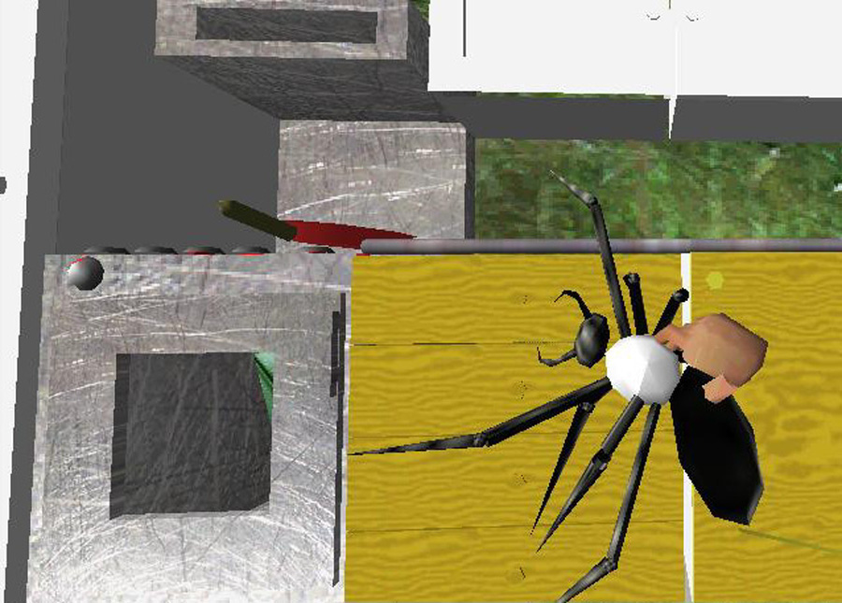

Figure : Footage from the VR Software SpiderWorld. (Hoffman, 2004)

This software is one method used in therapy for treating arachnophobia [Hoffman, 2004]. Researchers from the Universities of Emory, North Carolina and Jaume I University in Spain conducted their first study with a woman named Ms. Muffet (whose name is kept anonymous) using this SpiderWorld VR equipment. The researchers describe her as having a fear of spiders for 20+ years and along with her arachnophobia, she has acquired many other Obsessive-Compulsive Disorders from it. She was brought into one-hour sessions where she would use the Spider World VR technology to decrease her anxiety. The results showed after 10 sessions of this therapy, Ms. Muffet’s fear of spiders greatly decreased and she was able to hold a spider with slight anxiety. In addition, from this therapy many of her obsessive-compulsive disorders went away. Further studies with other patients, 23 patients diagnosed with clinical phobias, result in 83 percent reported experiencing a decrease in their fear of spiders (Stanica, Lulia-Cristina, Dascula, Maria-Luliana, Moldoveanu, Alin, Bodea, Constanta-Nicoleta, Hostic, Sorin, 2016).

## Effectiveness of VR in Treating Phobias

VR has proven to be an effective outlet to treat phobias. Many phobias have been effectively improved including, but not limited to, arachnophobia, agoraphobia, and dental phobia. Virtual Reality Exposure Therapy (VRET) has undoubtedly been helpful in the effort to resolve peoples’ phobias as shown below.

A study done on the feasibility of using VRET to treat dental phobia concluded that VRET is a feasible alternative for patients with dental phobia (Gujjar, Wijk, Sharma & Jongh, 2018). Six out of the nine treatment completers no longer had dental phobia and four out of the five VRET participants scheduled a dental appointment after the study. A review of the progress of using VRET done in 2017 confirmed the effectiveness of using VRET (Botella, Fernandez-Alvarez, Garcia-Palacios & Banos). It was determined that VR helps improve exposure therapy and that VR helps analyze the ways to enhance exposure therapy.

Two others with very different participants also arrived at the conclusion that VR is effective at treating phobias. One of these studies was done in 2019 on the use of VR to treat autistic adults with phobias (Maskey et al.). The study indicated that all of the participants’ phobias had been improved and some of the participants no longer experienced their phobia.

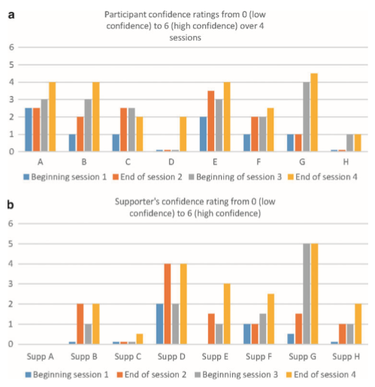

Figure : Participant and Supporter’s Confidence Ratings (Maskey et al., 2019)

Figure 2 shows that both the participants and supporters were not confident that the treatment would work, but their confidence in the treatment increased by the time they got to the end of the fourth session. The other study was done in 2002 on the use of VR to treat people with a spider phobia(Garcia-Palacios, Hoffman, Carlin, Furness III & Botella). The participants included students from a college psychology class, through the university newspaper, and people who requested to be treated. 23 individuals were chosen to participate. The goal of the participants treatment was to be able to hold a big virtual spider with low levels of anxiety. The number of sessions required to do so averaged at around four. Of the 23 participants, 83% showed a clinically significant improvement in their spider phobia (Garcia-Palacios et al., 2002).

## Affordability of VR in Treating Phobias

Thanks to the powerful computers and technology of today, VR has moved away from being a tool that only large facilities could afford and become one that is easily accessible to the public. Due to this, many companies have created their own VR systems with their own software at different prices. These VR kits can range from cheap and accessible systems like the Oculus Quest to more robust and expensive systems like the Limbix VR kit.

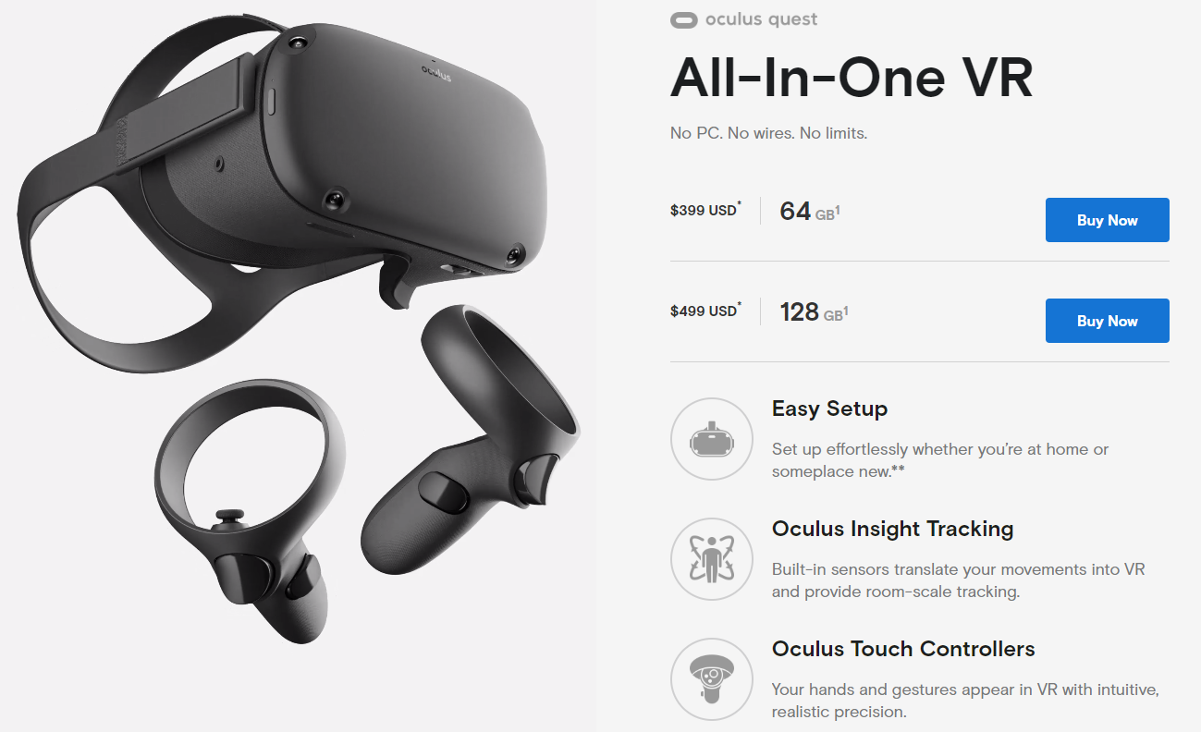

Figure : Oculus Quest overview (Oculus VR, 2020)

According to an article from M. Malmlund (2019), Oculus is one of the biggest names in VR in the current market. According to Oculus, the company is currently owned under facebook and contains a massive library of software created by Oculus and third parties. One of the models in the Oculus series is the Oculus Quest. Unlike the other Oculus headsets, the Oculus Quest is a standalone VR headset which means it does not need to be connected to a computer (Oculus VR, 2020). According to Figure 3, the Oculus Quest is an easy to set up VR headset that can run downloaded software acquired from either the Oculus store or a third party. The Oculus Quest also comes with a set of controllers to allow tracking and movement which allows for a more realistic experience (Oculus VR, 2020). The cons of the Oculus Quest and Oculus series altogether is that they are built more for gaming than for therapy. This can make it difficult to find supported software from the oculus store but still can be acquired through a third party. The price of the Oculus Quest is currently $400 (Oculus VR, 2020).

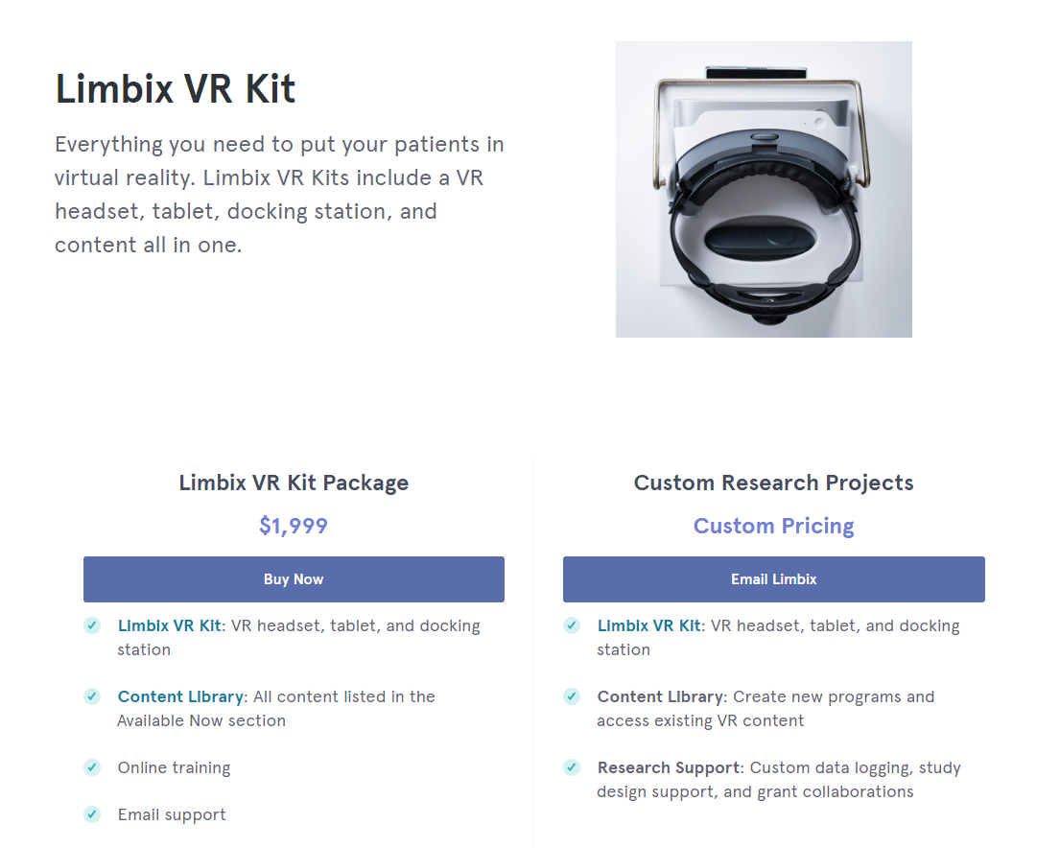

Figure : Limbix VR Kit overview (Limbix, 2020)

There are also VR headsets the specifically tailor towards exposure therapy like Limbix’s VR kit. Limbix is a company that sells their own personal headsets with their own built in software. With research from over 300 peer reviewed studies and credible partners such as Harvard University and the National Mental Health Innovation Center, Limbix has designed specific software and hardware to deal with common phobias and anxiety (Limbix, 2020).

Limbix has software that tackles phobias such as agoraphobia, glossophobia, claustrophobia, trypanophobia, and Acrophobia. Along with their current software Limbix is continually releasing more software overtime and conducting more research to solve other mental health issues like depression. According to Figure 4, Limbix’s VR kit comes with a VR headset, a tablet used to control and set up the headset and a docking station to charge it. The kit also includes online training and access to their suite of software. Similarly, to the Oculus, the Limbix VR headset does not require a computer. The major difference between the Limbix VR kit and the Oculus Quest is the price. Retailing at $2,000 the Limbix VR kit costs 5 times the Oculus Quest’s price of $400(Limbix, 2020).

# Analysis

Virtual Reality has been proven to be a useful tool in treating specific phobias. The research provided demonstrates the easy adaptability it has with almost any environment, the effectiveness it has towards treating individuals with phobias, and the flexibility in cost ranges.

The results of this research are important to show the change in accessibility of VR in the past years. Instead of looking to enhance VR itself this research looks at current VR and enhancing its application in different settings, specifically school settings. Until recently VR has been an expensive and typically complicated process which has made it difficult to implement in a school setting.

These findings show the importance of applying VR in a school counseling setting. Through this research it is shown that VR exposure therapy (VRET) is an effective technique that broadens a counselor's ability to treat phobias and with VR systems ranging from basic kits to more advanced kits VR is accessible at any budget. In addition, the research demonstrates that this VR technology can be adaptable to any environment with no potential drawbacks. With this knowledge school counselors should be able to implement VR into their own systems to improve efficiency and effectiveness of treating phobias. This information also provides feedback to the school counselors with the result of them knowing that this treatment will prove beneficial in treating phobias within these teens. With multiple headsets comes the ability to treat multiple students and with software that does the therapy for you it makes treatment more manageable.

Even though VR therapy is accessible to the general public, many are not aware of this method of treatment. In order to effectively use VR exposure therapy, awareness needs to be spread to the public. Parents may also not want their children to use VR therapy because their children already have too much screen time. This therapy method is more of a tool than a game and should not be thought of in this way.

The results all agree that VR is an effective method in therapy to treat phobias. In all of the studies, a majority of the participants had reported that their condition was improving, and that the treatment was effective. It is also shown that VRET can be applied in any location from households to colleges. Through all of the studies, there is no apparent bias, as a wide variety of participants were selected.

# Conclusion

This report analyzed the applications of virtual reality in school counseling and in the treatment of phobias. With advancements in technology, VR has become an accessible, effective, and affordable method of treatment that can be implemented into a school counseling system to help with phobias that students may be suffering from at an efficient rate. The research indicates that VR is an effective way to treat phobias and can be applied in a school environment at an affordable price. While all these statements are true, VR therapy is not well-known, and awareness needs to be spread about it.

The results from this research provides many beneficial points toward the effectiveness of VR, however there is still more to learn and develop about the technology. Currently VR only supports two of your five senses, sight and hearing. To enhance virtual reality even further, all senses must be developed to provide better treatments to where there is no difference between the VR world and real life. Eventually after this challenge is addressed, the use of VR can be implemented to more than just exposure therapy, but into different types of medical fields as it currently has been. Overall, VRET is an effective, and affordable system that is not gaining enough attention in school counseling due to a lack of awareness of the benefits of VR.

# References

Botella, C., Fernández-Álvarez, J., Guillén, V., García-Palacios, A., & Baños, R. (2017). Recent Progress in Virtual Reality Exposure Therapy for Phobias: A Systematic Review. *Current Psychiatry Reports*, *19*(7). doi: 10.1007/s11920-017-0788-4

Digital Therapeutics for Mental Health. (n.d.). Retrieved from

https://www.limbix.com/

Garcia-Palacios, A., Hoffman, H., Carlin, A., Furness III, T., & Botella, C. (2002, September 9). Virtual reality in the treatment of spider phobia: a controlled study. *Behaviour Research and Therapy*, *40*(9), 983-993. doi: https://doi.org/10.1016/S0005-7967(01)00068-7

Gujjar, K. R., Wijk, A. V., Sharma, R., & Jongh, A. D. (2017). Virtual Reality Exposure Therapy for the Treatment of Dental Phobia: A Controlled Feasibility Study. *Behavioural and Cognitive Psychotherapy*, *46*(3), 367–373. doi: 10.1017/s1352465817000534

Hoffman, H. G. (2004). Virtual Reality Therapy. In *Scientific American*. Retrieved from https://www.behavioralassociates.com/pdf/scientificamerica.pdf

Hoffman, H. G. (n.d.). VR Therapy for Spider Phobia. In *HITLab*. Retrieved from http://www.hitl.washington.edu/projects/exposure/

Introduction to the Grand Challenges for Engineering. (2008). In *National Academy of Engineering.*

Retrieved from http://www.engineeringchallenges.org/challenges/16091.aspx

Malmlund, M. (2019, May 3). 10 Best Virtual Reality Headsets. Retrieved from https://heavy.com/tech/2018/12/best-virtual-reality-headsets/

Maskey, M., Rodgers, J., Ingham, B., Freeston, M., Evans, G., Labus, M., & Parr, J. R. (2019). Using Virtual Reality Environments to Augment Cognitive Behavioral Therapy for Fears and Phobias in Autistic Adults. *Autism in Adulthood*, *1*(2), 134–145. doi: 10.1089/aut.2018.0019

Oculus Quest: All-in-One VR Headset. (n.d.). Retrieved from https://www.oculus.com/quest/?locale=en_US

Randy, A. (2008, February 15). 21 Century's Grand Engineering Challenges Unveiled. In *The National Academies of Sciences, Engineering, and Medicine*. Retrieved from https://www8.nationalacademies.org/onpinews/newsitem.aspx?RecordID=02152008

Stanica, L., Dascalu, M., Moldoveanu, A., Bodea, C., & Hostiuc, S. (2016). A SURVEY OF VIRTUAL REALITY APPLICATIONS AS PSYCHOTHERAPEUTIC TOOLS TO TREAT PHOBIAS. In *ProQuest*. Retrieved from https://search.proquest.com/docview/1792386488?pq-origsite=gscholar