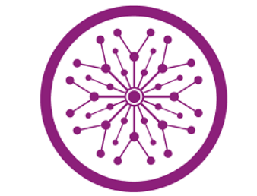

NAME:
Basit Abbas
ROLL NUMBER:
SU92-BSDSM-F23- 013
PROGRAM:
BS DATA SCIENCE
SUMBITTED TO:
SIR RASIKH

TASK : 04

1. Importing OpenCV
The notebook starts by importing the OpenCV library (cv2), which is essential for image processing tasks such as reading, writing, manipulating, and displaying images.
2. Reading an Image
The first operation performed is reading an image file from the system. OpenCV’s imread() function is used to load an image into a variable so that it can be processed.
3. Displaying an Image
Once the image is loaded, it is displayed in a separate window. The program waits for a user key press before closing the window to ensure the image remains visible.
4. Writing and Saving an Image
The notebook then demonstrates how to save an image to a file using OpenCV’s imwrite() function. This allows modifications or processed images to be stored.
5. Color Channel Separation
In color images, each pixel consists of three channels: Blue, Green, and Red (BGR format in OpenCV). The notebook extracts these individual color channels from an image, allowing users to analyze the intensity of each component separately.
6. Displaying Individual Color Channels
After extracting the Blue, Green, and Red channels, each one is displayed separately. This helps in understanding how different colors contribute to the final image.
7. Blending Two Images
The notebook includes an example of combining two images by overlaying them with specific weights. This technique is commonly used for transparency effects, such as blending a watermark onto an image.
8. Resizing an Image
To demonstrate image scaling, the notebook resizes an image by reducing its dimensions to half of its original size. Resizing is crucial for optimizing images for different applications, such as displaying them on smaller screens or reducing memory usage.
9. Other Possible Operations
Based on the structure, the later parts of the notebook likely cover additional transformations, such as rotation, filtering, edge detection, or other image manipulations.

