1. Picipo

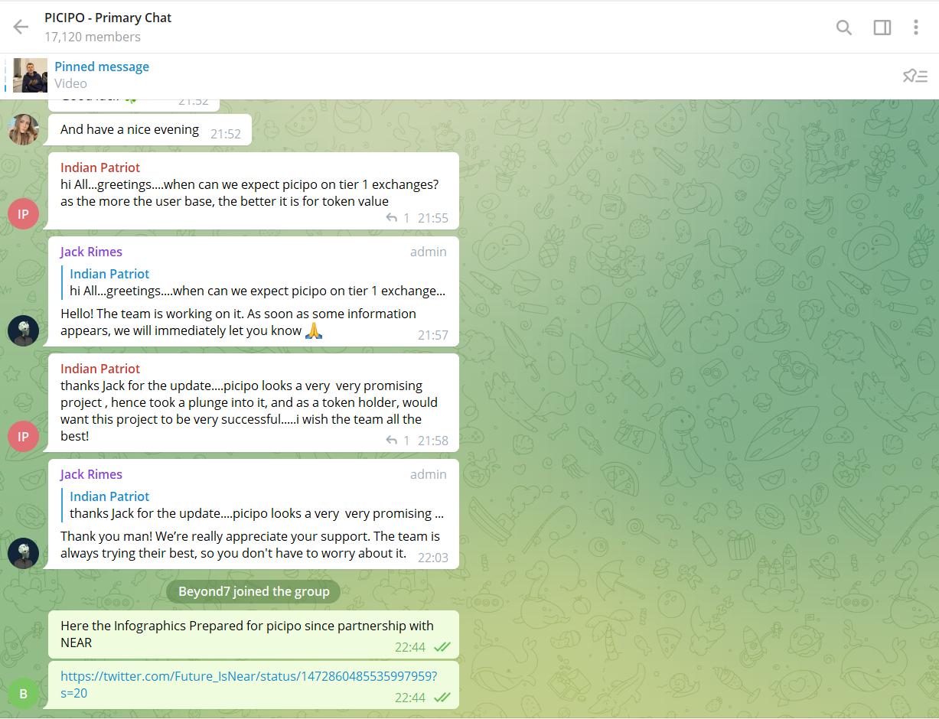

1. Paras

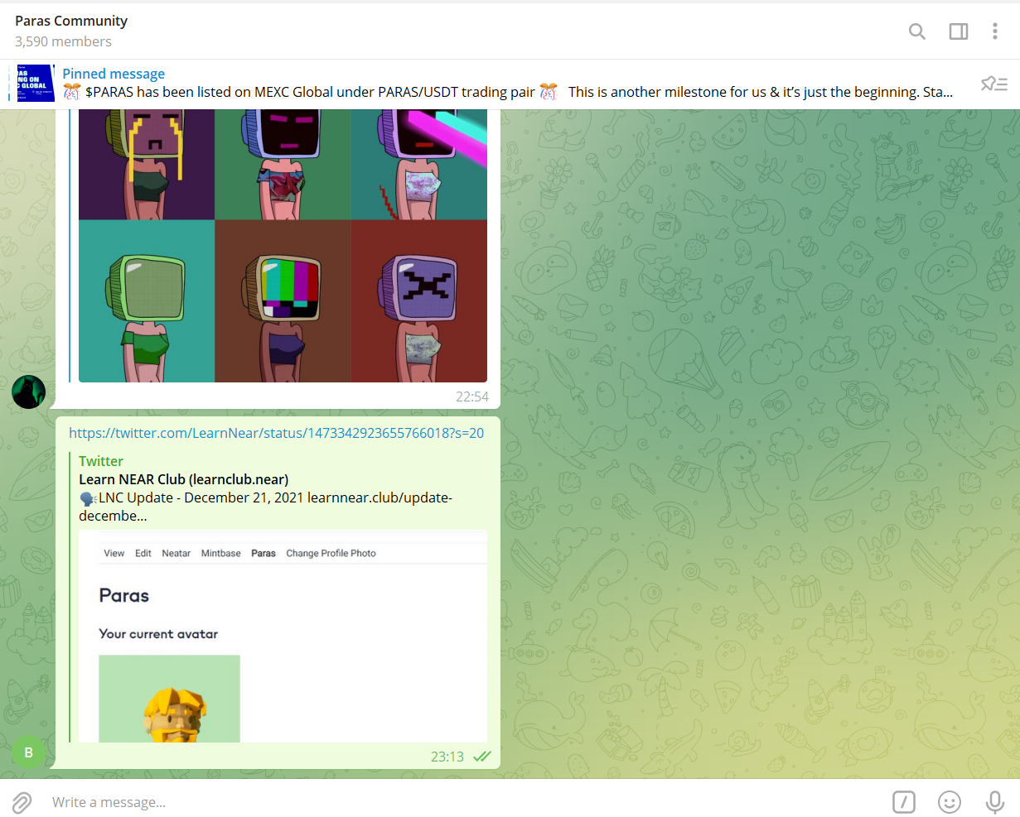

1. Aurora

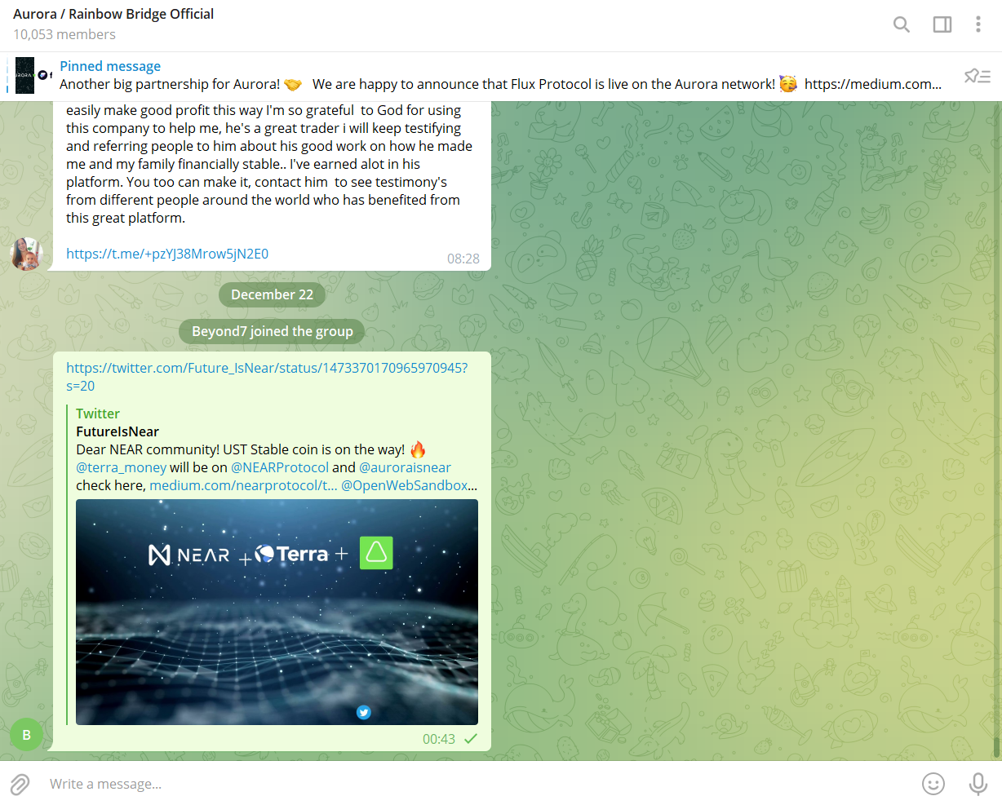

1. Terra

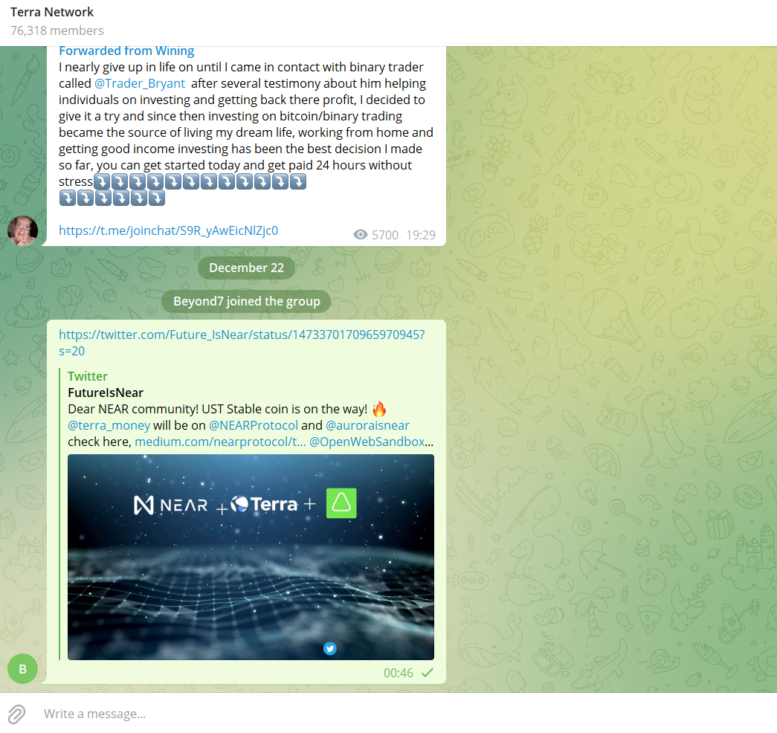

1. NEARPAD

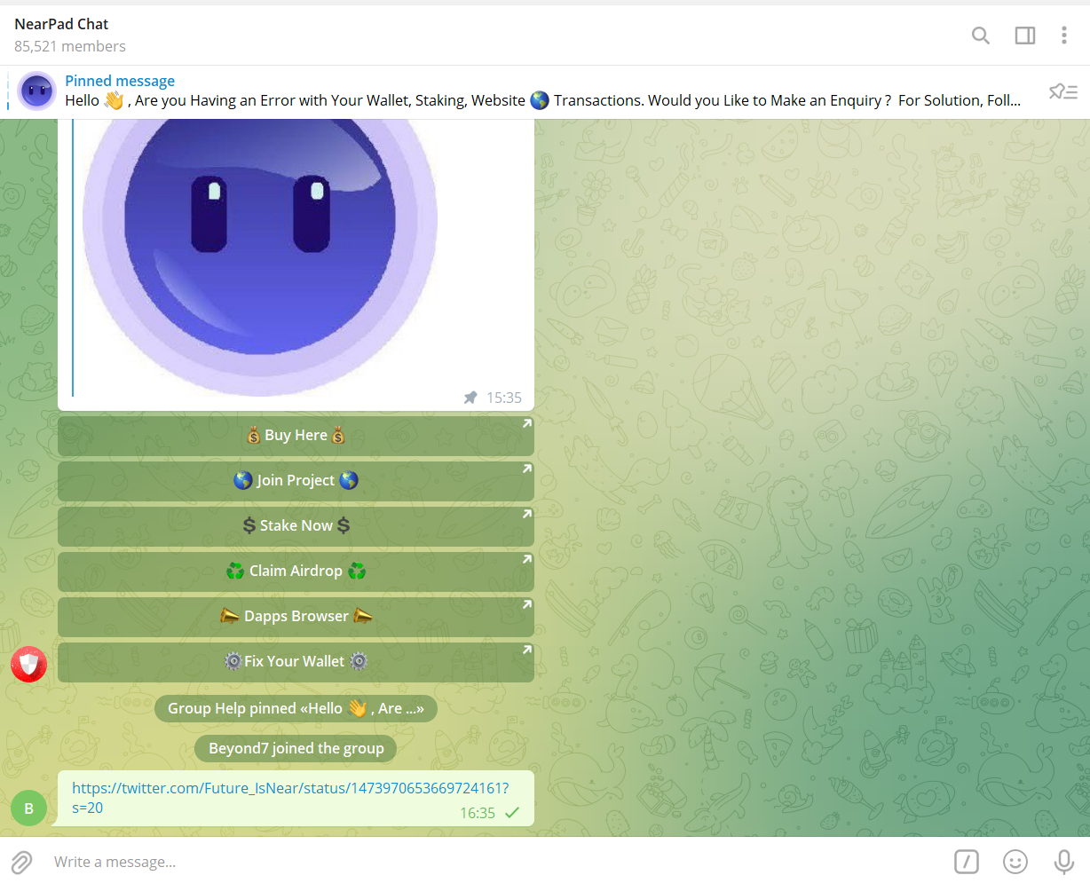

1. Binance Ads to Merchants of near

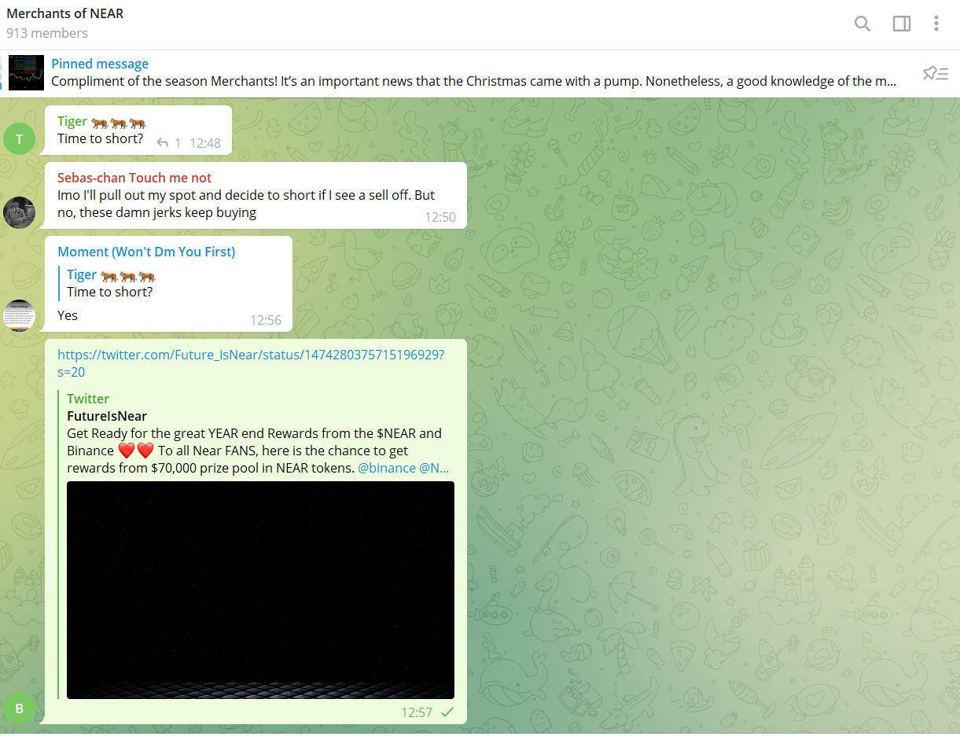

1. Near Q4 Updates to Merchants of NEAR

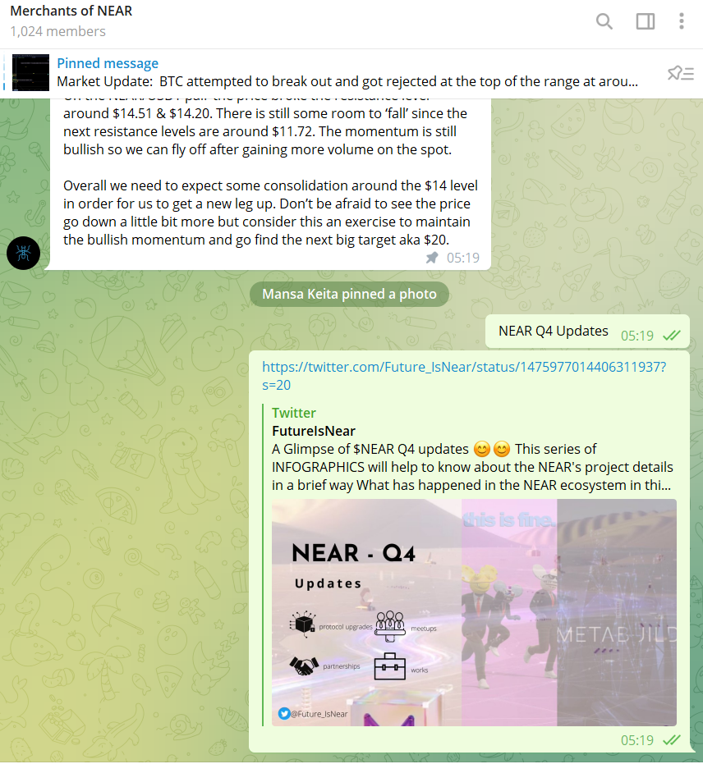

1. <https://t.me/auroraisneardev/5047>
2. <https://t.me/TrisolarisLabs/17835> TRISOLARIS NEWS