**The University of Azad Jammu and Kashmir, Muzaffarabad**



**Course:** CAand Logic Design

**Course Code:** CS-1205

**Roll No:** 2024-SE-18

**Lab Report:** 2

**Submitted To:** Engr. Sidra Rafique

**Submitted By:** Syed Muhammad Abdulrehman Naseem

**Date:** 2 june, 2025

***Department Of Software Engineering***

**DE Morgan’s law**

**Procedure:**

I opened Electronics Workbench and started a new project.

1. I added the 7400 IC (NAND gate), 7404 IC (NOT gate), and 7432 IC (OR gate) to the workspace.
2. I connected Vcc (pin 14) and GND (pin 7) on all three ICs.
3. For the left side of the circuit, I used a single NAND gate from the 7400:
   * I connected two switches to the inputs (pins 1 and 2).
   * The output was taken from pin 3, which showed the direct NAND result of A and B.
4. For the right side, I built the equivalent circuit using DE Morgan’s Law:
   * I took the same two inputs (A and B) and connected each to a NOT gate.
   * Their outputs were then connected to an OR gate.
   * This way I created: A' + B' which, according to DE Morgan’s Law, is equal to (A ⋅ B)’.
5. I connected LEDs to both outputs (NAND and OR-NOT combo) to compare them.
6. I tested all input combinations using the two switches:
   * (0,0), (0,1), (1,0), (1,1)

which is DE Morgan’s Theorem.

1. The LEDs lit up the same on both sides every time, so the proof worked perfectly.
2. This was a clean and clear way to verify DE Morgan’s Law using logic gates and ICs.

(A + B)' = (AB)’…………(i)

(AB)’ = A’ + B’…………...(ii)

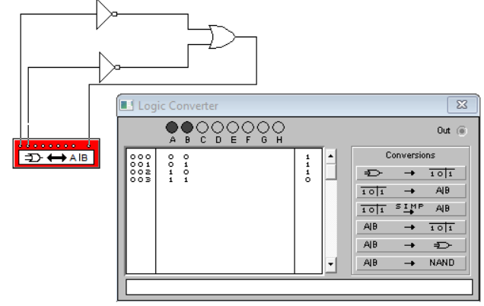

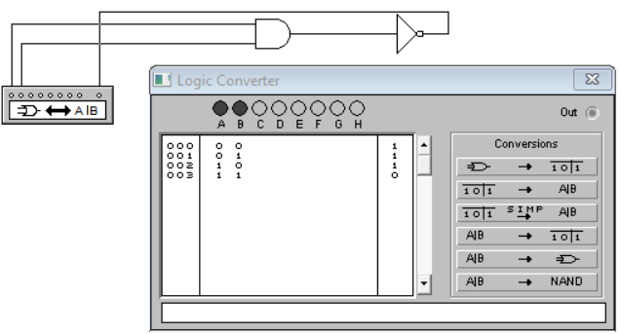 . .**is equivalent to**

(AB)’ = A’ + B’

(1 * 0)’ = 1’ + 0’

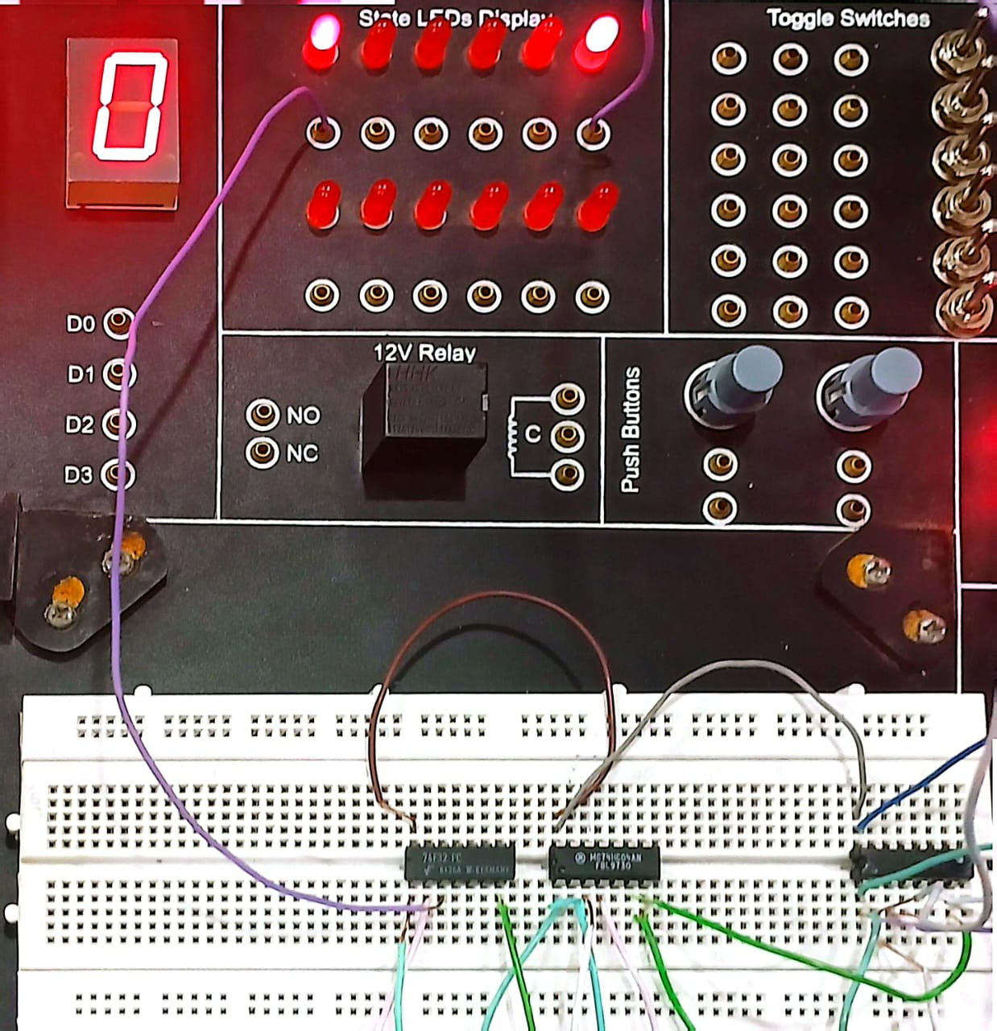

(A + B)' = (AB)’

(1 + 1)’ = 1’ * 0’

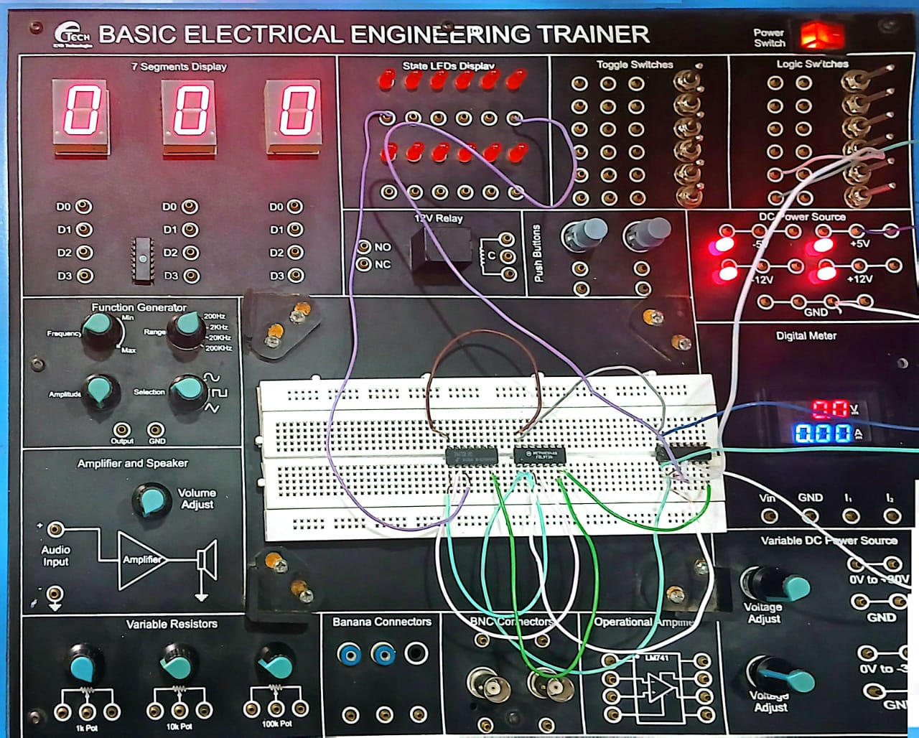

(AB)’ = A’ + B’

(0 * 1)’ = 0’ + 1’

