**The University of Azad Jammu and Kashmir, Muzaffarabad.**

**Object Oriented Programming**

**­**

|  |  |
| --- | --- |
| Student Name: | Syed Abdulrehman Naseem |
| Roll No: | 2024-SE-18 |
| Instructor: | Engr. Muhammad Awais |
| Title: | UML Class Diagrams |
| Submission Date: | 19-May-2025 |

**Department of Software Engineering**

**OBJECTIVE:**

The objective of creating this assignment is to gain the understanding of UML Class Diagrams, which are essential in software design. By learning to make these diagrams, we will master the ability to structure and represent system components effectively.

**UML DIAGRAMS:**

UML ( Unified Modeling Language) diagrams are a powerful way to visualize the structure and behavior of a system. They help developers and engineers to design, analyze and communicate complex software architectures effectively.

**TOOL USED AND CHALLENGES FACED:**

So far, for this assignment, I used DRAW.IO, well there were more tools available, but the reason behind choosing this tool is that, I have previously work on this tool, so to achieve the goal of time management and accuracy, I prefer this tool. Some challemges that I faced using DRAW.IO are:

1: Choosing Right Boxes and Arrows

2: Precisely Correct Class Diagram

3: Time Management



**DRAW.IO LOGO**

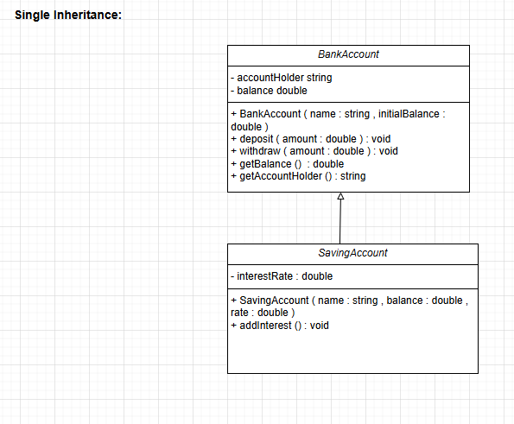

**FIGURE#1 : UML DIAGRAM OF SINGLE INHERITANCE**

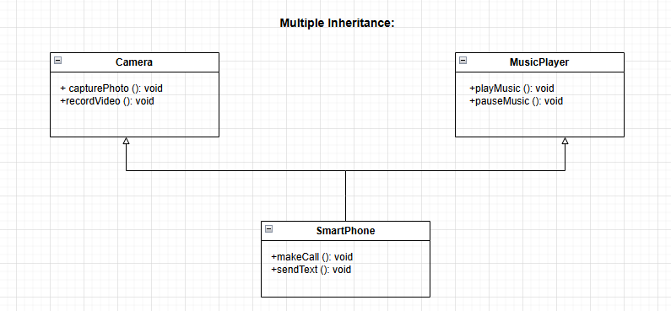

**FIGURE#2 : UML DIAGRAM OF MULTIPLE INHERITANCE**

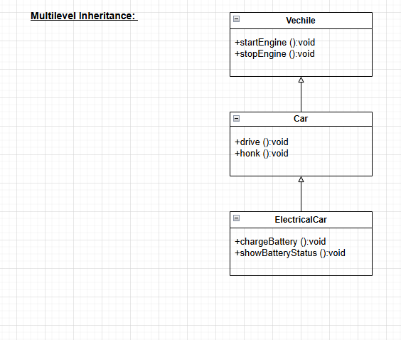

**FIGURE#3 : UML DIAGRAM OF MULTILEVEL INHERITANCE**

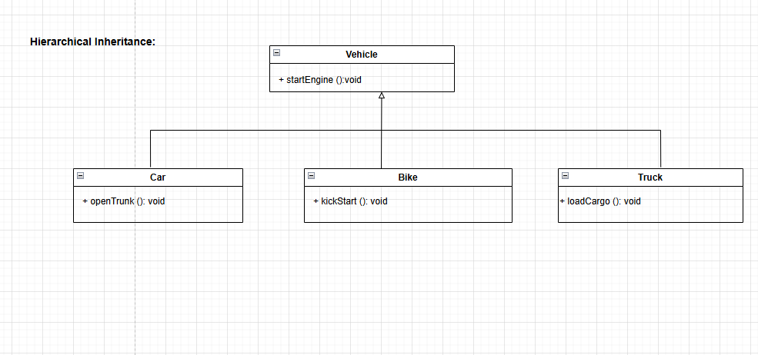

**FIGURE#4 : UML DIAGRAM OF HIERARCHICAL INHERITANCE**

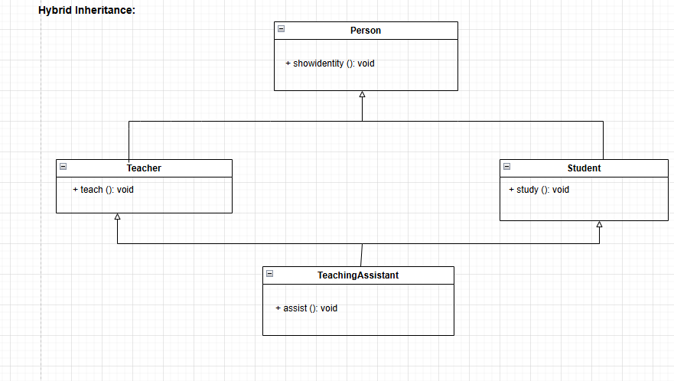**FIGURE#5 : UML DIAGRAM OF HYBRID INHERITANCE**

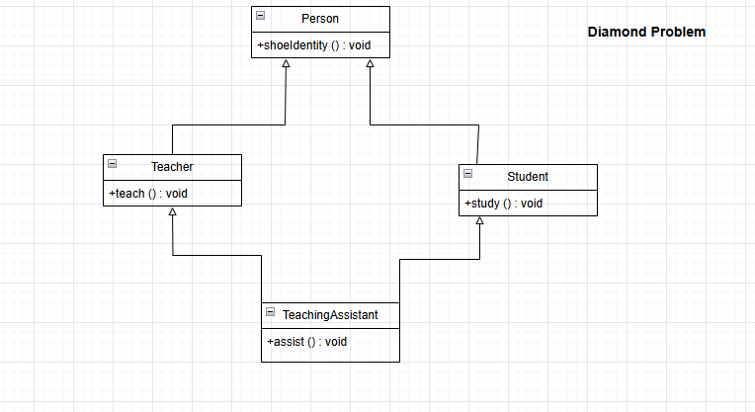

**FIGURE#6 : UML DIAGRAM OF DIAMOND PROBLEM**

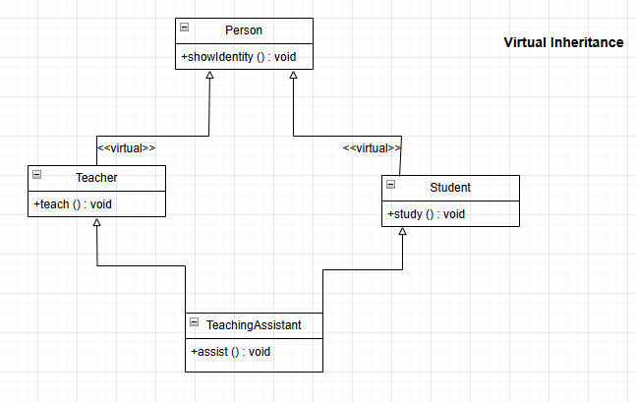

**FIGURE#7 : UML DIAGRAM OF VIRTUAL INHERITANCE**

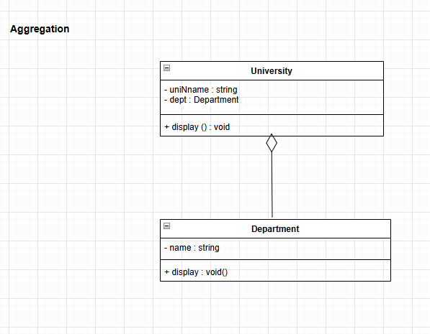

**FIGURE#8 : UML DIAGRAM OF AGGREGATION**

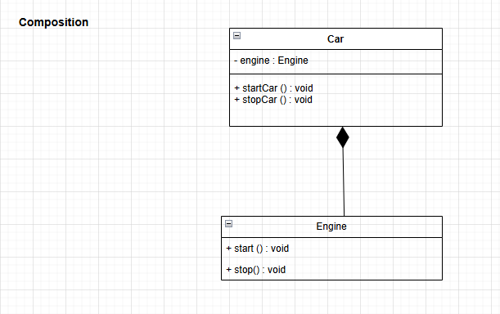

**FIGURE#9 : UML DIAGRAM OF COMPOSITION**

**LEARNING OUTCOME:**

So basically after working in DRAW.IO , I have learned how to make Class Diagrams which were a task, given by our course instructor. I hope this learning will prove beneficial for me in present and future. Working on DRAW.IO proved as a good decision because it help me to achieve the goals of time management and accuracy, that I set for this assignment.