WORKING WITH THE RAW DATA THAT HAS 256 FEATURES CONTAINING GREY SCALE VALUES FOR 256 PIXELS

============================================================================================

PLA ALGORITHM

=============

Training set has 7291 rows and 257 columns

A sample digit from the dataset:

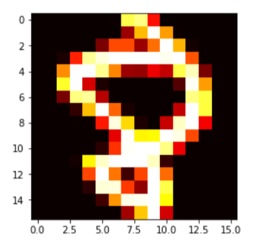

(10, 256)

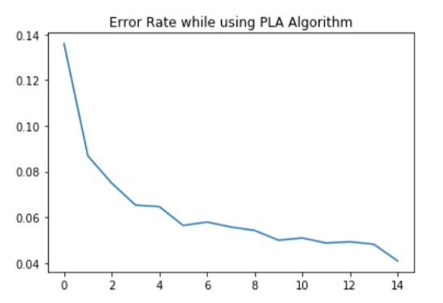

Test set has 2007 rows and 257 columns

Preparing the Predictions file with the guesses

Error Rate for the PLA Algorithm: 1.2148393222865288

Accuracy for the PLA Algorithm:

0.903836571998

POCKET PLA ALGORITHM

====================

Training set has 7291 rows and 257 columns

A sample digit from the dataset:

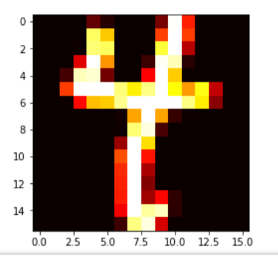

(10, 256)

Test set has 2007 rows and 257 columns

Preparing the Predictions file with the guesses

Error Rate for the Pocket PLA Algorithm: 1.2963864537893437

Accuracy for the Pocket PLA Algorithm:

0.890881913303

WORKING WITH THE PROCESSED DATA THAT HAS ONLY TWO FEATURES INTENSITY AND SYMMETRY

=================================================================================

Training set has 7291 rows and 3 columns

GRAPHS DRAWN USING THE PLA ALGORITHM

=====================================

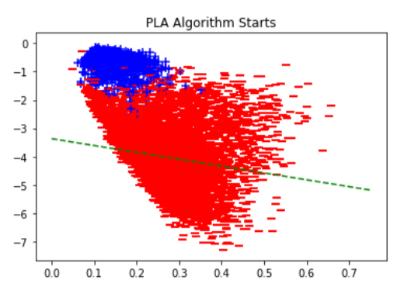

final weights [[ 8.66566003 -9.88130215 4.11032284]]

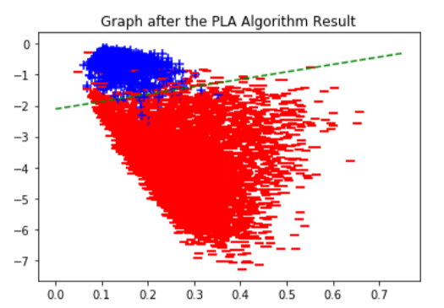

numer of iterations 5000

GRAPHS DRAWN USING THE POCKET PLA ALGORITHM

=============================================

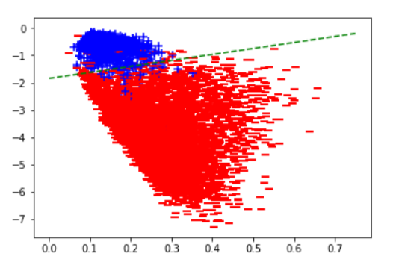

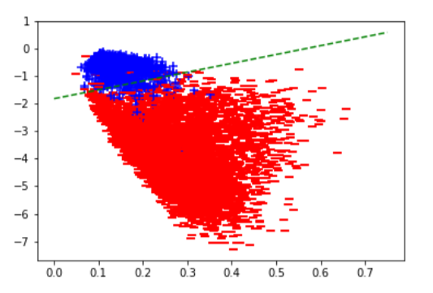

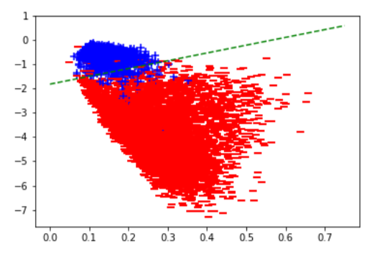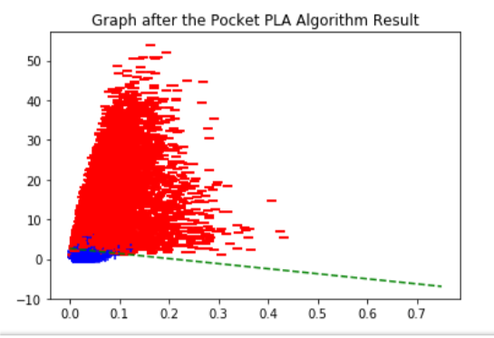

[ 0.54592846 -0.96745805 0.30085587]

[ 0.54592846 -0.96745805 0.30085587]

[ 0.54592846 -0.96745805 0.30085587]