UI Screenshot:

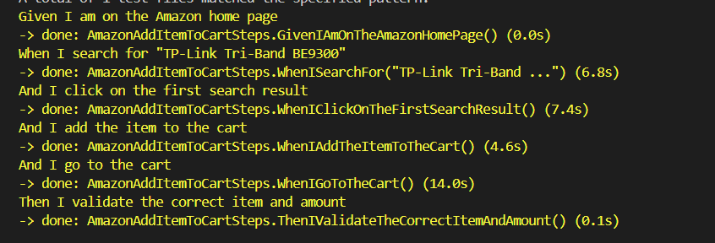  
  


Extent report Screenshot:  
  
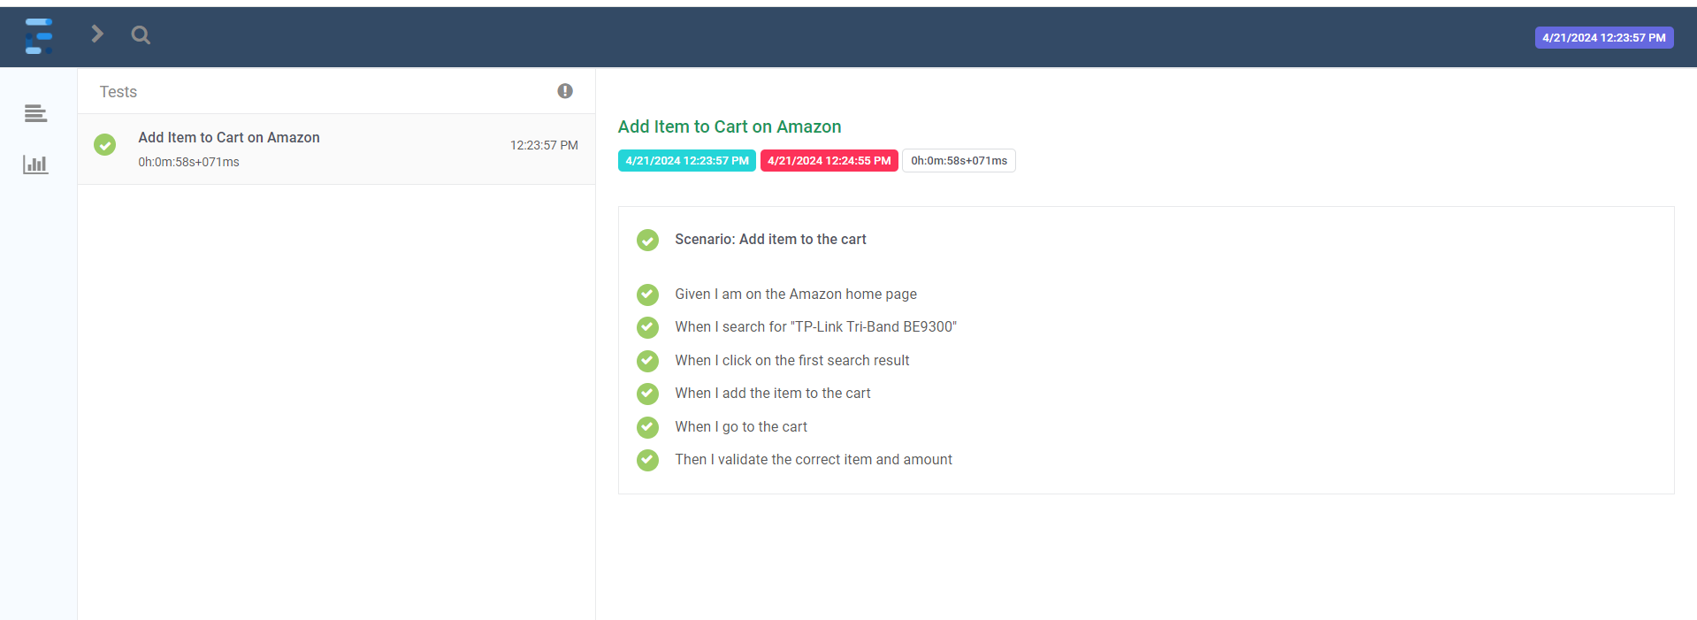

API Screenshot:  
  
  
  
  
  
  
