Name : Malik Zaryab Awan

Roll No : 24k-3055

Class : BSE-2A

Q1:-  
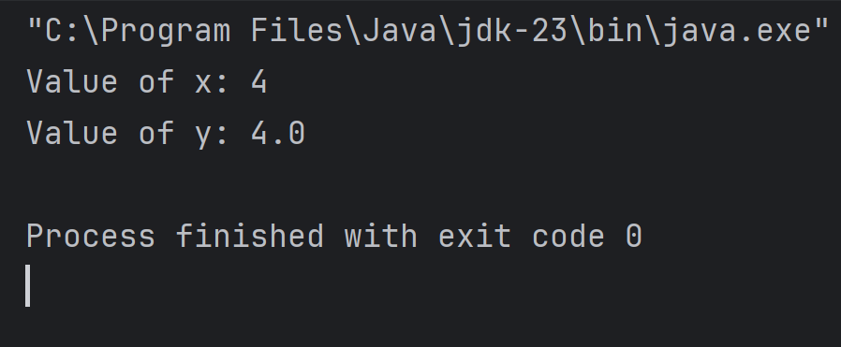

Q2:-

Q3:

Q4:

Q5:

Q6:

Q7:

Q8:  
