

Iqra University – Gulshan Campus
Department of Computer Science (CSC-232)- Data Structures and Algorithms
Laboratory Manual
Name of Student: Roll No: Sec. Date of Examination:
Marks Obtained/Remarks:

Signature:

LAB NO. | Lab Objectives
LAB 1 | Revision of Object Oriented Programming in Java  Objective: The purpose of this lab is to recall the concepts about classes, objects and constructors.
LAB 2 | Introduction to Data Structures  Objective: The purpose of this lab is to recall the concepts of Access Modifiers and arrays. This will help students better implement the concepts of Stack and Queue.
LAB 3 | Introduction to Stack and its Basic Operations using Arrays  Objective: In this lab students will learn how to create Stack and implement the basic  operations of Stack such as Push, pop, peek, isEmpty and isFull. All these operations will be implemented using Arrays.
LAB 4 | Introduction to Queue and its Basic Operations using Arrays  Objective: In this lab students will learn how to create Queue and implement the basic  operations of Queue such as Enqueue, Dequeue, peek, isEmpty and isFull. All these operations will be implemented using Arrays.
LAB 5 | Introduction to Circular Queue  Objective: This lab introduces students to Circular Queue data structure by focusing on its implementation using arrays..
LAB 6 | Search Algorithms - Linear search, binary search and Agnostic Search  Objective: This lab aims to introduce students to fundamental search algorithms - linear search, binary search and agnostic search, enhancing their understanding of algorithmic problem-solving and their ability to analyze and apply search techniques efficiently.
LAB 7 | Exploring Singly Linked Lists: Introduction and Fundamental Operation.  Objective: This lab serves as an introduction to Singly Linked Lists. Students will learn the concept of linked lists and their implementation using nodes.
LAB 8 | Continuation of Singly Linked List  Objective: Students will learn the concept of traversal, searching and reversal operation on singly linked list.
LAB 9 | Exploring Doubly Linked Lists: Introduction and Fundamental Operation. Objective: This lab aims to introduce students to Doubly Linked Lists, focusing on the concept of linked lists, node-based implementation, and fundamental operations such as  insertion and deletion at both ends.
LAB 10 | Stack and Queue implementation using Linked List  Objective: This lab aims to introduce students to the implementation of Stacks and Queues  using Linked Lists.
LAB 11 | Implementation of Sorting Algorithms- Insertion sort, Bubble sort and Selection sort Objective: This lab aims to familiarize students with fundamental sorting algorithms, including Insertion Sort, Bubble Sort, and Selection Sort.
LAB 12 | Implementation of Advanced Sorting Algorithms- Merge sort and Quick sort Objective: This lab aims to familiarize students with fundamental sorting algorithms, including Merge Sort and Quick Sort.
LAB 13 | Implementation of recursion  Objective: The objective of the lab is to develop understanding of the recursion and its basic implementation.
LAB 14 | Implementation of binary tree and applying traversal techniques  Objective: The objective of this lab is to implement a binary tree and apply traversal techniques (in-order, pre-order and post-order).
LAB 15 | Implementation of search, insert, and delete operations on a binary search tree (BST) Objective: The purpose of this lab is to apply search, insert, and delete operations on a binary search tree (BST).

Title: Data Structures and Algorithms Course Code: CSC-232

Lab 1 (Revision of Object Oriented Programming in Java)

How to Submit
Instructor: Asma Qaiser
E-mail: asma.qaiser@iqra.edu.pk Semester: Spring, 2024

- Make front page and index of your lab file.
- Print the tasks, front page and index.
- For assessment do bring your lab file in the next class.

Objectives
The purpose of this lab is to recall the concepts about classes, objects and constructors

Class
A class is the building block of OOP. It is the prototype that defines methods and variables that are common to all specified types of objects. It is the way to bind the data and its logically related functions together. It's a non-primitive data type that can be treated like any other built-in data type.
A class is a group of objects which have common properties. A Class is like an object constructor, or a "blueprint" for creating objects. It is a template or blueprint from which objects are created. It is a logical entity. It can't be physical. A class can be considered as a blueprint using which you can create as many objects as you like. Data members are also known as fields, instance variables and object states.

When you define a class, you declare its exact form and nature. You do this by specifying the instance variables that it contains and the methods that operate on them. Although very simple classes might contain only methods or only instance variables, most real-world classes contain both. A class is created by using the keyword class. In general, class declarations can include these components, in order:

- Modifiers: A class can be public or has default access. (Discuss in future Lab)
- class keyword: class keyword is used to create a class.
- Class name: The name should begin with an initial letter (capitalized by convention).
- Superclass (if any): The name of the class’s parent (superclass), if any, preceded by the keyword extends. A class can only extend (subclass) one parent. (Discuss in future Lab)
- Interfaces (if any): A comma-separated list of interfaces implemented by the class, if any, proceeded by the keyword implements. A class can implement more than one interface. (Discuss in future Lab)
- Body: The class body surrounded by braces, { }.

The general form of a class definition is shown below.

Syntax
//Syntax of a class public class classname
{
// declare instance variables

type var1; type var2;
//…
type varN;

// declare methods

type method1(parameters)
{ // body of method }
Example 1.1
//FileName:cellPhone.java
//Defining class public class CellPhone
{
//Declaring instance variables
string name;
string processor; string memory; string os;

//Declaring and Defining member function void display()
{
system.out.println("\====Displaying Phone Information====\n"); system.out.println("Device Name = " + name); system.out.println("Processor = " + processor); system.out.println("Memory = “ + memory);

Object:
A class provides the blueprints for objects. So basically, an object is created from a class. In Java, the new keyword is used to create new objects. It is used to allocate memory at runtime. The new operator also invokes the class constructor. All objects get memory in the Heap memory area.
There are three steps when creating an object from a class −
- Declaration − A variable declaration with a variable name with an object type.
- Instantiation − The 'new' keyword is used to create the object.
- Initialization − The 'new' keyword is followed by a call to a constructor. This call initializes the new object.

We have already created the class named CellPhone, so now we can use this to create objects.

To create an object of CellPhone, specify the class name, followed by the object name, and use the keyword new:

Syntax
public static void main(String[] args) { ClassName ObjectName = new Constructor();

Creating an object of CellPhone class

Syntax
public static void main(String[] args) { CellPhone myObj = new CellPhone();
}

Calling member function through an object

Syntax
//syntax of calling member function of a class through an object objectName.member_function;

Calling display function of CellPhone class

Syntax
myObj.display();

New Operator:
An operator instantiates a class by allocating memory for a new object and returning a reference to that memory. The new operator also invokes the object constructor.

Constructor:
When discussing classes, one of the most important sub topics would be constructors. Every class has a constructor. If we do not explicitly write a constructor for a class, the Java compiler builds a default constructor for that class.

A constructor in Java is a special method that is used to initialize objects. The constructor is called when an object of a class is created. It can be used to set initial values for object attributes
Each time a new object is created, at least one constructor will be invoked. The main rule of constructors is that they should have the same name as the class. A class can have more than one constructor.

Types of Java constructors
There are three types of constructors in Java:

- Default constructor
- Non-Parameterized (no-arg constructor)
- Parameterized constructor

Default constructor
If you do not implement any constructor in your class, Java compiler inserts a default constructor into your code on your behalf. This constructor is known as default constructor. You would not find it in your source code (the java file) as it would be inserted into the code during compilation and exists in .class file.

Example 1.2
Let’s see the example of the default constructor that displays the default values. Here, we are creating a main() method inside the class.
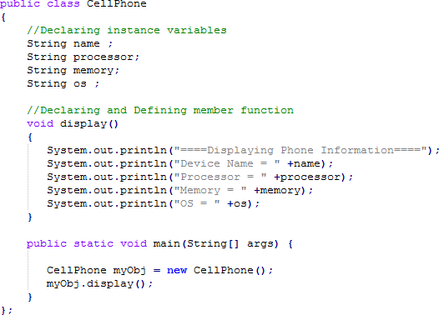

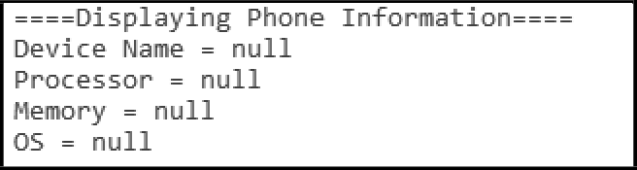
Output:

In the above class, you are not creating any constructor so the compiler provides you a default constructor. Here null values are provided by default constructor.

Non-Parameterized constructor
Constructors that do not take any arguments are non-Parameterized constructors.

Syntax
public class ClassName
{
//Syntax of creating a non-parameterized constructor className()
{
In this example, we are creating the no-arg constructor in the CellPhone class. It will be invoked at the time of object creation.

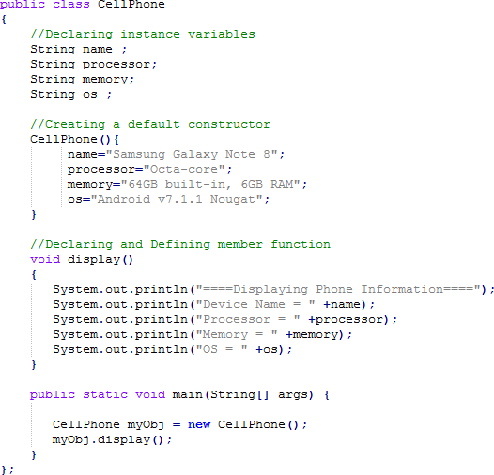
Example 1.3

Output:
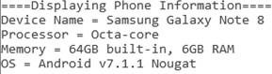

Parameterized constructor
Constructors that take arguments are Parameterized constructors.

Syntax

class className
{
//Syntax of creating a non-parameterized constructor
className( datatype )
{
}
}

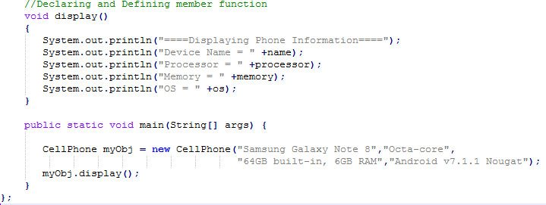
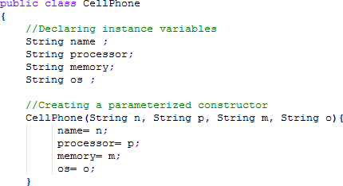
Example 1.4

Output:
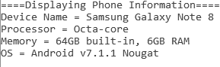

Lab Task:
- Create a class named 'Product' with String variable 'name', float variable 'price' and integer variable 'quantity'. Initialize all variables by creating an object of the class Product.

- Print the quantity and price of two products having names "Marker" and "Pen" respectively by creating two objects of class 'Product'.

Title: Data Structures and Algorithms Course Code: CSC-232

Lab 2 (Introduction to Data Structures)

How to Submit
Instructor: Asma Qaiser
E-mail: asma.qaiser@iqra.edu.pk Semester: Spring, 2024

- Make front page and index of your lab file.
- Print the tasks, front page and index.
- For assessment do bring your lab file in the next class.

Objectives:
The purpose of this lab is to recall the concepts of Access Modifiers and arrays. This will help students better implement the concepts of Stack and Queue.

Access Modifiers
Access modifiers help to set the accessibility (visibility) of a class or to restrict the scope of a class, constructor, variable, method, or a data member. There are four types of access modifiers available in java:
  - Default – No keyword required
  - Private
  - Protected
  - Public
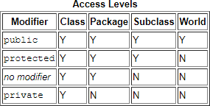

  - Private: The access level of a private modifier is only within the class. It cannot be accessed from outside the class. Any other class of the same package will not be able to access these members.
  - Default: The access level of a default modifier is only within the package. It cannot be accessed from outside the package. If you do not specify any access level, it will be the default.
  - Protected: The access level of a protected modifier is within the package and outside the package through child class. If you do not make the child class, it cannot be accessed from

outside the package.
  - Public: The access level of a public modifier is everywhere. It can be accessed from within the class, outside the class, within the package and outside the package.

Example 1 (Using Public)
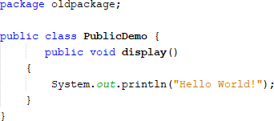
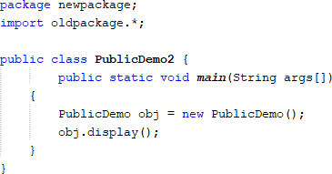

Output

Example 2 (Using Default)
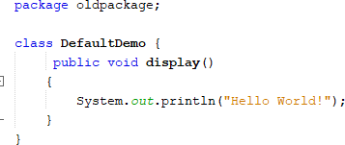
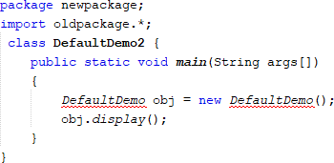

Output:

Example 3 (Using Private):
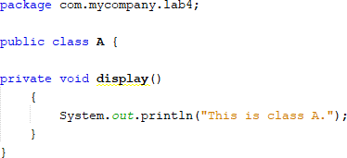
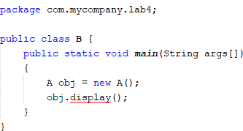

Output:
Compile time error

Data structures
The primary objective of programming is to efficiently process the input to generate the desired output. We can achieve this objective in an efficient and neat style if the input data is organized in a way to help us meet our goal. Data structures are nothing but ways and means of organizing data so that it can be processed easily and efficiently. Data structures dictate the manner in which the data can be processed. In other words the choice of an algorithm depends upon the underlying data organization.

Java Arrays:
Java array is an object which contains elements of a similar data type. Additionally, the elements of an array are stored in a contiguous memory location. It is a data structure where we store similar elements. We can store only a fixed set of elements in a Java array.
Array in Java is index-based, the first element of the array is stored at the 0th index, and 2nd element is stored on 1st index and so on.
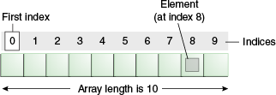

Creating an array requires two steps:
- Declaring the reference to the array
- Instantiating an array

To declare a reference to the array, use this
syntax: datatype [] arrayName; To instantiate an array, use this syntax:
arrayName = new datatype[ size ];
where size is an expression that evaluates to an integer and specifies the number of elements.

Example:
Declaring arrays:
double [] dailyTemps; // double arrays String [] cdTracks; // String arrays boolean [] answers; // Boolean arrays

int [] cs101, bio201; // two integer arrays

Instantiating these arrays:
dailyTemps = new double[365]; // 365 elements cdTracks = new String[15]; // 15 elements
int numberOfQuestions = 30;
answers = new boolean[numberOfQuestions];

Combining the Declaration and Instantiation of Arrays:
Syntax:
datatype [] arrayName = new datatype[size];

Examples:
String [] cdTracks = new String[15]; int numberOfQuestions = 30;
boolean [] answers = new boolean[numberOfQuestions];
double [] dailyTemps = new double[365];
When an array is instantiated, the elements are assigned default values according to the array data type:
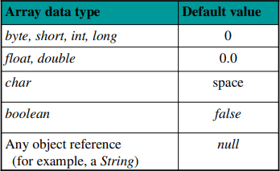

Types of Array in java:
There are two types of array.
- Single Dimensional Array
- Multidimensional Array

Single Dimensional Array in Java Syntax to Declare an Array in java

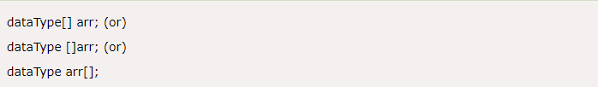

Declaration, Instantiation and Initialization of Java Array
We can declare, instantiate and initialize the java array together by:

Example 4:
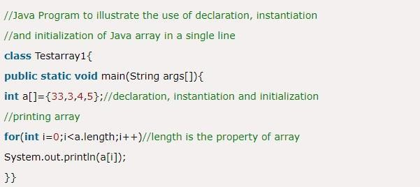

Output

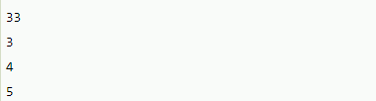

For-each Loop for Java Array
We can also print the Java array using for-each loop. The Java for-each loop prints the array elements one by one. It holds an array element in a variable, then executes the body of the loop.

Syntax:
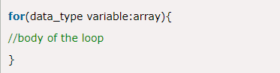

Example 5:
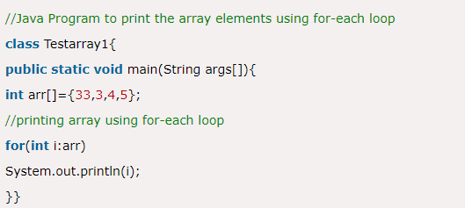

Output
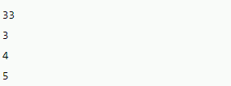

Multidimensional Array in Java
In such case, data is stored in row and column based index (also known as matrix form).

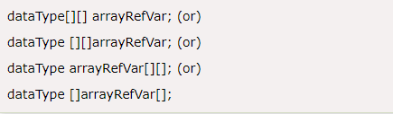
Syntax:

Example to instantiate Multidimensional Array in Java


Example 6:

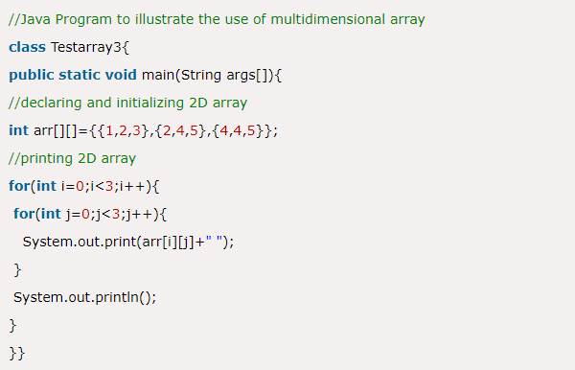
Output

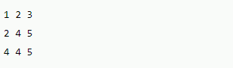

Basic Array Operations
Following are the basic operations supported by an array.
- Traverse − print all the array elements one by one.
- Insertion − Adds an element at the given index.
- Deletion − Deletes an element at the given index.
- Search − Searches an element using the given index or by the value.
- Update − Updates an element at the given index.

Insertion of an array

- Insertion at an index


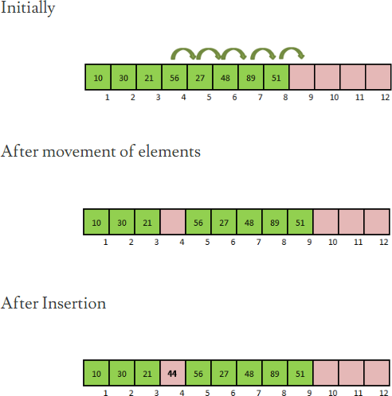

Example7:

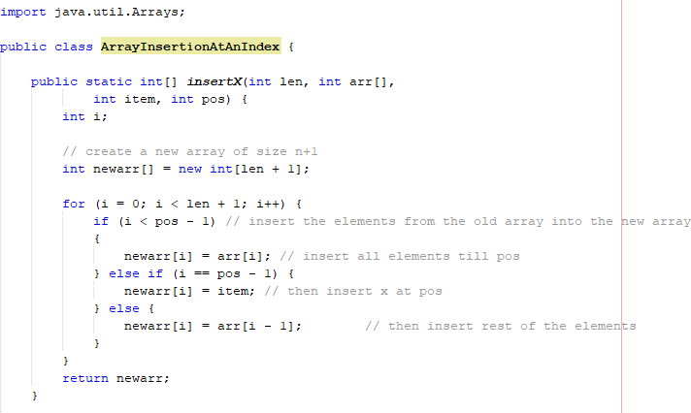


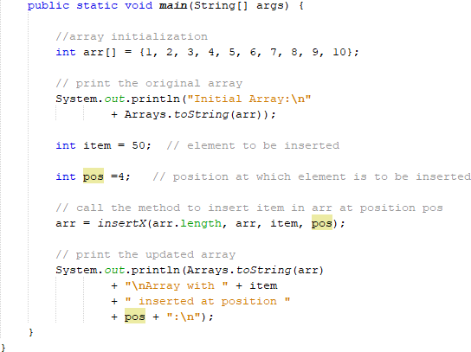

Output

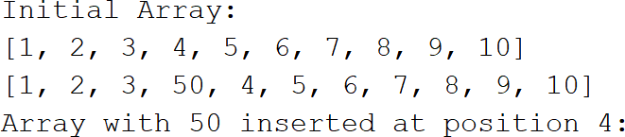

Deletion of an array
- Deletion at an index


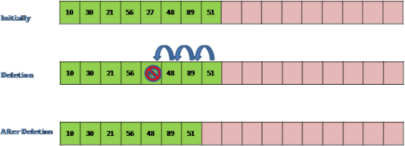

Example 8:

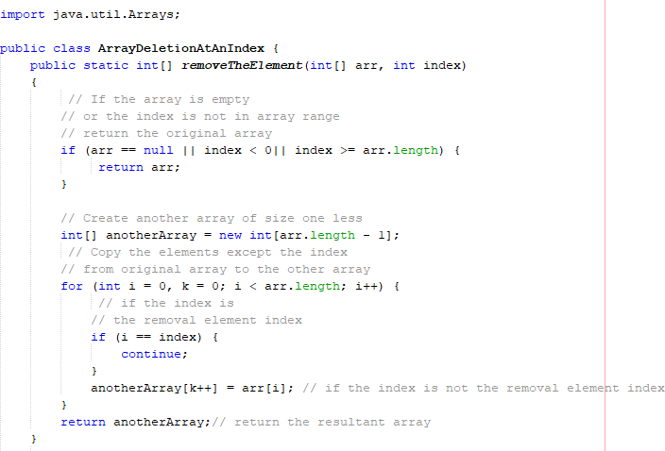


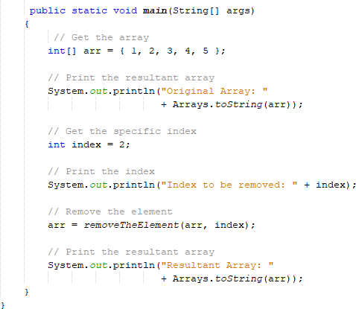

Lab Task:
- Write a Java program that creates an array of integers and removes all duplicates from the array.
- Write a Java program that creates an array of integers and finds the sum of all the even numbers in the array.

Title: Data Structures and Algorithms Course Code: CSC-232

Lab 3 (Introduction to Stack and its Basic Operations using Arrays)


Instructor: Asma Qaiser
E-mail: asma.qaiser@iqra.edu.pk Semester: Spring, 2024
Objectives:
In this lab students will learn how to create Stack and implement the basic operations of Stack such as Push, pop, peek, isEmpty and isFull. All these operations will be implemented using Arrays.

Stack
A stack is a list of elements in which an element may be inserted or deleted only at one end, called the top of the stack. This means, in particular, that elements are removed from a stack in the reverse order of that in which they were inserted into the stack.
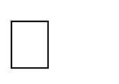

Special terminology is used for two basic operations associated with stacks: "Push" is the term used to insert an element into a stack.
"Pop" is the term used to delete an element from a stack.
The operation of adding (Pushing) an item onto a stack and the operation of removing (Popping) an item from a stack may be implemented, respectively, by the following procedures, called PUSH and POP.
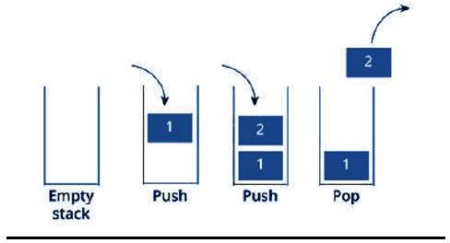
In executing the procedure PUSH, one must first test whether there is room in the stack for the new item; if not, then we have the condition known as overflow. Analogously, in executing the procedure POP, one must first test whether there is an element in the stack to be deleted; if not, then we have the condition known as underflow.


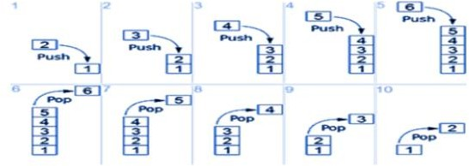
Following are the basic operations
Push( x ): Insert element x at the top of a stack

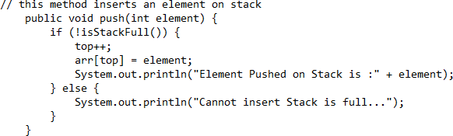

Pop( ): Removes an element from the top of a stack

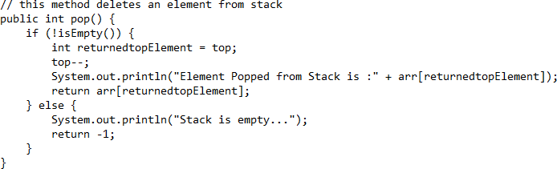
Top ( ) or Peek ( ): Access the top element of a stack


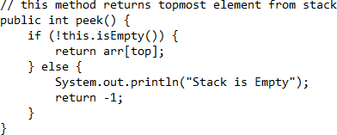

isEmpty ( ): Check whether a stack is empty

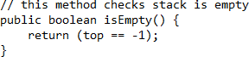

isFull ( ): Check whether a stack is full

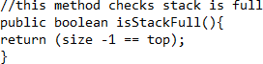

Lab Task:
- Combine all the above functions into a single program.
- Reverse a string using stack.

Title: Data Structures and Algorithms Course Code: CSC-232

Lab 4 (Introduction to Queue and its Basic Operations using Arrays)


Instructor: Asma Qaiser
E-mail: asma.qaiser@iqra.edu.pk Semester: Spring, 2024

Objectives:
In this lab students will learn how to create Queue and implement the basic operations of Queue such as Enqueue, Dequeue, peek, isEmpty and isFull. All these operations will be implemented using Arrays.
Queue
Queues are data structures that, like the stack, have restrictions on where you can add and remove elements. To understand a queue, think of a cafeteria line: the person at the front is served first, and people are added to the line at the back. Thus, the first person in line is served first, and the last person is served last. This can be abbreviated to First in, First Out (FIFO).
The cafeteria line is one type of queue. Queues are often used in programming networks, operating systems, and other situations in which many different processes must share resources such as CPU time.
In queues insertions are permitted at one end – called the rear, and deletions are permitted from the other end – called the front. This means that the removal of elements from a queue is possible in the same order in which the insertion of elements is made into the queue.



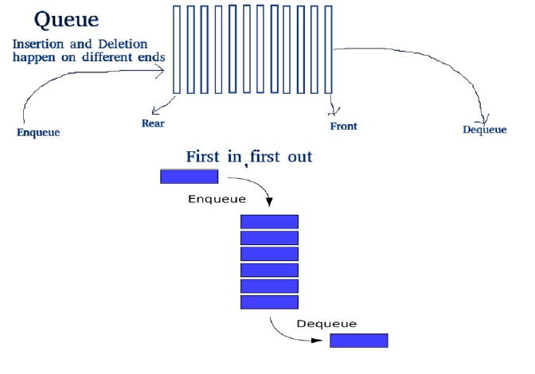

Operations on Queue:
Mainly the following basic operations are performed on queue:

Enqueue:
Add an item to the queue. If the queue is not full, this function adds an element to the back of the queue, else it prints “OverFlow”.
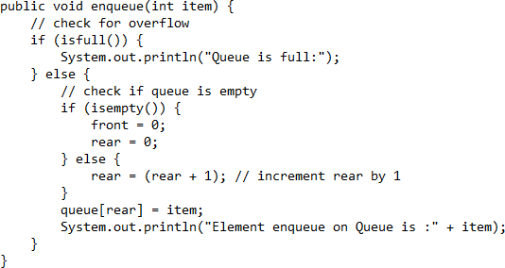

Dequeue: Removes an item from the queue. The items are popped in the same order in which they are pushed. If the queue is empty, then it is said to be an Underflow condition.



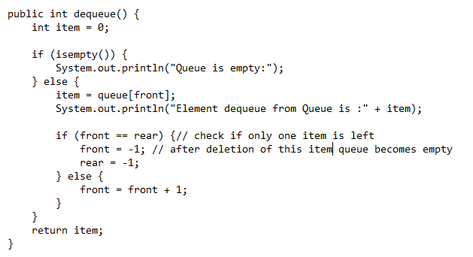
isFull ( ): Check whether a stack is full
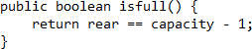
isEmpty ( ): Check whether a queue is empty.
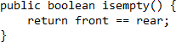
Peek ( ): Access the first element of a queue.
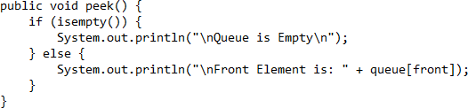

Lab Task:
Implement the linear queue along with the all operations.

Title: Data Structures and Algorithms Course Code: CSC-232

Lab 5 (Introduction to Circular Queue)


Instructor: Asma Qaiser
E-mail: asma.qaiser@iqra.edu.pk Semester: Spring, 2024

Objective:
This lab introduces students to Circular Queue data structure by focusing on its implementation using Arrays.
Queue variations
The standard queue data structure has the following variations:
- Double-ended queue
- Circular queue
- Priority queue
We are going to discuss Circular Queue implementation in detail.
Circular Queue
Circular queue is a linear data structure in which the operations are performed based on FIFO (First In First Out) principle and the last position is connected back to the first position to make a circle. It is also called ‘Ring Buffer’.

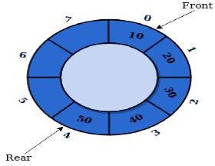
In a normal Queue, we can insert elements until queue becomes full. But once queue becomes full, we cannot insert the next element even if there is a space in front of queue.


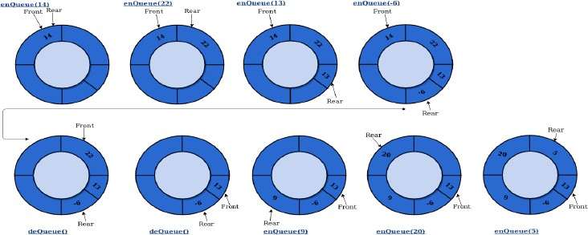
Lab Task:
Implement the circular queue along with the all operations.

Title: Data Structures and Algorithms Course Code: CSC-232

Lab 6 (Search Algorithms - Linear search, binary search and Agnostic Search)


Instructor: Asma Qaiser
E-mail: asma.qaiser@iqra.edu.pk Semester: Spring, 2024

Objectives:
This lab aims to introduce students to fundamental search algorithms - linear search, binary search and agnostic search, enhancing their understanding of algorithmic problem-solving and their ability to analyze and apply search techniques efficiently.
Search Algorithms
Linear Search
One of the simplest searching algorithms is linear search. To search an element in the array we compare the given element with each element starting with leftmost element in array, if element found at any index, return the index position otherwise return -1 to indicate that element was not found in Array.
Following code demonstrated the implementation of Linear Search Algorithm in java:

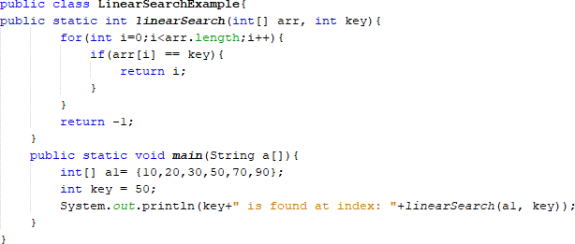

Binary Search


Binary search algorithms searches the element in a sorted array by comparing the given element with the middle element of the search space, if element is smaller than the middle element, the search space is limited to the left half of the middle element. In other case the search space is limited to right half of the middle element. This operation is carried out repeatedly until element is found or search space becomes empty.
Following code demonstrated the implementation of Binary Search Algorithm in java:

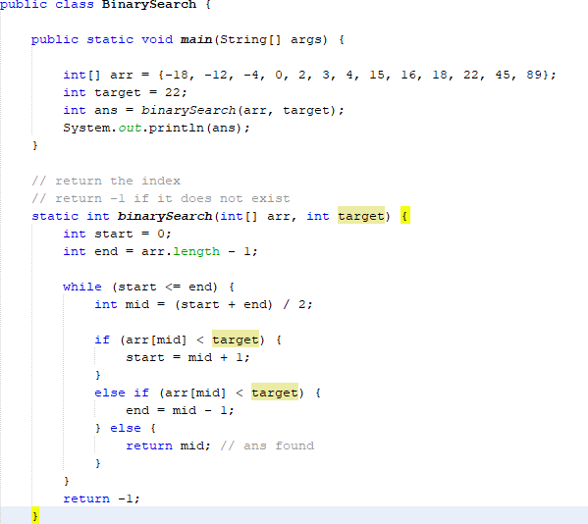

Lab Task:
Write down the code for order agnostic search.

Title: Data Structures and Algorithms Course Code: CSC-232

Lab 7 (Exploring Singly Linked Lists: Introduction and Fundamental Operation)


Instructor: Asma Qaiser
E-mail: asma.qaiser@iqra.edu.pk Semester: Spring, 2024

Objective:
This lab serves as an introduction to Singly Linked Lists. Students will learn the concept of linked lists and their implementation using nodes

Linked List:
A linked list is a linear data structure where each element is a separate object. Linked list elements are not stored at contiguous location; the elements are linked using pointers. Each node of a list is made up of two items - the data and a reference to the next node. The last node has a reference to null. The entry point into a linked list is called the head of the list. It should be noted that head is not a separate node, but the reference to the first node. If the list is empty, then the head is a null reference.

Pros:
- Linked list is dynamic in nature which allocates the memory when required.
- Insertion and deletion operations can be easily implemented.
- Stacks and queues can be easily executed.
- Linked List reduces the access time.

Cons:
- The memory is wasted as pointers require extra memory for storage.
- No element can be accessed randomly; it has to access each node sequentially.
- Reverse Traversing is difficult in linked list.
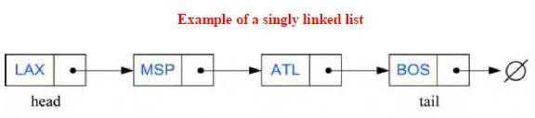

For creating a node, you can use the following class to hold the node data structure:


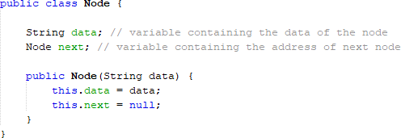

In a single linked list we perform the following operations...
- Insertion
- Deletion
Insertion:
In a single linked list, the insertion operation can be performed in two ways. They are as follows...
- Insertion at end of the list
- Insertion at start of the list
Insertion at end of the list:

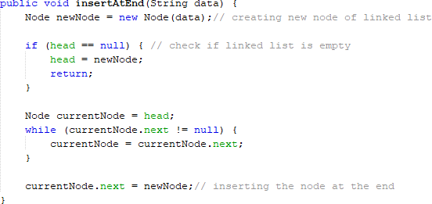

Insertion at start of the list:


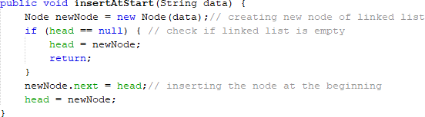
Class Task:
- Combine all the methods into single class.
- Write a function which returns

Title: Data Structures and Algorithms Course Code: CSC-232

Lab 8 (Continuation of Singly Linked List)


Instructor: Asma Qaiser
E-mail: asma.qaiser@iqra.edu.pk Semester: Spring, 2024

Objective:
Students will learn the concept of traversal, searching and reversal operation on singly linked list.
Deletion:
In a single linked list, the deletion operation can be performed in two ways. They are as follows…
- Deletion from the start of the list
- Deletion at the end of the list
Deletion from the start of the list:

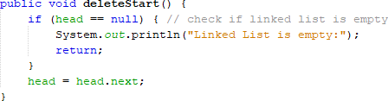

Deletion at the end of the list:


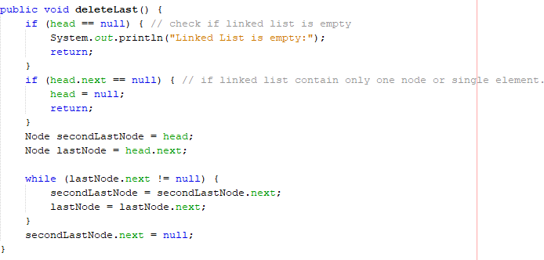
Class Task:
- Combine all the methods into single class.
- Write a function which returns the reversed form of the linked list.



Title: Data Structures and Algorithms Course Code: CSC-232

Lab 9 (Exploring Doubly Linked Lists: Introduction and Fundamental Operation.)

Instructor: Asma Qaiser
E-mail: asma.qaiser@iqra.edu.pk Semester: Spring, 2024

Objective:
This lab aims to introduce students to Doubly Linked Lists, focusing on the concept of linked lists, node-based implementation, and fundamental operations such as insertion and deletion at both ends.

Doubly Linked List:
Doubly linked list allows us to go in both directions (Forward and reverse) in a linked list and allow for a great variety of quick update operations, including insertion and removal at both ends, and in the middle. A node in a doubly linked list stores two references—a next link which points to the next node in the list, and a prev link, which points to the previous node in the list.
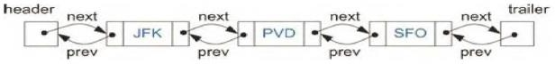

For creating a node, you can use the following class to hold the node data structure:

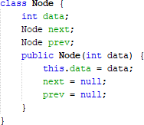

In a doubly linked list we perform the following operations...



- Insertion
- Deletion

Insertion:
In a doubly linked list, the insertion operation can be performed in two ways. They are as follows...
- Insertion at end of the list
- Insertion at start of the list

Insertion at end of the list:
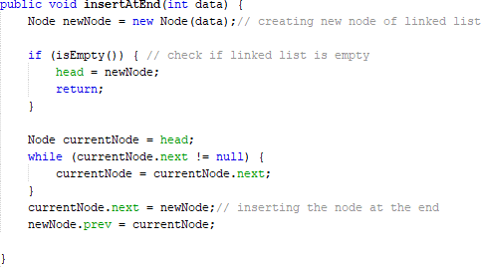

Insertion at start of the list:
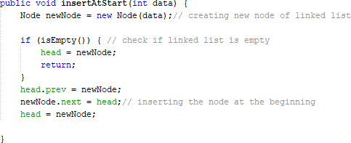



Deletion:
In a doubly linked list, the deletion operation can be performed in two ways. They are as follows…
- Deletion from the start of the list
- Deletion at the end of the list

Deletion from the start of the list:
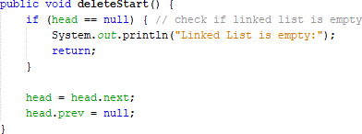

Deletion at the end of the list:
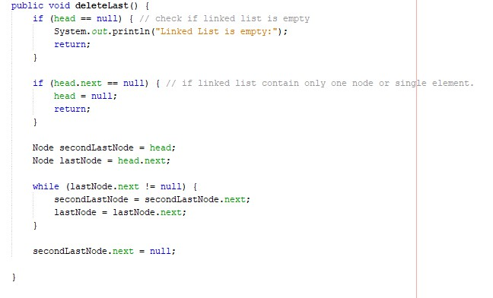

Lab Task:
- Combine all the methods into single class.
- Write a function which returns the number of elements in the linked list.

Title: Data Structures and Algorithms Course Code: CSC-232

Lab 10 (Stack and Queue implementation using Linked List)


Instructor: Asma Qaiser
E-mail: asma.qaiser@iqra.edu.pk Semester: Spring, 2024

Objective:
This lab aims to introduce students to the implementation of Stacks and Queues using Linked Lists.

Stack
A stack is a list of elements in which an element may be inserted or deleted only at one end, called the top of the stack. This means, in particular, that elements are removed from a stack in the reverse order of that in which they were inserted into the stack.
Special terminology is used for two basic operations associated with stacks: "Push" is the term used to insert an element into a stack.
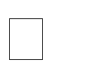

"Pop" is the term used to delete an element from a stack.
The operation of adding (Pushing) an item onto a stack and the operation of removing (Popping) an item from a stack may be implemented, respectively, by the following procedures, called PUSH and POP.


In executing the procedure PUSH, one must first test whether there is room in the stack for the new item; if not, then we have the condition known as overflow. Analogously, in executing the


procedure POP, one must first test whether there is an element in the stack to be deleted; if not, then we have the condition known as underflow.


Following are the basic operations
isEmpty ( ): Check whether a stack is empty

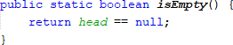

Push( x ): Insert element x at the top of a stack

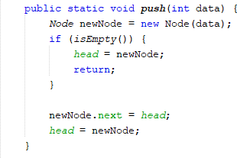
Pop( ): Removes an element from the top of a stack


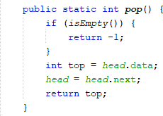
Top ( ) or Peek ( ): Access the top element of a stack

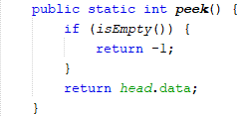

Lab Task:
- Combine all the above functions into a single program and also construct a Node class.
- Implement queue using linked list.

Title: Data Structures and Algorithms Course Code: CSC-232

Lab 11 (Implementation of Sorting Algorithms- Insertion sort, Bubble sort and Selection sort)


Instructor: Asma Qaiser
E-mail: asma.qaiser@iqra.edu.pk Semester: Spring, 2024
Objective:
This lab aims to familiarize students with fundamental sorting algorithms, including Insertion Sort, Bubble Sort, and Selection Sort.

Sorting algorithms
Sorting algorithms are methods for arranging elements in a list or array in a certain order, typically in ascending or descending order. Sorting is a fundamental operation in computer science and is used in various applications such as searching, data analysis, and database management. Here are some common sorting algorithms and a brief description of each:

Common Sorting Algorithms

- Bubble Sort:
  - Concept: Repeatedly steps through the list, compares adjacent elements, and swaps them if they are in the wrong order. The process is repeated until the list is sorted.
  - Complexity: O(n^2) time complexity for worst and average cases; O(n) for the best case.
- Selection Sort:
  - Concept: Divides the list into a sorted and an unsorted region. Repeatedly selects the smallest (or largest) element from the unsorted region and moves it to the end of the sorted region.
  - Complexity: O(n^2) time complexity for all cases.
- Insertion Sort:
  - Concept: Builds the sorted list one element at a time by repeatedly taking the next element from the input and inserting it into its correct position in the sorted part of the list.
  - Complexity: O(n^2) time complexity for worst and average cases; O(n) for the best case when the list is already sorted.


Insertion Sort

Concept: Insertion Sort builds the sorted array one item at a time. It takes each element from the input and inserts it into its correct position in the sorted part of the array.

Algorithm:
- Iterate from the second element to the end of the array.
- For each element, compare it with the elements in the sorted part of the array.
- Shift the sorted elements to the right until the correct position for the current element is found.
- Insert the current element into its correct position.

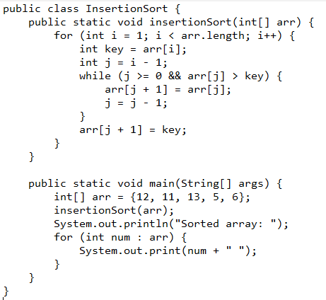
Implementation:


Bubble Sort

Concept: Bubble Sort repeatedly steps through the list, compares adjacent elements, and swaps them if they are in the wrong order. This process is repeated until the list is sorted.

Implementation:

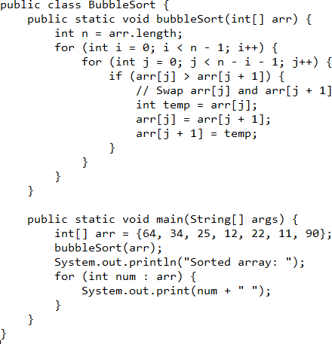


Selection Sort

Concept: Selection Sort divides the input list into two parts: the sublist of items already sorted and the sublist of items remaining to be sorted. It repeatedly selects the smallest (or largest) element from the unsorted sublist and moves it to the end of the sorted sublist.

Implementation:

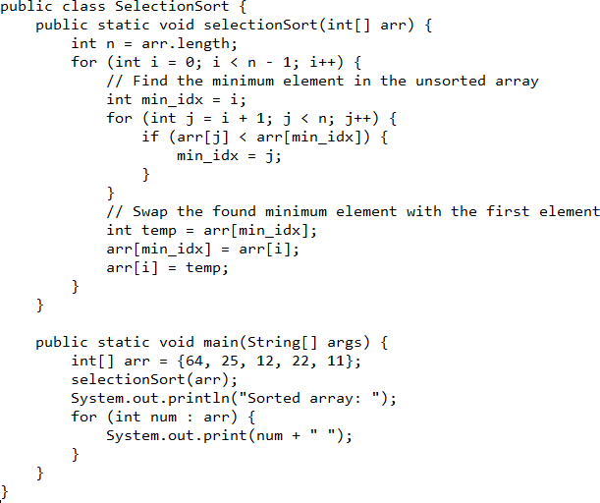
Lab Task:
Implement Insertion Sort, Bubble Sort, and Selection Sort in Java.

Title: Data Structures and Algorithms Course Code: CSC-232

Lab 12 (Implementation of Advanced Sorting Algorithms-Merge sort and Quick sort)


Instructor: Asma Qaiser
E-mail: asma.qaiser@iqra.edu.pk Semester: Spring, 2024
Objective:
This lab aims to familiarize students with fundamental sorting algorithms, including Merge Sort and Quick Sort.

Concept: Merge Sort is a divide-and-conquer algorithm that splits the list into halves, recursively sorts each half, and then merges the sorted halves to produce the sorted list.
Algorithm:

- Divide the unsorted list into two approximately equal halves.
- Recursively sort each half.
- Merge the two sorted halves to produce the final sorted list.

Implementation:

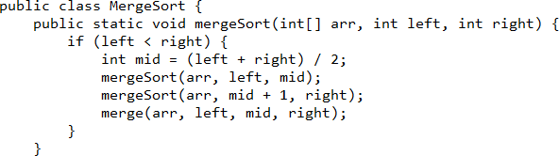

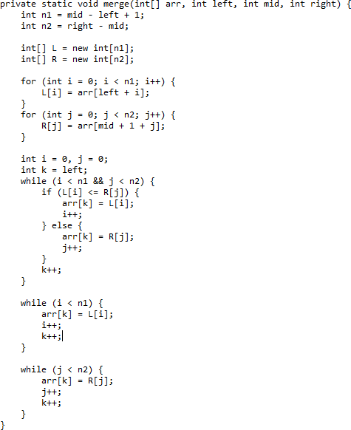

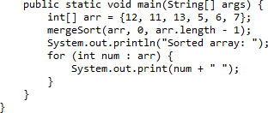



Concept: Quick Sort is a divide-and-conquer algorithm that selects a "pivot" element, partitions the list into elements less than and greater than the pivot, and recursively sorts the partitions.

Algorithm:

- Choose a pivot element from the list.
- Partition the list into two sublists: elements less than the pivot and elements greater than the pivot.
- Recursively sort the sublists.
- Combine the sorted sublists and the pivot to form the final sorted list.

Implementation:

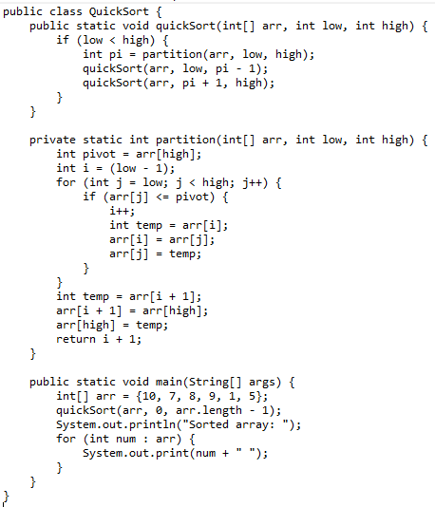

Lab Task:
Implement Merge Sort and Quick Sort in Java.

Title: Data Structures and Algorithms Course Code: CSC-232

Lab 13 (Implementation of Recursion)


Instructor: Asma Qaiser
E-mail: asma.qaiser@iqra.edu.pk Semester: Spring, 2024

Objective:
The objective of the lab is to develop understanding of the recursion and its basic implementation.
What is Recursion?

Recursion is a programming technique where a function calls itself directly or indirectly to solve a problem. Recursive solutions often involve breaking a problem down into smaller, more manageable sub-problems of the same type.

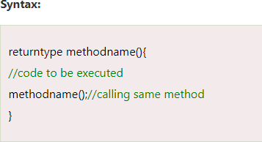

Example 1: INFINITE TIMES
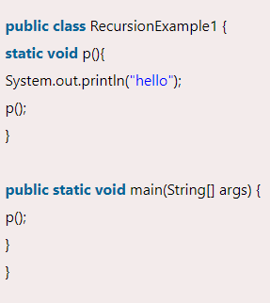


Example 2: FINITE TIMES

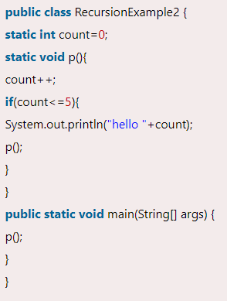
Output:
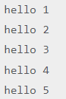


Example 3: FACTORIAL NUMBER

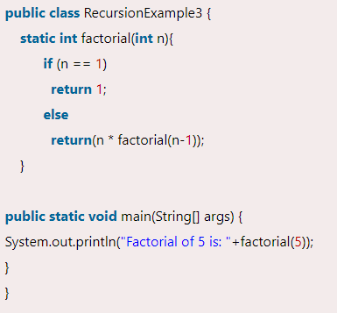
Output:
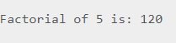

Example 4: FIBONACCI SERIES

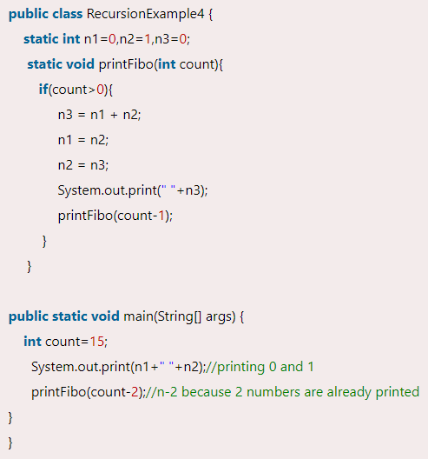


Output:
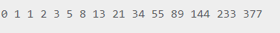
Lab Task:
Implement the `towerOfHanoi` method using recursion.

Title: Data Structures and Algorithms Course Code: CSC-232

Lab 14 (Implementation of binary tree and applying traversal techniques)


Instructor: Asma Qaiser
E-mail: asma.qaiser@iqra.edu.pk Semester: Spring, 2024
Objective:
The objective of this lab is to implement a binary tree and apply traversal techniques (in-order, pre-order and post-order).

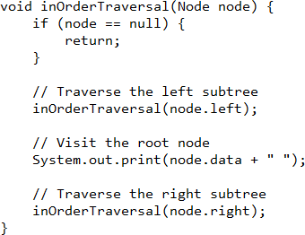

Preorder Traversal:
Preorder traversal visits the node in the order: Root -> Left -> Right

Algorithm for Preorder Traversal: Preorder (tree)
- Visit the root.
- Traverse the left subtree, i.e., call Preorder (left->subtree)
- Traverse the right subtree, i.e., call Preorder (right->subtree)



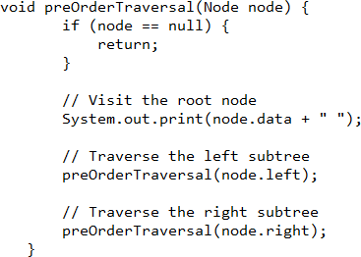

Postorder Traversal:
Postorder traversal visits the node in the order: Left -> Right ->Root

Algorithm for Postorder Traversal: Postorder(tree)
- Traverse the left subtree, i.e., call Postorder (left->subtree)
- Traverse the right subtree, i.e., call Postorder (right->subtree)
- Visit the root.
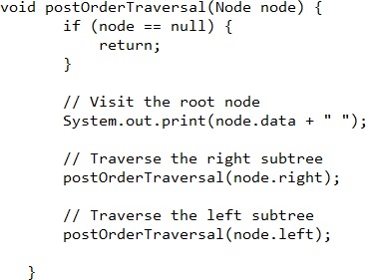

Lab Task1:
Combine all the above functions into a single program.

Title: Data Structures and Algorithms

COURSE CODE: CSC-232

Lab 15 (Implementation of search, insert, and delete operations on a binary search tree (BST))


Instructor: Asma Qaiser
E-mail: asma.qaiser@iqra.edu.pk Semester: Spring, 2024
Objective:
The purpose of this lab is to apply search, insert, and delete operations on a binary search tree (BST).

Binary Search Tree
Binary Search Tree is a data structure used in computer science for organizing and storing data in a sorted manner. Binary search tree follows all properties of binary tree and
its left child contains values less than the parent node and the right child contains values greater than the parent node. This hierarchical structure allows for
efficient Searching, Insertion, and Deletion operations on the data stored in the tree.

Insertion Code:

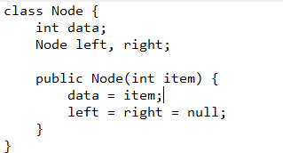


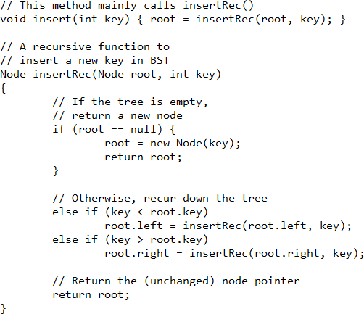

Lab Task1:
Combine all the above functions into a single program.

