Name: Syed Fahad Ali
ID: IU02-0125-0370
Slot: Saturday

LAB 3

- Combine all the above functions into a single program.
- class Stack {
- int top;
- int size;
- int[] arr;

- Stack(int size) {
- this.size = size;
- arr = new int[size];
- top = -1;
- }

- boolean isStackFull() {
- return (top == size - 1);
- }

- boolean isEmpty() {
- return (top == -1);
- }

- void push(int element) {
- if (!isStackFull()) {
- top++;
- arr[top] = element;
- System.out.println("Element Pushed: " + element);
- } else {
- System.out.println("Stack is full...");
- }
- }

- int pop() {
- if (!isEmpty()) {
- int value = arr[top];
- top--;
- System.out.println("Element Popped: " + value);
- return value;
- } else {
- System.out.println("Stack is empty...");
- return -1;
- }
- }

- int peek() {
- if (!isEmpty()) {
- return arr[top];
- } else {
- System.out.println("Stack is empty...");
- return -1;
- }
- }
- }

- public class task1 {
- public static void main(String[] args) {

- Stack s = new Stack(5);

- s.push(10);
- s.push(20);
- s.push(30);

- s.pop();

- System.out.println("Top Element: " + s.peek());
- }
- }

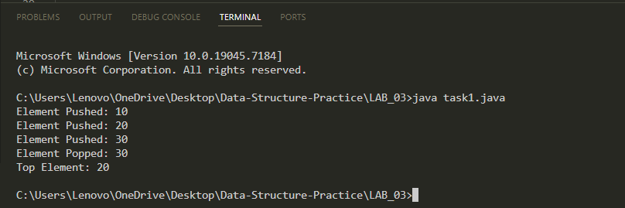

2. Reverse a string using stack.
