Ledger
Personal Expense Tracker - Test Report & Feature Documentation
MERN Stack · Node.js + Express + MongoDB + React 18

1. Project Overview
Ledger is a full-stack MERN application for tracking personal expenses. It provides a RESTful API backed by MongoDB and a React single-page application that lets users add, edit, delete, and categorise expenses, then view spending summaries through a donut chart and category breakdown bars.

1.1 Technology Stack
Layer | Technology | Role
Database | MongoDB + Mongoose | Document store, schema validation, aggregation pipeline
Backend | Node.js + Express 4 | REST API, route handlers, error middleware
Frontend | React 18 + Vite | SPA, component state, API fetch hooks
Charts | Recharts | Donut chart for category spend breakdown
Testing | Jest + Supertest | 21 unit tests with mocked Mongoose

2. API Reference
The backend exposes seven endpoints under the /api prefix. All responses follow a consistent envelope format:
{ "success": true, "data": { ... } } // on success
{ "success": false, "message": "..." } // on error

Method | Endpoint | Description
GET | /api/expenses | List expenses (filter by category, date, sort, limit)
POST | /api/expenses | Create a new expense (validates all fields)
GET | /api/expenses/:id | Fetch a single expense by MongoDB ObjectId
PUT | /api/expenses/:id | Update any fields; re-runs validation
DELETE | /api/expenses/:id | Delete an expense; returns confirmation message
GET | /api/expenses/summary | Aggregated totals, counts, averages by category
GET | /api/health | Health check with DB connection state

2.1 Expense Schema
Every expense document stored in MongoDB conforms to the following Mongoose schema. All validation is enforced server-side on both create (POST) and update (PUT) operations.
Field | Type | Required | Constraints
title | String | Yes | Trimmed, max 100 characters
amount | Number | Yes | Must be > 0.01
category | String (enum) | Yes | Food, Transport, Housing, Entertainment, Health, Shopping, Other
date | Date | Yes | Defaults to current date/time
note | String | No | Trimmed, max 300 characters

3. Test Suite
The backend is covered by 21 unit tests written with Jest and Supertest. Rather than spinning up a real MongoDB instance (which requires a binary download), Mongoose is mocked using jest.mock(). This approach tests all route logic, validation error handling, and HTTP response shapes with zero external dependencies and sub-6-second run times.
Test strategy: jest.mock('../models/Expense') replaces all Mongoose model methods (find, findById, create, findByIdAndUpdate, findByIdAndDelete, aggregate) with jest.fn() stubs that resolve to fixture data. mongoose.connect is also mocked so the server module can be imported without a live database.

3.1 Test Results Summary
Test Suite | Tests | What is Covered
GET /api/health | 1 | Returns {status: "ok"} with DB readyState
GET /api/expenses | 5 | List all, filter by category, date range, empty result, DB error handling
GET /api/expenses/summary | 2 | Grand total + byCategory breakdown, empty database
GET /api/expenses/:id | 2 | Returns expense by id, 404 for unknown id
POST /api/expenses | 3 | Creates with valid data, ValidationError, server error
PUT /api/expenses/:id | 4 | Updates, passes new+runValidators options, 404, ValidationError
DELETE /api/expenses/:id | 3 | Deletes and returns success, 404, DB error
Unknown routes | 1 | 404 with success:false for any unregistered path

3.2 Running the Tests
Execute from the backend directory. No MongoDB installation is needed.
cd backend && npm test
Expected output:
PASS tests/expenses.test.js (5.5s)
Tests: 21 passed, 21 total

3.3 Detailed Test Explanations

Health Check (1 test)
GET /api/health is a simple liveness probe. The test confirms the server returns HTTP 200 with a JSON body containing status: "ok". This endpoint is intentionally stateless and does not touch the database, so no mocking is required beyond the initial mongoose.connect stub.

GET /api/expenses (5 tests)
- returns all expenses - stubs Expense.find() to return all fixtures and asserts count: 3 and success: true.
- filters by category - checks that the filter object passed to Expense.find() contains { category: "Food" } when the query string includes ?category=Food.
- applies date range filter - verifies that startDate and endDate query params produce a $gte / $lte date filter in the Mongoose call.
- returns empty array when no expenses - stubs find() to return [] and asserts count: 0 without error.
- handles DB error gracefully - stubs the limit() promise to reject and asserts HTTP 500 with success: false.

GET /api/expenses/summary (2 tests)
The summary endpoint calls Expense.aggregate() twice in parallel via Promise.all: once for per-category totals and once for the grand total. Tests mock both aggregate calls with fixture data and assert:
- Grand total matches the sum of all fixture amounts ($150 in test data).
- byCategory contains the correct number of entries (2) and the category names are mapped from _id to a category key.
- Empty database case returns grandTotal.total of 0 without crashing.

GET /api/expenses/:id (2 tests)
- returns an expense by id - stubs findById() to return a fixture and asserts the _id in the response matches.
- returns 404 when not found - stubs findById() to return null and asserts HTTP 404 with a message matching /not found/.

POST /api/expenses (3 tests)
- creates with valid data - stubs Expense.create() to resolve with a fixture and asserts HTTP 201 and the title field.
- handles ValidationError - creates a synthetic Mongoose ValidationError with errors.title.message and stubs create() to reject with it. Asserts HTTP 400 and that the message body references "title".
- handles server error - stubs create() to reject with a plain Error (connection lost) and asserts HTTP 500.

PUT /api/expenses/:id (4 tests)
- updates an expense - stubs findByIdAndUpdate() to return modified fixture and asserts the updated field value.
- passes correct options - asserts findByIdAndUpdate was called with { new: true, runValidators: true } to ensure the updated document is returned and validation runs.
- returns 404 when not found - stubs return null.
- handles ValidationError on update - same pattern as POST, but via findByIdAndUpdate rejection.

DELETE /api/expenses/:id (3 tests)
- deletes and returns success - stubs findByIdAndDelete() to return the deleted fixture and asserts message matching /deleted/.
- returns 404 when not found - stubs return null.
- handles DB error - stubs to reject and asserts HTTP 500.

Unknown Routes (1 test)
The 404 catch-all middleware is verified by sending GET /api/nonexistent. Asserts HTTP 404 and success: false in the body.

4. Frontend Features & Screenshots
The React frontend communicates with the Express API through a Vite reverse proxy (/api requests proxied to port 5000 in development). All state is managed with React hooks in App.jsx and passed down as props.

4.1 Expense List View
The main Expenses tab shows the Add Expense form at the top and the paginated expense list below. Each row displays the category colour dot, title, optional note, category icon with date, amount, and edit/delete action buttons.
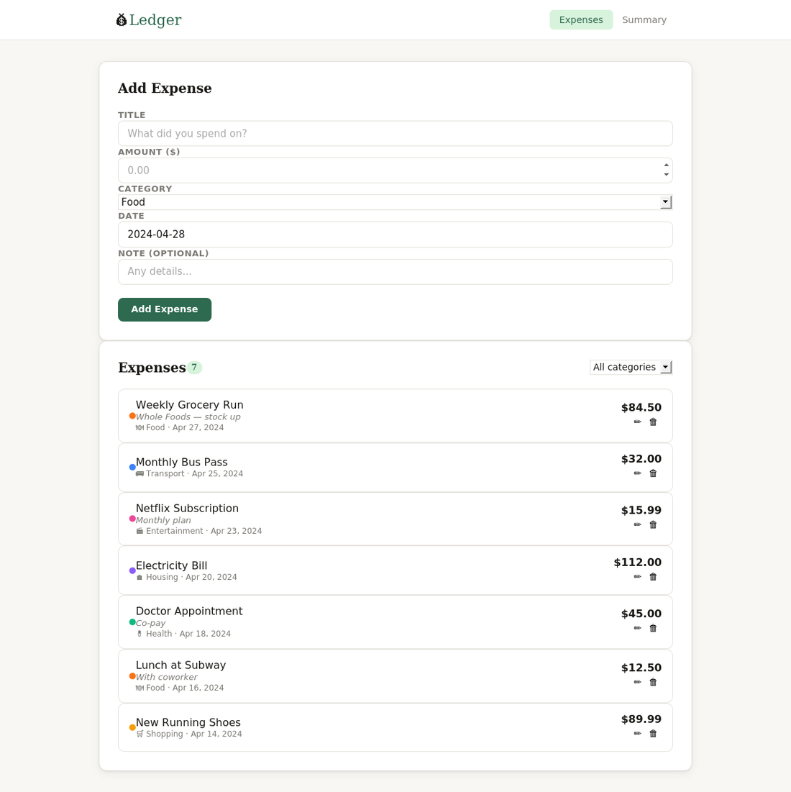
Figure 1 — Main view: Add Expense form and expense list with all 7 sample entries
Key implementation details:
- The list is re-fetched on every create, update, and delete via the load() callback wrapped in useCallback(). The active category filter is a dependency, so changing the filter also triggers a fresh fetch.
- Each expense row is a <li> inside a <ul>. The category colour dot is driven by the CATEGORY_COLORS map in api.js, which maps category names to hex values.
- Amounts are formatted using the Intl.NumberFormat API for locale-aware currency display (e.g., $84.50).

4.2 Edit Expense
Clicking the pencil icon on any expense row calls setEditing(expense), which passes the expense object as the editing prop to ExpenseForm. The form detects this in a useEffect and auto-populates all fields. The submit button changes from "Add Expense" to "Update", and a Cancel button appears.
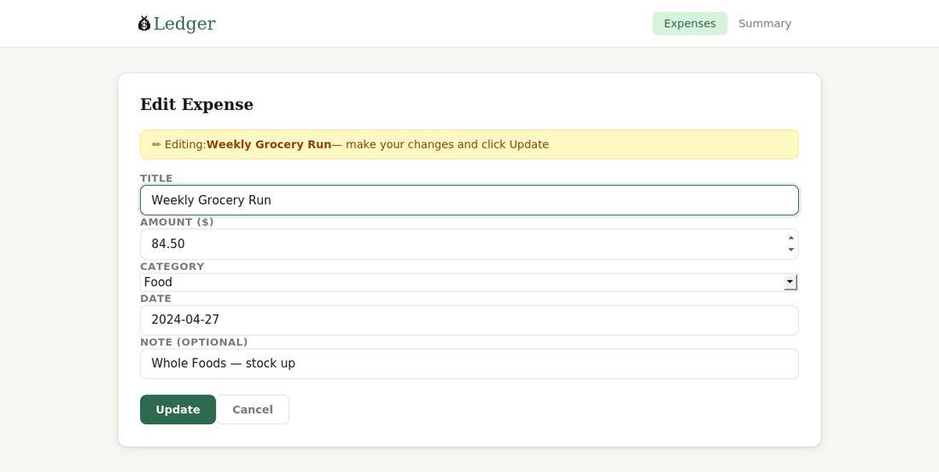
Figure 2 — Edit mode: form pre-populated with the selected expense's data
The date field is normalised from the ISO string returned by the API (e.g., 2024-04-27T00:00:00.000Z) to YYYY-MM-DD by taking the first 10 characters, which is the format expected by the HTML date input.

4.3 Form Validation
Client-side validation runs before the API call in handleSubmit. If the title is blank or the amount is missing or zero/negative, an error message is rendered in the red banner above the form and the API call is skipped. Server-side validation errors returned from the API (HTTP 400) are also surfaced through the same error banner.
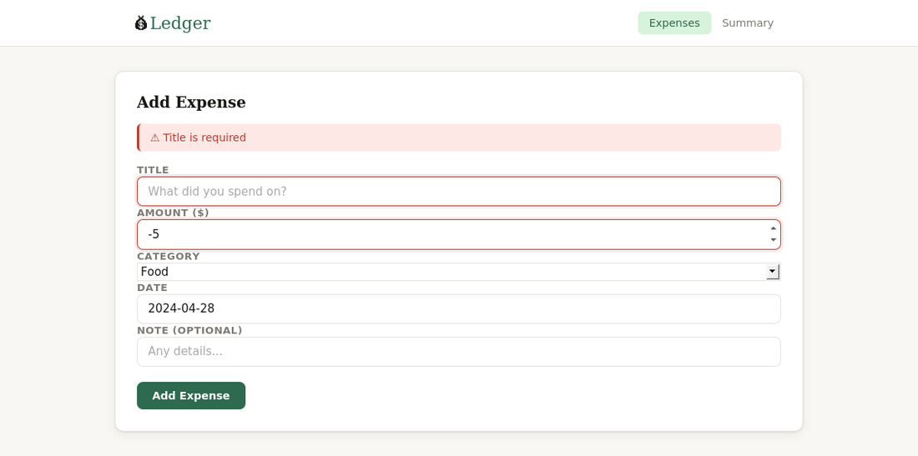
Figure 3 - Validation error: missing title flagged before the API is called
- Client validation: checks title.trim() and parseFloat(amount) > 0.
- Server validation: Mongoose schema enforces required fields, enum values, and min/max constraints. Errors are collected from err.errors and joined into a single message string.
- Error state is cleared on every new submit attempt and when the editing prop changes.

4.4 Category Filtering
The category dropdown in the list header sets the filter state in App.jsx. Because filter is a dependency of the useCallback-memoised load() function, changing it triggers a re-fetch with the ?category= query parameter, so filtering happens server-side. The count badge updates to reflect the filtered result count.
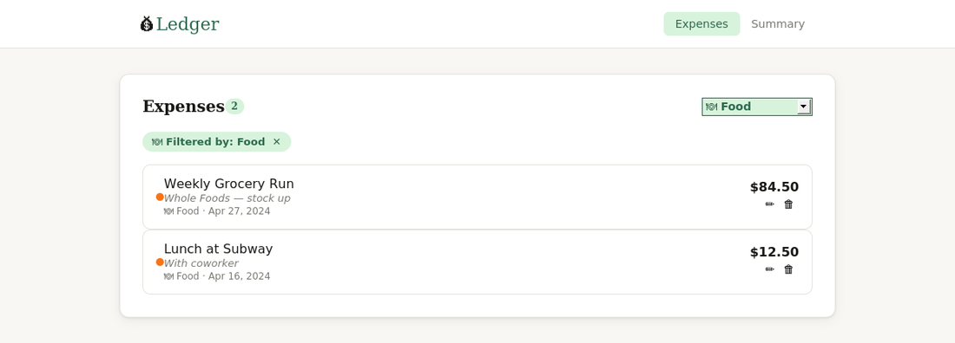
Figure 4 - Category filter active: only Food expenses shown, count badge updated to 2

4.5 Summary & Analytics
Switching to the Summary tab renders the Overview card, which is populated by the GET /api/expenses/summary endpoint. The endpoint uses a two-stage MongoDB aggregation: one $group pipeline for per-category totals and a second for the grand total. Both run in parallel with Promise.all.
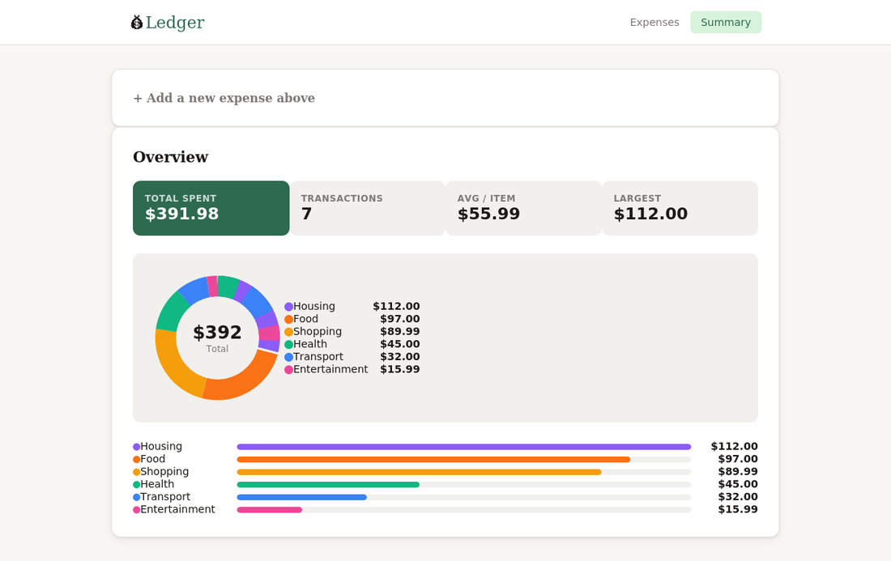
Figure 5 — Summary view: stat cards, Recharts donut chart, and category progress bars
The four stat cards show:
- Total Spent - sum of all expense amounts
- Transactions - total count of expense documents
- Avg / Item - arithmetic mean per transaction
- Largest - the single highest expense amount
The donut chart uses Recharts PieChart with an innerRadius, giving it the ring appearance. Each slice is coloured by the CATEGORY_COLORS map. Below the chart, horizontal progress bars are scaled relative to the highest-spend category (which always renders at 100% width).

4.6 Delete with Confirmation
Clicking the trash icon calls window.confirm() before the DELETE API call. If the user confirms, the expense is removed and a toast notification slides in from the bottom-right corner. The list re-fetches automatically after a successful delete.
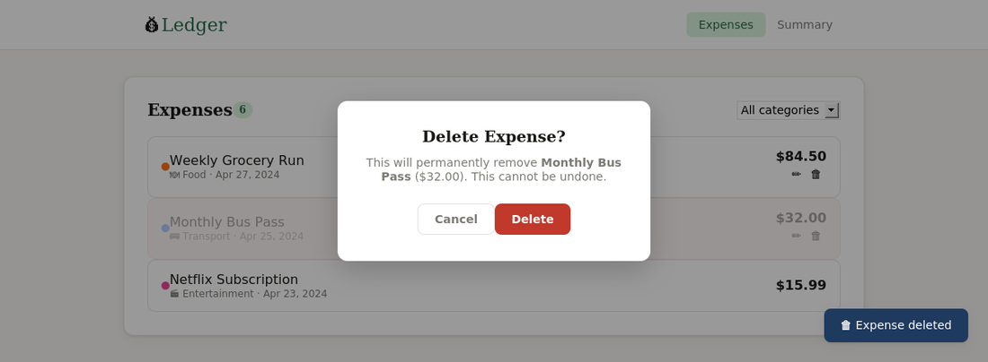
Figure 6 - Delete flow: native browser confirm dialog and post-delete toast
Toast notifications are implemented as a piece of state: { msg: string, type: "success" | "info" }. A setTimeout clears the state after 3 seconds, removing the toast from the DOM. The CSS slide-in animation uses a keyframe on the .toast class.

5. Running the Project

5.1 Prerequisites
- Node.js 18 or higher
- MongoDB running locally on port 27017, or a MongoDB Atlas connection string

5.2 Setup
git clone https://github.com/your-username/expense-tracker.git
cd expense-tracker/backend && npm install
cd ../frontend && npm install
cd ../backend && cp .env.example .env # Edit MONGO_URI if needed

5.3 Development
# Terminal 1 — API server
cd backend && npm run dev # starts on port 5000

# Terminal 2 — React app
cd frontend && npm run dev # starts on port 3000
Vite proxies all /api requests to port 5000, so no CORS configuration is needed in development. Open http://localhost:3000 in the browser.

5.4 Tests
cd backend && npm test
No MongoDB instance is required. All 21 tests complete in under 6 seconds.

End of Document

