***PROCEDURES***

1. *Get Student Profile*

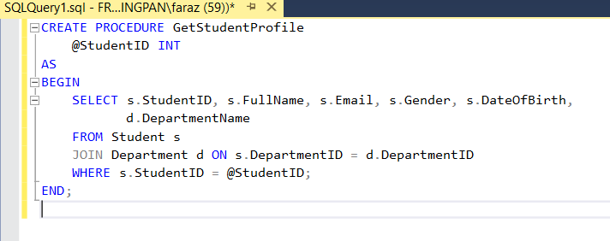

***Description:***

*Retrieves a student's complete profile along with their department name using their StudentID.*

1. *Get Student GPA*

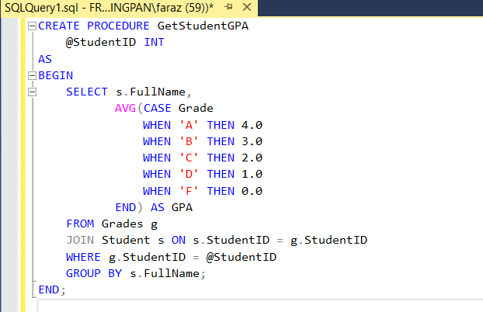

***Description:***

*Calculates and returns the GPA of a student based on letter grades assigned in the Grades table.*

1. *Get Total Fee Paid*

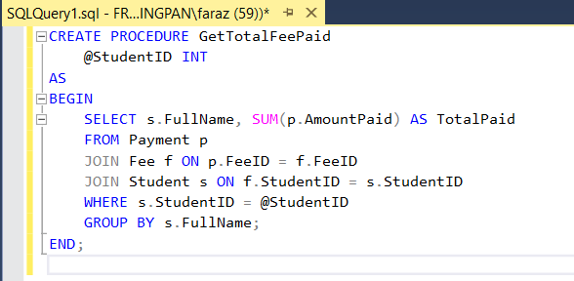

***Description:***

*Returns the total amount of fees paid by a specific student across all semesters.*

1. *Get Student Books*

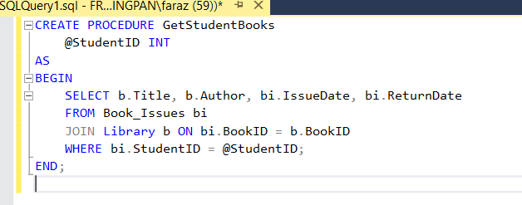

***Description:***

*Lists all books issued to a student, including issue and return dates, based on their StudentID.*

1. *Get Attendance Report*

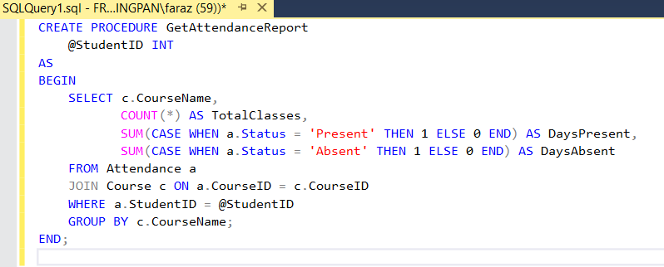

***Description:***

*Shows the number of total classes, days present, and days absent for a student in each course.*