*TRIGGERS*

1. *Auto update available copies of books*

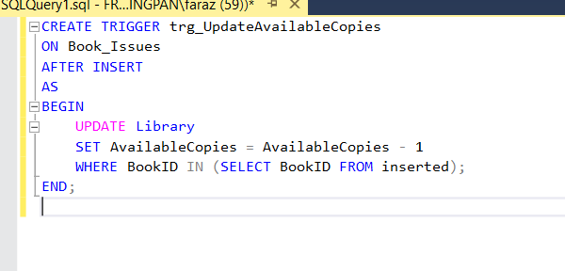

***Description:***

*Automatically decreases the available copies of a book in the Library table when it is issued to a student.*

1. *Auto Update return copies*

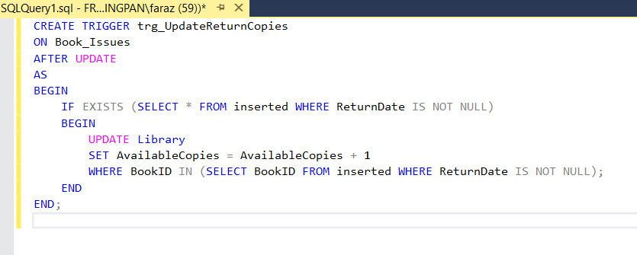

***Description:***

*Automatically increases the available copies in the Library table when a book is returned.*

1. *Prevent Duplicate Enrollment*

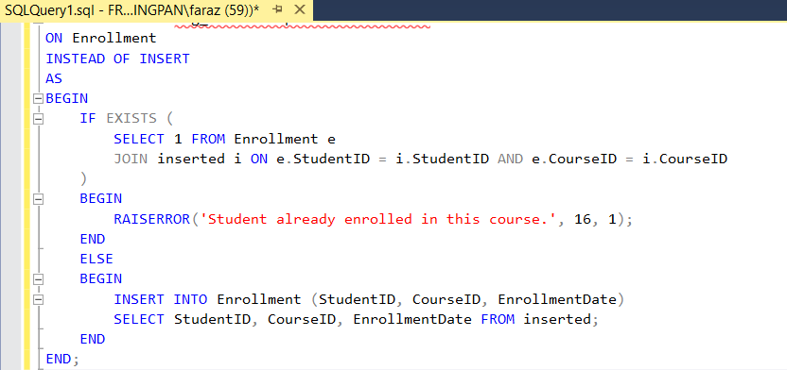

***Description:***

*Prevents a student from being enrolled in the same course more than once by checking for duplicates before insertion.*

1. *Validate Payment*

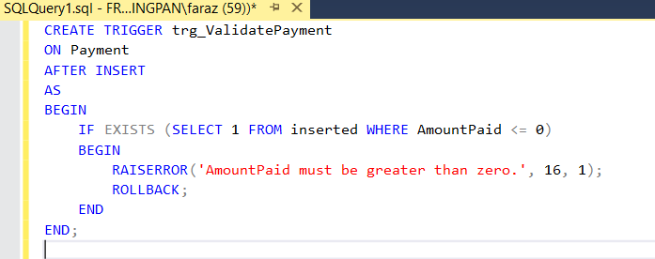

***Description:***

*Ensures that no payment with zero or negative amount is inserted into the payment table.*