VelocityGo – Ride Hailing System


1. Introduction
VelocityGo is a desktop-based ride-hailing system developed using C++ and the SFML graphics library. The project simulates real-world ride-hailing platforms such as Uber and Careem while emphasizing the practical application of Data Structures and Algorithms. The system provides separate interfaces for riders and drivers, enabling booking, route optimization, live tracking, and history management.

2. Problem Statement
Urban transportation systems often suffer from inefficient routing, delayed driver matching, and poor user interfaces. Traditional console-based systems fail to provide a realistic simulation of such platforms. VelocityGo addresses these issues by combining graphical programming with optimized algorithms to deliver a realistic and efficient ride-hailing simulation.

3. Project Objectives
- Design a visually rich SFML-based interface
- Implement shortest path navigation using Dijkstra’s Algorithm
- Simulate real-time ride tracking
- Apply file handling for persistent storage
- Demonstrate real-world usage of DSA concepts

4. System Overview
The system consists of multiple interconnected modules including authentication, ride booking, driver management, map routing, and history storage. Each module communicates internally through well-defined data structures and functions.

5. Technologies Used
Programming Language: C++
Graphics Library: SFML
Operating System: Windows
Development Tools: Visual Studio

6. Data Structures Used
Data Structure | Usage | Purpose
Vector | Store nodes and edges | Dynamic data storage
Priority Queue | Dijkstra Algorithm | Efficient shortest path
Structs | User & Ride objects | Data encapsulation
Unordered Map | User lookup | Fast searching
Graph (Adjacency List) | City map | Route computation
File Streams | Persistent storage | Save/load data
Graph Data Structure (Road Network Representation):
The core of the VelocityGo application is based on a graph data structure, which is used to model the road network of Islamabad. Each location such as Blue Area, F-7 Markaz, Centaurus Mall, etc., is represented as a vertex (node) in the graph, while the roads connecting these locations are represented as edges with associated weights.
The weight of each edge represents the distance between two locations, measured in meters. This representation allows the system to realistically simulate urban navigation and enables efficient route calculation between pickup and drop-off points.
Using a graph structure is ideal for ride-hailing applications because real-world road networks naturally form graphs. This approach allows the program to solve routing problems efficiently using well-known graph traversal algorithms such as Dijkstra’s Algorithm.

Vector Data Structure:
The vector data structure from the C++ Standard Template Library (STL) is extensively used throughout the VelocityGo application. Vectors provide dynamic resizing and fast random access, making them suitable for storing collections of data that may grow or shrink during runtime.
Vectors are used to store:
- Locations in the Islamabad map
- List of drivers
- Edges connected to each location
- Ride history records
Vectors allow the program to iterate efficiently through stored elements while maintaining memory safety and simplicity.
Why Vector Was Chosen:
- Dynamic size management
- Cache-friendly storage
- Constant-time element access
Priority Queue (Driver Selection & Pathfinding):
- The priority queue data structure plays a critical role in two major features of the VelocityGo application:
1-Dijkstra’s shortest path algorithm
2-Nearest driver selection
In driver matching, the priority queue stores drivers sorted by their distance from the pickup location. This ensures that the closest available driver is selected first, improving customer satisfaction and reducing waiting time.
- In Dijkstra’s algorithm, the priority queue ensures that the node with the minimum tentative distance is processed first, which guarantees the correctness of the shortest path calculation.
- Benefits:
- Automatic ordering of elements
- Efficient minimum extraction
Improved performance for large datasets
DriverMatching logic pseudocode:
1. Retrieve list of available drivers
2. Calculate distance of each driver from rider location
3. Insert drivers into priority queue based on distance
4. Select nearest available driver
5. Assign ride and update driver status

Unordered Map (User Authentication System):
The unordered_map data structure is used to store and manage user accounts in VelocityGo. Each user’s username acts as a unique key, while the corresponding value stores the user’s profile information such as password, role, rating, and ride count.
Unordered maps provide constant-time average complexity for insertion and lookup operations, making them ideal for authentication systems where fast access is essential.
Usage in VelocityGo:
- Login authentication
- User registration
- Persistent user data management

7. Algorithms Used
The core algorithm implemented in VelocityGo is Dijkstra’s Shortest Path Algorithm. The city map is represented as a weighted graph where nodes represent locations and edges represent distances. A priority queue ensures efficient path calculation.
Dijkstra’s algorithm pseudocode:
1. Create a distance array and initialize all distances to infinity
2. Set distance[source] = 0
3. Create a priority queue and insert (source, 0)
4. While priority queue is not empty:
a. Extract node with minimum distance
b. For each adjacent node:
i. Calculate newDistance = currentDistance + edgeWeight
ii. If newDistance < distance[adjacent]:
- Update distance[adjacent]
- Update parent node
- Push into priority queue
5. End While
6. Return shortest distance and path

8. File Handling Implementation
VelocityGo uses file handling to store user data and ride history persistently. Since no database system is used, text files act as a lightweight storage solution.
Files Used:
File Name | Purpose
users.txt | Stores registered users
ride_history.txt | Stores completed ride records
File handling ensures that data remains available even after the application is closed, simulating real-world system persistence.
FileHandling logic pseudocode:
1. Open file in read mode
2. If file exists:
a. Read user and ride data line by line
b. Store data into appropriate data structures
3. If file does not exist:
a. Create new file
4. On program exit or data update:
a. Open file in write mode
b. Save updated records
5. Close file

9. Use of SFML Graphics Library
SFML is used to design the graphical user interface of VelocityGo. It handles window creation, event processing, rendering of buttons, animations, text input, and map visualization. SFML enhances user experience by providing smooth transitions, hover effects, and real-time updates.

10. User Interface Design
The application provides separate dashboards for riders and drivers. Riders can book rides, track drivers, and view ride history, while drivers can accept rides, navigate routes, and monitor earnings. The UI follows a clean and modern design approach.
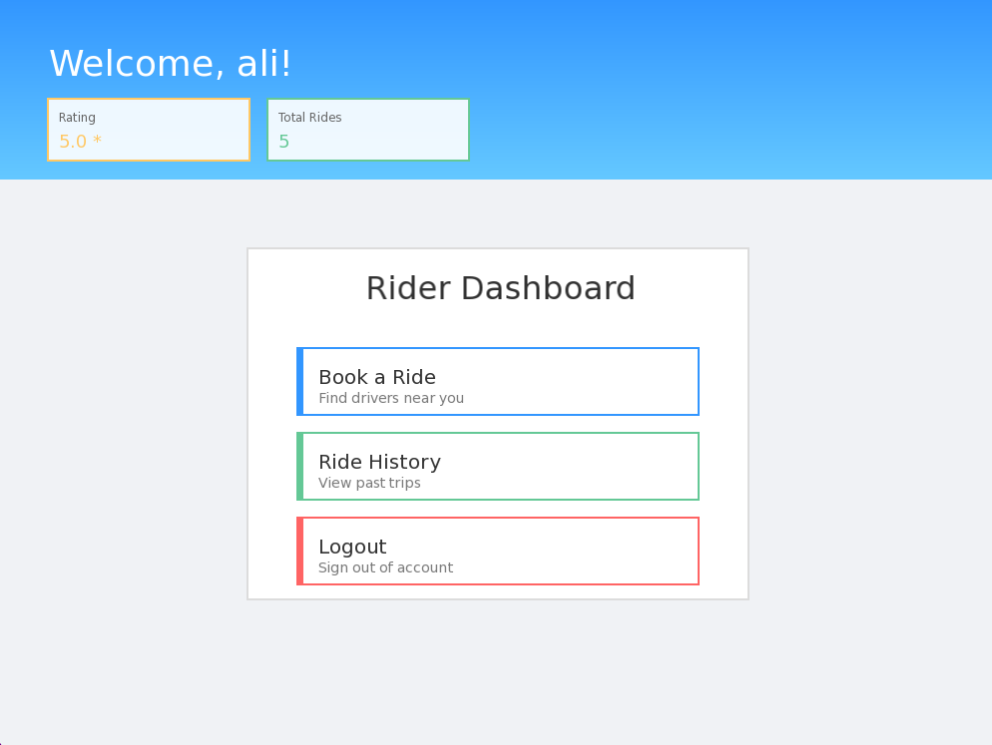
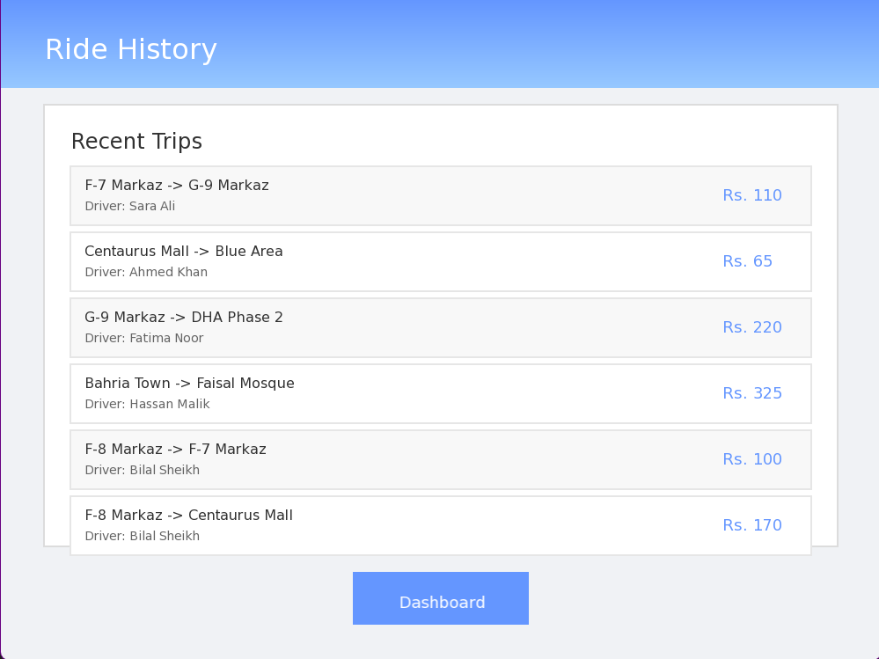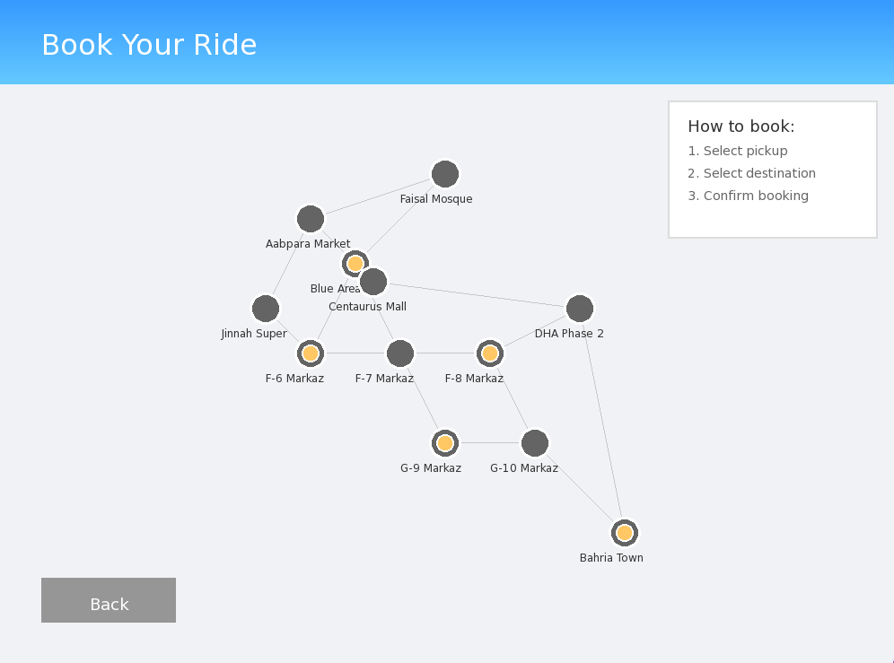

11. Testing & Validation
The system was tested using multiple scenarios including incorrect login attempts, route calculation accuracy, file persistence, and UI responsiveness. All core modules performed as expected.

12. Limitations
- Desktop-only application
- Static map data
- No real GPS or network connectivity
- Text-based file storage

13. Future Enhancements
Future improvements may include mobile application development, real-time GPS integration, online databases, payment gateways,real time map data showing traffic congestions,an extended well implemented non strutucred database to handle large number of users and AI-based driver matching.

14. Conclusion
VelocityGo successfully demonstrates the practical application of Data Structures and Algorithms in a real-world scenario. The project combines algorithmic efficiency with graphical programming, making it a strong academic and technical achievement.

