# Marina Fleet

|  |  |  |
| --- | --- | --- |
| **Supervisor.** | Sir Sajid Mehdi |  |
| **Batch.** | 202012c |  |
| **Group.** | 1 |  |
| **Serial No.** | **Enrollment Number** | **Student Name** |
| 1. | 128068 | Faraz |
| 2. | 1297067 | Saad Khan |
| 3. | 1293679 | G Mustafa |

## ACKNOWLEDGEMENT

The first, we would like to express my special thanks of gratitude to my teacher Sajid Mehdi, who helped us a lot in finalizing this project within the limited time frame, valuable counselling and assistance for the accomplishment of this project.

Secondly we would also like to thank the eProject team at Aptech Head Office, who gave us the golden opportunity to do this wonderful project about Marina Fleet.

Thirdly, we also thank the eProject team, some of the benefits are as under:

* Re-enforcement of skills happens in the experiential learning process. 
* A mentor, ensuring that we do not get drifted, constantly guides us. 
* It gives us a lot of confidence to face an interview as we have worked on a project. We can explain virtually everything on the subject we have learnt. 

***SYNOPSIS***

Follow the strong development of the internet, technology watches and the growing watch market, every business needs a website design to display products on the internet.

The following Marina product are designed with many different designs, suitable for all styles and preferences, which are the most special suggestions from Marina Fleet.

Attached are the introductions hidden behind the watch gift from the gift you want to send to your lover, colleagues or loved ones.

So Marina Fleet shares the best product images through the website for everyone to know.

However, purchases are not made directly on the website

***PROBLEM DEFINITION***

Marina Fleet website will present the information about the various fleets of yachts and boats available with them. The website will help the customers in choosing the yacht or boat as per their requirements. The company may also be benefitted with the information available on the website in reaching to wide range of customers.

* How the sitemap possibly looks alike?
* What information should be displayed on each page?
* How to put every comment is friendly?
* How to give users the best experience when using the website?
* How to let the website properly functioning along with the system requirement?
* Will the user be able to contact with Marina Fleet company for advice?

## CUSTOMER REQUIREMENT SPECIFICATION (CRS)

The Web site is to be created based on the following requirements.

1. The Home Page should be created making use of Sections with a suitable logo, the header section can be added which will show images yachts and boats
2. The site must contain the links to navigate through any category for the information.
3. Links of fleets can be categorized like (Luxury, Sailing, Fishing etc.)
4. Specification and Pricing of Yacht/Boat can be added along with the images.
5. Gallery section can be added for viewing different images.
6. Feedback must be allowed to enter by the viewer
7. Site map, Gallery, about us, Queries link, Contact us link must be added.
8. The complete description must be allowed to get download as pdf or doc file.
9. The advertise section with various facilities provided should be mentioned.

## SCOPE OF THE WORK (IN BRIEF)

The website is to be developed for the Windows Platform using HTML5, JavaScript and Geolocation. The site should work well in all leading browsers including Chrome, IE, Firefox etc..

Homepage show Top best sell items, big sale, collection, new shop...

Every content direct to relative content.

## AGGREGATED SITEMAP

***SITEMAP ENGLISH***

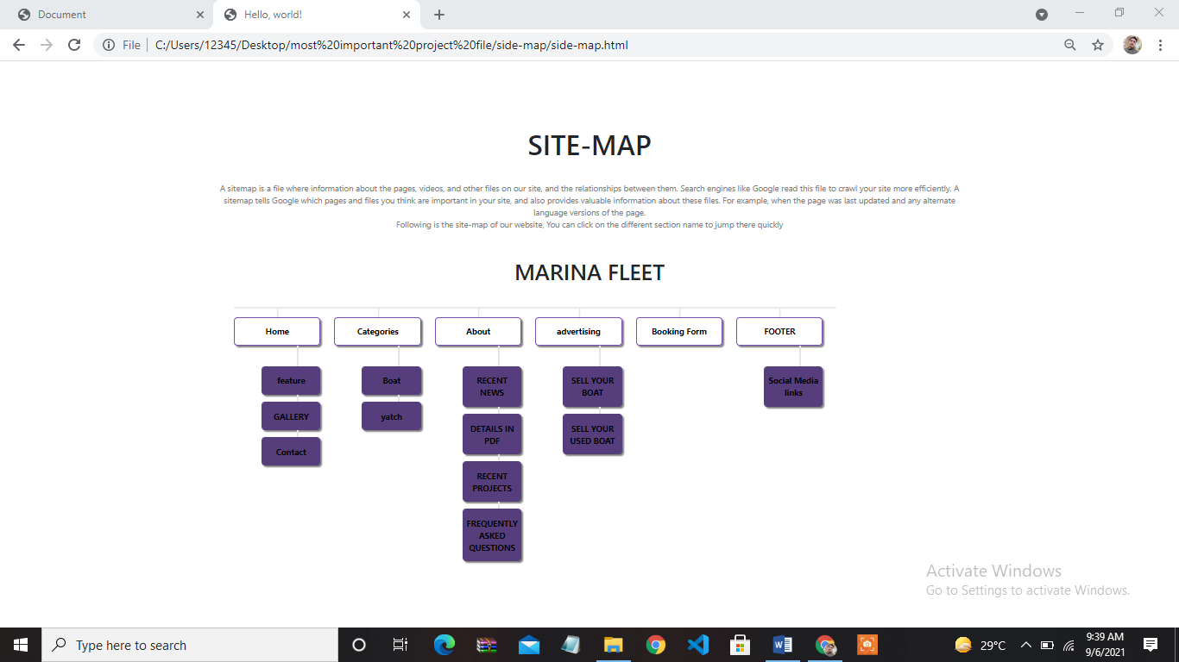

## WIREFRAMES

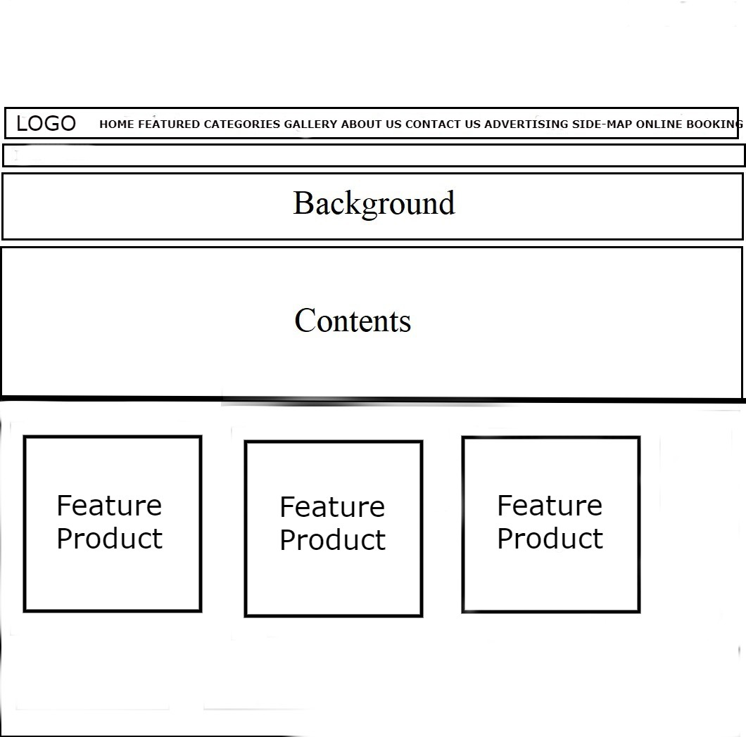

***TASK SHEET***

|  |  |  |  |  |  |  |
| --- | --- | --- | --- | --- | --- | --- |
| Project Ref. No.: eP/Advertisement Portal Management System/01 | | Project title | Date of Preparation of Activity Plan | | | |
| No | Task |  | Actual | Actual | Team-mate | Status |
| Start Date | Days | Names |
| 1 | Build Home Page | 9/8/21 | 1 | Student-1 | Complete |
| 2 | Build Product  Page And  Product Line-Up  Pages | 12/8/21 | 1 | Student-2 | Complete |
|  | Build |  |  |  |  |
| 3 | Technology,  Support, Store  Locator, Register |  | 15/8/21 | 1 | Student-3 | Complete |
|  | Pages | MARINA  FLEET |  |  |  |  |
| ­­­4 | Build Price Page | 16/8/21 | 7 | Student-3 | Complete |
| 5 | Begin Code  Javascript For  The Home Page | 18/8/21 | 1 | Student-1 | Complete |
|  | Begin Code |  |  |  |  |
| 6 | Javascript For  The Product  Page And  Product Line-Up  Pages |  | 19/8/21 | 1 | Student-2 | Complete |