1. Create a function module to import a range of customer numbers and export the customer data for the given range.

Customer Data can be found in table KNA1.

Time : 30 minutes

Create a package and keep all objects created for this task in that package.

Paste screenshots of all the objects created for this task.

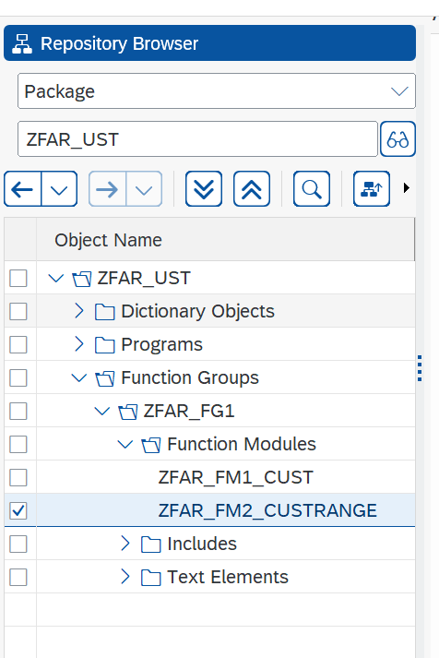

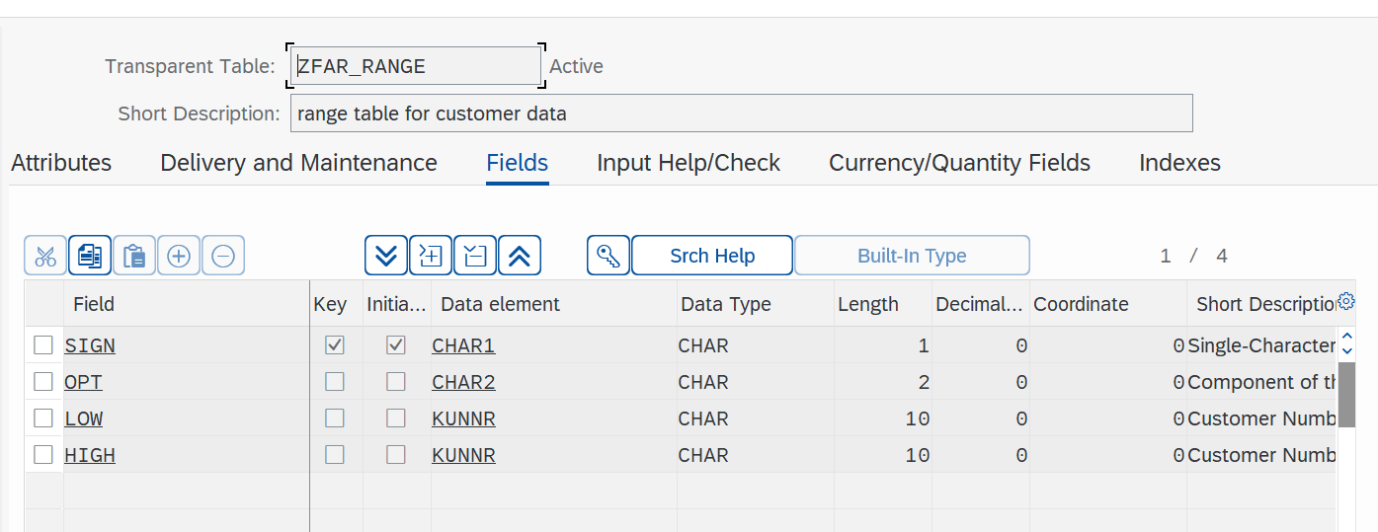

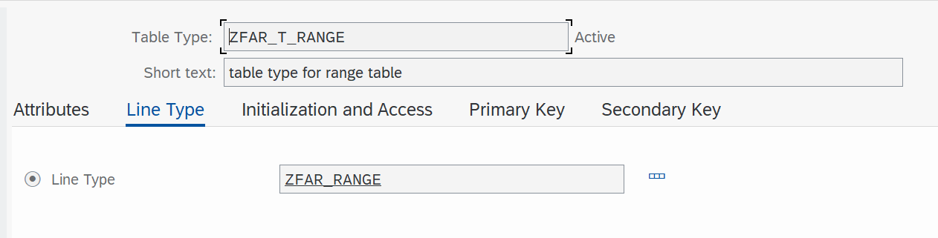

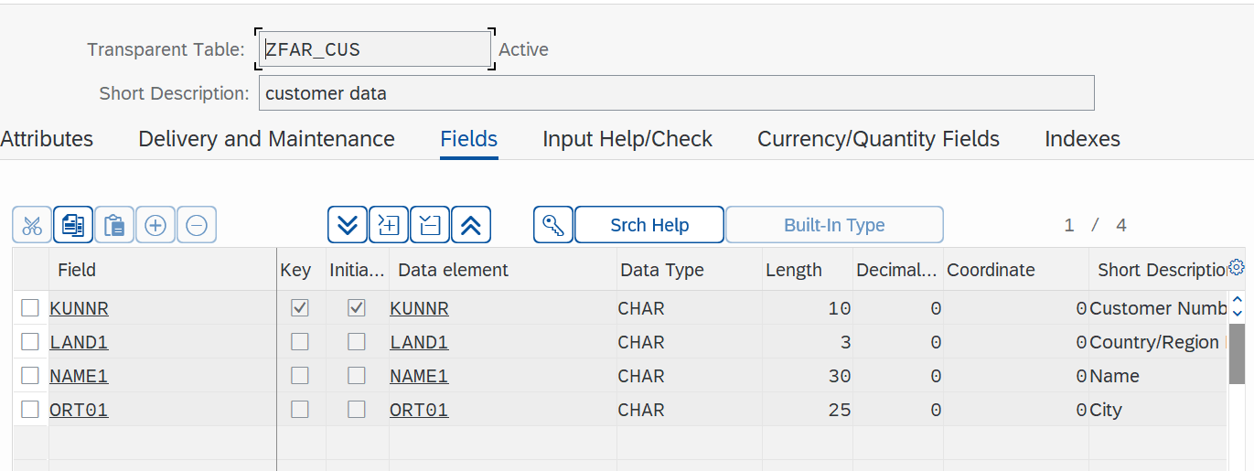

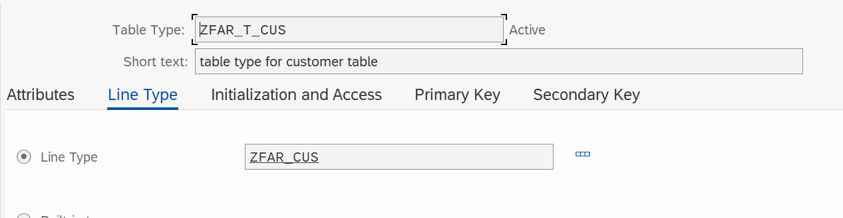

SOURCE CODE:

FUNCTION zfar_fm2_custrange.

*"----------------------------------------------------------------------

*"*"Local Interface:

*" IMPORTING

*" REFERENCE(P_KUNNR) TYPE ZFAR_ASS1_RANGE_TYPE

*" EXPORTING

*" REFERENCE(IT_HEADER) TYPE ZFAR_ASS1_CUS_DA_TYPE

*" EXCEPTIONS

*" INVALID_CUSTOMER

*"----------------------------------------------------------------------

DATA: lt_kna1 TYPE TABLE OF kna1,

lw_kna1 LIKE LINE OF lt_kna1.

DATA lw_header LIKE LINE OF IT_HEADER.

SELECT * FROM kna1 INTO TABLE lt_kna1 WHERE kunnr IN P_KUNNR.

LOOP AT lt_kna1 INTO lw_kna1.

MOVE-CORRESPONDING lw_kna1 TO lw_header.

APPEND lw_header TO IT_header.

CLEAR lw_header.

ENDLOOP.

ENDFUNCTION.

MAIN PROGRAM

*&---------------------------------------------------------------------*  
*& Report ZFAR_ASSESSMENT_1  
*&---------------------------------------------------------------------*  
*&  
*&---------------------------------------------------------------------*  
REPORT ZFAR_ASSESSMENT_1.  
  
DATA : it_header TYPE table of ZFAR_CUS,  
      lw_header LIKE LINE OF it_header.  
  
DATA v_kunnr TYPE ZFAR_CUS-kunnr.  
SELECT-OPTIONS s_KUNNR FOR v_KUNNR.  
  
START-OF-SELECTION.  
PERFORM get_data.  
  
END-OF-SELECTION.  
PERFORM DISPLAY.  
  
FORM get_data .  
  
 CALL FUNCTION 'ZFAR_FM2_CUSTRANGE'  
  EXPORTING  
    p_kunnr                = S_KUNNR[]  
 IMPORTING  
   IT_HEADER              = IT_HEADER  
 EXCEPTIONS  
   INVALID_CUSTOMER       = 1  
   OTHERS                 = 2  
          .  
IF sy-subrc <> 0.  
* Implement suitable error handling here  
  CASE sy-subrc.  
    WHEN 1.  
  
    WHEN 2.  
    WHEN OTHERS.  
  ENDCASE.  
ENDIF.  
  
  
 ENDFORM.  
  FORM display .  
  
  
LOOP AT it_header INTO lw_header.  
  READ TABLE it_header INTO lw_header WITH KEY s_kunnr.  
   WRITE : / 'Customer number:', lw_header-kunnr,  
            / 'Country:', lw_header-land1,  
           / 'Name 1:', lw_header-name1,  
          / 'City :', lw_header-ort01.  
  
    SKIP.  
    ENDLOOP.  
  
  
endform.

Output:

