Print header and item data,

1.if double clicked on header data doc num print that doc numbers item data

2.if double clicked on payer no display payer details.(xd03)

3.if double clicked on material num display material details.(mm03).

*&---------------------------------------------------------------------*  
*& Report ZFAR_PRAC_ASSESS  
*&---------------------------------------------------------------------*  
*&  
*&---------------------------------------------------------------------*  
REPORT zfar_prac_assess.  
DATA: it_vbrk TYPE STANDARD TABLE OF zfar_vbrk1,  
      wa_vbrk LIKE LINE OF it_vbrk,  
      it_vbrp TYPE STANDARD TABLE OF zfar_vbrp1,  
      wa_vbrp LIKE LINE OF it_vbrp.  
SELECT-OPTIONS s_vbeln FOR wa_vbrk-vbeln.  
START-OF-SELECTION.  
  PERFORM get_Data.  
END-OF-SELECTION.  
  PERFORM show_Output.  
*&---------------------------------------------------------------------*  
*& Form get_Data  
*&---------------------------------------------------------------------*  
*& text  
*&---------------------------------------------------------------------*  
*& -->  p1        text  
*& <--  p2        text  
*&---------------------------------------------------------------------*  
FORM get_Data .  
  SELECT * FROM zfar_vbrk1 INTO TABLE it_vbrk WHERE vbeln IN s_vbeln.  
ENDFORM.  
*&---------------------------------------------------------------------*  
*& Form show_Output  
*&---------------------------------------------------------------------*  
*& text  
*&---------------------------------------------------------------------*  
*& -->  p1        text  
*& <--  p2        text  
*&---------------------------------------------------------------------*  
FORM show_Output .  
  CALL FUNCTION 'REUSE_ALV_GRID_DISPLAY'  
    EXPORTING  
      i_callback_program      = 'ZFAR_PRAC_ASSESS'  
      i_callback_user_command = 'USER_COMMAND'  
      i_structure_name        = 'ZFAR_VBRK1'  
    TABLES  
      t_outtab                = it_vbrk  
    EXCEPTIONS  
      program_error           = 1  
      OTHERS                  = 2.  
  IF sy-subrc <> 0.  
* Implement suitable error handling here  
  ENDIF.  
ENDFORM.  
  
FORM user_command USING r_ucomm LIKE sy-ucomm  
                        rs_selfield TYPE slis_selfield.  
  IF r_ucomm EQ '&IC1'.  
     IF rs_selfield-fieldname EQ 'VBELN'.  
      DATA v_vbeln TYPE vbeln.  
      v_vbeln = rs_selfield-value.  
      CALL FUNCTION 'CONVERSION_EXIT_ALPHA_INPUT'  
        EXPORTING  
          input  = v_vbeln  
        IMPORTING  
          output = v_vbeln.  
      SELECT * FROM zfar_vbrp1 INTO TABLE it_vbrp WHERE vbeln EQ v_vbeln."rs_selfield-value.  
      CALL FUNCTION 'REUSE_ALV_GRID_DISPLAY'  
        EXPORTING  
          i_callback_program = 'ZFAR_PRAC_ASSESS'  
         i_callback_user_command = 'USER_CMD'  
          i_structure_name   = 'ZFAR_VBRP1'  
        TABLES  
          t_outtab           = it_vbrp  
        EXCEPTIONS  
          program_error      = 1  
          OTHERS             = 2.  
      IF sy-subrc <> 0.  
* Implement suitable error handling here  
      ENDIF.  
    ELSEIF r_ucomm EQ '&IC1' AND rs_selfield-fieldname EQ 'KUNRG'.  
      SET PARAMETER ID 'KUN' FIELD rs_selfield-value.  
      CALL TRANSACTION 'XD03'AND SKIP FIRST SCREEN.  
    ENDIF.  
  ENDIF.  
ENDFORM.  
  
FORM user_cmd USING r_ucomm LIKE sy-ucomm  
                        rs_selfield TYPE slis_selfield.  
  IF r_ucomm EQ '&IC1' AND rs_selfield-fieldname EQ 'MATNR'.  
    SET PARAMETER ID 'MAT' FIELD rs_selfield-value.  
    CALL TRANSACTION 'MM03' AND SKIP FIRST SCREEN.  
  ENDIF.  
ENDFORM.

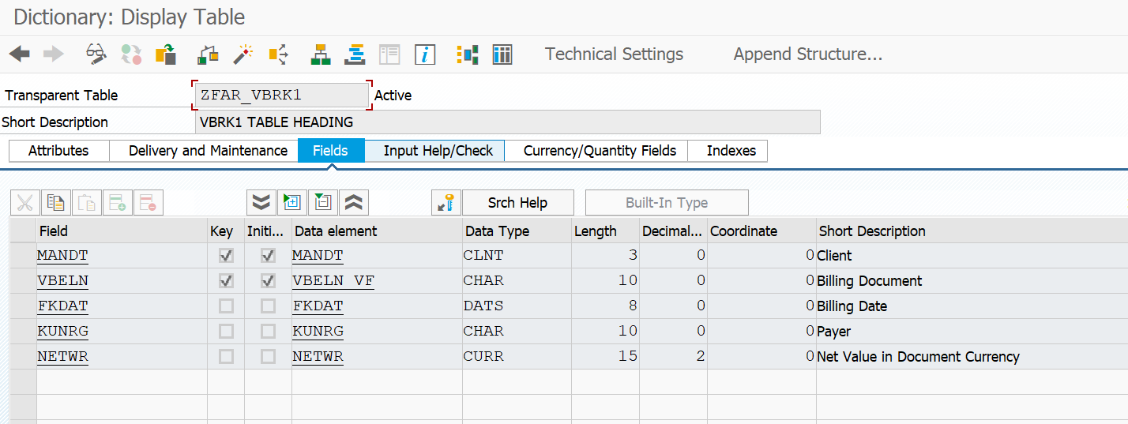

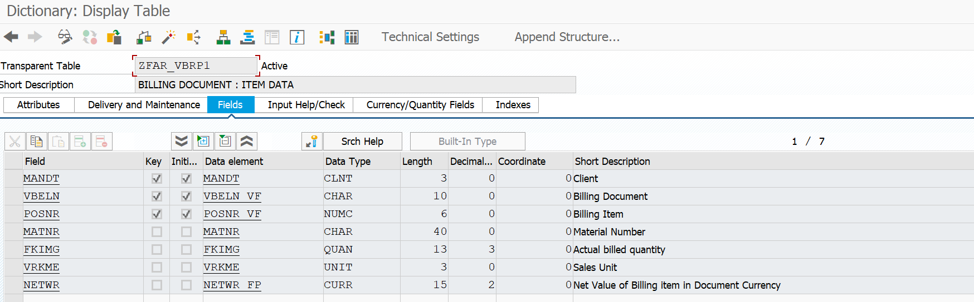

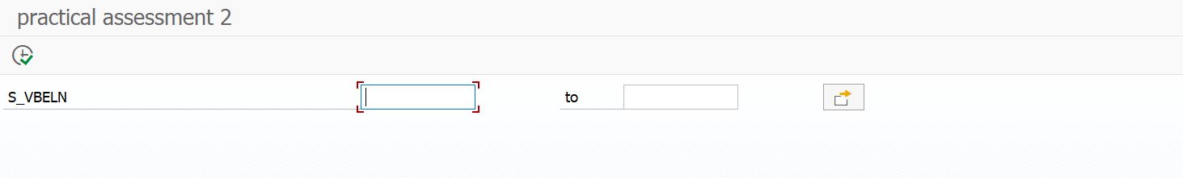

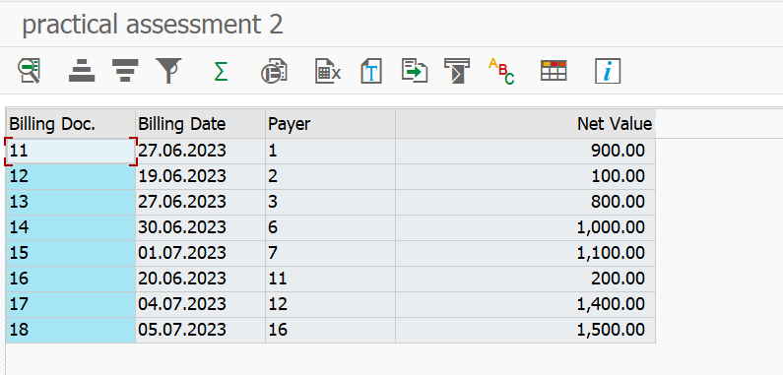

Double click on payer, it will take you to xd03.

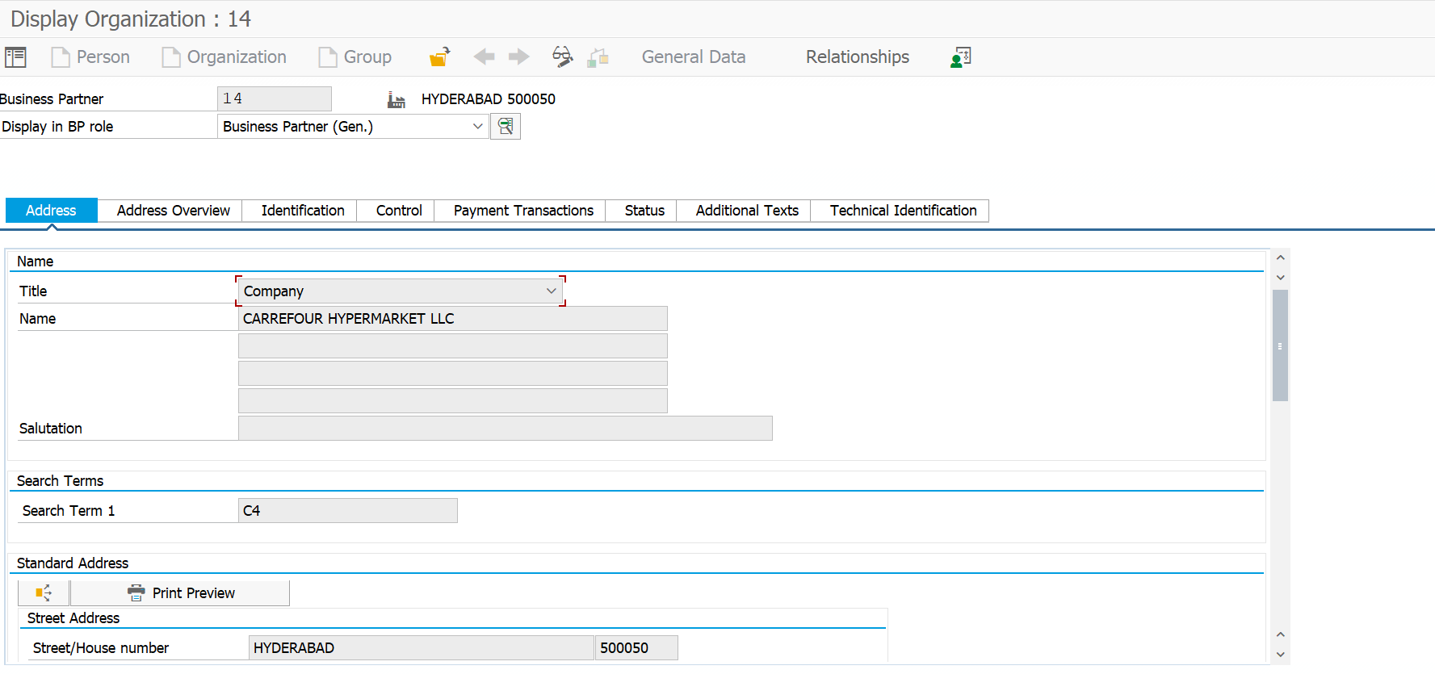

Double click on doc number it will print the item data for that document number

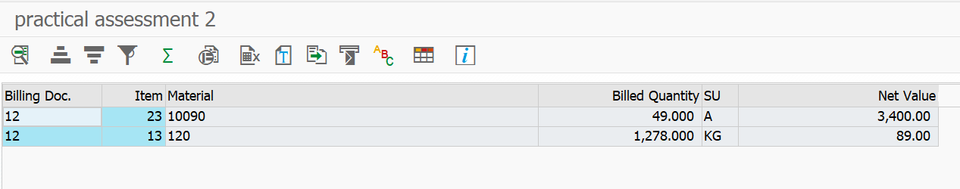

If double clicked on material number it will take you to mmo3.

