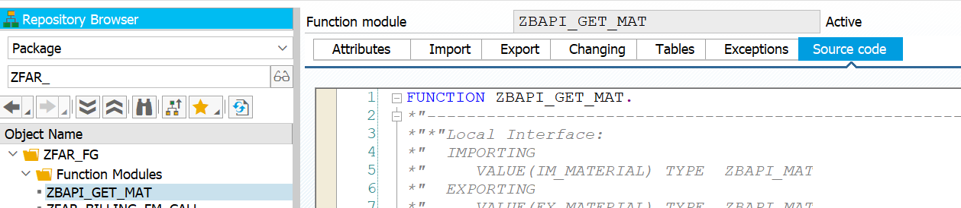

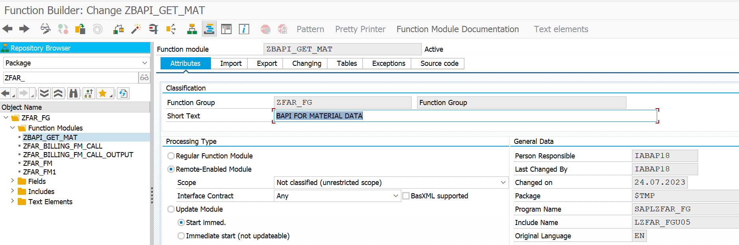

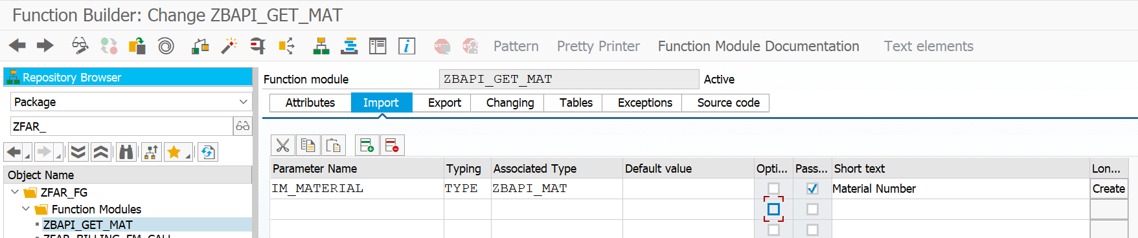

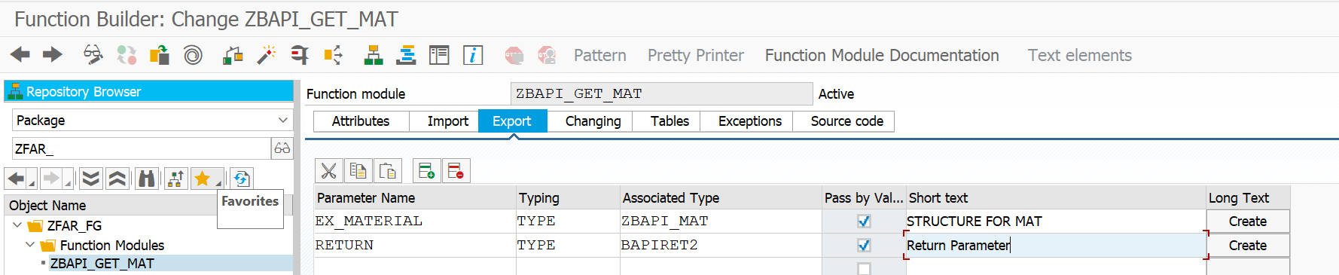

FUNCTION ZBAPI_GET_MAT.  
*"----------------------------------------------------------------------  
*"*"Local Interface:  
*"  IMPORTING  
*"     VALUE(IM_MATERIAL) TYPE  ZBAPI_MAT  
*"  EXPORTING  
*"     VALUE(EX_MATERIAL) TYPE  ZBAPI_MAT  
*"     VALUE(RETURN) TYPE  BAPIRET2  
*"----------------------------------------------------------------------  
SELECT SINGLE MATNR SPRAS MAKTX FROM MAKT INTO EX_MATERIAL WHERE matnr EQ IM_MATERIAL.  
IF SY-SUBRC IS NOT INITIAL.  
  RETURN-TYPE = 'E'.  
  RETURN-MESSAGE = 'NO RECORD FOUND'.  
ENDIF.  
  
ENDFUNCTION.

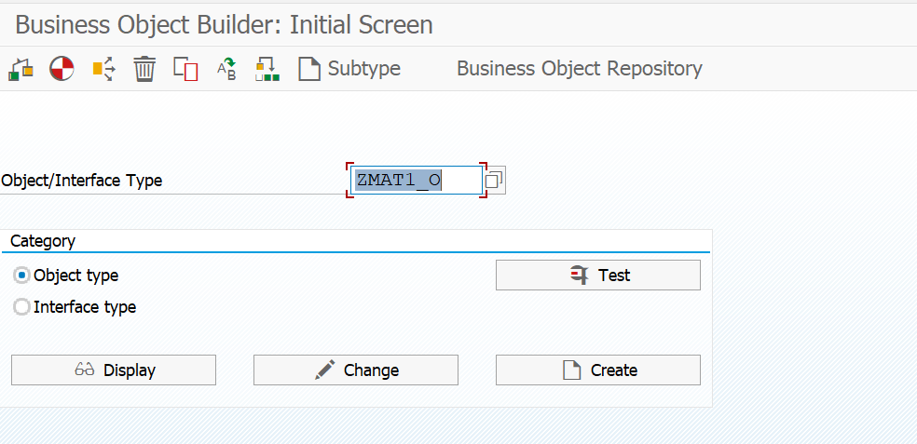

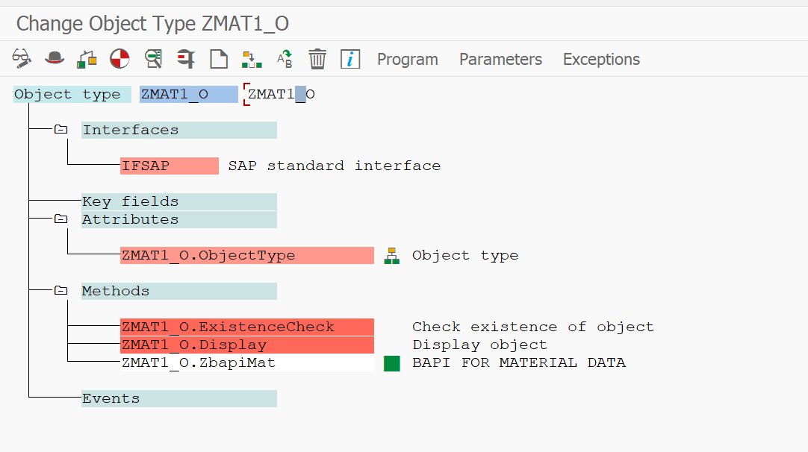

Go to swo1 transaction and give object name Zmat_o and click on test u can see the data.

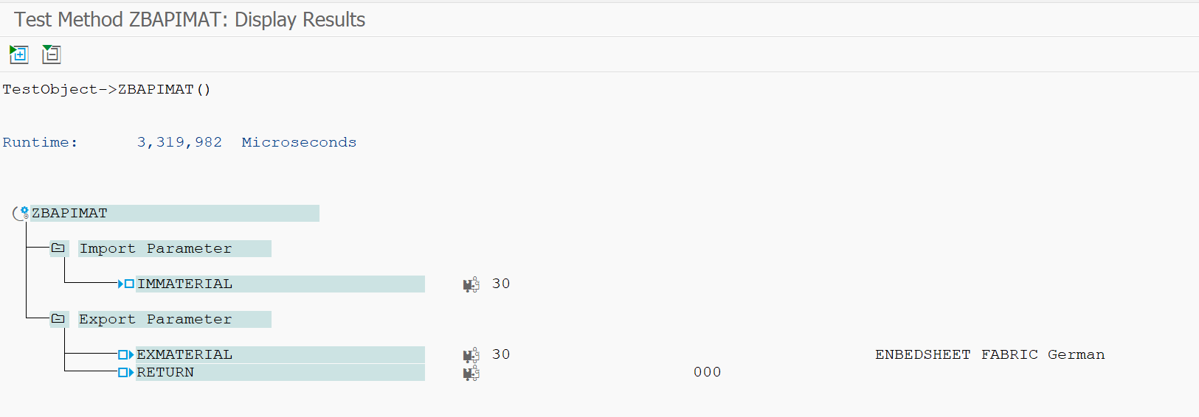

This can be used for external u can also check in bapi explore (/bapi)) first in goto->BAPI’s to display->select

