**TITLE**

**Aim:**

**Algorithm:**

**User Registration:**

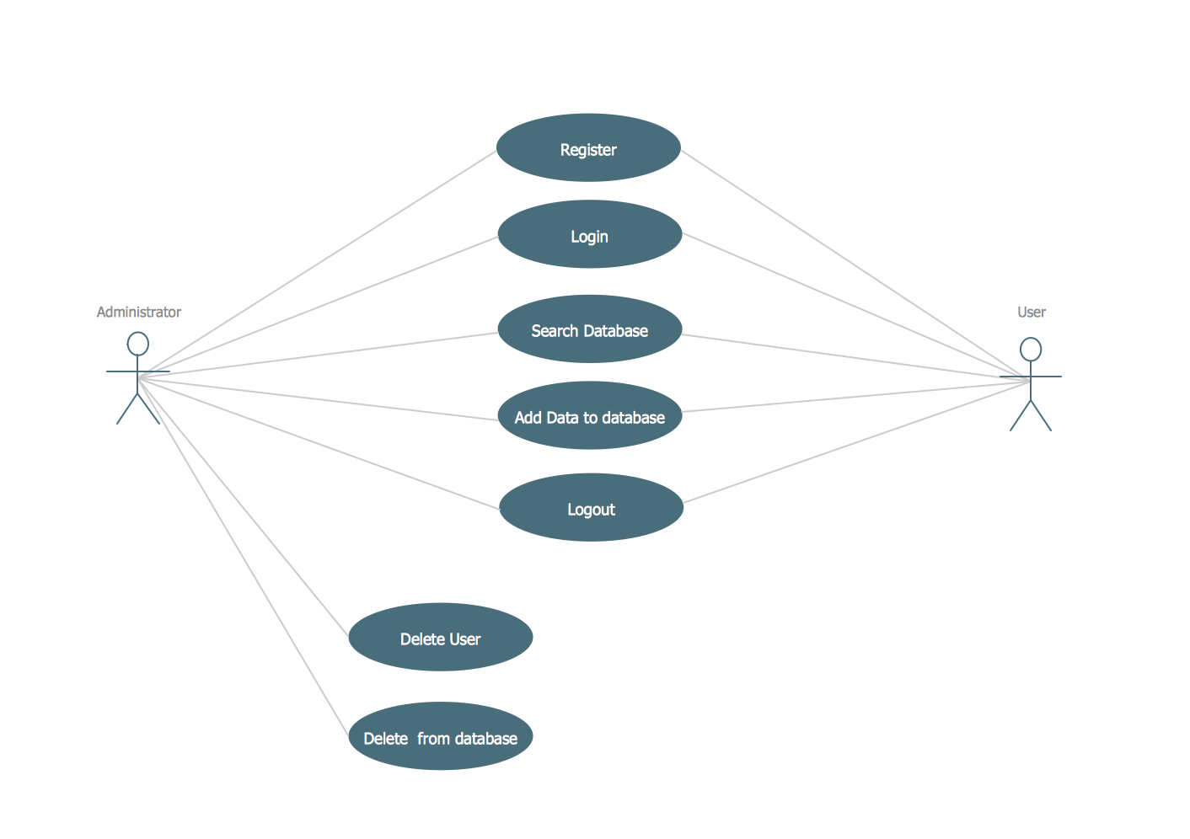

**Result:**

The diagram for the above program was drawn successfully and its output is verified.

**ATM**

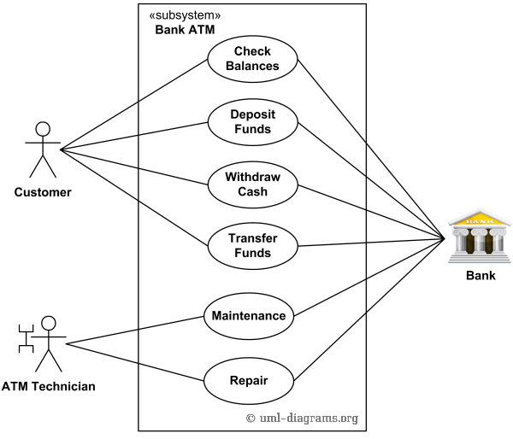

**Result:**

The diagram for the above program was drawn successfully and its output is verified.

**Stock Management**

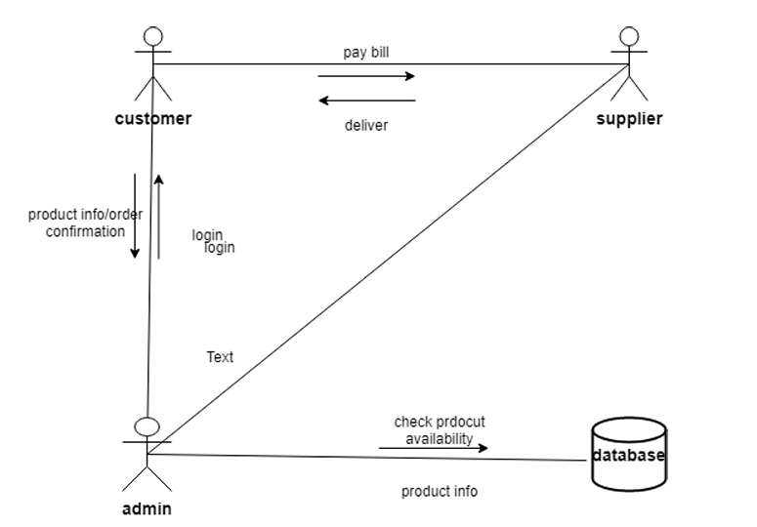

**Result:**

The diagram for the above program was drawn successfully and its output is verified.

**Online Store**

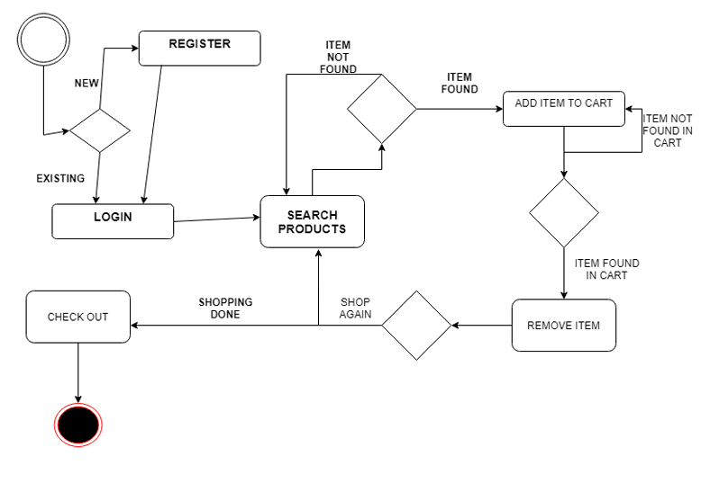

**Result:**

The diagram for the above program was drawn successfully and its output is verified.

**Banking System**

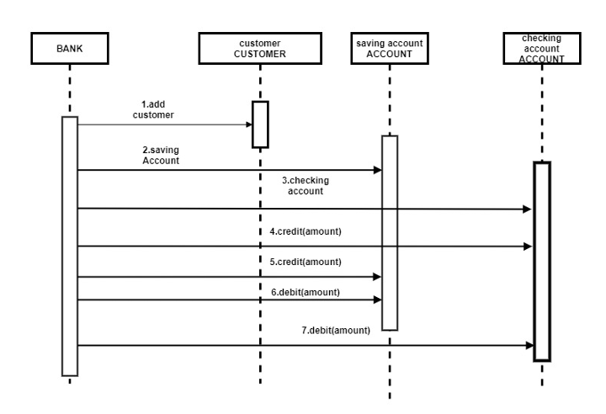

**Result:**

The diagram for the above program was drawn successfully and its output is verified.

**Apartment Plan**

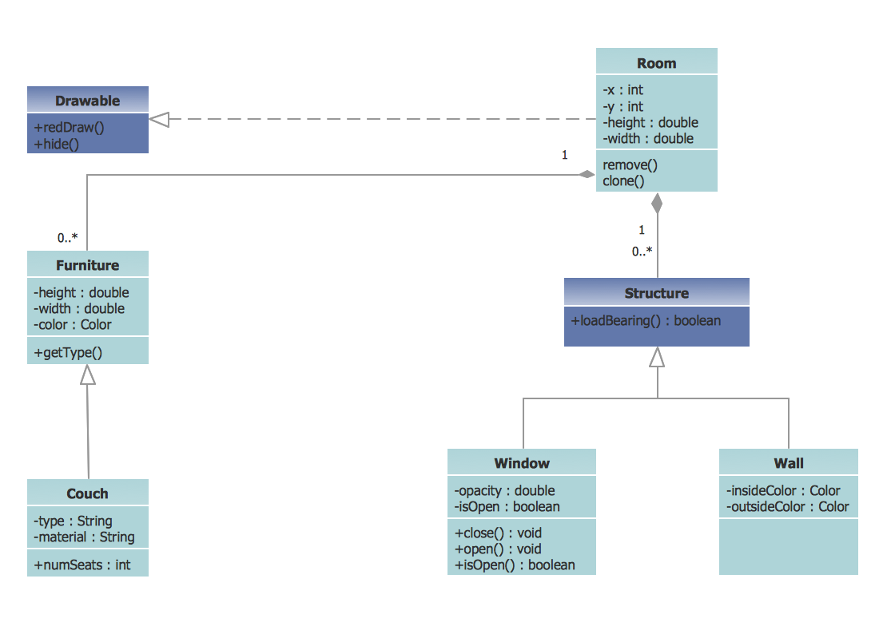

**Result:**

The diagram for the above program was drawn successfully and its output is verified.

**Ticket Booking**

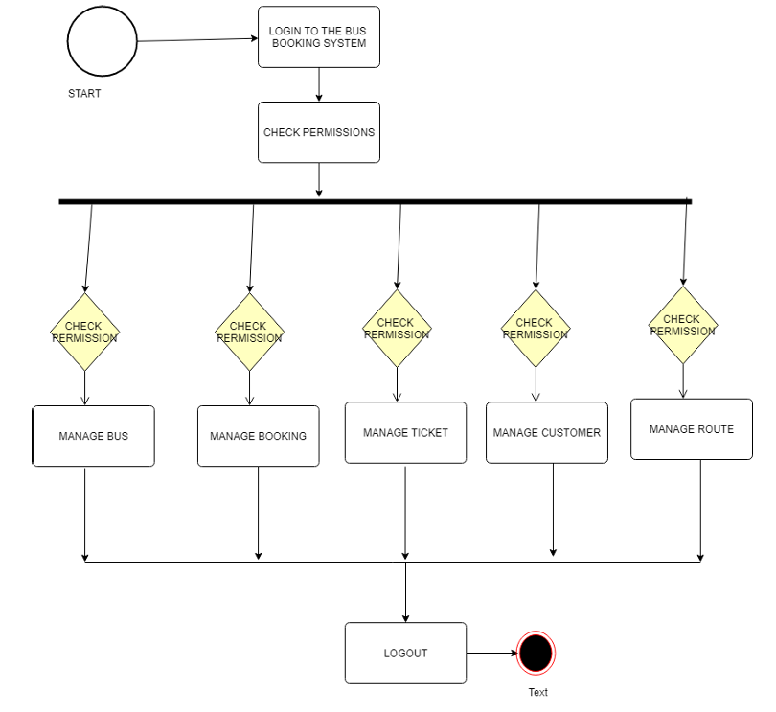

**Result:**

The diagram for the above program was drawn successfully and its output is verified.

**Pharmacy Management**

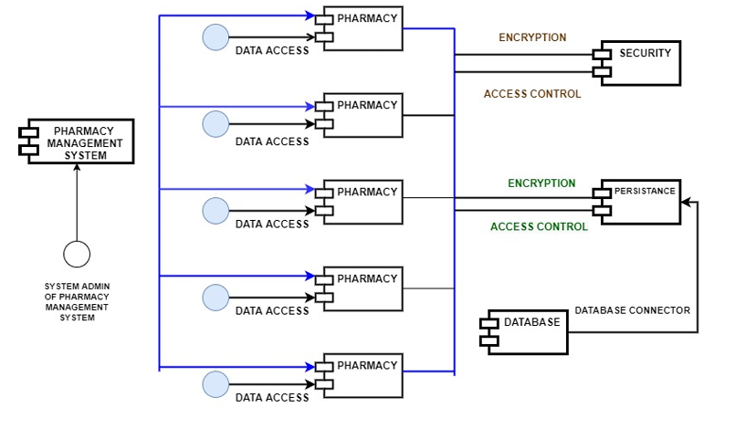

**Result:**

The diagram for the above program was drawn successfully and its output is verified.

**Library Management**

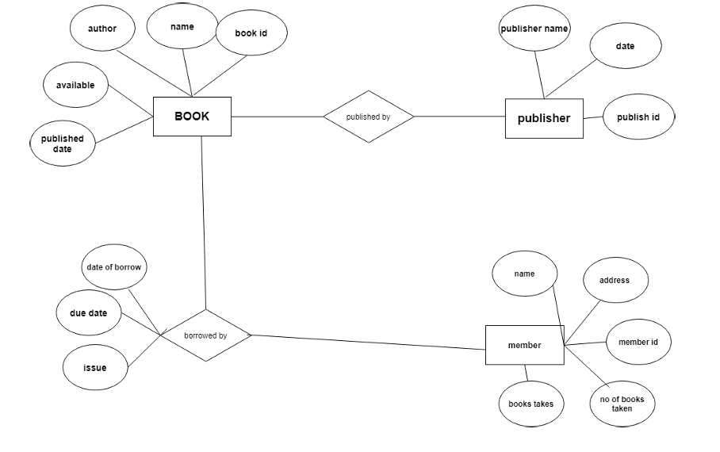

**Result:**

The diagram for the above program was drawn successfully and its output is verified.

**Payroll Management**

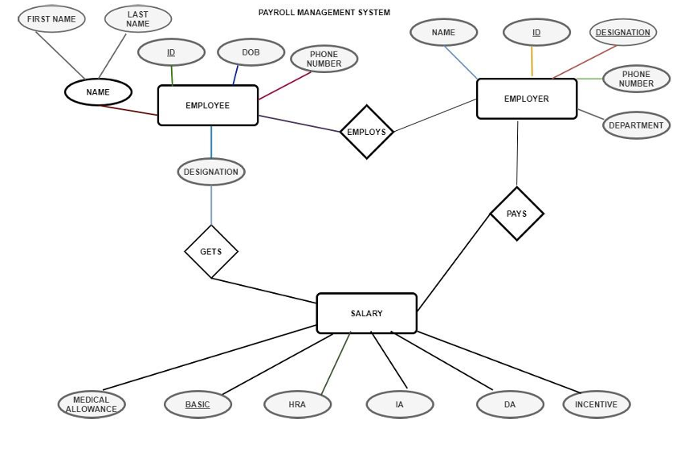

**Result:**

The diagram for the above program was drawn successfully and its output is verified.

**Student Information**

**Level zero DFD**

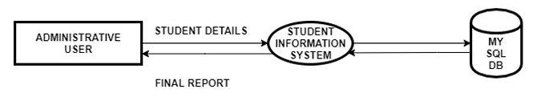

**Level one DFD**

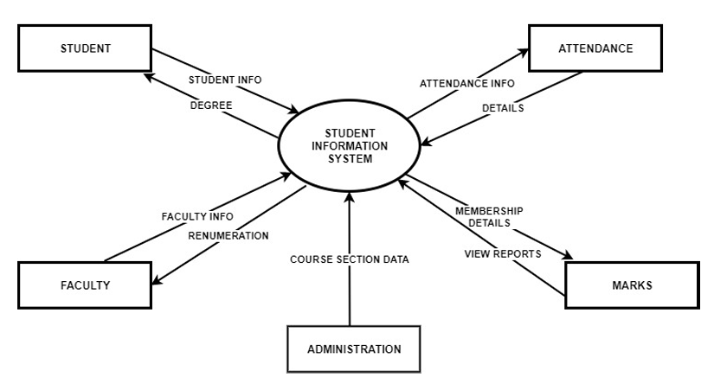

**Result:**

The diagram for the above program was drawn successfully and its output is verified.

**Food Ordering System**

**Level zero DFD**

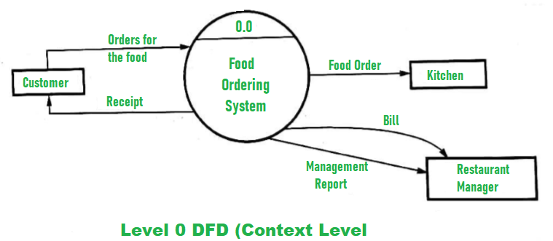

**Level one DFD**

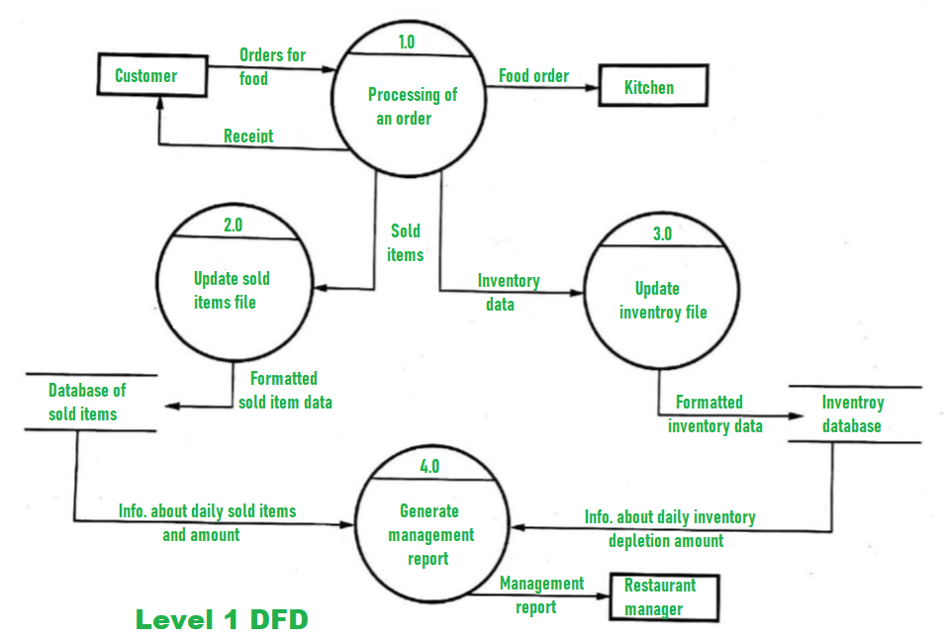

**Result:**

The diagram for the above program was drawn successfully and its output is verified.