Designing Secure and Efficient Biometric

In this project we are using Face and Finger print authentication to validate all users and if user validate then he will be allowed to upload his files to cloud or he can download also.

To use finger print device you need to install software’s come with device and then test the device by reading manual and after device working then you can run this application

To run project first copy content from ‘DB.txt’ file and paste in MYSQL to create database and then double click on ‘run.bat’ to start python DJANGO server and get below output

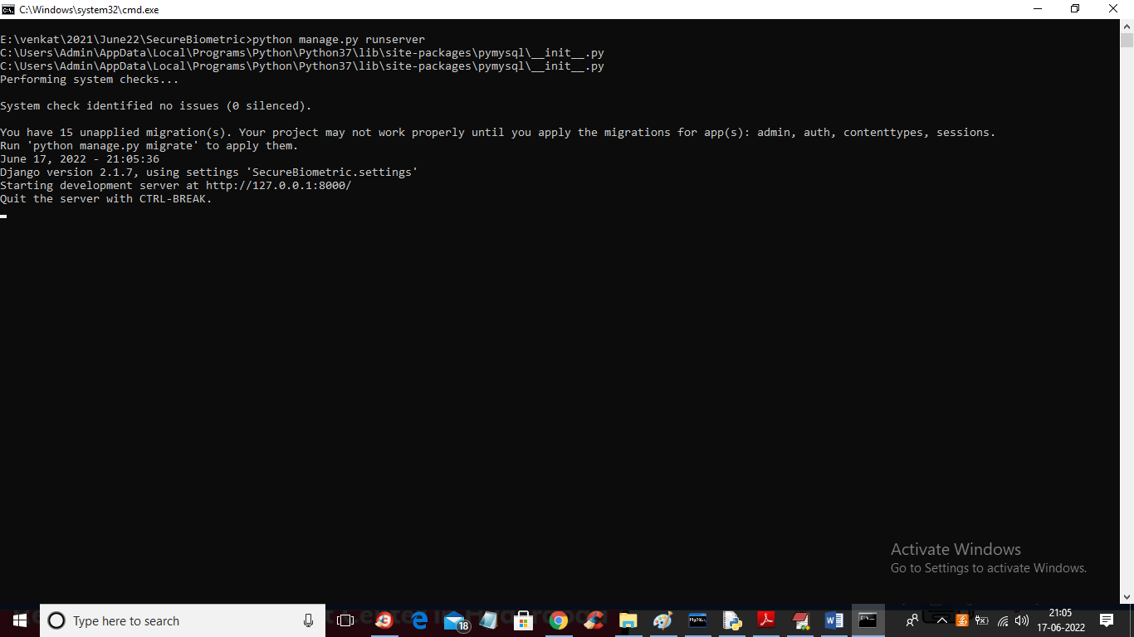

In above screen python DJANGO server started and now open browser and enter URL as <http://127.0.0.1:8000/index.html> and press enter key to get below home page

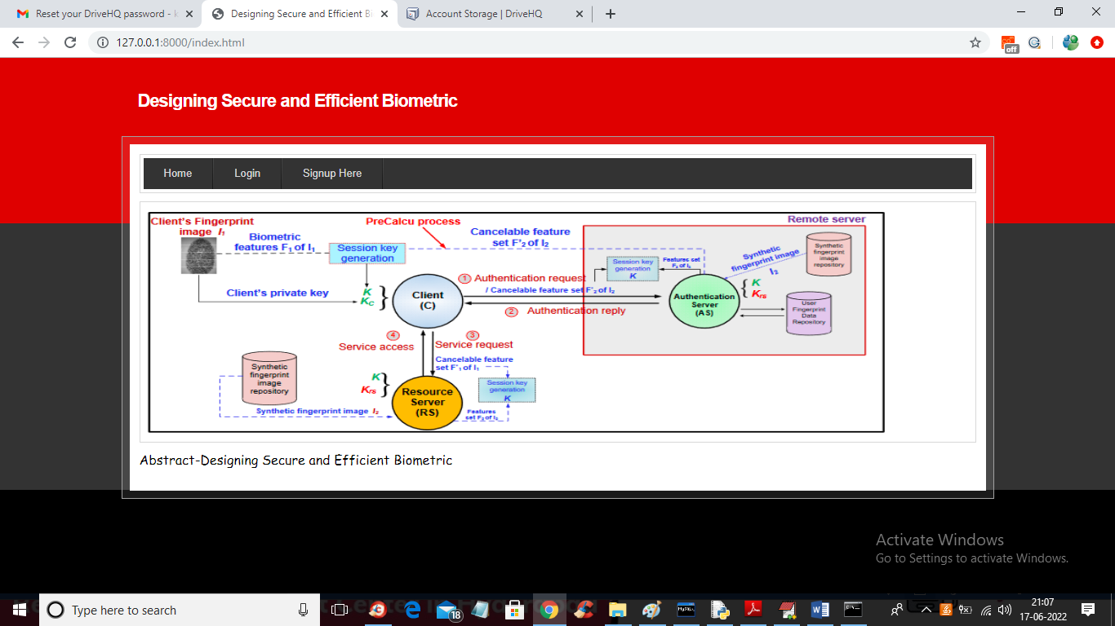

In above screen click on ‘Signup Here’ link to allow user to register with the application with finger and face like below screen

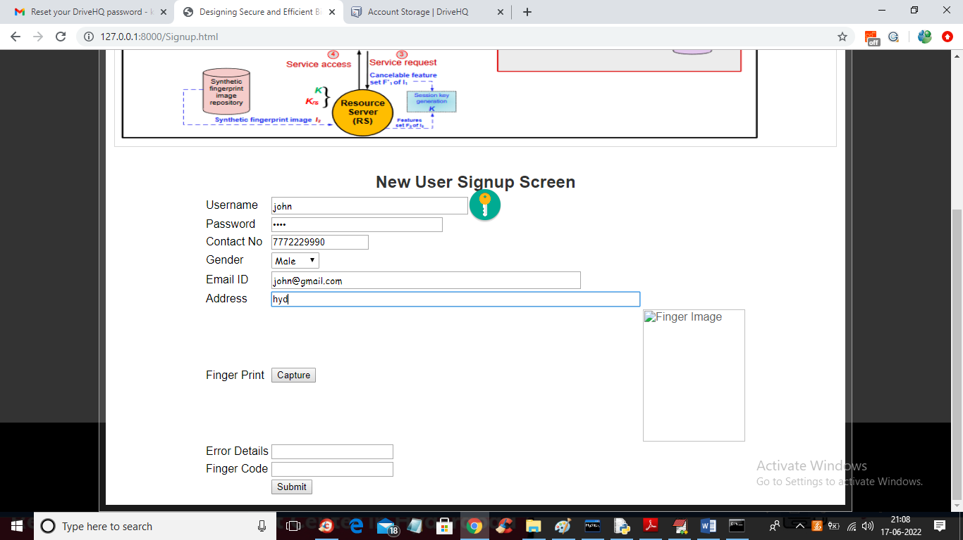

In above screen user is entering signup details and then click on ‘Capture’ button to activate your finger print device and device will show red light and then place your thumb or finger till light gone and you will get finger code in bottom text fields and then click on ‘Submit’ button to capture face.

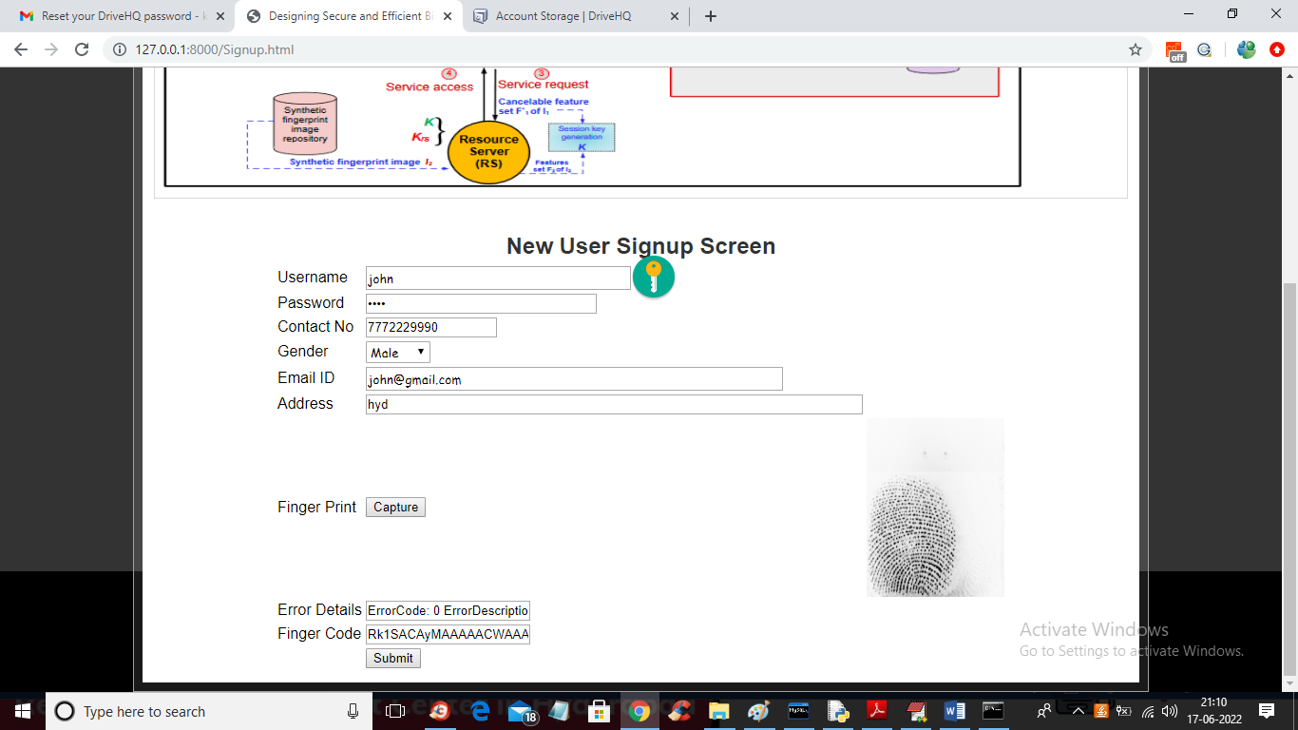

In above screen finger is captured and press submit button to get below screen

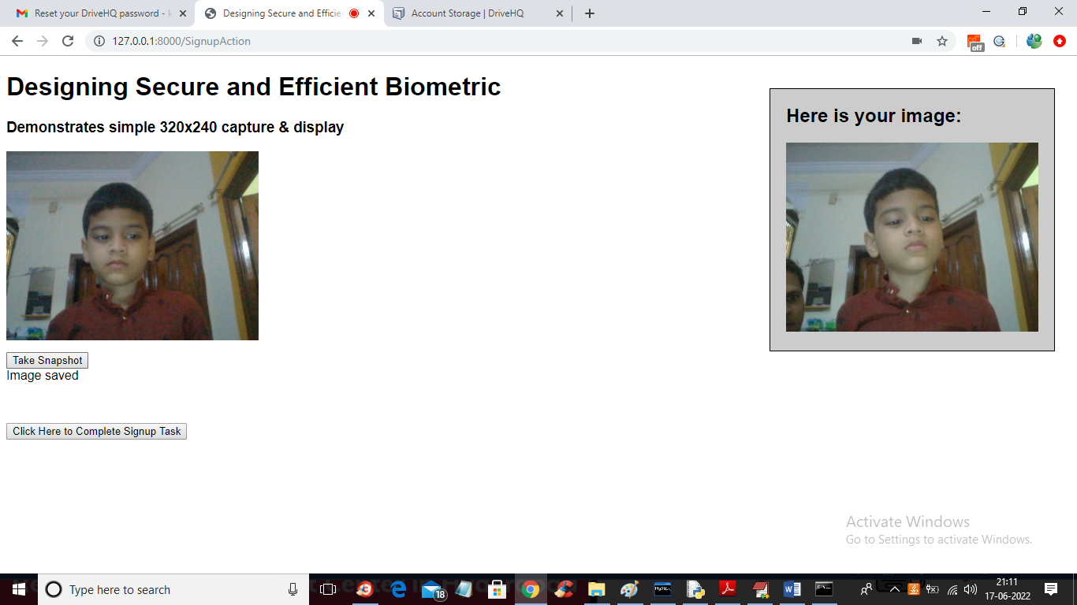

In above screen captured the face by clicking on ‘Take Snapshot’ and then pressed on ‘Click Here to Complete Signup Task’ button to get below output

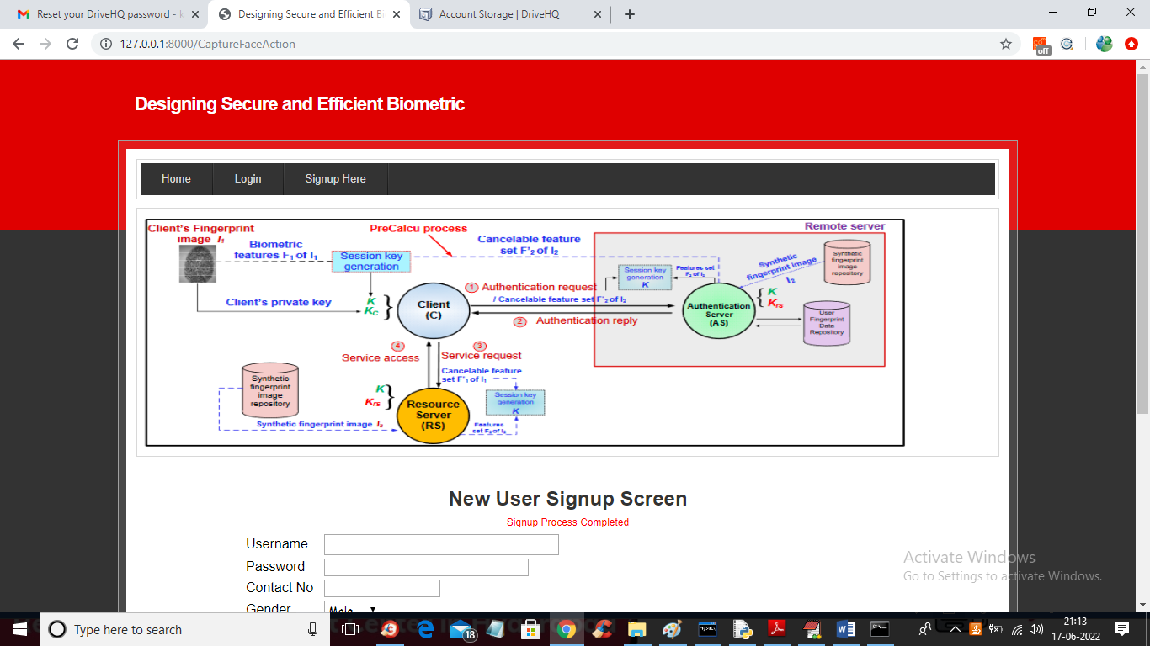

In above screen signup process completed and now click on ‘Login’ button to login user. First user will get authenticate with username and password and then ask for finger print and then ask for face validation.

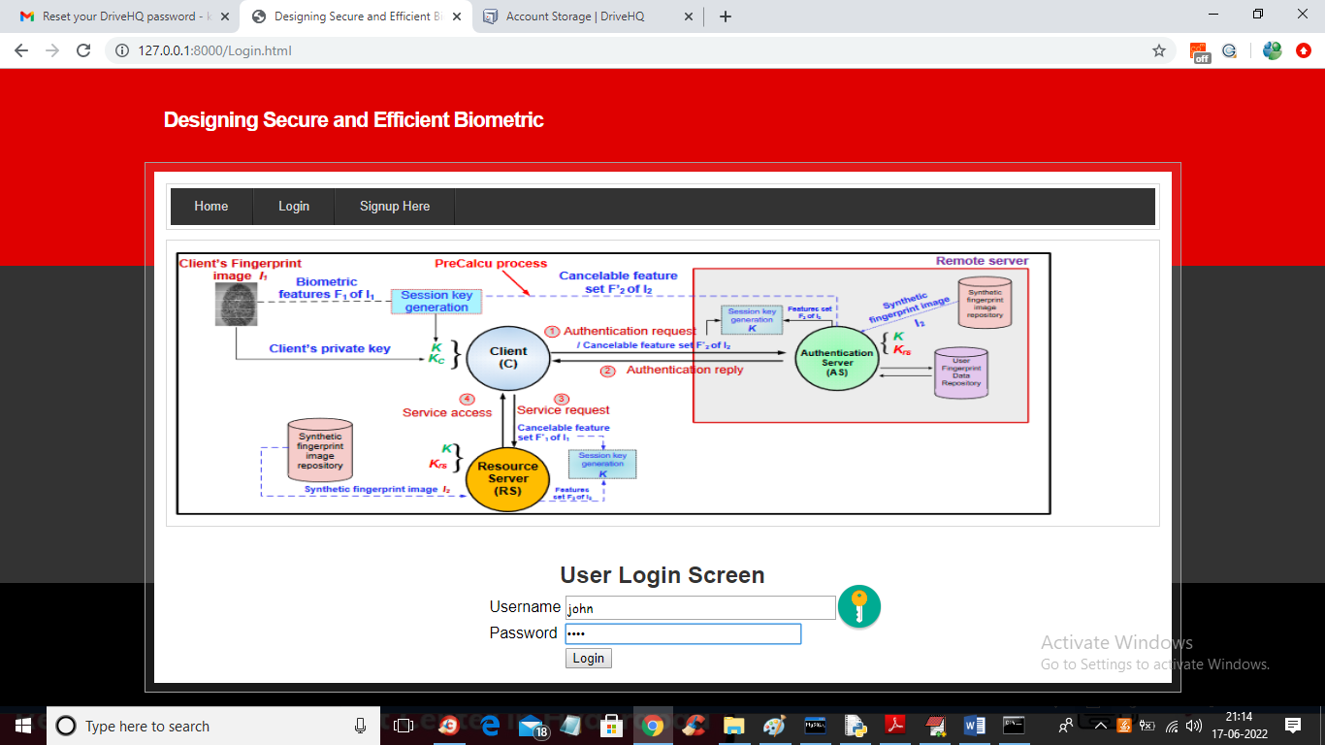

In above screen user is login and then press button to get below finger screen

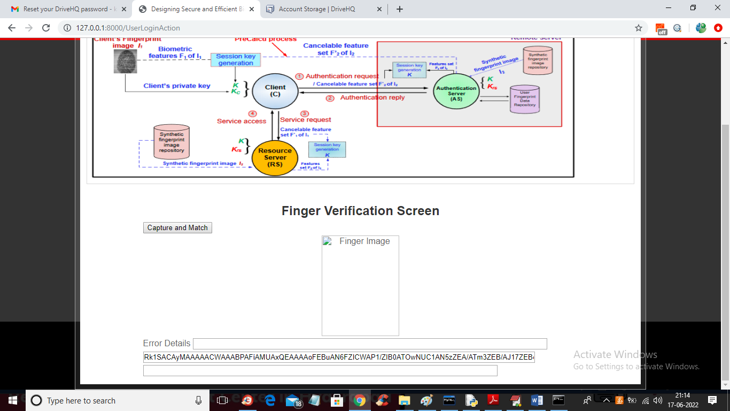

In above screen click on ‘Capture and Match’ button then place you finger to get below screen

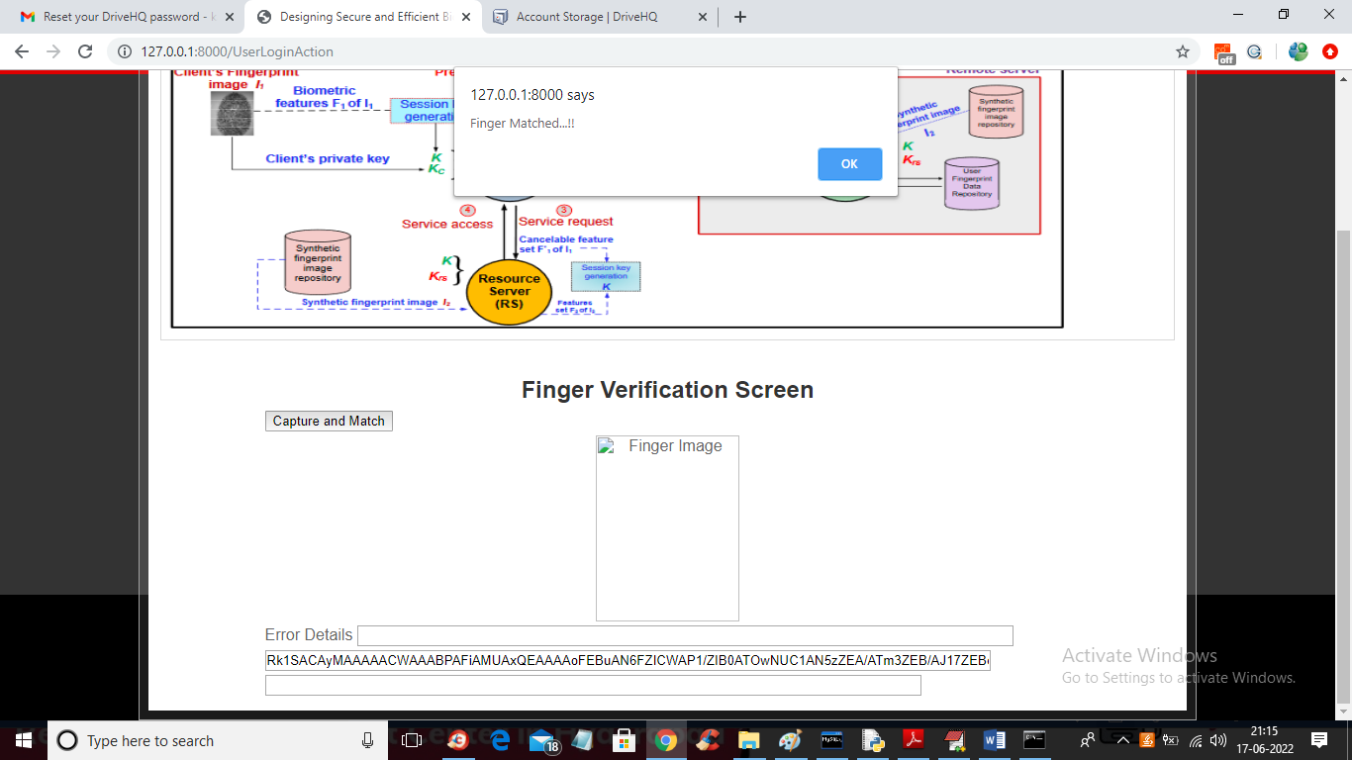

In above screen finger is matched and now click on ‘OK’ button to get below screen for face validation

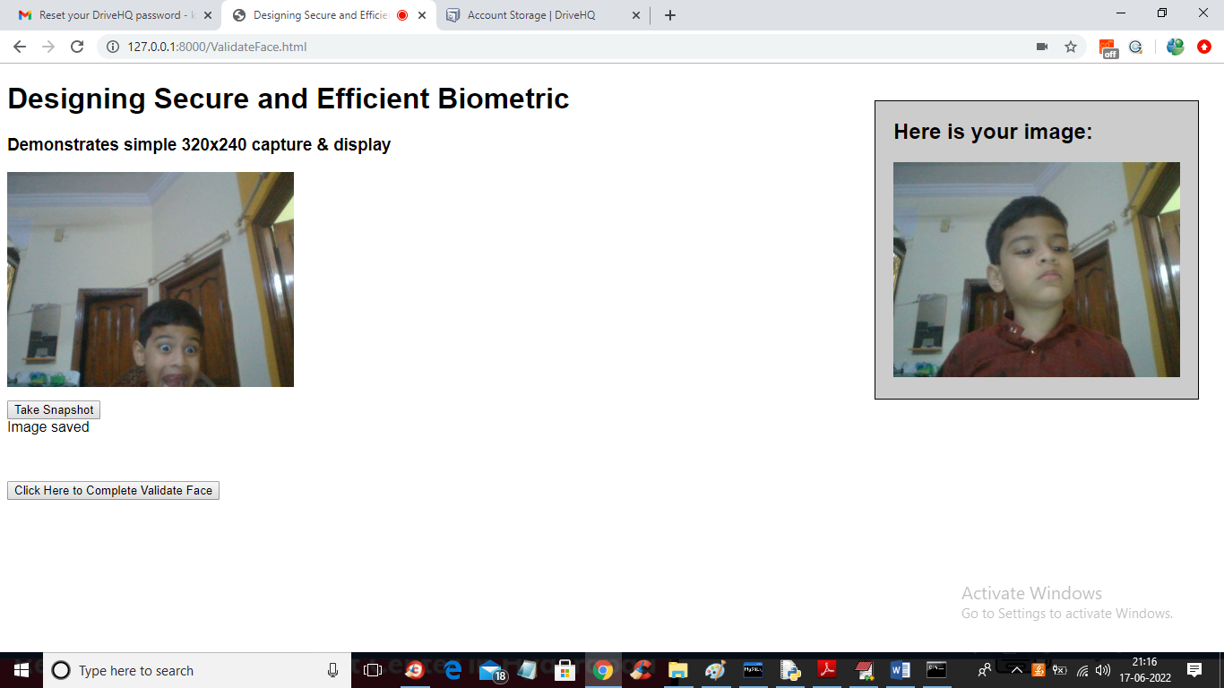

In above screen user image is captured and now click on ‘Click Here to Complete Validate Face’ button to validate face and if validated then will get below screen

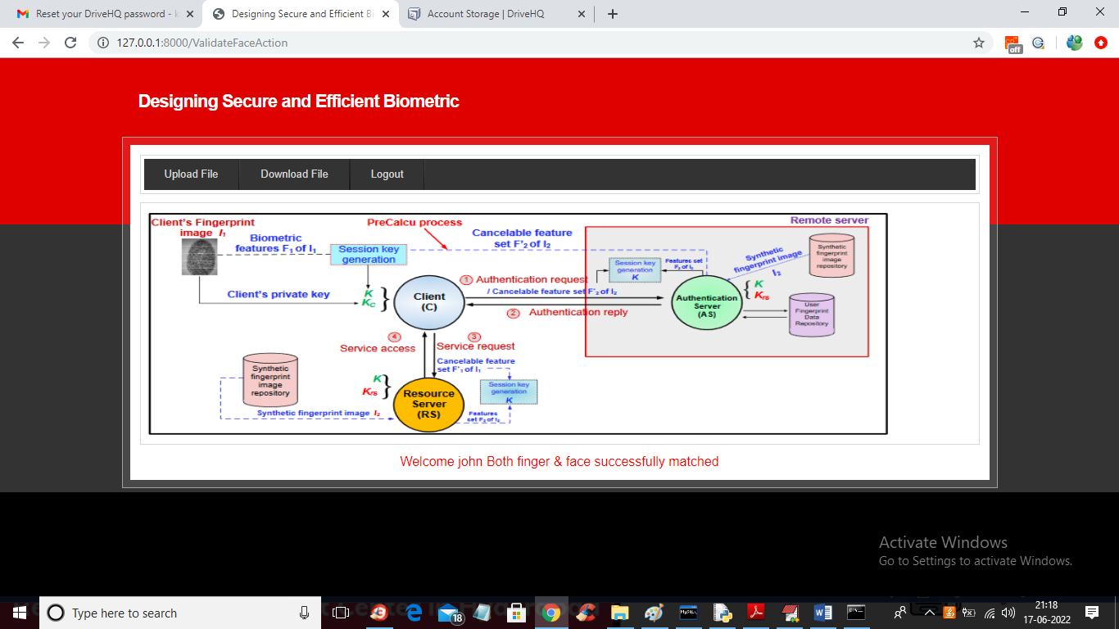

In above screen in red colour text we can see both face and finger matched successfully and now click on ‘Upload File’ button to get below screen

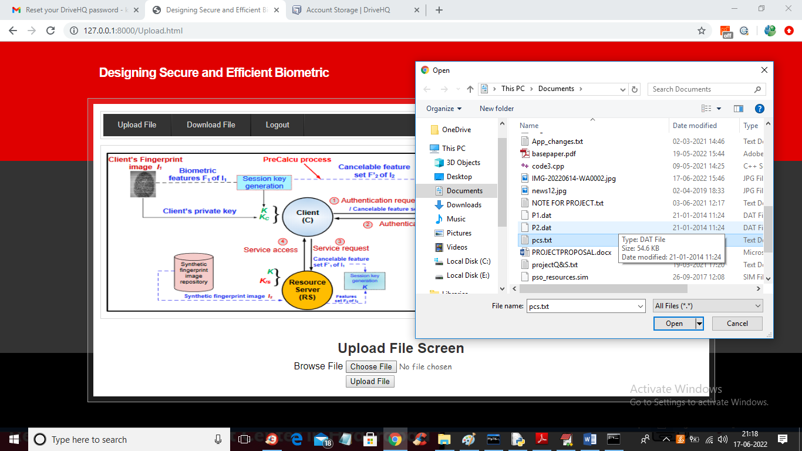

In above screen selecting and uploading ‘pcs.txt’ file and then click on ‘Open’ and ‘Upload’ button to upload file to DRIVEHQ cloud and get below screen

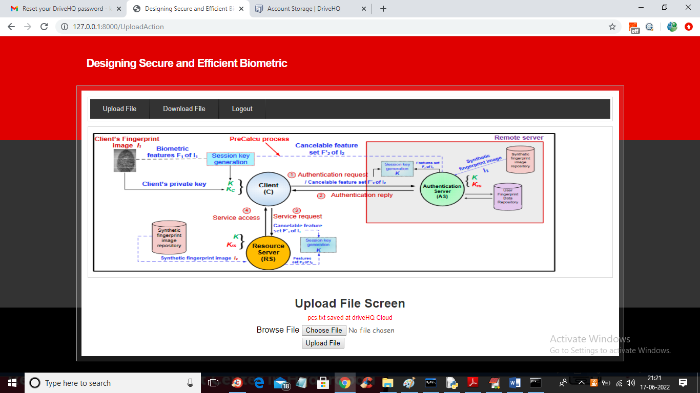

In above screen we can see ‘pcs.txt’ file saved in cloud DriveHQ server and now open DRIVEHQ by entering URL as ‘drivehq.com’ and then enter username as ‘cdaproject’ and password as ‘Offenburg965#’ to get below screen

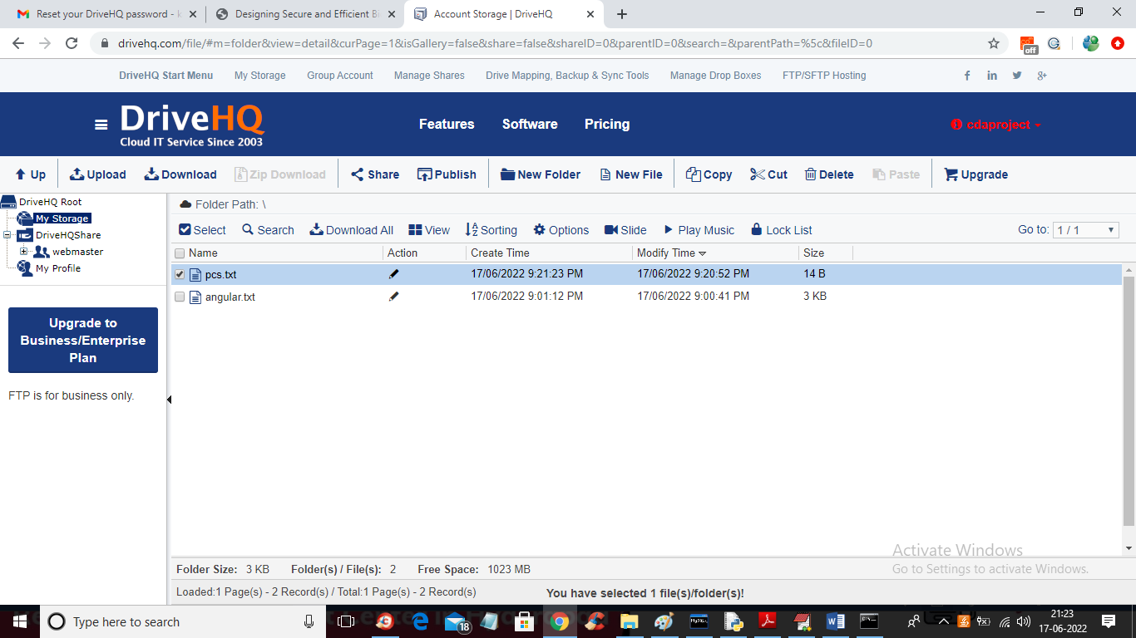

In above screen we can see ‘pcs.txt’ file saved in DRIVEHQ and in application click on ‘Download’ link to get below screen

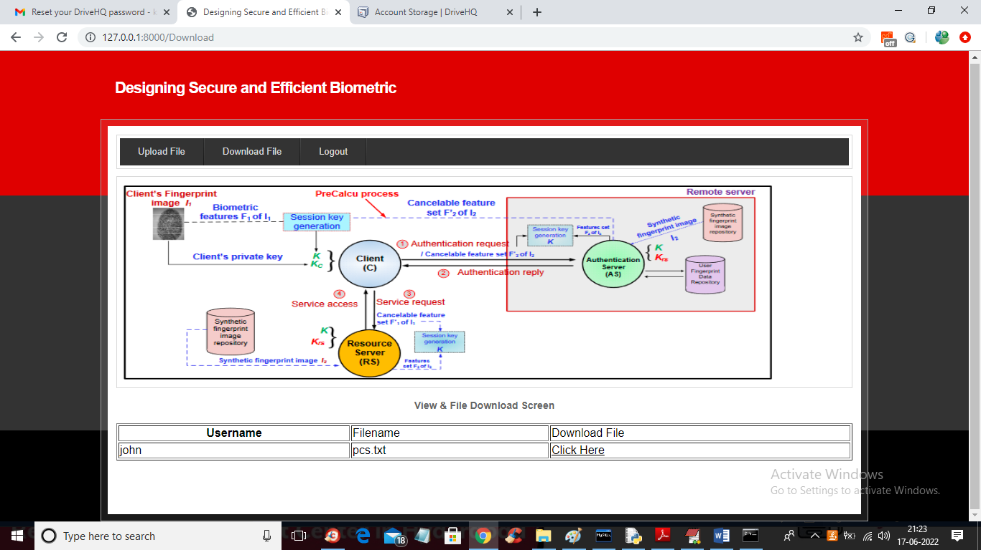

In above screen user can view all files uploaded by him and then press ‘Click Here’ link to download that file and get below output

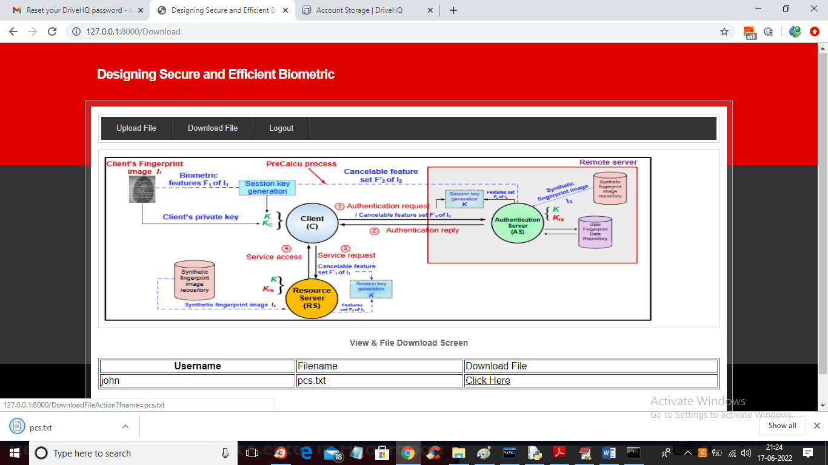

In above screen in browser status bar we can see pcs.txt file downloaded and similarly you can signup any number of users and then upload and download file

Note: upload small files as DRIVEHQ will take too much time for upload