Skairova User Manual
This manual explains how a regular customer uses Skairova to search for flights, review flight details, enter traveler information, and complete a booking.
No technical knowledge is required. A user only needs a web browser, internet access, traveler details, and payment details if live payments are enabled.

1. Open Skairova
Open the Skairova website in your browser.
The homepage opens on the Flights section. From here, you can search using either AI Search or Manual Search.
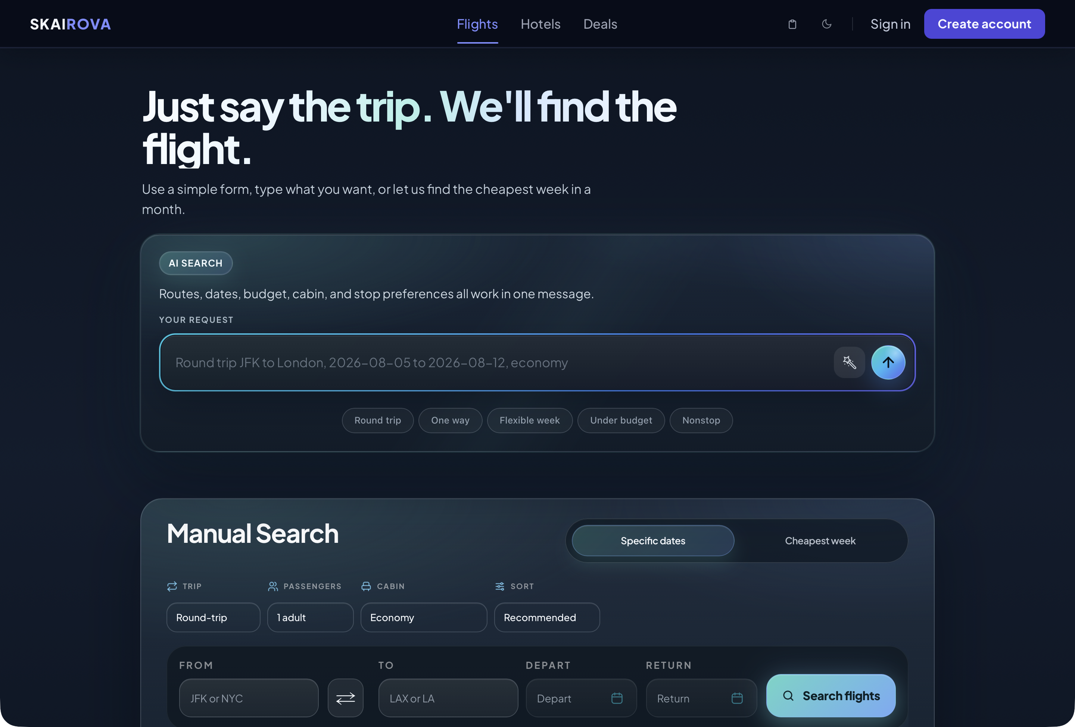
Homepage AI Search

2. Search Using AI Search
Use AI Search when you want to describe your trip in plain language.
- Click inside the Your request text box.
- Type your trip request.
- Include the route, date, cabin, budget, or stop preference if you know them.
- Click the round send button on the right side of the text box.
Example request:
Nonstop from SFO to JFK on 2026-11-22, economy
You can also write requests such as:
JFK to LAX from August 5 to August 12, one adult, economy
The AI can understand:
- Departure city or airport
- Destination city or airport
- Departure date
- Return date
- Cabin class
- Nonstop preference
- Budget preference
- Flexible travel timing
If the AI cannot understand the request, reword it with clearer airport names and dates.

3. Open Manual Search
Use Manual Search if you prefer filling out fields yourself.
- Click Manual search below the AI Search card.
- The full manual search form opens.
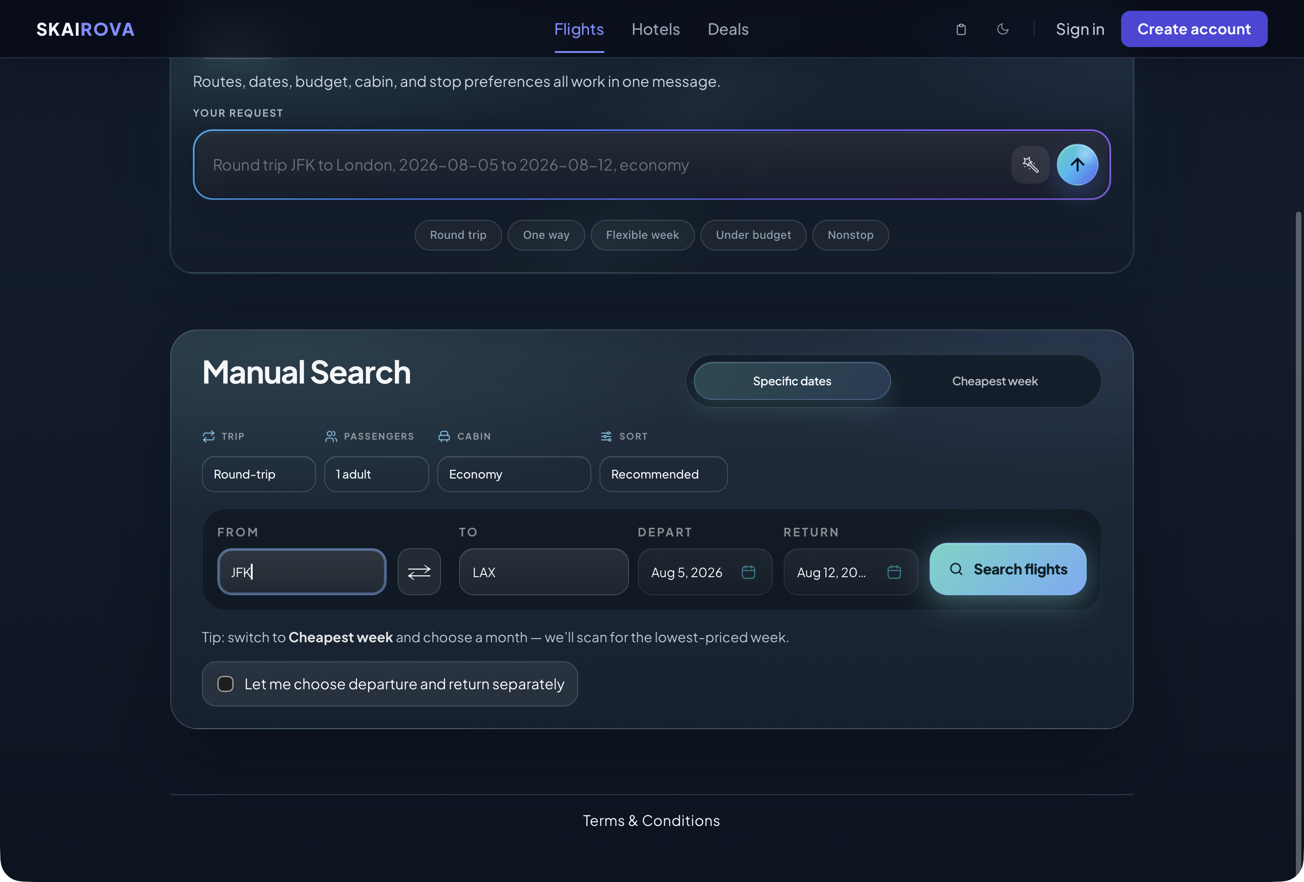
Manual Search

4. Fill Out Manual Search
In Manual Search, complete the trip fields.
- Choose the trip type.
- Choose the number of passengers.
- Choose the cabin.
- Choose the sort option.
- Enter the departure city or airport in From.
- Enter the destination city or airport in To.
- Choose the departure date.
- Choose the return date if this is a round trip.
- Click Search flights.
Trip type options may include:
- Round-trip
- One-way
Cabin options may include:
- Economy
- Premium Economy
- Business
- First
Sort options may include:
- Recommended
- Cheapest
- Fastest
Important: For best results, use airport codes such as JFK, LAX, SFO, or clear city names such as New York or Los Angeles.

5. Search For The Cheapest Week
Use Cheapest week when your travel dates are flexible.
- Open Manual Search.
- Select Cheapest week.
- Enter the departure city or airport.
- Enter the destination city or airport.
- Select the month.
- Select the trip duration.
- Click Find cheapest week.
Skairova scans possible dates in that month and looks for the lowest-priced trip window.
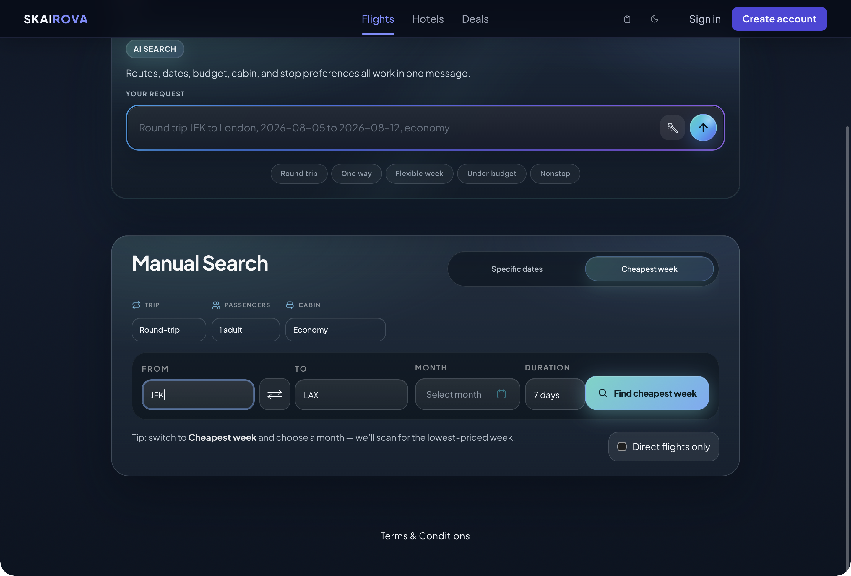
Cheapest Week Search

6. Review Flight Results
After searching, Skairova opens the Results page.
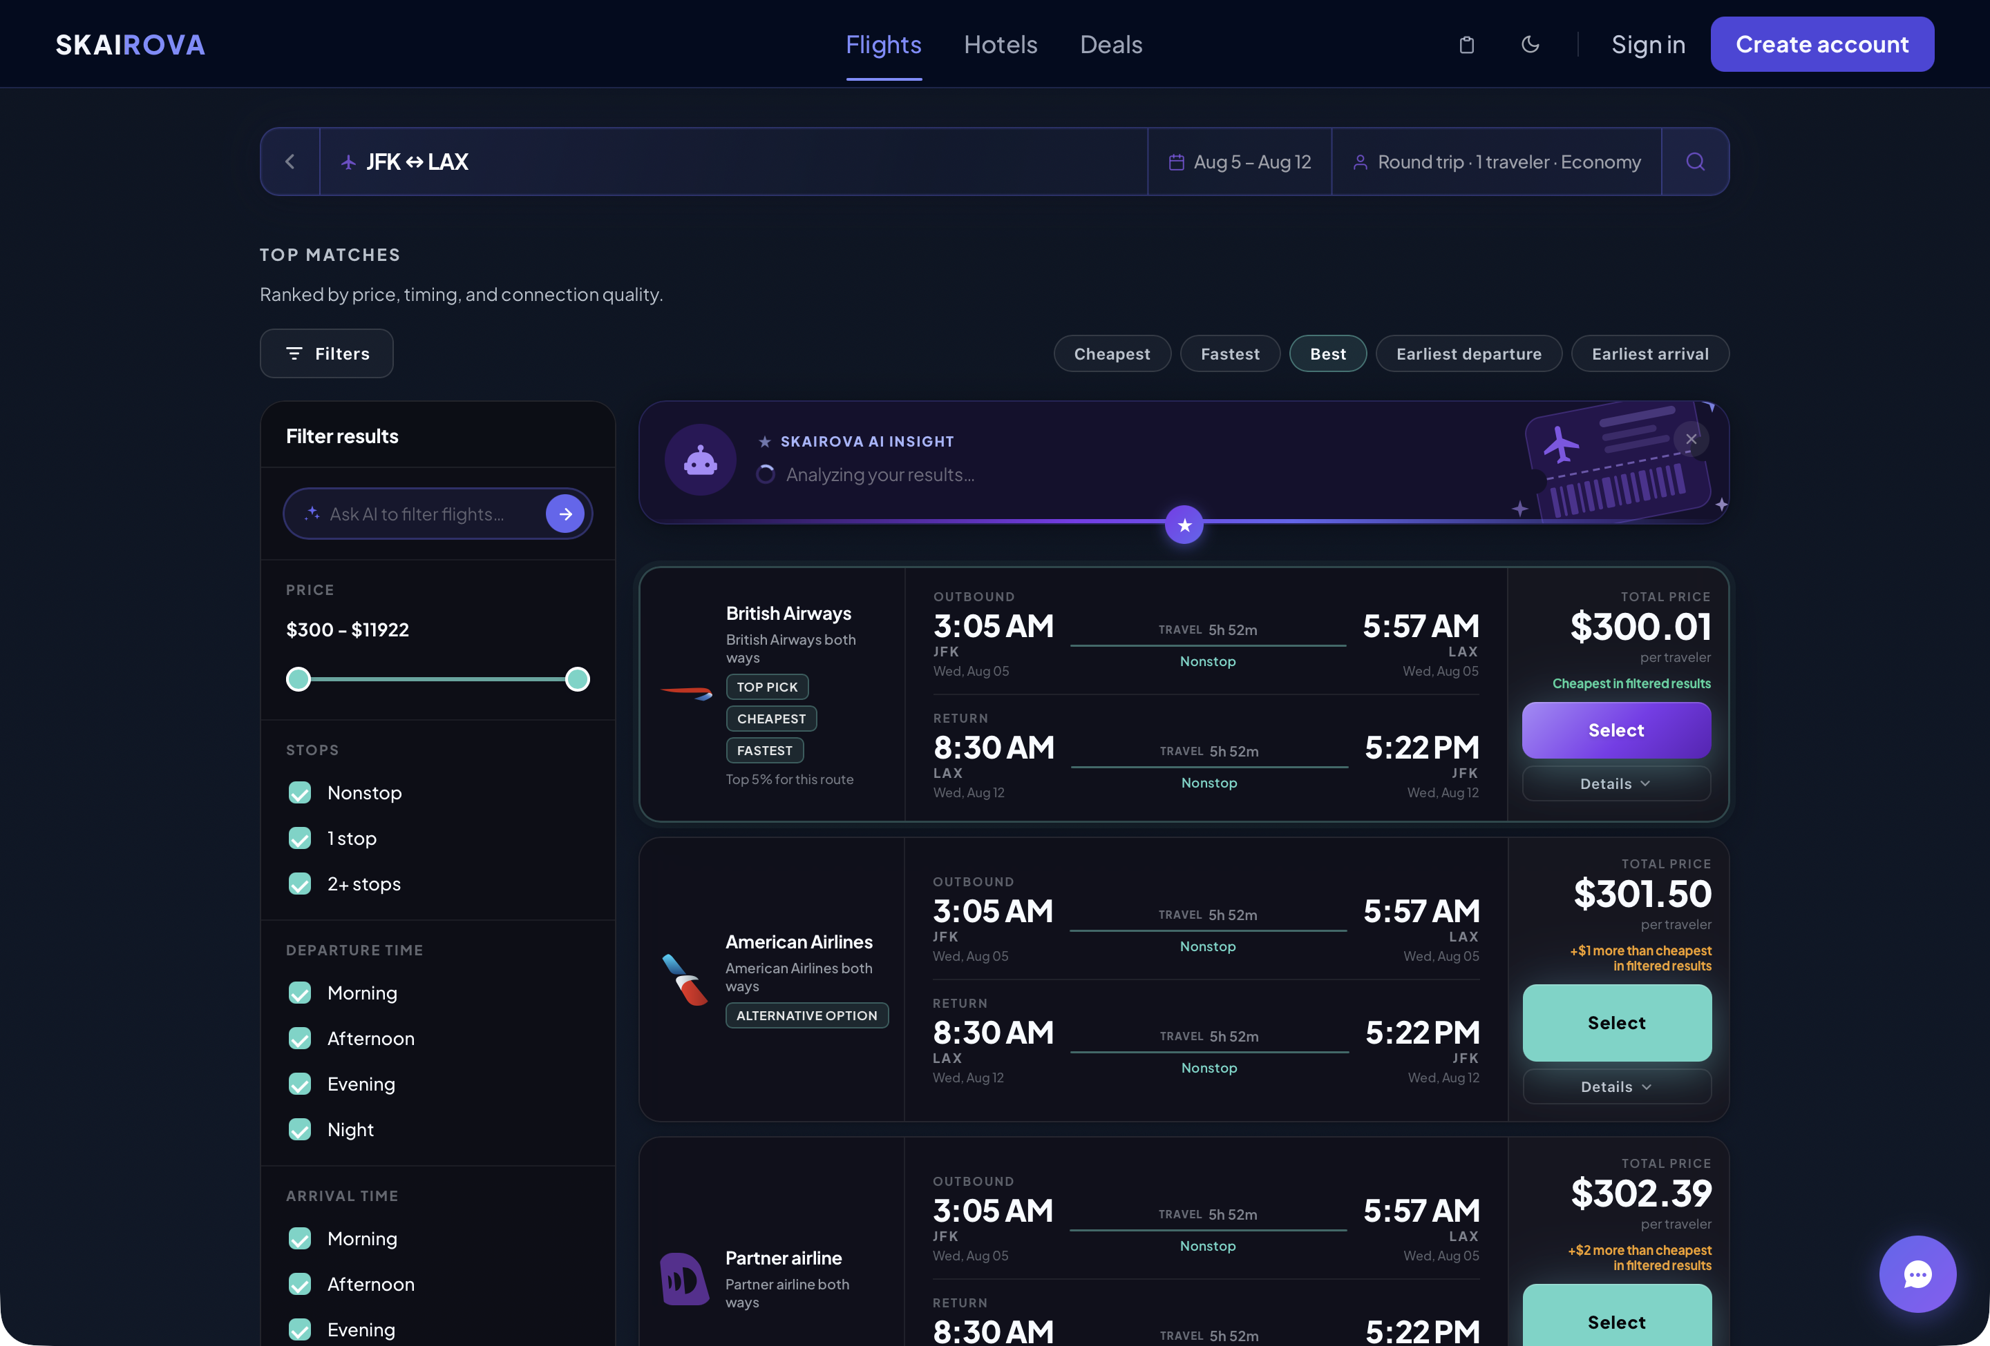
Results Page
Each result can show:
- Airline
- Departure time
- Arrival time
- Departure airport
- Arrival airport
- Flight duration
- Stop or nonstop information
- Total price
- Price comparison
- Details button
- Select button
Use this page to compare flights before choosing one.

7. Edit A Search From The Results Page
At the top of the Results page, you can adjust the search without returning to the homepage.
You can change:
- Route
- Dates
- Passengers
- Cabin
- Sort option
- Trip type
After changing the details, run the search again to refresh the results.

8. View Flight Details
Some results include a Details option.
Open the details area when you want more information about the flight, especially if the trip has stops.
Details may include:
- Stop airport
- Arrival time at the stop
- Departure time from the stop
- Layover duration
- Segment details
- Airline and operating airline information
This is useful when comparing connecting flights.

9. Select A Flight
When you find a flight you want:
- Review the price and timing.
- Check whether it is nonstop or has stops.
- Click Select.
Skairova then opens the trip review page.

10. Review Your Trip
The Review your trip page gives a clearer view of the selected flight before checkout.
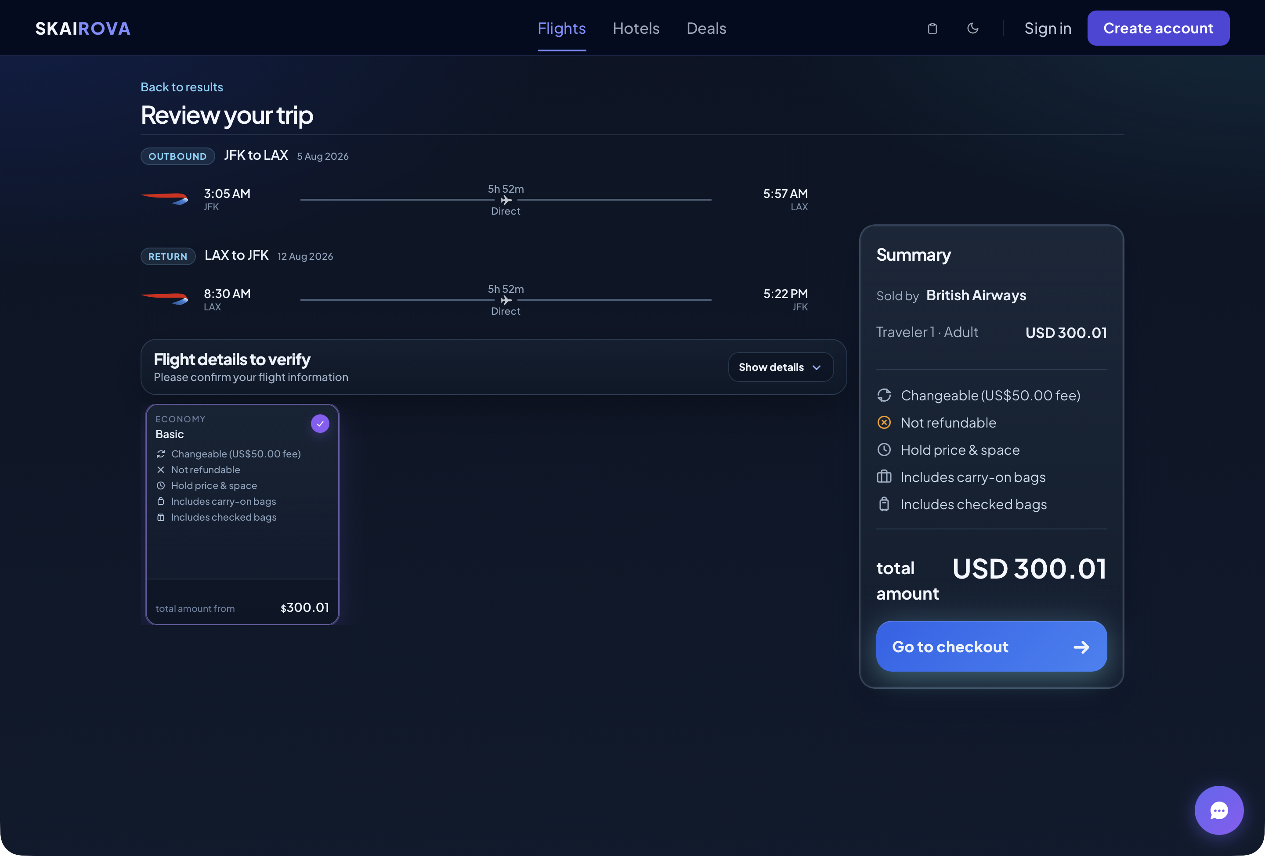
Review Trip Collapsed
Review:
- Outbound flight
- Return flight, if this is a round trip
- Airline
- Route
- Departure time
- Arrival time
- Travel date
- Duration
- Direct or stop information
- Price summary
Do not continue until the route and dates are correct.

11. Expand Complete Flight Details
Click Show details to open the full flight information.
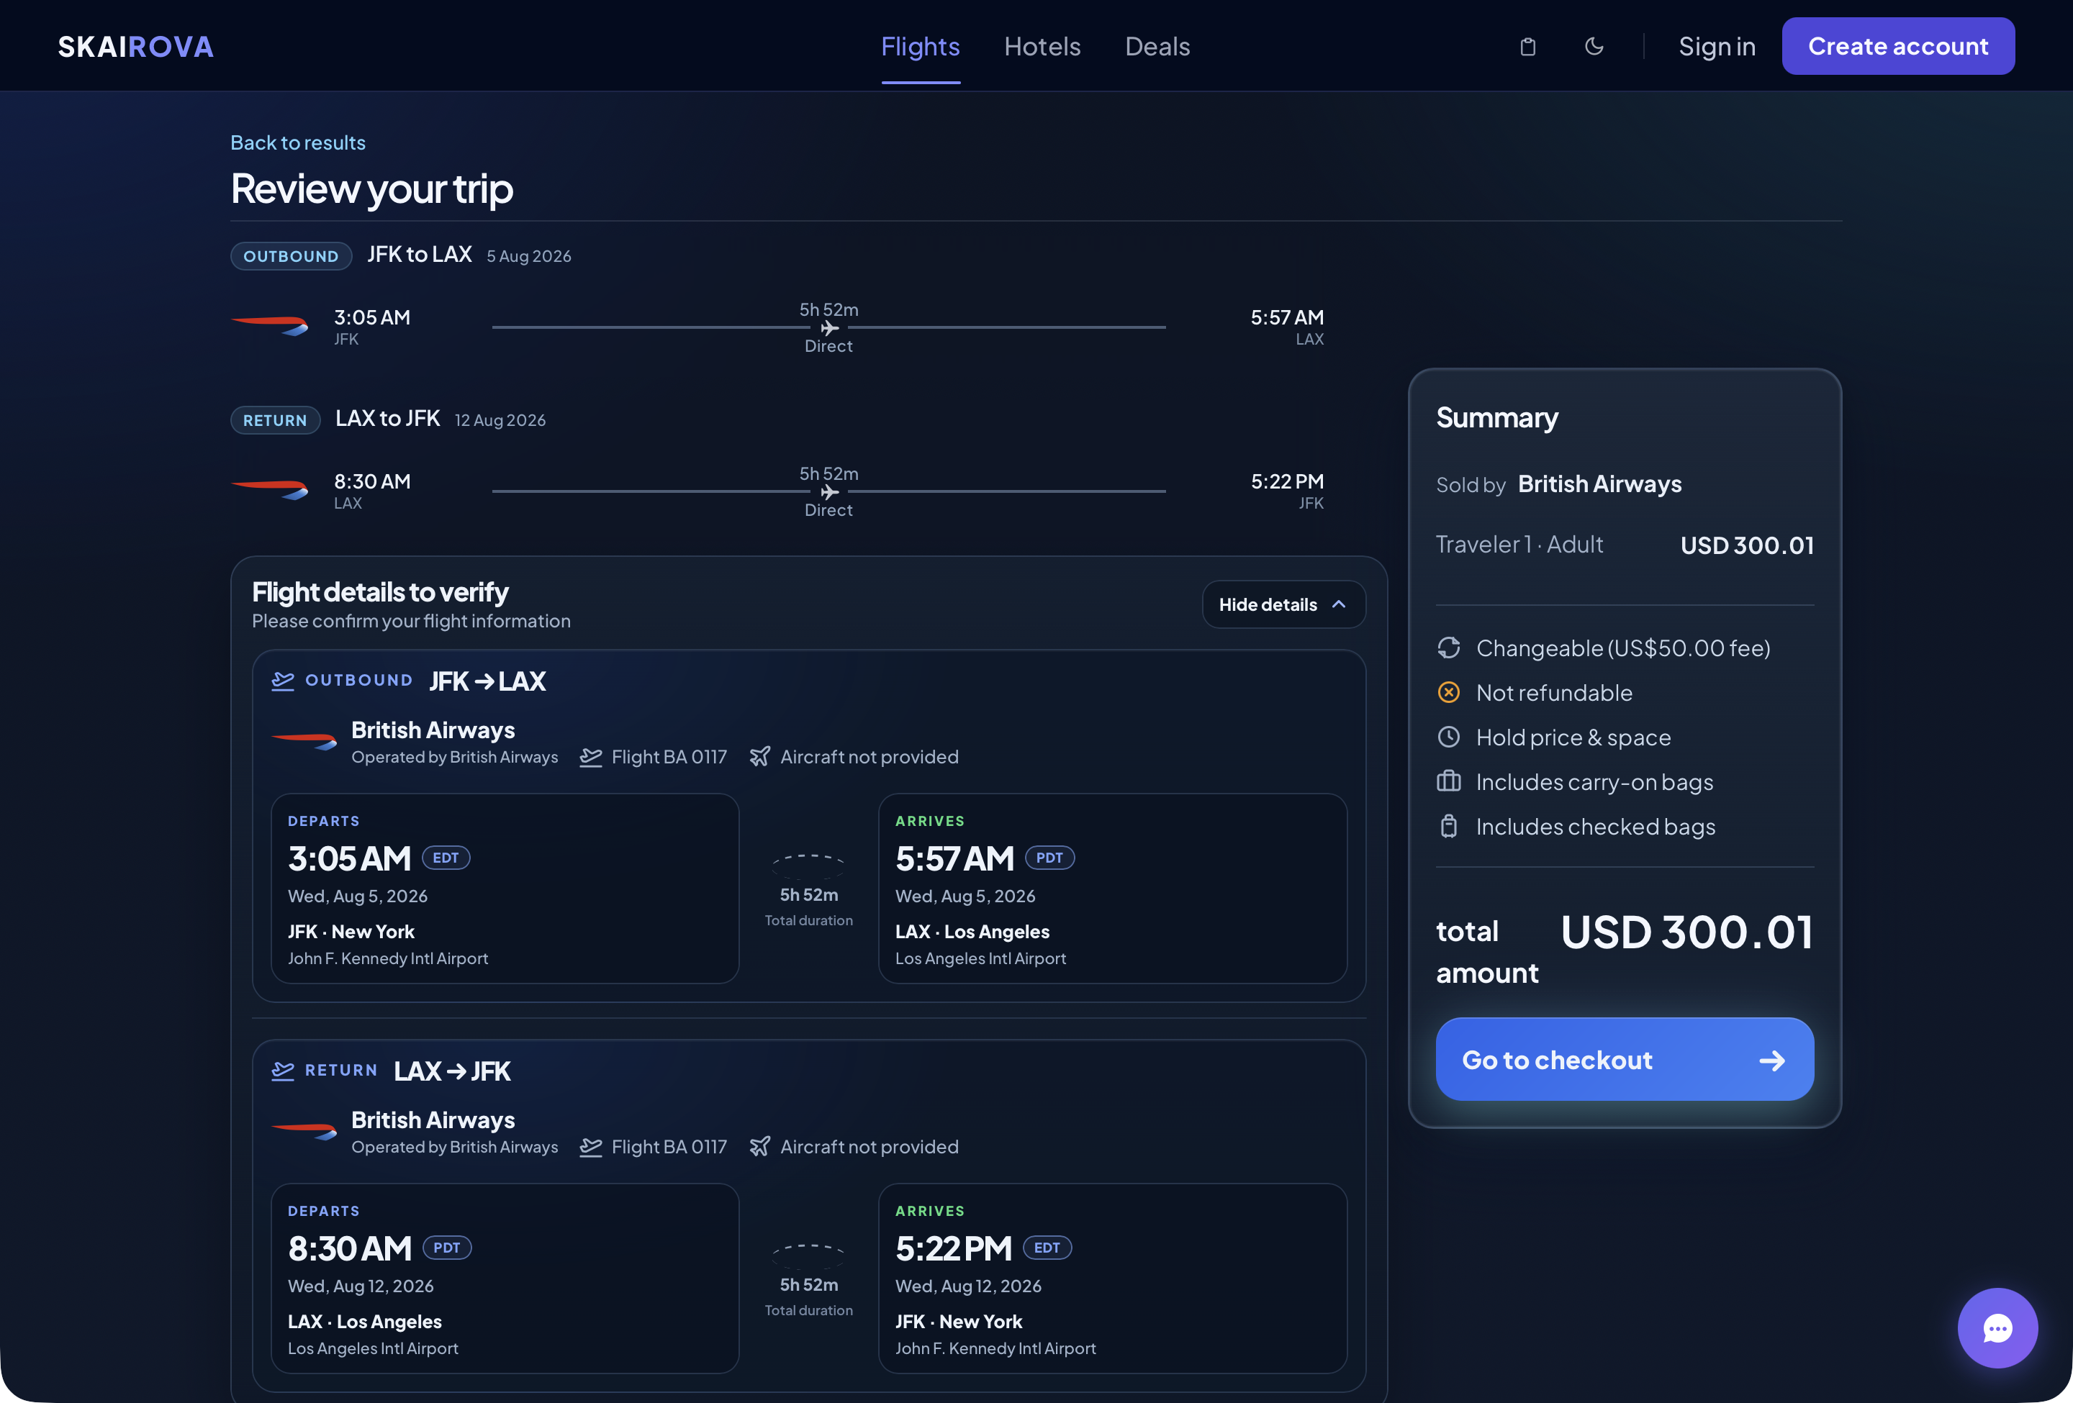
Review Trip Expanded
The expanded view can show:
- Marketing airline
- Operating airline
- Flight number
- Aircraft type
- Departure airport
- Arrival airport
- Departure time and time zone
- Arrival time and time zone
- Segment duration
- Stop or layover information
- Airport names and cities
This page is where the user should confirm the complete flight from start to finish.

12. Choose A Fare Option
If multiple fares are available, Skairova may show fare cards.
A fare card may include:
- Cabin type
- Fare name
- Whether changes are allowed
- Whether refunds are allowed
- Carry-on bag information
- Checked bag information
- Price
Select the fare that best matches your needs.

13. Review The Price Summary
The price summary shows the selected trip total.
It may include:
- Airline selling the ticket
- Traveler count
- Fare benefits
- Baggage information
- Change rules
- Refund rules
- Total amount
Click Go to checkout when ready.

14. Enter Traveler Details
The checkout page asks for passenger information.
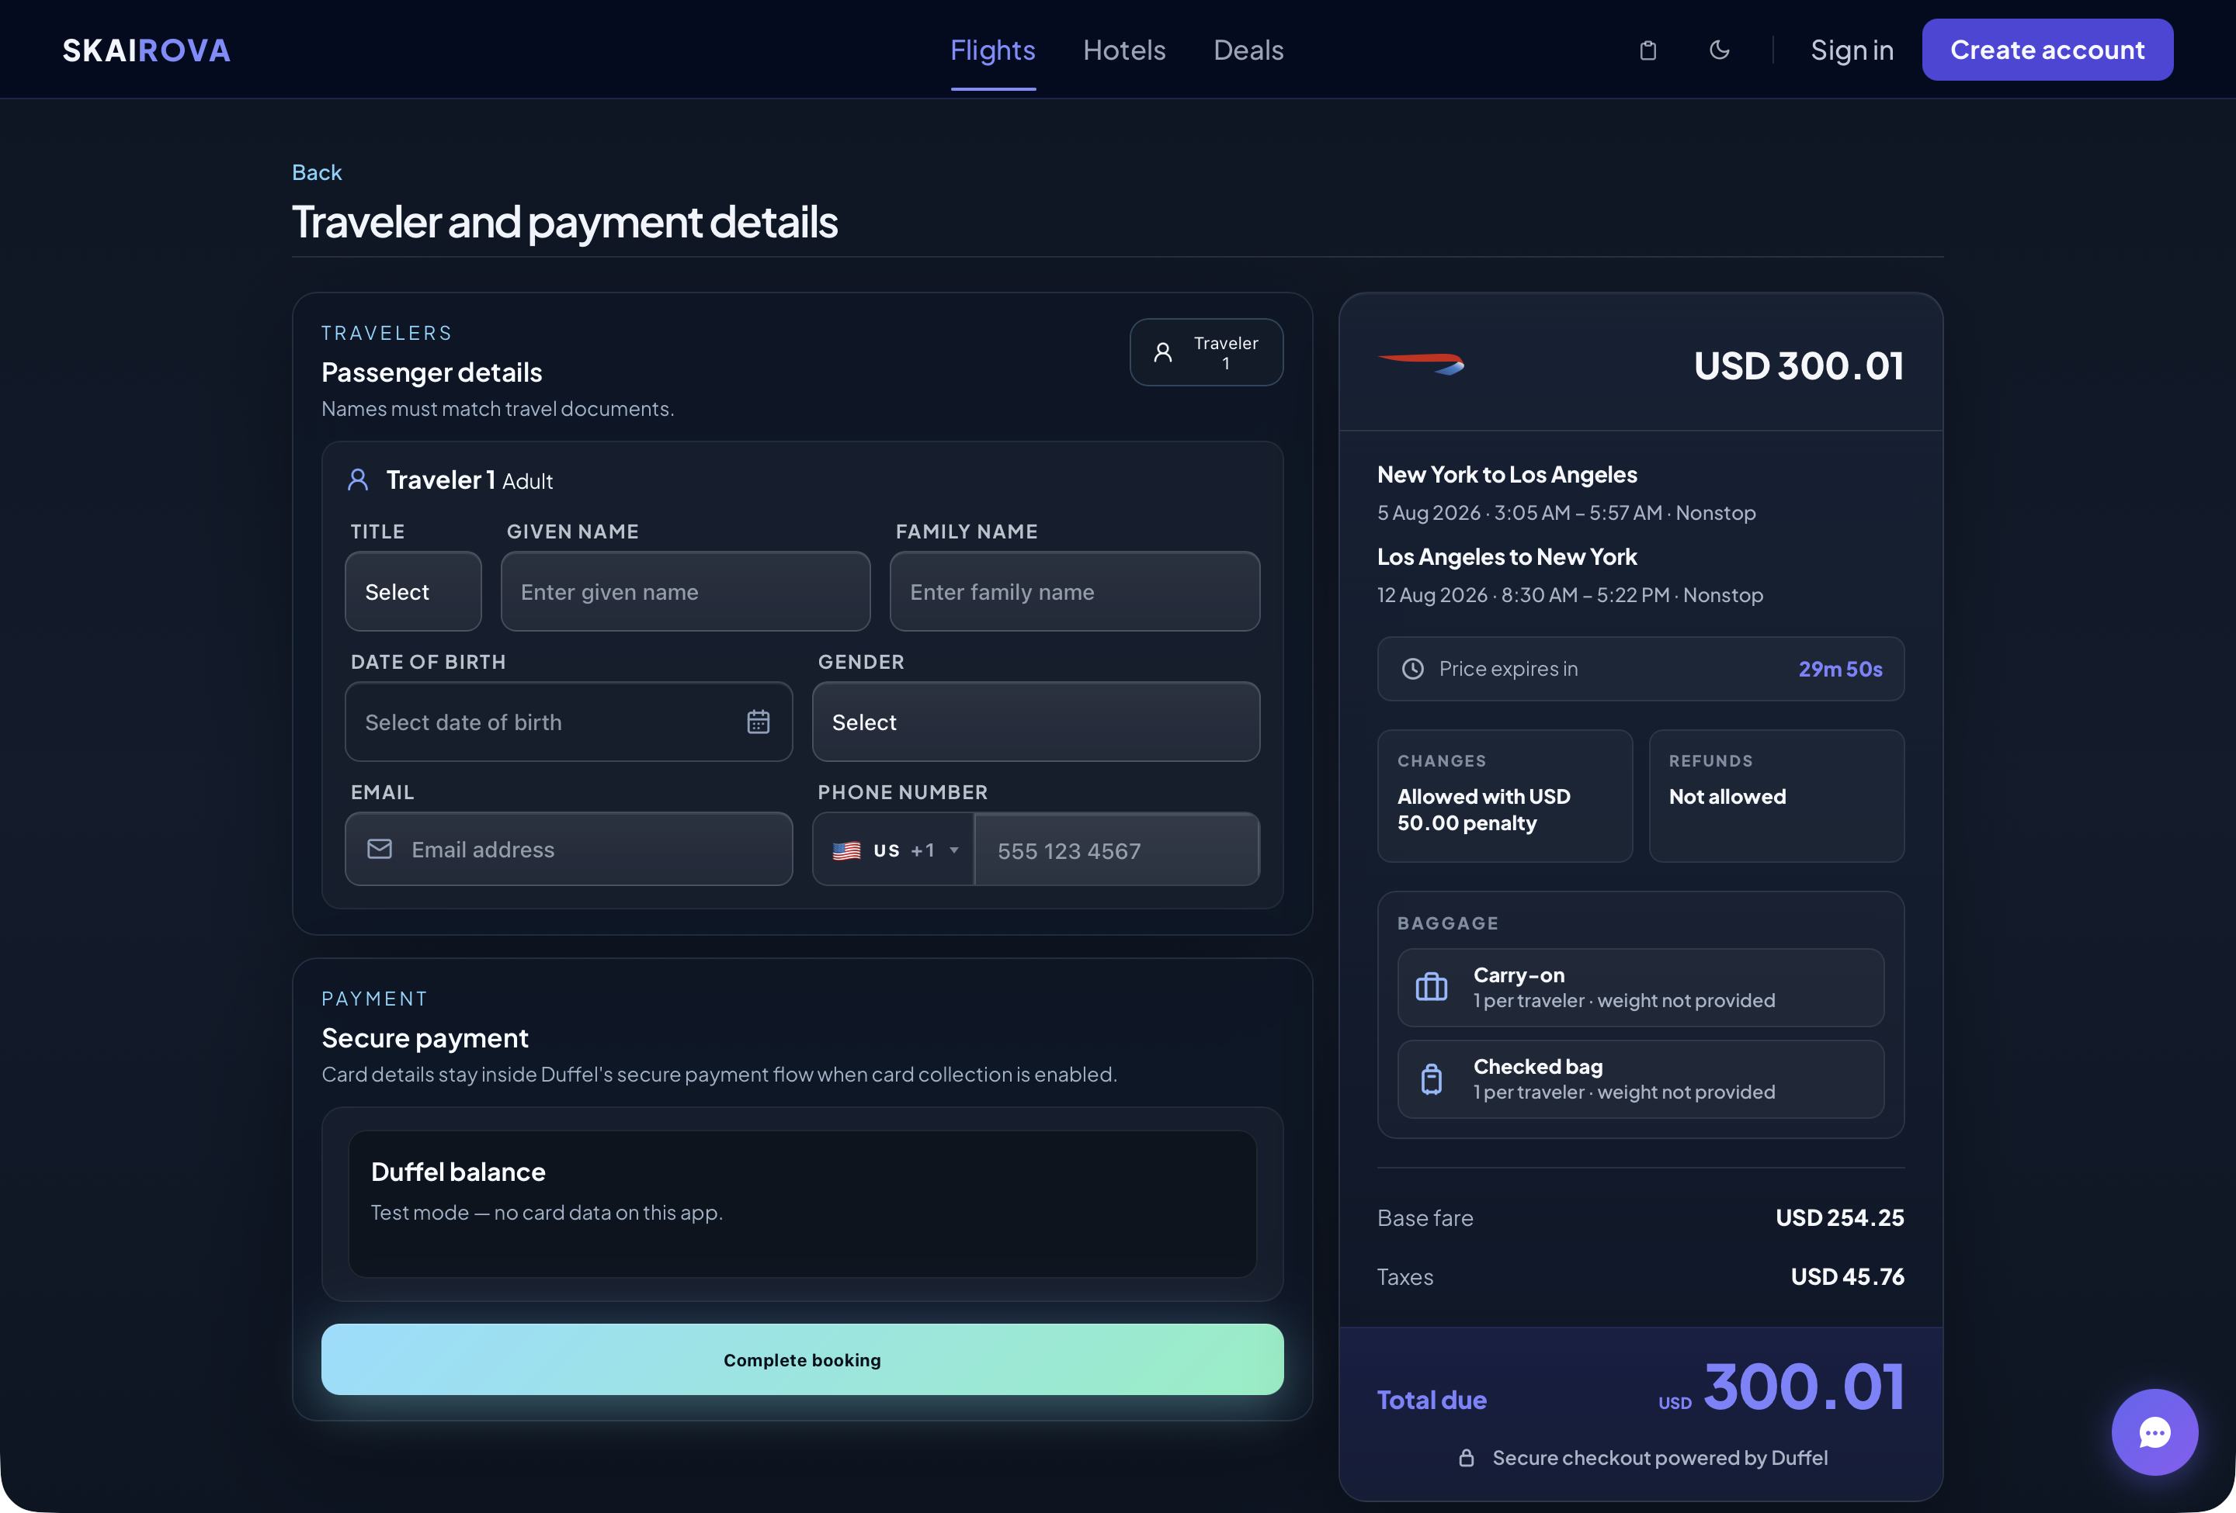
Checkout Traveler Details
Enter the traveler’s details exactly as they appear on official travel documents.
Required fields may include:
- Title
- Given name
- Family name
- Date of birth
- Gender
- Email address
- Phone number
Important: Incorrect names can cause airline check-in or boarding problems.

15. Enter Passport Or Identity Details If Requested
Some international flights require identity document details.
If Skairova shows document fields, enter:
- Passport number
- Passport issuing country
- Passport expiration date
- Nationality, if requested
If these fields are not shown, they are not required for that booking.

16. Review The Checkout Price
The checkout price section shows the final payment information.
It can include:
- Airline logo
- Route summary
- Flight date and time
- Price expiration timer
- Change rules
- Refund rules
- Included baggage
- Base fare
- Taxes
- Total due
Review this carefully before booking.

17. Complete Payment
Scroll to the payment section.
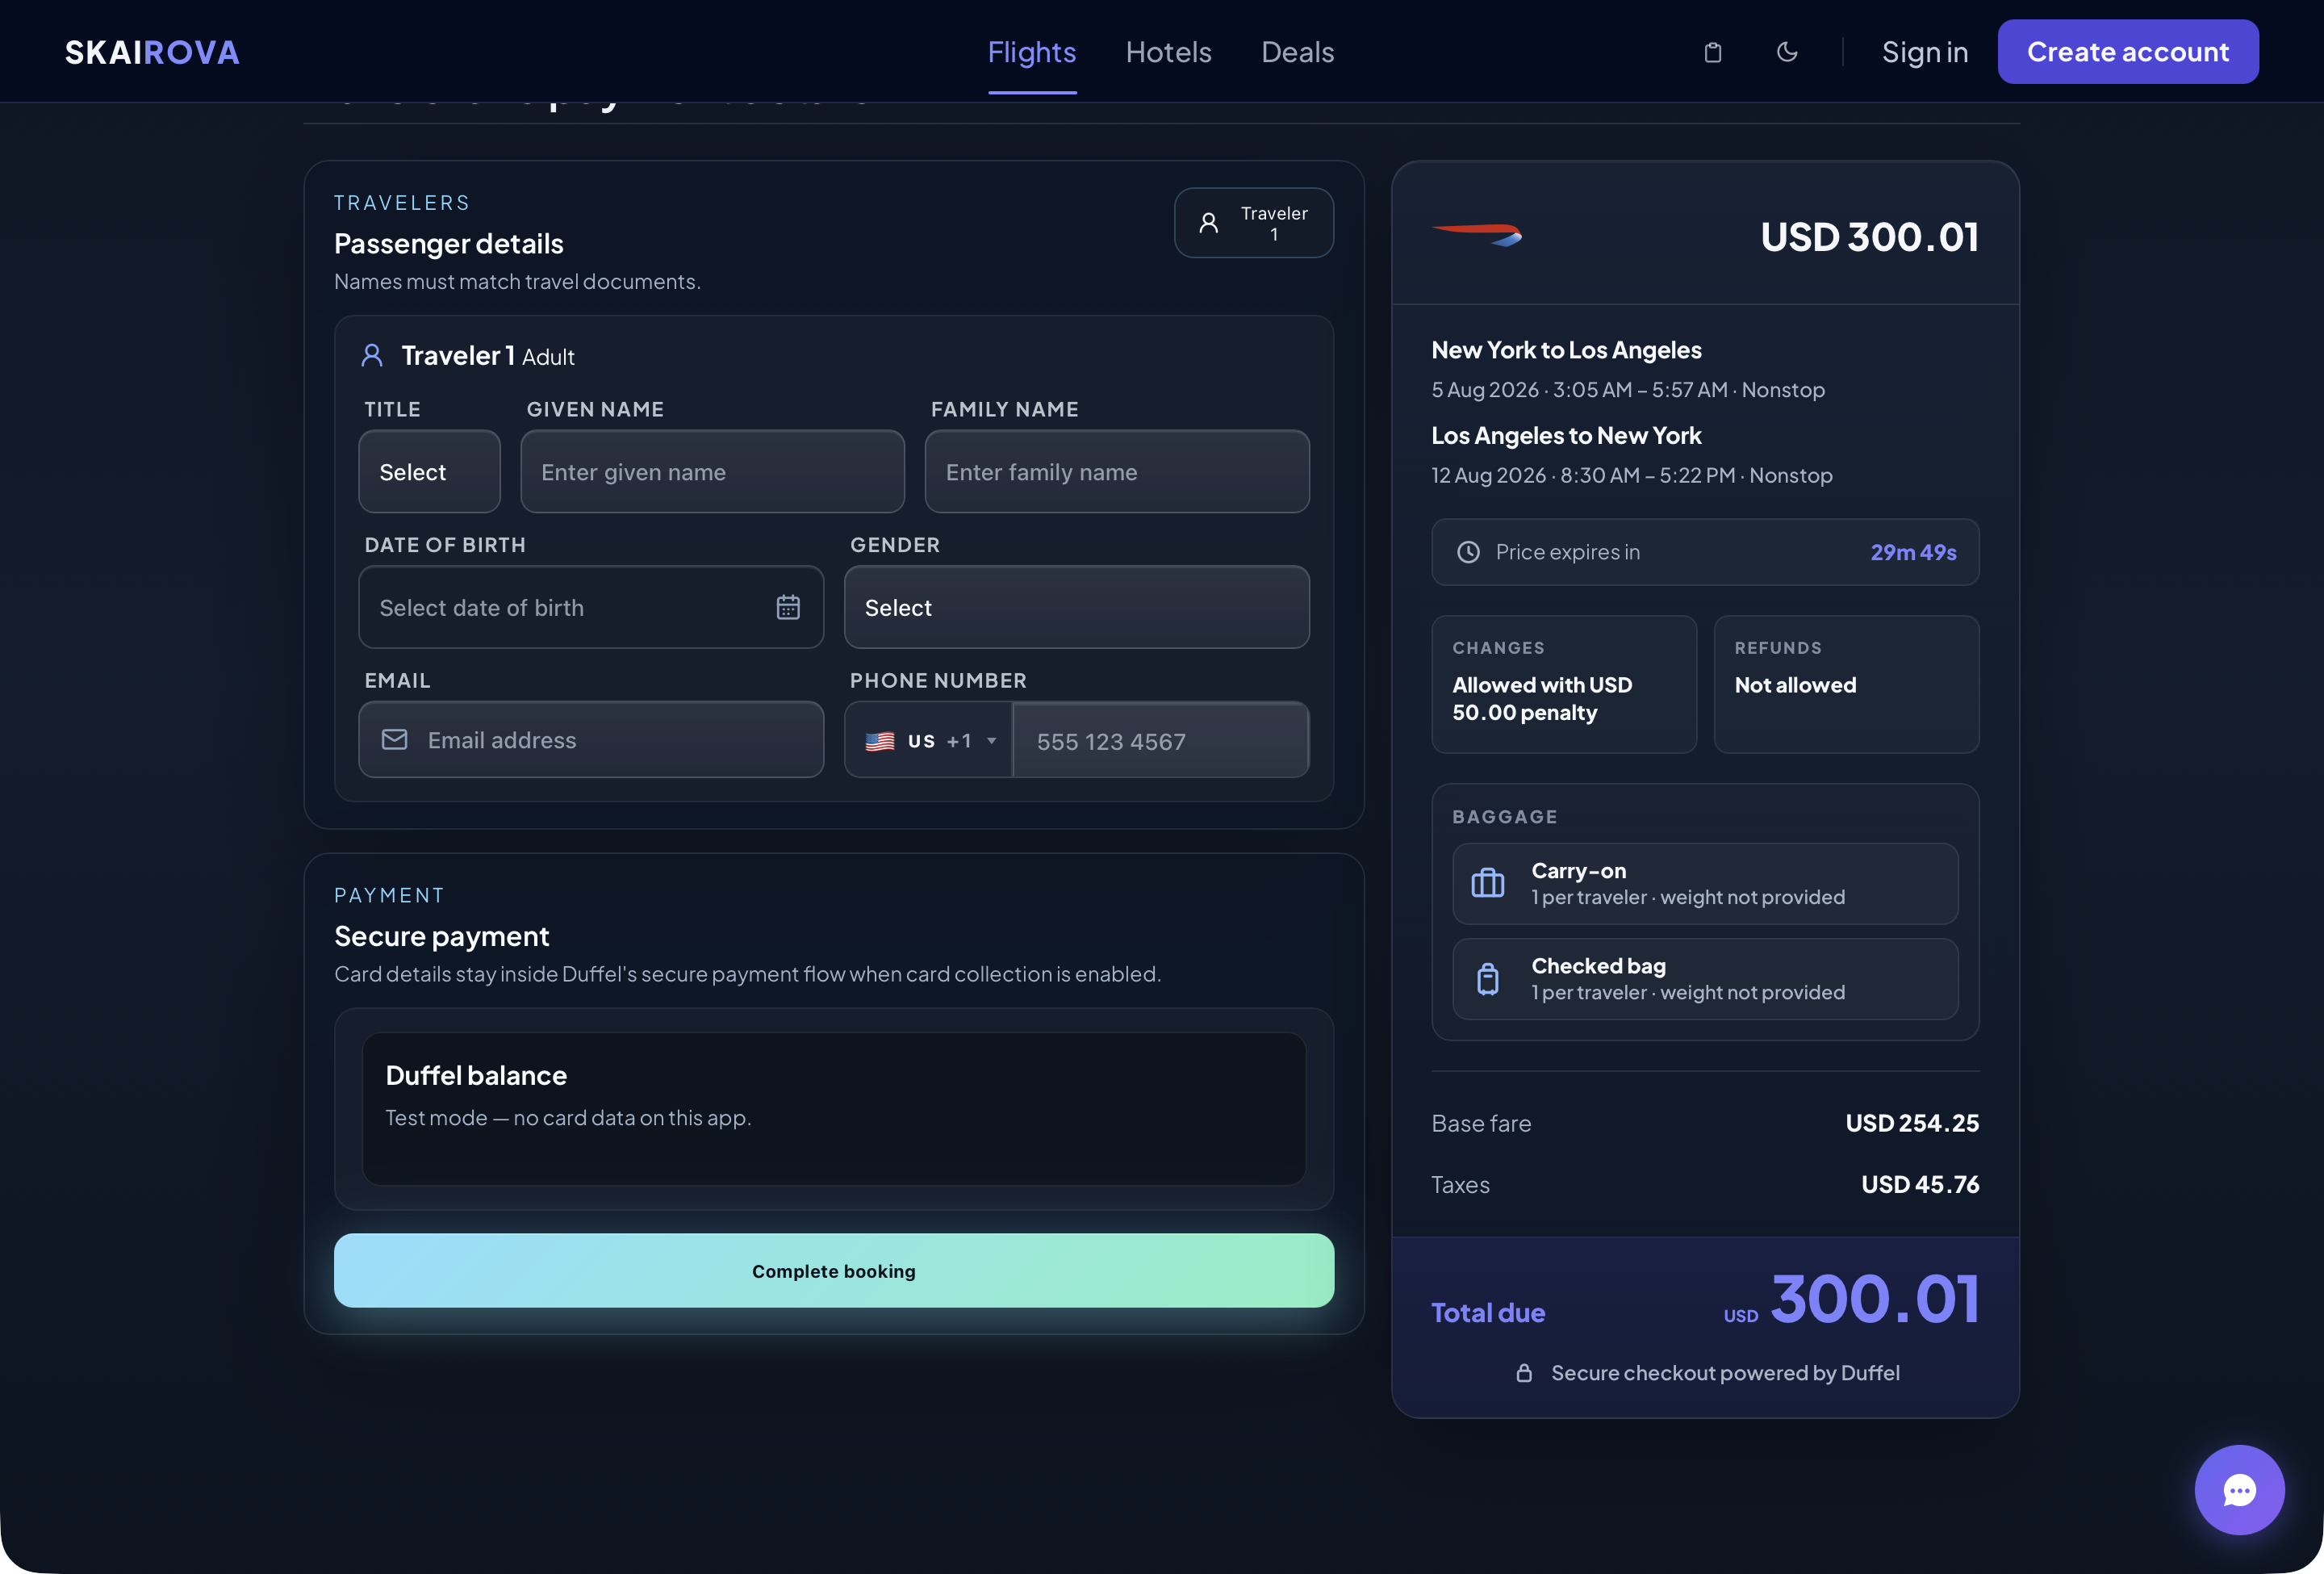
Checkout Payment Section
Depending on the environment, the payment section may show:
- Duffel balance for test bookings
- Secure card payment for live bookings
When all traveler and payment details are complete, click Complete booking.
Do not refresh or close the page while the booking is being submitted.

18. View Booking Confirmation
After a successful booking, Skairova opens a confirmation page.
The confirmation page may show:
- Booking reference
- Booking status
- Airline
- Route
- Flight details
- Traveler details
- Baggage allowance
- Payment summary
- Fare and ticket rules
From the confirmation page, users may also access itinerary tools such as a PDF itinerary or calendar file.
Screenshot to add after a successful test booking: Booking confirmation page.

19. Manage A Booking
Use Manage Booking if you need to find or update an existing booking.
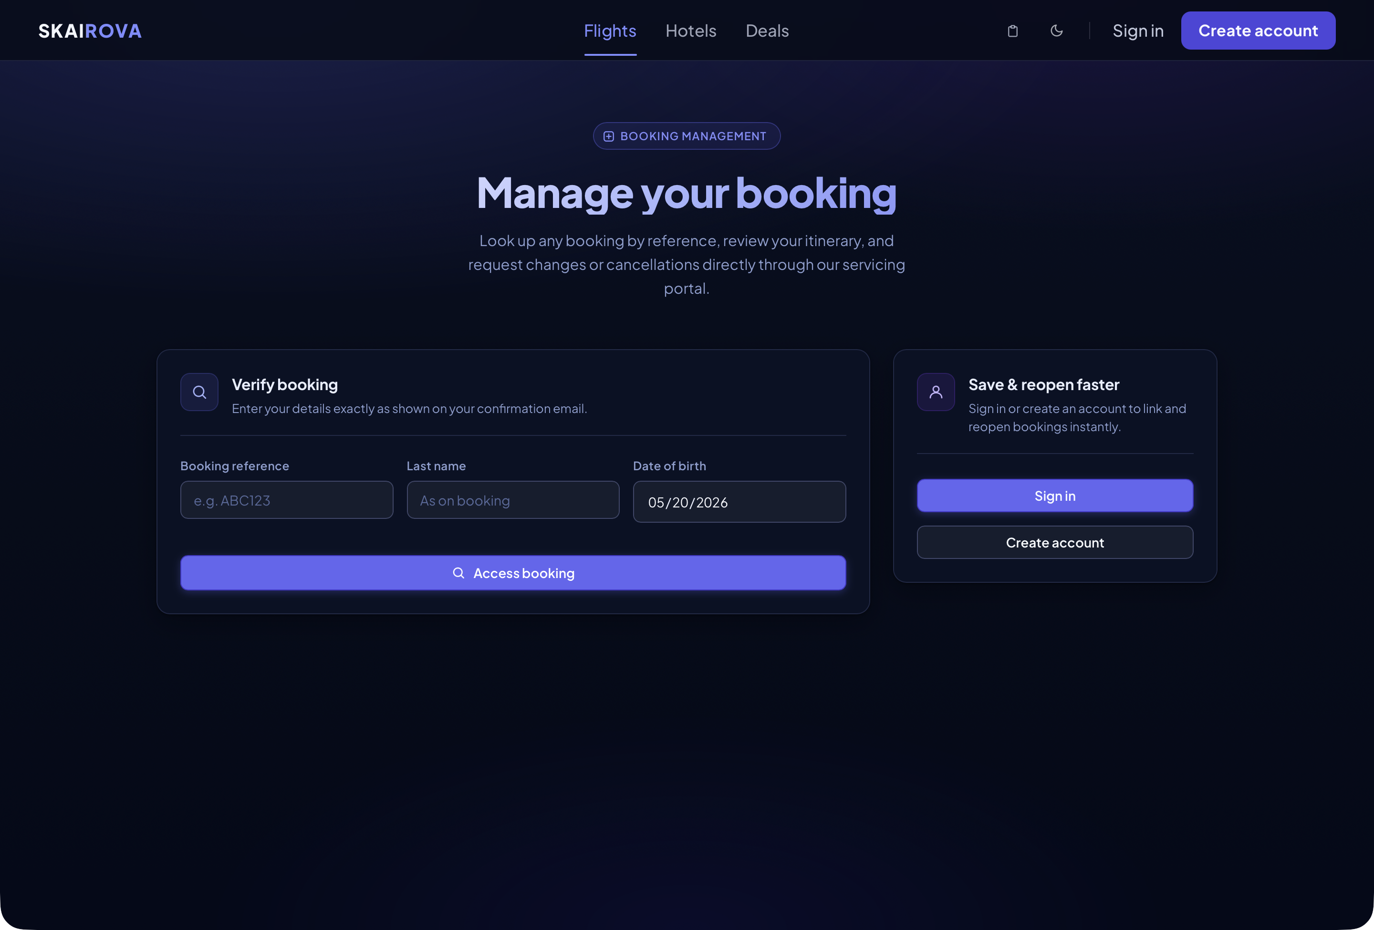
Manage Booking
Depending on the booking and airline rules, you may be able to:
- View booking details
- See linked bookings
- Request cancellation
- Request flight change options
- Apply an available flight change
You may need to enter:
- Booking reference
- Passenger name
- Other verification information

20. Sign In Or Create An Account
Users can sign in or create an account.
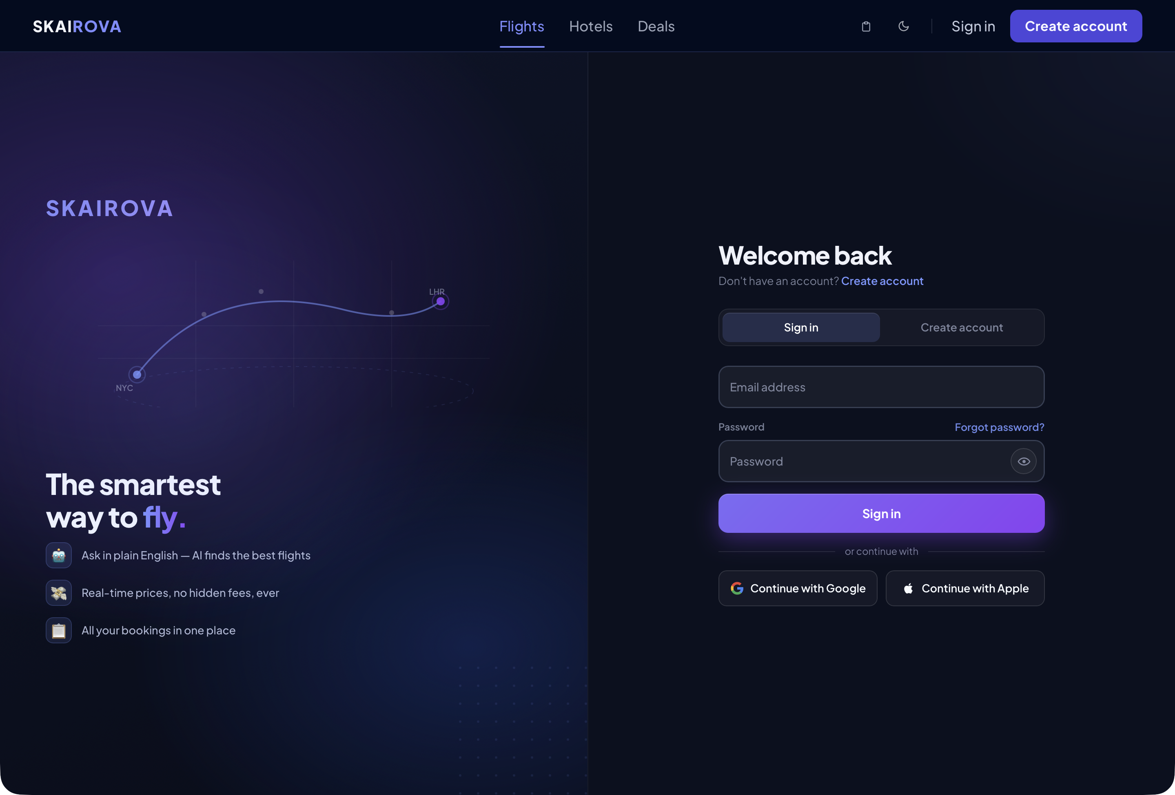
Auth Page
An account can help users:
- View their portal
- Link bookings
- Save profile details
- Save preferences
- Review recent searches
- Manage account settings
Skairova may also offer Google or Apple sign-in if those options are configured.

21. Use The User Portal
After signing in, the user portal may show:
- Saved or recent searches
- Linked bookings
- Profile details
- Travel preferences
- Account security options
Users can update preferences and profile information from the portal.

22. Use The AI Chat Assistant
Some pages include an AI chat bubble.
The chat assistant can help with:
- Understanding flight options
- Explaining search results
- Checkout questions
- General booking guidance
Click the chat bubble to open it, type a question, and send the message.

23. Hotels Page
The Hotels page is currently a coming-soon page.
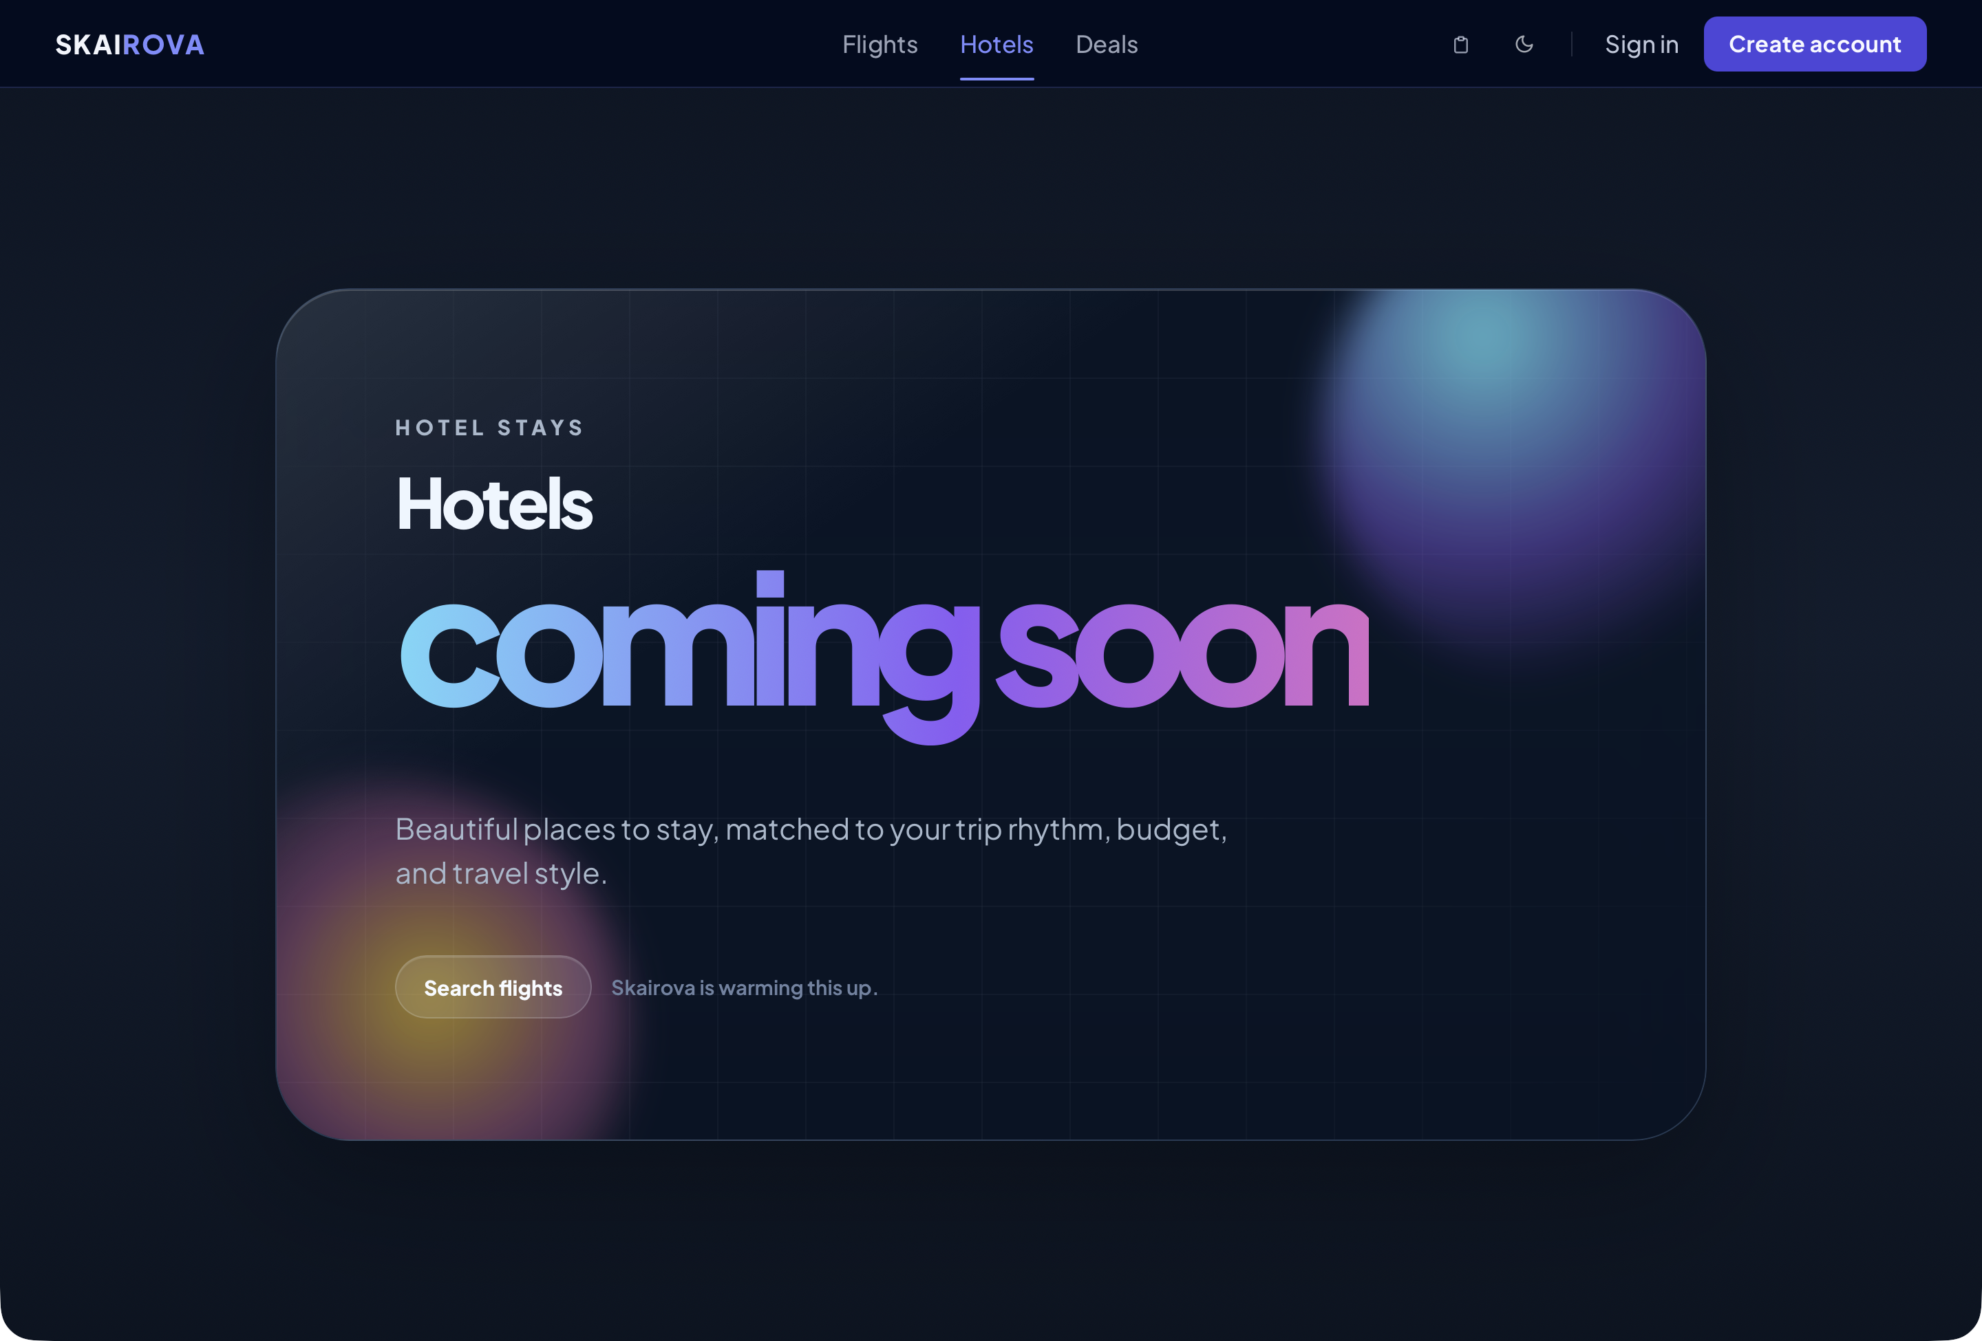
Hotels Coming Soon
Users can open it from the header, but hotel booking is not active yet.

24. Deals Page
The Deals page is currently a coming-soon page.

Deals Coming Soon
Users can open it from the header, but deal booking is not active yet.

25. Switch Light Or Dark Mode
Use the theme button in the header to switch between light and dark mode.
The site updates its colors automatically.
This is optional and does not affect search or booking.

26. User Configuration
Regular users do not need to configure the system.
A regular user only needs:
- A modern web browser
- Internet connection
- Passenger details
- Payment details if live card payment is enabled
- Passport or identity document details if required by the airline
Optional user choices include:
- Signing in or creating an account
- Using light or dark mode
- Saving profile/preferences in the portal

27. Important Checks Before Booking
Before clicking Complete booking, always check:
- The departure airport is correct.
- The arrival airport is correct.
- The travel dates are correct.
- The flight times are acceptable.
- The return flight is included if this is a round trip.
- Passenger names match official documents.
- The baggage allowance is acceptable.
- Change and refund rules are acceptable.
- The total price is correct.
- Passport details are correct, if required.
Once a booking is submitted, changes depend on airline rules and may cost extra.

28. Troubleshooting
If the search does not return flights:
- Try a different date.
- Remove nonstop-only preferences.
- Use airport codes instead of city names.
- Try a nearby airport.
- Use Manual Search instead of AI Search.
- Check that the return date is after the departure date.
If the AI does not understand the request:
- Use a simpler sentence.
- Include airport codes.
- Include the date in YYYY-MM-DD format.
- Mention whether the trip is one-way or round-trip.
If checkout does not continue:
- Check all required fields.
- Make sure email and phone number are valid.
- Make sure date of birth is selected.
- Check passport fields if shown.
- Confirm the offer has not expired.
If payment fails:
- Check payment details.
- Try again before the price expires.
- Search again if the offer has expired.

