BRANDSHIELD AI
Unified Intelligence for Digital Threat Detection and Brand Protection
PROJECT DOCUMENTATION
Submitted as part of the B.Tech Hackathon Project
ABSTRACT
BrandShield AI is a digital risk protection platform developed to help users identify potential online threats. Nowadays, many people and organizations face problems such as phishing websites, fake social media profiles, online impersonation, and potentially harmful mobile applications. These threats can lead to data theft, privacy problems, and financial losses.
The main objective of BrandShield AI is to provide a single platform where users can check suspicious URLs, analyze social media profiles, and assess potential mobile application risks. The system uses automated analysis and available threat intelligence to provide results that help users understand possible security risks.
The application includes a secure login system, an interactive onboarding section, and a dashboard for viewing scan results and scan history. Flask is used for the backend, Supabase is used for database storage, and VirusTotal integration provides access to available threat intelligence. The project aims to make digital threat checking easier and more accessible through a simple and user friendly interface.
INTRODUCTION
The internet has become an important part of everyday life. People use websites, social media platforms, and mobile applications for education, communication, shopping, banking, and business activities. At the same time, online threats have become a growing concern.
Phishing websites may try to collect personal information, fake social media profiles may impersonate individuals or organizations, and potentially harmful applications may create security and privacy risks. Users may find it difficult to identify these threats without technical knowledge or suitable security tools.
BrandShield AI is designed to bring different digital risk checking features together in one platform. It allows users to submit information for analysis and view the results through a centralized dashboard.
PROBLEM STATEMENT
Users often depend on different tools to check suspicious websites, social media profiles, and mobile applications. This makes the process time consuming and difficult for users who do not have strong technical knowledge.
Another challenge is that not every suspicious link or profile can be identified accurately using simple rules. Some legitimate websites may appear suspicious, while some harmful websites may not show obvious warning signs.
Therefore, there is a need for a platform that combines different analysis methods and available threat intelligence to help users understand potential online risks in one place.
OBJECTIVES
The main objective of BrandShield AI is to develop a centralized platform for digital risk protection.
The project aims to identify potentially suspicious URLs and phishing indicators, analyze social media profiles for possible impersonation, assess potential risks associated with mobile applications, maintain scan history for future reference, and present results through a simple dashboard.
Another objective is to provide a professional user interface with secure authentication and centralized database storage. The platform is also designed to help users understand the evidence behind scan results rather than depending only on a risk score.
EXISTING SYSTEM
In the existing approach, users may need to visit different websites or use separate tools to check links, social media profiles, and mobile applications. Some tools focus only on one type of threat, while others may provide limited explanations of their results.
Manual verification can take time and may require technical knowledge. Simple detection methods can also produce incorrect results when the input data is incomplete or misleading.
BrandShield AI aims to simplify this process by providing multiple risk analysis features through a single application.
PROPOSED SYSTEM
BrandShield AI is proposed as a web based digital risk protection platform with three main analysis modules.
The first module focuses on URL threat detection. It examines submitted URLs using the implemented analysis methods and available threat intelligence to identify possible phishing or suspicious domain indicators.
The second module focuses on social profile analysis. It examines available profile information for possible impersonation and suspicious similarities. The results should be treated as indicators for further verification rather than final proof that a profile is fake.
The third module focuses on mobile application risk analysis. It uses available application information and implemented analysis methods to identify potential security concerns. The reliability of the results depends on the quality and completeness of the available data.
The platform also provides user authentication, a Get Started onboarding slider, a dashboard, and scan history. These features make the application easier to navigate and allow users to review previous analysis results.
SYSTEM ARCHITECTURE
The system follows a web application architecture consisting of a frontend, backend, analysis modules, external threat intelligence, and database storage.
The user opens the application through a web browser and logs in using the configured authentication system. After successful login, the dashboard provides access to the available scanning features.
The frontend sends requests to the Flask backend. The backend validates the submitted information and passes it to the appropriate analysis module. When configured and available, VirusTotal provides additional threat intelligence for supported inputs.
The analysis results are returned to the frontend and stored in Supabase according to the application's database and security configuration. The dashboard retrieves stored records to display scan history and relevant statistics.
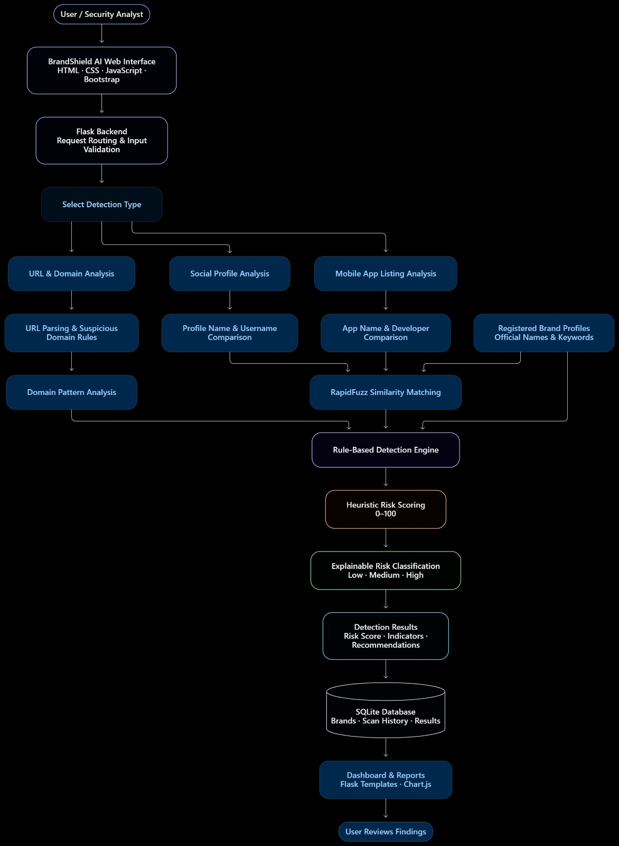

TECHNOLOGIES USED
Python is used as the main programming language for backend processing and analysis.
Flask is used to build the backend routes and connect the frontend with the analysis modules.
HTML is used to structure the web pages.
CSS is used to style the application and create the visual design.
JavaScript is used for frontend interactions, animations, and dynamic interface behavior.
Supabase provides PostgreSQL database storage for scan records and other supported application data.
VirusTotal API integration provides access to external threat intelligence for supported URLs and domains.
Machine learning techniques may be used for classification where the corresponding models have been trained, tested, and integrated successfully. The actual model performance depends on the quality of the datasets, feature extraction, and evaluation process.
MAIN MODULES
User Authentication
This module allows users to access the application through the configured login system. It supports existing authentication features such as account registration, password recovery, and third party login wherever implemented.
Get Started Onboarding
This section introduces users to the main features of BrandShield AI. It explains URL threat detection, social profile analysis, mobile application risk analysis, and dashboard functionality through an interactive slide presentation.
URL Threat Detection
This module accepts a URL for analysis and checks available indicators of suspicious activity. The result may include a risk assessment and supporting information from the implemented analysis methods and threat intelligence sources.
Social Profile Analysis
This module examines available social profile information for possible impersonation and suspicious similarities. The findings help users decide whether further verification is necessary.
Mobile Application Risk Analysis
This module analyzes available mobile application information using the implemented checks. It aims to highlight potential security concerns based on the information provided.
Dashboard and Scan History
The dashboard displays relevant scan information, statistics, and previous scan records retrieved from the database. It provides a centralized place for users to review the results of their analysis.
DATABASE DESIGN
Supabase is used as the database platform for storing application information. PostgreSQL provides structured storage for records such as scan history and other supported application data.
The scan history records may include the scan type, submitted input, analysis result, risk score, supporting evidence, and scan timestamp. Additional fields may be included depending on the existing database schema.
Database access is controlled through the application's backend and appropriate security policies. Authentication details and API secrets should not be stored unnecessarily in scan records.
The database helps maintain scan history and retrieve information for the dashboard. However, database storage alone does not improve detection accuracy. Accuracy depends on the analysis logic, training data, external intelligence, and evaluation methods.
WORKING PROCESS
First, the user opens the BrandShield AI application and logs in using the configured authentication system.
After login, the user reaches the dashboard, where the available scanning modules are displayed.
The user selects the required module and submits the URL, social profile information, or mobile application information supported by that module.
The Flask backend validates the input and performs the appropriate analysis. External threat intelligence is requested when supported and available.
The system processes the available findings and presents the result to the user. Where configured, the scan record is saved in Supabase and displayed in the scan history.
Users can review previous scans and use the available evidence to decide whether further verification is needed.
ADVANTAGES
BrandShield AI brings multiple digital risk checking features together in one application.
It provides a simple interface for users who may not have advanced cybersecurity knowledge.
The dashboard helps users review scan results and previous scans from one place.
Supabase provides centralized database storage for supported application records.
External threat intelligence can provide additional information for supported URLs and domains.
The modular design allows the application to be improved by updating individual analysis modules without rebuilding the entire platform.
LIMITATIONS
The accuracy of the results depends on the quality of the available data, analysis methods, and external threat intelligence.
Some new phishing websites may not yet be listed in threat intelligence databases.
Social profile information may be incomplete or unavailable, making impersonation difficult to confirm.
Mobile application analysis is limited by the application information and inspection methods currently implemented.
External API availability, request limits, and network connectivity may affect some results.
A suspicious indicator does not always mean that a website, profile, or application is harmful. Users should review the available evidence before making important security decisions.
FUTURE ENHANCEMENTS
In the future, the project can be improved by training and evaluating dedicated machine learning models for URL detection, social profile analysis, and mobile application risk assessment using suitable labeled datasets.
The platform can include more threat intelligence sources, better explanations for predictions, improved evidence collection, and more detailed security reports.
Additional improvements may include email alerts for important findings, support for more social platforms, enhanced mobile application metadata analysis, and an expanded verified brand registry.
The system can also be improved through larger evaluation datasets, regular model updates, stronger access controls, and user feedback based on verified findings.
CONCLUSION
BrandShield AI is a student project focused on improving awareness of digital threats through a centralized web application. It combines URL threat detection, social profile analysis, and mobile application risk assessment in a single platform.
The application uses Flask for backend development, Supabase for database storage, and VirusTotal integration for available threat intelligence. Its dashboard and scan history help users access and review analysis results in a convenient way.
The project provides a foundation for further work in cybersecurity and digital risk management. With continued testing, improved datasets, and reliable analysis methods, the platform can be developed into a more effective tool for identifying and understanding potential online threats.
REFERENCES
Flask Official Documentation
Supabase Official Documentation
VirusTotal API Documentation
Python Official Documentation
Scikit-learn Official Documentation, where applicable to the implemented machine learning models

