

**KRR/KGLD**

**Course Project**

# **Competency Questions and Conceptual Model**

**Team Members:**

19I-1715 Umeed Salman (AI)

19I-0401 Haider Ali (CS)

19I-0610 Abdur Rafay (CS)

**Domain Description:**

The domain of our course project is Webtoons

Webtoon is the largest Web-comic community in the world, averaging more than 50 million monthly active users, with 10 million daily readers. Many people want to analyze its data and design recommendation systems for webtoons. Moreover, analysis of such data could be useful for people who want to replicate the success of webtoons for their own, similar product.

So designing an ontology for this data could be useful for people who are interested in using this data for the above stated reasons.

**Competency Questions:**

1. Which Webtoons are up every <insert day of the week here>?
2. What are the Webtoons written by <insert name of Writer here>?
3. What is the publish date of <insert name of Webtoon here>?
4. What is the rating of <insert name of Webtoon here>?
5. What is the Subscriber count of <insert name of Webtoon here>?
6. What is the Like count of <insert name of Webtoon here>?
7. What is the Genre of <insert name of Webtoon here>?
8. What is the Reading Link of <insert name of Webtoon here>?
9. Get summary of < insert name of Webtoon here>
10. Display list of all Writers
11. Display list of all Webtoons
12. Display list of Genres available
13. Which genre of webtoon is the most abundant?
14. Which webtoon is the most popular/liked?
15. Which author has the most likes on their webtoon?
16. What is the most liked Genre?
17. Which genre has the most Subscribers?
18. How many genres/authors/webtoons are available?
19. Which genre has the most ratings?
20. Who is the <insert relationship here> of <insert name of character here> in the webtoon <insert name of webtoon here>?
21. Get all Main Characters of the Webtoon <insert name of webtoon here>
22. Get all Side Characters of the Webtoon <insert name of webtoon here>
23. When was a character’s first appearance in the webtoon <insert name of webtoon here>? Display that chapter number
24. When was a character’s last appearance in the webtoon <insert name of webtoon here>? Display that chapter number
25. Which chapters of the webtoon <insert name of webtoon here> does <insert name of character here> appear in?
26. Which chapter of the webtoon <insert name of webtoon here> does <insert name of character here> die?
27. Check the status of the character in a webtoon and if the character is deceased, display the chapter in which they die
28. Get the list of all the characters who are “Alive” along with the names of the webtoons they are a part of.
29. Get the list of all the characters who are “Deceased” along with the names of the webtoons they are a part of.
30. Get the list of all the characters who are “Missing in Action” along with the names of the webtoons they are a part of.

**Conceptual Model:**

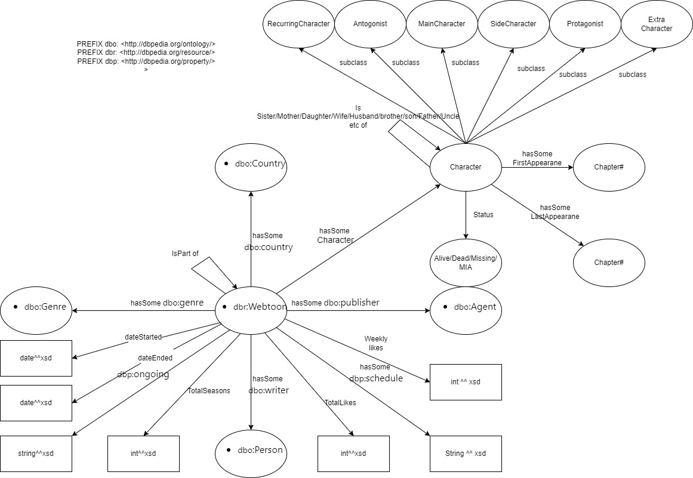

**Dataset:**

We have identified a dataset relevant to our domain. The dataset contains scraped information of 500+ webtoons. The data is stored in csv format and has the following content:

id - Unique id identifying the comic.

Name - full name of the comic.

Writer- Author of the comic.

Likes- Total no. of Likes

genre - genres for comic.

rating - an average rating out of 10 for the comic.

Subscribers- Total no. of subscribers

Summary- Summary of the comic

Update - Day of the week for an update

Reading Link- Link where you can read the comic

The link of the dataset: <https://www.kaggle.com/datasets/swarnimrai/webtoon-comics-dataset>

**External Linked Datasets**

We will be using <http://dbpedia.org/ontology/> for the following entities:

Country

Genre

Person

Agent

Publisher

Writer

We will be using <http://dbpedia.org/resource/> for the following entities

Webtoon

We will be using <http://dbpedia.org/property/> for the following entities

Ongoing

Schedule

We also looked “Marvel Comics” Ontology on DBPedia: <http://dbpedia.org/resource/Marvel_Comics>