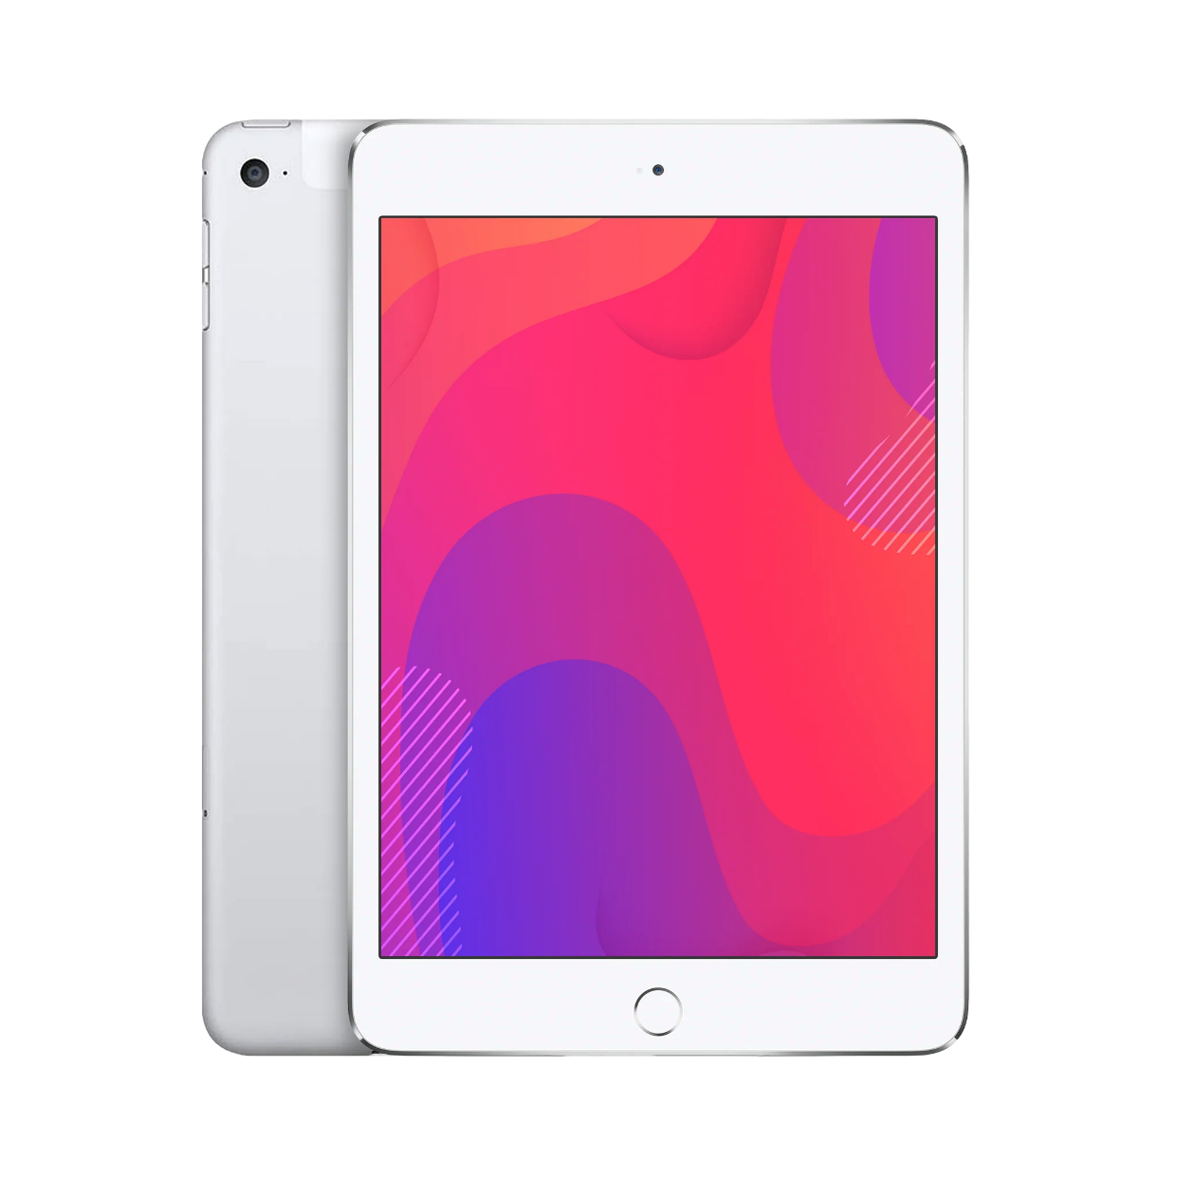

$475

Apple iPad Mini 2019

* Processor: Apple A12 Bionic (7 nm)
* Front Camera:7 MP
* Rear Camera:8 MP
* Display:7.9 “
* NFC:No
* Colors:Space,Gary,

Silver,Gold

* Operating System:

Ios 12.1.3

* Charging Type: Lightning, USB 2.0
* SIM:Nano-SIM,Esim
* Fingerprint:Yes
* Release Date:2019,

March 18

RAM

3

GB

ROM

256

GB

BATTERY

5124

mAh



+001-28272300-2466-2469



webmaster@cellinfo.com



A-65, ACME Co. ,

Street No. 12,

New York

Ask Me Ltd.