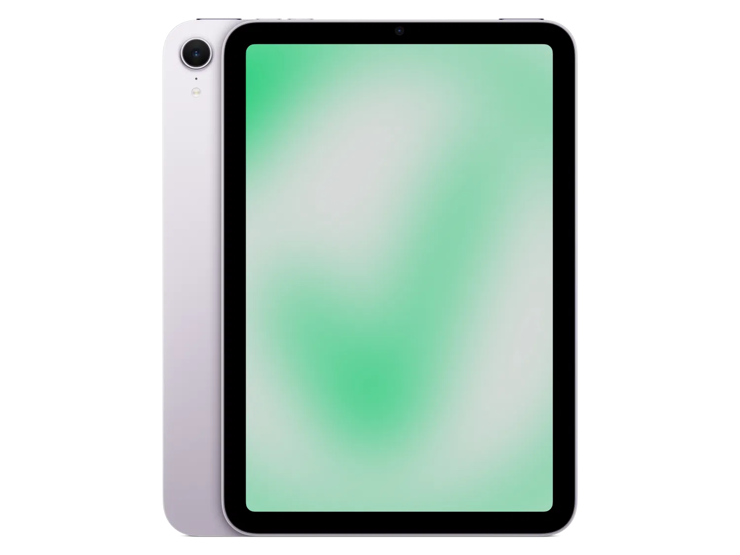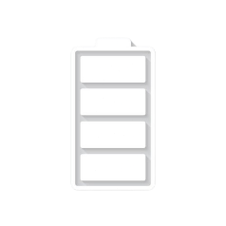

$634

Apple iPad Mini 2024

* Processor: Apple A17 Pro
* Front Camera:12 MP
* Rear Camera:12 MP
* Display:8.3 “
* NFC:No
* Colors:Space,Gray,

Blue,Purple,Starlight

* Operating System:

iPadOS 18

* Charging Type:USB Type-C
* SIM:Esim
* Fingerprint:Yes
* Release Date:2024,

October 23

RAM

8

GB

ROM

512

GB

BATTERY

5078

mAh



+001-28272300-2466-2469



webmaster@cellinfo.com



A-65, ACME Co. ,

Street No. 12,

New York

Ask Me Ltd.